Nodulation of black gram as influenced by rhizobium inoculation using different types of adhesives.

Md. Abu S.Aleh¹, Shahriar Zaman¹, Golam Kabir²

^{1.} Dept. of Genetic Engineering and Biotechnology University of Rajshahi, Bangladesh
^{2.} Dept. of Botany, University of Rajshahi, Bangladesh
saleh@ru.ac.bd

Abstract: Beneficial roles of certain symbiotic nitrogen fixing bacteria such as Rhizobium on growth and yield of Black gram are well known.Three Rhizobium strains were isolated from different species of legumes. RLc107 from Lentil, RCa 220 from Chick pea and RVm 307 from Black Gram. To find out the effect of these strains on nodulation (Nodule number per plant, nodule fresh weight per plant and nodule dry weight per plant) of two Black gram varieties (BARI MASH-1 and BINA MASH-1), investigations were carried out in the field of Rajshahi University. For better seed inoculation of those varieties, four different types of adhesives like sucrose, peptone, molasses and glycerol were used. It was observed that Rhizobium inoculation improved nodulation in both the varieties than that of un inoculated control. The highest nodule number (58.45) per plant, nodule fresh weight (46.11mg) per plant and nodule dry weight (12.07 mg) per plant were observed in BINA MASH-1 when inoculated by RVm 307 with the adhesive peptone.
[Saleh M. A., Zaman S., Kabir G. Nodulation of black gram as influenced by rhizobium inoculation using different types of adhesives. Nat Sci 2013; 11(7): 152-157]. (ISSN: 1545-0740). http://www.sciencepub.net/nature. 25

Keywords: Adhesives, Black Gram, Inoculation, Nodulation, Rhizobium

Introduction:
The increasing demand for production of crops and food for such a vast population has led to an interest and necessity for the use of biofertilizers for the betterment of the crops and even for the health of soil. Biofertilizers can be a very good complimentary to the chemical pesticides as they not only kill the harmful insects but also the beneficial insects such as pollinators.
By the turn of this century, food requirement is increasing day by day. One of the key limiting factors in crop productivity is the availability of nitrogen. Because of the constraints on the production, availability and use of chemical nitrogenous fertilizers, biologically fixed nitrogen will play an important role in increasing the crop production. Amongst the leguminous crops, Black gram is one of the most important crop, like other pulse crops. it has unique characteristics of maintaining and restoring soil fertility through biological nitrogen fixation and its deep root system also maintains physical properties of soil. But there are many agro-ecological, biological and management related constraints that are responsible for the lower productivity of blackgram. Non-availability of proper biofertilizer and inadequate use of macro and micronutrients are some of the important factors that are responsible for lower yield of black gram. For higher yield of Black gram, an optimum rhizobial population in the rhizosphere, artificial seed inoculation with an efficient rhizobial strain is necessary.
But many leguminous seeds contain certain water soluble toxic compound such as α,ϒ –diaminobutyric acid which adversely affect the viability of Rhizobium (Jacobs and Daad,1959; Millington,1959; Thomson,1960).Therefore, it is essential to ensure the adhesion and survivality of large number of Rhizobia per seed to compete with indigenous microorganisms. To ensure maximum number of viable cells per seed, different types of adhesives like sucrose, peptone, molasses etc. may be used. The present study was carried out to investigate the effect of three Rhizobium strains on nodulation of two Black Gram varieties using four different types of adhesives.
Materials and Methods:
To evaluate the response of Black Gram to Rhizobium inoculation, a field experiment was conducted at the University of Rajshahi, Bangladesh. For this study, two Black Gram varieties i.e. BARI MASH-1 and BINA MASH- 1 (Mutant variety); three Rhizobium strains such as RLc 107 (isolated from Lentil); RCa 220 (isolated from Chick Pea) ; RVm 307 (isolated from Black Gram) and four different types of adhesives namely sucrose, peptone, molasses and glycerol were used as experimental materials.
The seeds of Black Gram varieties were disinfected with 0.2% HgCl₂ (3-4 mins.) followed by 6-7 washings with sterile water. The disinfected seeds were then suspended in 50 ml thick suspension (10¹² cells/ml) of Rhizobium in presence of 1% sucrose, peptone, molasses and glycerol separately for 30 minutes. These seeds were air dried and sown in the field with three replications. Nodulation data were collected at flowering stage because at maturity most of the nodules were disintegrated and decomposed. For collection of this data, three plants were carefully uprooted from each experimental plot by digging 15 cm around the plant using a spade and washed with clean tap water to remove all attached soil from the roots and the nodules. The nodules were counted and carefully picked using a pair of tweezers, oven dried and dry matter weights determined. Data were analyzed by DMRT and ANOVA.
Results:
Data pertaining to the number of nodules per plant are presented in Table 1. It was evident that differences between the means of treatments were significant. Plant inoculated with different Rhizobium strains produced significantly higher number nodules as compared to that of un inoculated control. The highest number (58.45) of nodules were obtained with the strain RVm 307 using the adhesive peptone in BINA MASH-1 and the second highest (56.23) number of nodules were obtained with the same strain but using the adhesive sucrose in the same variety (Fig.1) which was statistically similar to the effect of RCa 220 with the adhesive peptone. The lowest number (33.45) of nodules were obtained with RLc 107 in BARI MASH-1 using adhesive glycerol, which was statistically similar to the effect of same strain with adhesive molasses in the same variety (Table 1). Among the different types of adhesives, peptone showed the better result than other adhesives in both the varieties (Fig.2).
Analysis of variance (Table 4) showed that except replication, interaction between variety and adhesive & strain and adhesive , all the sources had a significant effect in nodule number per plant.
Table 2 showed that the highest fresh weight (46.11 mg) of effective nodules was obtained with the strain RVm 307 using peptone as an adhesive in BINA MASH-1 which was statistically similar to the effect of RCa 220 with the same adhesive in the same variety. Plants inoculated with RLc 107 using adhesive sucrose produced the lowest fresh weight (24.22 mg) of nodule in BARI MASH-1 which was statistically similar to the effect of same strain with other three adhesives. Seed inoculated with the strain always showed the higher fresh weight of nodule in comparison to that of control. Among the strains and adhesives, RVm 307 and peptone showed the better result (Fig. 3&4).

Table 1: Nodule no. per plant of the two varieties treated with different Rhizobium strains using different types of adhesives
BARI MASH-1 |  |  |  |  | BINA MASH-1
Strains  Adhesives | RLc 107 | RCa 220 | RVm 307 | Control | RLc 107 | RCa 220 | RVm 307 | Control
Sucrose | 35.56 n | 37.56 m | 40.34 k | 32.75 q | 50.56 f | 54.19 cd | 56.23 b | 44.68 i
Peptone | 37.33 m | 39.45 kl | 41.96 j | 33.00 q | 53.33 cde | 55.78 b | 58.45 a | 44.67 i
Molasses | 34.34 op | 36.90 m | 39.23 l | 30.89 r | 49.33 g | 52,89 e | 54.34 c | 44.23 i
Glycerol | 33.45pq | 35.23 no | 37.89 m | 31.56 r | 48.11 h | 51.44 f | 53.23 de | 44.34i
Means followed by same letter (s) are statistically non significant at 5% level as tested by DMRT.

Table 2: Nodule fresh weight (mg) per plant of the two varieties treated with different Rhizobium strains using different types of adhesives
BARI MASH-1 |  |  |  |  | BINA MASH-1
Strains  Adhesives | RLc 107 | RCa 220 | RVm 307 | Control | RLc 107 | RCa 220 | RVm 307 | Control
Sucrose | 24.22 jk | 26.33 hij | 27.33 fghij | 19.78 l | 37.33 de | 40.22 cde | 42.oo bc | 30.11 fgh
Peptone | 28.11 fghij | 29.55 fghi | 30.66 f | 21.11 kl | 42.78 abc | 44.77 ab | 46.11 a | 31.22 f
Molasses | 26.55 ghij | 28.77 fghij | 31.00 f | 20.89 kl | 37.44 de | 39.77 cde | 40.55 cd | 30.44 fg
Glycerol | 26.00 ij | 28.11 fghij | 29.55 fghi | 20.22 l | 36.55 e | 38.89 cde | 40.89 cd | 30.00 fghi
Means followed by same letter (s) are statistically non significant at 5% level as tested by DMRT.

Varieties, strains, adhesives & interaction between varieties and adhesives showed highly significant and the remaining sources showed non significant effect on this character (Table 4).
There was a significant variation in dry weight of nodule per plant of Black Gram treated with different Rhizobium strains (Table 3). BINA MASH-1 produced highest nodule dry weight (12.07 mg) when inoculated with the strain RVm 307 using peptone as an adhesive and the lowest nodule dry weight (5.033 mg) was observed in BARI MASH-1 when treated with RLc 107 using the adhesive molasses. In both the varieties, treatment with strains and adhesives showed better result than control and among the strains and adhesives, RVm 307 (Fig.5) and peptone (Fig.6) gave the better result. In this case, except replication, interaction between variety and adhesives & variety, strains and adhesives, all the other sources showed significant effect on the above character (Table 4).

Table 3: Nodule dry weight (mg) per plant of the two varieties treated with different Rhizobium strains using different types of adhesives
BARI MASH-1 |  |  |  |  | BINA MASH-1
Strains  Adhesives | RLc 107 | RCa 220 | RVm 307 | Control | RLc 107 | RCa 220 | RVm 307 | Control
Sucrose | 5.090 jkl | 5.897 ij | 7.473 h | 4.190 lm | 9.481 def | 10.37 bcd | 10.77 bc | 7.240 h
Peptone | 6.730 hi | 6.837 hi | 8.437 g | 4.513 klm | 10.73 bc | 11.18 b | 12.07 a | 7.360 h
Molasses | 5.033 jkl | 5.887 ij | 6.527 hi | 4.250 lm | 9.207 efg | 10.08 cde | 10.34 bcd | 7.043 h
Glycerol | 5.523 j | 5.300 jk | 5.957 ij | 3.867 m | 8.926 fg | 9.870 cdef | 10.70 bc | 7.197 h
Means followed by same letter (s) are statistically non significant at 5% level as tested by DMRT.

Table 4: Analysis of variance of nodule number, nodule fresh weight and nodule dry weight of two Black Gram varieties treated with different Rhizobium strains using different types of adhesives
Source | df | Mean square
 |  | Nodule number | Nodule fresh weight | Nodule dry weight
Replication  Variety (V)  Strains (S)  V×S  Adhesives (A)  V×A  S×A  V×S×A  Error | 2  1  3  3  3  3  9  9  62 | 0.126 ^{ns}  5325.707 **  394.979 **  17.544 **  58.380 **  0.152 ^{ns}  3.415 **  0.640 ^{ns}  0.388 | 6.942 ^{ns}  3415.893 **  522.715 **  10.777 ^{ns}  55.252 **  18.875 **  2.931 ^{ns}  1.907 ^{ns}  4.389 | 0.266 ^{ns}  349.527**  47.763 **  2.053 **  8.470 **  0.110 ^{ns}  0.698 *  0.286 ^{ns}  0.294
*,** significant at 5% and 1% respectively; ns : non significant

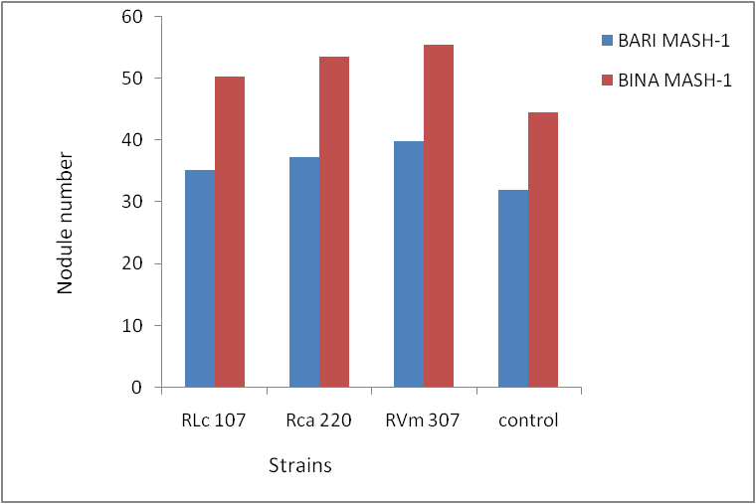  Fig.1. Effect of Rhizobium strains on Nodule no. of two Black gram varieties | 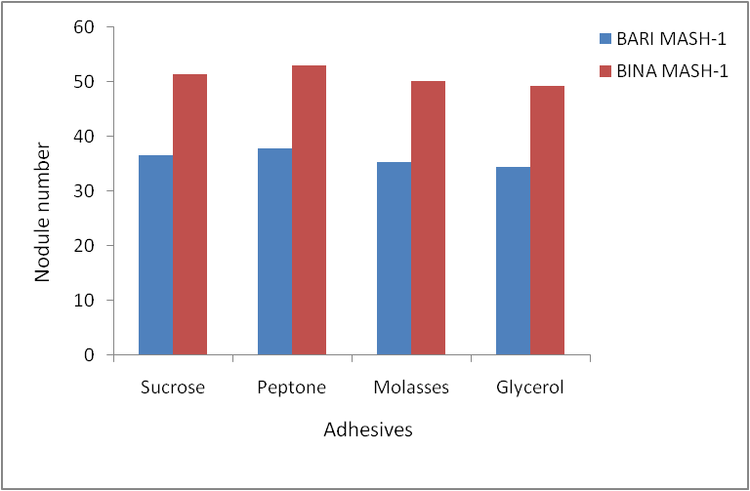  Fig.2. Effect of different types of adhesives on Nodule no. of two Black gram varieties
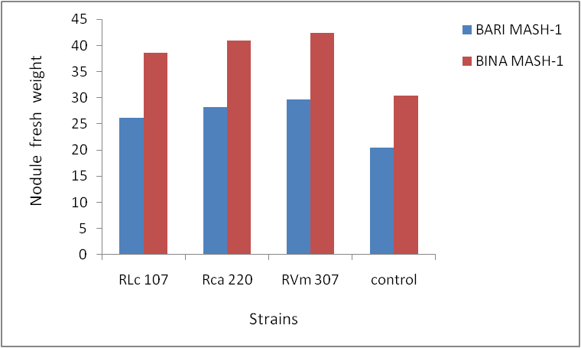  Fig.3. Effect of Rhizobium strains on Nodule fresh weight of two Black gram varieties | 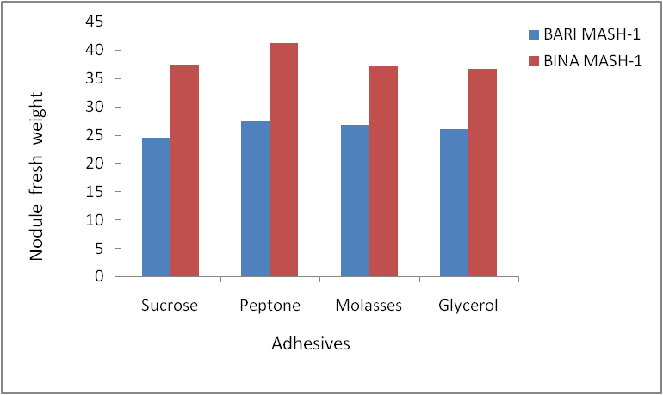  Fig.4. Effect of different types of adhesives on two Nodule fresh weight of two Black gram varieties
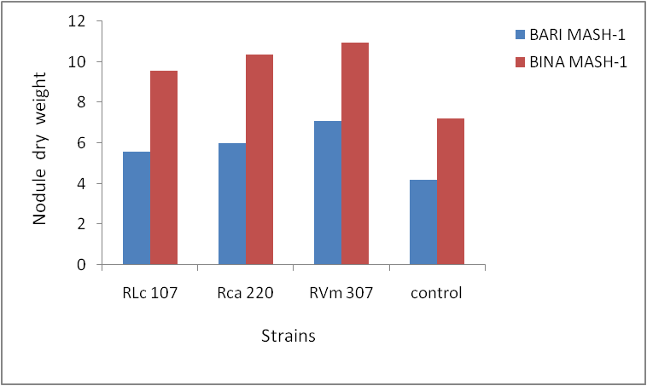  Fig.5. Effect of Rhizobium strains on Nodule dry weight of two Black gram varieties | 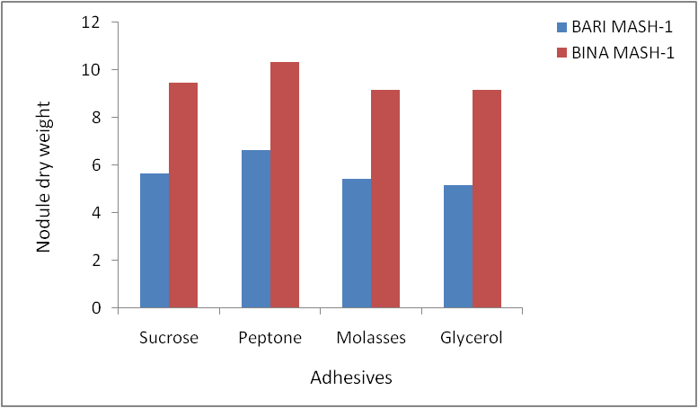  Fig.6. Effect of different types of adhesives on Nodule dry weight of two Black gram varieties

Discussions:
An essential desired characteristic for the inoculum strains of Rhizobia is the highly effective nitrogen fixing ability with the intended host species and in some instances there is a requirement to effectively nodulate a wide range of host legumes. Other beneficial characteristics include stress tolerance, competitive ability against indigenous strain, genetic stability and satisfactory growth and survival during the production of commercial inoculums (Howieson et al. 2000b) .This study was undertaken to find out the relative ability of different Rhizobium strains for nodulation in Black Gram using different types of adhesives.
Nodule number per plant is very important character as there are evidences that the bacterium thrives in root exceretions, although no single component in the root exudates has any special root in stimulating its growth. Jagdale et al. (1980) stated that in field conditions nodulations were increased with the inoculation of Rhizobium in Bengal gram. However, in the present study, it was observed that nodulation was increased due to seed inoculation with different adhesives in comparison to that of control. Prasad et al. (1984) reported that number of nodules were found to increase with Rhizobium inoculation in comparison to control. Tippannavar and Desai (1992), Shah et al. (1994) and Biswas et al. (2003) reported that seed inoculation increased the number of nodules per plant. These results are also in conformity with the findings of El-Hadi and Sheikh (1999) as they reported that Rhizobium inoculation significantly increased total number of nodules per plant. Yadav et al. (1994) observed an increase in the number of nodules and grain yield due to grain inoculation. Roy et al. (1995) also reported that grams inoculation with Rhizobium increased nodule number per plant. Ahmed et al. (2006) reported that inoculation of soil and seed with Rhizobium in combination with nitrogen fertilizer significantly affected the growth and nodules formation in green gram. Similar results were also obtained by Alam et al. (1999), Solaiman and Rabbani (2006), Javaid (2009), Muhammad Aslam et al. (2010) and Javaid and Bajwa (2011). Among the different types of adhesives, peptone always showed the better result than other adhesives as observed by Saha and Kapadnis (2001).
Nodule fresh weight is an important character related to yield. In the present investigation, nodule fresh weight was always higher than that of control. In case of adhesives, peptone showed better performance. Javaid (2009) reported that nodule fresh weight was always increased with the inoculation of Rhizobium and soil amendments. Similar results were also obtain by Pawar and Ghulgule (1977), Vaishya et al. (1982) and Javaid and Bajwa (2011).
Nodule dry weight may be considered as a useful character for selecting efficient strains of Rhizobium. Dry weight of nodules per plant compared to number of nodules was more closely related to seed yield as reported by Khurana et al. (1984). This may also be used as a selection criterion for improvement in seed yield of blackgram. In the present investigation, highest nodule dry weight was observed in case of adhesive peptone as reported by Saha and Kapadnis (2001). From the table 3, it had been seen that nodule dry weight was always higher in case of treatment with Rhizobium using different adhesives in comparison to control. Eusuf Zai et al. (1999) conducted a pot experiment on chickpea and found that Rhizobium inoculation increased dry weight of nodules. This result was in agreement with Solaiman and Rabbani (2005) who reported that Rhizobium inoculant significantly increased dry weight of nodules per plant in edible-podded pea. Similar results were also obtained by Pawar and Ghulgule (1977), Vaishya et al. (1982), Hafeez et al. (2007), Talukder et al. (2008), Solaiman et al. (2010) and Javaid and Bajwa (2011).

Acknowledgements
Ministry of science and technology, government of the people’s republic of Bangladesh is gratefully acknowledged for funding this research.

Corresponding Author:
Md. Abu Saleh
Assistant Professor
Dept. of Genetic Engineering and Biotechnology
University of Rajshahi,Bangladesh
E-mail: saleh@ru.ac.bd

References
1. Ahmed ZI, Anjum MS and Rauf CA. Effect of Rhizobium inoculation on growth and nodule formation of Green Gram. International Journal of Agriculture and Biology 2006; 08(2):235-237.
2. Alam MJ, Solaiman ARM, Karim AJMS and Hossain MT. Potential of some Rizobium strains on nodulation, nitrogen fixation, crop growth and dry matter production of chickpea. Bangladesh J. Microbiol 1999;16(2):107-114.
3. Biswas P, Hosain D, Ullah M, Akter N and Bhuiya MAA Performance of groundnut under different levels of bradyrhizobial inoculum and nitrogen fertilizer. SAARC J. Agric 2003;1:61-68.
4. El-Hadi EA and El-Sheikh EAE Effect of Rhizobium inoculation and nitrogen fertilization on yield and proteincontents of six chickpea (Cicer arietinum L.) cultivars in marginal soils under irrigation. Nutrient cycling in Agroecosystems 1999;54(1):57-63.
5. Eusuf Zai AK, Solaiman ARM and Ahmed JU. Response of some chickpea varieties to Rizobium inoculation in respect of nodulation, biological nitrogen fixation and dry matter yield. Bangladesh J Microbiol 1999; 16(2):135-144.
6. Hafeez FY, Naeem F, Shaheen N and Malik KA. Nodulation of Sesbania spp.,by introduced Rhizobia in competition with naturalized strains in different soil types. Pak.J.Bot 2007; 39(3):919-929.
7. Howieson JG, O’Hara GW and Carr SJ. Changing roles for legumes in Mediterranean agriculture: developments from Australian perspective. Field Crop Research 2000b; 65:683-697.
8. Jacobs SE and Daad AH. Antibacterial compounds in seed-coat and their role in infection of sweet peas by Corynebacterium fascians (Tilford) Dawson.Ann. Appl. Biol 1959; 47:666-672.
9. Jagdale BB, More BK, Konde and Patil. Effect of different doses of Rhizobium inoculant on nodulation, dry matter weight, nitrogen content and yield of Bengal gram (Cicer arietinum L.). Food Fmg. Agric 1980; 12(9): 216-217.
10. Javaid A. Growth, nodulation and yield of black gram (Vigna mungo L.Hepper) as influenced by biofertilizers and soil amendments. African Journal of Biotechnology 2009; 8(21): 5711-5717.
11. Javaid A and Bajwa R. Field evaluation of ef ective microorganisms (EM) application for growth, nodulation, and nutrition of mung bean. Turk J Agric 2011; 35:443-452.
12. Khurana SR, Lakshminarayana K and Narule Neeru. Response pattern of soyabean (Glycine max) genotypes as influenced by nodulation traits. Indian. J. Agric.Res 1984; 18:193-196.
13. Millington AJ. Deep-placement of Rhizobial cultures as an aid to legume inoculation. J. Aust. Inst. Agric. Sci 1959; 21:102-103.
14. Muhammad Aslam, Haji Khallil Ahmad, Himayatullah, Muhammad Ayaz, Ejaz Ahmad, Abdul Ghaffar Sagoo,Inayat Ullah, Amir Hussain, and Muhammad Manzoor. Nodulation, Grain Yield and Grain Protein contents as affected by Rhizobium inoculation and fertilizer placement in Chick pea cultivar bittle-98. Sarhad J. Agric 2010; 26(4):467-474.
15. Pawar NB and Ghulgule JN. Study of synergistic effects of Rhizobium,Azotobacter and nitrogen on the grain yield and other yield attributes of mung (Phaseolus aureus syn. Vigna radiata).Trop.Grain Leg.Bull 1977; 9:22-25.
16. Prasad R, Jamaluddin and Dadwall VS. The studies on nodulation behavior in Lucaena leucocephala. Indian Forester 1984; 110:1149-1154.
17. Roy SK, Rahaman SML and Salahuddin ABM . Effect of Rhizobium inoculation and nitrogen on nodulation, growth and seed yield of gram (Cicer arietinum L.). Indian J. Agron 1995; 65: 853–857.
18. Saha AK and Kapadnis BP. Effect of adhesives on population of green fluorescent protein (GFP) marked Rhizobium on legume seeds and their germination. Bangladesh J. genet. biotechnol 2001; 2(1&2):133-141.
19. Shah SH, Khan DF and Madani MS. Effect of different Rhizobial strains on the performance of two chickpea cultivars under field conditions. Sarhad Journal of Agriculture 1994; 10(1):103-107.
20. Solaiman ARM and Rabbani MG. Effects of Rhizobium inoculant,compost, and nitrogen on edible-podded pea. Bangladesh J Microbiol 2005; 22(1): 5-9.
21. Solaiman ARM and Rabbani MG. Effects of Rhizobium inoculant,compost, and nitrogen on nodulation, growth, and yield of pea. Korean J Crop Sci 2006; 51(6): 534-538.
22. Solaiman ARM, Talukder MS and Rabbani MG. Influence of Some Rhizobium Strains on Chickpea: Nodulation, dry matter yield and Nitrogen uptake. Bangladesh J Microbiol 2010; 27(2): 61-64.
23. Talukder MS, Solaiman ARM, Khanam2,D.and Rabbani MG. Characterization of Some Rhizobium Isolates and Their Effectiveness on Pea. Bangladesh J Microbiol 2008; 25(1): 45-48.
24. Thomson JA. Inhibition of nodule bacteria by an antibiotic from legume seed coats. Nature 1960; 187:619-620.
25. Tippannavar CM and Desai SA. Effect of Rhizobium with cultural practices on Bengal gram production. J. Maharashtra Agri. Univ 1992; 17: 326–327.
26. Vaishya UK, Gajendragadkar GR and Pandey RL. Effect of Rhizobium inoculation on nodulation and grain yield of mung bean (Vigna radiata L. Wilczek).Indian J. Microbiol 1982; 22:228-230.
27. Yadav KS, Suneja S and Sharma HR. Effect of dual inoculation Rhizobium and Azotobacter in chickpea (Cicer arietinum L.). Envir. & Ecol 1994; 12(4): 865-868.

5/25/2013

