Antioxidants Status in Breast Cancer Patients under Chemotherapy

Ashraf A. EL-Bindaryª, Raida S. Yahya^{b}, Hatem A. EL-Mezayen^{c}, Hossam Darwish^{d}, and Mohammed A. Eissa^{e}

ªChemistry Department, Faculty of Science, Damiette University, Damiette , Egypt, ^{b} Children Hospital ,Faculty of Medicine, Mansoura University, Mansoura,Egypt, ^{c}Chemistry Department, Faculty of Science, Helwan University,Cairo,Egypt, ^{d}Medical Oncology Department, ^{e}Clinical Pathology Department, Damiette Cancer Institute, Damiette, Egypt.

Abstract: The latest experimental evidences on cancer diseases were implicated the involved oxygen derived radicals in the development and spread of these diseases in human's body. Oxygen derived radicals were able to attack and damage the cell membranes, mitochondria and macromolecules including proteins, lipids and DNA. These damaged molecules were accumulates in the cells especial for DNA damages that it have the ability to increase the rate of cell carcinogenesis. The present study was aimed to evaluate the biochemical role of some antioxidants enzymes in breast cancer (BC) patients under therapy treatment. Spectrophotometric standard technique was used to estimate the activities of super oxide dismutase (SOD),catalase (CAT) and glutathione – S– transferase (GST) in sera and plasma of 50 BC patients before and after their chemotherapy courses and 40 healthy women as controls. Statistical analyses were performed by a statistical package for social sciences (SPSS, version 15.0 for windows, Inc.). We found that the activities of both SOD and CAT in pretreated BC patients were significantly lower (P<0.001) than those of controls. In contrast, the activity of GST was significantly increased (P<0.001) in pre treated BC patients than those of controls. After all BC patients received the first chemotherapy course, the effects of chemotherapy on SOD, CAT and GST activities were observed, where there was further significant decreasing (P<0.001) in these activities in post treated than other pretreated BC patients and controls. In conclusion, administration of these antioxidants is necessary to all BC patients that it may be helpful to support and manage the efficiency of their chemotherapy courses.
[Ashraf A. EL-Bindary, Raida S. Yahya, Hatem A. EL-Mezayen, Hossam Darwish, and Mohammed A. Eissa. Antioxidants status in breast cancer patients under therapy. Nat Sci 2013;11(7):1-6]. (ISSN: 1545-0740). http://www.sciencepub.net/nature.

Keywords: breast cancer, superoxide dismutase, catalase, glutathione–s–transferase, reactive oxygen metabolites

1. Introduction
Breast cancer is the most common malignancy among women in the most developed countries with nearly a million new cases each year. It accounts for nearly 21% of all cancers among women world wide [1]. In Egypt, breast cancer is the most common cancer among women that is representing 18.9 % of total cancer cases (17.8 % in women and 1.1% in men) [2]. Addition to palpation, mammography and other similar procedures, series of tumor markers were not specific for breast cancer. These tumor markers were used to measure the screening, early detection and progression of breast tumors. These markers includes tumor size, grade, lymph node status, estrogen (ER) or progesterone (PR) receptors, Her-2/neu gene , over expression of carcino embryonic antigen (CEA) and cancer antigen (CA15.3) [3]. Recently, all patients with breast cancer may develop progression or recurrence of disease and thus needs an effective long life follow up of the disease. In fact, this follow up depends on two potential applications as early detection of recurrent disease and monitoring the responds of patients to the therapy [4]. Some enzymes such as SOD, CAT and GST have a vital role in the follow up of breast cancer disease. These enzymes counteracts the deleterious action of reactive oxygen metabolites (ROMs) such as singlet oxygen (O2o) , super oxide anions (O2o-) , hydrogen peroxide (H2O2) , and hydroxyl radical (oOH) [5,6] . Under normal circumstances, major sources of ROMs in cell are electron leakages from electron transport chains in mitochondria and endoplasmic reticulum. These ROMs have a wide range of cellular and molecular effects resulting in mutagencity, cytotoxicity and changes in gene expression. Experimental evidence reveals that ROMs are involved in initiation and promotion of carcinogenesis, where inactivation or loss of certain tumor suppressor genes is occurred [7],G-C base pairs in CPG dinucleotide sequences as a common site for point mutations in the p53 tumor suppressor gene linked to breast and other site of specific cancers [8].
The present study was aimed to evaluate the biochemical role of antioxidant enzymes in breast cancer patients under therapy treatment.

2. Patients and Methods

Patients
The present study was carried on 50 breast cancer patients that were attended to surgical units of Damiette Cancer Institute. They were adult females aged between 25 and 78 years and their consent were based on clinical criteria and histopathological confirmation, table (1).The evidence of patient's follow up were occurred before and after their therapeutic treatment. The study was comprised 40 normal women without any neoplastic diseases and aged between 23 and 68 years to act as controls.

Samples
Blood samples were drawn from all patients before any form of treatment and also were drawn from the same patients after they received the first cycle of chemotherapy (e.g. FAC: 5-Fluorouracil, Adriamycin, Cyclophosphamide). Venous blood samples were collected in sterile plain tubes, centrifuged at 2,000 r.p.m for 10 minutes to separate sera loquat and it were collected by using EDTA tubes, centrifuged at 4,000 r.p.m for 15 minutes at 4 °C to separate plasma loquat. Both sera and plasma were stored at −70°C until assays.

Assays of SOD activity
Assays of SOD activity depends on the ability of the enzyme to inhibit the phenazen methosulphate reaction of nitro blue tetrazolium dye (Sigma Chemical Co.,Cario,Egypt) [9]. The reaction was initiated by addition of phenazine methosulphate and increase in absorbance spectrophotometrically measures at 560 nm. The activity of the sample was determined by comparing the increase of absorbance during one minute between sample and blank then the percent of inhibition was determined by subtracting the activity of sample from one hundred percent activity of blank (% inhibition) of reaction of nitro blue dye.

Assays of CAT activity
CAT activity was measured by using CAT assay kit (Biodiagnostic,Cairo,Egypt) [10]. The activity of CAT was determined by following the decomposition of H2O2 in phosphate buffer pH 7.2 and spectrophotometrically measured at 230 nm. One unit of CAT is defined as the amount of enzyme which liberates half the peroxide oxygen from H2O2 solution in 60s at 25º C.

Assays of GST activity
GST assay kit (Biodiagnostic,Cairo,Egypt) measures total GST activity (cytosolic and microsomal) by detecting the conjugation of 1-chloro-2,4-dinitrobenzene (CDNB) with reduced glutathione[11]. The conjugation is accompanied by an increase in absorbance spectro- photometrically at 340 nm. The rate of the increase in absorbance is directly proportional to the GST activity in the sample.

Statistical analysis
All statistical analyses were done by a statistical package for social sciences (SPSS, version 15.0 for windows, Inc.). Data were presented as the mean ± standard deviation (mean±SD). Student t-test and ANOVA methods were used to compare between means and (P<0.001) was determined the statistically significant of associations.
Table (1): Characteristics of breast cancer patients.

Clinical data No. of patients %

Age mean | 49 (25-78)
Menopausal status
Pre menopausal | 19 | 38
Post menopausal | 31 | 62
Family history
Positive | 12 | 24
Negative | 38 | 76
Clinical stage
Stage I | 11 | 22
Stage П | 19 | 38
Stage ш | 20 | 40
Tumor size
T1 ≤ 2 | 17 | 34
T2 (2 – 5) | 12 | 24
T3 > 5 | 21 | 42
Auxiliary lymph node
Positive | 34 | 68
Negative | 16 | 32
Estrogen receptor (ER)
Positive | 22 | 44
Negative | 28 | 56
Progesterone receptor (PR)
Positive | 20 | 40
Negative | 30 | 60
Her-2 / neu
Positive | 6 | 12
Negative | 44 | 88

3. Results
The activity of SOD was significantly decreased (P<0.001) in sera of the pretreated breast cancer patients compared to those in the sera of controls, and also it was significantly decreased (P<0.001) in sera of the post treated breast cancer patients compared to those in the sera of pretreated breast cancer patients and controls, table (2) and figure (1).
The activity of CAT was significantly decreased (P<0.001) in plasma of the pretreated breast cancer patients compared to those in plasma of controls, and also it was significantly decreased (P<0.001) in plasma of the post treated breast cancer patients compared to those in plasma of pretreated breast cancer patients and controls, table (3) and figure (2).
The activity of GST was significantly increased (P<0.001) in plasma of the pretreated and post treated breast cancer patients compared to those in plasma of controls, but it was significantly decreased (P<0.001) in plasma of the post treated breast cancer patients compared to those in plasma of pre treated breast cancer patients, table (4) and figure (3).

3. Discussion
The exact cause of breast cancer is not completely known but it represents a complex interplay of genetic and environmental factors [12,13]. Oxygen free radicals which were generated through several enzymatic and non enzymatic biological reactions in aerobic organisms have the ability to attack a wide variety of macromolecules such as lipid, protein, carbohydrate and DNA [7]. Batra et al., (1998), demonstrates that there were increases of reactive oxygen metabolites (ROMs) production in various path physiological conditions [14]. In addition, Negahdar et al., (2005), hypothesized that mutagenecity of oxygen led to chromosomal damage resulting from an increase in the free radical production [6].
In the present study, SOD and CAT activities were significantly decreased (P<0.001) in the sera and/or plasma of pre treated (without therapy) BC patients than healthy controls, thus occurred due to high production of free radicals that leaded to accumulation of ROMS. This is agrees with the study of Jayaraman et al.,(2003) that it observed the role of antioxidants to lower incidence of various human morbidities or mortalities molecules as ROMS[15]. The decreased activities of both SOD and CAT also have been reported by different researches in other malignancies [16, 17].
Several researches were considered SOD and CAT enzymes acts as anti carcinogens, antitoxins and inhibitors at initiation, promotion and transformation of carcinogenesis [16, 18, 19]. Boon et al., (2007), found that Plasmid DNA strand scission caused by xanthine oxidase was prevented by SOD and CAT enzymes [20].
Elchuri et al., (2005), reported that the mutation caused by potassium super oxide in mammalian cells can be blocked by SOD [16].
CAT also prevented chromosomal aberration caused by hypoxanthine/xanthine oxidase in Chinese hamster cells. It prevented the onset of spontaneous neoplastic transformation in mouse fibroblast and epidermal keratinocytes [6] In contrast, the present study found a significant increased (P<0.001) of GST activity in the plasma of the pre treated BC patients than other healthy controls. The increasing in GST activity was correlated with the increasing in erythrocyte lipid peroxidation under oxidative stress in BC patients [21].
According to the ability of GST enzyme to catalyze the conjugation of glutathione -via sulfhydryl- group to electrophilic center of endogenous compounds, the dangerous per oxidized lipids detoxified and cleavage out of the body[22]. Tas et al., (2005), shown that lipid per oxidation was enhanced in BC tissue with a higher oxygen free radical production compared to non malignant tissues [23].In addition, Kumaraguruparan et al., (2005) suggested the correlation between tissue redox status and tumor progression ,where up regulation of antioxidants enables tumor cells to counter oxidative stress during carcinogenesis[24].
Our study found that the activities of SOD, CAT and GST were significantly decreased (P<0.001) in the sera and/or plasma of the BC patients after they have been received the first cycle of therapy (e.g.FAC chemotherapy) compared to other pre treated patients. This illustrated the inability of FAC chemotherapy to contract higher ROMS production during carcinogenesis. To line with some researches [25, 26], administration of antioxidants such as super oxide dismutase, catalase, glutathione –S– transferase, glutathione (peroxidases and reductases) , vitamin E (tocopherols and tocotrienols) and vitamin C as apart from many dietary components is important to manage and support chemotherapy courses during follow up of BC patients .

Table (2): The mean activity of SOD in the sera of pre treatment, post treatment breast cancer patients and controls.
Parameters | Number of BC patients and Controls (n) | The mean activity of SOD (% inhibition)  (Mean± SD) | P. value
Controls | 40 | 48.16±0.5
Pretreatment  BC patients | 50 | 25.24±10.1ª | P<0.001
Post treatment  BC patients | 50 | 16.96±6.6 ^{b} | P<0.001
a: significant compared to controls
b: significant compared to pretreatment BC patients and controls

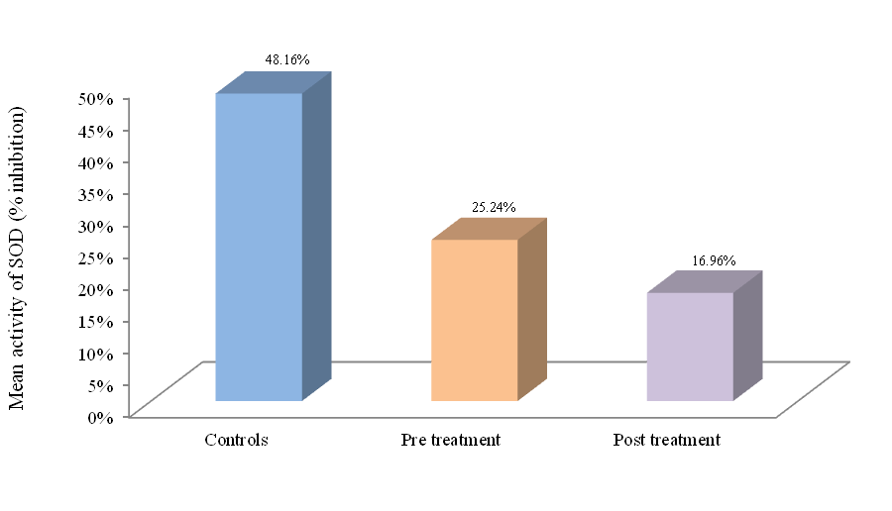
Fig. (1): Comparison of SOD activities in the sera of pre treatment, post treatment breast cancer patients and controls.

Table (3): The mean activity of CAT in the plasma of pre treatment, post treatment breast cancer patients and controls.
 | Number of BC patients and Controls (n) |  |  | The mean activity of CAT ( U/L)  (Mean± SD)
Parameters |  |  |  |  |  |  | P. value
Controls |  | 40 |  | 650.025 | ± | 65.172
Pretreatment  BC patients |  | 50 |  | 412.250 | ± | 174.827ª | P<0.001
Post treatment  BC patients |  | 50 |  | 214.500 | ± | 177.162 ^{b} | P<0.001
a: significant compared to controls
b: significant compared to pretreatment BC patients and controls
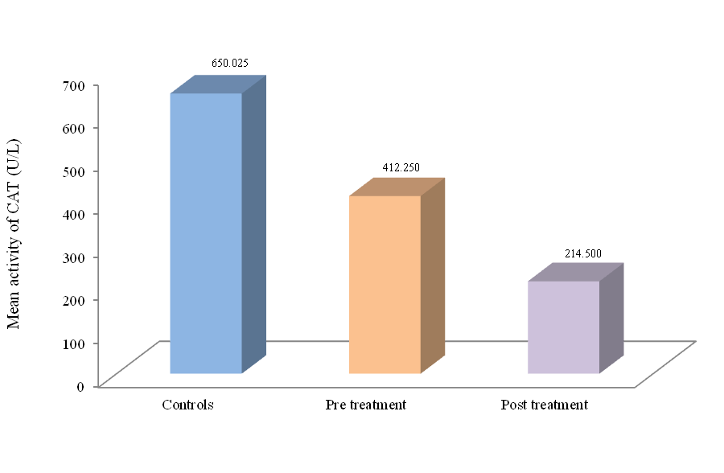
Fig. (2): Comparison of CAT activities in the plasma of pre treatment, post treatment breast cancer patients and controls.

Table (4): The mean activity of GST in the plasma of pre treatment, post treatment breast cancer patients and controls.
 | Number of BC patients and Controls (n) |  |  | The mean activity of GST ( U/L)  (Mean± SD)
Parameters |  |  |  |  |  |  | P. value
Controls |  | 40 |  | 265.124 | ± | 48.278
Pretreatment  BC patients |  | 50 |  | 443.765 | ± | 166.740ª | P<0.001
Post treatment  BC patients |  | 50 |  | 358.472 | ± | 115.740 ^{b} | P<0.001
a : significant compared to controls
b: significant compared to pretreatment BC patients and controls

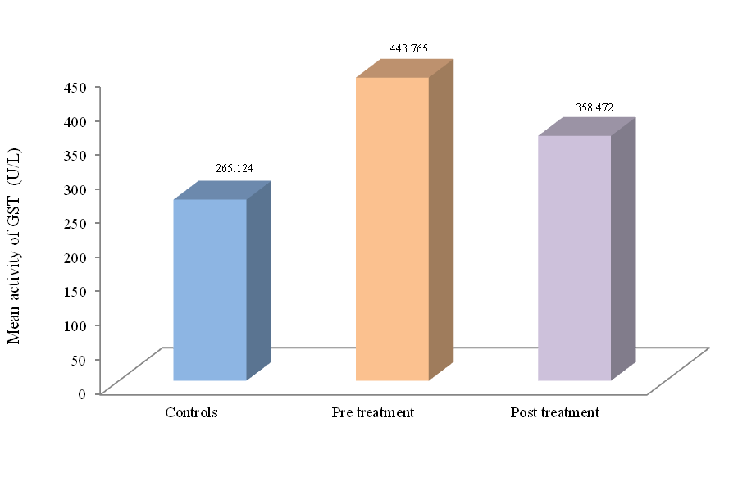
Fig. (3): Comparison of GST activities in the plasma of pre treatment, post treatment breast cancer patients and controls

On the other hand, our study results agree with other recant studies [27, 28] that observed the status of antioxidants enzymes under therapy treatment as genetic polymorphism, altered expression and activity changes were associated with oxidative DNA damage and subsequently the individual's risk of cancer susceptibility. In conclusion, according to the biochemical changes of SOD, CAT and GST in both pre treatment and post treatment BC patients, our study was considered these enzymes as biomarker for early detection of recurrent disease and also monitoring the effective therapeutic follow up of the patients.

Corresponding Author:

Dr. Hatem A. El-mezayen
Biochemistry department Faculty of Science
Helwan University
Cairo, Egypt
Mobile +201005874449
E-mail: hatem_mezayen@yahoo.com

References
[1] Althuis, M.D.; Dozier, J.M.; Anderson, W.F.; Devesa, S.S. and Brinton, L.A. (2005): Trends in breast cancer incidence and mortality. Int. J. Epidemiol., 34: 405.
[2] Omar, S.; Khaled, H.; Gaafer, R.; Zekry, A.R.; Eissa, S. and El-khatib, O. (2003): Breast cancer in Egypt: a review of disease presentation and detection strategies. Nat. cancer Inst., 9: 3.
[3] Anan, K.; Mitsuyama, S.; Tamae, K.; uchara, N.; Vishihara, K. and Ogawa, Y. (2002): Postoperative follow up of patients with early breast cancer: reappraisal of serum tumor markers. Surg . To day , 32: 13-8.
[4] Molina, R.; Barak, V.; van Dalen, A.; Duffy, M.J., Einarsson, R. and Gion, M. (2005): Tumor markers in breast cancer: European Group of Tumor Markers (EGTM) recommendations. Tumor Biol., 26: 281.
[5] Rao, D.N.; Desai, P.B. and Ganesh, B. (1996): Epidemiological observation on cancer of the esophagus- a review of Indian studies. Ind. J. Cancer., 33: 55-75.
[6] Negahdar, M.; Djalali, M.; Abtahi, H.; Sadeghi, M.R.; Aghvami, T.; Javadi, E. and Layegh, H. (2005): Blood super oxide dismutase and catalase activities in women affected with breast cancer. Iranian J. Pub. Health., Vol. 34, No.(3),pp:39-43.
[7] Haris, C. (1989): Individual variation among humans in carcinogen metabolism,DNAadduct formation and DNA repair. Carcinogenesis, 10: 1563-66.
[8] Lane, D.P. (1994): P53 and human cancers. British Med. Bull., 50(3): 582-99.
[9] Nishikimi, M. ; Roa , N.A. and Yogi, K. (1972): Biochem. Bioph. Res. Common., 46, 849 – 854.
[10] Abei, H. (1984): Catalase invitro. Methods Enzymol., 105:121-26.
[11] Habig, W.; Pabst, M. and Jakoby, W. (1974): J. Biol. Chem., 249,7130-7139.
[12] Mckeown, N. (1999): Antioxidants and breast cancer. Nutr. Rev., 57: 321-24.
[13] Wesseling, C.; Antich, D.; Hogstedt, C.; Rodriguez, A.C.and Ahlbom, A. (1999): Geographical differences of cancer incidence in Costa Rica in relation to environmental and occupational pesticide exposure. Ind. J. Epidemiol., 28: 365-74.
[14] Batra, S.; Ray, G.and Singh, S.K. (1998): Respiratory disease in children is associated with increased serum free radical scavenging activity. Med. Sci. Res., 26:357- 59.
[15] Jayaraman, K.S. (2003): Technology tradition unite India’s drug Discovery scheme. Nat. Med., 9:982.
[16] Elchuri, S.; Oberley, T.D.; Qi, W.; Eisenstein, R.S.; Jackson, R.L.; Van, R. H.; Epstein C.J. and Huang, T.T. (2005): CuZnSOD deficiency leads to persistent and widespread oxidative damage and hepato carcinogenesis later in life. Oncogene., 24 (3): 367–80.
[17] Kaplan, J.H.and Groses, J.N. (1972): Liver and blood cell catalase activity of tumour bearing mice. Cancer Res., 26: 1190-94.
[18] Antonyuk, S.V.; Strange, R.W.; Marklund, S.L. and Hasnain, S.S. (2009): The structure of human extracellular copper-zinc superoxide dismutase at 1.7 A resolution: insights into heparin and collagen binding. J. Mol. Biol., 388 (2): 310–26.
[19] Chelikani, P.; Fita, I. and Loewen, P.C. (2004): Diversity of structures and properties among catalases. Cell. Mol. Life Sci., 61 (2): 192–208.

[20] Boon, H.S.; Olatunde, F. and Zick, I. (2007): Trends in complementary/ alternative medicine use by breast cancer survivors: Comparing survey data from 1998 and 2005. B.M.C. Women’s Health, 7: 4.
[21] Kumaraguruparan, R.; Subapriya, R.; Kabalimoorthy, J. and Nagini, S. (2002): Antioxidant profile in the circulation of patients with fibroadenoma and adenocarcinoma of the breast. Clinical Biochemistry, 35(4): 275-79.
[22] Allocati, N.; Federici, L.; Masulli, M. and Di Ilio, C. (2009): Glutathione transferases in bacteria. FBES J. 271(1):58-75.
[23] Tas, F.; Hansel, H. ; Belce, A. ; Ilvan, S. ; Argon, A. ; Camlica, H. and Topuz, E. (2005): Oxidative stress in breast cancer. Med. Oncol., 22(1):11-5.
[24] Kumaraguruparan, R.; Kabalimoorthy, J. and Nagini, S. (2005): Correlation of tissue lipid peroxidation and antioxidants with clinical stage and menopausal status in patients with adenocarcinoma of the breast. Clin. Biochem., 38(2):154-8.
[25] Tilak, J.C.; Devasagayam, T.P.A. and Lele, R.D. (2001):Antioxidant activities from Indian medicinal plants: A review – Current status and future prospects.International Conference on Natural Antioxidants and Free Radicals in Human Health and Radiation Biology (NFHR). Mumbai, India, 52:21-22.
[26] Krishnaswami, K. (1996): Indian functional food: role in prevention of cancer. Nutr. Rev., 54:S127-31.
[27] Khan, M.A.;Tania, M.; Zhang, D. and Chen, H. (2010): Antioxidant enzymes and cancer. Chin. J. Cancer Res., 22 (2): 87–92.
[28] Milani, P.; Gagliardi, S.; Cova, E. and Cereda, C. (2011): SOD1 Transcriptional and Posttranscriptional Regulation and Its Potential Implications in ALS. Neurol. Res. Int., 2011: 458427.

17/05/2013

