**Nutraceuticals from Bitter Leaf (*Vernonia amygdalina* Del.) Protects against Cadmium Chloride induced Hypertension in Albino Rats**

Olaiya C.O 1, Choudhary M.I 2, Ogunyemi O.M.1, Nwauzoma A. B3

* 1. Department of Biochemistry, University of Ibadan, Ibadan, Nigeria.
  2. H.E.J. Research Institute of Chemistry, International Center for Chemical and Biological Sciences, University of Karachi, Karachi-75270, Pakistan.
  3. Department of Applied & Environmental Biology, Rivers State University of Science & Technology, Port Harcourt, Nigeria.

[cooolaiya@yahoo.com](mailto:cooolaiya@yahoo.com)

**Abstract:** In recent years, the consumption of nutraceuticals, natural plant foods, and the use of nutritional therapy and phytotherapy have become progressively popular to improve health, and to prevent and treat diseases. This study investigated the cardioprotective and hepatoprotective effects of some nutraceuticals from *Vernonia amygdalina* namely, β-sitosterol (BSS), β-sitosterol glucoside (BSSG) and BSS: BSSG mixture on certain parameters in hypertensive wistar albino rats. Hypertension was induced with Cadmium Chloride and the biochemical analyses of serum were carried out following treatment with BSS, BSSG, BSS:BSSG mixture and lisinopril. Serum urea, creatinine, calcium and electrolytes levels were assayed using appropriate standard methods as tests for renal function, while alkaline phosphatase (ALP), aspartate transaminase (AST) and alanine aminotransferase (ALT) served as enzyme indices of the liver function. The effect on the serum lipid profile was also assessed. Data collected were expressed as mean ± SEM and analysed using one-way ANOVA. The sodium levels had a significant (p<0.05) reduction in BSS and BSS:BSSG mixture treated rats. BSS treatment also gave a significant (p<0.05) decrease in triglyceride and total cholesterol levels while BSSG treatment gave 60.4% increase in HDL-Cholesterol levels and increased HDL-Cholesterol: LDL-Cholesterol ratio. Generally, treatments with the phytosterols reduced the levels of serum AST, ALT, ALP and tends to maintain urea and creatinine basal levels while lisinopril significantly increased (p<0.05) serum urea and creatinine levels. Tissue sections from phytosterol-treated groups show no visible lesion as against those from hypertensive rats that show areas of extensive necrosis. This study revealed that these nutraceuticals possess cardioprotective and hepatoprotective properties, with possible practical application in the management of cardiovascular diseases (CVDs).

[Olaiya CO, Choudhary MI, Ogunyemi OM, Nwauzoma AB. **Nutraceuticals from Bitter Leaf (*Vernonia amygdalina* Del.) Protects against Cadmium Chloride induced Hypertension in Albino Rats**. *Nat Sci* 2013;11(6):136-145]. (ISSN: 1545-0740). <http://www.sciencepub.net/nature>. 16

**Keywords:** Nutraceuticals, *Vernonia amygdalina*, bioactivity, lisinopril, hypertension.

**1. Introduction**

Plants contain a cornucopia of micronutrients and other compounds that promote health and reduce the risk of heart disease. *Vernonia amygdalina,* commonly called bitter leaf, is a small shrub that is native to tropical Africa. It is a member of the Asteraceae family whose leaves have been consumed for many years, either as a vegetable (macerated leaves in soup) or aqueous extracts for the maintenance of good health. One family of plant compounds, phytosterols, found naturally,mainly as β-sitosterol, campesterol and stigmasterol in *Vernonia amygdalina* and many food substances of plant origin with vegetable oils (especially unrefined oils), nuts, seeds and grains as the major dietary sources (Piironen *et al,.*2000) have been investigated for their biochemical roles in chronic diseases. β-sitosterol had earlier been reported in the literature to be effective as nutraceuticals and in combination therapy for the treatment of hypercholesterolemia, benign prostatic hyperplasia and breast cancer. It is also suggested to be immunomodulatory (Bouic, 2001), anti-artherogenic and antioxidative (Awad *et al*, 2001). Thus there is substantial evidence that the incidence of cardiovascular diseases can be reduced by phytosterols mainly via serum cholesterol levels lowering actions. There are extensive studies and research findings as to the use of phytosterols through diet or through combination therapy with other lipid lowering agents such as statin and fibrates. However there are still insufficient findings as to the roles they play in hypertensive conditions.

The phytosterols are biochemically heterogeneous in plant derived food matrices and the form of the phytosterols might be important in bioactivity. For instance esterified phytosterol solubilized in the triglyceride phase of margarines tends to produce a more desirable bioactivity than the crystalline form (Katan *et al,.*2003; Spilburg *et al,.*2003). A portion of β-sitosterol is glycosylated with little known effects on biological activity. However, the amphipathic structure of phytosterol glycosides raises questions about the degree of solubility in intestinal bile salt micelles and reactivity with pancreatic enzymes. Although literature on the physiology of phytosterol glycosides is sparse, previous workers have shown that fatty acids are cleaved from glycosylated phytosterols in vitro by pancreatin, but the sugar moiety itself is not removed (Moreau, 2004).

Dyslipidemia and hypertension, the two major risk factors of CVDs have been shown to contribute individually and synergistically to the pathogenesis and progression of cardiovascular diseases (Edward, 1994). The kidney also plays a primary role in the genesis and maintenance of essential hypertension. The work of Curtis *et al.* (2000) demonstrated that the remission of essential hypertension and monogenic hypertension with hypokalemia (Liddle’s syndrome) was possible after successful renal transplantation with kidneys from normotensive donors. Renal capacity for the handling of sodium, potassium, chloride, and other electrolytes is important in the context of extracellular volume expansion and hypertension. Also important are the epidemiologic observations that there is an inverse continuous relationship between renal function and cardiovascular events (Samak *et al.,* 2003). Modulation of various parameters associated with dyslipidemia and hypertension with natural products could be valuable in the prevention and treatment of cardiovascular diseases.

With the current incidence of cardiovascular diseases, there is a need for population-based, cost-effective, adverse-effect free hypertension control strategies to be developed. The development of a safe and effective way to manage hypertension which has challenged medical researchers for centuries has prompted a lot of researchers to shift focus to the therapeutic uses of medicinal plants and their natural products as other means for the populace, especially low-risk individuals and patients experiencing adverse effects of drugs (Kharb and Singh, 2004). While the literature is replete with findings about hyperlipidemia and the associated therapeutic agents in relation to cardiovascular diseases, there are continuous needs to better investigate the therapeutic options of hypertension. This study was therefore designed to investigate the cardioprotective and hepatoprotective effects of bitter leaf nutraceuticals, β-sitosterol and its glucoside form on some selected parameters in hypertensive rats and to compare the biological activities of the two forms.

**2. Materials and Methods**

**Plant material, extraction and chemical analysis**

Fresh leaves of *Vernonia amygdalina* were collected from the premises of the University of Ibadan, Ibadan, Nigeria. They were authenticated at the Department of Botany, University of Ibadan where a specimen voucher was deposited. The leaves were air-dried, finely powdered and further processed at the H.E.J. Research Institute of Chemistry, International Center for Chemical and Biological Sciences (ICCBS), University of Karachi, Pakistan. The finely powdered leaves, weighing 1.4Kg were extracted three times consecutively with ethyl acetate and 80% ethanol. The extracted solutions were concentrated in vacuo (Buchi Rotavapor R-200, Tokyo Rikakikai Co. Ltd.) to obtain crude extracts. Thin layer chromatography (TLC), column chromatography, and high-performance liquid chromatography (HPLC) were used to fractionate the bioactive extracts and to isolate the active compounds. Spectroscopic analyses (1H-NMR, 13C-NMR, LC-MS, EI-MS, IR, and UV) were employed to determine their chemical structures. All work were carried out in accordance with the general guidelines for methodologies on research and evaluation of traditional medicine (WHO, 2000; Trease and Evans, 2002; Reuben*, et al*., 2012).

**Animal Treatments**

Thirty albino rats of Wistar strain, weighing between 75-100g were procured from the Central Animal House, University of Ibadan, Nigeria. They were housed at room temperature with a 12-hour light and dark cycle, acclimatized for a week, allowed free access to clean drinking water and fed on standard feed throughout the period of study. They were grouped into six different groups according to their weight, with five animals in each group. The first group served as negative control and were fed on standard feed with distilled water throughout the study, while the animals in the other five groups were given Cadmium Chloride (CdCl2) orally for four weeks at 1mg/kgbw/day to induce hypertension (Puri, 1999). Using the second group as a ‘positive control’ the animals in the last four groups were placed on treatments of standard antihypertensive drug (lisinopril), the nutraceuticals (BSS, BSSG and BSS:BSSG (1:1) mixture), respectively at 2.3mg/kg/day.

**Histopathological Studies**

Small pieces of heart and kidney tissues were fixed in 10% formalin solution, followed by embedding in melted paraffin wax. Histopathological assessment and photomicrography of the prepared slides was done by using an Olympus light Microscope with attached Kodak digital camera.

**Biochemical Analysis**

Indices used in hypertension diagnosis were selected as recommended in Harrison's Principles of Internal Medicine.(Loscalzo et al., 2008). Serum urea, creatinine and electrolytes were assayed as kidney and endocrine function tests while lipid profile was assessed as a metabolic system function test. In addition, serum Alkaline Phosphatase (ALP), Alanine Aminotransferase (ALT), and Aspartate Aminotranferase (AST) served as liver function tests. Estimation of serum calcium was done using colorimetry. Serum sodium and potassium ions were estimated by Flame Emission Spectrophotometry using SEAC FP 20. The method of ‘back titration’ described by Meites and Faulkner, (1962) was used for the determination of serum bicarbonate levels. Estimation of Serum Chloride was assessed by the method described by Mather et al., (1982). The reaction mixture in the tubes were mixed and incubated for 5mins in the dark and absorbance of sample and standard were measured at 590nm against the reagent blank. Estimation of serum triglycerides, Total Cholesterol, HDL-Cholesterol and LDL-Cholesterol levels were done by standard kit methods based on CHOD-PAP colorimetric method, and the analyses carried out following the standard protocols. Serum creatinine levels were determined according to the standard kit method of Bartels *et al,* (1972). Serum urea levels, AST, ALT and ALP enzyme activities were measured using standard kit methods.

**Statistical analysis**

Data collected were expressed as mean ± SEM and subjected to analysis of variance (ANOVA) according to Snedecor and Cochran (1990). Least significant differences (LSD) were used as a test of significance within treatments. A p-value of < 0.05 was considered statistically significant in statistical comparison.

**3. Results**

**Serum Electrolyte, Urea and Creatinine Levels**

Table 1 shows that there was a significant (p<0.05) increase in sodium levels in rats with untreated hypertensive conditions (Group 2) in comparison to that of the control (normal rats), while there was no significant difference (p>0.05) on potassium, chloride, bicarbonate and calcium levels. Treatments with phytosterols have no significant effect (p>0.05) on the urea and creatinine levels, while the lisinopril treatment shows significant increase (p<0.05) in both urea and creatinine levels (Table 2).

**Table 1:** **Effects of BSS, BSSG, BSS:BSSG mixture and lisinopril on serum electrolytes of normal and**

**hypertensive rats**

|  |  |  |  |  |  |
| --- | --- | --- | --- | --- | --- |
|  | SODIUM * | POTASSIUM * | CHLORIDE* | BICARBONATE * | CALCIUM * |
| Group 1 | 134.25±3.02 | 3.90±0.32 | 99.25±2.01 | 26.50±1.26 | 0.90±0.19 |
| Group 2 | 149.00±2.41a | 3.98±0.43 | 101.50±2.40 | 25.00±1.58 | 0.94±0.15 |
| Group 3 | 161.25±2.48f | 4.33±0.39 | 104.25±1.44 | 22.25±1.25 | 0.90±0.16 |
| Group 4 | 137.25±3.98 | 4.40±0.34 | 102.25±3.52 | 22.75±2.18 | 1.05±0.13 |
| Group 5 | 138.50±3.38 | 4.45±0.45 | 104.50±2.50 | 25.50±1.50 | 0.57±0.05 |
| Group 6 | 132.33±2.33e | 4.22±0.48 | 98.67±4.49 | 22.33±2.33 | 0.98±0.25 |

*Values expressed in mmol/l are means ± SEM, *n* = 5

**a** = statistical significance for comparison between the group 1 and 2 (p< 0.05).

f  = statistical significance for comparison between the group 1 and 3 (p< 0.05).

e = statistical significance for comparison between the group 2 and 6 (*p* < 0.05).

**Table 2:** **Effects of BSS, BSSG, BSS:BSSG mixture and lisinopril on serum urea and creatinine levels of**

**normal and hypertensive rats**

|  |  |  |
| --- | --- | --- |
|  | Urea (mmol/l) | Creatinine(μmol/l) |
| Group 1 | 4.33±0.68 | 71.50±9.61 |
| Group 2 | 3.23±1.19 | 75.00±9.39 |
| Group 3 | 7.70±1.21b | 131.25±17.96bf |
| Group 4 | 6.65±1.86 | 85.25±18.64 |
| Group 5 | 5.25±0.35 | 108±37.50 |
| Group 6 | 6.00±1.42 | 77.33±17.57 |

*Values are expressed as means ± SEM, *n* = 5

b  = statistical significance for comparison between the group 2 and 3 within treatments (p< 0.05).

h = statistical significance for comparison between the group 1 and3 within treatments (*p* < 0.05).

**Effects on Lipid Profile and Liver function**

Figures 1 and 2 shows that induction of hypertension gave no significant difference (p>0.05) in serum lipids except for triglycerides which was significantly increased (p<0.05) relative to control. However, the phytosterol treatment shows modulation of lipid profile: the groups treated with lisinopril, BSS, BSSG and BSS:BSSG mixture show slight modulation of triglyceride levels while the total cholesterol levels were significantly reduced (p>0.05) in comparison to the hypertensive untreated group. LDL-Cholesterol levels were not obviously modulated but HDL-Cholesterol levels were increased in the groups treated with BSS and BSSG. Most importantly, the HDL-Cholesterol: LDL-Cholesterol ratio increased in the group treated with BSSG. Figure 3 shows an increase in AST, ALT and ALP activities under hypertensive conditions. Treatments with the phytosterols and lisinopril shows reduction in the levels of these liver function markers, particularly, the significant reduction (p<0.05) in serum ALT in group 6 (treated with BSS:BSSG mixture)..

**Figure 1:** Effects of BSS, BSSG, BSS:BSSG mixture and lisinopril on serum levels of Total-Cholesterol and

Triglyceride of normal and hypertensive rats

**a** = statistical significance for comparison between the group 1 and 2 (p< 0.05).

**Figure 2:** Effects of BSS, BSSG, BSS:BSSG mixture and lisinopril on serum levels of HDL-Cholesterol and

LDL-Cholesterol of normal and hypertensive rats

HDL-Chol = High Density Lipoprotein Cholesterol

LDL-Chol = Low Density Lipoprotein Cholesterol

**Figure 3:** Effects of BSS, BSSG, BSS:BSSG mixture and lisinopril on ALT, AST and ALP levels in the normal and

treatment groups

**Effects on Kidney and Heart Tissues**

Figures 4 to 15 show the effects of treatments on the kidney and heart tissues. While there are some foci of tubular necrosis and interstitial cellular infiltration by mononuclear cells (mild) in the kidney section of the normal rats (figure 4), there was an extensive area of tubular necrosis at the cortex in the kidney section of group 2 (treated with cadmium chloride). There appear to be no visible lesions seen in the kidney tissue sections of rats in groups 4, 5 and 6 (treated with BSS, BSSG and BSS: BSSG mixture, respectively).

The heart tissue section shows foci of myofibre necrosis with cellular infiltration by mononuclear cells in the hypertensive group. There appear to be no visible lesions seen in the heart tissue sections of groups of rats treated with BSS, BSSG and BSS:BSSG mixture.

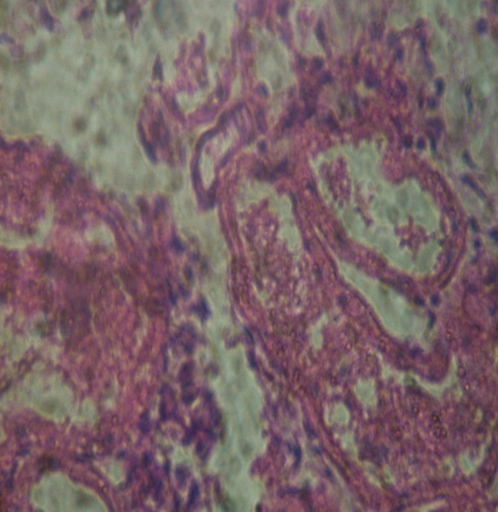

**Figure 4:** Kidney- normal rats

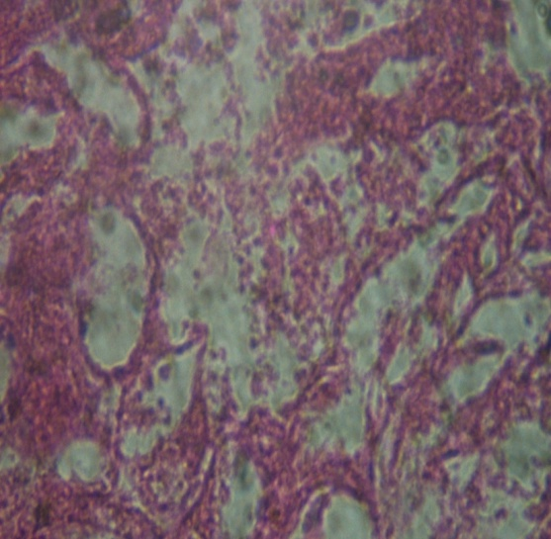

**Figure 5:** Kidney- hypertensive rats

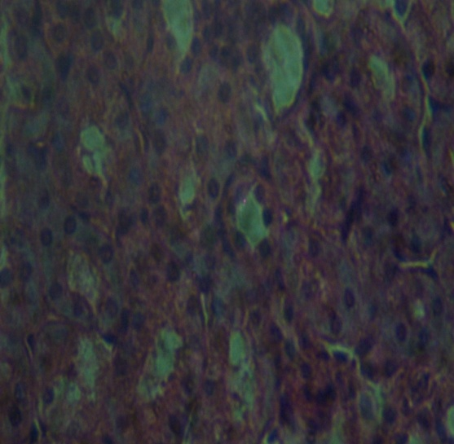

**Figure 6:** Kidney – lisinopril treated rats

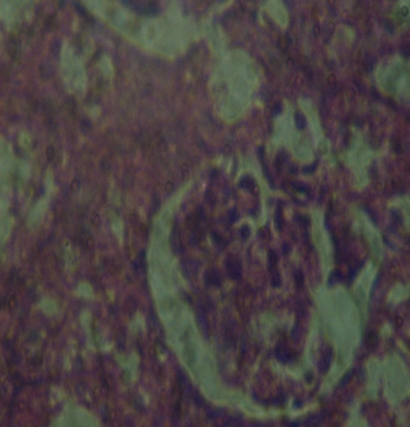

**Figure 8:** Kidney- BSS treated rats

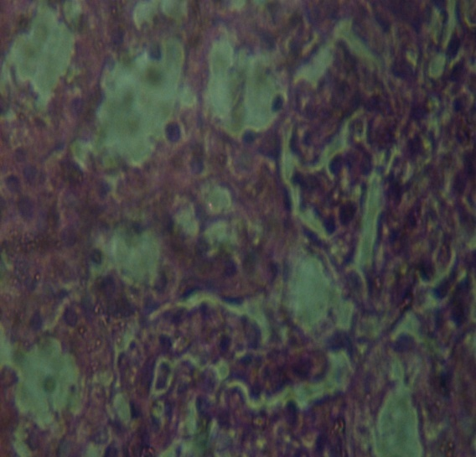

**Figure 7:** Kidney – BSSG treated rats

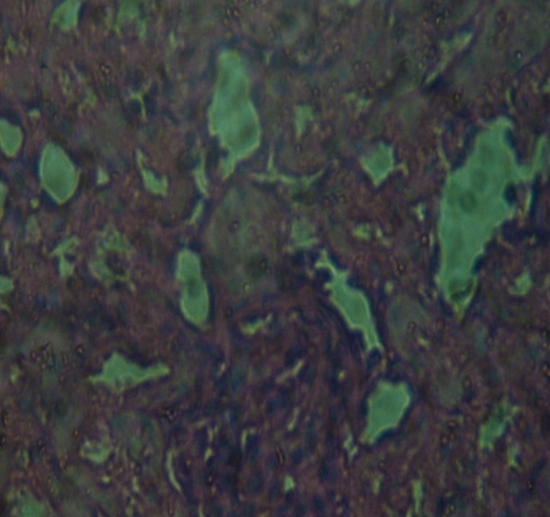

**Figure 9:** Kidney – mix*

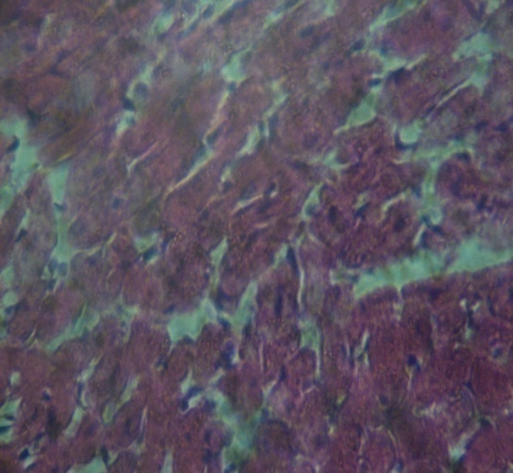

**Figure 10:** Heart – normal rats

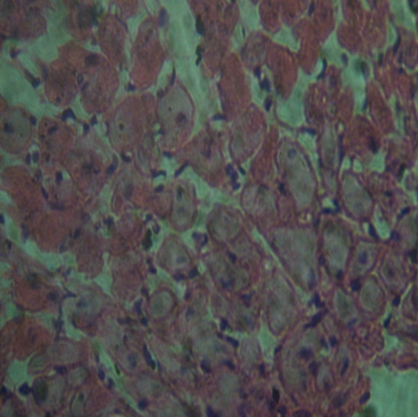

**Figure 11:** Heart – hypertensive rats

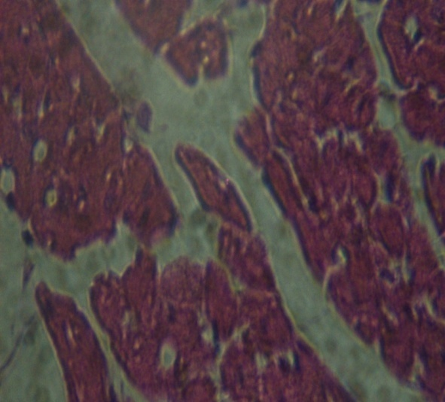

**Figure 12:** Heart- lisinopril treated rats

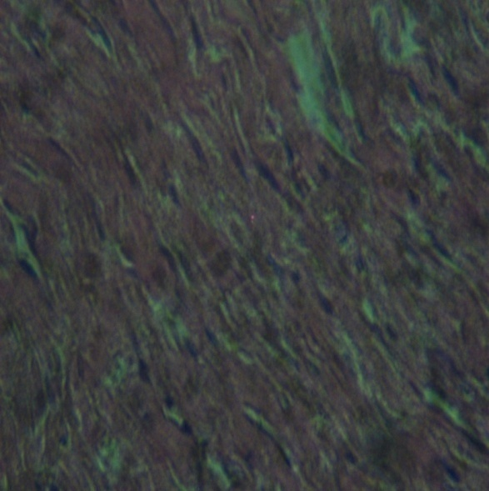

**Figure 14:** Heart – BSS treated rats

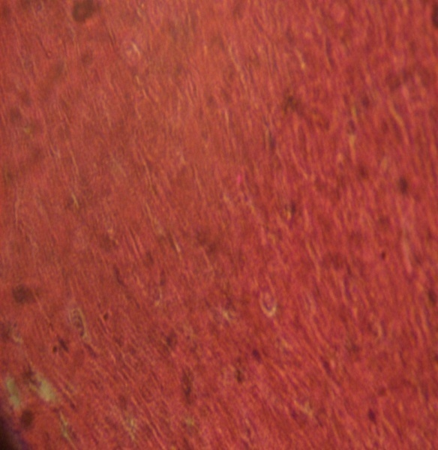

**Figure 13:** Heart – BSSG treated rats

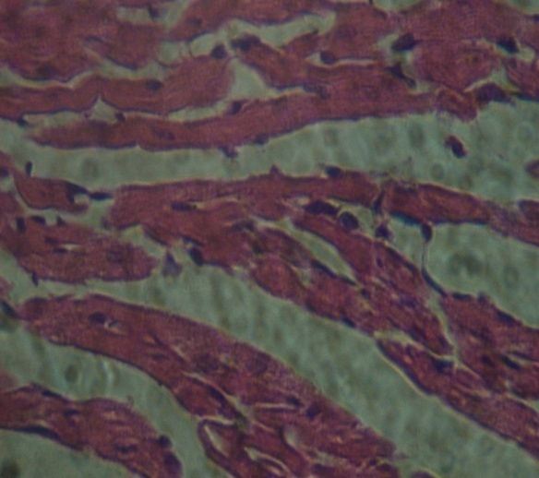

**Figure 15:** Heart – mix*

*BSS:BSSG mixture treated rats.

**4. Discussion**

Balance of electrolytes is essential for normal function of cells and organs. Electrolyte tests are commonly used to monitor treatment of certain health problems, including high blood pressure (hypertension), heart failure, liver and kidney disease. Common electrolytes that are measured with blood testing include sodium, potassium, chloride, and bicarbonate. The observed significant increase (p<0.05) in sodium levels in the untreated hypertensive rats is expected, and could have resulted from retention and volume overload, culminating in the expression of hypertensive phenotype (Blaustein *et. al*., 2006). Other electrolytes such as chloride, potassium and calcium also tend to show slight modulations in hypertensive conditions; however, no significant change (p>0.05) in their levels was observed in this study.

Significant independent relationships have been found to exist between blood pressure and several serum cations (Agada and Braide, 2009). The mechanism of hypertension induction might occur through the tubular injury pathway and the current study showed that the tissue section of the kidneys in the hypertensive group (Figure 5) exhibits an extensive area of tubular necrosis at the cortex and one total whole kidney damage; however, it is not clear why the urea and creatinine levels were not significantly affected.

There was reduction of sodium in the groups treated with BSS and BSSG when compared with hypertensive rats (Table 1). The BSS:BSSG mixture significantly reduced (p<0.05) the sodium level when compared with the hypertensive group and also with the normal rats. These results suggest that BSS and BSSG may have the potential to correct a condition of sodium retention and volume overload which may be associated with salt induced hypertension. The repair and toning effects of these compounds on tissue damage may contribute to this biological action as shown by appearance of no observable lesions in all the kidney sections from treatment groups in comparison with the extensive necrosis observed in the hypertensive group (Figures 4 to 9). The significant reduction shown by the BSS:BSSG mixture may predict an additive interactions in their biological activities (Chobanian, 2009; Xiaobo *et. al.*, 2009). It is noteworthy that the lisinopril treatment gave a significant increase (p<0.05) in sodium levels (Table 1). Thus the beneficial role played by the phytosterols in this study on electrolyte levels versus the toxic role played by the standard drug at 2.3mg/kg/day suggests that BSS and BSSG may be more efficacious and less toxic than the standard drug.

There appears to be slight effects of BSS and BSSG on urea and creatinine. They tend to maintain the basal levels of these parameters while lisinopril treatment led to significant increase in both urea and creatinine levels (Table 2), suggesting that lisinopril tends to be nephrotoxic. It is therefore obvious that BSS and BSSG could maintain basal kidney function. Moreover, the observation from the hispathological studies of the kidney section with no visible lesion gave credence to this fact.

A build-up of cholesterol in blood vessel walls leads to atherosclerosis, which increases with age (Shanmuganayagam *et. al*, 2007). High total cholesterol, triglyceride and LDL-Cholesterol accelerate atherosclerosis while low levels of HDL-Cholesterols are correlated with risk of CVDs (NCEP, 2002). Atherosclerosis and increased blood pressure have synergistic effects in causing CVDs. Atherosclerosis also reduces the diameter of blood vessels around the body. A lipid profile consists of total cholesterol, LDL, HDL and triglycerides. Each component of the lipid profile is usually evaluated when checking cholesterol. The significant increase (p<0.05) in triglyceride levels observed in the hypertensive group is consistent with the reports of Bonaa and Thelle (1991) that established a positive association between triglyceride levels and blood pressure. The rise in the triglyceride level may contribute to the expression of hypertension phenotype. There are slight modulations in the other lipid profile parameters, however total-cholesterol was significantly increased (p<0.05) in the hypertensive group.

The group treated with BSS:BSSG mixture significantly decreased (p<0.05) triglyceride levels when compared to the untreated hypertensive rats in group 2 (Figure 1). These findings are consistent with those of Gupta *et al.*, 2011 who observed that phytosterols significantly reduced triglyceride levels in the hypertensive state. Lowering serum LDL-Cholesterol and increasing high-density lipoprotein cholesterol (HDL-C) has been shown to lead to a regression in atherosclerotic lesion progression (Aviram *et al*., 2000). The significant increase (p<0.05) in HDL-Cholesterol observed in the BSSG - treated group (Figure 2) together with the observed activity of BSS suggests that these phytosterols could reduce risk of cardiovascular disease in hypertensive conditions. The cholesterol reducing potential of phytosterols had long been known and used in combination with medicine such as statins or fibrates. The combined effects of statins, which inhibit cholesterol synthesis and phytosterols which act on intestinal absorption of cholesterol has been studied in patients suffering from moderate hypercholesterolaemia, showing 44 to 45% decrease in cholesterol (Nature life, 2005). Also combination with fibrates resulted in a supplementary reduction of total cholesterol and LDL-cholesterol by 8.5 and 11.1% respectively with no side effects of the treatment observed (Nature life, 2005).

The desirable observations on the ALP, AST and ALT levels showed that the phytosterol treatments had ameliorating effects on liver damage that may be associated with hypertensive conditions. While tissue sections from the hypertensive untreated group shows extensive tubular necrosis in the kidney, those from the heart show little or no damage, thus confirming that the kidney rather than the heart, is the direct target for cadmium toxicity as reported by Satarug *et al.* (2006) who enumerated the multiplicity of cadmium targets and toxicities with kidneys and livers as specific targets through accumulation, and renal hepatic necrosis as outcomes. The heart and kidney sections from treatment groups had no visible lesion. This suggests that tissue repair occurred upon treatment with the phytosterols. Thus, the BSS, BSSG and BSS:BSSG mixture are capable of ameliorating tissue damage such as endothelial injury, left ventricular injury, and renal injury that may occur in association with hypertension.

The results in the present study indicate that BSS and BSSG have some biological activities comparable to that of the standard drug, lisinopril at 2.3mg/kg/day in hypertensive conditions. The phytosterols portrayed little or no associated toxic effects in comparison with lisinopril which could be nephrotoxic at high doses. However, further studies are needed to fully understand the impact of the chemical structure of these compounds on their biological activities, especially their interactions, in mediating key biochemical processes in hypertensive conditions. This is relevant in the therapeutic and nutraceutical applications of these plant natural products.

**Acknowledgements**

This research was supported in part by Third World Academy of Sciences (TWAS) through a postdoctoral fellowship award to C.O. Olaiya.

**Corresponding Author:**

Dr. Charles O. Olaiya

Department of Biochemistry,

University of Ibadan,

Ibadan 200005, Nigeria

E-mail: [cooolaiya@yahoo.com](mailto:cooolaiya@yahoo.com)

**References**

1. Agada PO, Braide VB (2009). Effect of Dietary Garcinia Kola Seed on selected serum electrolytes and Trace Metals in male Albino rats. Nig J Physiol Sci 24: 53-57.

2. Aviram M, Dornfeld L, Rosenblat M,

Volkova N, Kaplan M et al. (2000).

Pomegranate juice consumption

Reduces oxidative stress, atherogenic

modifications of LDL, and platelet

aggregation : studies in humans

and in atherosclerotic apolipoprotein E-

deficient mice, Am. J. Clin. Nutr. 71: 1062–

1076.

3. Awad AB, Smith AJ, Fink CS (2001). Plant

sterols regulate rat vascular smooth muscle

cell growth and prostacyclin release in

culture. Prostaglandins Leukot Essent Fatty

Acids 64:323-330.

4. Bartels H, Bohmer M, Heierli C (1972). Serum creatinine determination without protein precipitation. Clinica Chemica Acta 37: 193-197.

5. Blaustein MP, Zhang J, Chen L, Hamilton BP (2006). How does salt retention raise blood pressure? Am J Physiol Regul Integr Comp Physiol 290(3):R514-523.

6. Bonaa KH, Thelle DS (1991). Association

between blood pressure and serum lipids in

a population. The Tromsq Study. Circulation Apr; 83(4):1305-1314.

7. Bouic PJ (2001): The role of phytosterols

and phytosterolins in immune modulation: a

review of the past 10 years. Curr Opin Clin

Nutr Metab Care 4:471-475.

8. Chobanian AV (2009). The hypertension paradox - More uncontrolled disease despite improved therapy. N Engl J Med 361:878-887.

9. Curtis JJ, Luke RG, Dustan HP, Kashgarian M, Whelchel JD, Jones P, Diethelm AG (2000). Remission of essential hypertension after renal transplantation. J Am Soc Nephrol 11: 2404–2412.

10. Edward JR (1994). .National high blood pressure education programme working group report on hypertension in the elderly. Hypertension 23(3): 274-285.

11. Guptal AK, Savopoulos CG, Ahuja J, Hatzitolios AI (2011). Role of phytosterols in lipid lowering: current perspectives. Q J Med 104:301–308.

12. Katan MB, Grundy SM, Jones P, Law M, Miettinen T, Paoletti R (2003). Efficacy and safety of plant stanols and sterols in the management of blood cholesterol levels. Mayo Clin Proc78:965- 978.

13. Kharb S, Singh V (2004). Nutraceuticals in

health and disease prevention. Indian J Clin

Biochem19 (1) 50-53.

14. Loscalzo J, Fauci AS, Braunwald E, Dennis

L, Kasper H, Stephen L, Longo DL (2008). Harrison's Principles of Internal Medicine. McGraw-Hill Medical Pubs.

15. Marther HM, Levin GE, Nisbet JA (1982). Hypomagnesaemia and ischemic heart disease in diabetes. Diabetes Care 5: 452-453.

16. Meites S, Faulkner WR (1962). Manual of Practical Micro and General Procedures in Clinical Chemistry,Charles C Thomas,Springfield, IL, pp 5-9.

17. Moreau RA, Hicks KB (2004). The in vitro hydrolysis of phytosterol conjugates in food matrices by mammalian digestive enzymes. Lipids 39: 769–776.

18. Nature Life SA (2005). Cardiovascular Journal of South Africa 16 (3), May/June 2005.

19. NCEP (2002). Third Report of the National Cholesterol Education Program (NCEP) Expert Panel on Detection, Evaluation, and Treatment of High Blood Cholesterol in Adults (Adult Treatment Panel III) Final Report: Circulation, vol 106, pp. 3143-3421.

20. Piironen V, Lindsay DG, Miettinen TA, Toivo J, Lampi AM (2000). Plant sterols: biosynthesis, biological function and their importance to human nutrition. J Sci Food Agric 80:939–966.

21. Puri VN (1999). Cadmium induced hypertension. Clin Exp Hypertens. 21(1-2) : 79-84.

22. Reuben KD (2012). Thin layer

Chromatographic Examination of *Croton zambeicus* Muell Aeg. Stem bark.

Report and Opinion2012: h<ttp://www.> Sciencepub Net/report. 1; 4(5). Pp. 1 – 4.

23. Sarnak MJ, Levey AS, Schoolwerth AC, Coresh J, Culleton B, Hamm LL, McCullough PA, Kasiske BL, Kelepouris E, Klag MJ, Parfrey P, Pfeffer M, Raij L, Spinosa DJ, Wilson PW (2003). Kidney disease as a risk factor for development of cardiovascular disease: A statement from the American Heart Association Councils on Kidney in Cardiovascular Disease, High Blood Pressure Research, Clinical Cardiology, and Epidemiology and Prevention. Circulation 108: 2154–2169.

24. Satarug S, Nishijo M, Lasker JM, Edwards RJ, Moore MR (2006). Kidney dysfunction and hypertension: role for cadmium, p450 and heme oxygenases? Tohoku J Exp Med 208:179–202.

25. Shanmuganayagam D, Warner TF, Krueger CG, Reed JD, Folts J (2007). Concord grape juice attenuates platelet aggregation, serum cholesterol and development of atheroma in hypercholesterolemic rabbits, Atherosclerosis 190:135–142.

26. Snedecor GW, Cochran WG (1990).Statistical methods 9th ed., Iowa State Univ. Press, Iowa, U.S.A.

27. Spilburg CA, Goldberg AC, McGill JB, Stenson WF, Racette SB, Bateman J, McPherson TB, Ostlund RE Jr (2003). Fat-free foods supplemented with soy stanol-lecithin powder reduce cholesterol absorption and LDL cholesterol. J Am Diet Assoc 103: 577–581.

28. Trease GE, Evans WC (2002). Pharmacognocy. 15th Edition. Sanders Pup. London. Pp. 42-44, 221-229,

246-249, 304-306, 331-332, 339-393.

29. WHO (World Health Organization), (2000). General Guidelines for Methodologies on Research and

Evaluation Techniques of Plant Analysis. Pub. By Chapmand Ltd. London. Pp. 1-226.

30. Xiaobo L, Lina M, Susan B, Racette CL, Anderson S, Richard EO, Jr (2009). Phytosterol glycosides reduce cholesterol absorption in humans. Am J Physiol Gastrointest Liver Physiol. 296(4): G931–G935.

5/13/2013