The Effect of Steamed and Microwaved Cooking on the Levels of Heavy Metals; Lead and Mercury in the Cyprinus carpio’s Muscle

Forouzanfar, F¹, Askari Sari. A², Chelemal Dezfool Nezhad. M³

¹. Department of Fisheries, Islamic Azad University, Khouzestan Science and Research Branch, Khouzestan, Iran
^{2, 3}.Department of Fisheries, Ahvaz Branch, Islamic Azad University, Ahvaz, Iran

Abstract: The survey in 2012 to assess the heavy metals lead and mercury concentrations in common carp cooked in steam and microwave cooking methods were crude samples. Randomly assigned to 24 common carp Azadegan warm fish culture center (Ahvaz) was caught. After the fillets, steamed muscles and microwave cooking methods of lead and mercury fish were then measured with the Spectrophotometer using One-way Anova using SPSS software were compared. The results of this study showed higher concentrations of mercury in the steam way (258± 11.05) compared to the microwave (50.33± 7.75) and the raw samples (185.66 ± 17) showed that mercury concentrations in steamed raw muscle and cooked in a microwave muscle shows significant differences (p <0.05) the highest concentrations of mercury instead of lead metal in the microwave cooking method (304± 8.54) and the lowest concentration steamed mode (254.33± 7.63) showed that both methods lead metal concentrations than controls (232± 12.28) increased. Lead concentrations in the raw muscle muscle cooked by microwave shows a significant difference (p <0.05) while no significant difference was observed with steamed muscles (p ≥ 0.05).
[Forouzanfar, F, Askari Sari. A, Chelemal Dezfool Nezhad. M. The Effect of Steamed and Microwaved cooking on the Levels of Heavy Metals; Lead and Mercury in the Cyprinus carpio’s Muscle. Nat Sci 2013;11(6):25-28]. (ISSN: 1545-0740). http://www.sciencepub.net/nature. 5

Keywords: cooking methods,heavy metal,lead, mercury,Cyprinus carpio

1. Introduction
The significance of feeding the fish and its existence in the diet to provide the animal protein is an issue, which is clear for everyone. The experts have found out that being fed with fish and other seafood are the most valuable resources by providing protein around the world [11]. The fish pollution with heavy metals creates irreparable damages to the human, since fishes are one of the important nutrition resources for human. If the level of some of the heavy metals such as mercury, cadmium, Selenium and arsenic increases in the body of fishes, it may be tolerable for some time; however, the consumption of these metals may result in severe injuries and even deaths in humans [6]. The heavy metals may transfer in the environment, and on the higher steps of the food pyramid, they may result in a sudden intoxication or ailments [13]. The danger created by the accumulation of these heavy metals at the higher level of the food chain is regarded as one of the main concerns in the human health [3]. The available heavy metals in the environment are regarded as one of the potential dangers for the organisms. Human as well as the animals are always faced with the pollution with heavy metals. These metals create a connection with the necessary combinations of the body such as Oxygen, sulfur, and nitrogen in the form of groups such as COOH, COO, OH, SH, and S-S. Regarding the fact that most of the necessary combinations of the body such as enzymes and proteins include such groups, the heavy metals may result in a delay of the enzymes activities and disorders in the synthesis of the necessary combinations of the body [12]. When the heavy metals enter the body, they don’t get repulsed from the body, and they accumulate in the body, and cause health problems. The fish is regarded as one of the resources of providing protein in the human nutrition, which has been considered a lot due to the high demands, since it is free from any pollution. Moreover, fish is cooked in different ways. The Cyprinus carpio has a special place in the diet of a tropical area. Therefore, it is possible to apply the best cooking methods and avoid the side effects of heavy metals in humans.

2. Material and Methods
1.2. Sample Preparation and Cooking
The Cyprinus carpio used in this study (31.35± 1.70 cm, and 434.90±69.15 g) was prepared from a complex of fish farming in Khozestan. The fish was kept in the icy water bags, and was transferred to the laboratory in two hours. When the fish was about to be transferred to the laboratory, the fresh fish was washed several times so that the blood and mucus were removed. After that the biometric and weight tests were performed, and then they were ready by performing the domestic methods including cutting the head, and abdominal drain. Then they were cut in fillets. Then, the fillets were divided into three groups. The first group, which is the control group were cooked raw, the second group in the steam cooker (18-20 minutes, at 150 centigrade’s), and the third group in microwave (8-10 minutes 2450 MHz). The samples of each group were weighted equally, and were kept in the polyethylene cans, which were closed tightly. Then they were digested in the wet digestion method, and they were ready to be injected to the atomic absorption machine. To measure the lead element, first 5 ml of the Pyrrolidine ammonium carbonate 5% was added to the 10 ml of the digested sample solution, and they were stirred for about 20 minutes so that the elements were complexed as an organometallic form in the solution. Then, 2 ml of Isobutyl methyl ketone was added to the samples and they were stirred for about 30 minutes, and then they were centrifuged after 10 minutes at 2500 rounds per minute, then the elements were transferred to the organic phase. When the furnace as well as the EDL system was set and the Perkin Elmer 4100 atomic absorption machine was optimized, the calibration curve of this element was drawn with the standards of this element and palladium matrix modifier by software Win La 32, and the amount of this element was measured in the prepared solutions. To measure the level of mercury, FLMS system was installed and set on the atomic absorption machine with the standard solutions in the optimum mode. The mercury calibration curve was drawn with the software Win Lab 32, and the level of mercury was read in the prepared solution and then it was reported in microgram to kilogram.

2.2. Statistical Analysis
One-way ANOVAs in SPSS was used to analyze the data, and the significance level of the mean differences was determined by the accuracy of 95% (p=0. 05).

3. Results
The heavy metal concentrations with mean ± SD are shown in table 1. The lead metal available in the muscle in the raw mode (232 ±2. 28 mg/Kg) has the most quantity in comparison with that of mercury (185.66 ±17 mg/kg). Usually, the lead is applied and consumed in different modes such as lead arsenate, which is used in producing the pesticides. Tetra ethyl Lead and tetra methyl lead, which are used as the fuel optimization are toxic and enter the aquatic ecosystems through agricultural and industrial wastes as well as the human activities, and are regarded as the dangerous pollutants. The indiscriminate use of this metal and its entrance to the aquatic ecosystems can be effective in the ascending procedure of absorption and their accumulation in tissues and organs of different fishes [9]. Lead is one of the elements that has a high level of absorption through breathing. Such ions as the lead attack the sulfur bonds of the enzyme molecules due to the strong desire to bond with sulfur, and deactivated it by degrading the enzyme. Amino and Carboxylic groups available in proteins are also attacked and the lead connected to the cell membrane and disrupts the material transport from the cell wall. One of the biochemical effects of the lead, is disturbing the synthesis “hem”, as well as the incidence of neurological effects and renal disorders in the creatures [14]. Lead is a neurotoxin, which results in behavioral disorders in vertebrate animals, and may result in survival decreasing, growth rate, learning rate, and metabolism [8].
The lead is high in amount (185. 66 ±17 mg/kg) which is compatible with the results of Abreu et al (2000) study on the metal accumulation in Sybas, and that of Gonzales et al (2005) on analyzing the effects of methyl mercury in the liver, muscle, and brain of the Zebra fish, which both show higher concentrations of the mercury in the tissue of the liver in comparison with heavy metals [1, 7].
In the cooking method with steam cooker, the amount of lead increased in comparison with the raw mode, and a significance difference was observed in comparison with that of the control group. The reason for which the amount of lead did not decrease could be related to the reduction of water evaporation, which resulted in reducing the lead evaporation, and was compatible with the findings of Morgan et al (2004). However, there is not a clear reason for which it increased, and it might be due to the machine error, since it is expected that the lead is left in the raw muscle; however, the increase of it was observed [10]. In the cooking method with microwave, the concentration of lead decreased. It might be due to the fact that the heating resulted in increasing the amount of evaporation of this metal, and the longer cooking process, or the higher the temperature causes this element to be more reduced, which is compatible with the findings of Frsoy et al ( 2006) [4].
In the present study, the amount of heavy metals increased in the steamed mode. It is not compatible with the findings of Atta et al (1997) which was done of Tilapia nilotica. Atta et al declared that reducing the amount of metal in the fish while cooking can be related to the reduction of this metal with the reduction of water as the free salts, which are with the soluble amino acids and non-coagulated protein [2].
In analyzing the contamination of lead in the raw mode in the steamed mode, no significance difference was observed; however a significance difference was observed in comparison with that of the microwave group. Theses results are compatible with the results of Frsoy (2009), which was done on the Claries gariepinus,and Frsoy et al (2006) which was done on Labrax linne. However, the results are not compatible with the findings of Atta et al (1997), which was done on Tilapia nilotica. Atta et al declared that lead contaminations reduce after they are cooked. While in this study, the amount of lead increased, which is due to the reducing the humidity and increasing the contamination of the minerals in comparison with the raw mode [1, 4, 5].

Table 1. The concentration of heavy metals (ppb) with Mean ± SD
Microwave | Steamed | Raw | Metal
50.33±7.57 | 28533±11.015 | 185.66±17 | Mercury
304±8.54 | 254.33±7.63 | 232±12.28 | Lead

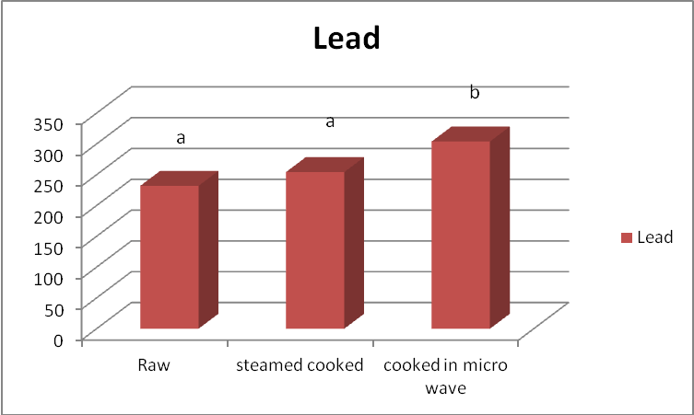
Ppb
Non-homonymous (p<0.05)
Homonymous (p≥0. 05)
Figure1. An Analysis of the Lead Concentration after Being Cooked in Two Different Modes in the Cyprinus carpio Muscle

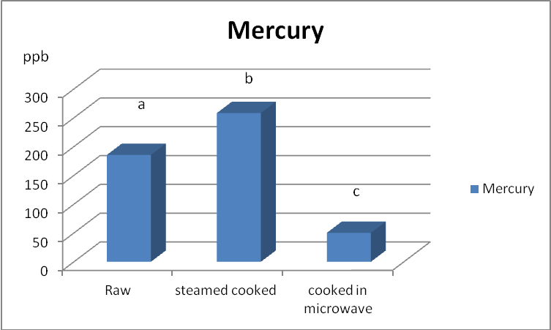
Non-homonymous (p<0.05)
Homonymous (p≥0. 05)
Fiqure2. An Analysis of the Mercury concentration after Being Cooked in Two Different Modes in the Cyprinus carpio Muscle

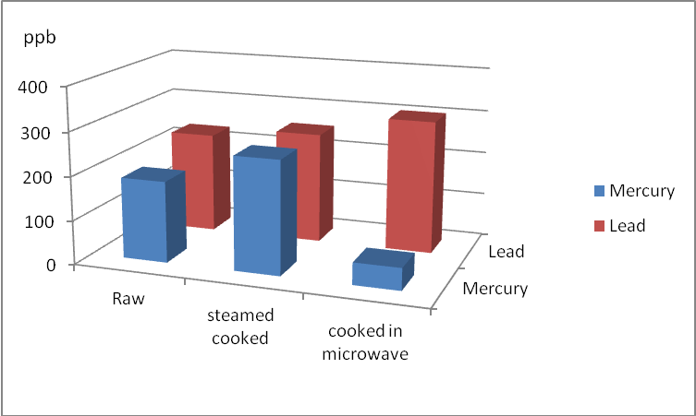
Fiqure3. A Comparison of the Metal Concentrations (Lead and Mercury) After Cooking Methods

4. Discussions
Regarding the toxicity of the metals studied and the effect of cooking method on the toxicity level of them, and regarding the fact that the toxicity level of lead, and then mercury is dangerous for humans, the best cooking method was cooking with microwave in this study, since the amount of lead, which is more toxic for the humans decreased in this cooking method.

Acknowledgements:
Authors are grateful to the Department of Fisheries, Islamic Azad University, Khouzestan Science and Research Branch for financial support to carry out this work.

Corresponding Author:
Forouzanfar, F
Department of Fisheries,
Islamic Azad University,
Khouzestan Science and Research Branch,
Khouzestan, Iran

References
- Abreu SN, Pereira E, Vale C, Duarte AC. 2000. Accumulation of mercury in sea bass from a contaminated lagoon (Ria de Aveiro, Portugal). Mar. Pollut. Bull, 40: 293-297.
- Atta MB, El – Sebaie LA, Noaman MA, Kassab H. 1997. The effect of cooking on the content of heavy metal in fish (Tilapia nilotica). Biological Abstracts,. 103( 5): PP.1-4.
- Bruska – Jastrzebska E, protawicke, M. 2005. Effects ofcadmium and nickel exposure on haem a tologocal parameters of camon carp, Cyprinus Carpio. A cta. Ichthyol. Pisca.35 (1) :29-38
- Ersoy B, Yasemen Yanar Y, Celik M.2006. Effects of four cooking methods on the heavy metal concentrations of sea bass fillets (Dicentrarchus labrax Linne, 1785), Food Chem.99:748-751.
- Ersoy B. 2009. Effects of cooking methods on the heavy metal concentrations of the African catfish (CLARIAS GARIEPINUS). Fisheries Faculty Mustafa Kemal University31200 Hatay, Turkey.PP:351-355.
- Gallali Gafarei, B and M, Aghazade Meshkei. 2007. Fish intoxication result of heavy metals and their important in general health. Man Book publisher. 134 p.
- Gonzalez P, Dominique Y, Massabuau JC, Boudou A, Bourdineaud JP. 2005. Comparative effects of dietary methylmercury on gene expression in liver, skeletal muscle, and brain of the zebrafish (Danio rerio). Environment Sciences Technology, 39: 3972-3980.
- .Karadede-Akin H, Unlu, E. 2007. Heavy metal concentrations in water, sediments, fish and some benthic organisms from Tigris River, Turkey. Environ. Monit. Assess. 131, PP. 323-337.
- Moore JW, Ramamorthy S.1984.Heavy metal in natural waters. Springer – Verlag. New rork 268P.
- Morgan JN, Berry MR, Graves RL.1997. Effects of commonly used cooking practices ontotal mercury concentration in fish and their impact on exposure assessments. J Expo Anal Environ Epidemiol. 7 (1): 119-33.
- Razavi shirazi, H. 2001. Seafood processing technology. Naghsh Maher publisher. 292pp.
- .Roknei, N. 1999. Principle Health of food Products. 3rd edition. Tehran university publisher, 154 p..
- Sadiq M., 1992. Toxic Metal Chemistry in marine environments. Marcel Decker, INC.389p.
- Varedei, S. 1997. Survey and determine the concentration of heavy metals on Challos River. Fisheries institute center of Mazandaran province.

4/15/2013

