Extraction of lycopene with cell wall degrading enzymes from tomato (Lycopersicon esculentum Mill) fruits deteriorated by Aspergillus niger

Ajayi, A.A¹, Adedeji, O.M¹, Olasehinde, G.I., ¹ Ayanda, O.O.¹ and Adejuwon, A.O.²

- Department of Biological Sciences, Covenant University, Ota, Ogun State
2. Department of Microbiology, Faculty of Information Technology and Applied Sciences, Lead City University, Ibadan, Nigeria
adesola.ajayi@ymail.com

Abstract: Lycopene is the carotenoid which gives tomatoes and other red fruits their characteristic colour. It is one of the most powerful antioxidants and singlet oxygen quenching agents. It has been found to be of great medical importance with various anticancer effects and its ability to ameliorate several other medical conditions. Freshly ripe tomato fruits of the Roma vf variety and the Ibadan local variety were allowed to deteriorate after infection with a 96-hr-old culture of Aspergillus niger. Extraction of cell wall degrading enzymes produced during the deterioration process was carried out ten days after inoculation of the tomato fruits. The crude enzymes were precipitated using ammonium sulphate precipitation technique and employed in the extraction of lycopene from tomato peels. The yield of lycopene was 45.25mg/kg and 45.86mg/kg for enzymes extracted from the Roma vf and the Ibadan local varieties of tomato fruits respectively. This study established an improvement in lycopene extraction with crude preparation of cell wall degrading enzymes and compared the yield from the two enzymes obtained from the two most commonly available varieties of tomato fruits in Nigerian markets.
[Ajayi AA, Adedeji OM, Olasehinde GI, Ayanda OO, Adejuwon AO. Extraction of lycopene with cell wall degrading enzymes from tomato (Lycopersicon esculentum Mill) fruits deteriorated by Aspergillus niger.
Nat Sci 2013;11(4):110-113]. (ISSN: 1545-0740). http://www.sciencepub.net/nature. 18

Keywords: Lycopene; Aspergillus niger; Tomato peels; cell wall degrading enzymes

1. Introduction
Tomatoes are grown and eaten all over the world (Evangelia et al., 2005). They are used in diverse ways in the raw form in salads or processed into ketchup or tomato soup. Lycopene which is the most abundant tomato carotenoids had been the primary focus of both in vitro and in vivo studies of the relationship between increased intake of tomato and reduced risk of prostate cancer (Giovannucci, 2002; Omoni and Aluko, 2005). Lycopene has been the focus of considerable attention for its potential health benefits (Redenbaugh et al., 1999). There are also experimental studies supporting the view that lycopene may provide protection against cardiovascular and certain types of cancer (Giovannucci, 1995). Lavecchia and Zuorro (2008) therefore reported the growing demand for natural lycopene and the possibility of obtaining lycopene from tomato processing wastes. Sharma and LeMaguer (1996) reported that tomato skin contain up to five time more lycopene than the pulp. Low extraction efficiencies had been attributed to the difficulty for the solvent to penetrate the compact tomato peel tissue and solubilize the pigment which is deeply embedded within the chromoplast membrane structures (Harris and Spurr, 1969). This study therefore compared the lycopene yield using enzymes obtained from the deterioration of the two common varieties of tomato fruits found in Nigeria by Aspergillus niger with a view of improving the extraction of lycopene from tomato peels.

- Material and Methods
Organisms and culture conditions
The isolate Aspergillus niger employed for this research work was from the culture collection of the Federal Institute for Industrial Research Oshodi (FIIRO). The organism was routinely grown and inoculated on potato dextrose agar slants. The organism was sub-cultured from the stock culture. A 96-hr-old culture of Aspergillus niger was used whenever it was needed.

Collection of tomato fruit samples
Two different types of tomato fruits were used for this research work, the Roma vf and the Ibadan local variety. Freshly ripe tomato fruits (the Roma vf and the Ibadan local variety) were surface sterilised with 10% v/v sodium hypochlorite solution for 15mins. The tomato fruits were properly rinsed with five changes of sterile distilled water to remove the residual effect of the sodium hypochlorite solution. The tomato fruits were bored with a cork borer (4mm) and the fungus introduced into them. Discs (4mm) obtained from the edge of a 96-hr-old culture of the organism served as the inoculums. The point of inoculation was sealed with molten wax and kept in a polythene bag to avoid contamination with other organisms. The control fruits were similarly treated except that sterile potato dextrose agar discs served as the inoculum. The tomato fruits were then transferred into sterilized bell jars. The experimental and control fruits were kept in different sterilized bell jars and were examined daily for deterioration and pH. The pH values were taken using the Jenway pH meter for ten days of incubation. The rims of the bell jars were sealed with Vaseline. Both the experimental and control tomato fruits were incubated at room temperature.

Extraction of the enzyme from the tomato fruits
The enzymes were extracted after ten days of incubation. This is because within ten (10) days of incubation, the inoculated tomato fruits had collapsed extensively. The collapsed tomato fruits were weighed prior to enzyme extraction. The tomato fruits were ground to pulp and homogenized with liquid extractant (1:1 w/v) for 2min at 30sec interval. The extractant was 0.5M NaCl in 0.01M citrate phosphate buffer (pH 4.5) containing 5mM NaN₃ to prevent microbial contamination. The homogenate from each jar was clarified by passing it through filter paper (Whatman No.1). Each extract was analysed for cellulase and polygalacturonase. In addition to this, the pH, total reducing sugars and the protein content of the enzymes were determined.

Ammonium sulphate precipitation
Ammonium sulphate (analytical grade) was added to crude enzyme preparation to 90% saturation according to the method described in Encor biotechnology Inc. (2012) and Collinghan et al. (1995). The solution was kept at 4ºC for 24h and the resulting precipitate was removed by centrifugation at 4000rpm for 15min. The precipitate was re-dissolved in a small volume of 0.05M citrate phosphate buffer, pH 4.5. The resulting solution was dialysed overnight against two changes of the same buffer. Dialysis was performed in acetylated cellophane tubing prepared from Visking dialysis tubing (Gallenkamp) as described by Whitaker et al. (1963).

Enzyme assays: polygalacturonase and cellulase
Polygalacturonase
Polygalacturonase activity was obtained by estimating the amount of reducing sugars released in the reaction mixture. The reaction mixture consisted of 1ml of 0.1%w/v pectin (Sigma) in 0.1M citrate phosphate buffer pH 4.5 and 0.5ml of the enzyme solution. The control tube contained the same amount of substrate and 0.5ml of the enzyme solution heated at 100ºC for 15min. Both the experimental and control tubes were incubated at 35ºC for 3h. The amount of the reducing sugars released during the reaction was measured by the modified dinitrosalicylic acid reagent method of Miller (1959).One unit of polygalacturonase activity was defined as the amount of enzyme in 1ml of the reaction that liberated reducing sugar equivalent to 1µg glucose per minute under the specified conditions of the reaction.

Cellulase
Cellulase enzyme activity was obtained by measuring the amount of reducing sugar released in reaction mixtures the reaction mixture contained 1ml of 0.6% w/v carboxymethyl cellulase (Sigma) in 0.1M citrate phosphate buffer pH 4.5 and 0.5ml of the enzyme solution. The control tube contained the same amount of substrate and 0.5ml of enzyme solution boiled at 100ºC for 15min. Both experimental and control tubes were incubated at 35ºC for 3hr. The reducing sugar released into the reaction mixture was estimated by the modified dinitrosalicylic acid reagent of Miller (1995). One unit of cellulase activity was defined as the amount of enzyme in 1ml of the reaction that liberated reducing sugar equivalent to 1µg galacturonic acid per minute under the specified conditions of reaction.

Spectrophotometric analysis of lycopene
Tomato sample preparation
After removal of damaged parts and washing, whole tomato fruits were immersed in boiling water for 1-2 min. Then they were cooled under tap water and hand peeled. The peels were dried in air for a few hours and then stored at 4°C.

Determination of lycopene content from tomato peels (lycopene assay)
The amount of lycopene contained in tomato peels was determined by a slight modification of the Sadler et al. (1990) method. Experiments were made using a hexane/ethanol/acetone solution (2:1:1) (v/v) as the extracting medium. Total lycopene content of the peels was evaluated from the amounts obtained in three consecutive extractions and was expressed as mg of lycopene per 100 g of dry matter.

Enzyme mediated extraction
Two grammes of partially dehydrated peels, obtained as described in the sample preparation section, were initially charged into 50-mL screw-top conical flasks. The flasks were placed in a water bath at 25°C and magnetically stirred. 10 mL of an aqueous enzyme solution were then added and incubated for about 20 h. After incubation, 30 mL of the extracting solution was poured into the flasks and kept under stirring, at the same temperature, to allow for lycopene solubilisation.
When the extraction was completed, the agitation was stopped and two liquid layers (the aqueous and the organic phases) formed. A sample of the hexane supernatant was taken and analysed for lycopene content. The following control experiments were made: (i) hexane extraction of peels pre-treated with sterile distilled water, in the same amount as the enzyme solution and (ii) hexane extraction of peels not subjected to either water or enzymatic pre-treatment.

- Results
Deterioration of tomato fruits
Ten days after the inoculation of freshly ripe tomato fruits with Aspergillus niger, the tomato fruits had deteriorated extensively and the infected fruits exhibited appreciable cellulase and polygalacturonase activities while the uninfected tomato fruits possessed only traces of polygalacturonase activity but lacked cellulase activity.

Lycopene and production of cell wall degrading enzymes:

Lycopene yield
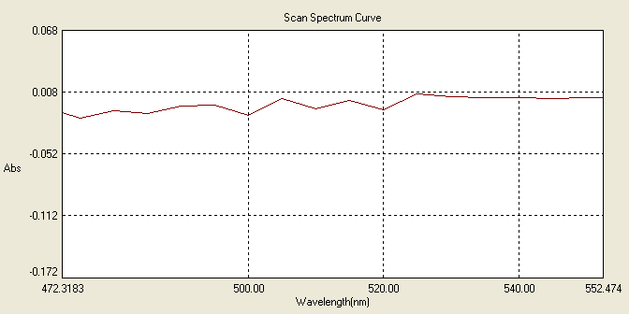
Fig 1a: Absorption spectrum for lycopene extracted with water
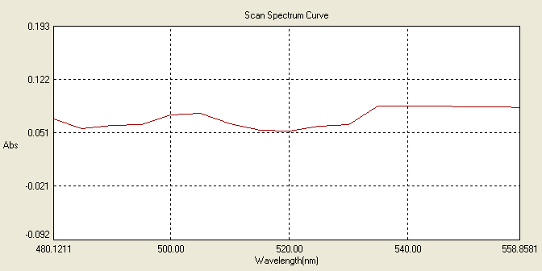
Fig 1b: Absorption spectrum for lycopene extracted with the extracting solution made of hexane, ethanol and acetone in the ratio 2:1:1
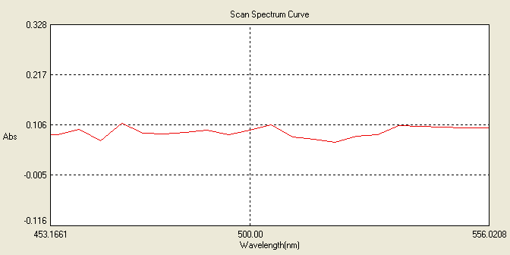
Fig 1c: Absorption spectrum for lycopene extracted with enzymes obtained from the Ibadan local variety of tomato fruits.

Fig 1d: Absorption spectrum for lycopene extracted with enzymes obtained from the Roma vf variety of tomato fruits.

Table 1 Partial purification table for polygalactorunase obtained from the Roma vf variety of tomato fruits infected by Aspergillus niger
Fraction | Total activity  (Units) | Total protein  (mg) | Specific activity  (Units/mg) | Yield  (%) | Purification fold
Crude | 1000 | 500 | 2.00 | 100 | 1
(NH₄)SO₄ | 880 | 164 | 5.37 | 88 | 2.69

Table 2: Partial purification table for polygalactorunase obtained from the Ibadan local variety of tomato fruits infected by Aspergillus niger
Fraction | Total activity  (Units) | Total protein  (mg) | Specific activity  (Units/mg) | Yield  (%) | Purification fold
Crude | 970 | 485 | 2.00 | 100 | 1
(NH₄)SO₄ | 400 | 172 | 2.33 | 41.24 | 1.17

Table 3: Partial purification table for cellulase obtained from the Roma vf variety of tomato fruits infected by Aspergillus niger
Fraction | Total activity(Units) | Total protein(mg) | Specific activity(Units/m) | ield%) | Purification fold
Crude | 1250 | 625 | 2.00 | 00 | 1
(NH₄)SO₄ | 1200 | 164 | 7.32 | 6 | 3.66
Table 4: Partial purification table for cellulase obtained from the Ibadan local variety of tomato fruits infected by Aspergillus niger
Fraction | Total activity(Units) | Total protein(mg) | Specific activity(Units/mg) | Yield(%) | Purification fold
Crude | 3600 | 1800 | 2.00 | 100 | 1
(NH₄)SO₄ | 3400 | 172 | 19.77 | 94.44 | 9.89

Table 5: lycopene content of tomato fruits after extraction with various solvents
Sample | Lycopene content of tomato fruits in extracting solution (mg/kg) | Lycopene content of tomato fruits extracted with water (mg/kg) | Lycopene content of tomato fruits extracted with enzyme from Roma vf tomato variety (mg/kg) | Lycopene content of tomato fruits extracted with enzyme from the Ibadan local tomato variety (mg/kg)
2g of tomato peels | 32.76 | 4.06 | 45.25 | 45.86

4. Discussions
In this investigation, Aspergillus niger was inoculated into freshly ripe tomato fruits for the production of cellulase and polygalacturonase enzymes. The ability of A. niger to produce cell wall degrading enzymes had been established by previous authors (Ajayi et al., 2007; Giovane et al., 2005).
The result of this investigation showed that appreciable polygalacturonase and cellulase activity occurred in extracts obtained from the two varieties of tomato fruits (i.e. the Roma vf and the Ibadan local variety) infected by Aspergillus niger while the uninfected fruits exhibited only traces of the enzyme activity. This suggests that the enzymes are of fungal origin.
The extracted enzymes were employed in the extraction of lycopene from tomato peels and showed a yield of 45.25mg/100g and 45.85mg/100g of lycopene obtained using enzymes obtained from the deterioration of the Roma vf variety and the Ibadan local variety of tomato fruits respectively by Aspergillus niger. Similar results were obtained by Lavecchia and Zuorro (2011) using industrially produced enzymes citrozyme and pectinase. This report adds to existing reports on extraction of lycopene from tomato fruits aided by cell wall degrading enzymes.

Corresponding Author:
Dr. Adesola A. Ajayi,
Department of Biological Sciences,
Covenant University, PMB 1023, Ota
Ogun State, Nigeria
E-mail: adesola.ajayi@ymail.com

References
- Ajayi, A.A and Olasehinde, G.I. Studies on the pH and protein content of tomato (Lycopersicon esculentum Mill) fruits deteriorated by Aspergillus niger. Scientific Research and Essay 2009; 4 (3): 185-187.
- Encor Biotechnology Incorporation. Ammonium Sulphate Precipitation Calculation. http://www.encorbio.com 2012
- Evangelia, M., Stefania, G, Ruggero, R., and Stefano, R. "Passionflower Fruit—A "New" Source of Lycopene?"Journal of Medicinal Food. Spring 2005; 104-106.
- Giovannucci, E., Ascherio, A., Rimm, E., Stampfer, M., Colditz, G., and Willett, W. "A prospective study of tomato products, lycopene, and prostate cancer risk" J. Natl Cancer Inst 2002; 94 (5): 391–396.
- Giovannucci, E., Willett, W., Stampfer, M., Liu, Y. And Rimm, E. (2002). @A prospective study of tomato products, lycopene and prostate cancer risk@. J. Natl Cancer Inst 2002; 94(5): 391 – 396
- Harrison, J.T. Growing tomatoes- Introduction of tomato types. 2004 www.tomascocompanies.com
- Harris, W.M. and Spurr, A.R. Chromoplasts of tomato fruits II. The Red Tomato. American Journal of Botany 1969; 56 (4): 380 -389
- Lavecchia, R. and Zuorro, A. Improved lycopene extraction from tomato peels using cell wall degrading enzymes. European Food Research and Technology 2008; 228: 153-158
- Miller, G.L. Use of Dinitrosalicylic acid reagent for determination of reducing sugars. Analytical Chemistry 1959: 31:426-428
- Omoni, A.O., and Aluko, R.E. The anti-carcinogenic and anti-artherogenic effects of lycopene: a review. Trends in Food Sci Technol 2005;16: 344 – 350
- Redenbaugh, K., Bill, H., Belinda,M., Matthew, K., Ray, S., Cathy, H. And Don, E. Safety Assessment of Genetically Engineered Fruits and Vegetables: A Case Study of the Flavr Savr Tomato. CRC Press.1992:288
- Sadler, G., Davis, J., and Dezman, D. Rapid extraction of lycopene and b carotene from reconstituted tomato paste and pink grapefruits homogenates. J. Food Sci.1990; 55:1460-1465.
- Sharma, S.K. and LeMaguer. Lycopene in tomatoes and tomato pulp fraction M. Ital. J. Food Sci. 1996; 2: 107-113
- Whitaker,D.R., Hanson, K.R. and Datta, P.K. Improved procedure for preparation and characterisation or Myrothecium cellulase. Part 2: Purification Procedures. Can. J. Biochem. Physiol. 1963;41: 671-696

2/25/2013

