Solar House Design with Focus on Sustainability Goals

Reza Mirzaei

Department of Architecture, Birjand Branch, Islamic Azad University, Birjand, Iran
Aspiran0080@yahoo.com

Abstract: Considering the impact of climatic and environmental factors in creation of residential spaces is not a new debate. From the beginning, human has tried to create a desirable living place based on the temperature and climatic conditions of his living area. The anthropogenic impact of urban housing on the biosphere can be traced back 6,000 years. It is proposed to study this impact through time and contemplate on the near future by examining the relationship between housing and architecture. The inter-related dynamic forces of culture, technology, and ecology that form the context for housing will be the backdrop framing the analysis. The influences that shape choices of habitation patterns that have evolved as the resultant equilibrium of culture, technology, and economy are examined to understand what has led us to this currently unsustainable situation. Paying attention to the sustainable elements in the building is one of the approaches of the sustainable architecture in which greenhouse is discussed as one of the mentioned factors. First, passive solar design, its importance and specifications are analyzed. Then, its related factors such as passive solar design elements, socio-cultural influences, multi-scale ordering principles and etc. are analyzed. Finally, the implementation and scale ordering principles of greenhouse passive heating are discussed.
[Reza Mirzaei. Solar House Design with Focus on Sustainability Goals. Nat Sci 2013;11(2):53-62]. (ISSN: 1545-0740). http://www.sciencepub.net. 10

Keywords: Solar House, Passive Solar Design, Energy Rebalance, Solarium

1. Introduction
Considering the impact of climatic and environmental factors in creation of residential spaces is not a new debate. From the beginning, human has tried to create a favorable living place based on the temperature and climatic conditions of his living area. Also in terms of scientific and technical point of view, the climatic design or suitable architecture with the climate has been developed as a scientific debate for many years. The discussion of climatic design has two important aspects, creating better quality and thermal comfort in the buildings and saving fuel required for heating control of such building. The importance of attention to the sustainable architecture could be vivid when we would be aware of 10 global issues according to the following image:
Energy-Water-Food-Environment-Poverty-War-Disease-Education-Democracy-Population.
It would be clear that lack of goals and sustainable strategies in making decisions and planning would fully impact the 10 mentioned items. And architecture, not separated from this major planning, would be on the verge of crisis.
From this knowledge base, the dynamics of possible choices in the housing marketplace can be proposed that will address our housing future while the major rebalance of the marketplace, the end of cheap oil, ultimately will reverse throughout our society.
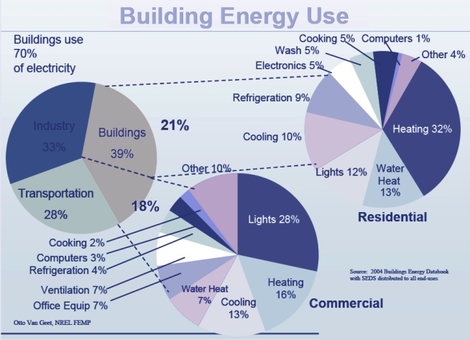
Fig.1.Considering housing status in energy consumption rate of different sectors
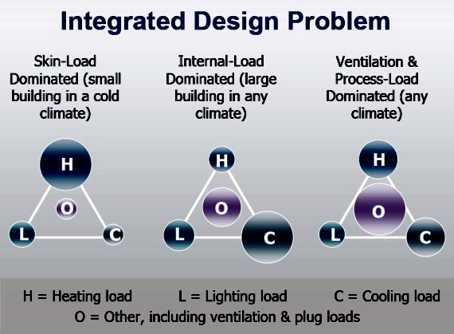
Fig.2. Considering the whole substantial problem of project design

If one accepts that the suburban single-family detached house typology has prevail the socio-cultural house form since 1945 based on the sheer numbers of units built5, a study of its typological characteristics can provide a guide to the underpinnings of the choices that influence the urban housing marketplace. Further, the typological characteristics can be examined as ordering principles in a denser typology, hopefully transposing that 'success' to the new typology (Straube, John 2008). Dr. Tang Lee addressed a group of architects at the 2007 Canadian Design and Research Network (CDRN) Sustainability Workshop held at the University of Waterloo and made the following opening comment:
“We (architects) do not design for the past, we do not design for the present, and we design for the future”.
Another point is that : Colin Davis, in his book, The Prefabricated Home, argues that architecture seems to need the concept of authorship as a means to distinguish architecture from mere building. If the designer of a building cannot be identified, then that building’s status as architecture is somewhat called into question (Davis, 2005).
The architectural speculation is not a design exercise on housing design ‘never seen before’ in a ‘would be’ future. Instead, it looks at the signs in the past and present that, with good reason, look promising for a sustainable future. Drastic Movement toward Sustainable Goals From a macro viewpoint, ‘civilization’ can be observed as a recent 10,000 year construct of a ‘habitat builder’ type called Homo sapiens. All types, and especially the habitat builders, create an impact on the environment. No types lives in isolation from the environment, but is just a part of the biosphere with its interconnected relationships of cause and effect. The price of ‘civilization’ in ecological terms is, (and always has been), to change the environment in which we live. The current degree and rate of anthropogenic change to the environment have now reached a global scale of awareness with greenhouse (GHG) emissions directly linked to hazardous climate change scenarios. The greenhouse gas CO2 in the atmosphere has had a dramatic increase that is now linked to fossil fuel emissions created by our current global annual energy needs of approximately 400 Quads of energy1. over the next 25 years, world energy consumption will increase 62%, or an additional 276 Quads. The convergence of these three issues – global scale awareness, global escalating energy needs, and resulting depletion of fossil fuel feed stocks, and global warming as an anthropogenic change linked to increases in GHG, specifically CO2, in the atmosphere – are the over-arching issues that will define the near future, including architecture. Anthropogenic change is now on a global scale, with 48% of manmade material and energy flows (see Fig. 1), and their associated GHG emissions, attributable to building activity 2. This makes the construction and operation of buildings the single largest contributor to global warming3. Conversely, dramatic reduction in GHG emissions can be achieved by changing the way buildings are constructed and operated and a sustainable built-environment would have a large impact in improving the prospects for our society as a whole.

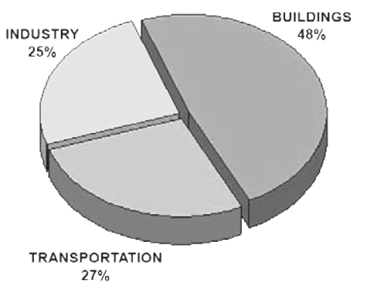
Fig.3. pie chart of US energy consumption
(Architecture2030, 2008)

New approaches will need to appear to transition towards sustainability in the midst of a major rebalance in the socio-economic (the end of cheap oil), socio-cultural (a global perspective), and socio-technological (efficiencies in material and energy flows) influences that will form our future and our architecture. One of the considerable points in saving energy consumption related to modern strategies for providing optimal life in recent century is preservation of future resources and their effects on (plant and animal) ecosystems. Preservation of nonrenewable energies, reduction of earth resources utilization and effect of low destruction of building on environment are important in architectural designing new methods of designing and making environmental compatible spaces for present and future generations are considered with minimum pollution. Paying attention to the free solar energy is one of the approaches to the architecture sustainable goals and solar house with systematic design could be effective and efficient approach. It is necessary to discuss the following for the recognition of pragmatic structure.

2.What is Passive Solar Design?
Passive solar design incorporates features in your home and its natural surroundings that restrain the sun’s low rays in winter and deflect the sun’s high rays in summer to naturally warm and cool the interior. A home’s orientation, elevation, room layout, materials, and surrounding outdoor landscaping all contribute to its passive solar design. Unlike active solar heating systems, passive solar design does not involve the use of mechanical and electrical devices, such as pumps, fans, or electrical controls, to move collected solar heat. Instead, it incorporates the use of windows, walls, and floors to collect, store, and distribute solar energy in the form of heat in the winter and block solar heat in the summer. Passive solar homes range from those heated almost entirely by the sun to those with south-facing windows that provide some fraction of the heating load.

3.Elements of Passive Solar Design
To design an entirely passive solar home, you need to incorporate what are considered the five elements of passive solar design:
3.1. Aperture (Windows) – Windows should face within 30 degrees of true south, and during winter months they should not be shaded from 9 a.m. to 3 p.m. The windows in living areas should face south, while the windows in bedrooms should face north. In colder climates, reduce the window area on north-, east-, and west-facing walls, while still allowing for adequate daylight. In warmer climates, use north-facing windows along with generously shaded south-facing windows. When buying windows, look for ENERGY STAR® qualified windows.
3.2. Absorber – The hard, darkened surface of the storage element is the absorber. This surface – such as a masonry wall, floor, or partition – sits in the direct path of sunlight. Sunlight hits the surface and is absorbed as heat.
3.3. Thermal Mass – Floors and walls that absorb heat are particularly useful for naturally heating homes in colder climates. Thermal mass refers to materials that retain or store the heat produced by sunlight. The difference between the absorber and thermal mass, although they often form the same wall or floor, is that the absorber is an exposed surface whereas thermal mass is the material below or behind that surface.
3.4. Heat Distribution – Passive solar design allows solar heat to circulate from collection and storage points to different areas of the house. A strictly passive design will rely on natural heat transfer, but some applications use fans, ducts, and blowers to help distribute heat.
3.5. Control – Elements such as roof overhangs or trees can be used to shade the window during summer months. Other elements for controlling temperature include electronic sensing devices, such as differential thermostats that signal a fan to turn on, vents and dampers that allow or restrict heat flow, low-emissivity (low-e) blinds, and awnings.
4.Socio-Cultural Influences
Culture, in very broad terms, can be viewed as the collective memory of a society’s ideas, institutions,and conventionalized activities. The connective tissue between building form and socio-cultural forces is man’s propensity to symbolize everything (Dubois, 1965). There is a symbolic element to housing that transcends the practical role of environmental mediator that modifies the environment to meet our preferences. The large tracts of essentially single-use housing built after WWII have become the icon of urban sprawl symbolizing the preferred housing choice. The success of that housing choice is linked to the cultural perception of the single-family detached house form as the ideal form to ensure one’s privacy and directly control one’s living environment. The origins of the strengths of this iconic form stems from the large size of the culturally homogeneous demographic of the population called the ‘middleclass’ after WWII.

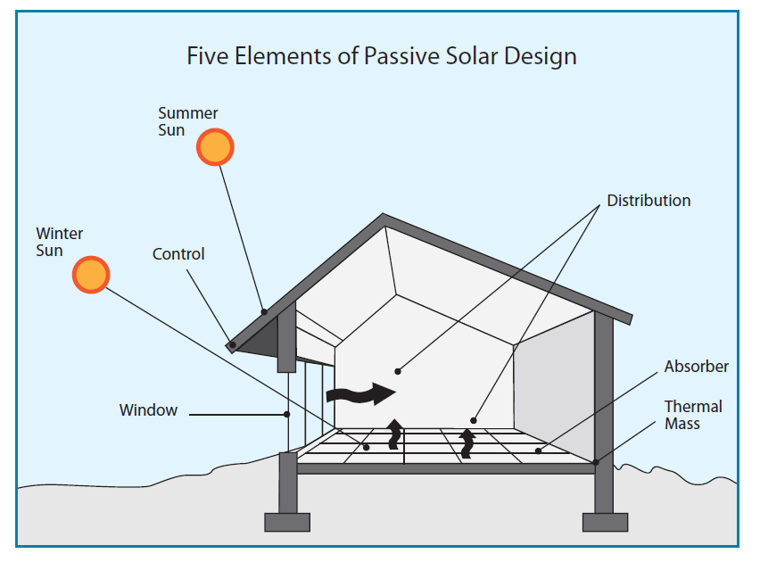
Fig.4. Elements of Passive Solar Design

5. House Form
In his article , House Form and Culture, Amos Rapoport states that originality and innovation in vernacular buildings are frowned upon and often condemned (Rapoport, 1969). Thus, the iconography of ‘home’ resists change. There is no question that the informal controls of culture defining the detached house as the typology of home is well established, but the cultural underpinnings are no longer homogeneous and fixed. The culture of sustainability is now mainstream; but it is new, and new is original and innovative. The iconography of sustainability is establishing itself but does not transplant to housing form in a readily identifiable way. To enlarge the cultural matrix from only detached dwellings as house and include stacked dwellings as home as well, it will require that the underpinnings of the detached home, privacy and control, be transplanted as well as notional architectural forms for housing.
6. Energy Rebalance
As the economic impact of energy costs dissolves the underpinnings of the low-density lifestyle, the housing mix can be expected to rebalance to meet the new economic realities. An immediate response will be that the demand for high performance buildings will increase as energy costs tied to operating expenses become more significant. High-performance buildings, with their inherent ‘energy savings’, will move housing towards sustainability to some extent; but holistic life-cycle cost analysis will require a rebalance in all segments of the Triple Bottom Line. It can also be expected that another immediate impact of high energy costs will be the increasing economic viability of technologies that need higher cost support levels. Finally, it will be economic forces that will provide the pressures to change lifestyles to those that support sustainability.

7. Multi -Scale Ordering Principles
Effective design strategies for sustainable design have an underpinning logic. To be effective, the macro to micro order of the scales has significance for sustainable design. To maximize the benefits of various strategies (and avoid potential negative results), the ordering principle for time is from timeless to temporary and for size is from large to small. The ordering principle of scale for time distinguishes layers based on their expected (or desired) life span and by their anticipated need for modification. An example would be a site as geologically timeless, a structure that lasts 100 to 300 years, a façade that lasts 40 to 100 years and interior finishes that last 10 to 25 years. It should also be self-evident that, in terms of scale applied to size, one must consider the climate zone before one considers the microclimate. It is also worth noting that specific opportunities for sustainability occur at specific scales, (ie: district based heating requires the scale of a district). One could use a formulaic approach such as LEED™ or Green Globes™ and achieve a level of ‘success’ as measured by that metric. There are, however, limits to that success. As previously discussed, achieving a set of generalized, prescribed targets may not result in moving towards sustainability for a specific project. The current limitations of the popular metrics to measure sustainability do not render those metrics without use and benefit; they are simply the ‘pioneer’ products of a paradigm shift in its infancy. A holistic metric that organizes and evaluates strategies based on the logical ordering of first principles to move towards sustainability are not available to designers. I would suggest that such a metric would be based on measuring the amount of resources and energy per unit of time, over the full life-cycle of the building; and, full accounting for the ‘ecological rucksack’ attached to the resources and energy used, that is removed from the biosphere as no longer useful and locked away in the landfill. In terms of solid waste, a truly sustainable building would score a ‘0’ going to the landfill. The landfill, as a human construct, severs the inflow and outflow balance of material flows. For a stable sustainable condition to exist, there would be no landfills, just temporary holding areas for materials that would eventually be inflows in another process. This kind of holistic metric implies a generalized order for design as follows:
Reduction, designs that reduce loads, inherently use less ‘nature’ and generate less waste that ends in a landfill. Macro level strategies include location efficiency, appropriate density and local/ district community infrastructure. Micro level strategies include load reduction through high performance building envelopes, controlled ventilation, and day lighting.
Passive energy systems: systems that are embedded into naturally occurring, stable, ecosystem cycles and forces, are the preferred design strategies. These strategies rely on bioclimatic forces to function in conjunction with limited resource and energy use. For this reason, sustainable design is site specific; as the location of a site determines the bioclimatic forces that need to be mitigated and are available to be used. An example would be the available passive solar heat gain based on the sun’s radiation and glazing. Another is natural (passive) ventilation based on prevailing winds and building form for cooling. Still another is thermal mass where the properties of a material are used to passively store and release heat radiation. Passive systems are based on an understanding of the climate and place by the designer. They would use the least amount of resources and energy, thus would probably contribute the least amount to the ‘landfill’ and receive the lowest ‘points’ in our holistic metric (where low points indicate moving towards sustainability).
Active systems: systems that manipulate bioclimatic forces with technology, are the next order of strategies. These strategies consume more resources and energy to use than passive systems but are still embedded in the bioclimatic forces of the site. Active systems are often the only options in urban settings where urban site constraints eliminate viable passive systems. The technology that is used in active systems needs to be evaluated and selected based on efficiency over the entire life cycle of that technology to mitigate energy and resource use. This metric would also have components that would apply to any scale:
Durability, the maximizing of resources to provide the most service life possible, is the next order of strategies. These strategies include design for disassembly, recycling, down cycling, adaptive re-use, and maintainability.
Reclamation, the increase of ‘nature’ in the built environment, is another order of strategies. As socio-cultural forces redefine the post-modern view of nature, architecture can be realized that provides new multiple connections between the biosphere and the built form. These strategies include urban forestry, green roofs, naturalized landscaping and bio-remediation plantings.

7.1. Infrastructure
Material and energy inflows supporting urban housing are ‘infrastructure’ while outflows are ‘waste stream’. In a stable system, there is a closed loop between the inflows and outflows. An imbalance in the flows eventually builds up pressures that rebalance the system, often suddenly, with surprising and unpredictable results. Efforts at sustainability are, in essence, efforts to close the loop between the input and output flows to maintain stability within a range that allow for human society. There are specific economies of scale for various infrastructure and as the rebalance progresses in our society, the correct scale for our existing infrastructure is being re-evaluated. In the past, basic municipal infrastructure was of very large scale and centralized. This was thought to be the most efficient method for delivery of services. The massive centralized scale for electric service, wastewater treatment and potable water has presented problems during natural catastrophes such as floods, ice storms, or heat waves. Basic large scale centralized infrastructure at current scales lack passive survivability, while individual small scale dwelling-based systems can be inefficient. As an example, all water to the city is potable water that is filtered and treated whether it is for fighting fires, watering the lawn or human consumption.
Historically, urban housing generated two major categories of ‘waste’ outflows: human waste disposed of by flushing and garbage disposed of by collection for transport to a landfill. Recent ‘recycling’ initiatives are trying to change the two big waste pipe outflows to at least two big pipes plus some small pipes for paper and glass. In order to actually be able to manage the mechanics of the outflow in a sustainable way, we must abandon all ‘big pipes’ and create discrete numerous small pipes that can become the inflows for processes that will close the material and energy flow loop. For sustainable urban housing, the flushing big pipe should be replaced by the urine collection pipe (valuable inflow for fertilizer process), the black water pipe (inflow for ‘living machine’ process), and grey water pipe (inflow for irrigation reclamation water process). The large garbage pipe should be replaced with as many small pipes as possible such as organic waste (inflow for composting), and glass/paper/plastics/ textiles (inflow as raw material in processes).
The following speculations on large scale infrastructure are possibilities of the near future that hopefully will be pursued to move the urban tissue of Toronto towards sustainability:
1. Water service will be provided in different categories for use such as raw water (i.e.: rainfall for irrigation), filtered water (i.e.: for cleaning), potable water (i.e.: for human consumption) and grey water (i.e.: recycled filtered water for human waste transport). The efficiency gains by not making all water used into potable water will be sought simply due to economics—treating all water unnecessarily is energy intensive. Reducing treatment to only what is needed is simply more efficient and broadens the potential sources of obtaining water .
2. Deep Lake Water Cooling (DLWC) from Lake Ontario will be expanded to residential use as a heat sink to provide chilled water for dehumidification and cooling. Since the resource sink is so large and it is recharged every winter, the potential for any heat build-up issues to the lake due to expanding the system is avoided.
3. Complete separation and harvesting of storm water runoff. Storm water will culturally shift from ‘something to get rid of’ to a valued natural resource to be managed.
The urban density of 60 units per acre building is a scale that would be able to support the following district scale infrastructures to move towards sustainability in 2020 :
1. District-based heating and cooling is feasible at urban densities. Since the density would support sufficient diversification factors for continuous predictable use, combined heating and power (CHP) systems would be practical.
2. Again, supported by the density, primary wastewater treatment using ‘living machine’ technology can be implemented on a neighborhood basis with anaerobic treatment occurring at the building and final aerobic treatment occurring off-site using bioengineering technologies such as artificial wetlands. Separate dedicated piping for the collection of urine for manufacturing fertilizer to replace synthetic fertilizers manufactured from natural gas would require a major cultural re-alignment but the ease of implementation and large economic gains make that scenario feasible speculation. It is speculated that by 2020 the changes in building scale infrastructure (what is called building mechanical systems today) will be radically changed. Building forms will be designed by architects to achieve reductions in energy flows as part of the culturally directed focus on sustainability gains through high-performance buildings. Passive solar based building infrastructure strategies are often limited in urban settings due to constraints such as property lines. Opportunities for shallow floor plates on an east-west axis with south-facing solar access to implement basic passive strategies to provide day lighting, direct solar gain, and natural cross-ventilation are limited by density. Active solar building systems can be employed for a broader range of built forms while achieving goals such as density or overcoming constraints such as property lines. The current and projected high cost of hydrocarbon based high-grade energy fuels coupled with the lowered energy demands for heating/cooling for high performance buildings vastly enlarges the range of passive and active solar strategies that can offer an economic payback. Because of building envelope advances, the BTU per sq.ft. of heating/cooling energy needed to maintain a building’s interior within a ‘comfort zone’ can be within the range of low-grade solar based energy sources. The incorporation of solar strategies will start to inform building spatial programming and form as tank space, light tubes, shading devices, reflectors, PV panels, solar panels, radiant cooling panels, and wind turbines become the new vernacular. This economic underpinning will change architectural form for housing since solar access will now have easily identifiable economic value. It is speculated that passive and active systems will impact building infrastructure design and form in the following ways:
1. Roofs, which now are bleak landscapes used to house rooftop mechanical units and are a major contributor to the ‘heat island’ effect, will start to become valuable real estate. Roofs are often the face of the building that has the best solar and wind access. In addition to roofs housing biota (green roofs), they will be used to harvest and pre-treat storm water as well as physically house solar collection panels, photovoltaic panels, and wind turbines.
2. The solid waste stream of a dwelling unit is currently disposed of as a homogeneous material we call ‘garbage’ regardless of its actual content. Some municipalities do offer voluntary recycling programs for limited sorting but all ’waste’ leaves the site. Future solid waste infrastructure will probably be much more demanding of sorting at the dwelling unit level (clear glass, green glass, newspaper, cardboard, mixed and glossy paper, type 2 plastics, other plastics, cloth, wood,aluminum, steel etc.) While readily compostable solid waste would not leave the site but would be treated and used on the premises for urban agriculture with access hauled off-site as a valuable resource.
3. The handling of solid waste using a single ‘garbage chute’ terminating in a dumpster will give way to multiple chutes terminating in a ‘recycling center’. This change in daily life will require new spatial arrangements at the dwelling unit level to pre-sort as well as significant spatial allowances for multiple chutes and a recycling center.
4. Since potable water for human consumption is such a small amount compared to all other water uses, it would be more efficient (use less energy and resources) to make potable water at the source of use, for housing, in the dwelling unit. The traditional two pipe (hot water and cold water) distribution system will give way to a multi-layered piped distribution systems increasing the spatial allocation for mechanical systems. To service these increasingly complex systems, the desirability of de-tangled finishes and access will inform architectural designs at many scales.
5. The inefficiencies in using air to transport heating/cooling energy from a central location in a large multi-story building will result in a new industry focus on hydraulic systems. The building heating/ cooling plant will integrate the building active solar systems with multi-fuel sources minimizing the need for high-grade energy sources. High-grade energy production for heating and cooling will still be needed when the active solar based systems cannot produce enough and that high grade energy will be based on traditional fossil fuel sources and the regional electric grid. Since the project has a six story density, a centralized multi-tank system can be used where the actual fuel form (fuel oil, coal, natural gas, wood, night rate electric) could be selected based on changing availability and cost.
6. Building envelope science will have improved to the point where infiltration is effectively eliminated. Controlled ventilation will be provided adding fresh air ductwork to the mix of standard mechanical systems found in residential units. The systems will change focus from the basic ‘discharge to outside’ focus to filtration and energy recapture.
7. Dwelling units today are currently connected to the regional electric grid as the single source of electrical power and when the grid fails, there simply is no electric power to the unit. This quickly renders the unit uninhabitable as heating/cooling/lighting/ventilation mechanical systems do not operate. The technology of the near future will allow for some on-site electrical generation through PV arrays and wind turbines to operate key mechanical and emergency systems for survivable buildings that better respond to large scale disasters. Since lighting and air are already passively provided, and heating and cooling are active solar-based systems, it becomes feasible to maintain a livable environment with a small electrical energy budget. The standard 220/110V electrical distribution system will also be changed into a layered system. The new standard dwelling unit’s ‘load center’ will have multiple buses segregating electrical power into life/safety circuits (fire detection, emergency lighting) which would always be powered; priority circuits (refrigeration, ventilation) selected to maintain the survivability of a dwelling unit, and general purpose circuits.
The standard ‘one size fits all’ receptacle will give way to specialized receptacles and wiring increasing the complexity of ‘adding on’. This will further the desirability of de-tangled accessible finishes that can readily accommodate change.

8. Close Scrutiny Of Greenhouse Passive Heating:
Attached greenhouse passive heating is discussed the 3 followings in this paper:
8.1 Split greenhouse design.
8.2 Fixed section – the solarium.
8.3 Controlled vent section – the solar greenhouse.

8.1. Split Greenhouse Design
First, we must clarify some terms. A solarium is a sunroom with a large expanse of glass roof and walls that accepts sun and heats the space inside. A solarium can also be a solar greenhouse for plants. So a split greenhouse can have two portions: a solarium and a solar greenhouse. The solarium heats the house and provides a sunny sitting area using the incoming rays from the sun and the solar greenhouse has its interior space heated so that plants can grow well in winter with the extra heating and its hot air can be used to heat the house.
The purpose of the split design is such that the solarium can supply a steady source of heat to the house throughout the year. The energy simulation modeling, discussed earlier, showed a steady heat supply was needed to keep the house at a pleasant living temperature. Various sizes of this fixed section can be examined by the model to find the optimum design. The solar greenhouse portion is a sealed room that can have its heated air either vented into the house or outside, depending on the house temperature. In addition, this greenhouse can also be used to grow vegetables and start other plants from seed.

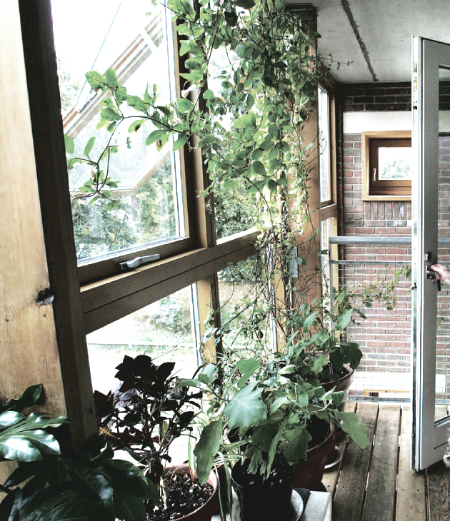

Fig.5. Split greenhouse design from the inside of the house.

Figure 4.1 show this split design from the inside of the house and Figure 4.2 shows an aerial view of the house from outside. In Figure 4.1, it can be noted that the windows from the dining room look out through the solar greenhouse to the outside allowing the view of the San Francisco Bay. These windows also allow sunlight to heat the thermal mass of the dining table as discussed earlier.

8.2. Fixed Section – The Solarium
The solarium is a fixed glass section that admits sunlight into the house to heat the tiled floor, air, and provide a pleasant atmosphere for the members living in the house to sit in the sun and read or talk in a very impressive environment. The window area was determined by the computer energy simulation code to provide the right amount of solar heat to the house throughout the year. In the summer time, when there is too much heat, shades can be automatically drawn to keep unwanted solar heat from entering the house. Section 2.3 provides a discussion of the results of this heating/cooling simulation with shades up and down in the space. The shades can be automated and/or manually controlled when members of the house want to sit under direct sun and when it is not too hot.

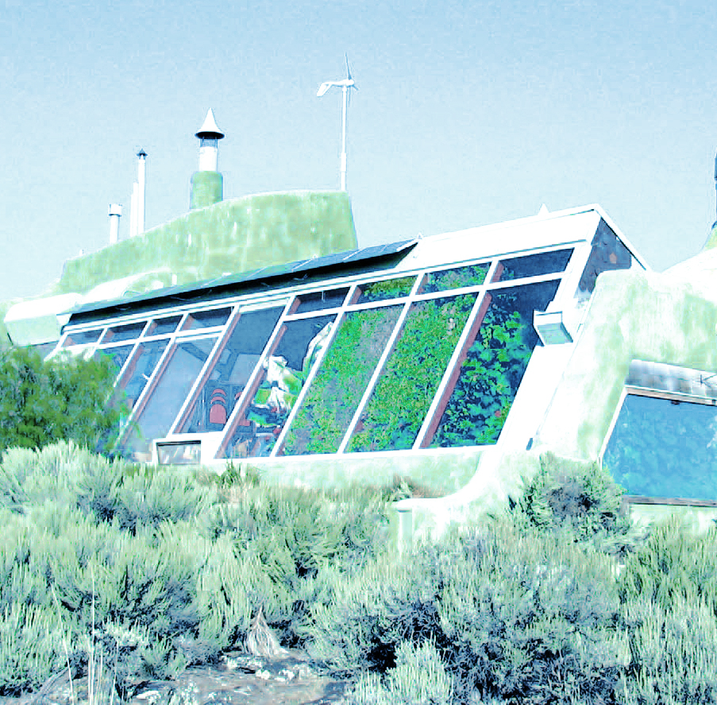

Fig.6. Aerial view of solar greenhouse from outside.

The glass type used in this space is Heat Mirror 88® which allows sunlight to pass through efficiently but blocks the re-radiation of the infrared heat energy from escaping to the outside. There is no overhang or designed shading of glass as part of the house outside. It receives the morning sun just after sunrise and continues to receive sunlight all day until sunset. This solarium fixed section is a very significant source of heat for the house. In order to establish a baseline of performance for the house, the first tests involved the heating and cooling of the house using only the solarium and ventilation, using no active elements through the summer and winter seasons.Figure 7 shows a typical day’s performance on March 26 when the outside temperature varied from 7.8°C to 11.7°C (46°F to 53°F).
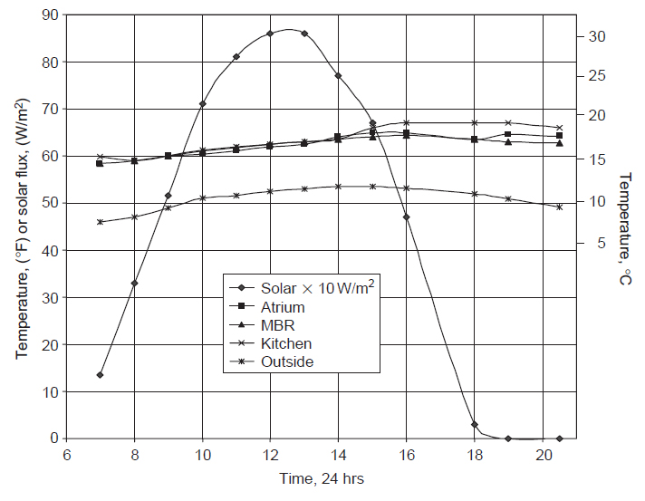
Fig. 7. Typical day of solarium solar heating of house.

The solar flux was measured by Kipp & Zonen pyranometer (Model CM3-L). The effects of the solar heating are clearly shown in the temperatures of the atrium, master bedroom (MBR), and kitchen starting early in the morning at 14.7°C (58.5°F) and increasingly heating to 17°C (62.5°F) at noon. Then in the afternoon, when the solar heating begins to decline, the rate of temperature increase is not so rapid and begins to steady out to reach a maximum of 17.8°C (64°F) downstairs to 20°C (68°F) in the kitchen upstairs. At night these temperatures decrease only slightly, owing to the substantial temperature storage in the thermal mass throughout the house. This thermal response to solar heating is entirely expected by the transient heating during the solar day. The computer simulation model, MicroPas4, predicted these transients very well. For the range of cold summer months from January through March, Figure 8. shows the average master bedroom temperature versus the minimum outdoor temperature. In the upper portion of the plot, the weather type observed for that day is shown. As discussed earlier in Chapter 03, Figure 3.3 shows data for a whole summer season from June to the end of October where the unshaded solarium provided heating sufficient to maintain the master bedroom average temperature at 24.4°C (76°F). The controls functioning at this point of time were nocturnal cooling bringing cool air at night. This combination of solarium heating and nocturnal cooling under computer control is the major operational function of this combination.
Over a whole year, the house without solar shading was found to maintain a consistently pleasant temperature from 16.7°C to 27.8°C (62°F to 82°F), with the peak outdoor temperature records of 38°C (100°F) for several days and 32°C (90°F) for a week-long period.

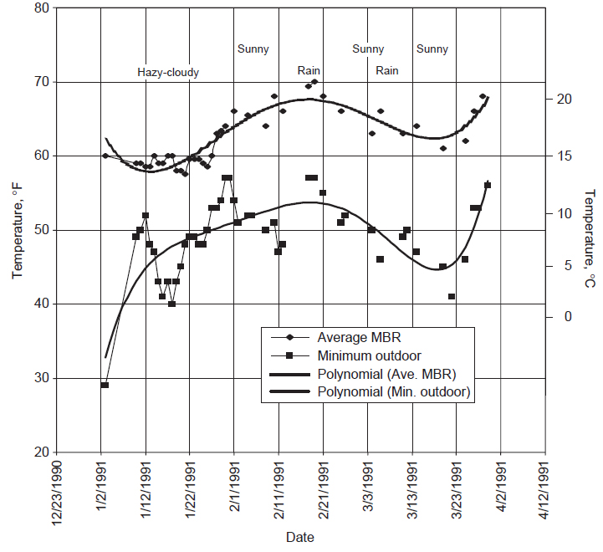

Fig .8. Three winter months of solarium heating of house.

8.3 Controlled Vent Section – The Solar Greenhouse
The illustration of the thermal performance of the greenhouse is shown in Figure 9 by thermal measurements made in the concrete storage slabs, using a pair of floor thermostat temperature sensors to determine the vertical temperature gradient. One floor sensor was 50 mm (2 inches) below the floor surface and the other 100 mm (4 inches) below. The data shows that the slab picks up heat to reach around 25°C (76°F) at 5 pm by which time the air temperature drops below the concrete temperature. At this point, the heat stored in the slab is released into the greenhouse air space, where this warm air stimulates plant growth and can be used for space heating.
By 4:30 am the next day, the outside air temperature had dropped to 10°C (50.1°F), compared to the greenhouse temperature of 15°C (60°F). Preliminary calculations with these data were performed, which, for brevity will not be detailed, torepresent the potential value of this kind of instrumentation.
The apparent heat transfer coefficient using a surface ΔT ₌ 5°C or 10°F from air to concrete calculates as 12W/m2-°C (2 Btu/hr-ft2-°F). It can be noted that this vertical gradient in the concrete reaches a maximum of about 0.05°C/mm or 30°F/ft at a solar flux of 880W/m2, while the vertical thermal stratification in the air is about 0.08°C/mm or 44°F/ft. The thermal conductivity ratio of air to concrete is around 40 – much larger than the temperature gradient ratio. So the heating of the floor appears to be a combination of heat convection and radiation. A slight circulation of the air in the greenhouse would help reduce the thermal stratification with height and would also improve the heat storage down into the slab. Pairs of temperature sensors spaced just below a thermal storage floor slab are suggested to be used as standard instrumentation in future passive designs to permit comparisons to other buildings on their heat storage ability using this important solar component – the solar greenhouse. Two other tests were done on the greenhouse on April 9 and 23, 1995 on a clear sunny day with a solar insolation rate of 903W/m2 and 934W/m2, respectively. With all the circulation to and from the house cut off and the greenhouse vent fan turned off, the temperature reached 49°C (120°F) and 54°C (130°F), respectively for these two days. However, with the fan external vent cooling in the control loop, the temperature was tempered to 35°C (95°F) for an outdoor temperature of 14.4°C (58°F) and 19.4°C (67°F), respectively. This illustrates that the greenhouse can provide both house heating and plant growing temperatures at the same time. During hot summer days, the temperatures can rise to 60°C (140°F), so the upper vent fan and automatic shades will reduce these high temperatures that are not conducive to ordinary plants in a greenhouse over the summer.

Conclusion
In the current condition, energy crisis and environmental pollutants is one of the human’s concerns and architecture should provide in this regard solution which is a multilateral issue indeed. In the present study, the potential benefits that solar systems offer are discussed in detail. Additionally, in the study the environmental protection offered by the most widely used renewable energy system. The results show that by using solar energy considerable amounts of greenhouse polluting gasses are saved. Ambient toxic emissions during solar system were very low, and blew detection limits. The application of such fuel system in industry of country offers a wide range of ecological and, in many cases, economical advantages like conservation of fossil fuel resources, utilization of reduction of emission of harmful species from fossil fuel burning, and minimization of waste disposal. The negative environmental impact of renewable energy is also expressed such as damage of animals like birds and land displacement by solar energy systems. However, it is clear that using of these sources of energy is more useful special for environment than conventional energy.
As a result, it is concluded that greenhouse in a minor scale could be to some extent toward sustainable goals and its systematic implementation could make great contribute to reserve energy and reduce environmental pollution. In this regard, it is necessary to pay attention to different factors such as cultural, social, traditional, economic and etc. in order to have a pragmatic sustainability.

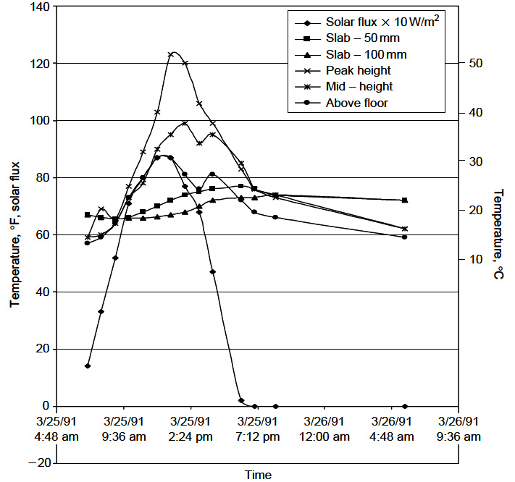
Fig. 9. Thermal performance of the greenhouse.

Corresponding Author:
Dr. Reza Mirzaei . (Ph.D). Moscow State University of Architecture ,Russia , Moscow
E – mail:aspiran00800@yahoo.com

References
- Mostafaeipour A, Mostafaeipour N. Renewable energy issues and electricity production in Middle East compared with Iran. Renewable and Sustainable Energy Reviews 2009; 13:1641–1645.
- Hosseinia R, Soltanib M, Valizadehb G.Technical and economic assessment of the integrated solar combined cycle power plants in Iran. Renewable Energy 2005; 30:1541–1555.
- The passive solar House: Using solar Design to Heat and Cool Your Home, 1997. James Kachadorain, White River Junction, VT: Chelsea Green Publishing.
- The passive solar Design and construction Handbook, 1997. Edited by Michael J. Crosbie, New York, NY: John Wiley and Sons Lid. Building Energy Software Tools DOE Office of Building Technology, State and Community Programs. Web site: www.eren.doe.gov/buildings/tools_directory/
- W. Marion, S.Wilcox, Solar Radiation Data Manual for Buildings, NREL. Available online at http://rredc.nrel.gov/solar/pubs/bluebook/.
- Pour Jaafar, M and Mahmoudi nejhad, H (2007). Effect of physical factors in reducing energy consumption of housing, commitment on climatic design with emphasis on cold regions of Iran,Journal of Rah va Sakhtemen, No. 42
- Mahmoudi Nejhad, H and Taqavaee, AA (2006). Solar Housing,requirement use of solar energy in housing design,concepts and qualitative evaluation, Payam e mohandes, No.34.
- Kasmaei, M (2004). Climate and Architecture, Tehran,Khak publications.
- Mahmoudi, M. (1387). Investigation of sustainable coexistence of architecture and nature in underground buildings. Road and Building Journal. No 51, July.
- Afshar Naderi, K. (1387). Architecture and Environment. Architect Journal. No 48. March, April.
- Dehban, M. (1387).The relationship between land and building from climatic architecture perspective. Architecture and Culture Journal. No 33.
- DOE Energy Savers: Passive Solar Home Design www.energysavers.gov/passive_solar
- DOE Energy Savers: Windows, Doors, and Skylights www.energysavers.gov/windows_doors
- New Mexico Solar Energy Association (Search “Homeowners”) www.nmsea.org
- American Council for Renewaable Energy www.americanrenewables.org
- Leadership in Energy and nviromental Levitron www.usgbc.org/LEED/Design – Building Rating index.asp
- Residential Energy Efficiency Data Base, Canadawww.its-canada.com/reed
- Energy Efficiency and Renewable Energy Office of US DOE www.eren.doe.gov
- Williams, J. Richard., (1974), “Solar Energy – Technology and Applications,”Ann Arbor Science, MI, 131 pp.
- Kreith, Frank and Jan F. Kreider., (1978), “Principles of Solar Engineering,”Hemisphere Pub. Corp., NY.
- Adams, Robert W., (1981), “Adding Solar Heat to Your Home,” Tab Books,Inc., PA, 280 pp.

12/22/2012

