Detection of Citrus Yellow Mosaic Virus Infection in Different Species of Citrus by PCR

Muneesh Kumar Barman

Assistant Professor, School of Studies in Biotechnology, Bastar Vishwavidyalaya, Jagdalpur, Chhattisgarh, India. PIN: 494005
E-mail: muni_1502@yahoo.co.in ; Contact: +919907476510

Abstract: Citrus yellow mosaic virus (CYMV) is a double stranded rod shaped DNA virus of genus Badnavirus, family Caulimoviridae. Its complete genome has been sequenced and characterized by Hang et al., (2001). It comprises of six putative open reading frames (ORF) and an intergenic sequence all lying on the plus strand of DNA and each capable of encoding proteins with a molecular mass of greater than 10 kDa. ORF 3, the largest ORF, encodes a putative polyprotein for functions involved in virus movement, assembly and replication. The other ORFs encode proteins whose exact functions are not completely understood. The genome also contains a plant tRNAmet binding site, which may serve as a primer for minus-strand DNA synthesis, in its intergenic region. In this study five samples of three different species of Citrus including C. sinensis (CS+ve, CSa and CSb), C. raticulate (CR) and C. aurentifolia (CA) (selected at random) were diagnosed for CYMV infection by PCR using sequence specific primer. The DNA was extracted from leaves of the plants by three protocols viz. sodium sulfite method, CTAB method and Dellaporta et al., (1983) method, to standardize the DNA extraction protocol for Citrus. Sodium sulfite method gave the best results. The PCR protocol was standardized and the temperature profile for PCR comprised of denaturation at 94ºC, primer annealing at 56ºC and primer extension at 72ºC. The PCR product was visualized under UV trans-illuminator at 260nm wavelength after electrophoresis on 2.5% agarose gel. In detection of CYMV, out of five samples, including C. sinensis (CS+ve, CSa and CSb), C. raticulata (CR) and C. aurentifolia (CA), two samples of Citrus sinensis (CS+ve and CSa) and one sample of Citrus reticulate (CR) were found infected by CYMV.
[Muneesh Kumar Barman. Detection of Citrus Yellow Mosaic Virus Infection in Different Species of Citrus by PCR. Nat Sci 2013;11(2):41-45]. (ISSN: 1545-0740). http://www.sciencepub.net. 7

Keywords: Citrus Yellow Mosaic Virus, Citrus, Polymerase Chain Reaction

1. Introduction
Citrus (Citrus sps.) being the third most important fruit crop after mango and banana, occupies an important place in the horticultural wealth and economy of India. However, the Citrus industry faces severe loss to economical production as the production areas are being severely challenged by pest, disease, and environmental problems to which current commercial cultivars are susceptible. (Draft of the International Citrus Genome Consortium Steering Committee, 2003). The crop suffers from extensive damage caused by viruses and virus like pathogens. Virus are the major cause in diseases of Citrus, one of which is Citrus yellow mosaic virus (CYMV) or Citrus mosaic badnavirus (CMBV), a bacilliform double standard circular DNA virus having a single genome of 7.5 kb, play a significant role in causing Citrus disease in India. Its complete genome has been sequenced and characterized by Hang et al., (2001). It comprises of six putative open reading frames (ORF) and an intergenic sequence all lying on the plus strand of DNA and each capable of encoding proteins with a molecular mass of greater than 10 kDa. ORF 3, the largest ORF, encodes a putative polyprotein for functions involved in virus movement, assembly and replication. The other ORFs encode proteins whose exact functions are not completely understood. The genome also contains a plant tRNAmet binding site, which may serve as a primer for minus-strand DNA synthesis, in its intergenic region.
Citrus yellow mosaic disease is common, widely distributed and severe disease in India and is reported to occur especially in Satgudi sweet orange [Citrus sinensis (L) Osbeck] in southern states, mosambi sweet orange [Citrus sinensis (L) Osbeck], acid lime [Citrus aurentifolia (Christm.) Swing] and Nagpur mandarin (Citrus reticulate Blanco) in north eastern states. (Dakshinamurti et al.,1975). The characteristic symptoms due to CYMV vary from general chlorosis to uniformly distributed leaf mosaic in field infected mosambi and Nagpur mandarin and yellow motellting to patches on acid lime. Mosambi sweet orange leaves sometimes develop yellow flecking along the veins. Infected plants often develop symptoms on part of the canopy and are moderately stunted with leathery texture of mature leaves. More variable symptoms may be observed if field grown plant is infected with other graft transmissible or soil borne pathogens (Ghosh et al., 2003). CYMV measures 130 × 30 nm in size and is transmitted by grafting, dodder and on few Citrus species by mechanical means (Ahlawat et al., 1996). Reports of experimental transmission by mealy bug, Planococcus citri Risso and aphid species, Myzus persicae Sulzer and Aphis craccivora Koch is available in the literature. However, the role of insect vectors for natural spread of the disease needs further tests and confirmation. CYMV is serologically related to Banana streak virus (BSV), Cocoa swollen shoot virus (CSSV), Sugarcane bacilliform virus (SBV) and Commelina yellow mosaic virus (ComYMV), and belongs to the member of Badnavirus genus of the family Caulimoviridae (Ahlawat et al., 1966).
Accurate information on the tools for indexing of virus infected trees is highly important for decisions to implement a virus eradication or suppression program (Sharma S. et al. 2009). Many efficient methods have been devised for the detection of various infectious particles causing diseases in plants. Molecular diagnostic techniques like, the immunological assay, electron microscopy, various polymerase chain reactions (PCR), and endonuclease restriction etc are most widely used techniques today. These methods score well over the conventional methods as these methods save time and present higher accuracy. In case of Citrus yellow mosaic disease the CYMV being poorly immunogenic could not be efficiently detected by immune-assay techniques like ELISA. However, its detection can be done by PCR using primer of specific conserved sequences in the genome of the virus and other infectious agents.

2. Material and Methods
The present study, was carried out taking five different species of Citrus, one sample (leaves) of each of C. reticulate (CR), taken from G.E. Road, Raipur, Chhattisgarh, India; C.aurentifolia (CA), taken from Sector-7, Bhilai Chhattisgarh, India; and three samples (leaves) of C. sinensis; one of which was positive to CYMV infection, provided by Dr. V. K. Baranwal, Principal Scientist, Indian Agriculture Research Institute, New Delhi was taken as standard (CS+ve). The other two samples CSa and CSb were taken from Santoshi Nagar, Durg, (C.G.) and Amrawati, Nagpur (Maharashtra) respectively. As revealed by the literature, Citrus sinensis is the prime host of CYMV. However, it also infects other species of Citrus. The leaves were collected at random taking into consideration either or all of the following symptoms including, stunting, chlorosis and uniformly distributed leaf mosaic, followed by leathery texture of matured leaves and mealy bug infection.
The genomic DNA was extracted by three different protocols, viz. sodium sulphite method (SSM), Dellaporta et al., (1983) method and cetyltermethylammonium bromide (CTAB) method with some modifications. The DNA was quantified and diluted up to a concentration of 50ng/ml.

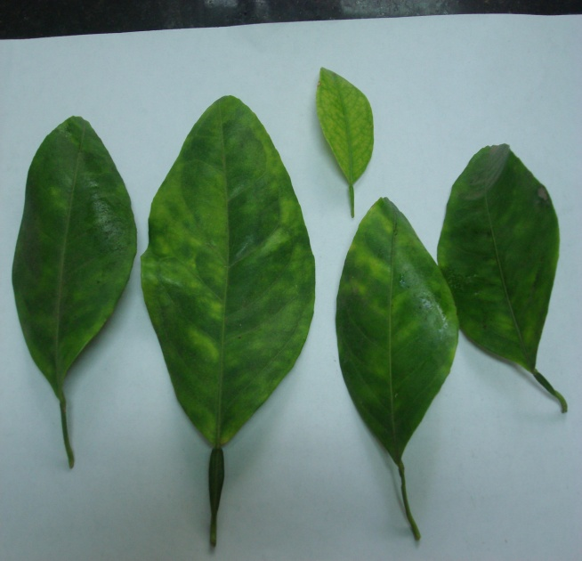
Figure 1: Samples of Citrus sinensis

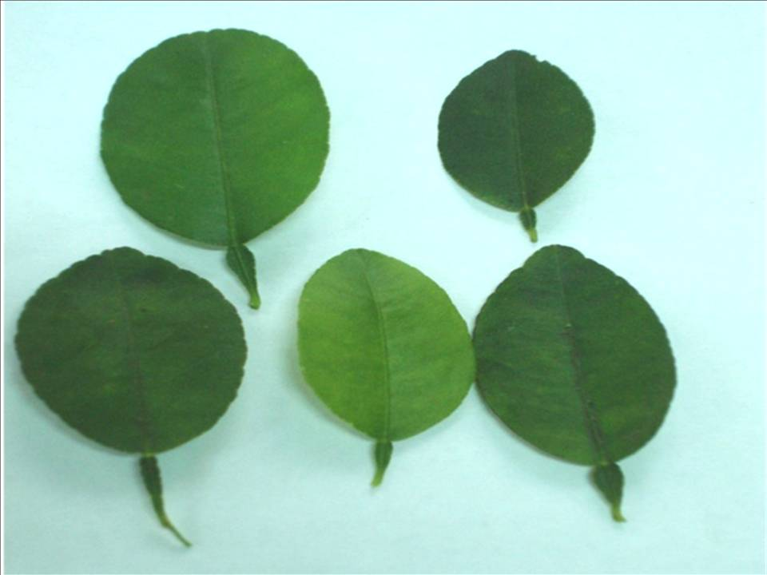
Figure 2: Samples of Citrus reticulate

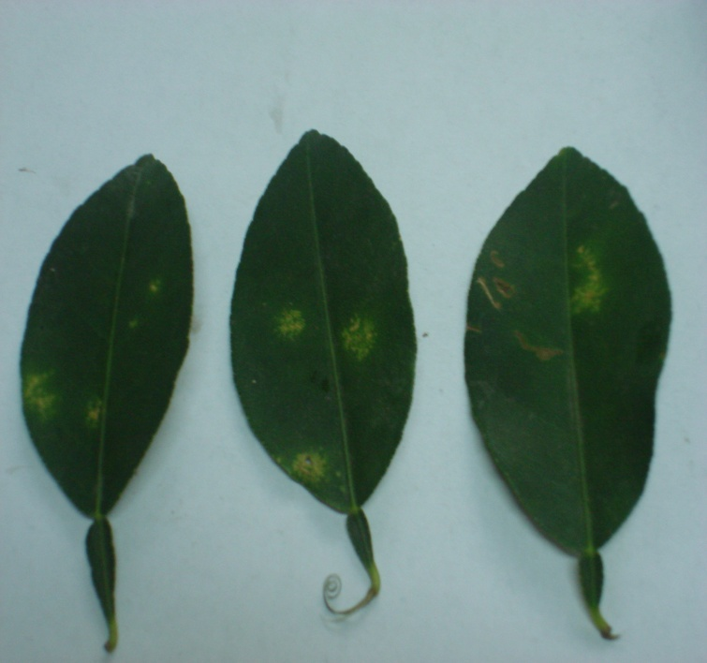
Figure 3: Samples of Citrus aurentifolia

The extracted genomic DNA were run on 1% agarose gel in 1X TAE buffer along with high range DNA ruler (GeNei). 2.5 µl ethidium bromide per 100ml gel was used to visualize DNA, to testify the extraction of full length DNA.
The DNA samples were screened for CYMV by PCR. PCR was run using sequence specific primers for intergenic region of CYMV. The primer sequence for forward and reverse were GTGGCTTTCATCAGGTAGC and CATGCATCCATCCGTTTCG respectively. The primers gave a product of 650kb on PCR amplification. The PCR profile consisted denaturation at 94ºC for 5 min followed by 30 cycles of denaturation at 94ºC for 1 min, primer annealing at 56ºC for 30s and primer extension at 72ºC for 30s. The final extension was carried out at 72ºC for 10 min. The product of the PCR was run on 2.5% agarose gel (with 2.5μl/100ml ethidium bromide) along with 1kb DNA ruler and standard CYMV +ve sample. After electrophoresis, the CYMV DNA was visualized under a UV trans-illuminator at 260nm and was photographed.

3. Results and Discussion
After agarose gel electrophoresis of PCR products bands of amplified DNA (650 kb) were observed in CS+ve, CR and CSa. Viral genome was amplified in the samples CS+ve, corresponding to the standard CYMV infected samples of Citrus sinensis (L) Osbeck taken from Indian Agriculture Research Institute, New Delhi; CR, corresponding to the Citrus reticulate collected from G.E. Road, Raipur (C. G.) and CSa, corresponding to the Citrus sinensis (L) Osbeck collected from Santoshi Nagar, Durg (C.G.). These samples are found to be infected by “Citrus Yellow Mosaic Virus”.

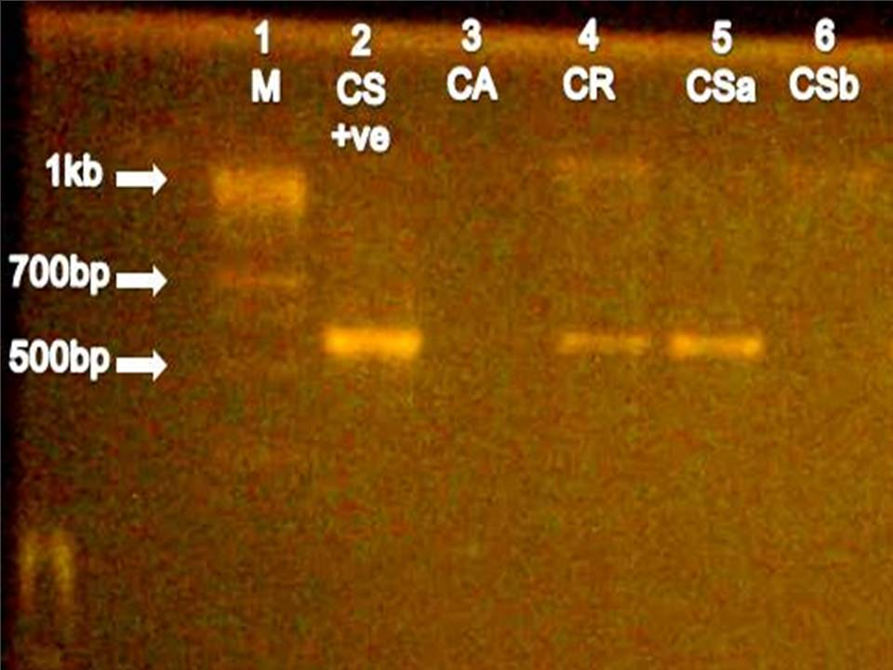
Figure 5: Bright bands of amplified CYMV (CS+ve, CR, and CSa) genome obtained on electrophoresis of PCR product on 2.5% agarose gel, confirm the infection of CYMV.

In India, mosaic diseases in Citrus were reported in sathgudi sweet orange and khasi mandarins but etiology of these diseases was not established. A mosaic disease of Citrus was also reported from Japan, where a spherical virus was reported to be associated with it. Ahlawat et al.(1985) reported a yellow mosaic disease on pummelo from Karnataka and showed the association of a badnavirus with the disease and was called Citrus mosaic badnavirus (CMBV). Subsequently, a badnavirus was reported infecting acid lime. Since the infected Citrus trees in India showed yellow mosaic symptoms, it was decided at the 13th International Organization of Citrus Virologists Conference held in China in 1995, that the name of disease may be changed to Citrus yellow mosaic disease and the Citrus mosaic badnavirus be called as Citrus yellow mosaic virus (Ahlawat et al. 2005).
CYMV is a member of the family Caulimoviridae, genus Badnavirus, which causes a mosaic disease in Citrus that has been termed Citrus mosaic disease or Citrus yellow mosaic disease. This virus is currently restricted to India. The causal agent is transmitted by grafting and experimentally, by mechanical inoculation and by the Citrus mealybug, Planococcus citri (Risso). CYMV causes mosaic and yellow flecking along the veins of the leaves. Trees affected by the disease not only show significant yield reduction, but also a decrease in the quality of fruits (less juice and ascorbic acid). The virus can infect and cause symptoms in almost all Citrus species and cultivars (Scientific Opinion of the Panel on Plant Health, 2008).
The present study was carried out, taking into consideration the apart from commercial point of view various Citrus plants are grown at homes as culinary and ornamental plants. These domestic plants might be infected with viral disease, yet undetected due to negative or under expression of symptoms. This could become a major cause for the establishment of diseases in new areas. So, the samples for this study were collected at random from non commercial sites.
Isolating high quality DNA is essential for molecular research. Polysaccharide contamination is a common problem in higher plant DNA extraction. DNA samples are often contaminated with melicera colloidal hyalosome, which is almost insoluble in water or TE buffer. This can affect manipulation, inhibit enzyme reactions, and hinder the downstream work in molecular biology research. DNA samples are unstable for long time storage. Several plant DNA extraction protocols for removing polysaccharides have been reported. However, in some woody fruit crops that contain high polysaccharide levels, such as crops of Citrus spp., the protocols could only be used on vigorous tissue, and the DNA isolated was not of high enough quality to be used in PCR and RFLP analyses due to presence of polyphenols and polysaccharides. These could be removed, and DNA can be precipitated selectively in the presence of high salt. This method is suitable for genomic DNA isolation from fruit crops containing high polysaccharide levels (Cheng et al. 2003). Three DNA extraction protocols viz. Sodium sulfite method (SSM), CTAB DNA extraction method and Dellaporta et al., (1983) method were employed in this study and a comparison was made. Unlike the study performed by Cheng et al. (2003) out of the three methods SSM was found more effective for extraction of Citrus DNA.
PCR is an enzymatic procedure which can detect the presence of even nano grams of concerned nucleic acid. Diagnosis of various pathogenic organisms including virus is efficiently done by PCR. In PCR, the template DNA are first melt by heating them to a high temperature around 90-94ºC. Two primers (a pair) are so designed that they are highly complementary to the template sequence and bind at specific sites on the two strand of the dsDNA. After the primer binding the template spanning in between the respective binding sites of the two primers is amplified on the primer by a thermostable Taq-DNA polymerase enzyme. This process is repeated for 30-40 times. This reaction proceeds as a chain reaction as in every cycle two new DNA strands are formed from one strand and each of it works as template for the subsequent cycles. In present study, denaturation was done at 94ºC first for five minutes and then for 1 minute for each subsequent cycle up to 30 cycles. The annealing temperature was kept 56ºC for 30s per cycle and primer extension was done at 72ºC for 30s for 30 cycles. A 10min final extension was also performed to ensure complete amplification of annealed primers. The temperature profile was standardized taking references of study ‘A novel approach for simultaneous detection of Citrus yellow mosaic virus and Citrus greening bacterium by multiplex polymerase chain reaction’ by Ahlawat et al., (2005). If the pathogen or the concerned nucleic acid is present in the reaction mixture it is amplified and bands are observed on gel after electrophoresis. In the present study out of five samples three were found CYMV infected and the study was carried out successfully.

Conclusion
Citrus plants are grown at homes as culinary and ornamental plants. These domestic plants might be infected with viral disease, yet undetected due to negative or under expression of symptoms. This could become a major cause for the establishment of diseases in new areas. Detection and characterization of the pathogen provides a better understanding for its prevention and cure. Citrus yellow mosaic disease is one of the major issues of Indian Citrus industry. Development of highly sensitive methods for detection of virus is advancement in molecular biology. CYMV is poorly immunogenic, thus PCR is a better alternative molecular diagnostic technique. In this study three out of five samples were found infected with CYMY. Citrus sinensis is considered the prime host of CYMV, which is confirmed in the present study as two out of three Citrus sinensis samples were found infected with the virus. However, the virus CYMV also infects other species of Citrus as C. reticulate was also confirmed for CYMV infection. The leaves of Citrus contain high percents of limnoids and flavonoids which interfere with the PCR by affecting the buffering action of PCR buffer and the enzymes. In the light of present study sodium sulfite extraction method can be concluded to be more efficient over the CTAB and Dellaporta et al. protocols of DNA extraction.

Acknowledgements:
I thank Dr. V. K. Baranwal, Principal Scientist, IARI, New Delhi, for providing samples and primers, Mr. Rajendra Surana, Director, Devleela Biotechs Pvt. Ltd. Raipur, for making their lab available for this study. I also acknowledge Dr. Chaitali Niratker, Chief Scientist, Devleela Biotechs, Raipur (C.G.) and Mr. Vinay Premi, Research Associate, IGKV, Raipur (C.G.) for their valuable support and guidance.

Corresponding Author:
Muneesh Kumar Barman
Assistant Professor, School of studies in Biotechnology, Bastar Vishwavidyalaya, Jagdalpur, Chhattisgarh, India-494005

References
- Abbas Mazhar, Khan M. M., Mughal S. M., Muhammad Jaskani J. And AbbaS Haider, 2006. Propagation of ctv-free sweet orange [Citrus sinensis (L.) osbeck] plants through microbudding technique. Pakistan. Journal Botany. 38(3): 583-587.
- Ahlawat Y. S. Baranwal V. K., Singh Jitender, Gopal K., and M. U. Charaya, 2004. Citrus yellow mosaic disease associated with mosaic disease in Rangpur lime rootstock of Citrus. Current Science, vol.89, No.9, 1596-1599.
- Ahlawat Y. S., Baranwal V. K., Majumdar S., Singh R. P., 2005. A novel approach for simaltenous detection of Citrus yellow mosaic virus and Citrus greening bacterium by multiplex polumerase chain reaction. Indian Journal of Biotechnology, Vol 4, pp 528-553.
- Ahlawat, Y. S., Chenulu, V. V., Vishwanath, S. M. and Pandey, P. K., 1985. Studies on a mosaic disease of Citrus. Current. Science. 54, 873–874.
- Ahlawat, Y. S., Pant, R. P., Lockhart, B. E. L., Srivastava, M., Chakraborty, N. K. and Verma, A., 1996. Association of badnavirus with Citrus mosaic disease in India. Plant Diseases. 80, 590–592.
- Bikandi, J., San Millán, R., Rementeria, A., and Garaizar, J., 2004. In silico analysis of complete bacterial genomes: PCR, AFLP-PCR, and endonuclease restriction. Vol. 20 no., pages 798–799.
- Brlansky R. H., Howd D. S., Huang Q., Hartung J. S., 2002. Ultrastructural Aspects of Citrus Infected with Citrus yellow mosaic virus. Fifteenth IOCV Conference, - Short communications, 378-381.
- Cheng Y. J. , Guo W. W., Yi Y. , Pang Y. M., and Deng X., 2003. An Efficient Protocol for Genomic DNA Extraction from Citrus Species. International Society for Plant Molecular Biology. 21: 177a–177g.
- Dellaporta SL, Wood J, and Hicks JB (1983). A plant DNA minipreparation: version II. Plant Mol Biol Rep 1: 19-21.
- International Citrus Genome Consortium Steering Committee, 2003. Draft of the International Citrus Genome Consortium, White Paper November 2003.
- Dakshinamurti, V. and Reddy, G. S., 1975. Moasic – A transmissible disorder of sweet oranges. Indian Phytopathology. 28, 398–399.
- Ghosh D. K., Balaji Aglave and Baranwal V. K., 2008. “Simultaneous detection of one DNA and One RNA virus from naturally infected Citrus plants using duplex PCR technique”. Current Science. vol 94, No.10, 1314-1318.
- Ghosh, D. K., Aglave, B., Bhanare, K. and Baranwal, V. K., 2007. PCR based detection of Citrus yellow mosaic disease from Vidarbha region of Maharashtra. Indian Phytopathologl. 60, 520–526.
- Ghosh, D. K., Das, A. K. and Singh, S., 2003. Individual and mixed infection of CTV and greening Liberobacter and their association with sweet orange decline in the state of Maharashtra. Journal of Mycology. Plant Pathology. 33, 69–72.
- Huang, Q. and Hartung, J. S., 2001. Cloning and sequence analysis of an infectious clone of Citrus yellow mosaic virus that can infect sweet orange via Agrobacterium mediated inoculation. Journal General. Virology. 82, 2549–2558.
- Iwanami, T., Shimizu, T., Ito, T., and Hirabayashi, T. 2004. Tolerance to Citrus mosaic virus in transgenic trifoliate orange lines harboring capsid polyprotein gene. Plant Disease. 88, 865-868.
- Manner Harley I., Buker Richard S., Smith Virginia Easton, Ward Deborah, and Elevitch Craig R., 2006. Citrus (Citrus) and Fortunella (kumquat), Species Profiles for Pacific Island Agroforestry ver. 2.1.
- Scientific Opinion of the Panel on Plant Health (2008). Pest risk assessment made by France on Citrus yellow mosaic virus or Citrus mosaic badnavirus considered by France as harmful in the French overseas departments of French Guiana, Guadeloupe, Martinique and Réunion; The EFSA Journal, 686, 1-16.
- Scora, R W., 1988. Biochemistry, taxonomy and evolution of modern cultivated Citrus. In Citriculture (Goren, R. and Mendel, K., Eds), International Society of Citriculture. pp. 227-289,
- Sharma Sanjeev, Singh Balwinder, Nagpal Avinash, Virk G. S. and Zaidi A. A., 2009. Indexing Tools for Indian Citrus Ring spot Virus (ICRSV). The Open Biology Journal, 2009, 2, 27-31
- Stone, B.C. 1985. Rutaceae. In: Dassanyake, M.D. and F.R. Fosberg (Eds.). A Revised Handbook of the Flora of Ceylon, Vol. V. Smithsonian Institution and the National Science Foundation, Washington, DC.

12/28/2012

