Standardization of propagation method in drumstick cv. PKM-1

Swati Barche, Kamal S. Kirad A.K. Sharma and P.K.Mishra

,AICRP MAP & Betelvine, Department of Plant Pathology, College of Agriculture, Jabalpur. College of Agric. (JNKVV) Tikamgarh, Madhya Pradesh, India
E-mail-sbkdap07@rediffmail.com
DFWAD, Govt. of M.P. India
file no.15151_aa_pub_20130107

Abstract:Drumstick (Moringa olifera Lank.) is well known for its multipurpose attributes, wide adaptability and ease of establishment. It is largely been grown by seeds which have provided variability. The vegetative propagation is a necessity to obtain true-to-type plants with uniformity in yield and quality. Hence, the present investigation was carried out to study the standardization of propagation method in drumstick cv. PKM-1on sandy clay loam soil of Research Farm, College of Agric, Tikamgarh, Madhya Pradesh, India.Four methods of propagation viz., seed, limb cuttings, half uprooted tree and fully uprooted trees were compared in Randomized Block Design with three replications in the pit at 2.5 meter spacing. The results showed that the crop performance with respect to the tree growth, yield and yield components were significantly influenced by propagation methods tested. Maximum number of primary inflorescence (26), secondary inflorescence (54), number of flowers per inflorescence (199),number of pod set/inflorescence (15),pod length (132cm), pod weight (319g), pod girth (21.8cm), number of seeds per pod (30), number of pods per plant (90) and pod yield per plant (28.71kg) received with limb cuttings. The higher yields were mainly due to higher number of pods produced per tree rather than fruit size.
[Swati Barche, Kamal S. Kirad A.K. Sharma and P.K. Mishra. Standardization of propagation method in drumstick cv. PKM-1. Nat Sci 2013;11(1):141-143]. (ISSN: 1545-0740). http://www.sciencepub.net/nature. 22

Key words: propagation,drumstick,cultivars

Introduction
Drumstick (Moringa oleifera Lank.) commonly referred to “moringa” is the most widely cultivated species of the genus moringa and it is the only genus in the family Moringaceae. It is an exceptionally nutritious vegetable tree with a variety of potential uses. The tree has vast The tree has vast potential to combat malnutrition especially among infants and nursing mothers. Almost every part of the plant is of food value. Leaves are good source of vitamin-A as reported by Vanisha etal (1).Moringa has largely been grown by seeds which have provided variability. However, with growing emphasis, availability of quality planting material which could ensure uniformity and assured yield is one of the constraint. The vegetative propagation of perennial types is a necessity to obtain true to type plants with uniformity in yield and quality. Thus, systemic studies on standardization of propagation technique in Moringa would be essential to raised healthy and quality material for commercial purpose.

Materials and methods
These studies were conducted at Research Farm-Jawaharlal Nehru Krishi Vishwa Vidyalaya, College of Agriculture, Tikamgarh, Madhya Pradesh, India during 2007-2008 and 2008-2009. Drumstick variety PKM-1 was collected from Perriyakulum, Horticulture Research Station & Training center, Tamil Nadu, India and planted in the month of August. During April May month of the same years, the seeds were obtained and planted in the month of July. Similarly, limb cutting of one year old trees, half uprooted and fully uprooted tree of one year age were taken. The experiment was laid out in a Randomized Block Design with three replications. Seeds of Moringa were directly sown in the pit size of 45x45x45cm3 at 2.5 meter spacing. Limb cuttings of 1-1.35 meter length and 14-16centimeter in circumference obtained from the selected tree are planted in situ during August in 60x60x60 cm3at 2.5 meter spacing in square system. For preparing the half uprooted trees, the already establish plant was heading back leaving the 50cm from the ground level and uprooted the tree and shifted to 1x1metre pit and under fully uprooted trees, heading back was not applied and whole tree was shifted at 2.5 meter spacing of 1x1x1meter in the month of August. The experimental data was collected on ten traits viz., number of primary inflorescence, number of secondary rachis per inflorescence, number of flowers per inflorescence, number of pod set per inflorescence, pod length (cm), pod girth, pod weight (g), number of seeds per pod, number of pods per plant, pod yield (kg/plant), the mean values of randomly selected plants from each treatments. The analysis of variance of design of experiment was carried out according to standard procedure suggested by Panse & Sukhatme (2).

Results and discussion
Table 1 elucidated the different propagation methods on various attributes of drumstick. Maximum number of primary inflorescence was obtained with limb cutting plant and minimum in the fully uprooted trees. Number of secondary rachis per inflorescence and number of flowers per inflorescence were significantly increased by all propagation methods and maximum number of secondary rachis per inflorescence and number of flowers per inflorescence were recorded in limb cuttings. Enhancement of results with limb cutting may be due to its fast regenerative capacity. It was cleared from Table-2 and depicted in fig-2 that the number of pod set per inflorescence, pod girth and pod weight were significantly influenced by different propagation techniques. The higher values were associated with limb cutting while lower values were found in fully uprooted trees. The reduction in pod weight ,number of seeds per pod ,number of pods per plant and pod yield per plant were 31.95%,5.38%,18.75% and 6.16%respectively in seed propagation method as compared to limb cutting. This reduction might be due to variation provided by seeds. The higher yields were mainly in limb cutting might be due to higher number of pods produced per tree rather than fruit size. This finding is in conformity with the findings of Prabhakar and Hebber.(3) Limb cutting ensure true to type plants with uniformity in yield and quality.enhacement of results with limb cutting may be due to fast establishment and better survivability of the plant. Fast metabolic activity ensures the maximum production of the plant.
It appears from the results that the limb cutting should be encouraged in old plants and popularized among farmers community.

References
- Nambiar,V.S.,Bhadalkar,K. and Daxini,M.2003. Drumstick leaves as source of vitamin A in ICDS-SEP.Indian J. of pediatrics 70:383
- Panse, V.G. and Sukhatme, P.V. 1989.statistical methods for Agricultural Workers. Indian Council of Agricultural Research, New Delhi, pp.157-64.
- Prabhakar, M and Hebbar, S. S.2009.studies on organic production technology of annual drumstick in a semi-arid agro-ecosystem. ISHS.Acta Horticulture.752:International conference on indigenous vegetable 7 Legumes. Prospects for fighting poverty, hunger & malnutrition.

Table-1. Response of different propagation methods on flower traits
 | No. of primary Inflorescence | No.of Flowers/inflo | No.of Secondary inflorescence
Seed | 18 | 171 | 39
limb cutting | 26 | 199 | 54
Half uprooted trees | 21 | 183 | 46
Full uprooted trees | 8 | 123 | 36
C.D.at 5% | 1.414 | 2.911 | 2.0792

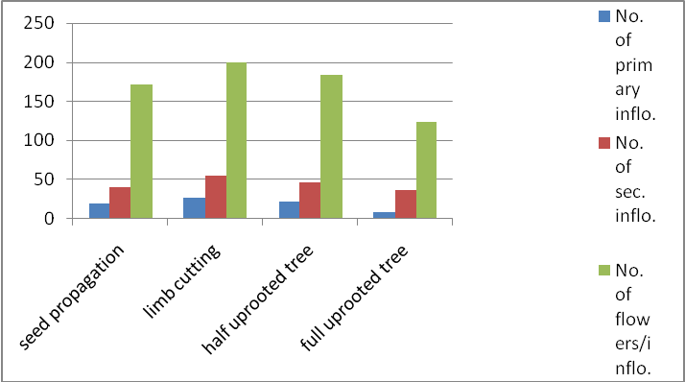
Fig-1. Response of different propagation methods on flower traits

Table-2. Response of different propagation methods on yield traits
Treatments | No.of pod set/inflo. | Pod length | Pod girth | Pod weight | No.of seeds/pod | No.of pods/plant | Pod yield (kg/plant)
Seed | 9 | 100 | 20.3 | 210 | 21 | 70 | 14.70
limb cutting | 15 | 132 | 21.8 | 319 | 30 | 90 | 28.71
Half uprooted trees | 10 | 110 | 20.8 | 300 | 25 | 82 | 24.60
Full uprooted trees | 7 | 95 | 17.7 | 200 | 28 | 65 | 13.00
C.D.at 5% | 1.852 | - | 0.162 | 15.93 | 2.0792 | 2.643 | 4.0

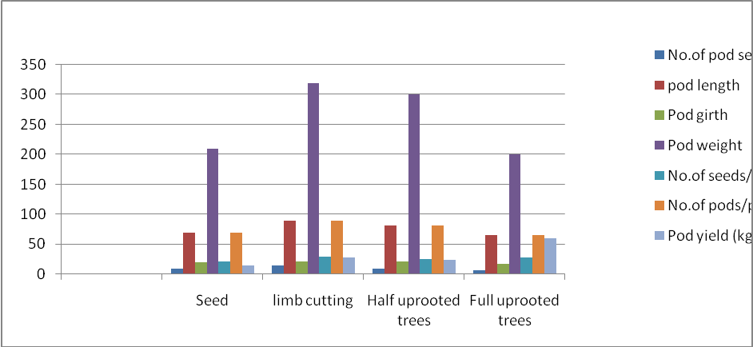
Fig-2. Response of different propagation methods on yield traits

12/29/2012

