**Theoretical Study on Substituent’s Effect on the Properties of Benzofused thieno [3, 2-b] Furan and its Isomeric Form**

Isaiah A. Adejoro, Collins U. Ibeji*, A. Endurance Aigbe

Department of Chemistry, University of Ibadan, Ibadan, Nigeria

Email: [ibejicollins@yahoo.com](mailto:ibejicollins@yahoo.com)

**ABSTRACT:** The theoretical study on the ground state properties of isomeric benzofused thieno[3,2-b]furans was carried out using semi-emperical AM1 and Density functional theory/B3LYP 6-31G* /6-31G* basis set. This was used in order to determine the effect of substituent; Br2, I2, OH-, on the stability, reactivity and other properties of the isomers. From the calculated values of E, *μ*, η, *ω,* ΔH-L obtained, it can be inferred that thieno[3,2-*b*]benzofuran is more aromatic, more stable and less reactive than isomeric benzothieno[3,2-*b*]furan. These results agree with the experimental result concerning the different reactivity and stability of both heterocyclic systems. The study of bond order uniformity, local ionization energy and electrostatic potential energy surfaces analysis revealed structural differences of isomeric thieno[3,2-*b*]furans that explains their reactivity features. Benzothieno[3,2-*b*]furan could be an analogue of aromatic benzothiophene substituted with C(2)=C(3) vinylic moiety. This evidently points out therefore that the electrophilic substitution reaction for benzothieno[3,2-*b*]furan goes via addition-elimination mechanism at the C(2).

[Isaiah A. Adejoro, Collins U. Ibeji, A. Endurance Aigbe. **Theoretical Study on Substituent’s Effect on the Properties of Benzofused thieno [3, 2-b] Furan and its Isomeric Form.** *Nat Sci* 2012;11(12):75-82]. (ISSN: 1545-1003). <http://www.sciencepub.net/nature>. 12

**Key words:** Density functional theory; Semi-empirical AM1; ab-initio; BLYP/6-31G*; order uniformity, local ionization energy and electrostatic potential energy

**INTRODUCTION**

Benzofused thieno [3,2-b]furans and it’s isomeric form thieno [3,2-b]benzofuran are aromatic system fused with five-membered heterocyclic ring containing sulphur and oxygen hetero atom which obey Dybe-Hunkel rule of aromaticity as they are cyclic, planar and sp2 hybridized. Benzofuran and benzothiophene are aromatic because they are cyclic and planar, every carbon in the ring has a p orbital, and the π cloud of each compound contain five pair of π electrons (paula *et al*; 2007). Different reactivity and regioselective behavior of benzofusedthieno[3,2-b]furan and thieno [3,2-b]benzofuran on reactivity with electrophilic aromatic substitution reaction (Svoboda *et al*; 1996; Vachal *et al*; 1997), show that the attack occur at carbon C2 and Carbon C3 but attack on C2 is more stable than at C3, this is because attack at C2 will lead to two additional resonance contribution while at C3 will lead to one additional resonance contribution. Eletrophilic aromatic substitution reactions include chlorination, bromination, alkylation, acylation and nitration.

The reactivity of heterocyclic compounds A and B under electrophilic substitution reactions shows that the heterocyclic system in the compound B is less reactive than Compound A (Svoboda *et al*; 1996; Vektariene *et al*, 2009). One of the reactions typehe is the electrophilic substitution of benzofused thieno [3, 2-*b*] furans as an aromatic compound, resulting in the substitution of 2-hydrogen through the aromatic electrophilic substitution reaction mechanism (Vektariene *et al*, 2009).

**A**





**B**

Figure 1: Chemical structures of benzofusedthieno[3,2-b]furan (**A**) and thieno [3,2-b]benzofuran(**B**)

**B**

The reactivity of heterocyclic compounds A and B under electrophilic substitution reactions shows that the heterocyclic system in the compound B is less reactive than Compound A (Svoboda *et al*; 1996; Vektariene *et al*, 2009). One of the reactions typehe is the electrophilic substitution of benzofused thieno [3, 2-*b*] furans as an aromatic compound, resulting in the substitution of 2-hydrogen through the aromatic electrophilic substitution reaction mechanism (Vektariene *et al*, 2009).

The electrophilic aromatic substitution reaction of compound **B** with bromine molecules involves an electrophilic addition-elimination mechanism on the double C2=C3 bond which was experimentally(Svoboda *et al*; 1996), proved in a bromination reaction of heterocyclic compound **A** by trapping the unstable trans – 2,3 dibromo intermediate in the reaction mixture using proton NMR Spectroscopy. In the case of bromination reaction with heterocyclic compound **B**, the appropriate addition intermediate was detected (Svoboda *et al*; 1996).

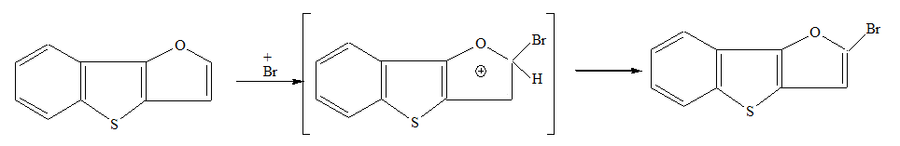

**A**

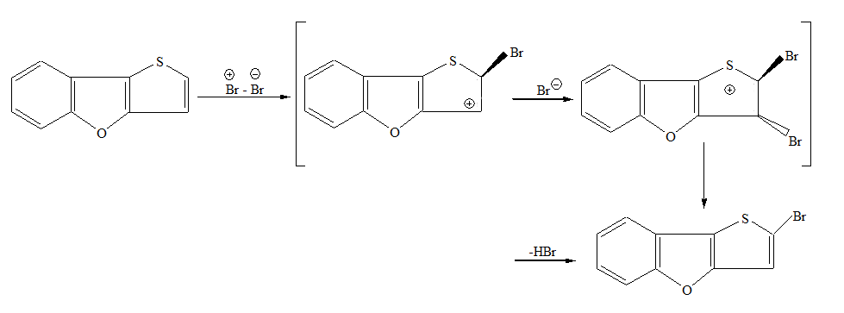

**B**

Figure 2:Electrophlic aromatic substitution reactions of compound **A and B** with bromination (Jursic and Zdravskovski, 1994)

This work aims at investigating the effect of some substituent such as Br-, I- and OH- on the geometric, electronic, thermodynamics and IR spectra of benzofusedthieno[3,2-b]furans



R= Br-, I- and OH-

Figure 3: Substitution pattern

**2.0** **COMPUTATIONAL DETAILS**

Computational methods offer a unique ability for the synthetic organic chemists to generate optimal geometry structure and through the structural and electronic properties of reactants and products make decisions as to which of the chemical transformations will occur in reaction. It was demonstrated (Jursic and Zdravskovski, 1994; Nathaniel *et al*; 1996) that the DFT B3LYP is a reliable method for the calculating electron density parameters of benzofusedthieno[3,2-b]furan which were estimated in order to determine their reactivity in electrophilic aromatic substitution reactions (Jursic and Can, 1996; Cyransky, 2005). Based on structural uniformity the relative aromaticity of the systems was predicted.

In this work we have investigated the effect of some substituents on the heat of formation, electronic properties, geometric properties, bond angle, bond length, total vibration, thermodynamic properties, infrared frequency vibration (IR) of benzofusedthieno[3,2-b]furan and it’s isomeric form thieno[3,2-b] benzofuran using Density Functional Theory DFT-B3LYP in conjunction with 6-31G* basis sets (Becke, 1993)and Semi-emperical AM1, (Dewar and Thiel, 1977) methods. The properties relatives to singlet species were fully optimized at their ground states. All quantum chemical calculations were performed using Spartan 10 program package.

**3.0 Results and Discussion**

3.1Geometry properties

The optimized structure of benzofusedthieno[3,2-b]furan and thieno[3,2-b]benzofuran at ground state has a symmetry of Cs and Cs respectively. The bond length, bond angle, and dihedral angle were calculated using DFT, B3LYP/6-31G*. Also when a single H atom in benzofusedthieno [3, 2-b]furan and theno[3,2-b]benzofuran was replaced with Br, I, and OH –, benzofused and its isomeric form retained the Cs symmetry, but there were slight increase in bond length (Table 1a and 1b).



Table 1a. Geometry properties of A

|  |  |  |  |  |  |  |  |  |  |  |  |  |  |  |  |  |  |  |  |  |  |  |  |
| --- | --- | --- | --- | --- | --- | --- | --- | --- | --- | --- | --- | --- | --- | --- | --- | --- | --- | --- | --- | --- | --- | --- | --- |
| Compound | A | | | A-Br | | | | | A-I | | | | | | | | A-OH | | | | | | |
| Bond length | |  | | | |  | | |  | | | | | | |  | | | |
| C1-C2 | 1.4046 | | | 1.4047 | | | | 1.4047 | | | | | | 1.4042 | | | | | | | | |
| C4-C5 | 1.4229 | | | 1.4230 | | | | 1.4229 | | | | | | 1.4249 | | | | | | | | |
| C8-S1 | 1.7518 | | | 1.7510 | | | | 1.7521 | | | | | | 1.7834 | | | | | | | | |
| C7-O1 | 1.3612 | | | 1.3672 | | | | 1.3647 | | | | | | 1.3799 | | | | | | | | |
| O1-C10 | 1.3729 | | | 1.3660 | | | | 1.3719 | | | | | | 1.3663 | | | | | | | | |
| C9-C10 | 1.3665 | | | 1.3676 | | | | 1.3698 | | | | | | 1.3673 | | | | | | | | |
|  |  | | |  | | | | | | | | |  | | | | | |  | |
| Bond Angle | |  | | | |  | | |  |  |  | | | | | | | | | | |
| C7-O1-C10 | 105.546 | | | | 104.967 | | | 105.251 | | | | | | 105.084 | | | | | | | | |
| C9-H4-C10 | 126.321 | | | | 126.381 | | | 126.356 | | | | | | 126.242 | | | | | | | | |
| C5-C7-C8 | 116.568 | | | | 116.775 | | | 116.734 | | | | | | 117.178 | | | | | | | | |
|  |  | |  | | | | | | | | |  | | |  | | |
| Dihedrals |  | |  | | | | | | | | |  | | |  | | |
| H4-C9-C10-O1 | 180 | | | | 180 | | 180 | | | | | | | 180 | | | | | | | | |
| C10-C9-C8-S1 | 180 | | | | 180 | | 180 | | | | | | | 180 | | | | | | | | |

C8-S1 increase in bond length1.7834

Table 1b. Geometry properties of Isomers B DFT

|  |  |  |  |  |  |  |  |  |  |  |  |
| --- | --- | --- | --- | --- | --- | --- | --- | --- | --- | --- | --- |
| Compound | | B | B-Br | | | B-I | | B-OH | | | |
| Bond length | |  |  | | |  | |  | | | |
| C1-C2 | | 1.3933 | 1.3929 | | | 1.3927 | | | 1.3940 | | |  |
| C4-C5 | | 1.0851 | 1.0850 | | | 1.0850 | | | 1.0852 | | |
| C8-S1 | | 1.7360 | 1.3686 | | | 1.3694 | | | 1.3673 | | |
| C7-O1 | | 1.3702 | 1.7389 | | | 1.7377 | | | 1.7464 | | |
| O1-C10 | | 1.3706 | 1.7616 | | | 1.7620 | | | 1.7786 | | |
| C9-C10 | | 1.7548 | 1.3708 | | | 1.3734 | | | 1.3693 | | |
| Bond angle(0) | |  |  | | |  | | | |  | |
| C7-O1-C10 | | 90.566 | 89.876 | | | 90.253 | | 89.94 | | | |  |
| C9-H4-C10 | | 124.586 | 124.689 | | | 124.739 | | 124.079 | | | |  |
| C5-C9-C8 | | 106.971 | 107.035 | | 107.004 | | | 107.402 | | | |
| Dihedrals(0) | |  |  | | |  | |  | | |
| H4-C9-C10-O1 | | 180 | 180 | | | 180 | | | 180 | | |
| C10-C9-C8-S1 | 180 | | | 180 | | | 180 | | | 180 | |

O1-C10, increase in bond length1.7786

3.2 Vibrational Frequencies

The simulated IR spectra of compound A and B are shown in (Fig. 4), with the strongest IR absorption peak located at 768cm-1 and 764cm-1 respectively. The strongest IR absorption peak spectra derived by replacing one of its H atoms was observed for OH-. This gave 1682cm-1 for A and 1322cm-1, for B. From the Absorption peaks, spectra of A and B appears to be quite similar, but there were marked difference between A and B substituted with OH, showing the effect of substituent on the compounds.

3.3 Electronic Properties

It is known that energy gap between the highest occupied molecular orbital (HOMO) and the lowest unoccupied molecular orbital (LUMO), or simply HOMO-LUMO gap (HLG; ΔEg), also called band gaps, is a key parameter which determines the molecular admittance because it is a measure of the electron density hardness (Meyer *et al.,* 1985). Result shows that replacement of an hydrogen atom with iodine in compound A and B, there was a significant reduction in the band gap (Table 4.2). Also the calculated dipole moment shows that compound B has the largest 1149.55D. It is worth knowing that the dipole moment of original compound A is the smallest 0.21D. This show that compound B is more stable than compound A.

3.5 Molecular electrostatic potential map

Further we made an attempt to compare results of bond order uniformity analysis with results of molecular surfaces, based on the molecular electron density analysis. Since the DFT method provides more convenient and accurate way to calculate electron density surfaces and to estimate the ionization energy of a large molecular system than earlier proposed HF method (Jiluo, *et al*; 2006) the DFT B3LYP 6-31G* basis set have been used for molecules A and Bto calculate local ionization energy *I(****r****)* and molecular electrostatic potential MEP energy surfaces. The visualized and solid results of MEP energy and *I(r)* surfaces are shown in Figures 5.

Table 2a. Electronic properties of Isomers A DFT

|  |  |  |  |  |
| --- | --- | --- | --- | --- |
| Compound | EHOMO(eV) | ELUMO(eV) | Eg (eV) | Dipole moment |
| IsomerA | -5.6 | -0.77 | 4.83 | 0.48 |
| IsomerA-Br | -5.72 | -1.01 | 4.71 | 1.04 |
| IsomerA-I | 9.49 | 9.72 | 0.23 | 1110.7 |
| IsomerA-OH | -5.23 | -0.58 | 4.65 | 1.64 |

Table 2b. Electronic properties of Isomers B DFT

|  |  |  |  |  |
| --- | --- | --- | --- | --- |
| Compound | EHOMO(eV) | ELUMO(eV) | Eg (eV) | Dipole moment |
| Isomer B | -5.71 | -0.95 | 4.76 | 0.29 |
| Isomer B-Br | -5.79 | -1.23 | 4.56 | 1.33 |
| Isomer B-I | 8.95 | 9.20 | 0.25 | 1149.55 |
| Isomer B-OH | -5.3 | -0.69 | 4.61 | 1.63 |

3.4 Thermodynamic Properties

The reaction energies, enthalpy, and zero point energy were evaluated by DFT B3LYP/6–31G* and semi empirical AM1 respectively (Table 3). The thermodynamic stability is expected when ΔH is negative, and the more negative the value of ΔH, the more stable the heterocyclic compound. With ZPE, the situation is the opposite which is, the more positive the value of ZPE, the more stable the compound. It can also be seen in the Table 3.

Table 3a Thermodynamic properties of isomer A AM1

|  |  |  |  |  |  |
| --- | --- | --- | --- | --- | --- |
| Compound | ZPEo | Ho | S0 | G0 | Hf |
| Isomer A | 357.61 | 0.21 | 368.1 | 0.178 | 196.73 |
| IsomerA-Br | 331.0 | 0.22 | 399.0 | 0.18 | 239.1 |
| IsomerA-I | 330.7 | 0.24 | 404.8 | 0.20 | 282.7 |
| IsomerAOH | 368.3 | 0.15 | 390.8 | 0.11 | 9.818 |

Table 3b Thermodynamic properties of isomer B AM1

|  |  |  |  |  |  |
| --- | --- | --- | --- | --- | --- |
| Compound | ZPE0 | H0 | S0 | G0 | ∆Hf |
| Isomer B | 357.1 | 0.22 | 366.0 | 0.18 | 202.137 |
| IsomerB-Br | 331.1 | 0.21 | 396.4 | 0.19 | 214.411 |
| IsomerB-I | 330.6 | 0.23 | 402.1 | 0.19 | 258.524 |
| IsomerB-OH | 367.3 | 0.17 | 390.2 | 0.12 | 47.399 |

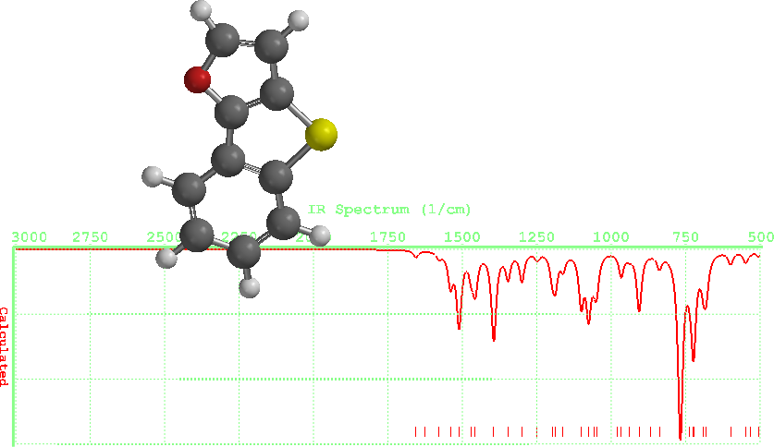 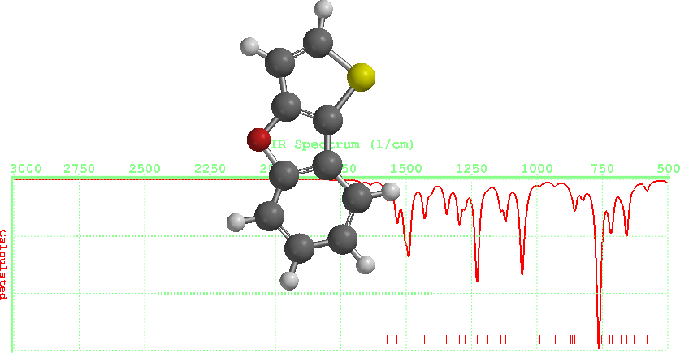

ISOMER A DFT ISOMER B DFT

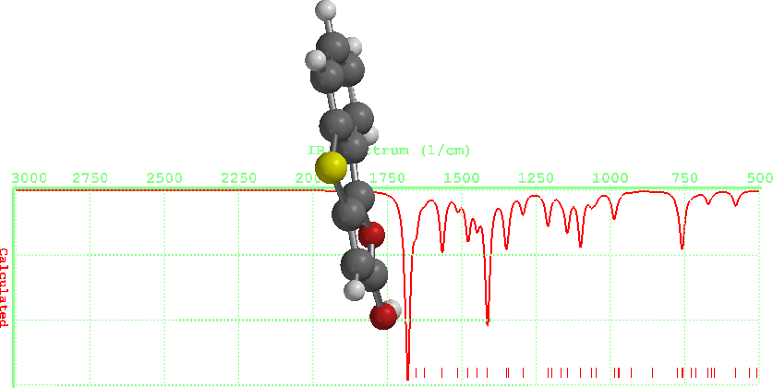 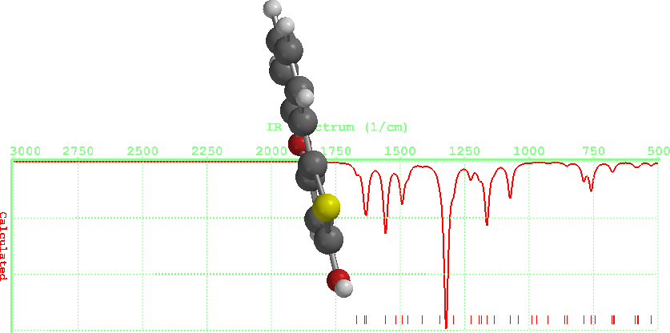

ISOMER A DFT ISOMER B DFT

Figure. 4. Showing simulated spectra for Isomers

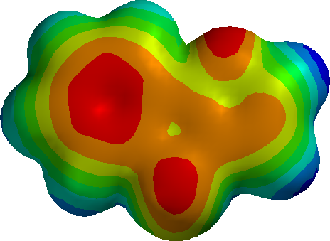

Compound A

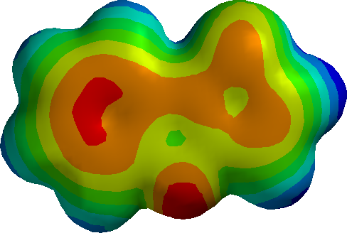

Compound B

Figure 5.Calculated electrostatic potential surfaces on the molecular surfaces of heterocycles A and B. Color ranges, in kcal/mol: from red -8.2 to blue +6.0. DFT B3LYP functional and 6-31G* basis set.

The presented MEP surface, an overlaying of the electrostatic potential (the attraction or repulsion of a positive charge for a molecule) is valuable for describing overall molecular charge distribution as well as anticipating sites of electrophilic addition. The red color indicates the π system by convention, indicating negatively charged potential and the fact that this area of surface is attracted to a positive charge, and the blues color indicates the system region is repelled by positive charge i.e nucleophiles. Another indication of electrophilic attraction is provided by the local ionization potential energy surface, an overlaying of the energy of electron removal (ionization) onto the electron density. The regions with red color represent regions in the molecular surface where electron removal goes (with minimal energy) most easily. The more the red color, the lower the ionization potential and the more susceptible toward electrophiles.

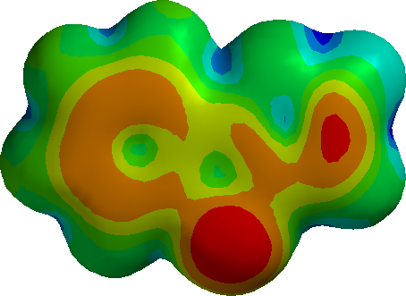

Compound A

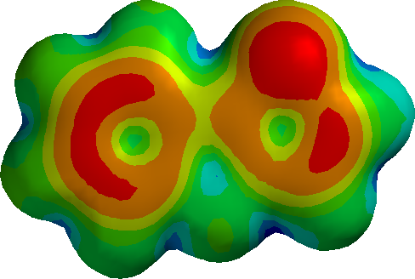

Compound B

Figure 6.Calculated local ionization energy surfaces on the molecular surfaces of isomers Aand B. Color ranges, in eV: from red 0.4 to blue 30.5. DFT B3LYP functional and 6-31G* basis set.

The differences in reactivity of isomers A and B can be judged from the values of electrostatic potential and local ionization energy surfaces presented in Figures 5and 6. For isomer Athe lowest local ionization energy values and negatively charged electrostatic potential values are found on the benzothiophene and over the C(2)=C(3) bond of furan ring.

This evidently points out why the electrophilic substitution reaction for Aundergoes via addition-elimination mechanism.

On the contrary the electrostatic potential and local ionization energy surfaces for isomer Bshows delocalized π–electron surface that reports stable aromatic system between benzene ring and thiophene heterocyclic. This result suggests the presumable possibility of aromatic electrophilic substitution mechanism scenario in the halogenation reactions of isomer B.

The local ionization energy *I(r)* and molecular electrostatic potential MEP energy surfaces study for molecules A and Bis compatible with the bond order uniformity study. These reactivity characteristics identically revealed structural differences between benzothieno[3,2-*b*]furan Aand thieno[3,2-*b*]benzofuran B.Namely benzothieno[3,2-*b*]furan Acould be structural analogue with a benzothiophene substituted with C(2)=C(3) vinylic moiety. This evidently points out wherefore the electrophilic substitution reaction for benzothieno[3,2-*b*]furan goes via addition-elimination mechanism. (Svoboda, *et al* 1996.)

This result also agreed, similarly with the earlier studies predicted by ( Vektariene, Vektaris, Svoboda,

While the bond order, *I(r)* and MEP surfaces values for thieno[3,2-*b*]benzofuran Bconfirms delocalized π–electron surface that reports stable aromatic system between benzene ring and thiophene heterocycle. This result suggests the presumable possibility of aromatic electrophilic substitution mechanism scenario for thieno[3,2-*b*]benzofuran.

3.6 Molecular orbitals

The frontier molecular orbital pictures of the both molecules A, Bunder study are shown in Figure 7. We present only the HOMO, and LUMO. The energy difference between the HOMO for Ais smaller than for B. For the heterocycles Aand Bthe π molecular orbital localization exists between benzene, thiophene and benzene, furan rings accordingly as shown in HOMO shapes. For both molecules the greatest extension value of HOMO is observed on C(2) atom. Moreover for Athe HOMO is delocalized on C(2)=C(3) bond while for Bthe HOMO shape located on C(3) atom. With this molecular orbital analysis the relative reactivity can be explained. The π molecular orbital delocalization agrees well with the reactivity behavior of heterocyclic rings. The greatest extension value of HOMO shape on C(2) atom suggest exceptional reactivity of this atom in the electrophilic reactions. Furthermore the HOMO delocalization on C(2)=C(3) bond in case Acompatible with addition-elimination mechanism version.

As outlined in the literature review it is possible to define atomic reactivity indexes, such as the condensed Fukui functions for given atom in a molecule. In Table 4 the absolute values of condensed Fukui function values for electrophilic attack calculated at DFT B3LYP 6-31G* level of theory are shown for relevant atoms in heterocyclic compounds Aand B For Aand Bthe largest of value belong to C(2) atom in the furan and thiophene rings. Fukui values obtained with B3LYP method shows the same tendencies. This means that C(2) atom should be mostly reactive site towards an electrophilic attack of molecules. The Mulliken charge population calculated at DFT B3LYP 6-31G* level presented in the Figure 7 shows the different situation. The negative charge increase in molecule represents the attraction of relevant sites of molecule in reactions with electrophiles. The highest negative charge located on C(3) atom of heterocyclic A. So Mulliken charge and Fukui indexe values for Bsuggest expectation that electrophilic reaction could occur with C(2) and C(3) atoms via three-membered cyclic intermediate. For heterocyclic Bthe increase of negative charge and highest Fukui function values were observed on C (2) atom. This is compatible with experimental results showing that C(2) site of molecule proceeds directly by an electrophilic mechanism.

**Compound A** **Compound B**

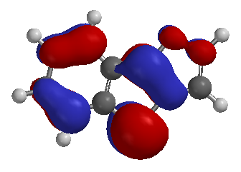

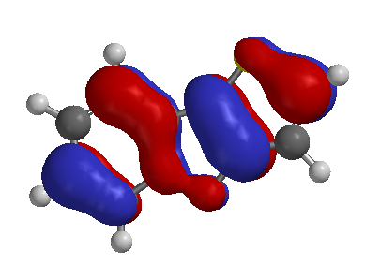

HOMO– 8.3 eV HOMO – 8.7 eV

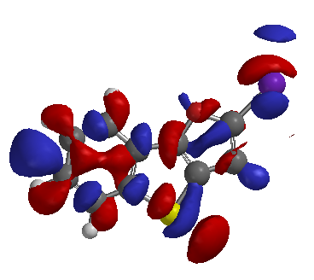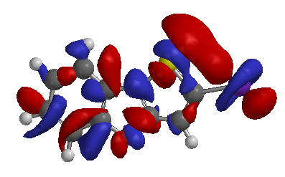

HOMO 9.5 eV HOMO 8.9 eV

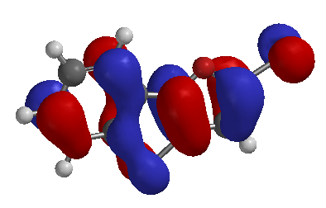 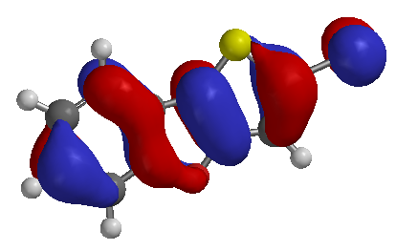

Fig. 7. The frontier molecular orbital pictures of both Isomers

Table 4a Compound A DFT

|  |  |  |  |  |
| --- | --- | --- | --- | --- |
| Compound | | η (eV) | µ(eV) | ω(eV) |
| IsomerA |  | 2.45 | -3.43 | 2.45 |
| IsomerA-Br | | 2.35 | -3.37 | 2.4 |
| IsomerA-I | | 0.12 | 9.61 | 384.8 |
| IsomerA-OH | | 2.31 | -2.91 | 1.83 |

Table 4b Compound B DFT

|  |  |  |  |  |
| --- | --- | --- | --- | --- |
| Compound | | η (eV) | µ(eV) | ω (eV) |
| IsomerB |  | 2.38 | -3.33 | 2.33 |
| IsomerB-Br | | 2.28 | -3.51 | 2.7 |
| IsomerB-I | | 0.12 | 9.07 | 342.77 |
| IsomerBOH | | 2.31 | 2.9 | 1.82 |

Fig 8.1. A plot showing the effect of substituent on reactivity (ω)

Fig 8.2. A plot showing the effect of substituent on reactivity (ω)

The idea of absolute hardness (Ƞ), chemical potential(µ), HOMO-LUMO energy gap (Eg), and electrophilicity index(ω), is commonly used as a criteria to study the chemical reactivity and stability (Aihira, et al. 1999). The theoretical result (Table 4) show that higher aromaticity and hardness correspond to higher stability and reactivity for particular aromatic system. From the result, it is expected that compound A is more reactive than compound B and exhibit higher reactivity and antiaromatic behavour. While compound B show higher aromaticity, hardness, and low reativity than compound A. A good electrophilic attack is charaterise with higher chemical potential and electrophilicity index. While a good nucleophilic attack is charaterise with lower chemical potential and electrophilicity index. Fig 8 above shows the effect of substituents on the the reactivity of both isomers using the electrophilicity index parameter which futher explains the fact that Isomer A is more reactive than Isomer B

**4.0 Conclusions**

A theoretical study of the stability and reactivity was carried out at the semi empirical method and density functional theory (DFT) calculation level for the structures of isomeric benzofused thieno[3,2-*b*]furans. Reactivity indexes derived from DFT calculations have been successfully applied in understanding of chemical reactivity. Global description such as chemical electronic potential,(µ) molecular hardness (*η*), electrophilicity (*ω*), frontier molecular orbital shapes and band gaps (ΔH-L), local ionization energy and electrostatic potential energy surfaces were determined and used to identify the differences in the reactivity of heterocycles.

DFT B3LYP 6-31G* calculations were used in this study to compare the performance of both approaches in the interpretation of reactivity descriptors.

DFT calculated reactivity descriptors: E, µ *η*, *ω*, Δ H-L, bond length and bond orders show very similar reactivity description values, and yield reasonable agreement with the relevant experiment reactivity results.

The study of bond order uniformity, local ionization energy and electrostatic potential energy surfaces analysis revealed structural differences of isomeric thieno[3,2-*b*]furans that explains their reactivity features: benzothieno[3,2-*b*]furan could be an analogue of aromatic benzothiophene substituted with C(2)=C(3) vinylic moiety. This evidently points out therefore the electrophilic substitution reaction for benzothieno[3,2-*b*]furan goes via addition-elimination mechanism at the C(2). Molecular orbital shapes presents the π molecular orbital delocalization between benzene and thiophene, also between benzene and furan rings for the isomeric benzofused thieno[3,2-*b*]furans. Moreover the highest occupied molecular orbital is delocalized on C(2) atom for both isomers suggesting this site to be mostly reactive towards electrophiles.

The calculated values for condensed Fukui function for electrophilic attack shows the largest value belong to C (2) atom for both heterocyclic.

Theoretical results from the molecular orbital analysis and Fukui function reactivity indexes are in complete agreement with the observed reactivity of these compounds showing exceptional reactivity of C(2) atom towards electrophilic attack for both isomers.

In conclusion all the calculated parameters considered E, *μ*, η, *ω,* ΔH-L leads to the conclusion that thieno[3,2-*b*]benzofuran is more aromatic, more stable and less reactive than isomeric benzothieno[3,2-*b*]furan. These results agree with the experimental information concerning the different reactivity and stability of both heterocyclic systems.

**REFERENCES**

1. Aihara, J.I. 1999. Kinetic instability of neutral and charge fullerenes with four membered ring *Chemical Physics* 2, 3193.

2. Becke*, A.D.* 1993. “Density functional thermochemistry. III. The role of exact exchange” *J. Chem. Phys.* **98**-p.5648-5652.

3. Cyransky, M. K. 2005. A linear bond length-Stabilization energy relation for five membered rings, *Chemistry Revision* 105, 3773

4. De Proft, F., Geerlings, P. 2004. Spin polarized conceptual density functional theory study of the regioselectivity in the [2+2] photocycloaddition of enones to substituted alkene) *Physical Chemistry* 6, 242.

5. Dewar, M., Thiel, W. Semi Emperical Quantum Chemistry *J. Am. Chem. Soc.* 1977-**99**-p.4499.

6. Ji Luo., Zeng Quan Xue., Wei Min Liu., Jin Lei Wu., Zhong Qin Yang. J. 2006. Koopmann’s Theorem for Large System within Density Functional Theorem *Physical Chemistry* 110, 12005.

7. Jursic B.S. J. 1998. Benzene Fused five-membered Heterocyclic in Theoretical Approach, Molecular Structure (Theochem) 427, 165.

8. Jursic, B. S. J. 1995. A Theoretical approach to the Nucleophilic Behaviour of 9. Benzofusedthieno[3,2-b]Furans *Chemical Society*., Perkin Trans. 2, 373.

9. Jursic, B. S. J. 1996. The Estimation of the Aromaticity of five Membered and Benzofused Five-membered Rings by the Hybrid DFT Computed magnetic Properties, *Heterocyclic Chemistry* 33, 1079.

10. Jursic, B.S and Zdravskovski, Z. 1994. Thoretical Study of Benzofusedthieno[3,2- b]Furans in the reaction with electrophiles, Int. *J. Quantum Chemistry* 54,161.

11. Jursic, B.S., Can, J. 1996. Theoretical Study on Benzofusedthieno[3,2-b]Furan Bromination Mechanism , *Chemistry* 74, 114.

12. Meyer, W.H., Kiess, H., Binggeli, B., Meier, E., Harbeke, G. polymer for use in information storage *Synth. Met*. **1985**-10--p.255-259.

13. Nathaniel, R., Mineva, T., Nikolova, R., Bojilova, A. 2006. Density Functional Study of the Interaction of (3ω-bromoacetyl) Coumarin with Phosphate, Int. *J. Quantum Chemistry* 106, 1357.

14. Okujama, T., Fueno, T. Bull.1974 Theoretical Study of Benzofusedthieno[3,2-b]Furans in the reactionwith Electrophiles, *Chemical Society*. *Japan*. 47(5), 1263.

15. Okujama, T., Kunugiza, K., Bull. 1974. Experimental and Theoretical Investigation of Substituent Effeects in a two Pathways Reaction of tetrahydro 1,5-benzodiazepine-2-thiones with 4-substituted 2-bromoacetophenone, *Chemical Society* *Japan*., 47(5), 1267.

16. Paula, Y.B. 2007. *Organic chemistry* *Fifth Edition*. 957, 1319.

17. SPARTAN 10, Wavefunction Inc, Irvine, CA, 92612.

18. Svoboda, J., Pihera, P., Sedmera, P., Palecek, J. 1996. A Theoretical Approach to the Nucleophilic Behavior of thieno[3,2-b]Furans using DFT and HF base reactivity Descriptors, Collect. Czech. Chem. Commun. 61, 888.

19. Vachal, P., Pihera, P., Svoboda, J. 1997 Thieno[3,2-b]Furan Synthesis and Reactions, Collect. Czech. Chem. Commun. 62, 1468.

20. Vektariene, A., Vektaris, G. 2004. Theoretical Study of Benzofusedthieno[3,2-b]Furans in the Reactions with electrophiles, *Heteroatom Chemistry* 15(3), 263.

11/01/2012