Cytomorphological and antifungal analysis of Acalypha wilkesiana , Moringa oleifera extracts, and sodium hypochlorite on Abelmoschus esculentus L. Moench. treated seeds

Nwangburuka Cyril C. ¹*, Ezekiel N. Chibundu.. ², Oyekale K.¹, Anokwuru, C. Prosper ² and Evbuomwan K. Ivie ²

1Department of Agriculture, Babcock University, Ilishan-Remo, Ikeja, Lagos, Nigeria
2Bioscience and Biotechnology, Babcock University, Ilishan-Remo, Ikeja, Lagos, Nigeria

Abstract: The effects of 1%, 2% and 3% concentrations of Acalypha wilkesiana and Moringa oleifera methanolic extracts, and sodium hypochlorite on the germinability, radicle extension, cytology of meristematic cells and inhibition of seed mycoflora of two okra (Abelmoschus esculentus) accessions (BAB 002 and BAB 003) were determined. Data obtained for the examined parameters were compared with those from seeds treated in sterile distilled water (control). Acalypha and Moringa extracts improved germination, radicle length and mitotic index better than sodium hypochlorite in the two accessions of okra seeds although significant (p<0.05) differences among the pre-treatments were not high. Acalypha, however, gave a more consistent data for all tested parameters at all concentration levels while Moringa performed best when overall effect was considered. Notwithstanding the enhanced germination and mitotic index of seeds pre-treated with Acalypha and Moringa, chromosomal aberrations were observed but at lower levels than in sodium hypochlorite treated seeds. Acalypha extracts had the best inhibitory activity towards seed-borne fungi, inhibiting all moulds at 2% and 3% pre-treatment concentrations. This study has therefore shown that Acalypha and Moringa may be alternatives for post-harvest storage of okra seeds as compared to the widely used chemical preservatives.
[Nwangburuka C. Cyril, Ezekiel, N. Chibundu, Oyekale K., Anokwuru, C. Prosper, and Evbuomwan, K. Ivie. Cytomorphological and antifungal analysis of Acalypha wilkesiana , Moringa oleifera extracts, and sodium hypochlorite on Abelmoschus esculentus L. Moench. treated seeds. Nat Sci 2013;11(1):31-39]. (ISSN: 1545-0740). http://www.sciencepub.net/nature. 5

Key words: Acalypha, fungi, mitosis, Moringa, Okra, seed preservation, seed pre-treatment.

1. Introduction
Okra, Abelmoschus esculentus (L.) Moench, is an important vegetable crop grown mainly in the tropical or sub-tropical regions during summer and rainy season. Hence, it is classified as a warm season crop (National Research Council, 2006). The major okra producing countries in the world include India (3.5 million tons), Nigeria (0.73 million tons), Pakistan (0.12 million tons), Ghana (0.10 million tons) and Egypt (0.08 million tons) (FAOSTAT, 2004; Nwangburuka, 2010; Badaru, 2011). Okra is cultivated for a variety of uses but mainly for its edible leaves and immature green seed pods/fruits (Siemonsma and Kouame, 2004). Okra seeds contain a considerable amount of good quality oil and protein, and can be used as a substitute for coffee (Valeriana, 2002). It can also serve as plasma replacement of blood volume expander (Siemonsma and Kouame, 2004).
In many parts of Africa, the mature fruits of okra are usually dried and stored intact for local use (eating or planting) in high temperature season. In other settings, however, the seeds in the dried matured fruit are removed, dried further and stored against subsequent planting. In most regions, where this crop is produced in large quantities, poor agronomic practices and storage conditions including improper drying and inadequate structures have contributed to the reportedly high prevalence of fungi contaminants of okra especially seed-borne moulds. Fungi are one of the most important and prevalent pathogens of okra and they usually attack the crop from seedling to harvesting. Most fungal diseases of okra during post-harvest storage are usually caused by residuals of fungi spores which are transferred from the field and develop into disease during storage. Fungi that affect okra seeds include; Alternaria alternate, Aspergillus niger, Curvularia lunata, Fusarium oxysporum, F. solani, F. moniliforme, Macrophomina phaseoli, Rhizoctonia, Stemphylium botryosum, Penicillium digitatum, Pythium aphanidermatum (Al-Kassim and Monawar, 2000; Odofin, 2010).
In the past, researchers explored the use of inorganic chemicals (e.g. fungicides) in post-harvest crop/seed protection against pathogens. Fungicides such as azoxystrobin, mefenoxam and several others have been registered for use against seed pathogens in okra (Mossler and Dunn, 2009). Recently, okra seeds have been treated with disinfectants like bleach and natural plant extracts such as neem and Moringa (Odofin, 2010; Nwangburuka et al., 2012). Many of the inorganic chemicals to an extent have been proven effective but show significant side effects on the crops (e.g. inhibition of germination and retardation of plant growth). Due to these challenges, researchers are exploring some plants with natural antimicrobial activities which at the same time are capable of enhancing seed growth and normal cytological division. Odofin (2010) reported that bleach increased germination and vigor in okra seeds, while neem extract inhibited vigor and induced some chromosomal aberrations in germinating okra seeds. In addition, Nwangburuka et al. (2012) reported that high concentrations (5 and 10%) of Moringa leaf extracts lowered fungal population in two accessions of okra but did not significantly improve germination, seedling length and seedling vigor index.
Seed quality and seed germination have adverse effects on the yield of crops. Most times, seed quality deteriorates during post-harvest storage as a result of pest and pathogen infestation and poor storage condition (Odofin, 2010). Hence, post-harvest treatments of seed are necessary to control seed losses during storage. In view of these, inexpensive and easily accessible alternatives to expensive inorganic chemicals used for post-harvest storage of seeds which will not pose serious detrimental effects on seed growth and development are needed. This research therefore aims at determining the post-harvest seed preservation potential of Acalypha and Moringa in comparison to sodium hypochlorite. This was assessed by evaluating germination, radicle extension, mitotic indices, induction of chromosomal aberrations, and inhibition of seed-borne fungi in pre-treated okra seeds.
2. Materials and Methods
2.1. Source of seeds
Seeds of two okra accessions (BAB 002 and BAB 003) were collected from the germplasm of the Department of Agriculture, Babcock University, Ogun State, Nigeria. The seeds were collected into Zip lock bags and kept in a dry place at ambient temperature prior to further studies.
2.2. Plant collection and extraction
Leaves of Acalypha wilkesiana and Moringa oleifera were collected from Babcock University horticultural garden, Ilishan Remo, Ogun State, Nigeria. The leaves were rinsed properly and allowed to air dry at ambient temperature for two weeks in the Chemistry Laboratory of Babcock University. The dried leaves of each plant were pulverized separately in a Waring blender and 50g were weighed into 500ml Erlenmeyer flask. Methanol (300ml; Sigma Aldrich) was added to each flask and left for 72 hours prior to filtration. Each mixture was filtered through two folds of Whatman #1 filter paper and the extracts were concentrated in a rotary evaporator (EYELA, Japan). The extracts from each plant were dried in a hot air oven at 40ºC for 6 hours, allowed to cool and stored in a cool dry place until further analysis.
2.3. Preparation of test concentrations of plant extracts and sodium hypochlorite
Extracts of Acalypha (0.22g) and Moringa (0.23g) were dissolved separately, each in 100ml of methanol. From each of the mixtures, 0.4ml was taken into 100ml of methanol to give 1% concentration of each plant extract. The 1% concentration of Sodium hypochlorite (NaOCl) was prepared similarly by taking 0.4ml of 99.9% NaOCl into 100ml distilled water. The 2% and 3% concentrations were prepared accordingly.
2.4. Seed viability
The viability of the okra seeds was tested using the floatation method as described by Nwangburuka et al. (2012). One hundred seeds each of the two accessions were put into different beakers (1L capacity) containing distilled water, and allowed to sink or float. Only “viable seeds” determined by the ability to sink at the base of the beaker were used for further studies on germination and growth rate tests as well as the effect of chemical and plant extract pre-treatment, inhibition of fungal growth and cytological studies. The seeds that floated were immediately discarded.
2.5. Assessment of germination rate and radicle length of seeds
Two folds of Whatman #1 filter paper were placed in each Petri dish and moistened with sterile distilled water. Ten seeds of each okra accession were soaked for 5 minutes in the different plant extract concentrations per treatment used. The 10 seeds of each accession soaked/treated with an extract concentration were then placed in each Petri-dish containing moistened Whatman #1 filter paper. This was replicated thrice per treatment concentration of extract used to treat each accession. Thirty seeds of each accession soaked in water were placed in three separate Petri dish (10 seeds per plate x triplicate) containing moistened filter paper and these served as controls. All treatment and control plates were moistened and the seeds were observed daily for radicle length (cm). The percentage germination rate (recorded as radicle length per time in days) was calculated.
2.6. Mitotic index and chromosomal behavioural studies
The effect of pre-treatment of okra seeds on mitotic index and chromosomal behaviour was studied following the procedures described by Nwangburuka et al. (2012). Healthy root tips (3–5) from each accession of okra in each treatment and concentration were harvested and pre-fixed in 0.04% colchicine for about 24 hours so as to arrest cell division in its mitotic phase. The root tips were then transferred to a fixative [1:3 (v/v) acetic acid/alcohol] and stored at 4˚C until further microscopic examination.
Prior to microscopic examination of cells, the root tips were rinsed in two changes of distilled water and soaked in 1N HCl for 10 minutes. The milky white zone at the tip of each root was then excised on a glass slide and flooded with orcein stain. This was followed immediately by squashing of the root tip. The prepared slides were examined at ×1000 (Olympus microscope) and the cells were counted. The total cells at various stages of mitosis were enumerated in order to determine the mitotic index which was calculated by finding the ratio of dividing cells to the total number of cells. Abnormalities in mitosis were also recorded.
2.7. Fungal analysis of pre-treated seeds
Mycological analysis was carried out on seeds pre-treated with plants extracts and sodium hypochlorite. Seeds were pre-treated by soaking in the appropriate extract concentration for 5 minutes. For each accession and treatment concentration, 10 pre-treated seeds were plated directly on two folds of moistened Whatman #1 filter paper laid carefully in 9cm Petri dish (Ø). This was replicated thrice per treatment concentration of extract used to treat each accession. Thirty seeds of each accession soaked in water were placed in three separate Petri dish (10 seeds per plate × triplicate) containing moistened filter paper and these served as controls. All treatment and control plates were incubated at ambient temperature for 3–5 days.
Discrete colonies of moulds originating from the seeds were picked with sterile toothpicks and plated at the centre of 9cm Petri dishes (Ø) containing freshly prepared ¼-strength Potato Dextrose agar (PDA). The PDA plates were incubated at 31˚C for 5 days after which colonies were transferred to full strength PDA plates. Fungal characterization was performed by examining macroscopic and microscopic (×400) features, and comparing them to descriptions in mycological literature (Samson et al., 1995; Leslie et al, 2006). The percentage occurrence of each isolated fungus and fungal genera was calculated.
2.8. Data analysis
The Statistical Analysis Software (SAS) version 9.1 was used as tool for data analysis. Analysis of Variance (ANOVA) of all data was performed to determine if treatment, treatment concentrations and accessions were significant on the parameters evaluated. Treatment means were separated by the Duncan’s Multiple Range Test (DMRT).

3. Results
3.1. Effect of pre-treatment and pre-treatment concentrations on germination, radicle length and mitotic index of two okra accessions
The influence of okra (BAB 002 and BAB 003) seed pre-treatment with 1%, 2% and 3% concentrations of the plant extracts and NaOCl on germination, radicle extension and mitotic index of the seeds are shown in Fig. 1. It was observed that the concentrations of Moringa and NaOCl influenced seed germination in a similar way for both accessions while Acalypha followed a different trend. In BAB 002, Moringa and NaOCl induced high mean germination percentages of 64 and 52 respectively at 1% concentration while the mean germination dropped at 2% and increased again at 3% concentration. However, Acalypha caused a low mean germination percentage (45%) at 1% concentration, which increased at 2% (up to 62%) and remained stationary at 3% concentration. In BAB 003, Acalypha and Moringa enhanced mean germination percentage best at the lowest concentration (1%) while NaOCl performed best at 3% although its performance at all concentrations did not measure up to the best germinal performance enhanced by 1% Acalypha and Moringa.
The effect of pre-treatment concentrations on radicle extension of the okra accessions showed that both accessions responded similarly to treatments except for the case of BAB 003 to NaOCl. In BAB 002, 1% Moringa and Acalypha enhanced radicle extension better than 1% NaOCl and higher concentrations (2% and 3%) of all treatments (extracts and chemical). In BAB 003, 1% NaOCl induced the best radicle extension but dropped at 2% until 3%. The 3% Acalypha pre-treatment enhanced radicle extension better than all concentrations of Moringa and 2% and 3% of NaOCl.
The pre-treatments influenced mitotic index of the two accessions in different ways. In BAB 002, Acalypha progressively increased the mitotic index from 0.18 at 1% concentration to 0.74 at 3% concentration while 2% Moringa pre-treatment induced the highest level of normal cell division in the germinating seeds. In BAB 003, 1% Moringa enhanced normal mitotic division in the cells of germinating seeds best than all other concentrations of Moringa, Acalypha and NaOCl. However, the mitotic index decreased constantly with increased concentration of Moringa. For Acalypha and NaOCl, 1% concentration performed best in enhancing normal cell division in germinating seeds although the performance was far lower than that of 1% and 2% Moringa.

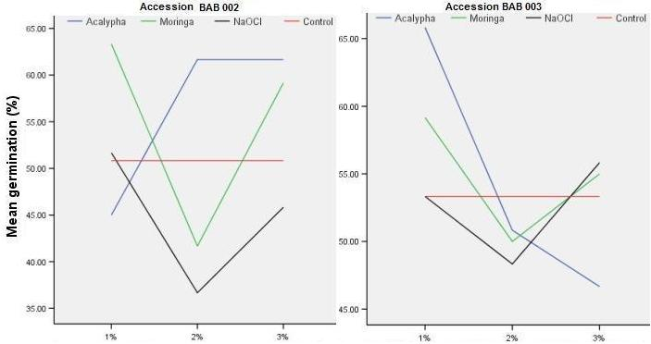
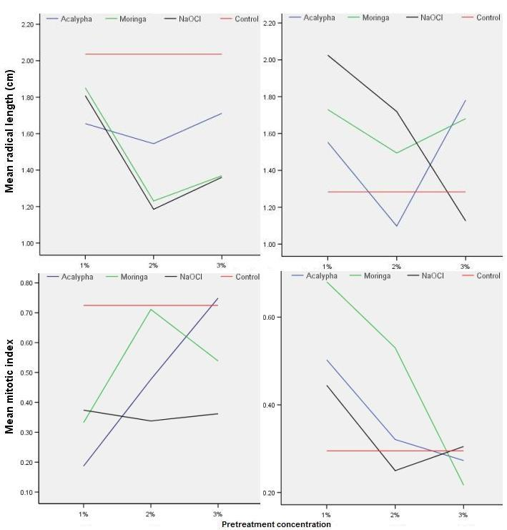
Figure 1. Germination (%), radicle length (cm) and mitotic index of two okra accessions pre-treated with different concentrations of Acalypha, Moringa and sodium hypochlorite.

3.2. Effect of pre-treatment concentration on germination, radicle length and mitotic index of okra seeds
When the effects of independent pre-treatment concentrations were considered (Table 1), seeds treated with 1% Acalypha and Moringa had significantly (p<0.05) higher mean germination (61.25% and 55.42%, respectively) and radicle length (1.77cm and 1.72cm, respectively) than those pre-treated with 1% sodium hypochlorite. However, there was no significant (p>0.05) difference in the mitotic index of seeds pre-treated with 1% concentration of any of the extracts and chemical (NaOCl) though Moringa (0.51) and distilled water (0.51) treatment enhanced more of normal mitotic division in germinating seeds than Acalypha (0.34) and NaOCl (0.41).
For seeds pre-treated with 2% concentration of the extracts and chemical (Table 1), Acalypha significantly (p<0.05) performed better (56.25%) than Moringa (45.83%) and NaOCl (42.50%) in enhancing germination while Acalypha (0.40) and Moringa (0.62) significantly (p<0.05) increased the level of normal cytological division than NaOCl (0.29). No significant difference (p>0.05) was observed between the radicle lengths of seeds pre-treated with 2% of the extracts and NaOCl. Pre-treating the seeds with 3% concentration of the extracts and chemical also showed no significant (p>0.05) treatment effect on germination, radicle length and mitotic index. When considering the overall effect of pre-treatment concentration on germination, radicle length and mitotic index of okra seeds, Moringa had a higher significant (p<0.05) effect than Acalypha and NaOCl although not much significant difference was observed between the treatments (Table 1).

Table 1. Germination, radicle length and mitotic index of okra seeds pre-treated with Acalypha and Moringa extracts, and sodium hypochlorite at different concentrations.
Pre-treatment concentration | Pre-treatment | Germination  (%) | Radicle length  (cm) | Mitotic index
1% | Acalypha  Moringa  NaOCl  Control | 55.42 ab  61.25 a  52.50 b  52.08 b | 1.72 a  1.77 a  1.47 b  1.66 ab | 0.34 a  0.51 a  0.41 a  0.51 a
2% | Acalypha  Moringa  NaOCl  Control | 56.25 a  45.83 b  42.50 b  52.08 ab | 1.32 b  1.36 b  1.45 ab  1.66 a | 0.40 ab  0.62 a  0.29 b  0.51 a
3% | Acalypha  Moringa  NaOCl  Control | 54.17 a  57.08 a  50.83 a  52.08 a | 1.63 a  1.55 a  1.69 a  1.66 a | 0.51 a  0.38 a  0.33 a  0.51 a
Means with different alphabets in a column within a pre-treatment concentration are significantly different by DMRT at p<0.05.

3.3. Effect of pre-treatment concentrations on germination, radicle length and mitotic index of seeds of two okra accessions
The 1% concentrations of the extracts and chemical pre-treatment significantly (p˂0.05) influenced higher germination in accession BAB 003 (57.92%) than in BAB 002 (52.71%) while the same concentration caused a significantly (p˂0.05) higher extension of the radicle in accession BAB 002 (1.84cm) compared to accession BAB 003 (1.47cm). Meanwhile, there was no significant (p˃0.05) difference in mitotic index between the two accessions when pre-treated with 1% concentration of the extracts and chemical though this concentration increased the level of normally dividing cells in BAB 003 than BAB 002.
Data obtained for 2% pre-treatment concentration showed no significant (p˃0.05) effect on both accessions for germination and radicle length. However, BAB 002 registered a significantly (p˂0.05) higher mean mitotic index (0.56) than the value obtained for BAB 003 (0.35). Data obtained from the 3% pre-treatment concentration followed the similar trend as observed in 2% pre-treatment concentration, i.e. no significant (p˃0.05) effect on both accessions for germination and radicle length. However, accession BAB 002 recorded a significantly (p˂0.05) higher mitotic index (0.59) than accession BAB 003 (0.27).

Table 2. Germinal, growth and cytological response of seeds of two okra accessions to pre-treatment concentrations of Acalypha and Moringa extracts, and sodium hypochlorite.
Pre-treatment concentration | Accession | Germination  (%) | Radicle length  (cm) | Mitotic index
1% | BAB002  BAB003 | 52.71 b  57.92 a | 1.84 a  1.47 b | 0.40 a  0.48 a
2% | BAB002  BAB003 | 47.17 a  50.63 a | 1.50 a  1.40 a | 0.56 a  0.35 b
3% | BAB002  BAB003 | 56.04 a  52.71 a | 1.62 a  1.63 a | 0.59 a  0.27 b
Means with different alphabets within a pre-treatment concentration in a column are significantly different by DMRT at p<0.05.

3.4. Cytology of pre-treated okra seeds
The cytological effects of pre-treating the okra seeds with extracts of Acalypha Moringa, and sodium hypochlorite are given in Fig. 2 (a–h). Seeds pre-treated with distilled water (control) showed normal cytokinesis with no aberrations in chromosomal behaviour (Fig. 2a–d). In addition, seeds of BAB 002 pre-treated with 3% Acalypha and those of BAB 003 pre-treated with 1% of both plant extracts showed no chromosomal aberrations. However, 1% Acalypha induced the highest number of aberrations in dividing cells of BAB 002 seeds including C-mitosis and metaphase anomaly (Fig. 2e and f). This may have lead to the very low mitotic index recorded in BAB 002 (Fig. 1). The dividing cells of seeds of BAB 003 were affected the most by 3% Moringa pre-treatment as shown by chromosome bridge and sticky anaphase (Fig. 2g and h). Other pre-treatments and pre-treatment concentrations also showed aberrations. However, the highlighted ones above were the most prominent ones observed.

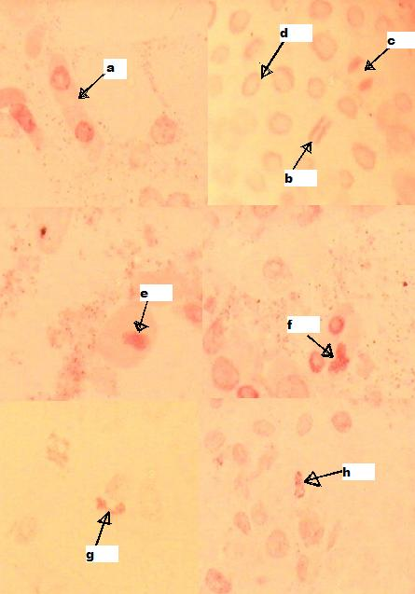
Figure 2. Mitotic activity in okra seeds pre-treated with distilled water (control) (a–d) and extracts of Acalypha (e and f) and Moringa (g and h). a–d = normal cytokinesis (a, telophase; b, metaphase; c, anaphase; d, prophase); e and f = abnormal cytological divisions (e, C-mitosis; f, abnormality at metaphase); g and h = abnormal cytological divisions (g, chromosome bridge; h, sticky anaphase).

3.5. Effect of pre-treatment on seed-borne fungi of okra
Firstly, three fungal genera were observed as seed-borne fungi of okra in this study regardless of type of pre-treatment applied (extract or chemical). The moulds are Alternaria, Fusarium and Rhizopus (Table 3). In terms of fungal occurrence in the pre-treated seeds, Fusarium spp. had the highest occurrence in every case of treatment and treatment concentration. The antifungal effects of Acalypha, Moringa and NaOCl pre-treatment and pre-treatment concentrations on seed-borne fungi showed that Acalypha extracts performed best in the inhibition of all seed-borne fungi of okra than the other two pre-treatments (Table 3). The 1% Acalypha and Moringa pre-treatments inhibited fungal occurrence than NaOCl pre-treatment, as seen from the very low mean fungal counts. It was observed that higher concentrations of Acalypha pre-treatment (2% and 3%) completely inhibited all seed-borne fungi. Following the overall trend of fungal inhibition, it was observed that as the concentration increased for Acalypha and NaOCl, the capacity of the pre-treatment to inhibit fungi increased as seen from the reducing mean fungal counts. However, no specific trend was observed for Moringa.

Table 3. Incidence (%) of moulds in okra seeds pre-treated with different concentrations of Acalypha and Moringa extracts, and sodium hypochlorite.
Pre-treatment concentration | Pre-treatment | Incidence (%) of fungal genera |  |  |  |  | Mean no. of fungi
Pre-treatment concentration | Pre-treatment | Fusarium |  | Rhizopus | Alternaria |  | Mean no. of fungi
1% | Acalypha  Moringa  NaOCl  Control | 80.0%  66.7%  75.0%  75.0% | -  -  8.3%  5.0% |  | 20.0%  33.3%  25.0%  20.0% | 5 a  6 a  12 b  20 b
2% | Acalypha  Moringa  NaOCl  Control | -  100.0%  80.0%  75.0% | -  -  -  5.0% |  | -  -  20.0%  20.0% | -  3 a  10 ab  20 b
3% | Acalypha  Moringa  NaOCl  Control | -  80.0%  83.3%  75.0% | -  -  -  5.0% |  | -  20.0%  16.7%  20.0% | -  5 a  6 a  20 b
Means with different alphabets in a column within a pre-treatment concentration are significantly different by DMRT at p<0.05.

4. Discussion
Post-harvest storage of seeds is considered an important issue in this time of global food insecurity. This is because the quality and germinability of seeds are major determinants of crop yield, and may be influenced negatively by pathogen infestation during poor storage in post-harvest (Odofin, 2010). It is therefore imperative to approach post-harvest pre-treatment of seeds in the best way especially in the case where seeds are preserved from one long planting season to another. This is the case of okra and as such, we tried to determine which of the two plant extracts (Acalypha and Moringa) will perform better than bleach (an inorganic chemical which is conventionally used for seed pre-treatment) in preserving okra seed during post-harvest storage. A good seed preservative should have the potential to inhibit pathogens and at the same time not negatively affect germination, vigor, growth rate or disrupt mitosis in treated seeds.
Both extracts increased germination, radicle extension (a measure of the growth of the seeds) as well as mitotic index (a measure of accurate growth rate of a cell) of pre-treated seeds and caused little or no chromosomal aberrations. At the same time, they inhibited proliferation of seed-borne moulds. This suggests that both plant extracts were better and suitable post harvest okra seed preservative compared to the inorganic sodium hypochlorite. This is in line with the reports of Odofin (2010), Badaru (2011) and Nwangburuka et al. (2012) who suggested that neem and Moringa extracts may be better alternatives to the inorganic chemical preservatives, bleach.
The analysis of the extract pre-treatment and pre-treatment concentrations on germination, radicle length and mitotic index of okra seeds showed that Moringa had a significantly (p<0.05) higher mean for the three parameters at 1% concentration compared to 2% and 3% concentrations, although it was not significantly (p>0.05) different from other pre-treatments. This suggested that higher concentrations of Moringa depressed germination, radicle length and mitotic index. This result agreed well with the reports of Badaru (2011) and Nwangburuka et al. (2012). On the other hand, Acalypha improved germination and mitotic index at significantly (p<0.05) higher levels in accession BAB 002 than BAB 003. Therefore, it can be implied that Acalypha extract influenced cell proliferation at higher concentrations but varies with okra accession and therefore, may be better suited for post-harvest preservation of okra seeds on a variety dependent basis.
An analysis of the pre-treatment concentration and accessions on germination, radicle extension and mitotic index suggested that accession BAB 002 and BAB 003 responded in significantly (p<0.05) different patterns for germination and radicle extension but showed no significant (p>0.05) difference for mitotic index at 1%. The significantly (p<0.05) higher mitotic index recorded for accession BAB 002 than BAB 003 at 2 and 3% concentrations of the pre-treatments indicated that though both concentrations had no significant (p>0.05) effect on germination and radicle extension of the accessions, they promoted better normal cell division with less chromosomal aberrations in BAB 002 than BAB 003. Our finding in this regard is in line with the reports of Odofin (2010) and the chromosomal aberrations recorded were similar to those reported by Menendez et al. (2000), Tabur and Oney (2009), and Odofin (2010).
Extracts from both plants inhibited okra seed-borne moulds at levels greater than those of sodium hypochlorite, however, Acalypha performed best at all concentrations tested. Research has shown over the years that there is a very high rate of fungal contamination in okra (Youssef, 2008; Nwangburuka et al., 2012). Therefore, the ability of Acalypha to progressively inhibit fungal growth at 1%, 2% and 3% concentrations than Moringa makes it more suitable as an alternative for post-harvest preservation of okra seeds. This observation agreed well with the report of Ezekiel et al. (2009) who stated that extracts of Acalypha showed high antifungal potential in culture. Moringa also inhibited fungal growth in a concentration-dependent manner from 1%, 2% to 3% concentration although to a lower degree than Acalypha. This is in agreement with the reports of Nwangburuka et al. (2012) who documented the increasing inhibitory activity of Moringa extracts against seed-borne mycoflora of okra with an increase in concentration.

5. Conclusion and Recommendation
This study has shown that natural plant extracts may be better alternatives for seed preservation during post-harvest. Among the two tested plant extracts, Acalypha gave a more consistent data for all tested parameters at all concentration levels while Moringa performed best when overall effect was considered. Both plant extracts are organic and safe in terms of human health and environment compared to the inorganic Sodium hypochlorite. In view of this, we may recommend the use of Acalypha extracts in preserving okra seeds regardless of accession.

Acknowledgements
The authors are thankful to Prof. K.O. Ogunwenmo for providing useful literature and offering technical advice on the cytology of seeds.

Corresponding author
Nwangburuka C. Cyril
Department of Agriculture, Babcock University, Ilishan-Remo, Ikeja, Lagos, Nigeria
Cykem2001@yahoo.com

References
1. National Research Council. 2006. "Okra". Lost Crops of Africa: Volume II: Vegetables. Lost Crops of Africa.
2. FAOSTAT, 2004. http://www.fao.org
3. Nwangburuka, C. C. 2010. Morphological characterization and genetic studies in okra (Abelmoschus esculentus (L.) Moench). Ph.D. Thesis, University of Agriculture Abeokuta, Nigeria.
4. Badaru, O. 2011. The effect of Moringa oleifera (Moringa species) leaf extract on germination and fungal growth of Abelmoschus esculentus L. (Okra). B.Sc. Dissertation, Babcock University, Nigeria.
5. Siesmonsma, J. S., and C. Kouame. 2004. Vegetable. Plant Resource of Tropical Africa 2. PROTA Foundation, Wageningen, Netherlands. Pp.21-29.
6. Valeriana, P. J. 2002. Training resource text on crop development, major economic practices, disease and insect ecology, insect pests, natural enemies and disease of okra.
7. Al-Kassim, M.Y., and M. N., Monawar. 2000. Seed-borne fungi of some vegetable seeds in Gazan Province and their chemical control. Saudi. J. Biol. Sci., 7(2): 179-184.
8. Odofin, O. 2010. The effect of neem extract and sodium hypochlorite pre-treatment on germination, fungal growth and mitotic index of Abelmoschus esculentus L. (Okra). B.Sc. Dissertation, Babcock University, Nigeria.
9. Mossler, M. A., and E., Dunn. 2009. Florida crop pest management profile: okra. University of Florida IFAS Extension Publication p.1-57.
10. Nwangburuka, C. C., K., Oyekale, C. N., Ezekiel, P. C., Anokwuru, and O. Badaru. 2012. Effect of Moringa oleifera leaf extract and sodium hypochlorite seed pre-treatment on seed germination, seedling growth rate and fungal abundance in two accessions of Abelmoschus esculentus (L.) Moench. Arch. Appl. Sci. Res. 4(2): 875-881.
11. Samson, R .A., E. S., Hoekstra, J. S., Frisvad, and O. Filtenborg. 1995. Introduction to Food-borne Fungi. 4th Ed. The Netherlands: Central Bureau voor Schimmelcultures. Pp. 3–165.
12. Leslie, J. F., B. A., Summerell, and S. Bullock. 2006. The Fusarium laboratory Manual. Blackwell, New York.
13. Menendez-Yuffa, A., R., Fernandez Da Silva, L., Riosa, N., Xena de Enrech. 2000. Mitotic aberrations in coffee (Coffee arabia cv. ‘catimor’) leaf explants and their derived embryogenic calli. Elec. J. Biotechnol. 3(2): 1-6.
14. Tabur, S., and S. Oney. 2009. Effect of some artificial fertilizers on mitotic index and chromosome behaviour in Vicia hybrida L. (Fabaceae). J. Agric. Res., 47: 1-9.
15. Youssef, M. S. 2008. Studies on mycological status of sundried Jew’s-Mallow leaves and okra fruits in Egypt. Res. J. Microbiol. 3(5): 375-385,
16. Ezekiel, C .N., C. P., Anokwuru, O. A., Nsofor, O. A., Odunsanya, and O. Adebanjo. 2009. Antimicrobial activity of the methanolic and crude alkaloid extract of Acalypha wilkesiana cv. macafeeana copper leaf. Res. J. Microbiol. 4(7): 269-277.

11/1/2012

