**Ecological studies and evaluation of some aggregation pheromone types with measuring the potential of female reproductive system in red palm weevil, *Rhynchophorus ferrugineus* (Olivier).**

Mohamed, k. Abbass1 and Abir, S. Al- Nasser2

1Plant Protection Research Institute, Agriculture Research Center, Giza, Egypt.

**\***2Department of Biology, Faculty of Applied Sciences, Um Al Qura University, KSA.

Email: [al-nasser.abir@hotmail.com](mailto:al-nasser.abir@hotmail.com), [asnasser@uqu.edu.sa](mailto:asnasser@uqu.edu.sa)

Abstract: The red palm weevil, *Rhynchophorus ferrugineus*(Coleoptera:Curculionidae) (Oliv.) is the most serious and destructive insect pest for date palm trees. The relative weevil-attracting potential of the aggregation pheromones procured from different countries and used in trapping the red palm weevil, *R. ferrugineus* Olivier, was evaluated in date plantations of Ismailia Governorate, Egypt. Results of this study indicated that high release rate pheromone obtained from Chemtica Natural, Costa Rica type pheromone was more attractive than France and Spain types pheromone. Moreover, ecological studies have clearly showed that the adult stage of red palm weevil, *R. ferrugineus* has two peaks of swarming activity on date palm trees throughout the year, one of them during October 2011 whereas, the other during March 2012. Results also, appeared that the female captured contains numbers of eggs not laid. The mean number of egg per female attractive and newly female were 220.2 and 261.8 eggs, respectively. No significant differences were found between numbers of eggs for the newly female and the female attractive.

**[**Mohamed, k. Abbass and Abir, S. Al- Nasser. **Ecological studies and evaluation of some aggregation pheromone types with measuring the potential of female reproductive system in red palm weevil, *Rhynchophorus ferrugineus* (Olivier).** *Nat Sci* 2012;10(12):188-193]. (ISSN: 1545-0740). <http://www.sciencepub.net/nature>. 28

**Keywords:** red palm weevil, aggregation pheromone, ecological, ovaries

**1. Introduction**

The date palm, *Phoenix dactylifera* L. (Palmace) is the most common and widely cultivated in the arid regions of the Middle East and North Africa. In many areas, date palm fruit has provided the stable carbohydrate food of local people since long time age. The total number of date palm trees recorded in the ancient life reached about 109 millions which yielded 4.2 million metric tons. Arab countries however, contain 78.3% of the total world date palm trees which demonstrate 75% of the production. Based on the Agricultural statistics issued by Ministry of Agriculture and Land Reclamation (2002), the number of female date palm trees revealed about ten millions planted in 70132 Feddan. The total production/ton at 2001 reached about 1.113.270 metric ton (estimated yield/tree = 108.83 kg) harbored 26.5% of the world production (Abdel-Megeed *et al.*, 2004). Recently date palm insect pests in general and the red palm weevil (RPW), *R. ferrugineus* (Coleoptera: Curculionidae) in particular are widely accepted as being the most destructive factors of date, coconut and oil palms throughout South and Southeast Asia (Wattanapongsiri, 1966). Nowadays, the date palm crop in Eastern Arab countries is under threat. Red palm weevil was probably introduced to the Middle East on infested ornamental palm from India or Pakistan. This insect was firstly discovered attacking palm in the Arabian peninsula especially United Arab Emirates in 1986 and progressively spread to Gulf states and crossed the red sea into North Africa as the latest record since 1992 in Egypt. It is found over a wide geographical area in Asia, involving many different Agro ecosystems. In United Arab Emirates, Abbas *et al*. (2006) used the aggregation pheromone traps to investigate the population density of *R. ferrugineus* infesting date palm. In Egypt, Zayed (2008) evaluated the efficiency of some food baits compared to chemical attractors for management of red palm weevil by pheromone/food-based trap system throughout the year, and determined the best efficient food bait during the subsequent annual season. The related species is highly polyphagous with a number of known hosts exceeding more than ten different palm species (Murphy and Briscoe, 1999). The wide uncontrolled translocation of offshoots is considered the main factor governing the spatial distribution pattern of red palm weevil. The larval and adult stages of this insect feed within tunnels inside the trunk of palms and this behavior frequently damage the infested trees. In infested plantations, yield has been dropped from 4.2 to 0.3 metric ton/Feddan (Gush, 1997). The present work was undertaken for evaluation of different types of aggregation pheromones, determination of seasonal abundance of RPW adults and comparing the number of eggs laid by both attracted females and newly females.

2. MATERIALS AND METHODS

Three aggregation pheromone traps were evaluated for RPW catch in the field at Qassasin, Ismailia Governorate, Egypt during August 2011-July 2012. The commercial pheromones with different release rate were tested; the first one from France, Qaluibe company, the second one from Costa Rica Chemtica company and the third one from Spain, Sedq Espana. The components of the pheromone are 4-methyl 1-5-nonanol (9 parts) + 4-methyl nonanone (1 part) – purity 99.9% + 0.1% colorant and 0.1% antioxidant. The experiments were carried out at Yousry El-Sebay Laboratory of red palm weevil at Qassasin, Ismailia Governorate.

**Trap design and related compounds:**

Bucket design traps were used in the present study. The traps were inserted slightly in the soil surface. A number of round holes were made to allow adult weevils to enter inside the trap safely and easy.The used traps commonly consists of plastic bucket (9 liter in size). The bucket was punctured around its wall with 4 holes each of 2-5 cm diameter at 15cm from the bottom. Selected Kairomone was used as a synergist to activate the potent ability of releasing ethyl acetate blooms. Ethyl acetate bags were hanged from the underside surface of the trap top releasing chemicals through a fine plastic tube (as 100 and 128 mg/d). Liquid soap was mixed with trap water used in the inside bucket trap. Number of collected weevils caught in the pheromone traps was weekly counted, sexed, and grouped into date record contains two weekly figures.

**Evaluation of different pheromone types:**

The Three commercial pheromones were tested in the form of recommend bucket traps and distributed uniformly in the selected severely infested area. Each pheromone traps were replicated five times and field evaluation was carried out during March 2011 till April 2011. The data recorded were kept in the experimental date palm field area**.**

**Seasonal abundance and population trends of *R. ferrugineus*:**

To estimate the seasonal abundance of *R. ferrugineus*, ten traps of Costa Rica pheromone were distributed in the experimental orchard, each trap has a distance 150 meter approximately from the other. The field trials were carried out during one successive date palm growing season from August 2011until July 2012.

**Comparative study on the number of eggs laid by captured and newly females:**

Thirty females and males captured in traps and thirty newly females and males collection cocoon in palm infestation paired (♂ and ♀), placed in separate cups and provided with palm slices of date palm wood until egg lying. Daily number of laid eggs was recorded and oviposition period was counted per each female.

**Anatomical study of female reproductive system:**

Twenty females in each pheromone trap were dissected monthly during season2011-2012. The dissected female was drowned using drowning eye piece under stereomicroscope and the number of mature eggs in calyx and immature eggs in ovarioles were counted Figures (2-4).

**Statistical analysis:**

All the obtained results were statistically analyzed using the computer program SAS (**SAS 1985)**.

**3. RESULTS AND DISCUSSION**

**3.1. Evaluation of different pheromone types.**

Data recorded in Table (1) show a comparison between different types of aggregation pheromones. The adults were significantly attractive with Costa Rica aggregation pheromone compared to Spain pheromone. A slight significant attraction was recorded by France pheromone. The mean number of attractive adults with Costa Rica, France and Spain pheromone was 82.25, 55, 38.125, respectively.

Table 1. Effect of aggregation pheromoneson the number of attracted adult *R. ferrugineus*

|  |  |  |  |
| --- | --- | --- | --- |
| Month/Week | Number of attracted adult *R. ferrugineus* | | |
| Costa Rica | France | Spain |
| **March**  Week1  Week2  Week3  Week4  **April**  Week1  Week2  Week3  Week4 | 78  102  121  119  78  84  66  34 | 24  67  89  103  27  79  44  7 | 30  34  55  50  36  56  39  5 |
| Mean | 82.25 a | 55ab | 38.125b |

L.SD.05 =28.7

**3.2. Seasonal abundance and population trends of *R. ferrugineus***

The data recorded in Table (2) and graphically illustrated in Figure (1) showed that the numbers of red palm weevil were changed from month to month during the tested period from August 2011 to July 2012. The number of captured adults increased gradually and reached their peak in October 2011 (112 individual/trap) then they decreased gradually once again till January. The number of captured adults of red palm weevils increased and reached the maximum peak again in March 2012 with a total number of 158 adults, followed by decline in the total number to 44 adults in July 2012. Data obtained proved that the reliable number of captured red palm weevil occurred during two periods which extended from March to May and from September to November. While, there was scarcely distributed individuals during the other months. The highest level of occurrence expressed as adults caught in aggregating pheromone traps during early spring months. These results in general agree with the findings of Abbas (2000 and 2005). In Egypt, El Sebay (2003) and El Sebay *et al*., (2010) estimated four overlapping generations of red palm weevil adults per year and recorded two peaks during March and November. In Saudi Arabia, Vidyasager *et al*., (2000) found that, the peak of the red palm weevil adult populations trapped was immediately after winter season during the months of April and May. A much smaller second peak was observed during October and November months just before winter. (Gunawardena and Bandarage, 1995 and El Garhy, 1996). Other previous studies reported maximum catches in March and April (Hallet *et al.*,1993, El Ezaby *et al*.,1998, Muralidharan *et al.*, 2000 and Oehlschlager,2004). In the present study, occurrence of females in traps was higher than males all over the year and the percentage of captured males was lower than that of female weevils. These results are in agreement with Al-Saoud(2004) and Zayed (2008).

Table 2. Monthly total numbers of *R. ferrugineus* adults (males and females) caught by pheromone traps.

|  |  |  |  |
| --- | --- | --- | --- |
| **Total** | **No of Female** | **No of male** | **Month** |
| 49 | 34 | 15 | August 2011 |
| 87 | 55 | 32 | September |
| 112 | 72 | 40 | October |
| 81 | 52 | 29 | November |
| 30 | 21 | 9 | December |
| 16 | 11 | 5 | January 2012 |
| 52 | 33 | 19 | February |
| 158 | 102 | 56 | March |
| 76 | 45 | 31 | April |
| 75 | 56 | 19 | May |
| 54 | 33 | 21 | June |
| 44 | 30 | 14 | July 2012 |
| 834 | 544 | 290 | Total |
| 69.5 | 45.3 | 24.2 | Mean±S.E |

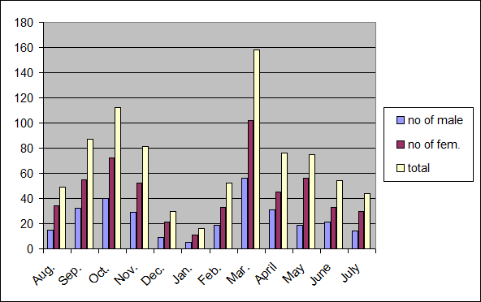

Figure 1. Monthly abundance of *R. ferrugineus* adult stage(males and females) caught by pheromone traps.

**3.3. Number of eggs laid by captured and newly females:**

Data presented in Table (3) demonstrate that, the lowest mean number of eggs (220.2 eggs/female) was recorded in female captured during 56.8 days. On the other hand, the highest mean number (261.8 eggs /female) was recorded in newly female during 76.4days. No significant differences were found between number of eggs in newly female and female attractive but there was a significant difference between number of days life in newly females newly and attracted females.

Abraham *et al*. (2001) found that the average life of female captured was three months and the number of eggs laid was 320 eggs.

On the other hand, the present results appeared that, the females captured contain eggs not laid. Similar results were obtained by Abbas (2005).

Table 3. Number of eggs and duration days of females captured and newly females

|  |  |  |  |  |
| --- | --- | --- | --- | --- |
| Replicate | female captured | | newly female | |
| Mean number of egg | Life female days | Mean number of egg | Life female days |
| 1 | 189 | 40 | 250 | 67 |
| 2 | 230 | 65 | 267 | 78 |
| 3 | 167 | 48 | 190 | 88 |
| 4 | 235 | 60 | 312 | 70 |
| 5 | 280 | 71 | 290 | 79 |
| Mean | 220.2a | 56.8a | 261.8a | 76.4b |

L.SD.05 =45.18 number of eggs

L.SD.05 =15.57 Life female days

**3.4. Anatomical structure of the reproductive system of captured females**

Monthly, twenty females were selected randomly from each trap and dissected after capturing to remove the reproductive system and count the number of both eggs in calyx (mature eggs) and in ovarioles (immature eggs) as shown in Figures (2-4). The data in Table (4) showed the oogenesis potential of captured females by estimating the total number of two types of eggs (immature and mature eggs). The maximum number of eggs was recorded during August, October 2011and March 2012 and it was 72, 60 and 78 respectively.

Table 4. Numbers of mature and immature eggs found in dissected females captured in aggregation pheromone traps of *R. ferrugineus*

|  |  |  |  |
| --- | --- | --- | --- |
| No of eggs | | |  |
| Total | Immature \ovariols | Mature \calyx |  |
| 60 | 48 | 12 | August 2011 |
| 44 | 36 | 8 | September |
| 78 | 60 | 18 | October |
| 56 | 44 | 12 | November |
| 44 | 36 | 8 | December |
| 46 | 40 | 6 | January 2012 |
| 48 | 32 | 16 | February |
| 72 | 52 | 20 | March |
| 56 | 44 | 12 | April |
| 56 | 40 | 16 | May |
| 56 | 44 | 12 | June |
| 50 | 36 | 14 | July 2012 |

**Authors:**

1. Mohamed, k. Abbass.Plant Protection Research Institute, Agriculture Research Center, Giza, Egypt.
2. Abir, S. Al- Nasser. Department of Biology, Faculty of Applied Sciences for girls, Um Al Qura University, KSA.

Email: al-nasser.abir@hotmail.com, asnasser@uqu.edu.sa

**\*Corresponding author:**

Dr. Abir Sulaiman Al-Nasser

Faculty of Applied Sciences, Department of Biology, Um Al Qura University, KSA.

e-mail: [al-nasser.abir@hotmail.com](mailto:al-nasser.abir@hotmail.com)

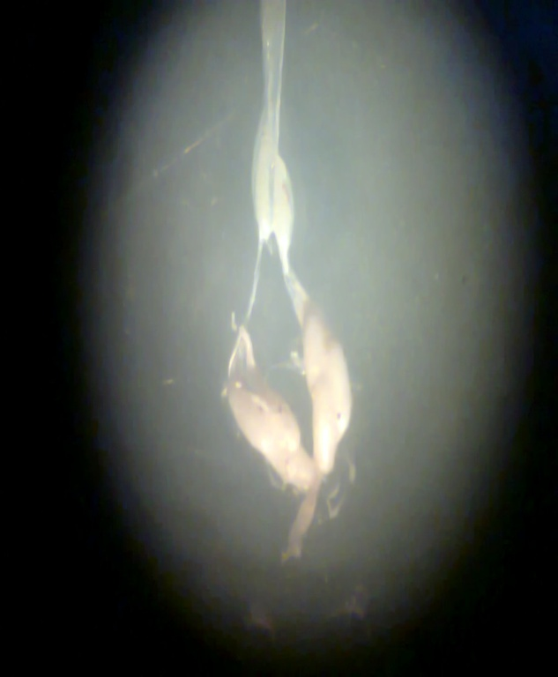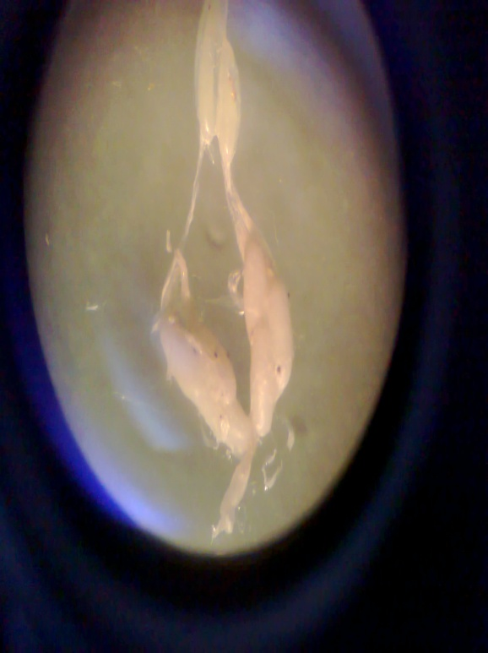

Figure 2. Eggs in calyx of *R. ferrugineus*

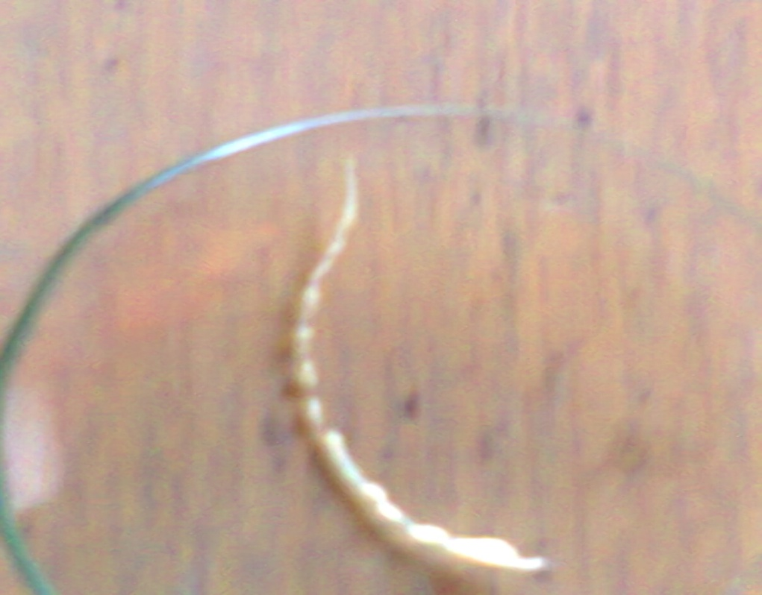 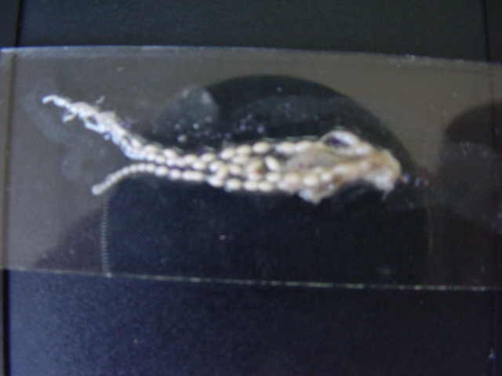

Figure 3. Immature eggs in ovarioles of Figure 4. Reproductive system of female *R. ferrugineus*

female *R. ferrugineus*

**REFERENCES**

1. Abbas, M.K. (2000). Studies on the red palm weevil. M. Sc. Thesis, Fac. Agric., Zagazig Univ., 104 pp.
2. Abbas, M.K. (2005). Integrated management for controlling red palm weevil. Ph.D. Thesis. Faculty of Agriculture, Ain - ShamsUniversity, 166 pp.
3. Abbas, M.S.T.; Hanouniki, S. B.; Shahdad,A.S.; El-Bagham, S.A. (2006). Aggregation pheromone traps, a major component of IPM strategy of the red palm weevil, *Rhynchophorus ferrugineus* (Coleoptera, Curculionidae)in date palm. J. of Pest Sciences, 79(2): 69-73.
4. Abdel-Megeed, M.E., Zedan H.A and El-Saadany, G.B. (2004). The integrated management for controlling pests of date palm. Kenza Group Pub. Egypt, 483 pp (in Arabic)
5. Abraham V.A., Faleira, J.R, Shuaibi, M.A., and Al Abdan S. (2001) :Status of pheromone trap captured females red palm weevil *Rhynchophorus ferrugineus*from date gardens in Saudi Arabia Journal of tropical Agriculture 39(2001):197-199
6. Al-Saoud, H.A. (2004). The role of aggregation pheromones in integrated control of red palm weevil *Rhynchophorus ferrugineus*oliver (curculioinidae: Coleoptera). Date palm regional workshop on ecosystem based IPM for Date palm in the Gulf Countries, Al Ain.\ UAE ; 28-30 March,2004
7. El-Garhy, M.E. (1996). Field evaluation of the aggregation pheromone of the red palm weevil, *Rhynchophorus ferrugineus* in Egypt. Brighton Crop Protection Conf. Pests and Diseases, Vol. 3. Brighton, U.K. 18-21 November, 1059-1064.
8. El-Sebay, Y. (2003). Ecological studies on the red palm weevil, *Rhynchophorus ferrugineus* (Coleoptera: Curculionidae) in Egypt. Egypt. J. Agric. Res., 81 (2): 523-529.
9. EL Sebay, y, Abbas. M.K. and El –Shezly,M. M. (2010). Seasonal abundance and population trends of red palm weevil, *Rhynchophorus ferrugineus* OLiver (ColeopteraL: Curculionidae). J. Plant Protection and Pathology, Mansoura University, Vol.1(8): 577 - 583, 2010
10. El-Ezaby, F.A. (1998). Injection as a method to control the red Indian date palm weevil, *Rhynchophorus ferrugineus*. Arab J. Plant Protec., 15 (1): 31-38 (in Arabic.
11. Gunawardena, N.E. and Bandarage, U.K. (1995). 4-methyl-5-nonanol (ferrugineol) as an aggregation pheromone of the coconut pest, *Rhynchophorus ferrugineus*. (Coleoptera: Curculionidae): Synthesis and use in a preliminary field assay. J. Nat. Sci. Council of Sri Lanka, 23 (2): 71-79.
12. Gush, H. (1997). Date with disaster. The Gulf today. September 29, p 16
13. Hallett, R.H., Gries,G.,and Oelhsclager,,O.C.. (1993). Aggregation pheromones for two Asin palm weevil *Rhynchophorus ferrugineus* and *Rhynchophorus vulnerates.* Naturwissenschaften 80:328-331.
14. Muralidharan, C.M.; Sodagar,N.N. and Vaghasia,U.R. (2000). Survey, distribution, extent of damage, field behavior and biology of the red palm weevil, *Rhynchophorus ferrugineus* (Oliv.) on date groves of Kachchh (Gujarat).. Journal [Gujarat Agricultural University Research Journal](http://www.cabdirect.org:80/search.html?q=do%3A%22Gujarat+Agricultural+University+Research+Journal%22), 20 (1): 35-46
15. Murphy, S. and Briscoe, B (1999). The red palm weevil as an alien invasive: biology and prospects for biological control as component of IPM. Biocontrol News and Information, 20 (1): 35-46.
16. Oehlschlager, A.C. (2004): Current status of trapping of palm weevil and beetls. Date palm regional workshop on ecosystem based IPM for Date palm in the Gulf Countries, Al Ain.\ UAE; 28-30 March, 2004.
17. S.A.S. Institute (1985): SAS users guide :statistics,5thEd SAS Institute, Cary, NC
18. Vidyasagar, P.S.P.V.; Hagi,M.; Abozuhairah, ;R. A.., Al-Mohanna, O. E. and Al-Saihati, A. A. (2000). Impact of mass pheromone trapping on red palm weevil: adult population and infestation level in date palm gardens of Saudi Arabia. Ministry of Agriculture and Water, Agriculture Improvement Scheme.Wattanapongsiri, A. (1966). A revision of the genera *Rhynchophorus* and dynamics (Coleoptera: Curculionidae). Dept. Agric. Sci. Bull. 1, Bangkok.1-326 pp.
19. Zayed, T.M. (2008). Studies on I.P.M of red palm weevil, *Rynchphorus ferrugineus* (Coleoptera, Curculionidae) in El-Beheira Governorate, Egypt. Ph.D. Thesis, Faculty of Agriculture Saba Basha, Alexandria Univ., 123pp.

10/10/2012