Endotracheal Tube Biofilm and its Relationship to Ventilator Associated Pneumonia in a Neonatal ICU

Iman Shehata¹, Marwa Shabban ^{1,} Rania Ibrahim ² and Youssef Shoukry ³

Departments of ¹ Medical Microbiology and Immunology, ² Pediatrics, ³ Anatomy, Faculty of Medicine, Ain Shams University, Cairo, Egypt.
marshabban@yahoo.com; emanhussein_68@hotmail.com

Abstract: Ventilator associated pneumonia (VAP) is one of the most common healthcare associated infections in critical care settings. Endotracheal tube (ETT) is an independent risk factor for developing VAP. This study aimed to investigate biofilm formation on the luminal and external surfaces of ETTs of neonates in ICU on mechanical ventilation and study its relation to VAP. The presence of biofilm on the surface of ETTs and biofilm stage were evaluated by Scanning Electron Microscope (SEM), meanwhile, bacteria harvested from the surface of ETTs and the secretions of lower respiratory tract were isolated, identified and assessed for antimicrobial susceptibility. Twenty ETTs from 20 neonates who were intubated and mechanically ventilated in the Neonatal Intensive Care Unit (NICU) of Ain Shams University Hospital were obtained. Bacterial colonization and biofilm formation was observed on 80% of inner and outer surfaces of collected ETTs using SEM. Staging of biofilm revealed that 50% of the biofilms were grade III, 31.25% were grade II, and 18.75% were grade I. Bacterial colonization and biofilm grading was shown to be time dependent (p value=0.006). Inner and outer endotracheal tube surfaces yielded 80% and 75% positive aerobic cultures, respectively. The most prevalent isolates were Klebsiella pneumoniae followed by coagulase negative Staph (CoNS), Enterobacter, Acinetobacter, Candida and normal flora . Thirteen samples had the same pathogen both on the surface of ETTs and in the secretions of lower respiratory tract which accounted for 81.25% of the positive cultures from ETTs. All Gram negative isolates were resistant to ampicillin-sulbactam, cefepime, cefotaxime, ciprofloxacin, and piperacillin. We can conclude that endotracheal tube colonization and biofilm formation are frequently observed in neonates undergoing mechanical ventilation, increases with the duration of intubation and is correlated with occurrence of VAP. Bacteria implicated in VAP showed multi-resistance towards most antibiotics used in the study.
[Iman Shehata, Marwa Shabban, Rania Ibrahim and Youssef Shoukry. Endotracheal Tube Biofilm and its Relationship to Ventilator Associated Pneumonia in a Neonatal ICU. Nat Sci 2012;10(12):133-140]. (ISSN: 1545-0740). http://www.sciencepub.net/nature. 20

Keywords: biofilm, endotracheal tube, neonates, scanning electron microscopy, ventilator associated pneumonia.

Introduction:
A biofilm is an aggregate of microorganisms in which cells adhere to each other or a surface. These adherent cells are frequently embedded within a self-produced matrix of extracellular polymeric substance (EPS). Biofilm EPS is an amalgam of extracellular macromolecules including nucleic acids, proteins, polysaccharides, and lipids (Bordi and de Bentzmann, 2011).The formation of a biofilm begins with the attachment of bacteria to a surface and is followed by proliferation and maturation, which ultimately leads to the characteristic 3D biofilm structure with mushroom-shaped bacterial agglomerations surrounded by fluid-filled channels. Later, cells may detach from the biofilm in a process believed to be of crucial importance for the dissemination of a biofilm-associated infection (Hoiby et al., 2010). Cells in microbial biofilms differ from planktonic cells in two major ways: they are usually more tolerant to antibiotics and antimicrobial treatment, and they may persist in the host, despite a heavy influx of inflammatory cells and effector functions of the adaptive immune response. The clinical importance is that biofilm infections are typically chronic infections (Hall-Stoodley et al., 2012).
Ventilator associated pneumonia (VAP) is one of the most common healthcare associated infections in critical care settings and accounts for 6.8% to 32.2% of health care-acquired infections among neonates. It is associated with prolonged hospitalization, increased health care costs, and high attributable mortality (Rosenthal et al., 2012). The presence of an endotracheal tube (ETT) is an independent risk factor for developing VAP and whilst tracheal intubation is necessary to facilitate mechanical ventilation, it also circumvents elements of patients' innate immunity. The endotracheal tube disrupts the cough reflex, promotes accumulation of tracheobronchial secretions and mucus, and provides a direct conduit for pathogenic microorganisms to reach the lower respiratory tract, increasing the risk of infection. Significantly, the endotracheal tube may also act as a reservoir for pathogens by providing a surface to which they can adhere and form biofilms. Aggregates of ETT biofilm can be easily detached by suction catheter and disseminate towards the lower respiratory tract by shear forces imparted by the ventilator inspiratory gas flow (Coppadoro et al., 2012).
The use of electron microscopy to demonstrate the presence of endotracheal tube luminal biofilm was first reported by Sottile et al. (1986). In their study of 25 patients in the intensive care unit (ICU) undergoing extubation, the ETT was completely covered in 84% of cases and partially covered in 16% by an amorphous bacterium-containing matrix .They suggested that there may be a relationship between nosocomial pulmonary infections and bacterial adherence to the interior surface of the ETT . Several investigators have subsequently studied this process further and have suggested not only that the formation of a biofilm may be an important mechanism of ETT obstruction, but also a potential source of pulmonary infection (Adair et al., 1999,Feldman et al.,1999).
This prospective observational study aimed to investigate biofilm formation on the luminal and external surfaces of ETTs of neonates in ICU on mechanical ventilation and study its relation to VAP. The presence of biofilm on the surface of ETTs were examined by SEM, meanwhile, bacteria harvested from the surface of ETTs and the secretions of lower respiratory tract were isolated, identified and assessed for antimicrobial susceptibility.
Patients and Methods:
Patients
This was a prospective study done at neonatal ICU (NICU) of Ain Shams University Hospital during the period from May 2011 to March 2012. Any intubated newborns in the NICU were enrolled in this study, with the exception of neonates who had undergone previous airway surgery or those in whom the endotracheal tube could not be immediately processed after extubation.
After obtaining a verbal and written consent from the parents or care givers, all newborns enrolled in the study were subjected to: i) full history taking laying stress on (complete perinatal history, duration of intubation, previous intubation history, history of antibiotics, history of H2-blocker therapy) and ii) full clinical examination with special emphasis on (gestational age, birth weight, sex, crown rump length, general and systemic examinations for any signs of sepsis). Laboratory investigations included: complete blood picture, C-reactive protein, blood cultures for bacteria and fungi, and the distance of ETT tip to carina on last chest radiograph.
Diagnosis of VAP was based on the criteria summarized by Foglia et al. (2007) as follows: i) develops 48 hrs. after initiation of mechanical ventilation; ii) new or persistent infiltrations on chest X-ray; and iii) worsening gas exchange and at least three of the following criteria: temperature instability with no other recognized cause, new onset of purulent sputum, increase in respiratory secretions or increased need for suctioning, WBC < 4000/mm3 or > 15000/mm3, respiratory signs (apnea, tachypnea, nasal flaring, retraction, wheezing, rales, or rhonchi), and bradycardia or tachycardia .
Calculation of Subglottic Point:
For each subject, the portion of the endotracheal tube that had been in contact with the subglottis was determined. The last chest radiograph for each neonate was examined and the distance (C) from the tip of the endotracheal tube to the carina was measured. The length of the trachea was determined by correlation with the patient’s crown rump length (CRL) using the following formula:
L = (0.708 + 0.106) CRL (cm).
The distance from the endotracheal tube tip to the subglottis (S) was then determined by the following formula: S = L – C – 0.3 (cm)
The factor 0.3 cm was added to ensure that the sampled section was not above the level of the vocal folds.
Collection of endotracheal tubes:
A sterile work area was prepared next to each infant at the time of extubation. Included on the field were a ruler, a knife, culture swabs, tubes and a vial filled with 3% glutaraldehyde. The above formulas were used to calculate the level of the subglottis on the chest radiograph and this point was marked on the ruler. A 1-cm cross-sectional segment of the endotracheal tube corresponding to the subglottis was cut with the sterile knife (0.5 cm below and 0.5 cm above the mark). The 1-cm segment was the divided cross-sectionally into two 0.5 cm segments. Swabs of the external surface and then (separately) the inner surface of the first 0.5 cm segment were sent for aerobic bacterial cultures. The remaining 0.5 cm segment was divided longitudinally into two equal segments both of which were placed in a vial filled with 3% glutaraldehyde and sent for SEM of both the outer and the inner surfaces of the ETT.
Isolation and identification of bacterial strains
i) Swabs of the external and inner surface of ETTs were inoculated onto blood and MacConkey's agar media and incubated aerobically at 37°C for 24 hours. Semiquantitative cultures onto blood and MacConkey's agar media were performed for endotracheal aspirates collected from intubated neonates using a 1µl calibrated loop of. Results of semiquantitative cultures were expressed as colony-forming units (CFU) per milliliter. A threshold concentration of 10⁵cfu/ml was used to diagnose infection.
ii) Identification of the isolated organisms was done according to Cheesebrough (2007) based on colonial morphology, microscopic examination of Gram stained films and biological activity of the isolated organisms.
iii) Antibiotic susceptibility of all isolated organisms was done by disc diffusion method, using Muller-Hinton (MH) agar plates. After overnight incubation results were reported and interpretation was done according to clinical and laboratory standards institute (CLSI , 2010).
Preparation for the scanning electron microscopy (SEM)
The specimens were collected from the patients and rinsed in 2.5% glutaraldhyde fixative solution buffered with 0.1% phosphate buffer for 24 hours. Specimens were then postfixed in osmium tetroxide for 15 minutes. The tissues were then dehydrated through ascending grades of ethanol and then were dried at critical point dryer using liquid carbon dioxide with Bal-Tec CPD030. The tissue were further mounted on brass studs with aluminum conducting tape and coated with gold in Bal-Tec SCD005. Specimens were examined with Philips XL30 scanning electron microscope operated at 10 – 30KV, at the electron microscopy unit, Ain Shams University. The biofilm formation (its existence and extent on the surface) was graded using a one to three integer scale (Tatar et al., 2006). Grade I shows microcolony formation and the beginning of glycocalyx production, Grade II shows an established microcolony, extracellular polymeric substance (EPS) and multidimensional structure and growth, and Grade III shows a fully mature biofilm covered completely by EPS.

Results
Twenty ETTs were obtained from 20 neonates (14 males and 6 females; with a gestational age between 27 and 37 weeks; mean 32 weeks), who were intubated and mechanically ventilated in the NICU of Ain Shams University Hospital. Admission diagnoses included: respiratory distress syndrome (17), pneumothorax (1), duodenal atresia (1) and hypoxic ischemic encephalopathy (1). The duration of intubation prior to endotracheal tube collection was between 1 and 9 days (mean 3.55 days). In the studied neonates, 40% were previously intubated and 25% received antacids. All neonates received antibiotics; the number of antibiotics administered per patient ranged from 2 to 9 antibiotics during the course of their hospital stay.
Bacterial colonization and biofilm formation was observed on the lumen and outer surface of 80% (16/20) of the collected tubes while 20% (4/20) showed no bacterial colonization or biofilm formation. As regards staging of biofilm by SEM: fifty percent (8/16) of the biofilms were grade III, while, 31.25% (5/16) were grade II, and lastly 18.75% (3/16) were grade I. A representative image depicting the characteristics of each biofilm stage as captured by SEM is shown in (Figures 1-4).
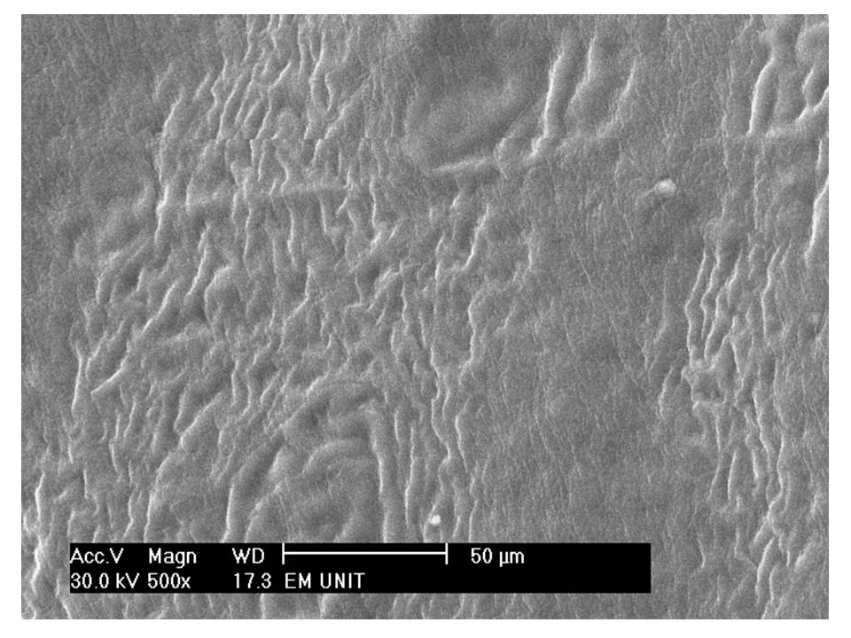
Figure1. Scanning electron micrograph of an endotracheal tube with no evidence of bacterial biofilm x 500.The duration of intubation was 24 hours.
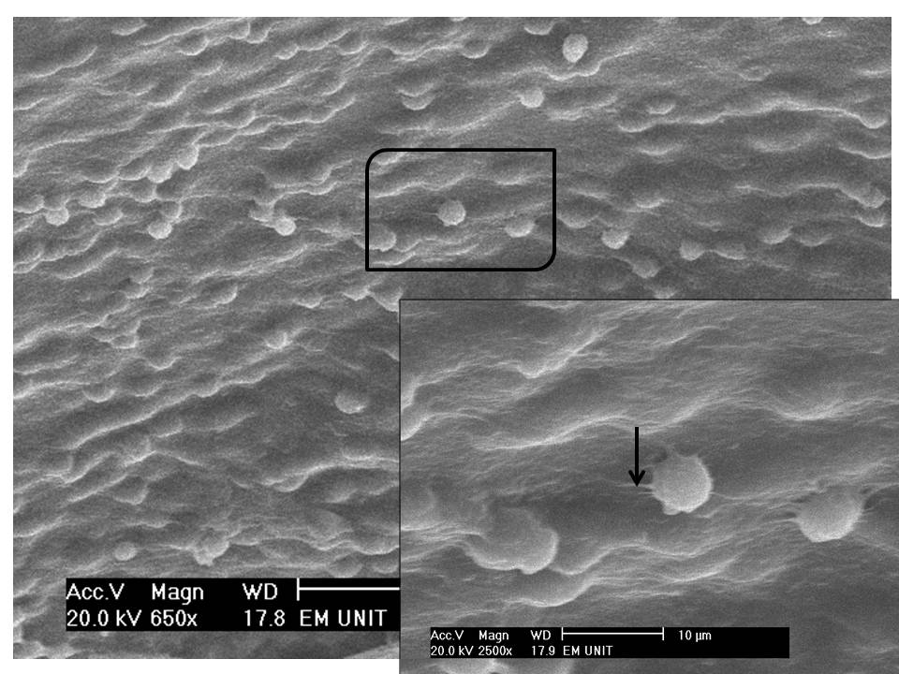
Figure2. Scanning electron micrograph of an ETT showing grade 1 biofilm with scattered large cocci. Higher magnification of the inset showing the beginning of secretion of EPS (arrow) of the cocci that will attract and coalesce more microbes (x650 & x 2500.The duration of intubation was 2 days.
The duration of intubation for different biofilm grades was as follows: 3 to 9 days (mean 5.67 days) for biofilm grade III, 3 to 6 days (mean 4.33 days) for biofilm grade II, and 2 to 3 days (mean 1.67 days) for biofilm grade I. While, for biofilm negative cases the duration of intubation was from 1 to 2 days (mean 1.67 days).A statistically significant relationship was observed between duration of intubation and biofilm stage (p=0.006). Figure 5 displays the duration of intubation relative to biofilm stage for all patients.
Relationships of bacterial colonization and biofilm formation with other factors as: gender, previous intubation, antibiotic therapy and antacids administration was not statistically significant (p>0.05).
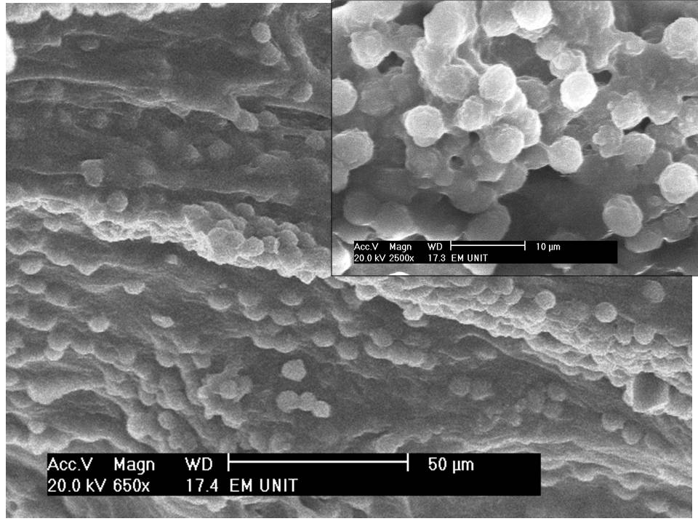
Figure3.Scanning electron micrograph of an ETT showing; grade 2 biofilm with increased amount of the EPS and number of trapped cocci, higher magnification showing large microbial aggregate x650 & x2500. The duration of intubation was 3 days.

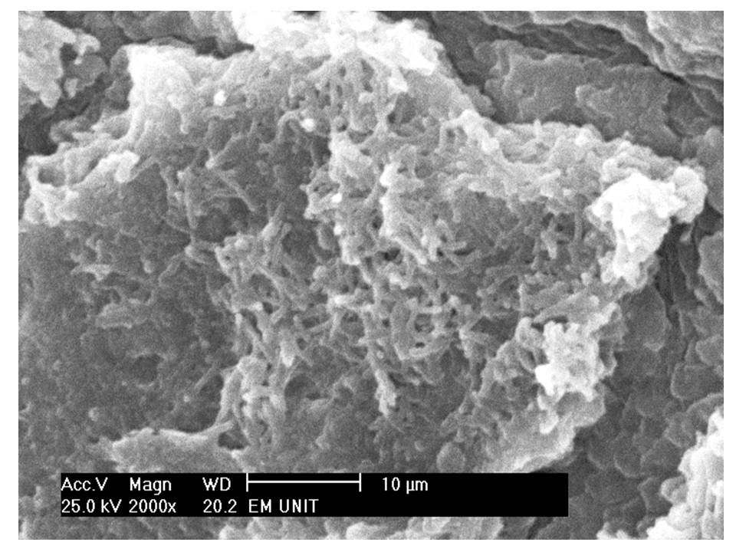
Figure4.Scanning electron micrograph of an ETT showing; grade 3 mixed biofilm with homogenous EPS that surrounds completely the cocci and trapping some bacilli over its surface x 2000. The duration of intubation was 9 days.

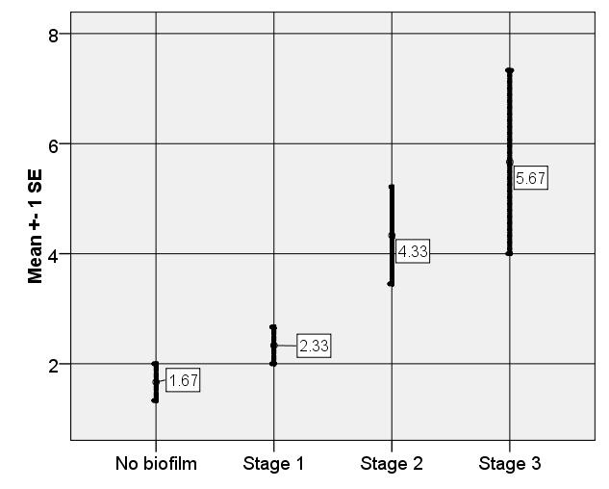
Figure5. Relation between duration of intubation & biofilm stage.

Inner endotracheal tube surface yielded 80% (16/20) positive aerobic cultures and 22 isolates were recovered; (10 samples gave a single isolate and 6 samples gave two isolates). The percentage of different organisms isolated from ETTs' inner surface cultures are shown in (Figure 6).

Figure6. Percentage of different organisms isolated from ETTs' inner surface cultures.

Outer endotracheal tube surface yielded 75% (15/20) positive aerobic cultures. A total of 18 isolates were recovered; (12 samples gave a single isolate and 3 samples gave two isolates). The percentage of different organisms isolated from ETTs' outer surface cultures is illustrated in (Figure7).

Figure7. Percentage of different pathogens isolated from ETTs' outer surface cultures.

All ETTs that showed bacterial colonization and biofilm formation by SEM gave positive microbiological culture results, while the ETTs that exhibited no bacterial colonization or biofilm formation gave negative microbiological culture results. This was translated statistically by a 100% agreement between biofilm formation observed by SEM and inner surface ETT cultures (Prevalence and adjusted Kapa test (k) =1).
Seventeen neonates (85%) developed VAP and this was confirmed by positive endotracheal aspirate cultures. A total of 20 isolates were recovered; 14 samples gave a single isolate and 3 samples gave two isolates. Thirteen samples had the same pathogen both on the inner surface of ETTs and in the endotracheal aspirate which accounted for 81.25% of the positive cultures from ETTs. Three samples (18.75%) of ET aspirate grew one organism phenotypically similar to ETT inner surface culture. The distribution of different pathogens is illustrated in (Figure 8).

Figure8. Percentage of different organisms isolated from endotracheal aspirate cultures.

Three neonates (15%) gave negative endotracheal aspirate culture results, and no organisms were isolated from their endotracheal tube inner and outer surfaces and no bacterial colonization or biofilm formation was observed on their endotracheal tubes by SEM. One neonate had a positive aspirate culture but negative ETT inner surface culture. This was translated statistically by a very good agreement between bacterial colonization / biofilm formation and ET aspirate culture results (kappa=0.828).
A significant relationship was observed between the duration of intubation and colonization of the ETT inner surface (p=0.01), while no significant relationship was detected between duration of intubation and ET aspirate culture results (p value=0.057).
Antibiotic resistant patterns by the disc diffusion test revealed that CoNS showed highest susceptibility to vancomycin, tetracycline, and trimethoprim sulfamethoxazole (50%), while being least susceptible to penicillin and cefoxitin (0%). As regards Gram negative isolates, all isolates showed highest susceptibility to imipenem, and ciprofloxacin (75-100%), while being least susceptible to ampicillin-sulbactam, cefepime, cefotaxime, cprofloxacin, and piperacillin (0%). The antibiotic susceptibility pattern for isolates is seen in (Table 1).

Table1. Antibiotic susceptibility pattern for isolates (% sensitive).
Antibiotic | CoNS | K.pneumoniae | Enterobacter | Acinetobacter
Penicillin | 0 | --- | --- | ----
Tetracycline | 50 | --- | ---- | 25
Vancomycin | 50 | --- | --- | --
Cefoxitin | 0 | 0 | 0 | --
Trimethoprim-sulfamethoxazole | 50 | 25 | 100 | 0
Gentamycin | --- | 50 | 66.6 | 75
Cefepime | --- | 0 | 0 | 0
Ampicillin/Sulbactam | --- | 0 | 0 | 0
Cefotaxime | --- | 0 | 0 | 0
Ampicillin | --- | 0 | 0 | --
Amikacin | --- | 25 | 0 | 0
Ceftriaxone | --- | 0 | 0 | 0
Ciprofloxacin | --- | 75 | 100 | 75
Piperacillin | --- | 0 | 0 | 0
Imipenem | --- | 100 | 100 | 75
---- = the corresponding antibiotic was not used in sensitivity pattern of this isolate.

Discussion:
Endotracheal tubes of intubated patients are constantly challenged with abundant bacteria-laden secretions. Quickly those bacteria may organize in a well-organized structure (biofilm) which is difficult to eradicate (Berra and Kumar, 2010). Fragments can detach spontaneously or become dislodged by suction catheters and enter the lungs representing a source of infection (Lorente et al., 2010).
In this study, bacterial colonization and biofilm formation was observed on 80% (16/20) of inner and outer surfaces of collected ETTs using SEM. These results agreed with previous reports obtained by Diaz-Blanco et al. (1989) and Poisson et al.(1991). In both studies all ETTs were coated with luminal biofilm, with the material appearing as early as 11 hours after intubation. In a study by Zur et al. (2004), bacterial colonization and biofilm formation were seen on 8 of 9 inner lumen tubes, and all of the outer endotracheal tube surfaces obtained after extubation exhibited biofilm formation. Comparing the inner and outer surfaces of the endotracheal tubes, there was no significant subjective difference in the appearance of these accretions
In this study, it was clearly observed that bacterial colonization and biofilm grading was shown to be time dependent (p value=0.006). This was in accordance with Chen et al.(2007); they used SEM to investigate microbial biofilms on inner surfaces of ETTs removed from neonates with intubated ventilation. They noted some amorphous material with no obvious bacterial colonies in 5 of 20 ETTs as early as one day of tube use. Up to 2 days of tube use (4/20), attached bacterial colonization was seen embedded in amorphous material. Up to 3 days (7/20), a layer of biofilm formation presented on ETTs. Furthermore, biofilm architecture became more mature and complex if the duration exceeded 3 days.
The presence of microbial structures on electron microscopy has generally correlated with the presence of positive microbial cultures. In the present work, inner and outer endotracheal tube surface yielded 80% and 75% positive aerobic cultures, respectively. The most prevalent isolated organisms were Klebsiella pneumoniae followed by CoNS, Enterobacter, Acinetobacter, Candida and normal flora. Globally, K. pneumoniae is a frequently encountered hospital-acquired opportunistic pathogen that typically infects patients with indwelling medical devices. Biofilm formation on these devices is important in the pathogenesis of these bacteria (Murphy and Clegg, 2012).
Similar results were also reported by Webber and colleagues (1990). In their study ETT colonization was observed in 94% of ventilated neonates with late-onset pneumonia, most commonly by Gram negative organisms and Staphylococcus epidermidis. In the study of Zur et al. (2004), 22% cultures of the inner surface of the endotracheal tube grew Staphyloccocus species, one inner tube culture grew normal flora and 66% of the tubes grew no organisms. The outer endotracheal tube surface cultures grew Staphylococcus species in 33% of cases.
We observed a significant relationship between the duration of intubation and bacterial colonization of ETT inner surface (p=0.01). This time-dependent bacterial colonization was also observed by Brown and Manning (1996) who found 10 days to be significant in the development of pathogenic cultures. In their study, neonates intubated for shorter periods generally demonstrated only normal flora. In another study by Friedland et al. (2001), thirty three ETTs were swabbed for culture after removal from patients in the NICU. A variety of organisms were cultured but there was a proponderance of Staphyloccocus epidermidis, meanwhile polymicrobial flora was detected in approximately 50% of specimens. Colonization was shown to be time dependent, with a statistically significant increase in the incidence of a positive culture after 4 days of intubation. A possible role for biofilm was suggested, but electron microscopy was not performed to confirm the presence of such a layer.
In the current work, no relationship was detected between colonization of ETT/ biofilm formation and antibiotic intake. This was in agreement with Zur et al. (2004), who observed no correlation between the use of antibiotics and the presence of bacterial colonies on electron microscopy or on culture. This could be explained by relative resistance of bacteria encased in biofilm to the action of antimicrobials and host defenses. The decreased susceptibility to microbial agents within a biofilm arises from multiple factors, including physical impairment of diffusion of antimicrobial agents, reduced bacterial growth rates, and local alterations of the microenvironment that may impair activity of the antimicrobial agent. Furthermore, the proximity of cells within a biofilm can facilitate plasmid exchange and hence enhance the spread of antimicrobial resistance (Hoiby et al., 2010).
Previous studies have suggested that accumulation of bacterial biofilm within the endotracheal tube lumen in mechanically ventilated adults may be a contributing factor in the development of nosocomial pneumonia (Adair et al., 1999) and (Feldman et al., 1999). This study provides further evidence of the role of ETT biofilm in the pathogenesis of VAP in neonates who were intubated and ventilated for a prolonged period. This was concluded first, from occurrence of lower respiratory infection in 85% of the intubated neonates. Second, a strong statistical relationship existed between bacterial colonization/biofilm formation and ET aspirate culture results (kappa=0.828). The majority (81.25%) had identical pathogens isolated from both inner ET biofilm and tracheal secretions while samples which grew one organism phenotypically similar to ETT inner surface culture accounted for 18.75% of the positive cultures from ETTs. The most prevalent isolates in endotracheal aspirate cultures were Klebsiella pneumoniae 40% followed by CoNS 20%, Enterobacter 20%, Acinetobacter 15%, and normal flora 5%.
Our results were in accordance with Chen et al.( 2007), who reported that 50% of the positive cultures from ETTs had the same pathogen both on the surface of ETTs and in the secretions of lower respiratory tract, including Xanthomonas maltophilia, Klebsiella pneumoniae, Acinetobacter lwoffii , Acinetobacter baumannii and normal flora. The Gram-negative bacteria isolated from the surface of ETTs and the secretions of lower respiratory tract presented multi-resistance to antibiotics. Indeed our study agreed with this data as shown by resistance pattern of isolated pathogens obtained by disc diffusion method.
Similarly Apisarnthanarak and colleagues (2003), noted Gram-negative organisms in 94% of tracheal aspirates from neonates with VAP. Multiple organisms were recovered from airway secretions in 58% of cases, and Staphylococcus aureus was recovered from approximately 25% of cases. Other studies, reported Gram negative bacteria (E.coli, Klebsiella, and Pseudomonas) as the most common agents that caused VAP in ventilated neonates (Yuan et al.,2007) and(Mohamed et al., 2011). Ying et al. (2010), detected that the majority (77%) of isolated pathogens from neonatal VAP were Gram negative bacilli, the most frequently isolated were Klebsiella (20%), Stenotrophomonas maltophila (18%), and Acinetobacter (13%).
In the current study, only one neonate had a positive aspirate culture but negative ETT inner and outer surface cultures. One study reported that the common sequence of bacterial colonization of patients undergoing mechanical ventilation is firstly the oropharynx/upper gastrointestinal tract, followed by the lower respiratory tract, leading to ETT colonization .In their study, the appearance of microorganisms in lower respiratory tract secretions of these patients almost invariably preceded their appearance in the interior of the ETT (Feldman et al., 1999).
In our study no significant relationship was detected between duration of intubation and VAP (p value=0.057). Similar results were obtained by Wilson et al. (2012), who didn't find a significant relationship between duration of intubation and development of pneumonia but reported a relationship between advanced biofilm stage and the incidence of pneumonia.
Prolonged antibiotic administration in NICU patients is expected to favor selection and subsequent colonization with resistant pathogens. Disk diffusion test detects antibiotic susceptibility of microorganisms which exist in planktonic growth mode and tend to show greater susceptibility to the action of antimicrobial agents. However, when present as a biofilm on the ET, pathogens exist in a sessile growth mode and are more resistant to the action of antimicrobials. One study reported a high rate of multidrug-resistant organisms from purulent tracheal aspirates associated with VAP, in particular, third/fourth generation cephalosporin resistant Pseudomonas aeruginosa, oxacillin resistant Staphylococcus aureus, and third/fourth generation cephalosporin- resistant Klebsiella, Enterobacter, and Serratia (Chun et al., 2011). Another study correlated the ability of biofilm formation of an organism with multidrug resistance. Sixty six percent of isolates in their study were multidrug resistant and from them 48.2% were associated with strong biofilm formation. Acinetobacter spp. was the most common organism isolated and was associated with strong biofilm formation. It was also the most common multidrug resistant organism followed by Pseudomonas aeruginosa, Klebsiella pneumoniae, E-coli and Staphylococcus aureus (Summaiya et al., 2012).
In conclusion, endotracheal tube colonization and biofilm formation are frequently observed in neonates undergoing mechanical ventilation from a very early stage, increases with the duration of intubation and is correlated with occurrence of VAP. Bacteria implicated in VAP showed multi-resistance towards most antibiotics used in the study. These results highlight the importance of discovering new strategies directed towards modification of the ET to prevent or reduce biofilm formation.

Acknowledgement
Authors are grateful to all staff in the Neonatal ICU of Ain Shams University Hospital for their help and support to carry out this work.

Corresponding Author
Marwa Shabban
Lecturer of Medical Microbiology and Immunology, Faculty of Medicine, Ain Shams University, Cairo, Egypt.
E-mail:marshabban@yahoo.com.
Authors
Iman Shehata
Medical Microbiology & Immunology Department
Faculty of Medicine – Ain Shams University, Cairo, Egypt.
E-mail: emanhussein_68@hotmail.com
Tel.: (+2) 01000160043
Address: Medical Microbiology & Immunology Department, Faculty of Medicine, Ain Sham University, Abbasia, Cairo, Egypt.
Marwa Shabban Corresponding author
Medical Microbiology & Immunology Department
Faculty of Medicine – Ain Shams University, Cairo, Egypt.
E-mail: marshabban@yahoo.com
Tel.: (+2) 01005208626
Address: Medical Microbiology & Immunology Department, Faculty of Medicine, Ain Sham University, Abbasia, Cairo, Egypt.
Rania Ibrahim
Pediatrics Department
Faculty of Medicine – Ain Shams University, Cairo, Egypt.
Address: Pediatrics Department, Faculty of Medicine, Ain Sham University, Abbasia, Cairo, Egypt.

Youssef Shoukry
Anatomy Department
Faculty of Medicine – Ain Shams University, Cairo, Egypt.
Address: Anatomy Department, Faculty of Medicine, Ain Sham University, Abbasia, Cairo, Egypt.

References:

Bordi C and de Bentzmann S. Hacking into bacterial biofilms: a new therapeutic Challenge. Annals of Intensive Care 2011;1: 19.
- Høiby N, Bjarnsholt T, Givskov M, Molin S, and Ciofu O. Antibiotic resistance of bacterial biofilms. Int J Antimicrob Agents 2010; 35(4):322-32.
- Hall-Stoodley L, Stoodley P, Kathju S, Høiby N, Moser C, Costerton JW, Moter A& Bjarnsholt T. Minireview: Towards diagnostic guidelines for biofilm-associated infections. FEMS Immunol Med Microbiol 2012; 65: 127–145.
- Rosenthal VD, Ramachandran B, Dueñas L, Alvarez-Moreno C, Navoa-Ng JA, Armas-Ruiz A, Ersoz G, Matta-Cortés L, Pawar M, Nevzat-Yalcin A, Rodríguez-Ferrer M, Bran de Casares AC, Linares C, Villanueva VD, Campuzano R, Kaya A, Rendon-Campo LF, Gupta A, Turhan O, Barahona-Guzmán N, de Jesús-Machuca L, Tolentino MC, Mena-Brito J, Kuyucu N, Astudillo Y, Saini N, Gunay N, Sarmiento-Villa G, Gumus E, Lagares-Guzmán A, Dursun O.Findings of the International Nosocomial Infection Control Consortium (INICC), Part I: Effectiveness of a multidimensional infection control approach on catheter-associated urinary tract infection rates in pediatric intensive care units of 6 developing countries. Infect Control Hosp Epidemiol 2012; 33(7):696-703.
- Coppadoro A, Bittner E, and Berra L. Novel preventive strategies for ventilator-associated pneumonia. Critical Care 2012; 16:210.
- Sottile FD, Marrie TJ, Prough DS, et al. Nosocomial pulmonary infection: possible etiologic significance of bacterial adhesion to endotracheal tubes. Crit Care Med1986; 14(4):265-70.
- Adair CG, Gorman SP, Feron BM, Byers LM, Jones DS, Goldsmith CE, Moore JE, Kerr JR, Curran MD, Hogg G, Webb CH, McCarthy GJ, and Milligan KR. Implications of endotracheal tube biofilm for ventilator-associated pneumonia. Intensive Care Med1999; 25:1072-1076.
- Feldman C, Kassel M, Cantrell J, Kaka S, Morar R, Goolam Mahomed A, and Philips JI. The presence and sequence of endotracheal tube colonization in patients undergoing mechanical ventilation. Eur Respir J 1999; 13: 546-551.
- Foglia E, Meier MD, Edward A. Ventilator-associated pneumonia in neonatal and pediatric intensive care unit patients. Clin Microbiol Rev 2007; 20: 409 – 425.
- Cheesebrough M. District laboratory practice in tropical countries part 2 second edition 2007; pp: 62-70 & 105-115.
- Clinical Laboratory Standards Institute (CLSI). Performance Standards for Antimicrobial Susceptibility Testing; twentieth Informational Supplement M100-S20 2010; vol.30 no.1 and Performance Standards for Antimicrobial Susceptibility Testing; twentieth Informational Supplement (June 2010 update) M100-S20-U.
- Tatar EC, Unal FO, Tatar I, Celik HH, and Gursel B. Investigation of surface changes in different types of ventilation tubes using scanning electron microscopy and correlation of findings with clinical follow-up. International Journal of Pediatric Otorhinolaryngology 2006; 70:411-417.
- Berra L and Kumar A. Prevention of Endotracheal Tube Biofilm Formation in Intubated Critically Ill Patients. Current Respiratory Medicine Reviews 2010; 6(1): 3 -10.
- Lorente L, Blot S, and Rello J. New Issues and Controversies in the Prevention of Ventilator-associated Pneumonia. Am J Respir Crit Care Med 2010; 182 (7): 870-876.
- Diaz-Blanco J, Clawson RC, Roberson SM, et al. Electron microscopic evaluation of bacterial adherence to polyvinyl chloride endotracheal tubes in neonates. Crit Care Med 1989; 17(12):1335-40.
- Poisson DM, Arbeille B, Laugier J. Electron microscopic studies of endotracheal tubes used in neonates. Res Microbiol 1991; 142(9):1019-27.
- Zur KB, Mandell DL, Gordon RE, Holzman I, Rothschild MA. Electron microscopic analysis of biofilm on endotracheal tubes removed from intubated neonates. Otolaryngol Head Neck Surg 2004; 130: 407-414.
- Chen BM, Yu JL, Liu GX, Hu LY, Li LQ, Li F, Yang H. Electron microscopic analysis of biofilm on tracheal tubes removed from intubated neonates and the relationship between bilofilm and lower respiratory infection. Zhonghua Er Ke Za Zhi.2007; 45(9):655-60.
- Murphy CN and Clegg S. Klebsiella pneumoniae and type 3 fimbriae: nosocomial infection, regulation and biofilm formation. Future Microbiol 2012; 7:991-1002.
- Webber S, Wilkinson AR, Lindsell D, et al. Neonatal pneumonia. Arch Dis Child 1990; 65: 207–11.
- Friedland DR, Rothschild MA, Delgado M, et al. Bacterial colonization of endotracheal tubes in intubated neonates. Arch Otolaryngol Head Neck Surg 2001; 127: 525-8.
- Brown OE, Manning SC. Microbial flora of the subglottis in intubated pediatric patients. Int J Pediatr Otorhinolaryngol 1996; 35:97-105.
- Apisarnthanarak A, Holzmann-Pazgal G, Hamvas A, et al. Ventilator-associated pneumonia in extremely preterm neonates in a neonatal intensive care unit: characteristics, risk factors, and outcomes. Pediatrics 2003; 112:1283–9.
- Mohamed AB, Yasser FA, Ehab AM, Mohamed RB, Gahdaa EA. Ventilator associated pneumonia in critically-ill neonates admitted to neonatal intensive care unit, Zagazig University Hospitals. Iran J Pediatr 2011; 21:418 – 424.
- Yuan TM, Chen LH, Yu H. Risk factors and outcomes for ventilator-associated pneumonia in neonatal intensive care unit patients. J Perinat Med 2007; 35:334–8.
- Ying Y, Chen S, Hu X, Wang N, Liu H, Hu S, and Lin Z. Risk factors for ventilator associated pneumonia in neonates and the changes of isolated pathogens. Chin J Contemp Pediatr 2010; 12(12):936-939.
- Wilson A, Gray D, Karakiozis J, and Thomas J. Advanced endotracheal tube biofilm stage, not duration of intubation, is related to pneumonia. J Trauma Acute Care Surg 2012; 72(4):916-23.
- Chun D, Xiaowen L, Youfu Z, Jin W,1 Jiarong W,1 Fumihiko N, Yoshi H, Jialin Yu, Yoshitada Y and Chunbao G. Risk factors and pathogen profile of ventilator-associated pneumonia in a neonatal intensive care unit in China. Pediatrics International 2011; 53:332–337.
- Summaiya M and Urmi J. Assessment of biofilm formation by the causative organisms of ventilator associated pneumonia at intensive care unit of a tertiary care hospital. National Journal of Medical Research 2012; 2 (1):15.

10/14/2012

