Nature and Science 2012;10(12) http://www.sciencepub.net/nature

Modeling African Trypanosomiasis Control Program Using Schematic Compartments

Yatta S. LUKAW

University of Juba, College of Natural Resources and Environmental Studies-South Sudan. Contact address: E-mail: yattalukaw2002@yahoo.com

Abstract: Schematic models have long been used to provide vital information on tropical diseases control programs. Recently schematic mathematical models found their application in predicting about the output of intervention of several diseases, for example mathematical schematic modeling has been successfully applied to model Onchocerciasis Control Program output in West Africa. This gives strong evidence that schematic models are really robust and can be widely applied to model diseases intervention program out comes. The proposed model in this study is a modification of the Ross Macdonald Schematic Model in a way that it might be used to predict the control program outcome of African Trypanosomiasis. The schematic model has therefore been successful in demonstrating that African Trypanosomiasis % Prevalence Rate might drop as a function of increasing % coverage by the control program.

[Yatta S. LUKAW. Modeling African Trypanosomiasis Control Program Using Schematic Compartments. Nat Sci

2012;10(12):63-66]. (ISSN: 1545-0740). http://www.sciencepub.net/nature. 10

Key words: Schematic modeling; African Trpanosomiasis; intervention program.

- Introduction

Human African trypanosomiasis (HAT)
(sleeping sickness) is a parasitic disease caused by a protozoan parasite belonging to the genus Trypanosoma. Approximately 60 million persons are exposed to the disease, and 500,000 are currently infected. HAT has been described as a disease affecting rural areas (Laveissiere et al., 1994) . During the recent increase in HAT in historic foci, emergence of foci with new epidemiologic features in urban areas was reported (Ebeja et al., 2003). Investigations of these new features showed that development of contiguous relationships between urban areas and surrounding HAT-endemic villages can create conditions favorable for HAT in urban areas (Ebeja et al., 2003 ). Few studies have suggested urban transmission of HAT despite potential epidemiologic consequences of such transmission.

The most important element in controlling the disease is to focus on the vectors of the disease; preventing the vector to reach to its target victims both human and the animals that act as disease reservoir.

The idea of modeling biological systems is a well-established concept; in the 1920.s, Alfred Lotka and Vito Volterra presented a basic mathematical/schematic model that demonstrated how the population of a predator and its prey relate to each other in an oscillatory fashion (Beals et al., 1999). Since then, population models have become increasingly sophisticated, including ones that incorporate time delays and can even depict the conflict between a parasite and human antibodies (Sibona et al.,2002 ).

In the recent years mathematical/schematic models have just come in to play a role in modeling tropical diseases. The power of modern computers has allowed the basic ideas of the compartment models to be taken down to the level of individuals, such that interacting populations are modeled as large numbers of interacting individual humans and individual mosquitoes, each with its own characteristics and dynamics, between parasite genotypes, each with its own characteristics and dynamics, can be transmitted. Further steps toward biologic realism have begun to include the effects of seasonality, meiotic recombination among parasites, immunologic cross-reactivity, and other factors (McKenzie et al., 2002).

However, complex mathematical/schematic models are often incomprehensible to non-specialists and few have been applied by anyone other than their original authors. The pitfalls of over-elaboration and tenuous assumptions in the modeling of malaria transmission have been summarized by Koella, ‘‘The qualitative predictions of simple models may be more biologically meaningful than the precise quantitative predictions of complex models involving many parameters (Koella JC, 1991). This is an especially important point in the context of disease control because the majority of those who might use such models come from medicine or public health backgrounds, rather than the basic sciences( Koella JC, 1991). It is therefore essential that simple models are made available that are broadly accessible and conceptually straightforward, and that use input and output variables that are meaningful in the field. One of the simplest and straight forward models is the one developed by Ross Macdonald to model malaria

63

Nature and Science 2012;10(12) http://www.sciencepub.net/nature

control program. Ross called this model “a priori” modeling, produces models that clarify the hypotheses about how world works. His models put in mathematical form of our ideas about the underlying mechanisms and interactions that generate the phenomena we are interested at. Those sorts of models are used every day. They are familiar, highly-valued tools in engineering and business, and in most sciences, but they remain rare in the biomedical research and public health communities. Ross used his models to arrive at important practical conclusions such as that, “…to counteract malaria anywhere we need not banish Anopheles there entirely…we need only to reduce their numbers below a certain figure (Ross R, 1928). This idea about threshold densities of Anopheles were tested successfully (Watson M, 1921). Ross also used a model to conclude that control programs that integrated vector reduction (larvicides), drug treatment (quinine), and personal protection (bed nets) were much more likely to succeed than efforts

that relied on just one intervention measure (Ross R, 1911) . Only a few of his contemporaries paid attention to such ideas. Some incorporated them in successful programs of environmental management (Takken W, et al., 1990; Utzinger J, et al., 2001).

This paper therefore discusses how schematic or compartment models be applied to plan meaningful interventions that might best find its application in controlling East African Trypanosomiasis. The paper also shades light on how and where the intervention should be intercalated in the control program in order to come up with an effective control output.

- Method

The model developed here is based on the Ross

Macdonald Model. Four important infection pathways considered in the development of this simplified model. The first infection pathway describes human-fly cycle; second animal –fly cycle; third fly-human cycle and the fourth describes fly-animal infection pathway. The four pathways are all integrated in the model.
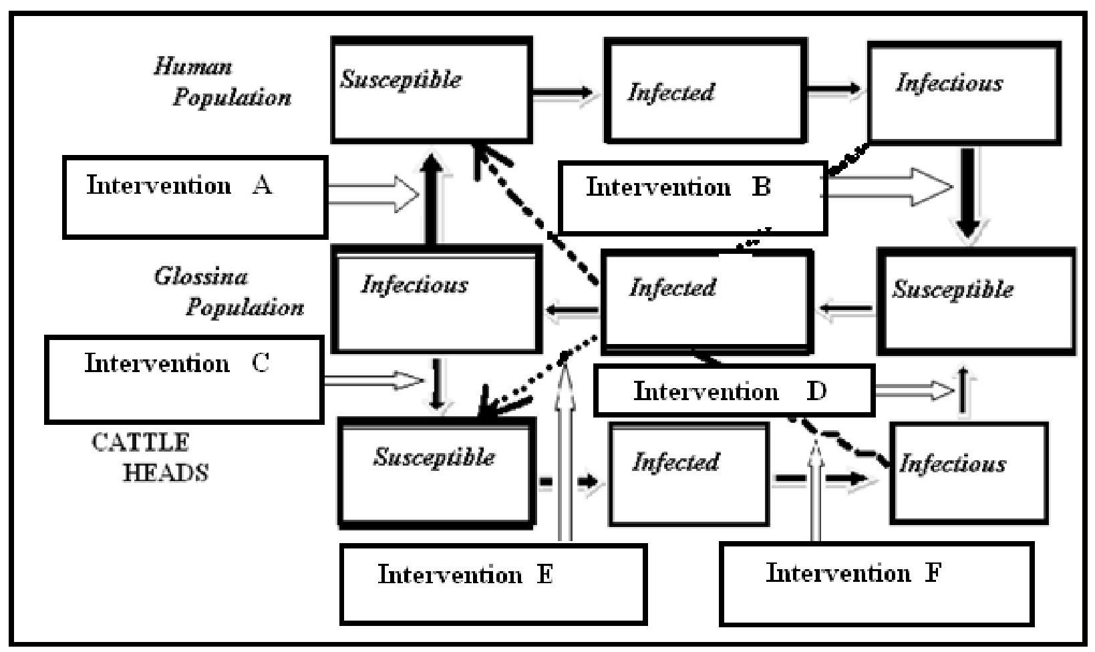

Figure 1. Planned Interruption of Human-Fly-Cattle Life Cycle

- Results

In the proposed schematic model, control
interventions are planned at six sites (Figure 1): Intervention (A) is planed between the infectious Glossina fly population and the susceptible human population, intervention (B) is intercalated between the infectious human population and the susceptible Glossina fly population. Whereas intervention (C) is planed between the infectious Glossina fly population and susceptible Cattle heads. Intervention

(D) is planed between the infectious cattle heads and the susceptible Glossina fly population. Intervention

- is intercalated between the infectious human population and the infected Glossina fly population and the susceptible cattle heads, whereas intervention

- is planed between the infectious cattle heads and the infected Glossina fly and the susceptible human population.

4. Discussions

- Why planning for intervention
Failure of the intervention program to
successfully prevent humans from being bitten by the fly would make them to become infected and later they become infective; a stage at which they

64

Nature and Science 2012;10(12) http://www.sciencepub.net/nature

themselves are capable of infecting the flies in a turn. However, still effort might be devoted to prevent the infectious human from passing the parasites to other healthy flies that might come for a blood meal bite. Again here, it should be noted failure of the control program at this stage might made the susceptible flies infected and in due time they might become infectious where they develop the capability of passing the parasites to the susceptible healthy humans and the cycle might continue if not interrupted. Intervention (A) from one hand, aims at mobilizing all the control activities at interrupting the infectious Glossina fly- Susceptible human cycle. The purpose of this intervention is to protect humans who might be susceptible to fly bites. However, intervention (B), from the other hand should disrupt the infectious human-Glossina fly cycle, preventing the susceptible Glossina fly from being infected as a result of biting the infectious human population. Fly that might have been infected as a result of biting an infectious human could also be a potential agent of introducing the disease to susceptible cattle population. Failure of intervention at this stage leads to the infection of the susceptible animals and they could therefore become infected and in the course of time they might become infectious and act as reservoir for the disease parasite. Intervention (C) should therefore interrupt the infectious Glossina population and the susceptible cattle heads.

Whereas teneral Glossina flies (flies that have not yet taken blood meal) might get infection by biting the infectious animals. Intervention at this stage might prevent this from happening. The aim of this intervention (intervention D) is to break down the infectious cattle-the susceptible fly cycle thereby preventing the parasite to reach the blood of the susceptible Glossina fly. Uninfected flies also bite the infectious human and could come and bite susceptible animal population transmitting the parasite into their blood. However, if intervention would be intercalated in between this cycle, the animal population might be saved. The aim of intervention (E) is therefore to prevent the susceptible cattle heads to bitten by the infected Glossina fly that is carrying the parasite of the disease from the infectious human population. If the human-fly cycle mentioned above not broken then the animals would be at risk of becoming infectious. Here, there exists still an opportunity to save the human population by planning an intervention between the infectious cattle and the susceptible human population by breaking the animal-Glossina fly cycle. This is exactly what intervention ( E ) should achieved if well planned.

4.2 The expected Output of the Intervention Program

65

In the figure 2, it is conspicuous that %prevalence rate of the disease drops as a function of %coverage by the control program. In other words, the % number of the infected human and animals drops with as much control of the disease as possible.

Understanding the dynamics of vector transmitted diseases is necessary in documenting the disease pattern of transmission. Many workers, for example (Connor SJ et al., 1999; Woodruff RE et al., 2006) found that mathematical models might contribute in best documenting patterns in dynamics of vector transmitted diseases. Mathematical schematic models might be valuable tools that should be considered in the whole planning stage by decision and policy makers in projecting a head of time of how to factor the program in the national budget.

Designing intervention programs for controlling African Trypanosomiasis using schematic models might play an important role in supplying the National Trypanosomiais Control Program with valuable information as to where to place the interventions.
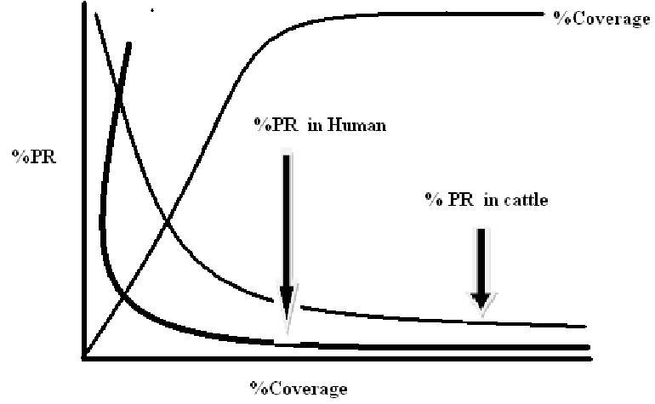

Figure 2. Hypothetical output from the hypothetical model. The horizontal x-axis shows the percentage of the population covered by an intervention of the control programe and the vertical y-axis shows the resulting percentage reduction in disease prevalence rate (PR) in human and cattle.

Conclusion

Modeling diseases control pattern using schematic models has a bright future and seems very promising. Schematic models and computer simulations can be used as experimental tools for testing control measures and determining sensitivities to changes in parameter values. The most important usage of these models is in providing policy makers with a yard stick that might lead them towards assessing the benefits that might be obtained from different intervention programs, it might contribute to the design of public health surveys especially by suggesting data that should be collected.

References
- Beals, M., Gross, L., and Harrell, S., Predator-Prey Dynamics, University of Tennessee Institute for Environmental Modeling, ©1999, http://www.tiem.utk.edu/~gross/bioed/bealsmodules/predator-prey.html-visited on 23/03/2011.
- Connor SJ, Thomson MC, Molyneux DH (1999). Forecasting and prevention of epidemic malaria: new perspectives on an old problem. Parassitologia 41: 439–448.
- Control and surveillance of African trypanosomiasis. Report of a WHO Expert Committee. World Health Organ Tech Rep Ser. 1998; 881:1–114.
- Ebeja AK, Lutumba P, Molisho D, Kegels G. Miaka mia Belinge C, Boelaert M. Sleeping sickness in the region of the town of Kinshasa: a retrospective analysis during the surveillance period 1996–2000. Trop Med Int Health. 2003;8:949–55.
- Koella JC(1991). On the use of mathematical models of malariatransmission. Acta Trop 49: 1–25.
- Laveissiere C, Sane B, Meda HA(1994). Measurement of risk in endemic areas of human African trypanosomiasis in Côte d’Ivoire. Trans R Soc Trop Med Hyg. :88:645–8.
- McKenzie FE, Baird JK, Beier JC, Lal AA, Bossert W.H(2002). A biologic basis for integrated malaria control. Am J Trop Med Hyg 67: 571–577.
- Ross R, 1911. The Prevention of Malaria. London: John Murray.
- Ross R(1928). Studies on Malaria. London: John Murray.
- Sibona, G. and Condat, C., Dynamic Analysis of a Parasite Population Model, Physical Review E 65, © 2002 The American Physical Society.
- Takken W, Snellen WB, Verhave JP, Knols BGJ, Atmosoedjono S (1990). Environmental measures for malaria control in Indonesia: a historical review on species sanitation. Wageningen, The Netherlands: Wageningen Agricultural University Papers 90-7.
- Utzinger J, Tozan Y, Singer BH(2001). Efficacy and costeffectiveness of environmental management for malaria control. Trop Med Int Health 6: 677–687.
- Watson M(1921). The Prevention of Malaria in the Federated Malay States: A Record of Twenty Years’ Progress. London: John Murray.
- Woodruff RE, Guest CS, Garner MG, Becker N, Lindsay M (2006). Early warning of Ross virus epidemics: combining surveillance data on climate and mosquitoes. Epid 17: 569–575

