Application of Geographic Information System (GIS) for mapping land use types in Musanze district, Rwanda

Alphonse Nahayo^{1,*}Concorde Nsengumuremyi¹, Isaac Ekise¹

- Higher Institute of Agriculture and Animal Husbandry (ISAE)-Busogo; Department of Forestry and Nature Conservation; P.O.Box 210 Musanze, Rwanda; Email: nahayo1@yahoo.fr
Abstract: The purpose of this study was to apply Geographic Information System (GIS) for mapping different land use types. This study was conducted in Sahara, Gisesero and Kavumu cells of Busogo Sector from May to June 2012. In this area, land use management practices are not well applied and therefore, the natural environment is being degraded and this is illustrated by the cropping on hills and mountains with high slope area while they are appropriate for forest plantations. This study provides the information on how forests and other land use types should be managed in order to sustain the environment. Global Positioning System (GPS) was used to collect data and Arc map GIS 9.2 software was used for data analysis. Results showed that forestland occupies 42.5 ha (3.15 % of total study area), the area covered by crops while it is more appropriate to grow forests occupies 45.7 ha (3.45 %), the total area that must be occupied by the forest is 6.6% and the area covered by human settlement, city and institutions is 116.5 ha (8.79 %). The remaining 1045 ha (84 % of study area) is used in agricultural activities, agroforestry and infrastructure. Forest managers should advocate for planting trees in all areas with steep slope on hills and mountains and in areas where agriculture has no potential with good sylvicultural practices and expanding the agriculture in lowland where the erosion risk is minimum.
[Nahayo A, Nsengumuremyi C, Ekise I. Application of Geographic Information System (GIS) for mapping land use types in Musanze district, Rwanda. Nat Sci 2012;10(11):163-167]. (ISSN: 1545-0740). http://www.sciencepub.net/nature. 24

Keywords: Geographic Information System (GIS), land use types, Musanze district, Rwanda

- Introduction
Land use assessment is often carried out in order to provide the information on the land use changes. The information and recommendations from land use assessment represent one of multiple inputs into the land use planning process, which often follows land evaluation (FAO, 1976). Geographic Information Systems for land use management may be characterized by two broad and related categories: a) Resource inventory and monitoring b) analysis, modeling, and forecasting to support decision making (Jordan, 1988).
Nowadays, Geographic Information Systems have been used to record and map the distribution of agricultural land uses, monitor and update agricultural land use changes, and plan and predict agricultural land use changes (Engelen, 1999). At present, climate changes and rapid population growth are making pressure on the highlands and the results are the decrease of forestland, loss of biodiversity, intensification of land degradation and soil erosion. These consequences oblige high demands on land use management practices (Pellikka, 2004).
In Busogo sector of Musanze district in Rwanda, more specifically in Sahara, Gisesero and Kavumu cells, there is a problem of poor knowledge of national forest stock: The forest mapping and inventory realized in 2007 is incomplete as it ignores forestlands smaller than 0.5ha whereas these tiny woodlots (as smaller as 0.01 ha) constitute the source of livelihoods for the majority of the population (Munyanziza et al., 2008). Human activity has led to the degradation of the environment through deforestation of existing forests by searching agricultural land and building the houses and unsuitable land use management practices. This study provides information on how different types of land use should be managed and mapped in order to sustain land resource management. The following specific objectives should be achieved: (1) to collect the attributes data of the actual land use practices in the study area; (2) to determine and map the area covered by the forests; (3) to determine and map the area covered by other land use types

2. Material and Methods
- Material and methods

Study area description
Busogo Sector is one of 15 Sectors of Musanze District in Northern Province of Rwanda. Busogo sector is made of 4 cells which are Gisesero, Sahara, Kavumu and Nyagisozi. In general Busogo Sector has a mean altitude of 2300 m with the highest point being at 2800 m a.s.l. The climate has a mean temperature of 16.7ºC and much rain comprising between 1400 and 1800 mm. Busogo Sector has 4 seasons, divided as follows: short dry season from mid December to mid February, heavy rainy season from mind February to the end June, heavy dry season extending from June to August, and short rainy season from August to mind December.
Busogo Sector has mainly volcanic soil which is very permeable with low depth on mountains and moderate depth in lower altitude. This kind of soil is subject to many erosion phenomena in the area of abrupt slope. The population is around 15.795 inhabitants, where 45.1% are male and 54.9% are female. The total surface area is 20.5km² with the population density of 787.8 inhabitants per km². Most of people in Busogo Sector are involved in agriculture and the main crops grown are potatoes, maize, beans and vegetables.

Materials
Materials used during this study are Arc Map GIS 9.2 software, GPS and Rwanda topographic map.

Methods
Field observation was primarily done in order to get the image of Sahara, Gisesero and Kavumu cells in Busogo sector, to observe how land use practices are done, and the consequences of inadequate land use management. Data were collected using Global Positioning System (GPS) and data analysis was done by using Microsoft Office Excel and Arc Map GIS 9.2 software.

- Results and discussion

The area covered by the forestland in Gisesero, Sahara and Kavumu cells of Busogo sector.

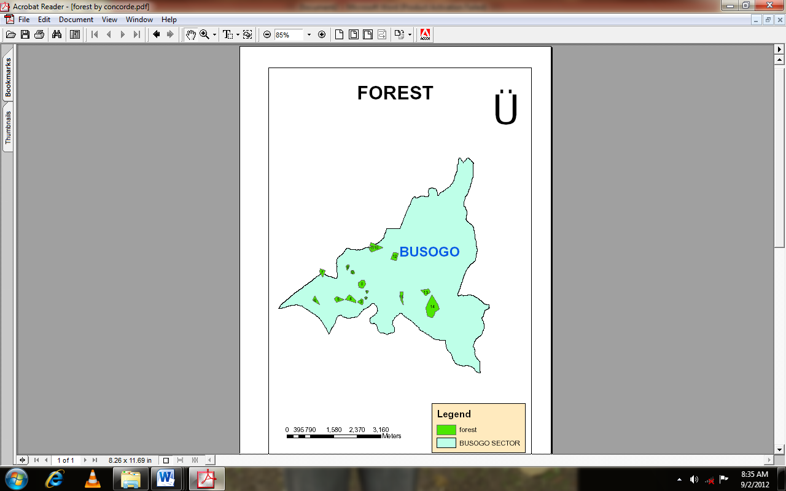
Figure 1: Area covered by the forests

Forestland in the study area is characterized by the presence of forests in both lower and higher lands of the sector. The figure 1 shows that 42 ha corresponding to 3, 15 % of the whole study area is used as forestland. Planting trees is practiced on the hilly land and large mountains that are found in Kavumu cell, the other forests on the non sloped area of Sahara and Gisesero cells. Those forestlands are characterized by over exploitation and inadequate sylvicultural practices which led to high reduction of quality and quantity of the wood production. The main forest tree species found in these cells of Busogo sector are Eucalyptus sp. The forests established on hills and mountains in Kavumu cell show positive impacts for agriculture activities practiced at the bottom of those mountains by controlling erosion. Yasin et al., 2005 confirm that based on the agricultural land topography, hills and mountains are designated to grow forest. Referring to land suitability and the steepness of the slope, forestland in Busogo sector must occupy 88.2 ha corresponding to 6.6% of the whole study area as shown by the figure 1 and 2. Similarly, Atesmachew et al., 2004 stated that higher slope areas (over 55%) are suitable for forest plantations.

The attributes data of the present forestlands
The following table 1 shows the number of forestlands in the study area, the forest ownership, the shape, the area covered by the forests in hectare and their perimeters in meters, the tree species found in each forestland, the location and the observation done on the managem

ent practice.

Table 1: Forestland attributes
Number | Ownership | Shape | Area in ha | Perimeter in meter | Tree species | Cell | Village | Management status
1 | Private | Polygon | 4.9 | 846.5 | Eucalyptus sp. | Sahara | Nyarubuye | Over exploited
2 | Private | Polygon | 0.5 | 335.8 | Eucalyptus sp. | Sahara | Nyarubuye | Over exploited
3 | Private | Polygon | 0.3 | 264.5 | Eucalyptus sp. | Sahara | Nyarubuye | Well managed
4 | Private | Polygon | 2.2 | 597 | Eucalyptus sp. | Sahara | Nyiragaju | Well managed
5 | Private | Polygon | 4.3 | 948 | Eucalyptus sp. | Sahara | Nyiragaju | Well managed
6 | Private | Polygon | 3.1 | 774.5 | Eucalyptus sp. | Sahara | N Nyiragaju | Over exploited
7 | Private | Polygon | 2.2 | 772 | Eucalyptus sp. | Sahara | Nyiragaju | Over exploited
8 | Private | Polygon | 2.7 | 709.7 | Eucalyptus sp. | Sahara | Karurambi | Over exploited
9 | Private | Polygon | 1.1 | 450.7 | Eucalyptus sp. | Sahara | Ryamukutsi | Over exploited
10 | State | Polygon | 1.1 | 406 | Eucalyptus sp. | Sahara | Ryamukutsi | Damaged by soil extraction
11 | Institution (ISAE) | Polygon | 4.2 | 999.9 | Eucalyptus sp. | Gisesero | Jabiro | Well managed
12 | Private | Polygon | 3 | 964.3 | Eucalyptus sp. | Gisesero | Jabiro | Over exploited
13 | Private | Polygon | 4.3 | 854.7 | Eucalyptus sp. | Gisesero | Jabiro | Deforestation
14 | Private | Polygon | 3.9 | 824.1 | Eucalyptus sp. | Kavumu | Gahanga | Over exploited
15 | Private | Polygon | 1.9 | 1866 | Eucalyptus sp. | Kavumu | Kaburiza | Well managed
16 | Private | Polygon | 2.8 | 1017.9 | Eucalyptus sp. | Kavumu | Karema | Damaged by erosion
Total area |  |  | 42.5

All forestlands have the same tree species and many of them belong to private owners. After making observation, we found that 68.75 % of forestlands are not well managed.

The area covered by crops
The figure 2 showed the area appropriate for forest which is used for agricultural activities (45.7 ha corresponding to 3.45%). It was determined based on the steepness of the slope on the hills and mountains and the degree of erosion caused on the lowland.
Cropping on hills and mountains caused the consequences of land loss and environmental degradation, the raison why this area must be used as forestland. Agriculture should be undertaken in areas without major negative environmental impacts therefore these hills and mountains should contain trees for protecting the environment (MINAGRI, 2004). According to Hackett (1988), agriculture on hills is not a perfect solution to the food production. It should be done in valleys and lowlands. The results showed that a part of forestland is not used correctly, because agriculture is performed on hills and mountains where forest plantations are appropriate.

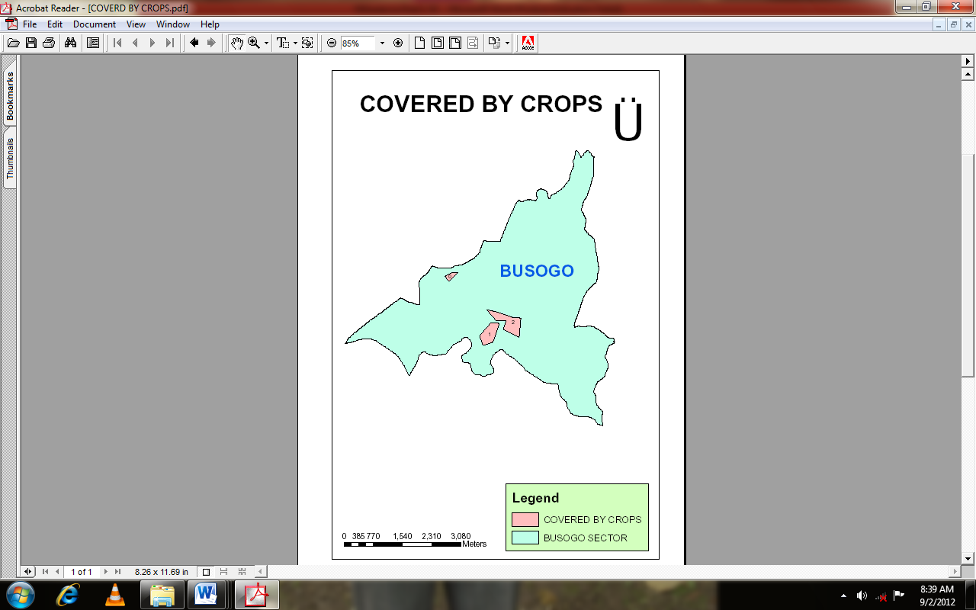
Figure 2: The area covered by agricultural crops while it should be more beneficial to grow forests

The attributes data of the area covered by crops
The following table 2 shows the number of croplands counted in the study area, the shape, the area covered by the crops in hectares and their perimeters in meters, the location and the observation done.

Table 2: The attributes data of the area covered by crops
No | Item | Shape | Area in ha | Perimeter in meter | Cell | Village | Observation
1 | Crops | Polygon | 3 | 841.4 | Gisesero | Gahanga | Erosion
2 | Crops | Polygon | 17.5 | 1734.5 | Gisesero | Kabaya | Erosion
3 | Crops | Polygon | 25.2 | 2773.2 | Kavumu | Kaburiza | High sloped area
Total area |  |  | 45.7

The table 2 shows the attributes data of the area covered by crops but appropriate for forest growing in the study area. The results showed that 45.7 ha of land are not used correctly, because agriculture is performed on hills and mountains where forests growing are appropriated. In Busogo sector, the agriculture practiced in areas with high slope on the hills and mountains has caused the increase of water velocity and then the soil erosion.

Land for human settlement, city and institutions.
The results showed that in the study area, human settlement, city and institutions are distributed as follows:

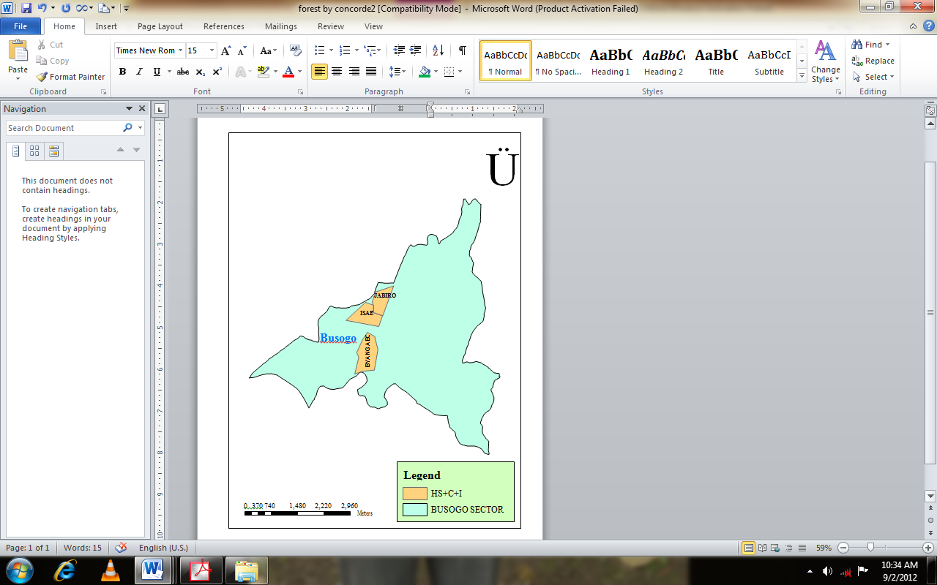
Figure 3: Area covered by human settlement, city and institutions.

Apart from the area covered by forest and crops, other land use types mapped are human settlement, city and institutions with 116.6 ha (8.79% of whole study area). The figure 3 shows the area covered by Byangabo city, ISAE buildings and Jabiro human settlement.
The proper land use method depends on the suitability or capability of land for specific purpose. The land suitability classification was developed by considering different land characteristic factors that can be quantified. Some of land characteristics are slope gradient, erosion risk and soil type.
The order of suitability ranges from suitable, that characterizes a land with sustainable use and which gives good benefits, to the land not suitable which indicates land qualities without enough sustainable outcomes. The increase human settlements have impacts on the environment through land use conversion, the development of economic and social infrastructure, the consumption of water and energy, and the generation of wastes (Krrishnamohan, 2002).

The attributes of the area covered by human settlement, city and institutions
The following table 3 shows the area covered by human settlement, city and institutions in the study area, the shape, the area in hectare and their perimeters in meters and the location.

Table 3: The attributes data of the area covered by human settlement, city and institutions
No | Item | Shape | Area in ha | Perimeter in meter | Cell | Village
1 | Byangabo city | Polygon | 50.6 | 3070.6 | Sahara and Gisesero
2 | ISAE building | Polygon | 37.5 | 2741.4 | Gisesero | Jabiro
3 | Jabiro human settlement | Polygon | 28.5 | 2326.2 | Gisesero | Jabiro
Total area |  |  | 116.5

The table 3 shows the attributes data of the area covered by Byangabo city, ISAE buildings and Jabiro human settlements with 116.5 ha.
Acknowledgements
We acknowledge the financial and technical supports provided by the Higher Institute of Agriculture and Animal Husbandry (ISAE)-Busogo for the completion of this study.
*Corresponding author
Alphonse Nahayo
Higher Institute of Agriculture and Animal Husbandry (ISAE) – Busogo; Department of Forestry and Nature Conservation; P.O.Box 210 Musanze, Rwanda; Mobile phone: +250 725 806 305; Email: nahayo1@yahoo.fr
References

1.Engelen G et al., 1999. Dynamic GIS and strategic physical planning support; London, Springer, pp.87-lll.

2.Atesmachew B et al., 2004. GIS Application for analysis of Land Suitability; Ethiopia International Livestock Research Institute (ILRI). Addis Ababa, Ethiopia, pp. 45-60

3. FAO, 1976. A framework for land evaluation. Soils Bulletin32. FAO, Rome pp. 31-43.
4. Hackett C, 1988. Matching plants and land, natural resources serie No 11 Canbera.Australia.CSIRO Division of water and land Resources. Pp 82-85

5. Jordan, C.B.K., 1988. “Forestry program fights rural poverty”, Journal of Forestry 86(5):37-41.

6. Krrishnamohan, K. 2002, 'Urban metabolism as an industrial ecology tool for sustainable development of human settlements-a viewpoint'. International Journal of Ecology and Environmental Sciences 28(1-2): 63-70.

7. MINAGRI, 2004. National Agricultural policy, pp1-40
8. MUNYANZIZA et al., 2008. Strategic Plan for the forest sector 2009-2012, Kigali pp-15

9. Pellikka P & Sirviö T, 2004. Farming and high population pressure, Department of Geography, University of Helsinki, Finland, pp14-18.

10. Yasin G et al., 2005. Determination of Grazing Pressure in Upland of the Awash River Basin, Ethiopia International Livestock Research Institute, Addis Ababa, pp. 17-19

9/18/2012

