Malaria Vaccine: Hope in the Future

Benson Otarigho

Cellular Parasitology Unit, Department of Zoology, University of Ibadan
otarighobenson@yahoo.com

Abstract: Malaria has been eating deep into the heart of mankind from time immemorial. This disease affects 10 percent of the world’s population. Every year about 2 million children are reported dead. In an attempt to control this disease since the late 1940s till date, many control measures had been put in place to reduce human suffering due to malaria. However many of these measures, if not all, had proved abortive in an effective control of this disease. Even though control, most measures are not effective, medicine will never leave mankind to her fate. The one and only hope for this human suffering to reduce or completely end, was the invention of malaria vaccine and since then, hundreds of vaccine had been developed, more than 80 had been tried at the preclinical stage, many are at the clinical phase and yet no success. However, the only one vaccine the world is waiting to be the first malaria vaccine to be licensed is the RTS, S vaccine. The RTS, S vaccine is in phase 3 presently, a clinical trial in 11 sites in seven sub-Saharan African countries. If this phase 3 clinical trial is successful, by first quarter of 2015 the world will celebrate the first successful vaccine against malaria.
[Benson Otarigho. Malaria Vaccine: Hope in the Future. Nat Sci 2012;10(11):87-95]. (ISSN: 1545-0740). http://www.sciencepub.net/nature.13

Keywords: Malaria, Control measures, Vaccine, RTS, S vaccine, Clinical and Preclinical phase

Introduction
Mankind had stepped into the 21st century and diseases such as malaria still present a major threat to population in many parts of the world (WHO, 2009). The exact extent of the malaria problem is not known, but several estimates provide a gloomy picture of the situation (Guerin et al., 2002). It is estimated that between 400 and 900 million cases occur every year only in African children with a minimum of 750,000 deaths (Martens et al., 2000). A child dies every 30 minutes from malaria, which is to say within 24hrs about 48 children die of malaria somewhere somehow in Africa.
Malaria is caused by infection with parasitic protozoa of the genus Plasmodium which infect human and insect host alternatively. Human malaria is caused by the Plasmodium species: P. falciparum which causes malignant tertian malaria; P vivax which caused benign tertian malaria; P. ovale causative agent of ovale tertian malarial and P. Malariae causative agent of quartan malaria. Thus malaria vaccine development has been an active field of research for over 2 decades, with a primary focus on Plasmodium falciparum, the deadliest of the 4 species of Plasmodia parasites that infect man (Genton et al., 2002). A recent WHO review “Portfolio of Candidate Malaria Vaccines Currently in Development” has identified more than 80 vaccines at the preclinical development stage. More than 30 malaria vaccines have entered clinical testing. Two vaccines have reached phase 2b efficacy evaluation in endemic regions, in adult volunteers and one malaria vaccine is now undergoing phase 2b evaluation in a paediatric endemic setting.

History of Malaria Control
Historically, in the late 1940s, there was great optimism in the fight against malaria, mainly owing to the introduction of dichlorodiphenyltrichloroethane (DDT) for the vector control (Hemingway et al., 2002) and chloroquine as a very efficient anti-malaria drug (WHO 2009). These and other available control tools prompted World Health Organization (WHO) to launch a campaign for complete malaria eradication. The campaign was very successful in some countries in Europe and North America. In Brazil, for instance, the number of cases per year dropped from nearly 6 million to around 37,000 in 1962 and became restricted to the Amazon region (Guerin et al., 2002). But since then, malaria has seen resurgence and/or is spreading in much area in the Amazon region of Brazil, the number of cases per year increased from nearly 37,000 in 1962 to around 600,000 in the late 1990s (WHO 2009). Indeed, already in the 1960s it became clear that eradication was not feasible, and the WHO strategy was switched, aiming to control rather than to eradicate. Environmental conditions, population habits and living condition migratory movement of people to endemic areas, regional development projects, resistance of parasites to drugs and mosquitoes to DDT, among other factors, greatly favoured the maintenance of malaria in the endemic regions (Guerin et al., 2002). All the difficulties concerning malaria control justify the search and adoption of new controls and measures to minimize the impact of malaria on the affected population (WHO, 2009).
Today, the tools available for control of malaria include drugs, insecticides, insecticide treated nets, environment management and others (Hemingway et al., 2002). With the availability of all these tools malaria infection, mortality and morbidity are still very high (Guerin et al., 2002). Therefore worldwide expectation is vaccine tool for safe and effective control (Moorthy et al., 2002)
Brief History of Malaria Vaccine
In history, modern vaccine development started over 200 years ago and it was Edward Jenner who first developed a small pox vaccine in 1789. Despite this great discovery, it was not until 1980 that WHO declared that small pox was eradicated (Paoletti, 1996). There were several other vaccines developed by renowned personality in the history of medicine whose contributions tremendously help in the control and spread of life threatening diseases; most of these vaccines were developed empirically from either killed or attenuated whole organism (Enea et al., 1984;Warrel et al., 2002). It suffices to say that these vaccines were not developed overnight as it took enormous time, energy, patience and resources to be able to do that. However, it could be said that vaccines has had a more positive effect on reducing death and helping populations across the globe (Egan, 1993).
Historically, attempt to develop an effective human malaria vaccine dates back to about 100 years, because of the complex nature of the parasite and its life cycle, little progress was made (Ellis et al., 1983). In 1900, an Italian Angelo Celli unsuccessfully attempted immunization with dried infected red blood cells to induce fever and the transfer of serum to prevent fever. There were several successful attempts in experimental animals and in 1961, McGregor and Sydney Cohen showed that children could acquire protection using gamma globulin component of immune sera (Collin et al., 1999; Warrel et al., 2002; Druilhe et al., 2007). However, the manufacturing, trial and assessment of malaria vaccine involve complex steps and thus the need to be increasingly redefined enable development of a multi-component vaccine which has both cellular and humoral components. There are recordable successes made in this regard which include the possibility of using live irradiated sporozoites to induce high levels of antibody directed against sporozoites invading liver cells circumsporozite protein (CSP), inclusion of epitopes that stimulate helper and cytotoxic T cells, synthetic peptide vaccine (SPf66) which include part of the N-terminal sequence of the merozoite surface protein, ultra-low dose infected red blood cells and MSP-1 (merozoite surface antigen) and AMA (apical merozoite antigen) acting on blood stage. The latest class is the new generation CSP vaccines with a powerful adjuvant named RTS, S which shows promising results in field trials in Africa (Kwiatkowski et al., 1997; Moorthy et al., 2002).
The RTS, S was the first candidate malaria vaccine to have reached this developmental stage; it has been subjected to extensive clinical studies in humans and had indicated possible protective efficacy especially when used in combination with an adjuvant therapy (Collin et al., 2008). In a randomized trial of SPf66 vaccine P. falciparum malaria in children in southern Tanzania, the best estimate of the SPf66 vaccine protective efficacy was 31% (95% CI: 0.52) (Alonzo et al., 1995). In another study, a double-blind randomized trial in Kenya and Tanzania, with a view to evaluate the efficacy of RTS,S given with a more immunogenic adjuvant system (AS01E) in children 5 to 17 months of age, the adjusted rate of efficacy against all malarial episodes was 56% (95% CI, 31 to 72; P<0.001) (Bejon et al., 2008) . Other clinical trials include synthetic, recombinant and DNA vaccines, and vector encoded vaccines. It should be noted that these vaccines are directed either against the development of the parasite before the blood stages appear, asexual blood stages, the sexual cycle of the parasite or against the liver stages (Warrel et al., 2002). It has been observed from trials that the single antigen CSP was not successful which lead to the issue of developing multi-component multi-antigen vaccine (MCMAV) (Abdulla et al., 2008). The MCMAV involves the use of more than one antigen with a view to get an additive effect such that together they will be much more effective thus to deal with the issue of antigenic polymorphism (Cochrane et al., 1980). The MCMAV will also ensure attack on different stages of the life cycle of the parasite, and a reduction in the chances of resistance to the vaccine by the parasite (Warrel et al., 2002). However, there are issues which include the possibility of one component interfering with the immune response to another and also the induced immune response may likely be complicated (Kwiatkowski et al., 1997; Warrel et al., 2002). Some of the Malaria Vaccines that had undergone trial and failed are shown in Table 1.
Why the World Needs Malaria Vaccines?
The world urgently needs a malaria vaccine to relieve human suffering associated with this parasitic disease that kills more than one million people annually mostly from Africa. Hundreds of millions more people suffer from the effects of malaria (Herrington et al., 1987). While drugs, insecticide-treated bed nets, and other interventions are being used to reduce malaria’s impact, the disease remains a tenacious adversary.
A safe, effective, and affordable malaria vaccine would create a powerful public health benefit by closing the gap left by other interventions (Herrington et al., 1987). Recognizing this urgent need, researchers, funders, and others in the malaria vaccine community are committed to changing the way the community works. The ultimate driver of their individual efforts is not only to publish and to fund their own research but also to develop a viable product—a malaria vaccine.
What are required of The Promising Vaccine?
According to Kilama (2007), malaria vaccine development has traveled a long and hard path. In recent years, more about malarial parasite, its biology and infectivity had been known and advanced biotechnology has helped to employ this knowledge in production of a promising vaccine against malaria. Over the last few decades, many anti-malarial vaccines had been formulated and had gone through clinical trial. But none has passed all four clinical trial phases to be licensed and used for public immunization. But happily, the clinical trials currently under way are providing an unprecedented depth of understanding of this killer disease, along with potential means of taming it. Kilama (2007) reported that an ideal malaria vaccine should have the following characteristics:
- highly effective in all ages including infants, children and adults.
- safe and not have very severe side effects.
- grant long term immunity without using multiple boosters.
- easy to administer.
- no interference with other childhood vaccines.
- easy and cheap to manufacture.
What are needed for Vaccine Development?
Vaccine development is a very difficult task and requires certain basic idea for it to arrive at the pre-clinical stage and some of these include:-
- Detail understanding of life cycle of the parasite-like that Plasmodium sp that have a complex life cycle.
- Detail understanding of the host immune responses to the parasite-even in nature enquire immunity to the malaria parasite is species specific and stage specific in nature.
- Surface protein and receptor of the parasite-some surface protein are highly immunogenic
- Funds.
Challenges of Malaria Vaccine Development and the Way Forward
Despite decades of intense research and significant advances in the field of immunology and molecular biology, the development of an effective vaccine for the control and prevention of malaria has been difficult. Development of an effective vaccine for malaria is challenging because: (1) the pathogen’s antigenic composition during different stages of the life cycle is complex; (2) there is multiplicity of epidemiology and clinical end points; (3) the candidate vaccine antigens exhibit genetic diversity and variation; (4) we lack a complete understanding of the characteristics of naturally acquired immunity and the mechanism of protection, and (5) alum, the adjuvant approved for human use has not worked well in human trials conducted so far (Ribeiro, 2002).
There is ample evidence suggesting that a malaria vaccine for prevention and control of malaria is feasible, and there is a consensus that an effective malaria vaccine would contain antigens/antigenic determinants from different stages of the parasite. Such a multistage, multicomponent vaccine would induce ‘multiple layers’ of immune response that would be capable of intervening at the level of circulating sporozoites, infected hepatocytes, infected red blood cells, and mosquitoes. The first evidence for an efficacious vaccine was provided in 1960s by immunizing mice with radiation-attenuated sporozoites (Nussenzweig et al., 1969). Several studies have shown that natural immunity confers protection against high-density parasitemia and clinical manifestations of illness (Kitua, 1999; Branch, 2000). Similarly, several studies have revealed that antibodies against specific parasite antigens can block the development of the parasite in mosquitoes (Kaslow, 1997). These observations have provided the proof-of-the-principle that a vaccine can be developed for the control and prevention of malaria. The challenge facing vaccine researchers is to develop an easy-to-produce recombinant vaccine that can generate long-lasting protective immune responses that are: (1) directed against different stages of the parasite; (2) strain-transcending, and (3) boosted by natural infection (Ribeiro, 2002).
Pre-erythrocytic Stage Malaria Vaccine: One strategy towards the pre-erythrocytic stage is to target the parasite during the short span of time that the sporozoites are in the bloodstream. This sporozoite vaccine must induce the production of protective antibodies that will block and neutralize the sporozoites from invading liver cells. The other strategy is to target the sporozoites once they are inside the liver cells through the induction of cytotoxic thymus lymphocytes (CTLs) that will destroy sporozoite infected liver cells (Genton et al., 2002; Graves et al., 2006). Example of this is CSP - a vaccine based on the circumsporozoite protein (CSP) has been developed and field tested in humans in a malaria-endemic region of Kenya. RTS, S - is a recombinant vaccine consisting of the circumsporozoite protein found on the surface of the sporozoite stage of Plasmodium falciparum (Alonso et al., 1994). This antigen elicits antibodies that are capable of preventing sporozoites from invading hepatocytes, and a cellular response that is capable of eliminating infected hepatocytes. The problem with the circumsporozoite protein is that it is poorly imunogenic (Bojang et al., 2001; Alonso et al., 2005). Therefore, in the RTS, S vaccine, the circumsporozoite protein is fused with a hepatitis B surface antigen, which creates a much more potent vaccine (MVI, 2009).

Table 1: Different malaria vaccine and efficacy
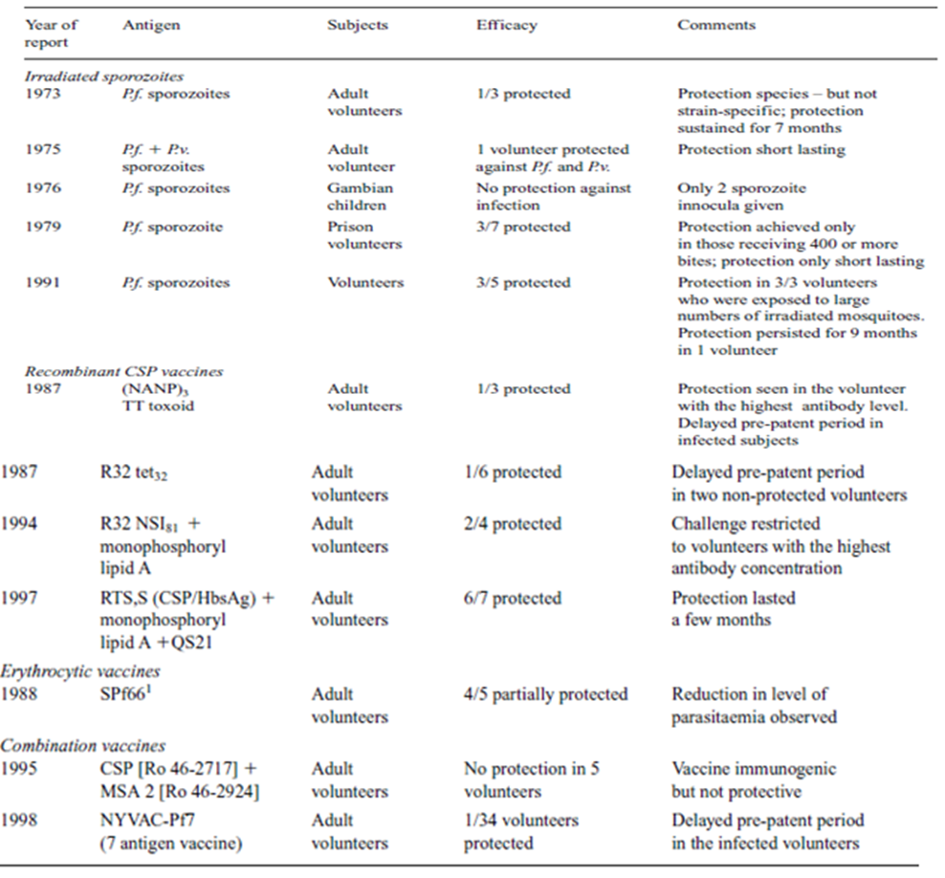
Source: Perlman et al.,2002

Erythrocytic Vaccine: Another approach is to induce blocking antibody towards the circulating merozoites, preventing them from infecting red blood cells. Once inside the erythrocytes, cytotoxic thymus lymphocytes (CTL) cannot be generated against them since red blood cells do not express MHC (major histocompatibility complex) molecules on its surface. However, some malaria antigens are expressed on the surface of the infected RBCs toward which antibodies can be directed against and be used for opsonization and complement (Rieckmann et al., 1979). Also, it may be helpful to induce antibodies that block the infected erythrocytes from adhering to the lining of blood vessels. It is during the erythrocytic stage that illness associated with malaria occurs. There are strategies, called 'anti-disease' vaccines, towards the toxic products produced during this phase. Example is SPf66 - the first recognized malaria vaccine. SPf66 was developed in Colombia by Manual Patarroyo in 1987 by purifying three merozoite-derived proteins and joining them with sequences derived from the repeat domain of the CS protein of P. falciparum.
Transmission Vaccine: There are also attempts to produce a 'transmission-blocking' vaccine. This approach targets the sexual stage gametocytes of malaria. The goal is to prevent the gametocytes from producing more sporozoites within the gut of the mosquito vector, thus blocking the transmission of malaria (Rieckmann et al., 1979;Clyde, 1990; Kennedy et al., 2002). This vaccine does not prevent illness in an infected host, but it may be important to reduce the spread of malaria (Good et al., 1988; Graves et al., 2006). An example is Pfs230 - This sexual-stage Plasmodium falciparum surface antigen can elicit antibodies which block the infectivity of gametes to mosquitoes.
Multistage Vaccine: This is designed by combination of antigens from different stages of the parasite Example is NYVAC-Pf7 - A recently developed multistage vaccine, NYVAC-Pf7 is a single NYVAC genome containing genes encoding seven Plasmodium falciparum antigens (Zevering et al., 1994; Ribeiro, 2002). Of these antigens, two are derived from the sporozoite stage of the parasite life cycle (CSP and sporozoite surface protein 2 (PfSSP2)), one from the liver stage (liver stage antigen 1 (LSA1)), three from the blood stage (merozoite surface protein 1 (MSP1), serine repeat antigen (SERA), and AMA-1), and one from the sexual stage (25-kDa sexual- stage antigen (Pfs25). The intent is that the use of multiple antigens from P. falciparum will induce immunity in recipient (Graves et al., 2006).

Hope in Progress
There is hope for malaria vaccine in the nearest future, because of there is more understanding of the life cycle of the parasite, also more understanding of the parasite genome, more understanding of the host immunity to the parasite and other which are detailed below.
DNA Vaccines - The ideal vaccine for malaria should encompass the following three essential characteristics: First, it is multi-stage, incorporating antigenic characteristics of multiple stages of P. falciparum’s life cycle. Second, it should be multi-valent, containing multiple epitopes restricted by different (major histocompatibility complex) MHC molecules (Ballou et al., 1987). This would help overcome genetic restriction and allelic and antigenic variation, problems plaguing single antigen-based vaccines (Graves et al., 2006). Lastly, it should be multi-immune, inducing more than one type of immune response, including cell-mediated and humoral. Such a multi-component vaccine would increase the probability of a more sustainable and effective host response (Ballou et al., 1987;Shi et al., 1999).
Consequently, the focus of current malaria vaccines is on DNA technology, which allows the reality of these three key characteristics. DNA Vaccines are currently in developments and include multiple B and T cell epitopes from different life cycle stages. This technology theoretically can incorporate the roles of both the cell-mediated and humoral arms of the immune system, which are needed for optimal protective efficacy. Cytotoxic thymus lymphocytes (CTLs) are needed against the intracellular hepatocyte stage, and antibodies can be targeted against antigens from all three life cycle stages. Two experiments illustrate this point. First, in an experiment by Wang et al., (1998) antigen-specific, genetically restricted, CD8+ T cell-dependent CTLs were developed against a P. falciparum circumsporozoite protein (PfCSP). This type of cell-mediated response would be directed against infected hepatocytes, since they have the appropriate MHC I molecules, while in contrast, erythrocytes lack MHC (Genton et al., 2002). Second, a multi-component vaccine created by Shi et al (1999), consisting of B and T-cell epitopes revealed the production of vaccine-elicited antibodies against all antigenic stages of P. falciparum. Examples of such antigens would be circumsporozoite-A on sporozoites and PfEMP-1 on PRBCs. A technical issue arose in this experiment that is applicable to future vaccine development. There was concern from preliminary data that a tandem arrangement of epitopes in the construct might generate epitope competition and/or complications with antigen processing and presentation, thus failing to elicit epitope-specific immune responses. Consequently, future research should be directed at determining an appropriate epitope sequence.
It appears, then, that multi-component DNA vaccines offer the best prospects for protection against malaria and subsequent cerebral malaria development. They can be tailored to include a variety of numbers and types of epitopes, and the arrangement of these epitopes can be altered as well. In addition, there are numerous other advantages of DNA vaccines over conventional vaccines, including high immunogenicity, modifiability, stability, and cost. Recent large-scale Phase I/II clinical trials of Spf66 and NYVAPf-7, two multi-component synthetic peptide malaria vaccines, revealed only limited protection. Thus, the need for DNA-based vaccine technology is apparent. The efficacy of these future DNA vaccines may be increased by adjuvant use. Shi et al.,(1999) demonstrated that adjuvants can have a significant influence on antibody response activity when used in conjunction with vaccines. Freund’s adjuvant was shown to produce higher level of antibodies, while block-copolymer adjuvant induced higher affinity antibodies.
There are some safety issues associated with DNA vaccines. There is the potential for insertional mutagenesis, in which random integration of the injected DNA into the host chromosome occurs. Although unlikely, this might lead to oncogene activation. In addition, there are possible adverse consequences with long-term persistence of a foreign antigen and induction of autoimmunity or hyper-immunity (Genton et al., 2002).
The RTS, S Malaria Vaccine Candidate
RTS, S is the malaria vaccine candidate that went furthest in the development process (MVI, 2011), in clinical trials conducted over the past decade. It is the first vaccine candidate to demonstrate that it can provide substantial, although not complete, protection for young children and infants in malaria-endemic areas against infection and clinical disease caused by Plasmodium falciparum (WHO, 2005; Stoute et al., 2007). In 2011, RTS, S is in the midst of a large-scale Phase 3 trial that involves 11 study centers in seven African countries. The RTS, S malaria vaccine candidate was created in 1987 by scientists working at GlaxoSmithKline Biological laboratories, the vaccine division of GlaxoSmithKline (GSK). Its early development was undertaken by GSK in close collaboration with the Walter Reed Army Institute of Research. In January 2001, GSK and the PATH Malaria Vaccine Initiative (MVI)—with grant money from the Bill & Melinda Gates Foundation to MVI—entered into a public-private partnership to develop the vaccine for use in infants and young children in sub-Saharan Africa (MVI, 2011).
RTS, S Results to Date
Evaluation of RTS, S in adult volunteers began in the United States in 1992 and in Africa in 1998. Results of a Phase 2 trial, initiated in 2002 and conducted with more than 2,000 children in southern Mozambique, demonstrated the feasibility of administering a malaria vaccine in children. The trial for this malaria vaccine candidate was the first to establish proof-of-concept of efficacy in infants.
The results of two distinct studies in infants and in young children living in Africa were published in the New England Journal of Medicine in December 2008. The studies demonstrated that RTS, S can provide significant protection against malaria infection and clinical disease. The study of children aged 5 to 17 months showed that RTS, S reduced the risk of clinical episodes of malaria by 53 percent over an eight-month follow-up period and was shown to have a promising safety profile (MVI, 2010). Figure 1 illustrates RTS, S Key milestones till date (MVI, 2011).

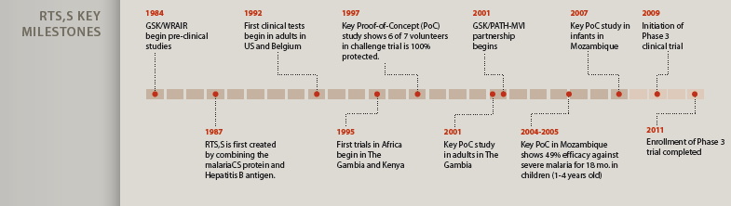
Figure 1: RTS, S Key milestones
Source: MVI, 2011

Next Steps in Advancing RTS, S
RTS, S is the first malaria vaccine candidate to reach large-scale Phase 3 clinical testing, typically one of the last steps before regulatory approval (figure 1). The Phase 3 efficacy trial began in May 2009, with the first child vaccinated in Bagamoyo, Tanzania, one of 11 trial sites in seven sub-Saharan African countries participating in the study (the others are Burkina Faso, Gabon, Ghana, Kenya, Malawi, and Mozambique) (figure 2). The trial completed enrollment on January 31, 2011 (figure 3), with a total of 15,461 confirmed participants, including 6,538 infants aged 6 to 12 weeks and 8,923 children aged 5 to 17 months. Initial results from the study are expected in late 2011 for the 5 to 17 month-old group and in late 2012 for the 6 to 12 week-old group. The final analysis is expected in late 2014 (MVI, 2011).
If all goes well in Phase 3 testing, the World Health Organization has indicated that a policy recommendation for RTS, S is possible as early as 2015, paving the way for implementation in countries through their expanded program on immunization. Already, MVI, GSK, and other partners are working to ensure that RTS, S—if approved for use—reaches the children and infants who need it most as quickly as possible.

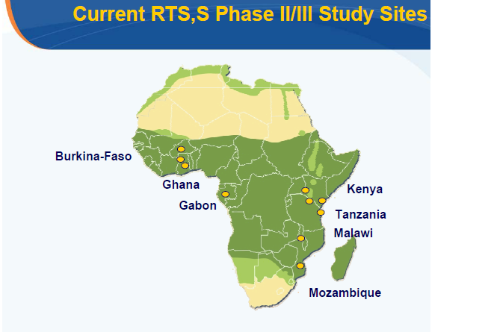
Figure 2: Current RTS, S phase III study sites
Source: MVI, 2011

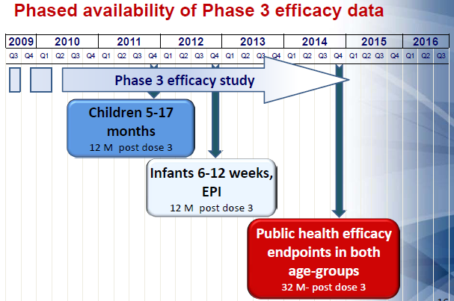
Figure 3: Phased availability of phase 3 efficiency data.
Source: MVI, 2011

Conclusion
Malaria vaccine has traveled a long and hard path. Time has now come for malaria vaccine to be a reality. The waiting has been for too long. RTS, S vaccine may be available in the next 3-5years. Malaria vaccines are going to be efficient control tool in next generation. Although they are in their trial phases and there is no one in market at present. However, this is just the beginning.

Corresponding Author:
Otarigho Benson, Parasitology Research Unit,
Department of Zoology, University of Ibadan, Nigeria.
E-mail: otarighobenson152799@gmail.com

References
- WHO. Malaria—a global crisis. Geneva: World Health Organization 2009; 4:5-9.
- Guerin PJ. Malaria: current status of control, diagnosis, treatment, and a proposed agenda for research and development. Lancet Infect Dis 2002; 2: 564–573.
- Martens P, Hall L. Malaria on the move: Humans population movement and malaria transmission. Emerg Infect Dis 2000; 6: 103–109.
- Genton B, Betuela I, Felger I, Al-Yaman F, Anders RF, Saul A, Rare L. A recombinant blood-stage malaria vaccine reduces Plasmodium falciparum density and exerts selective pressure on parasite populations in a phase 1–2b trial in Papua New Guinea J Infect Dis 2002; 185: 820–827.
- Hemingway J, Field L, Vontas J. An overview of insecticide resistance. Science 2002; 298: 96–97.
- Moorthy V, Hill AV. Malaria vaccines. Br Med Bull 2002; 62: 59–72.
- Paoletti E. Applications of pox virus vectors to vaccination: an update. Proc Natl Acad Sci USA 1996; 93: 11349–11353.
- Enea V, Ellis J, Zavala F, Arnot DE, Asavanich A, Masuda A, Quakyi I, Nussenzweig R. S. DNA cloning of Plasmodium falciparum circumsporozoite gene: amino acid sequence of repetitive epitope. Science 1984; 225: 628–630.
- Warrel DA, Gilles HM. Essential Malariology. 4th edition. Arnold 2002; 23-30.
- Egan J. Humoral immune responses in volunteers immunized with irradiated Plasmodium falciparum sporozoites. Am. J. Trop. Med. Hyg 1993; 49: 166–173.
- Ellis J, Ozaki LS, Gwadz RW, Cochrane AH, Nussenzweig V, Nussenzweig RS, Godson GN. Cloning and expression in E. coli of the malarial sporozoite surface antigen gene from Plasmodium knowlesi. Nature 1983; 302: 536–538.
- Collins WE, Jeffery GM. A retrospective examination of secondary sporozoite- and trophozoite-induced infections with Plasmodium falciparum: development of parasitologic and clinical immunity following secondary infection. Am. J. Trop. Med. Hyg 1999; 61: 20–35.
- Druilhe P, Barnwell JW. Pre-erythrocytic stage malaria vaccines: time for a change in path. Curr Opin Microbiol 2007; 10: 371-8.
- Kwiatkowski D, Marsh K. Vaccine series: development of a malaria vaccine. Lancet 1997; 350: 1696–701.
- Collins WE, Barnwell JW. A hopeful beginning for malaria vaccines. N Engl J Med 2008; 359: 2599-2601.
- Alonzo PL, Smith T, Schellenberg JR. Randomised trial of SPf66 vaccine against Plasmodium falciparum malaria in children in southern Tanzania. Med Trop 1995; 55(4): 41-6.
- Bejon P, Lusingu J, Olotu A. Efficacy of RTS,S/AS01E vaccine against malaria in children 5 to 17 months of age. N Eng J Med 2008; 359(24): 2521-32.
- Abdulla S, Oberholzer R, Juma O, Kubhoja S, Machera F, Membi C, Omari S. Safety and immunogenicity of RTS,S/AS02D malaria vaccine in infants. N. Engl. J. Med 2008; 359: 2533–2544.
- Cochrane AH, Nussenzweig RS, Nardin EH. Immunization against sporozoites. In: Kreier JP, ed. Malaria. New York 1980: New York Academic Press.
- Herrington DA, Clyde DF, Losonsky G, Cortesia M, Murphy JR, Davis J, Baqar S. Safety and immunogenicity in man of a synthetic peptide malaria vaccine against Plasmodium falciparum sporozoites. Nature 1987; 328: 257–259.
- Perlman P, Troye-blomberg M. Malaria Immunology. Chem. Immunology 2002; 80: 366-39.
- Kilama, W. Malaria- a serial killer. http://www.malariavaccine.org retrived on 2nd Feb. 2011.
- Ribeiro SHG. Malaria Vaccine: Candidate Antigens, Mechanism, Constraint and Prospects. Scand J, Immol 2002; 56:327-343.
- Nussenzweig RS, Vanderberg J, Most H, Orton C. Protective immunity produced by the injection of X-irradiated sporozoites of Plasmodium berghei. Nature 1967; 216:160–162.
- Kitua AY, Urassa H, Wechsler M, Smith T, Vounatsou P, Weiss NA, Alonso PL, Tanner M. Antibodies against Plasmodium falciparum vaccine candidates in infants in an area of intense and perennial transmission: Relationships with clinical malaria and with entomological inoculation rates. Parasite Immunol 1999; 21:307–317.
- Branch OH, Oloo AJ, Nahlen BL, Kaslow D, Lal AA. Anti-merozoite surface protein-1 19-kDa IgG in mother-infant pairs naturally exposed to Plasmodium falciparum: Subclass analysis with age, exposure to asexual parasitemia, and protection against malaria. V. The Asembo Bay Cohort Project. J Infect Dis 2000; 181:1746–1752.
- Kaslow DC. Transmission-blocking vaccines:Uses and current status of development. Int J Parasitol 1997; 27:183–189.
- Graves PM, Gelband H. Vaccines for preventing malaria (SPf66).Cochrane Database Syst. Rev. Issue 2. Art. no.: CD005966. DOI: 10.1002/ 14651858.CD005966.
- Bojang KA, Milligan PJ, Pinder M, Vigneron L, Alloueche A, Kester KE, Ballou WR. Efficacy of RTS, S/AS02 malaria vaccine against Plasmodium falciparum infection in semi-immune adult men in The Gambia: a randomised trial. RTS, S Malaria Vaccine Trial Team. Lancet 2001; 358: 1927–1934.
- Alonso PL, Sacarlal J, Aponte JJ, Leach A, Macete E, Aide P, Sigauque B. Duration of protection with RTS,S/AS02A malaria vaccine in prevention of Plasmodium falciparum disease in Mozambican children: single-blind extended follow-up of a randomised controlled trial. Lancet 2005; 366: 2012–2018.
- MVI. RTS,S/AS01 Candidate Malaria vaccine Summary for the SAGE meeting. Glaxo Kline Smith 2009; 1-13.
- Rieckmann KH, Beaudoin RL, Cassells JS. Use of attenuated sporozoites in the immunization of human volunteers against falciparum malaria. Bull. WHO 1979; 57 (suppl 1), 261–265.
- Clyde, D. Immunity to falciparum and vivax malaria induced by irradiated sporozoites. A review of the University of Maryland studies. Bull WHO 1990; 68 (suppl), 9–12.
- Kennedy MC, Wang J, Zhang Y, Miles AP, Chitsaz F, Saul A, Long CA. In vitro studies with recombinant Plasmodium falciparum apical membrane antigen 1 (AMA1): production and activity of an AMA1 vaccine and generation of a multiallelic response. Infect. Immun 2002; 70: 6948–6960.
- Good M F, Pombo D, Quakyi IA, Riley EM, Houghten RA, Menon A, Alling DW. Human T-cell recognition of the circumsporozoite protein of Plasmodium falciparum: immunodominant T-cell domains map to the polymorphic regions of the molecule. Proc. Natl. Acad. Sci USA 1988; 85: 1199–1203.
- Zevering Y, Khamboonruang C, Good MF. Natural amino acid polymorphisms of the circumsporozoite protein of Plasmodium falciparum abrogate specific human CD41T cell responsiveness. Eur. J. Immunol 1994; 24: 1418–1425.
- Ballou WR, Hoffman SL, Sherwood JA, Hollingdale MR, Neva FA, Hockmeyer WT, Gordon DM. Safety and efficacy of a recombinant DNA Plasmodium falciparum sporozoite vaccine. Lancet 1987; 1: 1277–1281.
- Shi YA, Ping. Immunogenicity and in vitro protective efficacy of a recombinant multistage Plasmodium falciparum candidate vaccine. Proc. Natl. Acad. Sci. USA 1999; 96: 1615-1620.
- Wang R. Induction of antigen-specific cytotoxic T lymphocytes in humans by malaria DNA vaccine. Science 1998; 282: 476–480.
- MVI. Vaccine Research on Malaria. PATH Malaria Vaccine Initiative (MVI) strategy 2011; 1-32.
- WHO. Portfolio of candidate malaria vaccines currently in development. Geneva : World Health Organization 2005; 7:1-17.
- Stoute JA, Slaoui M, Heppner DG, Momin P, Kester KE, Desmons P, Wellde BT. A preliminary evaluation of a recombinant circumsporozoite protein vaccine against Plasmodium falciparum malaria. RTS, S Malaria Vaccine Evaluation Group. N. Engl. J. Med 1997; 33: 86–91.
- MVI. The RTS, S malaria vaccine candidate. PATH Malaria Vaccine Initiative (MVI) strategy 2010; 1-20.

9/5/2012

