**Antimicrobial Activity of Orchid. Root Eastern Peninsular Flora in India.**

*A.Kalaiyarasan1, S.Ahmed john2, A.Edward3

1, P.G & Research Department of Botany Jamal Mohamed College, Tiruchirappalli- 620 020. Tamilnadu. India.

2, P.G & Research Department of Botany Jamal Mohamed College, Tiruchirappalli- 620 020. Tamilnadu. India.

3, Department of Biotechnology, St. Joseph’s College, Tiruchirappalli- 620 020 Tamilnadu, India.

[myla_kalai@yahoo.com](mailto:myla_kalai@yahoo.com)

**Abstract:** Medicinal plants are potential of antimicrobial activity. The phytochemical screening and antimicrobial investigation was made from root extracts of Bulbophyllum Kaitense. The plant material were collected and shade dried. The petroleum ether, chloroform. Ethanol and queous extracts were prepared using with soxhlet apparatus. The various extracts revealed that presence of phytocomponeds of terpenoids, sponins, Tanins, Courmarin, quinine, Glycosides, Carbohydrates and sugar. The antibacierial activity was studied by using agar-wee diffusion method. The results showed that ethanol and chloroform extracts inhibit the growth of organisms. The maximum zone of inhitition was observed in salmonalla typhi (20mm) salmonalla paratyphi (20 mm), Pseudomonas aeruginosa (20mm) and micrococcus Sp., (23mm) ethanolic root extracrt. Shigella flaxineri, streptococcus and Bacillus subtilis indicate moderate activity is both extracts. Antifungal activity was studied the result showed that petroleum ether. Chloroform. Ethanol and aqueous extracts. Inhibit the growth of all organisms. Antifungal organisms more or less activity. It is the first investigation of Bulbophyllum kaitense.

[A. Kalaiyarasan, S.Ahmed john, A.Edward.  **Antimicrobial Activity of Orchid. Root Eastern Peninsular Flora in India.** *Nat Sci* 2012;10(11):63-67]. (ISSN: 1545-0740). <http://www.sciencepub.net/nature>. 10

**Keywords:** *Bulphyllum kaitense,* Antimicrobial activity, Phytochemicals, Extract.

**1.Introduction**

Bulbophyllum kaitense. Rechib, Belongs to family orchidanceae. Aterrestrial orchid. This is an epiphytic and endemic plant of south India. It is very common and available only from dense mater ontress and rocks. This is native of India occurs in the forest of estern perisulor flora from kolli hills above 1300m. sympodial epiphytes with unimodel pseudobulb infloroscense. Umbellate scape Pseudobulbs grennish. Sub fusiform not angled 2cm long 3-5 cm part on the zone leaves 9-13 cm long flowers without mentum. Sepal unequal petals shorter then lateral sepals. The plants have been used in indigenous medicine. This information was gathered by questioning local fraditional healers and knowledgeable village people of the kolli hills. A part of the Estern penisulor flora in south India.

**Materials and Methods**

The healthy plant materials of Bulbophyllum kaitense root were collected from the Eastern penisulor flora is south India. Kolli hills. Tamilnadu. September 2011. the specimen thus obtained and authenticated by Ret. Dr. S.John Britto. The Director, The Rabinat Herbarium. St. Joseph’s College, Tiruchirappalli, Tamilnadu, India. with the help of herbarium record. The plant voucher number RHT 872.

**Preliminary Phytochemicals Screening**

The solvent extracts were subjected to routine qualitative chemical analysis to identify the nature of phytochemical constituents present in them. Standard procedures were followed to identify the

described by tharborne (1973) and Brindha etal., (1982).

1. **Test for Terpenoids**

5 ml of the extract was mixed with 2 ml of chloroform and concentrated sulphuric acid to form a layer. A reddish brown coloration in the interface showed the presence of terpenoids.

1. **Test for flavonoids**

5 ml of the diluted ammonia solution a portion of the aqueous extract was added, followed by addition of concentrated suphuric acid. Appearance of yellow coloration indicates the presence of flavonoids.

1. **Test for Reducing Sugars**

2 ml of test solution was added with a 2 ml Fehling’s reagent. A (or) B. and 2 ml of water formation of reddish orange color indicates the presence of reducing sugar.

1. **Test for Phenols**

2 ml of test solution in alcohol was added with one drop of neutral ferric chloride 5% solution. Formation of intense blue color indicates the presence of phenols.

1. **Test for Catechins**

2 ml of test solution in alcohol was added with Ehrich reagent and a few drops of concentrated HCl formation of pink color indicate the presence of catechins.

1. **Test for saponins**

2 ml of test solution was added with H2O and shacked formation of foamy eather indicates the prsence of saponins.

1. **Test for Tanins**

2 ml of test solution was added with H2O and head acetate. Formation of while precipitate indicates the presence of tannins.

1. **Test for Anthroquinone**

2 ml of test solution was added with magnesium acetate. Formation of pink color indicates the presence of Anthroquinones.

1. **Test for Quinine**

1 ml of extract, 1 ml of concentrated sulphuric acid was added and was allowed to and for some time to develop color. Development of red color shows the presence of quinine.

1. **Test for Coumarin**

1 ml of extract, 1 ml of 10% NaOH was added and was allowed to stand for some time development of yellow color shows the presence of coumanin.

1. **Test for Glycosides**

1 ml of the extract, 1 ml of alpha napthol was added to which chloroform was added along the sides and it was looked for the development of color and the result was recorded. Development of Violet color indicates the presence of glycosides.

1. **Test for Carbohydrate**

Aqueous or alcoholic solution of substance was added with 10% aqueous solution of alpha Napthol shaken and added concentrates sulphuric acid along the side of the side of the tuve. Violet ring at the Junction of two liquids shows presence of Carbohydrates.

1. **Test for Sugar**

0.5 ml of the Filtrate. 0.5 ml Benedict’s reagent was added. The mixture was heated on boiling water both for 2 minutes. A characterisets of red coloured precipitate shows presence of sugar.

**Antimicrobial Activity**

The extracts were tested for the antibacterial activity. The microbial strains employed in the biological assays were Gram-Positive bacterial Streptococcus pneumoniae (MTCC 2672), Bacillus subtilis (MTCC 441), Gram- negative bacteria: Salmonella typhi (MTCC 734) Salmonella paratyphi (MTCC 735) Pseudomonas aeruginosa (MTCC 2474) Escherichia coli (MTCC 119), Klebsilla pneumoniae (MTCC 3040), Entrobacter facalis, Shigella flexneri, Micrococcus sp., Fungal strains: Asperigillus fumicatus (MTCC 2584), Trichophyton rubrum (MTCC 296). Microsporum gypseum (MTCC 2819) Aspergillus flavors (MTCC 2813), Aspergillus niger (MTCC 2612) Mucor Sp.,

**Determination of Antibacterial Activity**

**Agar well diffusion assay**

Agar well diffusion method was followed. Muller-Hinton Agar (MHA) plates were swabbed (Sterile cotton Swabs) with 8-12 h old brothe cultures of the respective bacteria. Sterile circular steel was used to make wells, each measuring 8mm diameter, in each of the plates. About 0.3 ml each of 50, 25, 12.5 and 6.25 mg/ml of concentrated test sample swith DM so was added into the wells using sterilized dropping micropipettes and allowed for diffusion at room temperature for 2h. The plates were incubated at 37◦C for 24 h. The solvent without extracts served. After 24 h of incubation, diameter of the inhibition zone was recorded in mm. The experiment was repeated thrice and the average values were calculated for antibacterial activity.

**Determination of Antifungal Activity**

Agar well diffusion method was followed but nutrient medium used was sabouraud Dextrose Agar (SDA). The sabouraud Dextrose Agar plates were swabbed (Sterile Cotton Swabs) with 8 h old broth culture of the respective fungi. A sterile cork borer was used to place four wells, each measuring 8 mm in diameter, in each of the plates, about 0.1 ml each of 50, 25, 12.5 and 6.25 mg/ml of concentrated test samples with DMSO was added into the wells using sterilized dropping micro pipettes and allowed for diffusion at room temperature for 2h. The plates were incubated at 28◦C for 18-24 h. Diameter of the inhibition zones was recorded the experiment was repeated thrice and the average values were calculated for antifungal activity.

**Results**

Preliminary phytochemical analysis of various solvent extracts such as Petroleum either, Chloroform, Ethanol and aqueous of the *Bulbophyllum kaitense* root recorded in the (Table1) Terpenoids, Saponins, Tanins, Coumarin, Quinine, Glycosides, Carbohydrates were present in the chloroform extract. The petroleum ether extract alone contains Terpenoids, sponins, Tanins, Quinine, Carbohydrates and Sugar. The ethanol extract alone contains Tanins, Coumarin, Quinine, carbohydrates were as aqueous extract alone contains Tanins, Cumarin Different solvent extracts of *Bulbophyllum kaitense*  root were tested antibacterial activity.

The values were recorded and averaged (Table:2) such as petroleum ether, chloroform ethanol and aqueous were tested. Gram negative bacterial organisms were highly sensitive the gram positive bacteria in tested plant extracts. The zone of inhibition ranging from (12mm-23mm) against Microscoccus sp., Pseudomonas aeruginosa, Klebsilla pnemoniae, Bacillus subtilis, Entrobacter facalis, recorded in ethanol extracts were expressed more or less similar activity in petroleum ether, and aqueous extracts.The Bulbophyllum Kaitense Rechib root antifungal activity of ethanol extract showed highly sensitive activity (ranging from 12mm-23mm) receptivity (Table: 3) petroleum ether and chloroform extracts showed more or less activity.

**DISCUSSIONS**

The present work clearly denord maximum activity was observed from the *Bulbophyllum kaitense* root extract was potent against sixteen tested microbial strains depended manner. There are effectiveness of traditional herbs against gram positive and gram negative microorganisms and as a result this that plant extract used as a antimicrobial and antibacterial diseases. However, it was more active against fungal strains. The potential of compounds against the standard strains may be explored in order to develop therapeutics for micro organism. The results of the current to investigation provide scientific support for the claims of the medicinal plant. The microbial infections are possible if active principles from solvent extracts are tested pharmacologically and clinically.

**Conclusion**

Plants is the new versatile tool for the medicine of various diseases currently allopathy medicines are made by chemically that was cured aspect of diseases but it will make very big drawback of side effects. so we have to used naturally occurring medicines or drug are derived from plants. I am sure that plants are doing not affect side effects. In south people many plants are used as not for medicine. It’s used as plants are food of medicine like daily. Present work is scientific support for the drug discovery from herbal medicines.

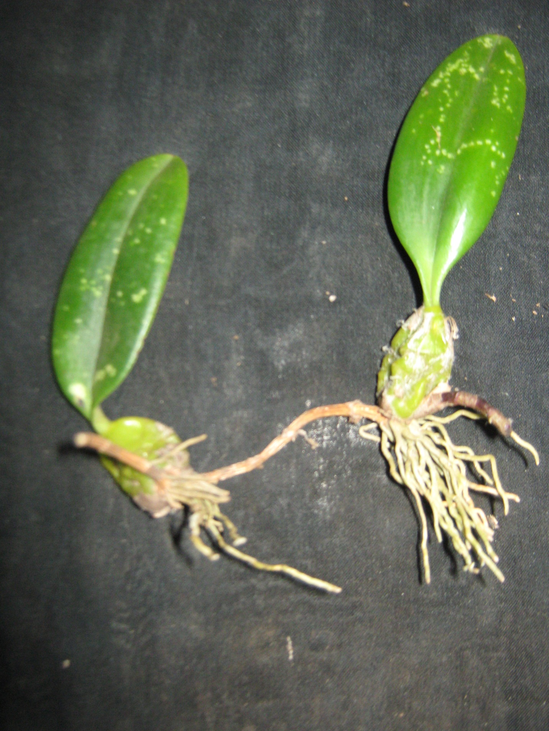

**Table.1 Qualitative Constituents Test of Various Extracts of Root of *Bulbophyllum kaitense***

|  |  |  |  |  |  |  |
| --- | --- | --- | --- | --- | --- | --- |
| **S.NO** | **CONSTITUENTS** | **TESTS** | **PET.ETHER** | **CHLOROFOR** | **ETHANOL** | **AQUEOUS** |
| **1.** | **TERPENOIDS** | **Test for Terpenoids** | + | + | - | - |
| **2.** | **FLAVONOIDS** | **Test for Flavonoids** | - | - | - | - |
| **3.** | **REDUCING SUGAR** | **Fehling’s Reagent (A)** | - | - | - | - |
| **Fehling’s Reagent (B)** | - | - | - | - |
| **4.** | **PHENOLIC COMPOUNDS** | **Test for Phenols.** | - | - | - | - |
| **5.** | **CATACTINIS** | **Test for Catactin.** | - | - | - | - |
| **6.** | **SAPONINS** | **Test for Saponin.** | + | + | - | - |
| **7.** | **TANNINS** | **Test for Tanins.** | + | + | + | + |
| **8.** | **ANTHROQUINONE** | **Test for anthroacunone** | - | - | - | - |
| **9.** | **COUMARIN** | **Test for coumarin** | - | + | + | + |
| **10.** | **QUININE** | **Test for Quinine** | + | + | + | - |
| **11.** | **GLYCOSIDES** | **Test for glycosides** | - | + | - | - |
| **12.** | **CARBOHYDRATE** | **Test for carbohydrate** | + | + | + | - |
| **13.** | **SUGAR** | **Sugar for Test** | + | - | - | - |

**Table . 2 Antibacterial Properties of Root Extract of *Bulbophyllum kaitense***

|  |  |  |  |  |  |  |  |  |  |  |  |  |  |  |  |  |  |
| --- | --- | --- | --- | --- | --- | --- | --- | --- | --- | --- | --- | --- | --- | --- | --- | --- | --- |
| **S.**  **NO** | **ORGNISMS NAME** | **ROOT** | | | | | | | | | | | | | | | |
| **PET.ETHER** | | | | **CHLOROFORM** | | | | **ETHANOL** | | | | **AQUEOUS** | | | |
| **50** | **25** | **12.5** | **6.25** | **50** | **25** | **12.5** | **6.25** | **50** | **25** | **12.5** | **6.25** | **50** | **25** | **12.5** | **6.25** |
| **1.** | **Kelebsilla pneumoniae** | **Nil** | **Nil** | **Nil** | **Nil** | **Nil** | **Nil** | **Nil** | **Nil** | **17mm** | **16mm** | **13mm** | **12mm** | **Nil** | **Nil** | **Nil** | **Nil** |
| **2.** | **Salmonella typhi** | **Nil** | **Nil** | **Nil** | **Nil** | **18mm** | **17mm** | **15mm** | **Nil** | **20mm** | **18mm** | **17mm** | **16mm** | **13mm** | **Nil** | **14mm** | **15mm** |
| **3.** | **Salmonella paratyphi** | **Nil** | **Nil** | **Nil** | **Nil** | **17mm** | **20mm** | **14mm** | **14mm** | **20mm** | **17mm** | **17mm** | **13mm** | **14mm** | **Nil** | **12mm** | **15mm** |
| **4.** | **Psuedomonas aeruginosa** | **Nil** | **Nil** | **Nil** | **Nil** | **22mm** | **18mm** | **17mm** | **15mm** | **21mm** | **19mm** | **17mm** | **16mm** | **Nil** | **Nil** | **Nil** | **Nil** |
| **5.** | **Bacillus subtilis** | **Nil** | **Nil** | **Nil** | **Nil** | **18mm** | **16mm** | **17mm** | **13mm** | **18mm** | **16mm** | **15mm** | **14mm** | **13mm** | **12mm** | **Nil** | **14mm** |
| **6.** | **Entrobacter facalis** | **13mm** | **12mm** | **14mm** | **13mm** | **15mm** | **20mm** | **18mm** | **17mm** | **16mm** | **15mm** | **14mm** | **14mm** | **15mm** | **14mm** | **13mm** | **Nil** |
| **7.** | **Eschericha coli** | **Nil** | **Nil** | **Nil** | **Nil** | **Nil** | **Nil** | **20mm** | **14mm** | **Nil** | **Nil** | **Nil** | **Nil** | **Nil** | **Nil** | **Nil** | **Nil** |
| **8.** | **Streptococcus pneumoniae** | **17mm** | **14mm** | **12mm** | **14mm** | **18mm** | **17mm** | **20mm** | **17mm** | **21mm** | **17mm** | **16mm** | **15mm** | **15mm** | **14mm** | **14mm** | **13mm** |
| **9.** | **Shigella flexneri** | **14mm** | **13mm** | **Nil** | **14mm** | **16mm** | **15mm** | **12mm** | **11mm** | **17mm** | **15mm** | **16mm** | **16mm** | **14mm** | **12mm** | **17mm** | **18mm** |
| **10.** | **Micrococcus Sp.,** | **Nil** | **Nil** | **Nil** | **Nil** | **21mm** | **17mm** | **19mm** | **15mm** | **23mm** | **20mm** | **17mm** | **15mm** | **16mm** | **15mm** | **13mm** | **Nil** |

**Table. 3 Antimfungal Properties of Root Extract of *Bulbophyllum kaitense***

|  |  |  |  |  |  |  |  |  |  |  |  |  |  |  |  |  |  |
| --- | --- | --- | --- | --- | --- | --- | --- | --- | --- | --- | --- | --- | --- | --- | --- | --- | --- |
| **S.**  **NO** | **ORGNISMS NAME** | **ROOT** | | | | | | | | | | | | | | | |
| **PET.ETHER** | | | | **CHLOROFORM** | | | | **ETHANOL** | | | | **AQUEOUS** | | | |
| **50** | **25** | **12.5** | **6.25** | **50** | **25** | **12.5** | **6.25** | **50** | **25** | **12.5** | **6.25** | **50** | **25** | **12.5** | **6.25** |
| **1.** | **Asperigilus fumicatus** | **Nil** | **Nil** | **Nil** | **Nil** | **Nil** | **Nil** | **Nil** | **Nil** | **13mm** | **15mm** | **12mm** | **12mm** | **Nil** | **Nil** | **Nil** | **Nil** |
| **2.** | **Trichophyton rubrum** | **17mm** | **16mm** | **16mm** | **15mm** | **22mm** | **17mm** | **16mm** | **13mm** | **23mm** | **19mm** | **18mm** | **16mm** | **Nil** | **Nil** | **Nil** | **Nil** |
| **3.** | **Microsporum gypsum** | **Nil** | **Nil** | **Nil** | **Nil** | **Nil** | **Nil** | **Nil** | **Nil** | **15mm** | **14mm** | **13mm** | **12mm** | **Nil** | **Nil** | **Nil** | **Nil** |
| **4.** | **Aspergillus flavus** | **15mm** | **10mm** | **14mm** | **14mm** | **17mm** | **16mm** | **16mm** | **15mm** | **18mm** | **17mm** | **16mm** | **15mm** | **Nil** | **Nil** | **Nil** | **Nil** |
| **5.** | **Aspergillus nigir** | **16mm** | **14mm** | **15mm** | **14mm** | **15mm** | **13mm** | **12mm** | **13mm** | **15mm** | **13mm** | **12mm** | **10mm** | **Nil** | **Nil** | **Nil** | **Nil** |
| **6.** | **Mucor. Sp.** | **17mm** | **18mm** | **17mm** | **16mm** | **Nil** | **Nil** | **Nil** | **Nil** | **20mm** | **19mm** | **18mm** | **17mm** | **Nil** | **Nil** | **Nil** | **Nil** |

**Acknowledgement**

I would like to thank whole heartedly Dr. S. Ahmed John Professor and Head. Department of Botany. Jamal Mohamed College, Tiruchirappalli-620 020. Tamil Nadu, India for guiding and supporting me, throughout course, of this investigation.

**Corresponding Author**:

A.Kalaiarasan M.sc., M.Ed., M.Phil., Ph.D.,

P.G and Research Department of Botany

Jamal Mohamed College

Tiruchirappalli-620 020

Tamil Nadu, India.

E-mail: [myla-kalai@yahoo.com](mailto:myla-kalai@yahoo.com)

**Reference**

1. Samy, R.P., Lgnacimuthu, G. and Sen, A. (1998). Screening of 34 Indian medicinal plants for antimicrobial properties. Journal of ethnopharmcology 62, 172-182.
2. Srinivasan, D., Nathan, S., Suresh, T. and Lakshmana perumalsamy, P. (2001). Antimicro bial activity of certain Indian medicinal plants used in folkloric medicine, journal of ethnopharmacology 74, 217-220.
3. Evens, C.E., Banso, A. and Samuel, O.A. (2002). Efficacy of some rupe medicinal plants against samonella type: An in vitro study. Journal of ethnopharmacology 80, 21-24.
4. N.Cube NS, afolayas AJ and Okoh A. (2008). Assessment techniques of antimicrobial properties of natural compounds of plant origin current methods and future trends. African Journal of Biotechnology, 7(12), 1797-1806.
5. Vaidya and Devasagayam. (2007). Current status of herbal drugs in India. an overview J.Clin Biochem Nutr. 41 (1):1-11.
6. Hedge, S.N. (1997) Orchid wealth of India. Proceedings of Indian National science academy 63, 229-244.
7. Harikrishnan, M. (1977) Working plan for the Salem forest Divison. Government of TamilNadu.India.
8. Amritpal sing and Sanjiv Duggal (2009) Medicianl orchids an overview. Ethanobotanical leaf lets. 13: 399-412.
9. Brindha P., Sasikala B., and Purushothaman K.K. 1982. Pharmacognostic studies on Merugan Kizhangu. Bulletin of Medicoethno botanical Research 3:84-96.
10. Mathew, K.M. (1981). The flora of the TamilNadu Carnatic. Rapinat

Herbarium St .Joseph’s College (Autonomous). Tiruchirappalli. pp.1592.

1. Harborne, J.B.1998.Phytochemical Methods: A Guide to modern techniques

of plant analysis, 3rd edition. Chapman Hall co., New York, pp. 1-302.

View of the Plant of Bulbophyllum kaitense

9/1/2012