Evaluation of Phytochemical and Antimicrobial Properties of Orchid in Kolli hills

*A.Kalaiyarasan¹, S.Ahmed john², A.Edward³

^{1,} P.G & Research Department of Botany Jamal Mohamed College, Tiruchirappalli- 620 020. Tamilnadu. India.
^{2,} P.G & Research Department of Botany Jamal Mohamed College, Tiruchirappalli- 620 020. Tamilnadu. India.
^{3,} Department of Biotechnology, St. Joseph’s College, Tiruchirappalli- 620 020 Tamilnadu, India.
myla_kalai@yahoo.com

Abstract: Eastern penisular floras in Indian medicinal plants are potaantiasl of antimicrobial compounds. The present study deals with the phytochemical analysis and antimicrobial activity were conducted with petroleum ether, chloroform, ethanolic and aqueous extracts of the leaves of bulbophyllum kaitense rechib. Orchid an attempt has been made together the information about the traditional use of herbs in the local healer’s .the leaves in used to anticancer, cancer preventive, anti-inflammatory, antioxidant and many more people used in to increase sex hormone activity. The preliminary phytochemical analysis of different extracts. The ethanol, aqueous extracts showed abundant occurance of phenolic the compounds, coumarin, quinine and carbohydrate. But the complete absence of petroleum ether and chloroform was observed. the antimicrobial activity of the various solvent extracts are screened for the samples of human pathogenic organism studied streptococcus pneumonia, bacillus subtilis, salmonella typhi, salmonella paratyphi, pseudomonas aeruginosa, eschericha coli, klebsilla pneumonia, entrobacter facalis, shigella flexneri, micrococcus species are found to be sensitive to leaf extracts. The fungi human pathogen organisms are fond to be higher sensitive to ethanolic extracts. The concentration of ethanolic extract had inhibitory effects against the fungus strains namely trichophyton rubrum and mucor species. The inhibition was higher in concentration 50µl/mg than high concentrations. High dose of extract was very effective against the tested human pathogens. It is the world first report antimicrobial activity of bulbophyllum kaitense, leaves part
[A.Kalaiyarasan, S.Ahmed john, A.Edward. Evaluation of Phytochemical and Antimicrobial Properties of Orchid in Kolli hills. Nat Sci 2012;10(10):184-188]. (ISSN: 1545-0740). http://www.sciencepub.net/nature. 27

Keywords: Bulphyllum kaitense, Leaves, Antimicrobial activity, Phytochemicals, Extract.

1. Introduction
Since the discovery of the first antibiotic, Penicillin, the need for antimicrobial agents is yet to be satisfied. This has been attributed to the emergence of antibiotic resistant strains of microorganisms (Davis, 1994).The Development of antimicrobial agents has been undeniably one of the greatest accomplishments of modern medicine. In recent years, multiple drug resistance in both human and plant pathogens has developed due to the indiscriminate use of commercial antimicrobial drugs commonly used in the treatment of infection diseases. The limited life span of antibiotics has rendered a necessity to search for new antimicrobial substances from various sources such as medicinal plants. Plants used in traditional medicine are one of the most promising areas in the search for new biologically active compounds. Medicinal plants are well-known natural source for the treatment of various diseases since antiquity. Furthermore, natural products, either pure compounds, or as standardized plant extracts, provide unlimited opportunities for new drug leads because of the unmatched availability of chemical diversity (Cos et al., 2006). This has urged microbiologists all over the world for formulation of new antimicrobial agents and evaluation of the efficiency of natural plant products as a substitute for chemical antimicrobial agents (Pandian et al., 2006). Herbal remedies used in the traditional medicine provide an interesting and still largely unexplored source for the creation and development of potentially new drugs for chemotherapy which might help to the medicinal value of a vandanous taxan and of some other taxa including the present day Eulopia (D.Don) Hocbr, Flickingeria nodosa in ‘Charaka Sanshita’. a classic ancient indian medicinal trealise written by characa in sanskrit, a few thousand years ago. This forms the first record of Indian orchids and their uses in Ayurvedic medicine (Manilal and SathishKumar, 1986). In India work has been carried out on chemical analysis of some medicinally usful orchids. Eulophia campestris, orhis latifolia, vanda roxburgii are some important plants. (Amritpal Singh, and Sanjiv Duggal, 2009).
Herbal medicine has reported Bulbophyllum kaitense a terrestrial orchid. This is an epiphytic family orchidaceae Endemic to south India. The plant is not very common is south India. The plant is dense maths on tress and rock. This is native of India occurs in the forest of estern penesulor flora from Kolli hills above 1300 m. Sympodial epiphytes with uninodal pseudobulb. Inflorescense, umbellate scape pseudobulbs greenish. Sub fusiform not angled 2Cm long 4-5 cm part on the Zone leaves 9-13 cm long flowers without mentum. Sepal unequal petals shorter then lateral sepals. A.kalaiarasan (2012).
The plants have been used in the herbal medicine. This information was gathered by questioning local healers and knowledgeable villages of the Kolli hills. Hence the present investigation was aimed to evaluated the phytochemical constituents and antimicrobial activity of the various extract of bulbophyllum kaitense.
Materials and Methods
Collection of Plant Materials
The Healthy Plant Materials Of Bulbophyllum Kaitense. Rechib. Were Collected From The Kolli Hills. Namakkal District, Tamilnadu, India. It Was Authenticated By Rev, Dr.S.John Britto, The Director, The Rabinat Herbarium, St. Joseph’s College, Tiruchirappalli, and Tamilnadu. India with the Help of Herbarium Record. The Plant Voucher Number: RHT.872.
The air dried plant powders (100g) were successively extracted with Petroleum ether, Chloroform, ethanol and aqueous using a soxhlet apparatus. The extracts so collected were distilled off on a water bath at atmospheric pressure, and the last trace solvents were removed in vaco.
Preliminary phytochemicals screening
The Phytochemical tests were carried out for the different solvent extracts. The plant extracts were subjected to routine qualitative chemical analysis to identify the nature of phytochemical constituents. Standard procedures were followed to identify the described by Harborne (1973).
- Test for Terpenoids
5 ml of the extract was mixed with 2 ml of chloroform and concentrated sulphuric acid to form a layer. A reddish brown coloration in the interface showed the presence of terpenoids.
- Test for flavonoids
5 ml of the diluted ammonia solution a portion of the aqueous extract was added, followed by addition of concentrated suphuric acid. Appearance of yellow coloration indicates the presence of flavonoids.
- Test for Reducing Sugars
2 ml of test solution was added with a 2 ml Fehling’s reagent. A (or) B. and 2 ml of water formation of reddish orange color indicates the presence of reducing sugar.
- Test for Phenols
2 ml of test solution in alcohol was added with one drop of neutral ferric chloride 5% solution. Formation of intense blue color indicates the presence of phenols.
- Test for Catechins
2 ml of test solution in alcohol was added with Ehrich reagent and a few drops of concentrated HCl formation of pink color indicate the presence of catechins.

- Test for saponins
2 ml of test solution was added with H₂O and shacked formation of foamy eather indicates the prsence of saponins.

- Test for Tannins
2 ml of test solution was added with H₂O and head acetate. Formation of while precipitate indicates the presence of tannins.

- Test for Anthroquinone
2 ml of test solution was added with the magnesium acetate. Formation of pink color indicates the presence of Anthroquinones.
- Test for Quinine
2 ml of extract, 1 ml of concentrated sulphuric acid was added and was allowed to and for some time to develop color. Development of red color shows the presence of quinine.
- Test for Coumarin
2 ml of extract, 1 ml of 10% NaOH was added and was allowed to stand for some time development of yellow color shows the presence of coumanin.
- Test for Glycosides
2 ml of the extract, 1 ml of alpha napthol was added to which chloroform was added along the sides and it was looked for the development of color and the result was recorded. Development of Violet color indicates the presence of glycosides.
- Test for Carbohydrate
Agueous or alcoholic solution of substance was added with 10% aqueous solution of alpha Napthol shaken and added concentrates sulphuric acid along the side of the side of the tube. Violet ring at the Junction of two liquids shows presence of Carbohydrates.

- Test for Sugar
0.5ml of the Filtrate. 0.5 ml Benedict’s reagent was added. The mixture was heated on boiling water both for 2 minutes. A characterisets of red coloured precipitate shows presence of sugar.
Antimicrobial Activity
The extracts were tested for the antibacterial activity. The microbial strains employed in the biological assays were Gram-Positive bacterial Streptococcus pneumoniae (MTCC 2672), Bacillus subtilis (MTCC 441), Gram- Negative bacteria: Salmonell typhi (MTCC 734) Salmonella paratyphi (MTCC 735) Pseudomonas aeruginosa (MTCC 2474) Escherichia coli (MTCC 119), Klebsilla pneumoniae (MTCC 3040), Entrobacter facalis, Shigella flancineri, Micrococcus sp., Fungal Strains: Asperigillus fumicatus (MTCC 2584), Trichophyton rubrum (MTCC 296). Microsporum gypseum (MTCC 2819) Aspergillus flavus (MTCC 2813), Aspergillus Nigiri (MTCC 2612) Mucor Sp.,
Determination of Antibacterial Activity
Agar well diffusion assay
Agar well diffusion method was followed. Muller-Hinton Agar (MHA) plates were swabbed (Sterile cotton Swabs) with 8-12 h old broth cultures of the respective bacteria. Sterile circular steel was used to make wells, each measuring 8mm diameter, in each of the plates. About 0.3 ml each of 50, 25, 12.5 and 6.25 mg/ml of concentrated test samples with DMSO was added into the wells using sterilized dropping micropipettes and allowed for diffusion at room temperature for 2h. The plates were incubated at 37◦C for 24 h. The solvent without extracts served. After 24 h of incubation, diameter of the inhibition zone was recorded in mm. The experiment was repeated thrice and the average values were calculated for antibacterial activity.

Determination of Antifungal Activity
Agar well diffusion method was followed by the nutrient medium used was Sabouraud Dextrose Agar (SDA). The Sabouraud Dextrose Agar plates were swabbed (Sterile Cotton Swabs) with 8 h old broth culture of the respective fungi. A sterile cork borer was used to place four wells, each measuring 8 mm in diameter, in each of the plates, about 0.1 ml each of 50, 25, 12.5 and 6.25 mg/ml of concentrated test samples with DMSO was added into the wells using sterilized dropping micropipettes and allowed for diffusion at room temperature for 2h. The plates were incubated at 28◦C for 18-24 h. Diameter of the inhibition zones was recorded the experiment was repeated thrice and the average values were calculated for antifungal activity.

Results
Preliminary phytochemical analysis of various solvent extracts such as Petroleum either. Chloroform, Ethanol and Aqueous of the Bulbophyllum kaitense. leaf recorded in the (Table1) The ethanol extract alone contains phenoliccompounds, coumarin, quinine and carbohydrate present were as aqueous extract alone contains Flavonoids, Tanins, Counarin, Quinine and Carbohydrate present. The petroleum ether and choloroform extracts were complete absence of phytochemical compound. Differerent solvent extracts of the plant leaves were tested in antibacterial activity the values were recorded and averaged (Table.2) Different solvent extracts of plant leaves such as Petroleum either, Chloroform, Ethanolic and Aqueous extracts were tested Gram- positive the plant were highly sensitive than gram-negative bacteria is tested plant extacts. The zone of inhibition ranging from (12mm-25mm) against Bacillus subtilis, Streptococcus pneumonia recorded in petroleum either and chloroform extract. Kelebsilla pnemoniae. Pseudomonas aeruginosa, salmonella paratyphi, Entrofacter facalis and micrococcus species were expressed more or less similar activity in zone of inhibition Petroleum either, Chloroform and Ethanol extracts. Where are less activity zone of inhibition recorded in aqueous extract. Antifungal activity of ethanol extract showed more activity in highly zone of inhibitory effects against the fungal strains namely Trichophyton rubrum and Mucor species 32mm respectively (Table:3) where as less activity recorded in aqueous. The inhibition was higher in highly concentration of 50µl/mg than high concentrations. This effezct was concentration dependent.
Discussions
The investigation clearly indicated the maximum activity was observed from the Bulbophyllum Kaitense leaves extract was potent against human pathogenic strains depended manner. There are effectiveness of traditional herbs against gram positive and gram negative microorganisms as a result. Plants are still recognized for modern herbal medicine to treat infection diseases. However, it was more activity against fungal strains. The plant parts synthesize sum chemicals in themselves which metabolize their physiological activities. the phytochemicals results of the current to investigation provide scientific support for the herbal uses of the medicinal plant are bused to cure the disease in herbal homeopathic medicine. Nowadays most of the people like to use traditional methods to cure general diseases .

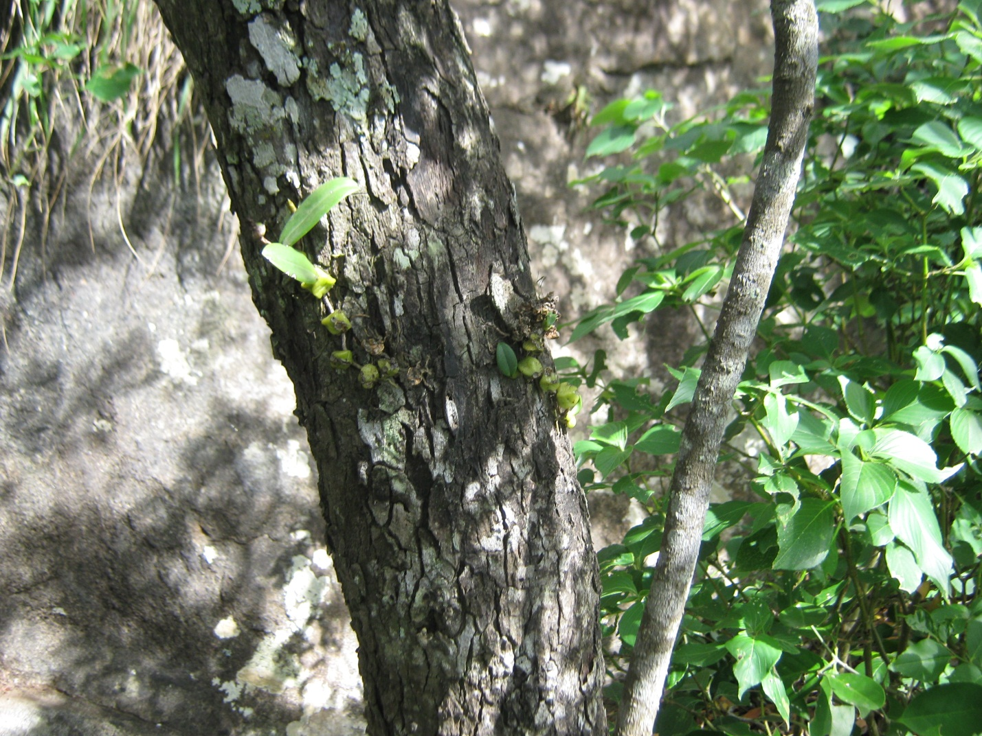
Epiphytic Plant of Bulbophyllum kaitese Reichb

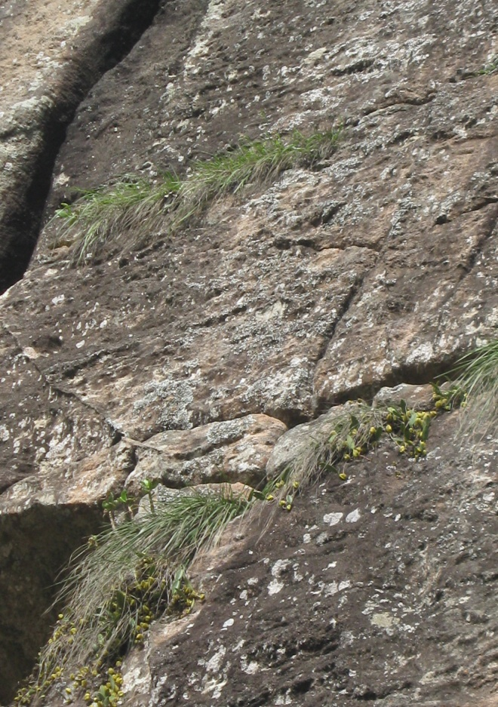
Lithophytic Plant of Bulbophyllum kaitese Reichb

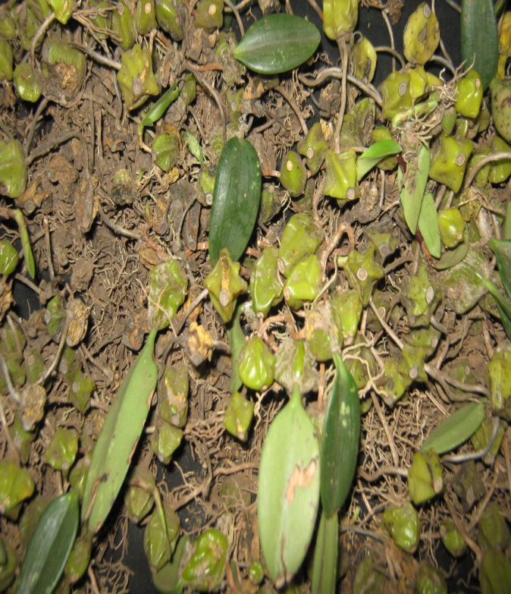
Plant of Bulbophyllum kaitense. Reic

Epiphytic
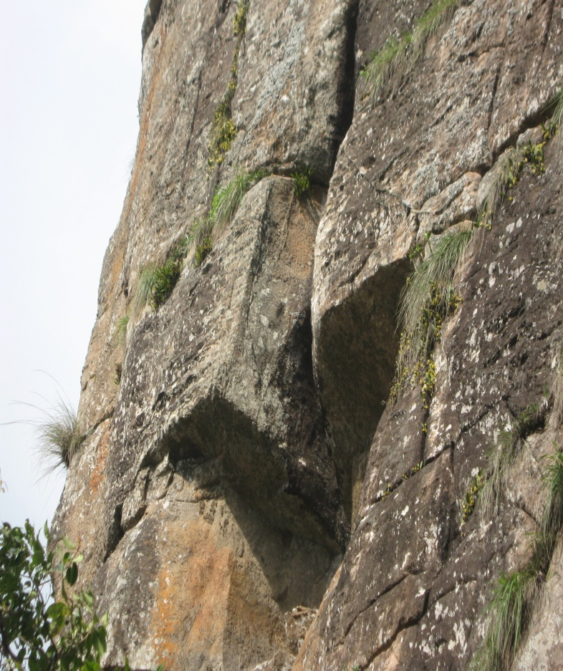

Conclusion
To conclusion, the investigation on phytochemical componounds analysis showed that authentic botanical of this crude drug prevents diseases . the preliminary phytochemical screening of the leaves bulbophyllum kaitens indicates the presence of secondary metabolites ,having an essential role in medicine .it is evident from the results that the plant bulbophyllum kaitens rechib ground in eastern peninsular flora in India has strong antimicrobial activity against human pathogenic micro organisms .
Our work has also shown that species containing flavonoids and phenolic compounounds exhibited anti bacterial activity. the action of different solvent extracts of bulbophyllum kaitens against some human pathogenic organisms. the great potential of the plant as a source of an antimicrobial agent. the presence of active principle of photochemicals present in bulbophyllum kaitens leaves . for it usefulness as a medicinal plant in the treatment of skin diseases . in south Indian people many –plant are used as not for medicine. it used as a plants are food of medicine like daily.

Acknowledgement
I would like to thank whole heartedly Dr. S. Ahmed John Professor and Head. Department of Botany. Jamal Mohamed College, Tiruchirappalli-620020. TamilNadu, India for guiding and supporting me, throughout course, of this investigation.

Corresponding Author:
A. Kalaiarasan M.Sc., M.Ed., M. Phil., Ph.D.,
P.G and Research Department of Botany
Jamal Mohamed College
Tiruchirappalli-620 020
Tamil Nadu, India.
E-mail: myla-kalai@yahoo.com

Reference
- Kalaiarasan, A. and S.Ahmed John (2011) Evaluation of rhaphidophoral Pertusa, schott (Araceae) for Antibacterial activities. Journal of pharmacy Research 4(1), 1-2.
- Kalaiarasan, A. Kumar.P and S.Ahmed John (2012) anti microbial activity of bulbophyllum kaitens rechib .stem of eastern peninsular flora in India. Nature And Science .10(2). 41-44
- Kalaiarasan, A. Kumar.P and S.Ahmed John (2011) phytochemical and anti microbial activities of bulbophyllum kaitens, psuedobulb extracts. Journal of Tropical Medicinal plants . 12(2), 173-176
- Collin, H. and Pareicia, N.L. (1970). Microbiology methods 3rd Edition London University press Butterworth.
- Davies, J. (1994) Inactivation of antibiotics and the dissemination of resistant genes. Science 264, 375-382.
- Evans, W.C. (2005) Trase and Evans pharmacognosy. 15th edn. Elsevier. pp.20.
- Cos, P., Velietinck, a.J., Vanden, B.D.and Maes, L. (2006). Anti infective potential of natural products: How to develop a stronger invitro ‘Proof- of concept’. Journal of Ethnopharmacology 106, 290-302.
- Pandian, M.R.Banu, G.S.and Kumar, G. (2006). A study of antimicrobial activity of Alangium salvi ifolium. Indian Journal of pharmacology 38. 203-204.
- Harikrishnan, M. (1977) Working plan for the Salem forest Divison. Government of Tamil Nadu. India.
- Hedge, S.N. (1997) Orchid wealth of India. Proceedings of Indian National science academy 63, 229-244.
- Manilal, K.S., and Sathiskumar, C. (1986) Researches on Indian orchids in: Biology Conversation and culture of orchids. vij. S.P. (ed.). pp.1-2.
- Pathak, P., Sehgal, R.N., Shekhar, N., Sharma, M.and Sood, A. (2001) orchids: Science and commerce ISBN. Shiva offset Press. Dehradun, India, 81,211-271.
- Amritpal sing and Sanjiv Duggal (2009) Medicianl orchids an overview. Ethanobotanical leaf lets. 13: 399-412.
- Brindha P., Sasikala B., Purushothaman K.K. 1982. Pharmacognostic studies on Merugan Kizhangu. Bulletin of Medicoethno botanical Research 3:84-96.
- Mathew, K.M. (1981). The flora of the TamilNadu Carnatic. Rapinat Herbarium St.Joseph’s College (Autonomous). Tiruchirappalli. PP.1592.
- Harborne, J.B. 1998. Phytochemical Methods: A Guide to modern techniques of plant analysis, 3rd edition. Chapman Hall co., New York, pp. 1-302.

8/5/2012

