Phytochemical and Biological Investigation of Vitis vinifera L. (Flame cultivar), Family Vitaceae Cultivated in Egypt

El- Hawary, S ¹, El- Fouly, k ², El Gohary, HM ¹, K.M. Meselhy ^{1, *}, Slem, A ³ and Talaat, Z ².

¹ Department of Pharmacognosy and Medicinal Plants, Faculty of Pharmacy, Cairo University, Kasr-el-Aini Street, 11562 Cairo, Egypt
² National Organization for Drug Control and Research, Cairo- Egypt.
³ Department of Pharmacology, National Research Centre, El-Bohouth Street, Dokki, Cairo, Egypt
kmeselhy@hotmail.com

Abstract: Extracts of the leaves & fruits of Eight cultivars(cv. Superior, cv. Fiesta , cv. Flame, cv. Thompson, cv. Queen, cv. Cardinal, cv. Black monukka and cv. Black rose) of Vitis vinifera L. were prepared from samples grown in EL Kanater El kheiria. GC/MS was used for qualitative and quantitative analyses of Lipoidal content of the different extracts. 19 Components representing 97.17% were identified in the fatty acid methyl esters of the fruits of Vitis vinifera L., while 15 components representing 91.1% were identified in the fatty acid methyl esters of the leaves. On the other hand, 17 components were identified in the unsaponifiable matter of the fruits representing 87.34%, while 16 components were identified in the unsaponifiable matter of the leaves representing 94.99%. HPLC (high performance liquid chromatography) was used for qualitative and quantitative analyses of sugar content in fruits of eight varieties where white grapes (cv. Thompson, cv. Superior, cv. Fiesta) recorded higher percentage of total sugars. HPLC analysis of red and black grape fruits extract revealed that the presence of peonidin and malvidin as the major anthocyanins in these colored varieties. RAPD analysis of DNA proved that the presence of characteristic bands that can be used as an accurate tool for authentication & differentiation between the eight cultivars of Vitis vinifera L. under investigation. The ethanol (95 %) extract of the leaves & fruits, as well as the juice of Flame cultivar exerted significant, although variable, biological effects including analgesic, anti-inflammatory, antipyretic, hepatocurative, diuretic and antioxidant.
[El- Hawary, S, El- Fouly, k, El Gohary, HM, K.M. Meselhy, Slem, A and Talaat, Z. Phytochemical and Biological Investigation of Vitis vinifera L. (Flame cultivar), Family Vitaceae Cultivated in Egypt. Nat Sci 2012;10(10):48-59]. (ISSN: 1545-0740). http://www.sciencepub.net/nature. 8

Keywords: Vitis vinifera L, Lipoidal content, sugar content, Anthocyanin, analgesic, anti-inflammatory, antipyretic, hepatocurative, diuretic and antioxidant.

- Introduction
Grape is considered one of the most important fruit crops in the world. In Egypt, grapes occupied the second rank after citrus. The total area of vine yards reached 141233 feddans (Ministry of Agriculture Statistics, 1999). Thompson seedless and Roumy Ahmer grape cultivars occupies almost two thirds of the total area. The former ripens early and the latter late in the growing seasons.
In 1981, Ministry of Agriculture (Agriculture Development System Project, ADS) introduced some seeded and seedless table grape cultivars from California, USA. Seeded cultivars viz: Black rose, Calmeria, Cardinal, Gold, Muscant of Alexandria, Queen and Ribier, while seedless grape cultivars viz: Beauty, Black monukka, Emerald, Fiesta and Ruby. (Ismail, 1989, Abd El Fattah and Kasstor, 1993).
Reviewing the current literature, it was found that Vitis vinifera L. contains many chemical constituents viz, phenolic acids, flavonoids, anthocyanins, proanthocyanidins, sugars, sterols, amino acids, and minerals (Sokar, 1991).
Natural antioxidants have gained considerable interest in recent years for their role in preventing the auto oxidation of fats; Vitis vinifera L. plant is considered as a natural antioxidant source. Sales in France of grape extract are 400 times greater than those of more expensive pine bark, which considered as a rich source of vitamin C.
Vitis vinifera L. is considered as an economic plant, whose several cultivars which are grown for their edible fruits, the source of raisins, wines, sultanas and currents (Alleweldt and Singh, 1991, Olmo, 1995). Grapes are also used as demulcent, laxative, refrigerant, stomachic, diuretic and cooling. Moreover, it is useful in bilious dyspepsia, haemorrhage, dysuria, in chronic bronchitis, heart diseases and gout. Grape juice is given to children to prevent constipation. Dried grapes or raisins are useful in thirst attendant on fevers, cough, catarrh, jaundice, and in sub-acute cases of enlarged liver and spleen.
The pharmacokinetics of grape revealed that fruit have a potent inhibitory effect on the intestinal cytochrome P450 system. For this reason grape fruit has a high potential for interaction with drugs (Ulbricht, and Seamon, 2010).
Researchers are experimenting with the use of grape seed to treat diabetes & heart diseases. An earlier study had shown grape seed to be significantly more effective than a placebo in improving night vision (Roth, 2010).
The beneficial health-related effects of phenolics in grapes are of importance to consumers, breeders and the grape industry. There is limited knowledge about the comparative phytochemical, DNA profiles of different grape varieties & biological activities of Flame cultivar. So it’s deemed of interest (1) to determine & compare the profiles of total sugars, total lipid & total anthocyanins in selected grapes varieties; (2) to differentiate similar & different bands of DNA profile of varieties under study to be used as accurate tool for authentication of different varieties of grapes (3) to measure different biological activities of juice & alcoholic extract of both leaves & fruit of edible Flame cultivar of grape.

- Material & Methods
  - Material:
    - Plant material
The leaves and fruits of the different cultivars of Vitis vinifera L. under investigation were obtained from plants grown in EL Kanater El kheiria, Agricultural Research Center, samples of cv. Superior and cv. Fiesta were obtained in June, samples of cv. Flame, cv. Thompson, cv. Queen and cv .Cardinal were obtained in July, samples of cv. Black monukka and cv. Black rose were obtained in August. Taxonomical identity was Kindly Verified by Dr. Ib. Maroed, Grape Department, Agricultural Research Center, Giza.
    - Material for chromatographic screening:
Pre-coated silica TLC plates 60 F254. (10×20cm and 20×20cm) (E. Merck),silica gel H for Vacuum Liquid Chromatography (VLC) (E. Merck), sephadex LH- 20 (Pharmacia Fine Chemicals AB Uppsala, Sweden) for CC and sheets of Whatman filter paper No.1 for paper chromatography (PC) (E. Merck).
    - Material for pharmacological screening:
- Plant extracts: alcoholic extracts of the leaves and fruits and the juice of Vitis vinifera L.
- Experimental animals: Albino mice, 25-30 g body weight, adult male albino rats of Sprauge Dawely Strain weighing 130-150g were used. The animals were kept on standard laboratory diet, and under the same hygienic conditions. Water was supplied Ad libitum., biomerieux kits: for estimation of liver function (AST, ALT, and ALP) and glutathione kits: for estimation of antioxidant activity
- Drugs and chemicals:
- Indomethacin: Epico, Egyptian Int. Pharmaceutical Industries Co., A.R.E., Under license of Merck Co. Inc – Rahaway, N.J., U.S.A. .
- Dipyron – metamizol (Novalgin): Hoechst Orient, S.A.E., Cairo, under license of Hoechst AG Frankfort, Germany.
- Paracetamol (paramol): Misr Co, Mataria, Cairo.
- Vitamin E (dl α- tocopheryl acetate ): Pharco pharmaceutical Co. It is available in the form of gelatinous capsules each contains 400 mg vitamin E.
- Silymarin: Sedico Pharmaceutical Co. 6 October City, Egypt (Dose 12.5 mg/kg b. wt).
- Moduretic (Amiloride HCl) Kahira Pharm Co (5 mg/ kg b. wt.).
- Carbon tetrachloride (Analar).
Doses of the drugs used were calculated according to Paget and Berne`s (1964) and were administrated orally by gastric tube.
    - Material for DNA fingerprinting:
- Plant materials:
Freeze – dried whole leaves were ground to a fine powder using a coffee grinder prior to DNA isolation.
- Solutions:
    - Extraction buffer : 0.7 M NaCl , M Tris (PH 7.5) .0.01 M EDTA, 1% ( W/V) N-cetyl –N, N ,N trimethyl ammonium bromide (CTAB), 1% (V/V) β-mercapto ethanol (added immediately before use ).
    - Washing buffer 1:76% ethanol, 0.2M Na –acetate.
    - Washing buffer 2:76% ethanol, 10 mM NH₄ O-acetate.
    - TE-buffer: 10 mM Tris (PH 8.0), 1 mM EDTA.
    - 10x reaction –buffer: 100 mM Tris (PH8.3), 500 mM KCl, 0.01% (W/V) gelatine.
    - Chloroform / iso-amyl alcohol 24:1 (V/V).
    - Isopropanol.
    - dNTP (Pharmacia, Sweden ).
      - Tag DNA polymerase (Perkin –Elemer / Cetus, USA; Advanced Biotechnologies, UK).
- Primers:
Six primers were used for RAPD analysis obtained from (Operon Technologies INC., Almeda, California, USA).
- Agarose gel: 1.4% with running buffer TAE.
- Molecular weight marker: 100bp (Biolab Co).

  - Anaylsis of the sugar content in the fruits of eight cultivars of grapes
Three grams of fruits were homogenized with 100 ml deionized water for 3 min, three times at 60º C. Non carbohydrate compounds were then separated according to (Black and Bagley, 1978). 10 ml of 10 % lead acetate solution was added to 25 ml of the solution to precipitate non carbohydrate compounds (deproteinization) and centrifuged at 10000 r.p.m. for 15 min. Excess lead was removed by addition of 10% oxalic acid solution to the supernatant till no more precipitate is formed. The solution was centrifuged again at 10.000 r.p.m. for another 15 min. The supernatant was then filtered through Whatman filter paper no.1, this solution was subjected to HPLC analysis.
HPLC analysis was carried out using Shimadzu HPLC apparatus, equipped with RI detector under these conditions: Column: Polygosil 60-5 NH_{2,} Detector; RI detector,Flow rate:2.0 ml / minute, Injection volume:20μl, Mobile phase: Acetonitrile: water (75:25).
Quantitive identification was achieved by comparing relative retention time of individual sugar with those of authentic sugars using internal normalization method, (Binder, 1980).
  - GC Analysis of the Saponifiable Matter and the Fatty Acid Methyl Ester
Light petroleum extracts of leaves & fruits of Flame cultivare were saponified to yield the unsaponifiable matter (USM) and fatty acids (FA) fractions. The FA fraction was subjected to methylation by refluxing with absolute methanol (50ml) and sulphuric acid (3ml) for 2hrs.
Finnegan SSQ7000 Gas Chromatography was used for lipid analysis, under the following conditions; Column type; DB-5 fused silica (5% phenyl methyl Polysiloxane), Temperature programming for Unsaponifiable matter: 50˚C increased to 300˚C by the rate of 5˚C/min. then isothermally for 5 min. while for Fatty acids methyl esters 150˚C for 4 min., increased to 280˚C by the rate of 5˚C/min. then isothermally for 4 min., Carrier gas: Helium, Detector: UV Detector, Sample size: 2µl, Mass range:50-500 m/z, Detector temperature: 250˚C, Flow rate: 1 ml / minute. Injection port temperature: 280˚C, Mobile phase: Methanol.
    - GC/MS analysis of the free fatty acids
Free fatty acids were isolated according to the method of British Pharmacopoeia, (1973). A solution of the fatty acid methyl esters (2μl) was prepared according to the method mentioned by Finar (1973) and dissolved in chloroform (2%) was analyzed using a Finnagann SSQ 7000 gas chromatography (GC).
    - GC/MS analysis of the unsaponifiable matter
This was carried out to investigate the hydrocarbon content and to examine the components of the sterol mixture. The chloroformic solution (2%) of the unsaponifiable matter of leaf of Vitis vinifera L. was analyzed (2μl) using a Finnagann SSQ 7000 gas chromatography (GC).
Identification of The fatty acid methyl esters, the hydrocarbons and sterols was achieved by comparing their retention times and mass fragmentation patterns with those of the database libraries [Wiley (Wiley Int.USA) and NIST (Nat. Inst. St. Technol. USA)]. The quantitative estimation of each peak was done using a computing integrator adopting the internal normalization procedure.
  - Analysis of anthocyanins in coloured cultivars
Five red and black cultivars were used for analysis of anthocyanins. (cv. Queen, cv. Black monukka, cv. Flame, cv. Black rose, cv. Cardinal), 100g of the fruits of each cultivar of Vitis vinifera L. was weighed and macerated with HCl/methanol (1:19) for 72 hrs. The extract was replaced each 24 hrs, the combined extracts concentrated to 25 ml at 35ºC in vacuum, the solution was diluted with methanol to 50 ml. Peonidin, pelargonidin, and malvidin solutions were prepared in a concentration of 40 mg in 50 ml methanol. The standard solutions were stored in dark at 18⁰C. HPLC determination of anthocyanins was carried out using Merck Hitach HPLC, D-7000 Interface apparatus, equipped with L.7110 UV-Vis detector and adopting the conditions: Column: Phenomenex – Bond clone 10 C18, 250x 4.6 mm, Detector: UV. adjusted at 420 nm, 0.5 AUFS, Injection volume: 20μl,Flow rate:1.0 ml / minute.
  - DNA fingerprinting of Vitis vinifera L.
In this study, DNA was extracted from each sample of eight cultivars under study, purified and subjected to RAPD analysis by reacting it with certain oligonucleotides (primers), this reaction resulting in fragments, which can be amplified by PCR reaction and visualized as bands on horizontal gel electrophoresis. The size and arrangement of bands is characteristic to each individual. RAPD analysis of eight cultivars of Vitis vinifera L., revealed the presence of identical bands in RAPD electrophoresis pattern for the eight cultivars indicating a degree of taxonomical relationship between the tested plants, while presence of characteristic bands may help in differentiation between the eight cultivars of Vitis vinifera L. under investigation
Perkin Elmer Cetus DNA and Thermal Cycler (Perkin Elmer, Warrington, UK) are used for amplification of DNA, gibco BRL Life Technologies, Paisley, UK, agarose gel electrophoresis tool, are used for separation of RAPD fragments according to size and UV Polaroid camera used for visualization of RAPD fragments Biometra Yno thermal cycler (Germany).
  - Total antioxidant activity (Determination of blood glutathione)
Glutathione in blood was determined according to the method of (Beutler et al., 1963) Adult male albino rats, weighing 130-150 g were divided into 6 groups (6 animals each). One group was kept as a negative control, while for the other groups; diabetes mellitus was induced according to the method described by Eliasson and Smart 1969.
  - Hepatocurative activity
Liver damage in rats was induced according to the method of klassen and Plaa (1969) by intraperitoneal injection of 5mL/kg b.wt. of 25% carbon tetrachloride (CCL₄) in liquid paraffin, blood samples were withdrawn to be used for the biochemical study. Animals were randomly divided into five groups each of 10 animals. Serum was isolated by centrifugation and divided for analysis of aspartate amino-transferase (AST/GOT), alanine amino-transferase (ALT/GPT) and alkaline phosphatase (ALP), (Thefweld, 1974).
  - Anti-inflammatory activity
This effect was determined according to the rate paw oedema method estimated by Winter et al. (1962). Eight groups of adult male albino rats were used each of six animals.
  - Antipyretic activity
This effect was conducted by following the method of Bush and Alexander (1960). Thirty male albino rats of average body weight (100g) were used. They were subdivided into five groups of six animals each.
  - Analgesic Activity
This effect was evaluated according to the method of Challier et al. (1961), by using electric current as anxious stimulus where electrical stimulation was applied to the rat tail by means of 515 master shocker (Laffayette Inst. CO.) using alternative current of 50 cycles/sec. for 0.2 second.
  - Diuretic activity
Thirty male albino rats were divided into five groups each consisted of six animals, which were held in the metabolic cages and fasted for 18 hours. The first group was left as negative control receiving 1ml saline & volume of urine was measured after administration of tested samples & standard (Moduretic (Amiloride HCl)) after 2, 4 & 24 hrs.

- Results & Discussion
  - Results of Sugar Content of Vitis vinifera L.
HPLC analysis of sugar content (Table 1 & Figures 1-8)) revealed that white grapes (cv. Thompson, cv. Superior, cv. Fiesta) contain higher percentage of total sugars than red grapes (cv. Flame, cv. Black monukka, cv. Queen, cv. Cardinal, cv. Black rose),The seedless cultivars of grapes (cv. Thompson, cv. Superior, cv. Fiesta, cv. Flame, cv. Black monukka ) contain higher percentage of total sugars than seeded cultivars of grapes (cv. Queen ,cv. Cardinal, cv. Black rose) ,The two cultivars (cv. Thompson and cv. Black rose) contain maltose (0.304 and 0.005g% respectively), Thompson cultivar contains the highest percentage of total sugars while cv. Black rose contains the least percentage (17.50 and 0.56g% respectively); Table(1), Figs. (1-8).
  - GC Analysis of the Saponifiable Matter and the Fatty Acid Methyl Ester
A total of 19 Components representing 97.17% were identified in the fatty acid methyl esters of the lipoidal matter of the fruits of Vitis vinifera L., while 15 components representing 91.1% were identified in the fatty acid methyl esters of the lipoidal matters of the leaves of Vitis vinifera L. The major component in the fatty acid methyl esters of the fruits (35.59%) was identified as stearic acid, followed by valeric acid (14.10%) then palmitic acid (13.24) while the major component in the fatty acid methyl esters of the leaves was identified as tridecanoic acid (25.5%) followed by stearic acid (17.7%) then palmitoleic acid (16.31%). Valeric acid, pentadecanoic acid, margaric acid and arachidic acid were detected in the fatty acid fraction of the fruits while they were absent in the fatty acid fraction of the leaves.
Seventen components were identified in the unsaponifiable matter of the fruits representing 87.34%, while 16 components were identified in the unsaponifiable matter of the leaves representing 94.99%. The identified sterols in the fruits represent 2.38% of the total unsaponifiable matter, while the identified sterols in the leaves represent 11.41% of its total unsaponifiable matter. The major component in the unsaponifiable matter of the fruits was octacosane 28.97% followed by pentacosane 12.74% and tricontane 11.81% while the major component in the unsaponifiable matter of the leaves was tetracosane 14.36% followed by pentacosane 13.46% and hexacosane 12.2%. (Table 2)
  - Anaylsis of anthocyanins in coloured cultivars
In the previous studies, anthocyanin compounds were determined in the red and black grape fruits. The major anthocyanins that were determined (Krisa et al., 1999, Moris et al., 2002, Vidal et al., 2002 and Wang et al., 2003): Cyanidin -3- glucoside, Pelargonidin -3- glucoside, Malvidin -3- glucoside, Peonidin -3- glucoside. HPLC analyses (Table 3 & Figures 9-13) of anthocyanins content in red and black fruits of different cultivars of Vitis vinifera L. revealed that the peonidin and malvidin were detected as the major anthocyanins in all fruits of cultivars under investigation (0.56 and 0.38 mg/g) except in Black manukka fruits, Pelargonidin was recorded highest percentage (0.58 mg / g) in the Black manukka fruits. Black manukka cultivar had the highest content of identified anthocyanins, while Flame cultivar had the lowest content (1.15 and 0.34 mg / g); Table (3) Figs.(9-13).
  - DNA fingerprinting of Vitis vinifera L.
Vitis vinifera L. has a current economic and potential importance, so this study may draw the attention of the forage working, development groups and conservation of grape cultivars. The development of DNA Markers has opened a new perspective on the study of genetic relationships in plants. Random amplified polymorphic (RAPD) DNA has generated a large number of polymorphic markers and it is the mostly common methods used. However, RAPD has been widely criticized especially for its lack of reproducibility .In this study, the presence of same bands in DNA of eight cultivars of Vitis vinifera L. indicates degree of taxonomical relationship between the tested plants; also the presence of characteristic bands in DNA of each cultivar may help for differentiation between these cultivars (Table 4 & Figures14-19).
  - Total antioxidant activity (Determination of blood glutathione)
From the data shown in table (5) it could be concluded that animals treated with vitamin E (7.5mg/kg b.wt.) restored the level of blood glutathione in diabetic rats (% change from control=1.9%). The level of blood glutathione in diabetic rats was restored after the oral administration (100mg/kg b.wt.) of alcoholic extracts of fruits, leaves and juice ( % change from control 6.15%, 10.2% and 2.5%, respectively), The juice of Vitis vinifera L. showed the highest antioxidant activity followed by alcoholic extract of the fruits and leaves respectively. The antioxidant activity of Vitis vinifera L. may be attributed to the presence of phenolic acids and flavonoids which are reported to have antioxidant effect (Stephen and Duke, 1996).
  - Hepatocurative activity
From the data shown in table (6); it may be concluded that animals with damaged liver induced by carbon tetrachloride showed high level of liver enzymes, namely AST, ALT and ALP enzymes after 60 days (143.6, 138.3 and 23.5 respectively). Liver damaged rats treated with silymarin (25 mg/ kg b.wt.) exhibited lower levels of these enzymes AST, ALT and ALP after 60 days (27.2, 25.1 and 6.3, respectively). All the tested extracts and the juice of Vitis vinifera L. subjected to hepatocurative activity showed significant decrease in the level of liver enzymes indicating their hepatocurative activity, generally the juice is more potent than the alcoholic extracts of the leaves and fruits. Oral administration of the juice of Vitis vinifera L. (100 mg/kg b. wt.) decreased the level of liver enzymes AST, ALT and ALP after 60 days (31.1, 36.2 and 9.4 respectively) followed by the alcoholic extract of the leaves of a dose of 100 mg/kg b. wt. (38.4, 43.6 and 13.1 respectively), and the alcoholic extract of the fruits of a dose of 100 mg/ kg b. wt. (42.3, 47.2 and 11.2) respectively.
  - Anti-inflammatory activity
From the data shown in table (7), it could be concluded that the alcoholic extracts of fruits, leaves and the juice of Vitis vinifera L. have significant anti-inflammatory activity compared to the reference drug. At a dose of 100mg/ kg b.wt., they reduced the oedema by 52.2%, 43.5% and 55.7%, respectively. While at a dose of 50mg/kg b. wt., they reduced the oedema by 24.7%, 29.4, and 36.1, respectively. Regarding the anti-inflammatory activity, the juice of Vitis vinifera L. is more potent than the alcoholic extracts of the fruit and leaves at both doses 50, 100 mg/ kg b. wt, since it showed higher percentage of oedema inhibition. The anti-inflammatory activity of Vitis vinifera L. may be attributed to the presence of high content of flavonoids viz, quercetin, rutin, kaempferol, and luteolin in addition to phenolic acids and β-sitosterol which are all reported to have anti inflammatory effect (Stephen and Duke, 1996).
  - Antipyretic activity
The data illustrated in table (8) revealed that, the alcoholic extracts of fruits and leaves and the juice of Vitis vinifera L. significantly decreased the raised temperature of hyperthermal rats after 1 hour by 3.8%, 4.3% and 2.8%, respectively; while decreasing the raised temperature after 2 hours by 5.6%, 6.3% and 4.6%, respectively. The antipyretic activity of Vitis vinifera L. may be attributed to the presence of high content of flavonoids viz. quercetin, rutin, kaempferol, luteolin and phenolic acids viz, chlorogenic and caffeic acid. (Stephen and Duke, 1996).
  - Analgesic Activity
The data shown in table (9) revealed that; the alcoholic extracts of fruits, leaves and juice of Vitis vinifera L significantly increased the voltage required to emit a cry after one hour by 72.65%, 79.4% and 61.9%, respectively, while after two hours by 100%, 102.7% and 85.5%, respectively.
  - Diuretic activity
The data illustrated in table (10) showed that; all tested extracts and juice of Vitis vinifera L. have significant diuretic effect compared to reference drug (Moduretic). The juice of Vitis vinifera L. (100mg/ kg b. wt.) increased the volume of urine in male rats after two, four and twenty four hours the results were 2.9, 5.6 and 13.1 ml respectively. The alcoholic extract of the leaves (100 mg/kg b.wt.) increased the volume of urine in male rats after two, four and twenty four hours; the results were 2.6, 5.3 and 11.2 ml. respectively. The alcoholic extract of the fruits (100mg/kg b.w) increased the volume of urine in male rats after two, four and twenty four hours, The juice Vitis vinifera L. has the highest diuretic activity than the alcoholic extracts of the leaves and the fruits.

- Conclusion:
Besides endogenous defenses, the consumption of dietary phenolic antioxidants contained in fruits and vegetables plays an important role in protecting against liver diseases & oxidative stress arising from an imbalance in the human antioxidant status. Previously, much attention has been paid to the antioxidant properties of ascorbic acid, tocopherol and β-carotene. In recent years, phytochemicals, especially phenolics as anthocyanin, have attracted increasing attention for their antioxidant activities. Most of Grape varieties provide phenolic antioxidants, which contribute to their potential health beneﬁts. This work has shown that the phytochemicals present in grapes have potent antioxidant and anti-proliferative activities in liver diseases and that the antioxidant activity in grapes is positively correlated with total phenolic content. Our results have also found that signiﬁcant differences in phytochemical content can exist among grape varieties. Therefore, our study correlate between phytochemical content & biological activities of different grape varieties & shed light on the biological active extract or juice to justify an effective product from grapes to face liver & cancer diseases which recorded highest mortality rate in our countries

/
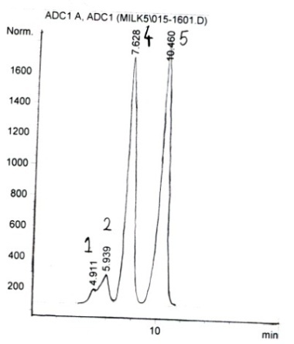  Fig.(1) cv. Superior | 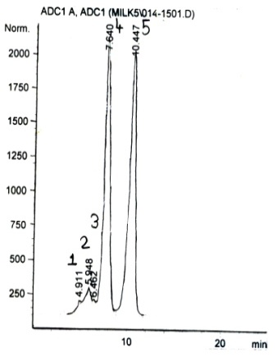  Fig.(2) cv. Thompson | 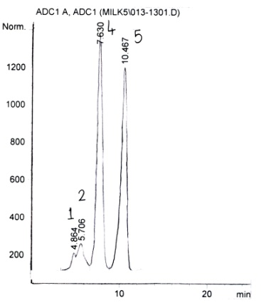  Fig.(3) cv. Queen
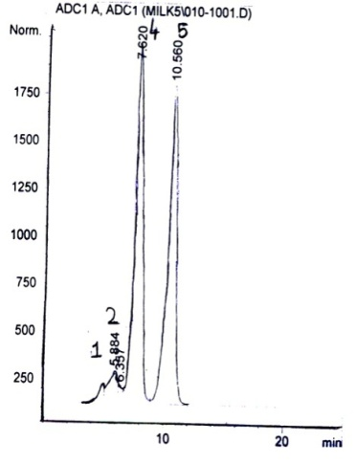  Fig.( 4) cv. Black monukka | 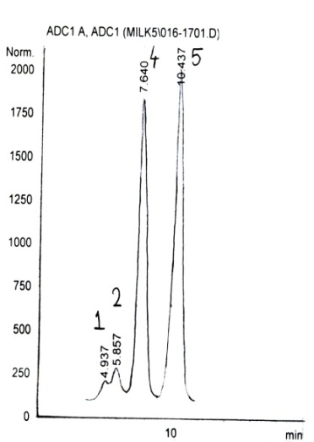  Fig.( 5) cv. Fiesta | 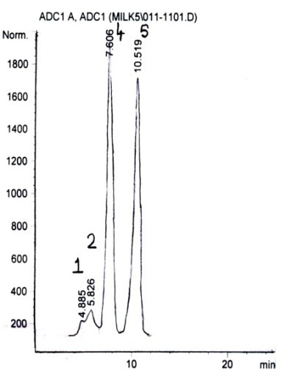  Fig.( 6) cv. Flame.
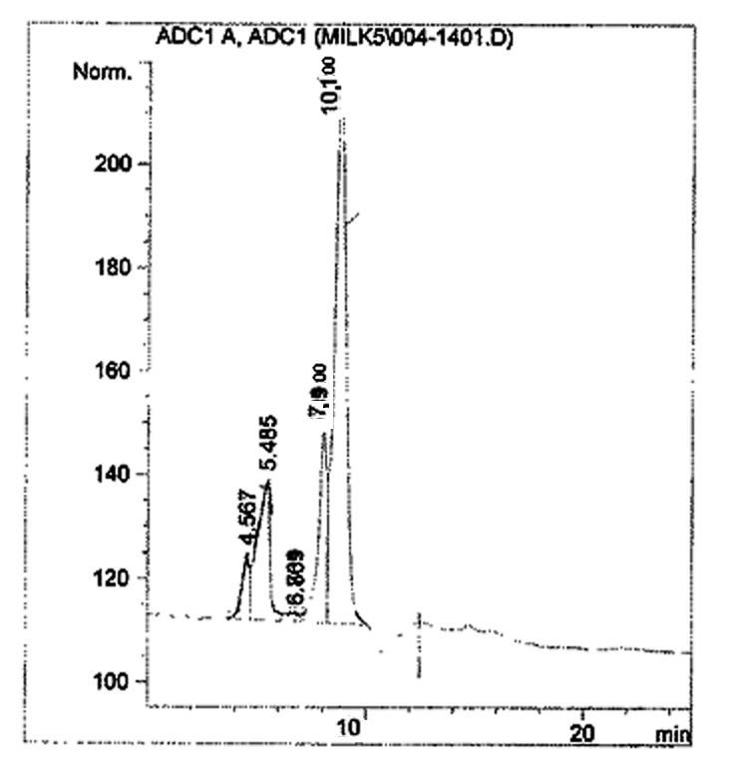  Fig.(7) cv. Black rose | Fig.(8) cv. Cardinal.

Figs. (1-8) HLPC chromatograms of sugar content in the fruits of eight cultivars

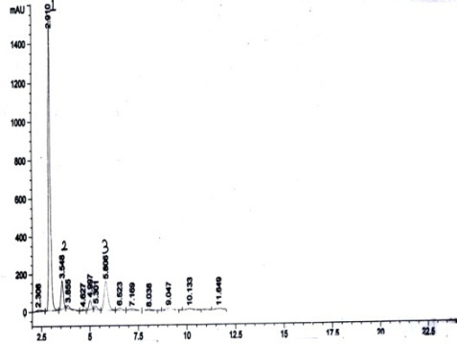  Fig.(9)cv. Queen | Fig.(10) cv. Black monukka | 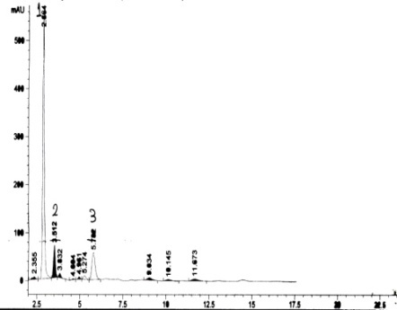  Fig.(11) cv. Flame
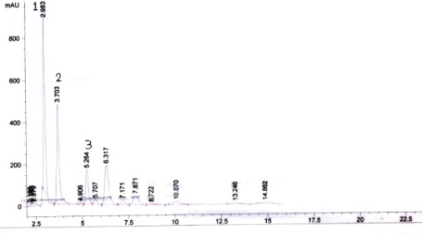  Fig.(12)cv. Black rose | 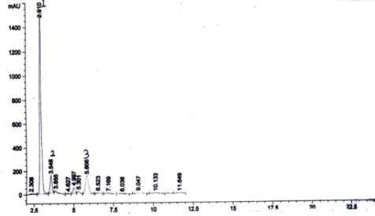  Fig.(13)cv. Cardinal.
Figs. (9-13): HPLC chromatogram of anthocyanins in alcoholic extract of the black and red fruits of five cultivars of Vitis vinifera L .

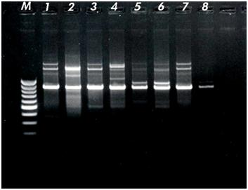
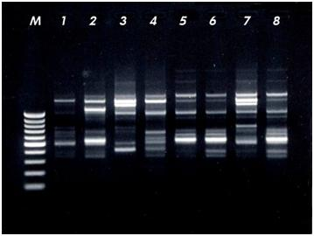
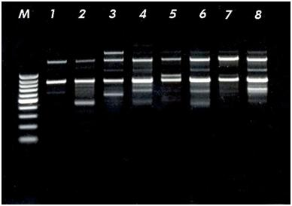

OPC07
OPA15
OPA02

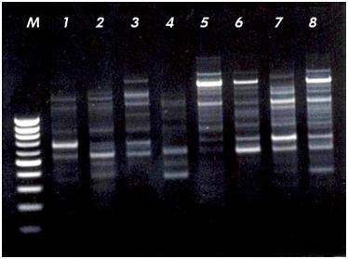
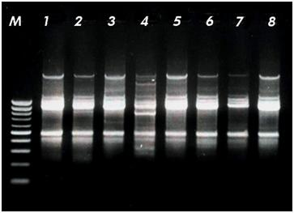
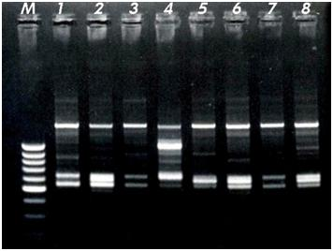

OPB10
OPC13
OPB13

Figs.(14- 19):Electrophoresis of DNA shows RAPD analysis of eight cultivars of Vitis vinifera L. with lane 1 to lane 8 resembles the eight cultivars.

Table (1): Results of HPLC analysis of the sugar content of the fruits of eight cultivars of Vitis vinifera L.
Peak No | Identified sugar | RRt* (min) | % of sugar content in the fruits of eight cultivars of Vitis vinifera L. g%
 |  |  | Thompson | Fiesta | Superior | Black monukka | Queen | Flame | Black rose | Cardinal
1 | Glucouronic acid | 0.86 | 0.395 | 0.398 | 0.359 | 0.676 | 0.364 | 0.259 | 0.034 | 0.351
2 | Sucrose | 1 | 1.044 | 0.995 | 1.03 | 0.141 | 0.839 | 0.779 | 0.113 | 1.101
3 | Maltose | 1.14 | 0.304 | - | - | - | - | - | 0.005 | -
4 | Glucose | 1.21 | 8.83 | 7.315 | 7.082 | 5.809 | 5.687 | 6.229 | 0.103 | 1.039
5 | Fructose | 1.64 | 6.905 | 6.555 | 6.03 | 4.196 | 3.97 | 4.527 | 0.301 | 0.829
RRt*, relative retention time to sucrose

Table (2): Results of GLC analysis of the lipoidal matter of leaves and fruits of flame cultivar.
Results of GLC analysis of fatty acids methyl esters of the lipoidal matter of leaves and fruits of flame cultivar. |  |  |  | Results of GLC analysis of unsaponifiable matter of fruits and leaves of flame cultivar.
Name of acid ester | RR_{t}* | Percentage in the fruits | Percentage in the leaves | Name of authentic hydrocarbon | RR_{t}* | Percentage in the fruits | Percentage in the leaves
Methyl valerate | 0.045 | 14.10 | -- | dodecane | 0.070 | 3.73 | --
Methyl caproate | 0.203 | 1.38 | 0.23 | Tetradecane | 0.417 | 0.46 | --
Methyl enanthate | 0.216 | 1.10 | 0.41 | Hexadecane | 0.459 | 0.61 | 0.61
Methyl caprylate | 0.232 | 4.41 | 0.32 | Heptadecane | 0.507 | 0.65 | 0.34
Methyl caprate | 0.287 | 4.06 | 0.43 | Octadecane | 0.601 | 0.44 | 0.21
Methyl undecanoate | 0.419 | 5.55 | 0.57 | Nonadecane | 0.644 | 0.45 | 0.31
Methyl laurate | 0.455 | 4.50 | 0.81 | Eicosane | 0.697 | 1.16 | 0.12
Methyl tridecanoate | 0.471 | 1.16 | 25.52 | Heneicosane | 0.726 | 1.35 | 5.71
Methyl myristate | 0.518 | 1.91 | 0.21 | Docosane | 0.769 | 3.65 | 8.53
Methyl myristoleate | 0.554 | 0.78 | 16.27 | Tricosane | 0.801 | 4.08 | 11.22
Methyl pentadecanoate | 0.585 | 0.63 | -- | Tetracosane | 0.842 | 4.97 | 14.36
Methyl palmitate | 0.675 | 13.24 | 10.62 | Pentacosane | 0.912 | 12.74 | 13.46
Methyl palmitoleate | 0.748 | 0.15 | 16.31 | Hexacosane | 0.957 | 9.89 | 12.20
Methyl margarate | 0.797 | 0.23 | -- | Octacosane | 1.000 | 28.97 | 11.17
Methyl stearate | 1.000 | 35.59 | 17.7 | Squalene | 1.110 | -- | 1.018
Methyl oleate | 4.060 | 4.74 | 1.30 | Triacontane | 1.129 | 11.81 | 4.19
Methyl linoleate | 1.115 | 0.97 | 0.30 | Stigmasterol | 1.277 | 1.92 | 0.21
Methyl linolenate | 1.182 | 0.95 | 0.10 | β-sitosterol | 1.463 | 0.46 | 11.20
Methyl arachidate | 1.540 | 1.73 | --

RR_{t}*: relative retention time to octacosane.

Table (3): Results of determination of the anthocyanins in fruits of coloured cultivars Vitis vinfera L. by HPLC analysis.
Fruit anthocyanins | R_{t} | Anthocyanin concentration in fruits of Vitis vinfera L. cultivars mg/g.
 |  | Queen | Cardinal | Flame | Black monukka | Black rose
Malvidin | 2.91 | 0.05 | 0.38 | 0.17 | 0.27 | 0.22
Pelargonidin | 3.54 | 0.09 | 0.07 | 0.04 | 0.58 | 0.32
Peonidin | 5.51 | 0.35 | 0.56 | 0.13 | 0.30 | 0.26
RT., retention time. Concentrations were expressed as mg/g. Each result is the mean of three determinations.

Table (4): RAPD polymorphic bands of eight cultivars of Vitis vinifera L. with six primers.
Band No. | MW-RF | Thompson | Fiesta | Superior | Queen | Black monukka | Flame | Black rose | Cardinal
OPB-10) primer | 0.477 |  |  |  |  | + | + | + | +
 | 0.489 | + | + | + | +
 | 0.800 |  |  |  | +
 | 0.980 | + |  | + | + | + | + | + | +
 | 1.010 |  | +
 | 1.610 | + | + | + | + | + | + | + | +
 | 3.15 |  |  |  |  |  |  |  | +
OPC-03) primer | 0.527 |  |  |  |  |  | + | + | +
 | 0.550 | + | + | +
 | 0.583 |  |  |  |  | + | +
 | 0.617 |  | +
 | 0.635 |  |  |  | + |  |  | +
 | 0.641 |  |  | +
 | 1.047 |  |  |  | +
 | 1.368 | + | + | + | + | + | +
 | 1.385 |  |  |  |  |  |  | + | +
(OPA-02) primer | 0.908 | + | + | + | + | + | + | +
 | 0.925 |  |  |  |  |  |  |  | +
 | 1.021 |  |  |  |  |  | +
 | 1.039 |  |  |  |  | +
 | 1.394 | + | + | + | + |  |  | +
 | 1.515 | + |  | +
(OPA-15) primer | 0.429 |  |  | +
 | 0.518 | +
 | 0.552 |  | +
 | 0.574 |  |  |  |  | + | + |  | +
 | 0.816 |  |  |  |  |  |  | +
 | 1.114 |  |  |  |  |  | + | + | +
 | 1.179 |  | +
 | 1.262 |  |  | + |  |  |  | +
 | 1.374 | + | + | + | + |  |  | +
 | 1.504 |  |  |  |  |  | + | +
(OPB-13) primer | 0.390 |  |  |  | +
 | 0.569 | + | + | +
 | 0.633 |  |  |  | + |  | + | +
 | 0.672 |  |  |  |  |  |  |  | +
 | 0.694 | +
 | 0.713 |  |  | +
 | 0.800 |  |  |  |  |  |  | + | +
 | 1.355 |  |  |  |  | + |  | + | +
 | 1.501 |  |  | +
 | 1.680 |  |  |  |  | + | + |  | +
(OPC-07) primer | 0.468 |  | +
 | 0.626 |  |  | +
 | 0.745 |  |  |  |  |  |  |  | +
 | 0.868 |  |  | +
 | 0.882 | +
 | 0.900 |  | + | + | + | +
 | 0.925 |  |  |  |  |  | +
 | 0.953 |  |  |  |  |  |  | +
 | 1.564 | + |  |  | + | +
 | 1.637 |  |  |  |  |  | + | + | +

Table (5): Antioxidant activity of alcoholic extracts of fruits, leaves and juice of flame cultivar and vitamin E in male albino rats (n=6).
Group | Blood glutathione (mg/dl) | % Change from control
Control | 36.3±0.7 | -
Diabetic | 23.8±0.4* | 34.4
Diabetic + alcoholic extract of fruits (100mg/kg b.wt.) | 34.1±0.3 | 6.1
Diabetic + alcoholic extract of leaves (100mg/kg b.wt.) | 32.6±0.4 | 10.2
Diabetic+ Juice (100mg/kg b.wt.) | 35.4±0.3 | 2.5
Diabetic + Vitamin E (7.5mg/kgb.wt.) | 35.4±0.6 | 1.9
*Significantly different from control at P<0.01
Table (6): Hepatocurative activity of alcoholic extracts of fruits, leaves and juice of flame cultivar and silymarin in male albino rats (n=10).
Group | AST (U/L)  ( Mean±S.E.) |  |  |  | ALT (U/L)  ( Mean±S.E.) |  |  |  | ALP (KAU)  ( Mean±S.E.)
 | Zero | 72 hrs | 30 days | 60 days | Zero | 72 hrs | 30days | 60days | Zero | 72 hrs | 30days | 60days
Control | 6.7±1.8 | 119.2±3.6• | 131.5±3.4• | 143.6±4.1• | 27.8±1.7 | 115.4±4.2• | 129.7±5.1• | 138.3±5.6• | 7.3±0.2 | 16.4±0.9• | 22.6±0.5• | 23.5±0.9•
Alc. ext. of fruits  (100 mg/kg b. wt.) | 29.1±1.3 | 127.8±3.7• | 89.5±2.6*• | 42.3±1.9 * • | 28.4±1.9 | 128.6±3.2• | 97.4±2.8*• | 47.2±2.6*• | 7.5±0.3 | 191±0.7• | 13.7±0.8*• | 11.2±0.4*•
Alc. ext. of leaves (100mg/kg b. wt. ) | 25.9±1.2 | 126.9±3.8• | 81.4±2.9*• | 38.4±1.6 *• | 29.3±0.7 | 136.4±6.2• | 101.5±4.6*• | 43.6±2.1*• | 7.8±0.2 | 20.4±1.1• | 16.1±0.5*• | 13.1±0.1*
Juice (100mg /kg) | 27.8±1.1 | 132.4±4.1• | 72.3±3.1*• | 31.1±1.2• | 28.5±1.9 | 124.2±5.1• | 82.1±3.4*• | 36.2±1.3*• | 7.6±0.3 | 18.2±0.7• | 11.8±0.2*• | 9.4±0.2*
Silymarin (25mg/kg.b.wt.) | 28.2±1.2 | 121.5±4.3• | 53.8±2.9*• | 27.2±1.5* | 25.8±0.6 | 119.6±3.8• | 64.2±2.1*• | 25.1±1.3* | 7.1±0.4 | 18.3±0.9• | 9.6±0.3*• | 6.3±0.1*
* Significantly different from control group at the same interval P< 0.01 • Significantly different from zero time at P< 0.01

Table (7): Anti-inflammatory activity of alcoholic extracts of fruits, leaves and juice of Vitis vinifera L. and indomethacin in male albino rats (n=6).
Group | Dose in mg/kg b.wt. | % Oedema
 |  | Mean ± S.E. | % of Change
Control | 1 ml saline | 59.6± 1.4 | -
Alcoholic extract of fruits | 50 | 44.9±0.1* | 24.7
Alcoholic extract of fruits | 100 | 28.5±0.6** | 52.2
Alcoholic extract of leaves | 50 | 42.1±1.3* | 29.4
Alcoholic extract of leaves | 100 | 33.7 ± 0.8** | 43.5
Juice | 50 | 38.1±0.7** | 36.1
Juice | 100 | 26.4±0.5** | 55.7
Indomethacin | 20 | 22.4±0.8* | 62.4
* Significantly diff. From control group at p<0.05. ** Significantly diff. From control group at p <0.01.
% of change calculated as regard the control group.

Table (8): Antipyretic activity of alcoholic extracts of fruits, leaves and juice of Vitis vinifera L. and paracetamol in male albino rats (n=6).
Group | Dose in mg/kg b.wt. | Body temperature change after single oral dose
 |  | Induced rise in temperature | One hour |  | Two hour
 |  |  | Mean +S.E. | % of change | Mean+ S.E. | % of change
Control | 1ml saline | 39.2±0.1 | 39.4±0.2 | 0.5 | 39.6±0.4 | 1.02
Alcoholic extract of fruits | 100 | 39.4±0.3 | 37.9±0.3* | 3.8 | 37.4±0.2* | 5.6
Alcoholic extract of leaves | 100 | 39.6±0.2 | 37.9±0.1* | 4.3 | 37.1±0.1* | 6.3
Juice | 100 | 39.3 ±0.2 | 38.2±0.04* | 2.8 | 37.5±0.2 | 4.6
Paracetamol | 20 | 39.8±0.4 | 37.2±0.1* | 6.5 | 36.4±0.1* | 8.5
* P < 0.01 corresponding induced rise in temperature of the tested group.

Table (9): Analgesic activity of alcoholic extracts of fruits, leaves and juice of Vitis vinifera L. and novalgin in male albino rats (n=6).
Group | Dose in mg/kg  b.wt. | Volts needed after single oral dose
 |  | Volts before  treatment (Zero time) Mean±S.E. | One hour |  | Two hours
 |  |  | Mean +S.E. | % of change | Mean+ S.E. | % of change
Control | 1ml saline | 73.2±1.31 | 37.2±1.4 | 0.5 | 73.4±1.5 | 0.3
Alcoholic extract of fruits | 100 | 74.3±1.6 | 123.1±2.7* | 72.6 | 146.8±6.2* | 100
Alcoholic extract of leaves | 100 | 75.2±1.8 | 134.9±3.6* | 79.4 | 152.4±5.1* | 102.7
Juice | 100 | 76.1 ±1.4 | 118.5±2.9* | 61.9 | 137.8±3.5* | 85.5
Novalgin | 20 | 75.8±2.1 | 165.2±5.1* | 117.4 | 183.2±5.8* | 114.7
* Significantly different from zero time at P < 0.01. % of change calculated regards the effect at zero time.

Table (10): Diuretic activity of alcoholic extracts of fruits, leaves and juice of Vitis vinifera L. and moduretic in male albino rats (n=6).
Group | Dose in mg/kg b.wt. | Volume of urine (in ml)
 |  | 2hrs | 4 hrs | 24 hrs
Control | 1 ml saline | 0.8±0.04 | 1.5±0.03 | 5.1±0.2
Alcoholic extract of fruits | 100 | 2.5±0.3* | 4.8±0.4* | 10.6±1.3*
Alcoholic extract of leaves | 100 | 2.6±0.1* | 5.3±0.2* | 11.2±0.5*
Juice | 100 | 2.9±0.2* | 5.6±0.3* | 13.1±0.6*
Moduretic drug | 5 | 4.3±0.1* | 7.1±0.4* | 15.6±0.8*
Values are mean of 6 observations ± S.E. * Significantly different from control at p< 0.01.

Acknowledgement:
The authors are indebted to Prof. Dr. Amani A. Sleem, professor of Pharmacology, Department, NRC for her kind help in carrying out the pharmacological and toxicological testing of the plant extracts and The authors are wish to express their gratitude to Dr. Eslam El-Grauani, Biotechnology Department, NODCAR, for Biogene software analysis.

Corresponding author
K.M. Meselhy
Department of Pharmacognosy and Medicinal Plants, Faculty of Pharmacy, Cairo University, Kasr-el-Aini Street, 11562 Cairo, Egypt
kmeselhy@hotmail.com

References
- Abd El-Fattah, S. E. and S. Kasstor (1993). “Evaluation of some introduced grapevine cultivars. Seeded cultivars’’, Minia J. Agric. Research and Development, 31: 493-505.
- Alleweldt, R. J. and Singh, L (1991). Grape Growing, A. Wiley Interscience Puplication, John Wiley and Sons, New York, London, Sydney, Toronto.
- Beutler, E.; Duron, O. and Kelly, B. (1963). Improved method for the determination of blood glutathione. J. Lab. Clin.Med. ,61: 882-888.
- Binder, H.(1980). Kokai Tokkyo Koh J. Chromatography, 189:414-421.
- Black, LT. And E.B. Bagley. (1978). Determination of oligosaccharides in soybeans by high pressure liquid chromatography using an internal standard. JAOC 55:228- 232.
- British Pharmacopoeia (1973). The Pharmaceutical Press, Lodon.
- Bush, J.E. and Alexander, R.W. (1960). “An improved method for the assay to anti-inflammatory substances in rats”. Acta En-docrinologica, 35: 268-276.
- Charlier, R.; Prost, H.; Binom, F. and Dellous (1961). “G. Pharmacolpogy of an antitussive, 1-phenyl 1-4(2-propenly)-4-propinoxypipridine acid Fumarate”: Arch. Intern. Phara-Codynamic, 134:306-327.
- Eliasson, S. G. and Samet, T.M. (1969). “Alloxan induced neuropathies, Lipid change in nerve and root fragment”, Life Science, 8(10):453-498.
- Finar, I.L (1973). Organic Chemistry, 6th. Ed., Longman Group Limited England.
- Ismail, M. A. (1989). “Studies on growth, productivity and fruit quality of some grape cultivars.” M. Sc. Thesis, Fac. Agric. Cairo Univ. Egypt.
- Klassen, J. K. and Plaa (1969). “Arndt, Christian. Berlin-Charlottenburg, Ber’, 97(8), 2125-2134.
- Krisa, J. P.; Mouly, P.P. and Gaydou, E.M. (1999)... Anthocyanic pigment determination in red fruit juices, concentrated juices and syrups using liquid chromatographyAnalytica Cimica. Acta, 382 (1-2): 39-50.
- Ministry of Agriculture (1999) Agricultural Development System Project, ADS)
- Moris, H.; Ramos; Foragacs, E.; Cserhati, T. and Olivea,J. (2002) Journal of Chromatography. B: Biomedical. Application, 770 (1-2): 296-304.
- Olmo, L. ( 1995). General Vitis culture, Univ. of Calif. Press., Berkely, Los Angelos, London.
- Paget, G. and Berne’s, E :( 1964). “Toxicity tests in Evaluation of drug activities sited in the laboratory rat”. Ed. Laurence, D. R. and Bacharach A. L. Academic Press London. P, 135-160.
- Roth, L. S. (2010). “Herbs & Natural Supplements” MOSBY Elsevier, USA. 4th Edition
- Sokar, A. S. J. ( 1991). “Comparative Studies on description and evaluation of five new table grape cultivars under Egyptian condition”. Annals of Agric. Sc. Moshtohor, , 3694: 2473-2486.
- Stephen, M. and Duke, J.A. (1996). “CRC Handbook of Medicinal Mints" Library of Congress; CRC Press, INC. Boca Raton, New York, London and Tokyo.
- Thefweld, W. (1974). “Enzymatic method for determination of serum AST and ALT. Med”. 99.343.
- Ulbricht, C. and Seamon, E. (2010). “Natural Standard Herbal Pharmacotherapy" Natural Standard Research Collaboration; MOSBY Elsevier, Canada.
- Vidal, E.; Ryan, J. and Martin, G. (2002) "Changes in proanthocyanidin chain length in winelike model solutions. Journal of Agricultural and Food Chemistry 50:2261-2266
- Winter, G.A.; Risley, E.A. and Nuss, G.W. (1962).” Carrageenan – induced oedema in hind paw of the rat as an assay for anti-inflammatory drugs”; Proc. Soc. Exp. Biol. Med. III:1544-1547.
- Wang, H. B.; Race, E. J. and Shrikhande, A. J. (2003) Characterization of anthocyanins in grape juices by ion trap liquid chromatography-mass spectrometry. J. Agric. Food Chem., 51, 1839–1844.

7/1/2012

