The application of FSM model for the prediction of sediment yield in Tehran basin

Abbas Atapourfard¹, Majid Moradi Sharaf¹, Gholamreza Shoaei²

^{1.} Watershed Research Group, Agriculture investigation center of Hamedan, P.O.Box: 887, Hamedan, Iran
² Assistant Professor, Tarbiat Modares University, P.O.Box: 14115-175, Tehran, Iran
g.shoaei@gmail.com

Abstract: Because of scarce recorded data, experimental models are widely used in Iran. Due to the model variable parameters and widely irregular conditions of the basins, particularly in Tehran region, the calibration of the models are necessary to reduce the prediction errors. The available data for the basins selected for this investigation are physiographic, vegetation cover, geology, the results of erosion and sedimentation studies and data of a few sedimentary gauge stations with more than 15 years of collected data (sediment and flow discharge) in their outlets. Daily flow records were compiled and combined with adopted sediment rating curve (the Model on mean values) to give annual sediment loads through the period of record. Bed load of selected basins have been estimated by the use of the accumulated bed load in the reservoir of small dams. Calibration and validation of The Factorial Scoring Mode (FSM) was done using specific sediment yield (SSY) data from 9 gauge stations. Then by comparing the results of calibrated and uncalibrated FSMs (calibrated and uncalibrated) and calculated annual SSY of gauge stations, the model efficiency (ME) as deﬁned by Nash and Sutcliffe (1970), and the relative root mean square error (RRMSE) were determined. The adjusted R2 between predicted and observed SSY of calibrated FSM was 0.8, the model efficiency is 0.62 and the RRMSE value is 0.27.
[Abbas Atapourfard, Majid Moradi Sharaf, Gholamreza Shoaei. The application of FSM model for the prediction of sediment yield in Tehran basin. Nat Sci 2012;10(9):105-112]. (ISSN: 1545-0740). http://www.sciencepub.net/nature. 14

Keywords: sediment yield; soil erosion; sedimentary gauge stations; Tehran basin

1. Introduction
Estimation of soil erosion and sediment yield might be carried out by using direct measurement techniques such as erosion pins and plots, cosmogenic radioisotopes (₁₃₇CS), sedimentary gauge stations, and measuring sediment deposition within dams’ reservoirs. The application of erosion pins and plots involves a high amount of time and expenditure. The cosmogenic radioisotops are often used in small catchments and, thus the method is not economic to apply in larger areas. In addition, the number of sedimentary gauge stations is usually limited (measurements are done most often at permanent and sometimes seasonal rivers) and the number of dams is low too. Thus, currently the most affordable and most practical method for estimating SSY of the basins (without sediment flux data), is the application of empirical models. During the past decades, several empirical models have been presented. Some of them are still in Use for predicting specific erosion and sediment yield (SESY) in the basins where lack data. Such empirical models are prepared based on the specific basin properties for different regions; so application of them to other areas involves the evaluation of the model efficacy and calibration based on the most significant factor resulting the SSY in those regions.
Different methods including erosion pin and plot, field observation and studies, ₁₃₇CS measurement, the sedimentary measurement of dams’ reservoirs, small barrage, and the flow of sedimentary and hydrometric station have been used for evaluation of the efficacy of experimental models. Erosion pins and plots only are able to estimate rate of lost soil as the result of sheet and rill erosion, and thus, their results cannot be used for estimating efficacy of erosion and the evaluation of SESY models. This method can only be used for the evaluation of the models that calculate rate of rill and sheet erosion. Some researchers have used erosion plots to determine the rate of the efficacy of experimental methods for estimating precipitation (Risse et al, 1993; Zhang et al, 1996 and Bhuyan et al, 2002).
The field observations is one of the most important approaches for quality evaluation of SESY models (Morgan, 1995). Bureau of Land Management (BLM) approach is suitable for quality evaluation of SESY models. It has been used by some of the soil scientists (Chugg and Lovely, 1982).
Using the ₁₃₇CS technique has been regarded for evaluating SESY models and developed in recent years.
The suspended sediment flux and flow discharge data’s(Clark, 1999; Shade,1986; Janson and Gebhadet, 1982), sediment of dams’ reservoir, and small bridge (check dam) also has been used for evaluation SESY models.
The method for estimating SSY by using the data from dams reservoirs and small bridges data is able to estimate the total rate of SSY (bed load and suspended sediment) in long-term; however, as they are uncertain in the trap efficiency calculation, the conversion from sediment volume to mass, building of tailing dams in upland of storage dams, construction of water diversion path for muddy waters in flood discharges, and in the dredge of dams that can make errors in estimate of long- term SSY.
Sediment and flow discharge method is used to estimate SSY at the scale of small to medium sized basins with relatively low data requirements (de Ventle et al., 2005).Prior to the applying this model in Iran Tehran basins, the model should be evaluated and calibrated based on the existing conditions of those basins.
This paper is a part of “Calibration of MPSIAC and FSM Models in Tehran basins” research project. Due to the lack of dams, and large size of their basins, lack of accurate sediment and erosion studies and data in the basins, and the widespread application of these models in small to medium sized basin, gauging station data were used for evaluation and calibration of these models.

2. Material and Methods
2.1. Study Area
The study area is at the central Alborz Range, north of Iran, and is located at north and north-east of Tehran province. The basins of Tehran province are 20017.29 Km² wide and are located between 50⁰ 10ʹ to 53⁰ 10ʹE and 34⁰ 53ʹ to 36⁰ 21ʹ N. In the study area, 14677.63 Km² is mountainous and located on foothills (Fig. 1).The basins of this area are categorized as Tehran basins. This region has been divided to 191 hydrological units. The area of these hydrological basins varies between 281 to 233 Km², and there are detailed studies on 35 of them.

2.2 Factorial Scoring Model (FSM)
Empirically relating sediment yield to basin properties such as area, rainfall and runoff is a common practice (Verstraeten & Poesen, 2001; Walling, 1983). As the regression method developed, Avendano et al. (1993), by using 60 reservoirs data, present an equation to define a relation between the area of basins and sediment yield.

(Eq. 1)

Area alone explained only little of variation in sediment yield, thus, Verstraeten et al. (2003) added a few additional basin properties to the existing regression. Verstraeten et al. (2003) presented a Factorial Scoring Model (FSM) to explain part of the remaining variation in Eq. 1 by using sedimentation rates of 22 (out of 60) reservoirs studied by Avendano et al. (1997). In a subsequent study, de Vente & Poesen (2005) developed an additional regression using data from all the 60 reservoirs, however, the regressions did not improve the explanation of variation in sediment yield variation, and thus, FSM is the approach that explains most of the variation in sediment yield.
FSM (Verstraten et al., 2003) predicts the annual specific sediment yield of a basin (>100 km2) based on a nonlinear equation involving the basin area and five weighted additional factors: topography, vegetation cover, gullies, lithology and slope. Verstraten et al (2003) identified the general geomorphic setting of the basin, the presence or absence of gullies in the immediate vicinity (5 km) of the reservoir or main river channels, the presence of highly erodible substrates such as like marls, and vegetation cover in the surroundings of the reservoir.
Eq. 2 shows the model presented by Verstraeten et al. (2003). This equation is based on the data from 19 reservoirs (out of 60).
(Eq. 2)
Where I is the total scoring index (product of scores of each factor).
The method consists scoring of each five factors (description given in table 1) with a score of 1, 2, and 3 for low, moderate and high sediment yields, respectively. Then, the index I is calculated by multiplying the score given to each factor. The index can vary between 1 and 243 (when all factors are assigned 3).

2.3 Methodology
2.3.1 Selection of the basin
Gauge stations within study area were identified and the data were collected. The basins with more than 15 years of data (sediment and flow discharge) were selected for this study. In addition, more available data such as physiographs, vegetation, geology, and erosion and sedimentation studies were collected. The Polygon map of selected basins and point map of selected gauge stations were overlapped and thus, 9 basins with appropriate gauge stations in their outlets were chosen to conduct this study (Figure 2).

2.3.2 Statistical analysis
Continuous measurements of water stage to estimate the discharge, and discrete water sampling to estimate the suspended sediment concentration were collected and considered for statistical analysis. Unlike discharge data, which were measured on the daily basis, measurement of suspended sediment concentration (SSC) at gauge stations was sporadic. The available measurement of daily SSC was used to

Table 1: Description of the scores for each of five factors used in FSM (Verstraeten et al. 2003)
Factor | Score | Description
Topography | 1  2  3 | Very gentle slopes near reservoir and main rivers; elevation difference !200 m within 5 km  Moderate slopes near reservoir and main rivers; elevation difference 200–500 m within 5 km  Steep slopes near reservoir and main rivers; elevation difference O500 m within 5 km
Vegetation cover | 1  2  3 | Good contact cover of the soil (O75% surface protected)  Moderate contact cover (25–75% protected surface)  Poor contact cover (25% protected)
Gullies | 1  2  3 | Bank and ephemeral gullies are very rare  Few bank and/or ephemeral gullies can be observed  Many bank and/or ephemeral gullies can be observed
Lithology | 1  2  3 | Dominant limestone, sandstone or conglomerate (low weathering degree)  Dominant Neogene sedimentary deposits (gravels, etc.)  Strongly weathered (loose) material loams and/or marls
Basin shape | 1  2  3 | Elongated basin shape with one main river channel draining to the reservoir. No significant direct runoff from slopes into the reservoir  Between elongated and (semi-) circular basin shape  (Semi-) circular basin shape with many rivers draining into the reservoir and/or much direct runoff from hill slopes to the reservoir

Table 2: FSM scores for each factor for all 9 basins as determined by field surveys and topographical and geological maps
Basin name | gauge station name | A(Km2) | topography | vegetation cover | gullies | lithology | basin shape | FSM Index | Observed SSY(t/ha/yr) | Predicted SSY(t/ha/yr)
Darakeh | Darakeh | 25 | 3 | 2 | 1 | 1 | 1 | 6 | 4.9 | 2.4
Darabad | Darabad Fashand | 34 | 2 | 2 | 1 | 2 | 3 | 24 | 3.9 | 3.2
Ah | Abali | 57 | 2 | 2 | 1 | 3 | 3 | 36 | 5.6 | 3.7
Kondrod | Najjarkola | 59 | 2 | 2 | 2 | 3 | 2 | 48 | 6.8 | 4.3
Joestan | Hasanjun | 64 | 2 | 3 | 2 | 3 | 1 | 36 | 7.7 | 3.7
Bomhen | Seiahrood | 93 | 1 | 2 | 2 | 3 | 2 | 24 | 5.1 | 3.2
Lavarak | Lavarak | 103 | 2 | 2 | 1 | 2 | 3 | 24 | 4.6 | 3.2
Solegan | Kan | 196 | 2 | 3 | 1 | 1 | 2 | 12 | 2.7 | 2.7
Sira kalvan | Sira kalvan | 725 | 1 | 2 | 1 | 2 | 2 | 8 | 2.1 | 2.5
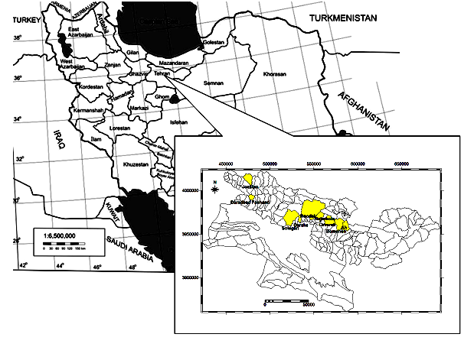

Figure 1: The location of the study area

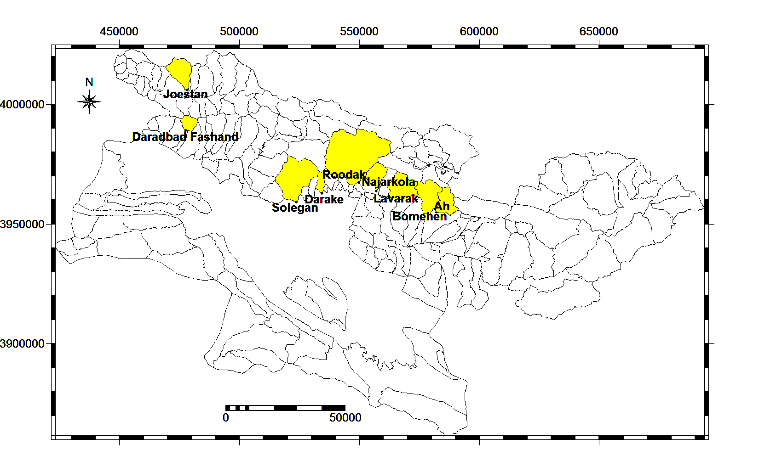

Figure 2: The location of selected basins and gauge stations for the calibration of FSM model

develop sediment rating curve, which depicts the statistical relationship between suspended sediment concentration and the discharge.
The relation between suspended sediment load, L, and water discharge, Q, in most areas is defined as a power equation,
L = aQb (Eq. 3)
Where: a and b are constants. Logarithmic model, power function model, model on mean values, and FAO method were used to fit a rating curve.
The Model on mean values adapts the rating curve close to the mean loads and eliminates (to some extent) the retransformation bias problem which complicates the rating curve technique (Jansson, 1995). Thus, we used this method for fitting the rating curve in this study.
There are several methods (such as Flow-Duration Curves, daily mean flow, combining daily and monthly mean flow) to calculate the annual suspended sediment loads of rivers, combined with the adopted sediment rating curve. Amongst the existing methods, the daily mean flow (if a complete daily means flow available) is more reliable. Thus, in this study, daily flow records were compiled and combined with adopted sediment rating curve relationship (the model on mean values) to give annual sediment loads through the period of record. This applies to 9 stations

2.3.3. Calculating bed load
Gauge stations measure the suspended sediment. We need the total sediment load of rivers to calibrate the FSM model. Thus, bed load of rivers has been estimated by the use of accumulated bed load in the reservoir of small dams (especially gabion dams).
2.3.4. Model calibration and its validation
Calibration and validation of FSM model in this paper was done using SSY of the 9 gauge stations. In order to split the dataset into two parts for the calibration and the validation, Jackknife procedure (Shao and Tu, 1995) was carried out. In this procedure, 8 of the reservoirs were used for model calibration, after the model was applied for predicting SSY for the remaining stations. This was repeated 9 times so that for each reservoir a predicted SSY-value was obtained by the model calibrated for the other 8 reservoirs.

2.3.5. Evaluate the annual SSY by FSM model and assessment of the results
FSM scores obtained from existing studies (topography, lithology and basin shape factors), field surveys (erosion and vegetation cover factors), and annual SSY of each basins were evaluated by using Verstraeten et al. (2003) method and calibrated equations (eq3.). Then, by comparing the results of two FSM models (calibrated and uncalibrated) and calculated annual SSY of gauge stations, the model efficiency (ME) as deﬁned by Nash and Sutcliffe (1970) and the relative root mean square error (RRMSE) were determined as:

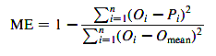 (Eq. 4)
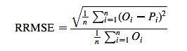 (Eq. 5)
In these equations, n, is the number of observations, Oi, the observed value, Pi, the predicted value and O_{mean} is the mean observed value. The model efficiency can range from ∞ to 1 and should be interpreted as part of the initial variance accounted for by the model. So, closer the ME approaches 1, the more efficient the model is. Instead, negative values of ME indicate that the model produces more variation than could be observed. The RRMSE is independent on units in which the values are expressed. The smaller the RRMSE value, the more accurate is the model.

3. Results
The scores of all ﬁve factors of the FSM and predicted annual SSY (by using of Verstraeten et al FSM), for the 9 basins, are illustrated in Table 2. The adjusted R² between predicted and observed SSY of Eq. (2) was 0.55 (see Fig. 3). The model efficiency 0.4 and the RRMSE value 1.49 approach to FSM needs to be calibrated.
For calibration of FSM model, the FSM Index correlated with the area of basins and Linear, logarithmic, exponential, and power regression models were built by regression analysis (fig. 4). The adjusted R2 value between FSM Index and area of the basins was higher for exponential model. Thus, the Eq. (5) might be a better and more reliable regression model.
$\text{Qs}=\text{17}\text{.}7A^{−0\text{.}\text{304}}$ Eq. (5)

Fig. 5 shows the relation between the FSM Index (e.g. multiplication of the five scores) and the residual sediment yield (e.g. predicted—observed) after prediction with basin area as:

$\text{Residual SSY}=\left(0\text{.}\text{077}\text{FSMindex}−1\text{.}\text{709}\right)$ Eq. (6)

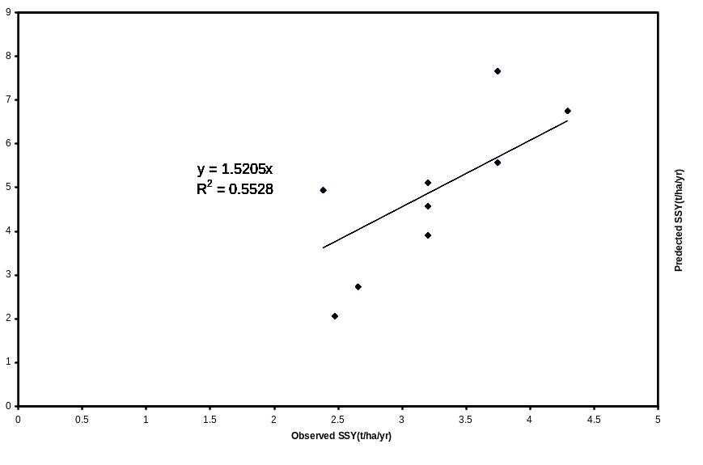
Fig.3. Validation of the Verstraeten et al. (2003) FSM by comparison of predicted and observed values.

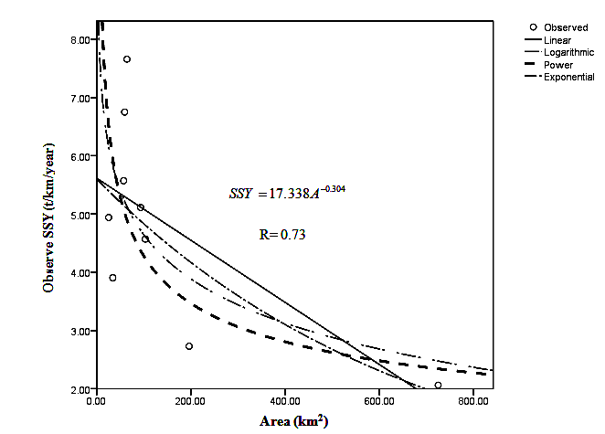
Figure. 4: types of regression models between FSMIndex and Area of basins
$$\text{SSY}=\text{17}\text{.}\text{338}A^{−0\text{.}\text{304}}$$
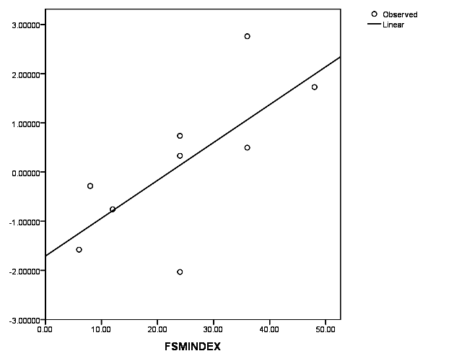
Fig.5. Relation between the FSM Index and residual SSY after prediction with basin area (n=9).

Here, basins with a low index are those with a lower observed SSY than expected; using basin area alone for prediction, represented by a positive residual. Basins with a high index are those with a higher observed SSY than predicted by the basin area model, represented by negative residuals. For SSY prediction, Eq. (6) was subtracted from the relation between basin area and SSY (Eq. (1)), yielding an equation for prediction of SSY calibrated for all 9 basins as:
$\text{SSY}=\text{17}\text{.}\text{338}A^{−0\text{.}\text{3030}}+\left(0\text{.}\text{077}\text{FSMIndex}−1\text{.}\text{709}\right)$ Eq. (7)
After validation, the predicted annual SSY, for the 9 basins, are illustrated in Table 3. The adjusted R2 between predicted and observed SSY in Eq. (6) was 0.8 (see Fig. 6), the model efficiency 0.62 and the RRMSE, 0.27.

4. Discussions
Semi-quantitative models provide fairly accurate and reliable estimates of SSY at the basin scale for Tehran province drainage basins, with relatively less data and low time requirements. Best was performed by the FSM, which uses five factors to characterize a basin in combination with basin area to predict SSY. The models comparison in Table 3 indicates that the calibrated FSM performs best for all with an adjusted R2 between predicted and observed SSY of 0.8.
Application of the FSM model to other areas than those for which they were developed should be done very carefully. The correlation between predicted and observed SSY was relatively high, but it systematically overestimated SSY for Tehran basins. Furthermore, the absence of a climate factor in the FSM is a limitation for applying the model to other areas with clearly different climate conditions.
Compared to the 60 Spanish drainage basins to which the FSM model was also applied (de Vente et al., 2005), vegetation cover in general seems to be lesser developed in the Tehran catchments, reﬂected on average in a somewhat higher score for the vegetation cover. This may imply that upland erosion in many of Tehran catchments is of higher significance than in Spain, as there is relatively less ground cover.
Our study showed that perennials gained dominance over annuals in oak forest as well as pine forest (Figure 1). Perennial have ability to conserve

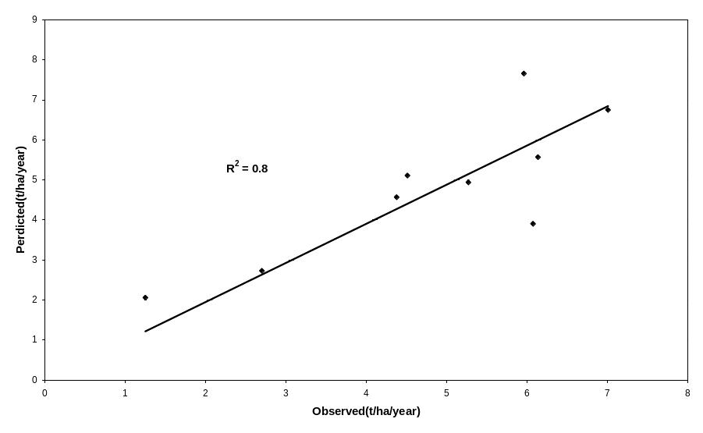
Fig. 6. Validation of the calibrated FSM by comparison of predicted and observed values. The model was calibrated using the Jackknife procedure (Shao and Tu, 1995).

soil and with their extensive root systems of perennial grasses they also add more organic matter to the soil than annuals which can be more favourable for plant growth. Singh and Singh (1987) observed that annuals colonize and dominate the early stages of succession. Annuals to perennials species ratio are higher at primary successional site than climax stage. Species richness generally increases during secondary succession when environmental and edaphic conditions are favourable with low fluctuations.
The above results indicate that the oak forest makes climax stage for succession. The evenness and β-diversity showed similar values in sub-sites of oak as well as pine forests. The high values of beta-diversity indicate that the species composition varied from one stand to another.
Equitability/evenness varied in pine forest with respect to sub-site from 27.3 (HB) to 31.4 (HT) (Table 3). This was because of the conditional presence or absence of functional relationship of species. Comparatively higher value of equitability in pine forest with respect to oak forest indicated that the individual herb species distribution is higher. This may perhaps due to intermediate level of disturbance.
The application of this model would be in regional plannings, e.g., when planning new dams or dam increment, and for the analysis of the impact of such constructions on downstream sediment budgets with consequences of bank erosion and spreading of possibly contaminated soil. However, for the identiﬁcation of source areas and for development of basin management strategies to prevent sediment inﬂow, these semi-quantitative models only give a first indication. In order to address these spatial issues in more detail, other spatially distributed approaches are required.

Table 3: Predicted speciﬁc sediment yield (t/ha/yr) of 9 Tehran basins by using of Verstraeten et al and calibrated FSM.
Basin name | A(Km2) | Observed SSY(t/ha/yr) | Predicted SSY (Verstraeten et al FSM) | Predict SSY(Calibrated FSM)
darakeh | 25 | 4.9 | 2.4 | 5.3
Darabad | 34 | 3.9 | 3.2 | 6.1
Ah | 57 | 5.6 | 3.7 | 6.1
Kondrod | 59 | 6.8 | 4.3 | 7.0
joestan | 64 | 7.7 | 3.7 | 6.0
bomhen I | 93 | 5.1 | 3.2 | 4.5
Lavarak | 103 | 4.6 | 3.2 | 4.4
Solegan | 196 | 2.7 | 2.7 | 2.7
Sira kalvan | 725 | 2.1 | 2.5 | 1.2

References
- Bhuyan S. J, Kalita P. K, Janssen K. A, Barnes. P. L. Soil loss predictions with three erosion simulation models. Environmental Modelling & Software. 2002; (17):137–146.
- Chugg J.C,Lovely C.J. BLM's interest in estimating erosion and sediment yield on rangelands. In proceedings of workshop on estimating erosion and sediment yield on rangelands, Tucson, Arizona,March 1982. US Department of Agriculture, Agricultural Reviews and Manuals, Western Series, No. 26, p. 36-38.
- Clark K.B. An Estimate of Sediment Yield for Two Small Watersheds in a Geographic Information System. M.Sc.Thesis.,Geography, University of New Mexico, 1999.
- de Vente J, Poesen J, Verstraeten G. The application of semi-quantitative methods and reservoir sedimentation rates for the prediction of basin sediment yield in Spain. Journal of Hydrology. 2005; 305 (1–4):63–86.
- Johnson C.W, Gebhardt K.A. Predicting sediment yields from sagebrush rangelands. In proceedings of workshop on estimating erosion and sediment yield on rangelands, ucson, Arizona, March 1981, US Department of Agriculture, Agricultural Reviews and Manuals, Western Series. 1982; (26):145-156.
- Morgan R.P.C, Soil and water conservation. Langman Scientific and Technical, 2nd edition. 1995: 60-8.
- Nash J.E, Sutcliffe J.V. River ﬂow forecasting through conceptual models part I—a discussion of principles. Journal of Hydrology. 1970; (10):282-290.
- Renard K.G, Stone J.J. Sediment yield from small semiarid rangeland atersheds. In proceedings of workshop on estimating erosion and sediment yield on rangelands, Tucson, Arizona, March 1981. US. Department of Agriculture, Agricultural Reviews and Manuals, Western Series, 1982; (26): 129-144.
- Shade P, Sediment Yield of Three Drainage Basins in Guam.Sediment Yield of Three Drainage Basins in Guam.Proceedings of the Fourth Federal Interagency Sedimentation Conference March 24-27, 1986, Las Vegas, Nevada. Volume I. 1986: 252-260.
- Stirilng G, Wilsey B. Emprical relationships Avendano C, Sanz E, Raya C, Gomez J.L. Sediment yield at Spanish reservoirs and its relationship with the drainage basin area. of: proceedings of the 19th symposium of large Dams, Florence. ICOLD (International Committee on large Dams). 1997: 863-874.
- Verstraeten G, Poesen J, de Vente J, Koninckx X. Sediment yield variability in Spain: a quantitative and semiqualitative analysis using reservoir sedimentation rates. Geomorphology. 2003; 50(4): 327-348.
- Walling DE. The sediment delivery problem. Journal of Hydrology. 1983; (65): 209-237.
- Walling D.E. Measuring sediment yield from river basins, in: RLal (Edd), Soil erosion Research Methods. Soil and Water conservation Society pobl., 2nd edition. 1994:39-83.
- Walling D.E, He Q, Whelan P.A. Using 137Cs measurements to validate the application of the AGNPS and ANSWERS erosion and sediment yield models in two small Devon catchments. Soil & Tillage Research. 2003; 69(2003):27-43.
- Zhang X.C. Nearing M.A, Risse L.M, McGregor K. Evaluation of WEPP runoff and soil loss predictions using natural runoff plot data. Transactions of the ASAE. 1996; 39(3):855–863.

7/28/2012

