**IMPACT OF TOTAL PETROLEUM HYDROCARBON CONCENTRATION AND ITS EFFECTS ON SOIL AROUND ASPHALT PRODUCING FACILITY IN OBINZE, OWERRI**

1Mgbahuruike Leonard Udochukwu, 2Njoku-Tony, Roseline Feechi, 3Nwachukwu, Joseph Ikechukwu

Department of Environmental Technology, Federal University of Technology, PMB 1526 Owerri, Nigeria.

[Leocash2k3@yahoo.com](mailto:Leocash2k3@yahoo.com)

**Abstract:** This study investigated the impact of plume emission on soil quality of New Idea Asphalt plant in Owerri West, Imo State. Four (4) locations SP1 (100m) from point of emission, SP2 (300m) and SP3 (600m) in a farm land with depths(0-30cm) were established in the downwind direction while a control location was also measured 5km away from the emission point in the upwind direction. In the soil, priority parameters: TPH, Nitrate, Phosphate, Sulphate, pH, Textural class, Moisture content, Total Nitrogen and TOC were investigated. The results of TPH in the soil was in the range of 60.97 to 356.76mg/kg and belonged to the group of aliphatics(C17/22,C31andC36) with C17 most contributed and C31 least contributed in variability of the thirty(30) original variables measured. The highest concentration of 356.76mg/kg was most contributed by SP2 location. Correlation(r) matrix and Principal Component Analysis (PCA) were basic statistical tools used to determine the interactions of the TPHs components at p< 0.05. Further structure detections were made with means plot for this analysis. Soil pollution is a major public health hazards, especially with inhabitants close to the industrial environment as there could be possible seepage and subsequent ground water contamination. This contaminated water will subsequently be ingested by drinking and this calls for serious public health intervention. Best Available Techniques (BAT) and policy reforms should therfore be intensified as a measure for ecological efficiency in production processes. Assessment of Total Petroleum Hydrocarbon and its Effect on Soil around Ashphalt Producing Facility in Obinze, Owerri.

**[**Mgbahuruike Leonard Udochukwu, Njoku-Tony, Roseline Feechi, Nwachukwu, Joseph Ikechukwu. **IMPACT OF TOTAL PETROLEUM HYDROCARBON CONCENTRATION AND ITS EFFECTS ON SOIL AROUND ASPHALT PRODUCING FACILITY IN OBINZE, OWERRI.** *Nat Sci* 2012;10(9):20-25]. (ISSN: 1545-0740). <http://www.sciencepub.net/nature>. 3

**Key words:** TPH, emissions, contamination, Asphalt, Facility, Obinze

**Introduction**

Petroleum products are integral part of our modern lives. It is nearly impossible to avoid exposure to hydrocarbons from petroleum products. They either come from industrial activities, solvent used at work or home or application of pesticides formulate from petroleum products.

The term total petroleum hydrocarbon (TPH) is used to describe a broad family of several hundred chemical compounds that originally come from crude oil. They are considered persistent hazardous pollutants, and include compound that can bioconcentrate and bioaccumulate in food chain (McElroy, 1983), (Heitkamp, 1988), acutely toxic compounds such as benzene (IARC, 2000) and benzo (a) and pyrene are recognized mutagen carcinogens (Mortelmans, 1986). Total Petroleum Hydrocarbons are components of most fossil fuels and are ubiquitous in the natural environment (Ellenhorn, 1988; Agency, 1993). TPHs are divided into two categories, the gasoline range organics (GRO) which corresponds to small chain alkanes and diesel range organics (DRO) which corresponds to the lager chain alkanes. There are concerns with short term (accident) and long term exposures to petroleum hydrocarbons e.g contaminated soil or drinking water). These contaminants are released to the environment through accidents, as managed releases, or as unintended by- products of industrial, commercial or private actions. Most TPH are introduced into the soil from atmospheric deposition after local and long range transport from industrial activity (8). This phenomenon can be deleterious to soil ecosystem as it can accumulate in the soils and migrate into the subsurface (Balks et al. 1998). This results to changes in microbial populations and activities at fuel contaminated sites (Aislabie et al, 1998).

Contaminated soils are usually deficient in macro and micro nutrients necessary for plant growth and uptimum yield. Osuji et al (2005) observed that beyond 3% concentration, oil has been reported to be increasingly deleterious to soil biota and crop growth. But very little is known about the effects of TPH contaminants on the physical properties of Obinze soil where the Asphalt plant is located. Although, loss of soil fertility through loss of soil organic matter, leaching of nutrients, loss of nutrient laden topsoil, changes in soil pH and other forms of soil degradation are evident.

Populations living in the vicinity of the industrial sites may be at greater risk of potential exposure to TPH than the general population through inhalation, ingestion and direct contact with contaminated media (Agency, 1990).

This present work therefore was conducted to assess the levels of TPH and their impact on the soil around Obinze Asphalt producing plant.

**Materials and Methods**

**Study Area.**

This study was carried out in an asphalt producing plant situated at Obinze along Owerri Port Harcourt road in Owerri west Local Government Area of Imo State. The area is located within 5067N and longitude 60361 and 70281E. Topography of the area supports sizeable human population settlement consisting of the indigenes and pockets of Hausa communities scattered in small discrete concentrations. Climate of the area is tropical with two distinct seasons (dry and rainy seasons). The rainy season last between March and October with a short dry spell in August popularly known as August break. While the Dry season last between November and February. (Njoku-Tony, 2008).The sand of the area is sand/loam and vegetation is typical rainforest. Annual rainfall ranges from 0.0mm to 2,500mm. The mean temperature over most of the area is 270C while relative humidity is about 70-80% (IMSG, 1993). The production capacity of the facility is designed to produce 400tons of asphalt per hour but because of some technical and environmental factors the facility now produces at 300 to 320 tons per hour. The main occupation of the people is agriculture and there are also civil servants and traders.

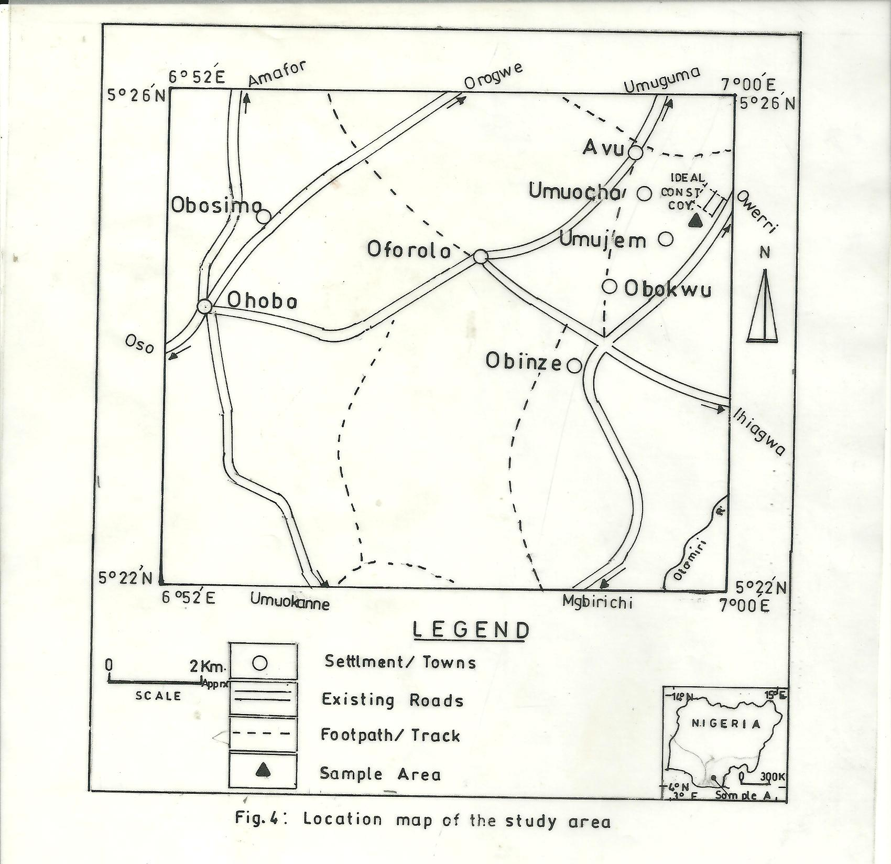

**Sample Collection**

Nine (9) soil parameters were investigated viz: TPH, Nitrate, Phosphate, Sulphate, pH, Textural class, Moisture content, Total Nitrogen and Total Organic Carbon. Soil samples were collected from four sampling locations, SP1 (100m from point of emission), SP2 (300m), and SP3 (600m) in the prevailing wind direction while a control sample 5km in the opposite wind direction were utilized for the study. Soil samples were collected at these different locations at the depth of (0-30cm) and transferred into an aluminum foil paper bag, labeled for each location and taken to the laboratory for analysis.



**Fig 1: A photographic plate of the vertical view of the plume at Obinze, Owerri**

**Analytical Procedure**

For TPH, the content was obtained by shaking 10g of a representative fresh sample with 20ml of toluene and oil extracted determined by absorbance at 420nm wavelength in a spectronic 21-D spectrophotometer

Soil moisture content was determined by using an oven dry method in which samples were dried to constant weight (Ahuja et al, 1976) and the difference in mass of wet and dry samples recorded and expressed in percentage



For pH, the method of Jackson (1964) was adopted. Air-dried sample was passed through a 2mm sieve and afterwards, 20g of it was placed in a 50ml beaker. 40ml of distilled water was added to it and the mixture was stirred with glass rod and allowed to stand for 30mins. The pH value was read off with a coming pH meter (model 7).

**Statistical Analysis**

Descriptive statistics and graphical illustrations as provided by SPSS© 17.0 and MS Excel© 2007 were utilized in the analysis of data.

**Result**

Nine (9) parameters: Total Petroleum Hydrocarbon (TPH),Nitrate, Phosphate, Sulphate, pH, Textural class (sand, clay and loam), moisture content, Total Nitrogen and Total organic Carbon (TOC) for soil were analyzed. These parameters showed moderate to high variations in concentration: TPH, Nitrate, Phosphate and Sulphate varied between 34.18 – 356.79(130.41±75.84), 28.90 – 31.00 (30.05±0.51), 8.65 – 10.80(10.02±0.51) and 58.20 – 66.50(61.58±1.76)ppm respectively. While pH, Sand, Clay, Loam, Moisture Content, Total Nitrogen and Total Organic Carbon varied between 5.00 – 5.60(5.33 – 0.13),65.00 – 72.00(69.25±1.49), 18.00 – 30.00(22.50±2.63),5.00 – 10.00(8.25±1.18),2.00 – 3.00(2.50±0.29),0.14 – 0.16(0.15±0.01) and 1.30 – 1.80(1.50±0.11) ppm

**Table 1.1 Descriptive Statistics for Soil**

|  |  |  |  |  |  |
| --- | --- | --- | --- | --- | --- |
| **QUALITY**  **PARAMETERS** | **MINIMUM** | **MAXIMUM** | **RANGE** | **MEAN** | **STANDARD ERROR** |
| **TPH** | 34.18 | 356.79 | 322.61 | 130.4100 | 75.83740 |
| **NITRATE** | 28.90 | 31.00 | 2.10 | 30.0500 | 0.504744 |
| **PHOSPHATE** | 8.65 | 10.80 | 2.15 | 10.0175 | 0.51102 |
| **SULPHATE** | 58.20 | 66.50 | 8.30 | 61.5750 | 1.759991 |
| **pH** | 5.00 | 5.60 | 0.60 | 5.3250 | 0.12500 |
| **SAND** | 65.00 | 72.00 | 7.00 | 69.2500 | 1.49304 |
| **CLAY** | 18.00 | 30.00 | 12.08 | 22.5000 | 2.62996 |
| **LOAM** | 5.00 | 10.00 | 5.00 | 8.2500 | 1.18145 |
| **MOIST. CONT** | 2.00 | 3.00 | 1.00 | 2.5000 | 0.28868 |
| **TOTALNITROGEN** | 0.14 | 0.16 | 0.02 | 0.1475 | 0.08479 |
| **TOC** | 1.30 | 1.88 | 0.05 | 1.5000 | 0.10801 |
| **C/N RATIO** | 8.67 | 12.86 | 4.19 | 10.0725 | 0.94412 |

The test of homogeneity in means variance of the soil showed high significant spatial inequality in means of the soil parameters under study.

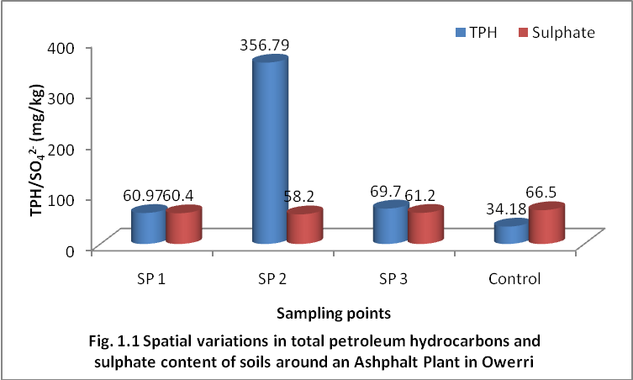

[F(11.366)> Fcrit(3.952)] at P< 0.05

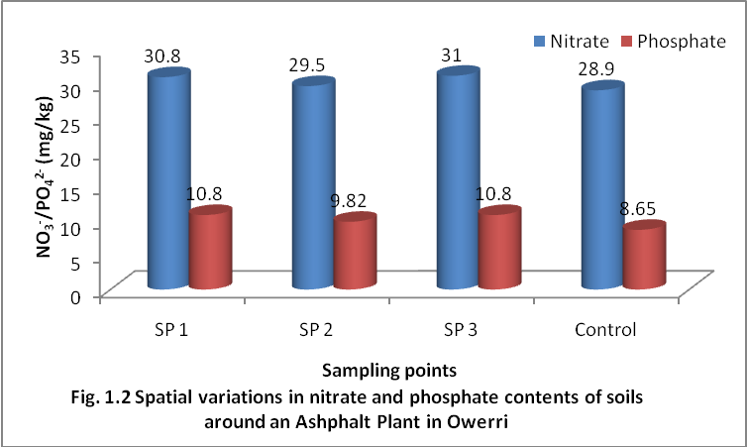

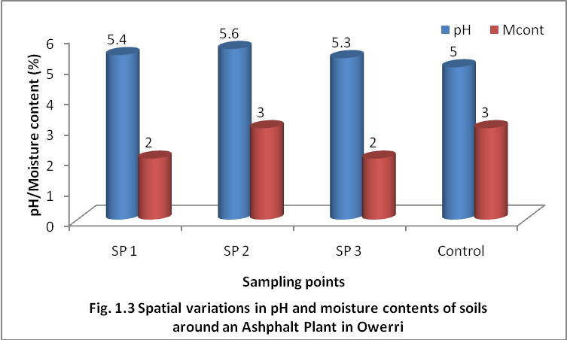

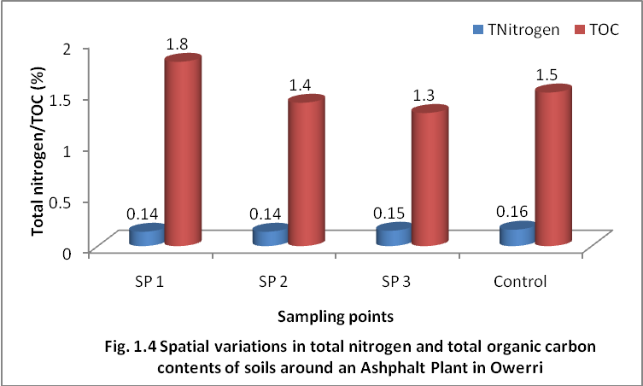

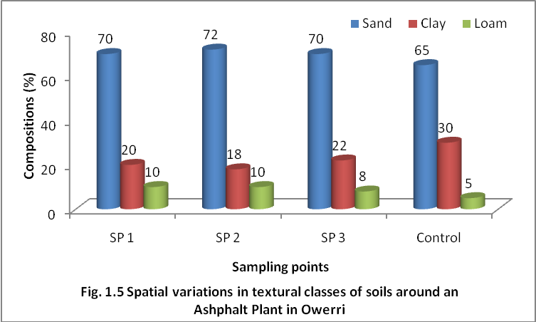



Fig 1.6 scree plot showing the thirty carbon components and their extent of influence in the soil

**Table 1.2: Rotated Component Matrix of Extracted Variables**

|  |  |  |  |
| --- | --- | --- | --- |
| **Parameter** | **Component** | | |
| **1** | **2** | **3** |
| C17/22 | 0.983 |  |  |
| C36 |  | 0.991 |  |
| C31 |  |  | 0.969 |

A total of thirty(30) hydrocarbon variables were analyzed in the soil locations. The screeplot (fig 1.6) represents the eigenvalue of each component in the initial solution

Extraction and rotation sums of square loadings (fig 1.5) revealed that the first three(3) principal components formed the extracted component on the steep slope while the other components are formed on the shallow slope.

The rotated components in table 1.0 revealed that the first component is highly correlated with C17 /C22(0.983), the second component is most highly correlated with C36(0.991) while the third component is most highly correlated with C31(0.969).

**Discussion**

The high concentration of TPH detected in the soil sample especially the point close to sourceof emission could readily be attributed to TPH contamination of the soil from the poorly treated emission from theneighbourhood.

The test of homogeneity in mean variance of the soil using the one way analysis of variance showed high significant spatial inequality in means of the soil parameters under study.

[F(11.366)> FCrit(3.952)] at P<0.05. Using means Plot for the structure detection of means difference, the inequalities were revealed to be contributed by all the parameters measured in all the locations.(fig 4.1……4.10). The most logical assumption could be adduced to non-isotropic (different properties in all direction) nature of the soil, high residence time and runoffs of pollutants along the soil gradients (Windgardner, 1996). From the results obtained, the TPH components extraction falls into the group of Aliphatics.

TPH in the soil ranged from 60.97 to 356.79. The highest concentration is most contributed by location two (SP2) 356.79mg/kg and less contributed at control point 34.18mg/kg farther from the Asphalt plant.(fig 1.1). There is significant difference between the samples near the Asphalt plant and control location from the plant. A review of existing data on the Niger Delta by NDES (1999), Osuji (2001) and Osuji et al (2004) affirms that such high hydrocarbon levels affect both above-ground and subterranean flora and fauna which are essential adjuncts in the biogeochemical cycle that affects the availability of plant nutrients. It is therefore asserted that the Asphalt plant has significant impact on the TPH content of the soil around it. The strong significant associations observed between most of the hydrocarbons agrees with the work of El-Deeb and Emara (2005). The source of this study is therefore generally believed to be of petrogenic and hydrocarbonic origin and components are closely related due to their molecular weight (Okoro, 2007)

Residual saturation of TPH in the soil determines the degree of soil contamination and can act as a continuing source of contamination for individual compounds to separate from bulk product and migrate independently in air (volatility) or ground water (solubility)(Bauman 1988).

Total Nitrogen content in the sample location nearest to the Asphalt plant is in the range of 0.14 to 0.15% while the control location which is farther away (5km) from the plant is 0.16%. Thus, the most logical assumption is that the Asphalt plant has no impact on Total Nitrogen content in the soil around it.

However, the slight difference in Total Organic Carbon from 1.8mg/kg near the plant (SP1) as against the control away from the plant 1.5mg/kg showed that Organic matter content increased following the addition of carbonaceous substances within the plant vicinity.

The significantly uncorrelated relationship between pH and TPH components imply that hydrocarbon ion concentration does not play any role in the biogeochemical availability of TPL rather their concentrations are anthropogenic in nature Agency, (1995).

In pH and Moisture content, there was no much significant difference between the sample location near the Asphalt plant and the control. For pH in SP1 to SP3 were in the range of 5.3 to 5.6 and the control location was at 5.0 while for moisture content, it was in the range of 2.0 to 3.0% across the sample locations. The plausible conclusion perhaps is that the Asphalt plant has no significant impact on pH and moisture content in the soil around it.

In Textural classes for sand, clay and loam, there were slight differences between the sample locations SP1 to SP3 against control location (fig 4.5d). The logical assumption could be the addition of such levels of carbonaceous substances to the impacted area which eventually affected the concentrations of Carbon/Nitrogen ratio in the soil.

Carbon/Nitrogen is an essential nutrient in the soil for plant growth. However, if there inputs to a soil exceeds both the biological demand and storage capacity, saturation becomes evident. This will eventually lead to Nitrogen leaching from the soil, causing soil acidification which incidentally alters the soil chemistry.

The result of this study calls for public health concern as it is confirmed that TPH are carcinogenic (Agency, 1995)

Moreover carcinogenicity is transgenic as oncogenes (cancer prone genes) could be inherited by filial generations (Evans 1977, Cema 1996)

Man inevitably suffers the risk of bioaccumulation as a result of his position in the food chain and his predisposition to other routes of exposure.

**Conclusion**

In the quest to meet with developmental challenges, man inadvertently destroys his nest by creating air pollution and consequently impacting adversely on human health.

The results of this research have shown that the Asphalt plant facility located along Owerri- Port Harcourt road has measurable impact on soil in its immediate environment especially for TPH. Although the concentration of some of the soil elements are negligible (asphalt plant has not operated for long).It is obvious that more quantities of TPH would be deposited in the environment with more years of production. If we must put a stop to this environmental menace, it becomes imperative that a feasible and economically viable equipment and techniques for controlling pollution irrespective of its location must be provided. Pollution caused by some of these pollutants can be reduced substantially by using equipment like: Double Catalyst Double Absorption(DCDA), Gravity Settling Chamber, Electrostatic Precipitator(ESP), Scrubbers and other properly designed plant, thus abating air pollution.

Government should introduce environmental value added tax(EVAT), strict laws implemented to make factories use pollution control measures or best available technology for abatement.

**Acknowledgment**

We sincerely acknowledge our able supervisor Dr Njoku, P.C for his able guidance all through the course of the research**.**

**Corresponding Author**

Mgbahuruike, Leonard Udochukwu

Department of Environmental Technology, Federal university of Technology, P.M.B 1526, Owerri.

Leocash2k3@yahoo.com

**References**

1. Agency for Toxic Substances and Disease Registry (ATSDR) (1995). Public Health Statement for PolyclicAromatic Hydrocarbons (PAHS). Agency for Toxic Substances and Disease Registry (ATSDR). US Department of Health and Human Services. Public Health Service, Atlanta,
2. Ahuja, L.R, D.K, Bruce, R.R, Barnes, B.B, 1989. Evaluation of Spatial Distribution of Hydraulic Conductivity using Effective porosity data. Soil Sci. 148, 404-411.
3. Aislabie, J., McLeod, M. and Fraser, R. (1998). Potential for biodegradation of hydrocarbon in soil from Ross Dependency, Antartica. Applied Microbiology and Biotechnology, 49, 210-214.
4. Bauman, B.J (1988) References dose (RFD): Description and use in Health Risk Assessment. Regul Toxicol Pharmacol 8:471-486
5. Cema, M. (1996) Mutagenicity Testing of Environmental Complex Mixtures (Air, Drinking water and Effluent, Soil etc) In: Abstract book, INREG, Rockilide University, Rocklide, 1996, p4.
6. Balks, M.R, Aislabie, J. and Foght, J.M. (1999) Preliminary assessment of constrain to biodegradation of fuel spills in Antartic soils. Symposium 38, proceeding 16th world congress of soil science, Montpelier, France, 20-26 August 1998
7. Montpelier: International Union of soil science CD-ROM Ellenhorn M.J. Barceloux D.G.(1988) Polycyclic Aromatic Hydrocarbons,D.G.(Eds):
8. Medical Toxicology: Diagnosis and Treatment of Poisoning. Elsevier, New York, NY, pp 952-954.
9. El- Deeb, M.K.Z and Emara, H.A (2005) Polycyclic aromatic hydrocarbons and aromatic Plasticizer Materials in the seawater of Alexandria Coastal area, Egyptian Journal of Aquatic Research, Vol. 31,pp.15-24.
10. Evans, H.J (1977) Molecular Mechanism in the indution of Chromosome Abberation. In: D. Scott, B.A. Bridges and F.H.Sobel, Eds.,Progress in Genetic Toxicity, pp 57-74.
11. Heitkamp M.A., and Cerniglia C.E. Appl. Environ. Microbiol., 54 (1988) 1612.
12. Imo State of Nigeria (IMSG, 1993) Atlas of Imo State of Nigeria. Ministry of works and transport. Department of lands, survey urban Development Owerri, Imo State. p 116
13. International Agency for Research on Cancer(IARC),Monographs on the Evaluation of the carcinogenic risk of some industrial chemicals to humans, Lyon France, 2000.
14. Jackson, D.N (1967) Manual for The Personality Research Form. Research Bulletin 43. London, Ontario University of Western Ontario.
15. McElroy E., Farrington J.W., and Teal J.M., In: Varansi U. (1983) (ed) Metabolism of Polycyclic Aromatic Hydrocarbons in Aquatic Environment, CRC Press Inc., Boca Rton, Florida, 1989.
16. Mortelmans. K, Harworth. S, Lawlor .T, Speck. W, Tainer and Zeiger. E. Environ Mutagen, 8(1986)
17. NDES (1999). Niger Delta Environmental Survey Phase I Report, vol.1 Environ. And socio-economic characteristics (Revised Edition) Technical Report submitted by Environmental Resource Managers Limited, Lagos. Pp. 101-116.
18. Njoku-Tony, R.F (2011) World Rural Observation. Prevalence of Paramphistomiasis among Goats Slaughtered in Some Selected Abattoirs in in Imo State, Nigeria.3(1) p82
19. Okoro, D.(2007) Source Determination of Polynuclear Aromatic Hydrocarbons in Water and Sediments of a Creek in Niger Delter Region” African Journal of Biotechnology. Vol.7.No3, pp.282-285.
20. Osuji LC (2001). Total hydrocarbon content of soils, fifteen months after Eneka and Isiokpo oil spill. *J. Appl. Sci.* *Environ mgt*. 5(2): 35-38
21. Osuji LC., Adesiyan S.O.(2005). The Isiokpo oil pipeline leakage: Total Organic Carbon/Organic matter contents of affected soils, *Chem.* *Biodiv.* 2: 1079-1085
22. Osuji LC, Adesiyan SO., Obute GC. (2004). Post Impact Assessment of oil pollution in the Agbada West Plain of Niger Delta Nigeria: Field reconnaissance and total extractable hydrocarbon content. *Chem. Biodiv.* 1(10):1569-1577.
23. Windgardner, (1996). ”Geology for Engineers”. New York Prentice Hall.

21st May, 2012.