Effect of whey protein and nandrolone in rat submandibular salivary glands

Eman M.Fathy El- Maghraby

Health Radiation Research Department, National Centre for Radiation Research and Technology (NCRRT), Cairo, Egypt
emey_maghraby@hotmail.com

Abstract: The purpose of this study was to verify the histological and the ultrastructural alterations produced in the salivary glands in groups of rats associated with nandrolone (anabolic steroid) and /or to the use of whey Protein (natural product). Material & Methods: 40 male albino rats weighing 100-120 g each were used. The experimental animals were divided into 4 groups (10 each). Group 1: Untreated control rats. Group II: Rats treated with whey protein orally administrated daily for 3 months. Group III: Rats treated with nandrolone intramuscular injected for 3 months. Group IV: Rats treated with whey protein and nandrolone, whey protein extract was orally administrated daily for 6 weeks and then, they were intramuscularly injected by nandrolone extract for 6 weeks. The animals were sacrificed after 1 and 30 days post treatment. Result: Histological &ultrastructure investigations of whey group showed no distinctive changes in the architecture of the gland after 1 &30 days. In nandrolone group III after 1 day post treatment, degeneration of the acinar cells, decrease in the number and size of secretory granules, large irregular cytoplasmic vacuoles were seen and the fibrous connective tissue septa was also increased. In whey & nandrolone group IV, some acinar cells appeared with normal nuclear appearance and having large number of secretory granules with different electron densities, others appeared with shrunken apoptotic nuclei having irregular outline. In this study, both group III & IV 30 days post treatment showed regeneration of acinar cells with intact cytoplasmic membrane, normal nuclear morphology and abundance of secretory granules. Conclusion: Administration of nandrolone can cause degenerative changes to the salivary gland tissues which may lead to loss of salivary function with expected xerostomia, however these changes were found to be reversible after stoppage of the drug. The whey protein did not cause any damaging effects to salivary gland tissues and it enhanced the immune system to resist the toxic effects of nandrolone.
[Eman M.Fathy El- Maghraby. Effect of whey protein and nandrolone in rat submandibular salivary glands. Nat Sci 2012;10(9):10-19]. (ISSN: 1545-0740). http://www.sciencepub.net/nature. 2

Key words: Nandrolone, Whey protein, Salivary gland, Histopathological, Ultrastructure.

1. Introduction
Whey is considered as popular dietary protein supplement purported to provide antimicrobial activity, immunomodulation, improved muscle strength and body composition and also to prevent cardiovascular disease and osteoporosis ^{(1, 2)}.
Whey is one of the two major proteins found in cow’s milk, comprising about 20% of total milk protein. Whey proteins boost the immune system by helping the body produce an antioxidant called glutathione ⁽³⁾. Specific components in whey thought to play a role in enhancing the immune system include: Cysteine, Lactoferrin, Immunoglobulins ⁽⁴⁾.
Whey protein have been shown to possess immunomodulatory activities such as stimulation of lymphocytes, increase in phagocytosis process as well as increase the secretion of immunoglobulin A (IgA) by Peyer’s patches ^{(5,6)}. It has potent antioxidant activity, likely by contributing cysteine-rich proteins that aid in the synthesis of glutathione (GSH), a potent intracellular antioxidant ⁽⁷⁾. Bounous ⁽⁸⁾ discussed its antitumor and anticarcinogenic potential, where the amino acid precursors to glutathione available in Whey might increase glutathione concentration in relevant tissues, stimulate immunity and detoxify potential carcinogens.
Nandrolone decanoate is an anabolic steroid that may be present naturally in the human body. Clinical studies have shown it to be effective in treating anemia, osteoporosis and some forms of neoplasia including breast cancer, and also acts as a progestin-based contraceptive. Because nandrolone is not broken down into dihydrotestosterone, the drug's liver toxicity is reduced ⁽⁹⁾. It has potent anabolic effects on growing skeletal tissue, it stimulates osteoblast proliferation and differentiation and matrix formation, including synthesis of type 1 collagen and other components ⁽¹⁰⁾.The anabolics are those promoting protein synthesis and muscle growth ⁽¹¹⁾ .
It is indicated as supportive therapy in pathological conditions characterized by a negative nitrogen balance to increase body weight as cachexia associated with chronic diseases ⁽¹²⁾.
Anabolic steroid abuse has become a major public health problem around the world. Olympic athletes, professional athletes, college and high school students utilize these drugs for their muscle and strength building benefits ⁽¹³⁾. Xu et al., ⁽¹⁴⁾ in their experiment found that the duration of the experiment was 12 weeks to cover complete spermatogenic cycle. The spermatogenic cells were few, disorganized and irregularly arranged. Most spermatogenic cells were of small size, separated from each other and their nuclei showed pyknosis. Many primary spermatocytes were degenerated, their nuclei were pyknotic and their cytoplasm was vacuolated ⁽¹⁵⁾.
There are numerous side-effects to anabolic steroids including hypertension and atherosclerosis, blood clotting, hepatic carcinoma, tendon damage ⁽¹¹⁾.
The aim of this study was to verify the histological, ultrastructural alterations produced in the salivary glands in groups of rats, associated with nandrolone anabolic steroid and /or to the use of Whey protein (natural product).

2. Material and Methods:
A total number of 40 male albino rats weighing 100-120 g were used. The animals were housed in especially designed cages, 5 rats per cage, in a room with a 12-h day–night cycle, temperature of 24 – 28 ⁰C, humidity of 45–64%. All animals were fed with semi purified diet and water ad libitum for 10 days before the start of the experiment. The experimental protocol used was approved by the department of Animal care, Cairo University that adhered to the European Communities Council guiding principles for the care and use of Laboratory animals.

Whey protein administration:
100% Gold standard Whey protein isolate primary source powder {0.8 g/kg/day /man} according to Brody and Press ^{(16,17)}. Whey protein is manufactured in the U.S.A. by ON Company and dissolved in distilled water. The drug was administrated orally by gastric tube at a dose of 5 mg/kg body weight/ day for 3 months. This dose for rats was calculated according to the Paget’s formula on the basis of the human dose ⁽¹⁸⁾.
Nandrolone injection:

Nandrolone decanoate (Deca-Durabolin) oily solution (The Nile Co. Pharmaceuticals-Cairo-A.R.E. under license of N.V.Organon-OSS-Holland) where each ampoule contains 25mg/ml. The drug was intramuscularly injected at a dose of 10 mg/kg body weight /week for 3 months ^{(19, 20)}.

Experimental design:
The experimental animals were divided into 4 groups (10 each).
Group 1: Untreated control rats.
Group II: Rats were treated with whey protein extract: 5 mg/kg body weight/day orally administrated daily for 3 months.
Group III: Rats were treated with nandrolone extract: 10 mg/kg body weight/week intramuscularly injected for 3 months.
Group IV: Rats were treated with whey protein and nandrolone: 5 mg/kg body weight/day of whey protein extract orally administrated daily for 6 weeks followed by intramuscular injection of 10 mg/kg body weight/week of nandrolone extract for 6 weeks.
The experimental rats were further subdivided into 2 subgroups a, b (5 rats each), where (a) represents 1 day and (b) represents 30 days post treatment.
Specimens preparation
Animals were sacrificed by cervical translocation. The submandibular salivary glands were excised. Light microscopic examination:
Salivary glands were fixed in 10% neutral formalin buffer, then embedded in paraffin wax. Specimens were dehydrated through graded alcohol, cleared in xylene and embedded in paraffin. Serial longitudinal sections of 5 micron thickness were cut and subjected to haematoxylin and eosin staining for routine histological examination.
For transmission electron microscopy:
Specimens were cut into small parts of one cubic mm, fixed in gluteraldehyde, then they were washed in three changes of phosphate buffer at pH 7.4. Secondary fixation was done in 1% osmium tetraoxide at 4˚C, for 1.5 hours followed by rinsing in phosphate buffer. Specimens were then dehydrated in ascending grades of ethyl alcohol, then cleared in propylene oxide and embedded in epoxy resin.
Ultra-thin sections were then cut using the ultra microtome, mounted on copper grids and stained with uranyl acetate and lead citrate ⁽²¹⁾. The grids were examined by Joel 100 CX transmission electron microscope at the National Centre for Radiation Research and technology.

3.Results:
Histological results:
One day post treatment
The submandibular gland of the control group showed normal histological structure af acini and ducts. The acini were lined by pyramidal cells with basal spherical nuclei and granular basophilic cytoplasm surrounding a narrow lumen. The duct system was composed of granular convoluted tubules with large columner cells with oval basal nuclei and apical eosinophilic granules. The striated ducts were lined by a single layer of columner cells with large rounded centrally situated nuclei and eosinophilic cytoplasm and basal striations. The excretory ducts were present in the connective tissue septa and were lined by pseudostratified columnar epithelium (Fig. 1).
The submandibular of group (IIa) showed normal acini, striated ducts and granular convoluted tubules. There was no distinctive changes in the architecture of the gland as compared to the control group. The acinar cells were intact with homogenous cytoplasm and preserved basophilia. The duct system appeared with normal architecture, widely dilated blood vessels engorged with RBCs appeared adjacent to the duct system (Fig. 2). The cells of the secretory portions of group (IIIa) showed numerous intracytoplasmic vacuolizations of variable sizes. Sometimes these vacuoles reached a large size, thus pushing the nuclei to one side of the cell. The cytoplasmic basophilia of the acinar cells appeared to be decreased than that of the control group. Regarding the duct system, reduction in the apical eosinophilic granules of the granular convoluted tubule cells was apparent when compared to those of the control group. Areas of degeneration were noticed in the epithelial lining of the granular convoluted tubule segments as well as in the striated and excretory ducts and there was an increase in the fibrous connective tissue septa between the lobules of the gland (Fig. 3). On the other hand in group (IVa), the roughly circular acini could be seen having a normal lining. The acinar cells showed increased basophilia of their cytoplasm as compared to these of the control group. Cells of granular convoluted tubules contained more intense granular eosinophilic content in their apical cytoplasm, less number of intracytoplasmic vacuolizations could be seen in the acinar cells. large number of chronic inflammatory cells were seen infiltrated between the acini and granular convoluted tubules as well as in the connective tissue septa between the lobules of the gland (Figs. 4&5).

30 days post treatment
No distinct histological changes have been detected in group (IIb) (Fig. 6). In addition, there were obvious regeneration of the acini and duct system of the gland in group (IIIb), the acinar cells showed increased cytoplasmic basophilia and decreased intracytoplasmic vacuolization, there was increased eosinophilic granules of the granular convoluted tubules. The degenerated areas were also decreased among acini and duct system, areas of retained secretion were present in excretory ducts (Fig. 7). While group (IVb) showed regeneration of the acinar cells, absence of inflammatory cell infiltration and nearly normal appearance of the acini and duct system (Fig. 8).

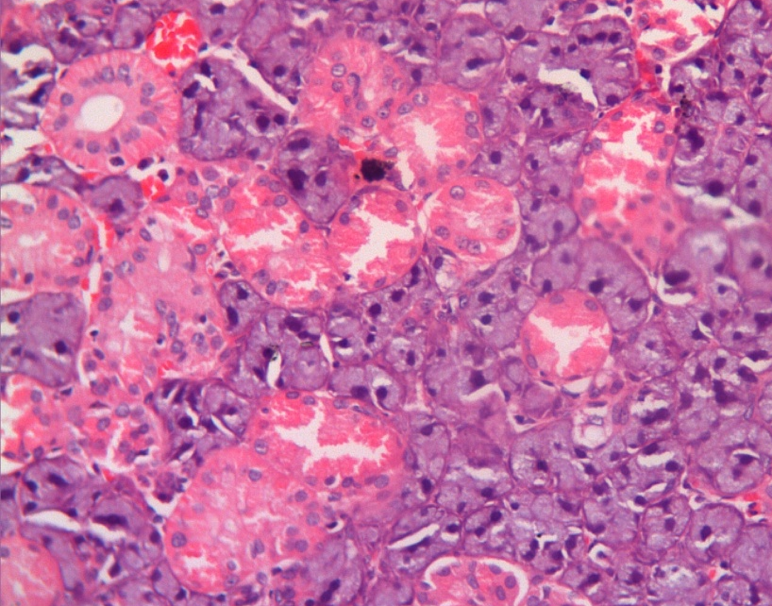

Fig. (1): A photomicrograph of rat submandibular gland of the control group showing normal acinar portion having basophilic cytoplasm and basal spherical nuclei , granular convoluted tubules having apical eosinophilic granules (white arrow) and central spherical nuclei of striated duct (yellow arrow) (H&E X200).

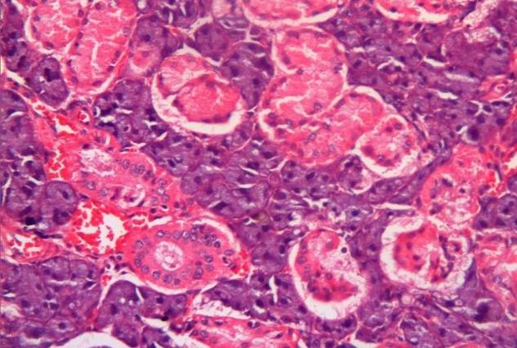

Fig (2): A photomicrograph of rat submandibular gland of group (IIa) showing normal acini, granular convoluted tubules (black arrow) and striated ducts with mild dilatation of blood vessels (white arrow) (H&E X 200).

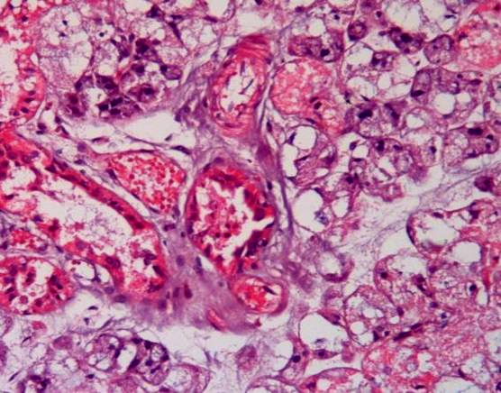

Fig. (3): A photomicrograph of rat submandibular gland of group (IIIa) showing decreased basophilia and intracytoplasmic vacuolization of the acinar cells pushing the nuclei to one end of the cell (white arrows), decrease in granular content of the granular convoluted tubules (blue arrow), areas of degeneration of striated and excretory ducts (yellow stars), retained secretion of the striated duct (black star) and increased fibrous content of the connective tissue septa (red arrow) (H&E X 200).

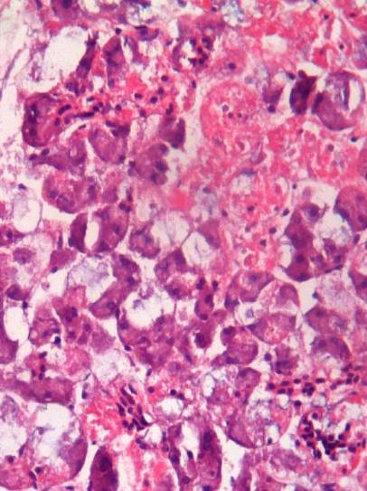

Fig. (4): A photomicrograph of rat parotid gland of group (IVa) showing increased basophilia among the acinar portion, increased eosinophilic granular content of the granular convoluted tubules (white star) , less intracytoplasmic vacuolization (black arrow), chronic inflammatory cell infiltration (yellow arrows) (H&E X 200).

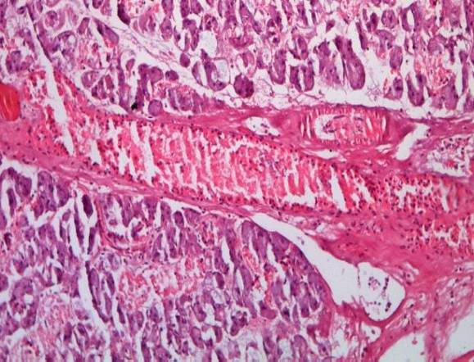

Fig. (5): A photomicrograph of rat submandibular salivary gland of group (IVa) showing chronic inflammatory cell
infiltration in the connective tissue septa (white arrows) (H&E X 100).

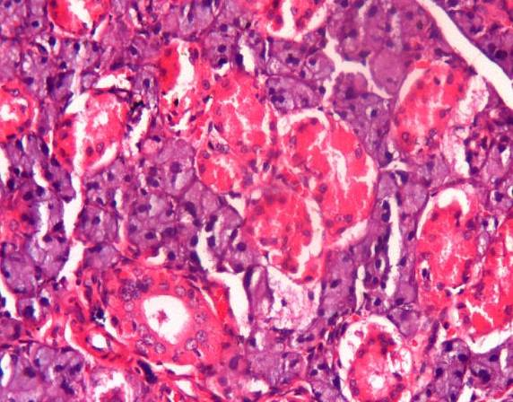

Fig. (6): A photomicrograph of rat submandibular gland of group (IIb) showing normal acinar cells, normal eosinophilic granules of granular convoluted tubules and intact striated duct (white arrow) (H&E X 200).

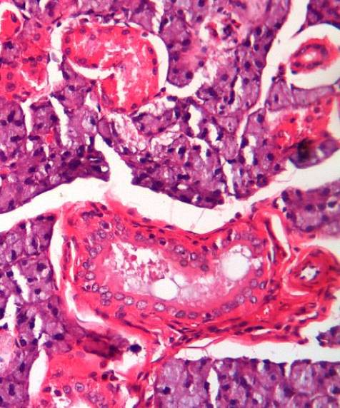

Fig.(7): A photomicrograph of rat submandibular gland of group (IIIb) showing regeneration of acinar architecture and basophilia, decreased cellular vacuolization (yellow arrows), increased eosinophilic granules of the granular convoluted tubules and area of retained secretion of excretory duct (red arrow) (H&E X 200).

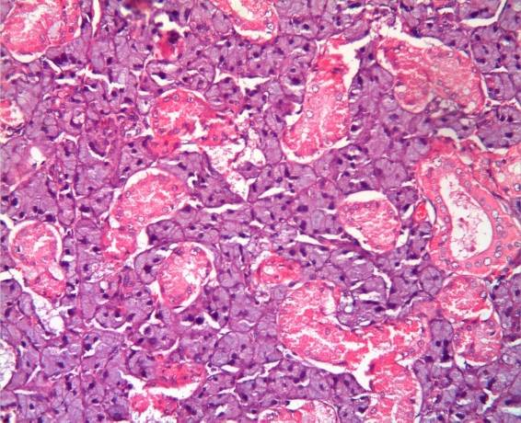
Fig.(8): A photomicrograph of rat submandibular gland of group (IVb) showing regeneration of acinar cells , absence of inflammatory cell infiltration , nearly normal appearance of acini and duct (H&E X 200).

Ultrastructural results:
One day post treatment
The ultrastructural results of the control group, group (IIa) showed normal appearance of acinar cells having intact cell membrane, basally situated nuclei with electron-lucent nuclear matrix and evenly dispersed chromatin. Normal rough endoplasmic reticulum with narrow parallel cysternae were also detected. The cytoplasm was filled with a mass of secretory granules of variable densities (Fig. 9). The striated duct cells appeared with centrally located nuclei having normal structural chromatin distribution. Basally, abundant elongated mitochondria were oriented in between the infolding of the basal plasma membrane . The granular convoluted tubules appeared with basally situated nuclei of normal structural characteristics and plenty of well formed mitochondria. The apical portion of the cell was loaded with electron-dense secretory granules of variable size (Figs.10, 11). While the ultrastructural results of group (IIIa) showed degeneration of the acinar cells in the form of electron-dense nuclei, decrease in the number and size of secretory granules , large irregular cytoplasmic vacuoles and wrinkled rough endoplasmic reticulum, the fibrous connective tissue septa was also increased (Figs. 12 &13). On the other hand, the ultrastructural results of group (IVa) showed some acinar cells with normal nuclear appearance and having large number of secretory granules with different electron densities, other cells appeared with shrunken apoptotic nuclei having irregular outline and electron-dense chromatin, erosion of the outer surface of the cell membrane were also noticed, evidence of binucleation were present among the cells (Figs. 14&15).

30 days post treatment
In this study, normal appearance of acinar cells in group (IIb). Both group (IIIb) and group (IVb) showed regeneration of acinar cells with intact cytoplasmic membrane, normal nuclear morphology and abundance of secretory granules (Figs. 16 &17).

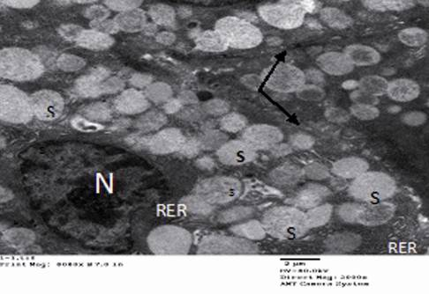
Fig.(9): Electromicrograph of group I (control group) showing an intact basal nucleus (N), lamellae of the rough endoplasmic reticulum (RER) and intact cell membrane (arrows). Secretory vesicles containing secretory material of different electron density (S) are also seen in the cytoplasm of the acinar cells (TEM x2000).

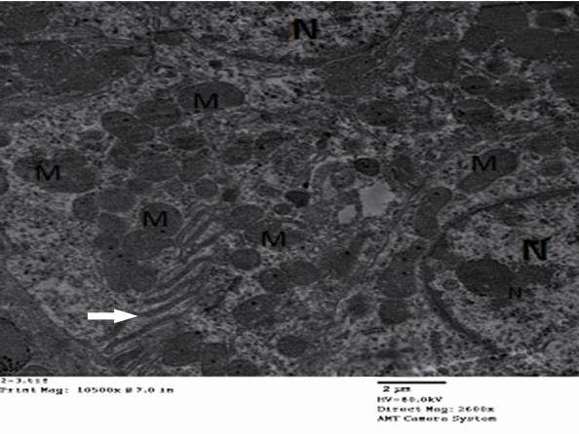
Fig 10: Electromicrograph of group (IIa) showing two striated duct cells having normal nucleus (N) with intact nucleur membrane. Mitochondria (M) arranged between the basal membrane infolding (arrow) (TEM x2600).

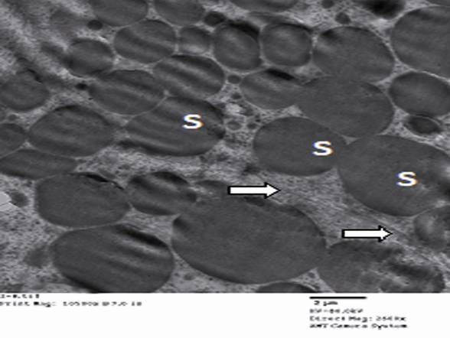
Fig. (11): Electromicrograph of two adjacent granular convoluted tubule cells of group (IIa) showing electron dense secretory granules (S) and intact cell membranes with desmosomal attachment (arrows) (TEM x 2600).

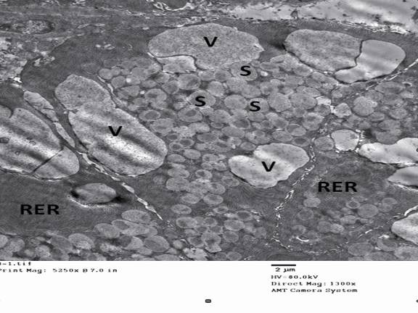
Fig 12: Electromicrograph of group III (a) showing degeneration of acinar cells , large irregular cytoplasmic vacuoles (V), fusion of secretory granules (S) and increased wrinkling of rough endoplasmic reticulum (RER), (TEM x1300).

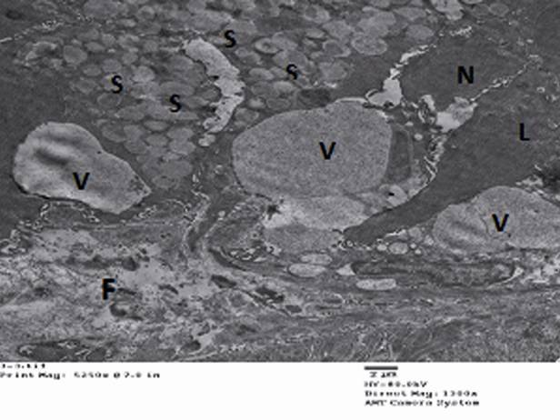
Fig 13: Electromicrograph of group III (a) showing dilatation of acinar lumen and increased infusion of secretory vesicles. Electron dense nucleus (N), large vacuolated cytoplasm (V) and increased fibrosis(F) were seen (TEM x1300).

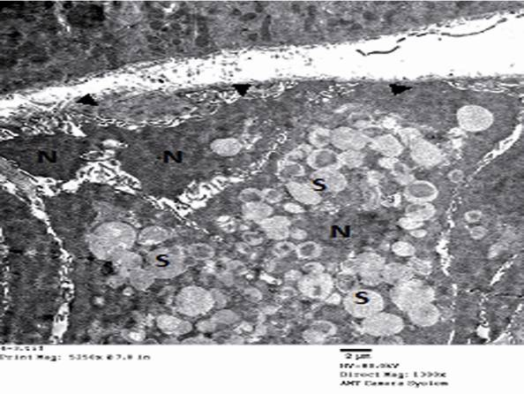
Fig 14: Electromicrograph of group IV (a) showing shrunken apoptotic nuclei having irregular outline and electron dense chromatin (N), numerous variable-sized secretory vesicles (S), and erosion of the outer surface of the cell membrane (arrow heads), (TEM x1300).
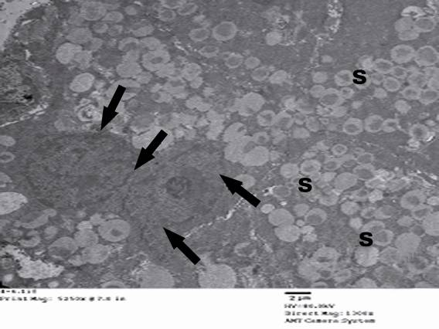
Fig. (15): Electromicrograph of acinar cells of submandibular salivary gland of group IV (a) showing binucleation among the cells. Nuclei appeared with normal outline and prominent nucleoli (arrows). Secretory granules are of large number and different electron densities (S) (TEM x 1300).

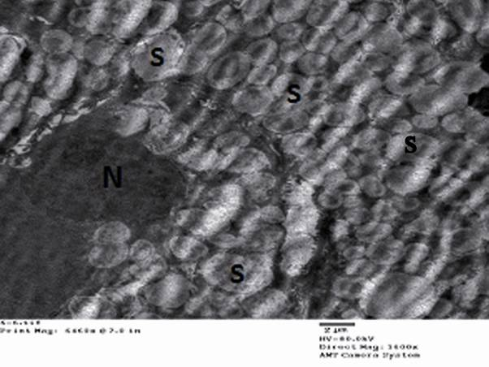
Fig 16: Electromicrograph of group III (b) showing regeneration of the acinar cells which have an intact cytoplasmic membrane, normal nuclear morphology (N), with abundance of secretory granules (S), (TEM x 1600).
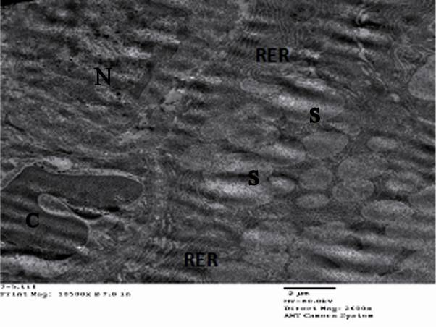
Fig 17: Electromicrograph of group IV(b) showing two acinar cells which have nearly normal nucleus (N), numerous secretory granules (S), regeneration of rough endoplasmic reticulum (RER) and blood capillary with normal wall (C), (TEM x2600).

4. Discussion:
Although the role of anabolic steroids in the etiology of various diseases in both animals and humans is still uncertain, steroid use in clinical trials and in laboratory studies has been associated with numerous deleterious changes in risk factors and in the physiology of various organs and body systems, suggesting potential for subsequent health problems ^{(22, 23)}. The best documented effects are those on the liver, serum lipids, and the reproductive system. Other suspected areas of concern include the psyche and behavior, coronary artery disease, cerebrovascular accidents, prostatic changes, and the immune function ⁽²⁴⁾. Anabolic steroids have been shown to be cardiotoxic in animals ⁽²⁵⁾. Liver structure and function have also been altered by administration of anabolic steroids; associated conditions include cholestatic jaundice, peliosis hepatitis, hepatocellular hyperplasia, and hepatocellular adenomas ^{(26, 27)}. The effects of anabolic-androgenic steroids on the male reproductive system include reductions in levels of endogenous testosterone, gonadotrophic hormones, and sex hormonebinding globulin (SHBG); reductions in testicle size, sperm count, and sperm motility; and alterations in sperm morphology ⁽²⁸⁾.
On the other hand, several studies revealed that whey proteins possess a myriad of activities including antioxidant activity attributed to increasing glutathione (GSH) content ⁽³⁾, anti-allergic ⁽²⁹⁾anti-inflammatory and immunomodulatory activities⁽³⁰⁾.
In the present study the effect of both anabolic steroid (nandrolone) and a major component of the protein fraction in bovine milk (whey protein) were studied on the submandibular salivary gland of rats histologically and ultrastucturally.
The results of this study proved that, the acini and duct system in group II (a) were preserving their normal shape and architecture in spite of mild dilatation in the blood capillaries associated with the duct system that might help in increasing the volume of saliva and consequently decrease the potentiality for xerostomia. The intracytoplasmic vacuolization of acinar cells which appeared in group III (a) both histologically and ultra structurally appeared to be a lipid nature since it seems to have been removed during fixation and processing of the tissue. The overall appearance of many of the cells was indicative of the advanced stages of degeneration often leading to cell death. Cell degeneration could be attributed to accumulation of secretory products within the acinar cells, this accumulation leads to chronic degenerative changes in the cells characterized by lipid accumulation, autophagy and eventual cell death. In group III (a) of this study, occasional vacuoles were noticed in some of the striated and excretory duct lining cells as well as areas of degeneration in the lining of some of the striated ducts, this degeneration may be ischemic degeneration due to decrease in blood supply to the gland which may be caused by the cardiovascular effect of nandrolone. Nandrolone was considered a cause of many cardiovascular diseases (CVD), including heart attacks, increased risk of atherosclerosis and left ventricular (LV) hypertrophy ^{(25, 31-32)}. Moreover, this degeneration may be toxic degeneration due to direct effect of nandrolone on salivary gland tissues. Similar toxic effects were observed in other tissues in different previous studies including liver ^{(26,27)}. The decrease in cytoplasmic basophilia appeared in the histological results of group III (a) may be correlated with the damage of the rough endoplasmic reticulum detected by the ultrastructural investigation of the same group. Increased fibrous tissue content of the connective tissue septa seen in group III (a) could be attributed to decreased digestion by collagenase enzyme, similar observation was associated with the aging process of salivary gland by Scott ⁽³³⁾who stated that “at very old age the fibro-fatty replacement of parenchyma was related to continual collagen synthesis occurring throughout life”. The loss of secretory cell mass may result in decreased salivary flow which may lead to xerostomia. Salivary gland hypofunction can occur as a result of chronic prescription of drug treatment, therapeutic x-ray irradiation of head and neck regions, during cancer chemotherapy and in certain systemic diseases ⁽³⁴⁾. Both histological and ultrastructural results of group IV (a) revealed milder form of cellular degeneration as compared to that of group III (a) in the form of less cytoplasmic vacuolization, more cytoplasmic basophilia and more preserved acinar architecture and cytoplasmic organelles this could be attributed to the protective effect of whey protein against cellular degeneration caused by nandrolone which may result from increasing the blood supply to the gland and enhancing the immune system. Similar observations were detected by Gill et al., and Beaulieu et al., ^{(5,6)} who declared that whey peptides have been shown to possess immunomodulatory activities such as stimulation of lymphocytes, increase in phaocytosis process as well as increase the secretion of immunoglobulin A (IgA). Marked chronic inflammatory cell infiltration which appeared in the histological results of group IV (a) may be a response to products released upon the death of some secretory cells caused by the action of nandrolone. This result was in agreement with that of Ebaid et al. ⁽³⁵⁾ who found that dietary supplementation with whey protein enhances the normal inflammatory responses during wound healing in diabetic mice by restoring the levels of oxidative stress and inflammatory cytokines. Furthermore, apoptosis detected in group IV (a) could be correlated to cellular degeneration caused by the effect of nandrolone which leads to mitochondrial damage and decreased glutathione (GSH) level in the cell leading to induction of apoptosis. It has been proposed that high intracellular GSH levels have been associated with apoptotic resistant phenotypes in several models of apoptosis ^{(36,37)} and GSH depletion by itself has been observed to either induce or stimulate apoptosis ^{(36,38)}. Accordingly, promotion of cell death by diseases or treatments that deplete cellular GSH seems to correlate closely to the extent of depletion of mitochondrial GSH rather than the changes in cytoplasmic pool ^{(39, 40)}. On the other hand, several studies revealed that whey protein possess a myriad of activities including antioxidant activity attributed to increasing GSH content ⁽³⁾. However, it was obvious from the results of group IV (a) of the present study that apoptosis is not prevented by the action of whey protein; this could be explained by the fact that, GSH must be actively transported into the mitochondria or exchanged for another anion ⁽⁴¹⁾. Recently, inhibition of mitochondrial GSH transport has been reported to exacerbate oxidant-induced cytochrom c (Cyt c) release, caspase 9 activation, and apoptosis ⁽⁴²⁾. Further studies are needed to explain the exact relation between whey protein and induction or prevention of apoptosis.
Regeneration of the normal histological structure of the acini and duct system was observed in group III (b) and IV (b) after stoppage of the drug administration. The same observation was also detected by several authors studying the effect of nandrolone on different tissues of the body. All of the cardiovascular effects of nandrolone have been demonstrated to be fully reversible within several months after cessation of the steroid use ^{(24, 28, 43)}. In addition, Dohle et al., ⁽⁴⁴⁾ concluded that, when steroid use is stopped, the testes resume sperm production and sperm quality usually recovers spontaneously within four months.

Conclusion:
From the previous results it has been concluded that:
- Administration of nandrolone can cause degenerative changes to salivary gland tissues which may lead to loss of salivary function and consequently xerostomia, however these changes were reversible after stoppage of the drug.
- The whey protein did not cause any damaging effects to salivary gland tissues on the contrary it enhanced the immune system to resist the toxic effects of nandrolone.
It is recommended to use the whey protein in enhancing the muscular activity since it was found to be safer than nandrolone. Further studies on the effect of the two drugs are also recommended on other tissues of the body.

Acknowledgment
The author would like to thank Dr. Seham M. Abu Nour, Professor Health Radiation Research Department, National Centre for Radiation Research and Technology, Cairo for her valuable advice, help and generous use of her time.

Corresponding author
Eman M.Fathy El- Maghraby
Health Radiation Research Department, National Centre for Radiation Research and Technology (NCRRT), Cairo, Egypt.
emey_maghraby@hotmail.com

References:
- Marshall MS (2004): Therapeutic applications of Whey protein. Altern. Med. Rev. 2: 136-156.
- Uenishi K, Ishida HY, Aoe S, Itabashi A, Takada Y (2007): Milk basic protein increases bone mineral density and improves bone metabolism in healthy young women. Osteoporos.Int. 3: 385-390.
- Kent KD, Harper WJ, Bomser JA (2003): Effect of whey protein isolate on intracellular glutathione and oxidant-induced cell death in human prostate epithelial cells. Toxicol. In Vitro. 17:27-33.
- Xiao R, Carter JA, Linz AL, Ferguson M, Badger TM, Simmen FA (2006): "Dietary whey protein lowers serum C-peptide concentration and duodenal SREBP-1c mRNA abundance, and reduces occurrence of duodenal tumors and colon aberrant crypt foci in azoxymethane-treated male rats". J. Nutr. Biochem., 17 (9): 626–634.
- Gill HS, Doull F, Rutherfurd KL, Cross ML (2000): Immunoregulatory peptides in bovine milk. Br. J. Nutr. 1: S111-117.
- Beaulieu J, Dupont C, Lemieux P (2006): Whey proteins and peptides: Beneficial effects on immune health. Therapy. 3: 1-10.
- Walzem RL, Dillard CJ, German JB (2002): Whey components: millennia of evolution create functionalities for mammalian nutrition: what we know and what we may be overlooking. Crit. Rev. Food Sci. Nutr. 42: 353-375.
- Bounous G (2000): Whey protein concentrate (WPC) and glutathione modulation in cancer treatment. Anticancer Res. 20: 4785-4792.
- Hakkak R, Korourian S, Ronis MJ, Johnston JM, Badger TM (2001). "Dietary whey protein protects against azoxymethane-induced colon tumors in male rats". Cancer Epidemiol. Biomarkers Prev. 10 (5): 555–558.
- Price JS, Oyajobi BO, Russell, RG (1994): The cell biology of bone growth. Eur.J. Clin. Nutr. 48: 131-149.
- Mottram DR, George AJ (2000): Anabolic steroids. Baillieres Best Pract. Res. Clin. Endocrinol. Metab. 14 (1): 55-69.
- Bagchus WM, Smeets JM, Verheul HA (2005): Pharmacokinetics evaluation of three different intramuscular doses of nandrolone decanoate: analysis of serum and urine samples in healthy men. J.Clin. Endocrinol. Metab. 90 (5): 2624-2630.
- Cohen JJ, Honig S (2005): Anabolic steroid associated infertility: a potentially treatable and reversible cause of male infertility. Fertility and Sterility, 84 (1): 223-228.
- Xu L, Zhan N, Liu R, Song L, Wang X (2004): Joint action of phoxim and fenvalerate on reproduction in male rats. Asian J. Androl. 6:337-341.
- Salem MA, Badawi E, Agha FE, Abd el-Salam (2007): The effect of the anabolic steroid “Deca- Durabolin on the structure and function of the testis of male albino rats.Sc. J. Az. Med. Fac. (Girls).28(3): 2059- 2079.
- Brody T (1999): Nutritional Biochemistry. 2nd ed. San Diego: Academic Press. Califorina USA.
- Press DC (2003): Dietary reference intakes for energy, carbohydrate, fiber, fat, fatty acids, cholesterol, protein, and amino acids. Part. 1. Washington DC: National Academy press, London.
- Paget GE, Barnes JM (1964): Evaluation of drug activity: Pharmaceutics Laurence and Bacharach eds., Vol. 1, Academic press, New York. pp.456-461.
- Ferry A, Vignaud A, Noirez P (2000): Respective effects of anabolic/androgenic steroids and physical exercise on isometric contractile properties of regenerating skeletal muscles in the rat. Arch. Physiol. Biochem. 108: 257–261.
- Joumaa WH, Leoty C (2001): Differential effects of nandrolone decanoate in fast and slow rat skeletal muscles. Med Sci Sports Exerc. 33: 397–403.
- Reynold ES (1963): The use of lead citrate at high pH as an electron opaque stain in electron microscopy. J. Cell Biol. 17: 208-212.
- Kruskemper HL (1968). Anabolic steroids. New York. Academic Press pp 128-133.
- American College of Sports Medicine (1984): Position stand on the use of anabolic-androgenic steroids in sports. Med Sci Sports Exerc. 19: 13-18.
- Friedl KE (2000): Effect of anabolic steroids on physical health. In C.E. Yesalis (Ed.), Anabolic steroids in sport and exercise. 2nd ed. Champaign, IL: Human Kinetics. pp. 175-223.
- Hartgens F, Cherlex E, Kulpers H (2003): Prospective echocardiographic assessment of androgenicanabolic steroids effects on cardiac structure and function in strength athletes. Int J Sports Med., 24: 344-351.
- Soe K, Soe M, Gluud C (1992): Liver pathology associated with the use of anabolic steroids. Liver. 12(2): 73-79.
- Dickerman RD, Pertusi RM, Zachariah NY, Dufour DR, McConathy WJ (1999): Anabolic steroid induced hepatotoxicity: is it overstated? Clin J Sport Med. 9(1): 34-39.
- Wright JE (1980). Steroids and athletics. Exer Sports Sci Rev. 8: 149-202.
- Ward PP, Uribe-Luna S, Conneely OM (2002): Lactoferrin and host defense. Biochem. Cell Biol. 80: 95-102.
- Kimber I, Cumberbatch M, Dearman RJ, Headon DR, Bhushan M, Griffiths, CE (2002): Lactoferrin: influences on Langerhans cells, epidermal cytokines, and cutaneous inflammation. Biochem. Cell Biol. 80:103-107.
- Karila TA, Karjalainen JE, Mäntysaari MJ, Viitasalo MT, Seppälä TA. (2003): Anabolic-androgenic steroids produce dose-dependent increase in left ventricular mass in power athletes, and this effect is potentiated by concomitant use of growth hormone. Int J Sports Med 24: 337-343.
- Urhausen A, Albers T, Kindermann W (2004): Are the cardiac effects of anabolic steroid abuse in strength athletes reversible? Heart 90: 496-501.
- Scott J (1977): Quantitative age changes in the histological structure of human submandibular salivary glands. Arch. Oral Biol. 22:221-227.
- Nakamura S, Ikebe-Hiroki A, Shinohara M, Ohyama Y, Mouri T, Sasaki, M (1997): An association between salivary gland disease and serological abnormalities in Sjogren’s syndrome. J Oral Pathol Med. 26:426–430.
- Ebaid H, Salem A, Sayed A, Metwalli A (2001): Whey protein enhances normal inflammatory responses during cutaneous wound healing in diabetic rats. Lipids Health. 10:235-244.
- Friesen C, Kiess Y, Debatin KM (2004): A critical role of glutathione in determining apoptosis sensitivity and resistance in leukemia cells. Cell Death Differ. 11 (Suppl 1): S73–S85.
- Cazanave S, Berson A, Haouzi D, Vadrot N, Fau D, Grodet A, Lettéron P, Feldmann G, El-Benna J, Fromenty B, Robin MA, Pessayre D (2006): High hepatic glutathione stores alleviate Fas-induced apoptosis in mice. J Hepatol. 46:858–868.
- Armstrong JS, Steinauer KK, Hornung B, Irish JM, Lecane P, Birrell GW (2002): Role of glutathione depletion and reactive oxygen species generation in apoptotic signaling in a human B lymphoma cell line. Cell Death Differ. 9: 252–263.
- Lash LH (2006): Mitochondrial glutathione transport: physiological, pathological and toxicological implications. Chem Biol Interact. 163: 54–67.
- Garcia-Ruiz, C, Fernandez-Checa JC (2006): Mitochondrial glutathione: hepatocellular survival death switch. J Gastroenterol Hepatol. 21 (Suppl 3): S3–S6.
- Franco R, Cidlowski JA (2009): Apoptosis and glutathione: beyond an antioxidant. Cell Death and Differentiation. 16: 1303-1314.
- Circu ML, Rodriguez C, Maloney R, Moyer MP, Aw TY, (2008): Contribution of mitochondrial GSH transport to matrix GSH status and colonic epithelial cell apoptosis. Free Radic Biol Med. 44: 768–778.
- Haupt H, Rovere G (1984): Anabolic steroids: a review of the literature. Amer J Sports Med. 12(6): 469-484.
- Dohle G, Smit M, Weber R (2003): Androgens and male fertility. World J Urol. 21(5): 341-345.

6/6/2012

