Does Methionine Supplementation Alters Beta Amyloid Levels in Brain Cells, Liver and kidney Functions?

Nada A. Abd El Aty;Hoda S. Ibrahim and Reham S. Ramadan

Nutrition and Food Science Department, Faculty of Home EconomicsHelwan University
Dropsofdew_86@yahoo.com

Abstract:The present study was carried out to investigate the effect of methionine supplementation on beta amyloid levels in brain cells, liver and kidney functions, serum levels of zinc and iron as well as histopathological changes of some organs. Fifty adult male of Sprague – Dawley strain rats (160 ± 5 g) were used. Rats were divided into 5 groups, (10 each) the negative control group was fed on basal diet, while the positive control was fed on basal diet with substitution of casein with methionine. The other groups from 3 to 5 were fed on the basal diet supplemented with (1%, 2% and 4% )methionine. Results of this study revealed that feeding diet with methionine at the highest two levels had significant increase in serum levels of beta amyloid(60.42 ± 8.32 N/ml and 72.36 ± 12.06 N/ml, respectively) compared to the positive control group (53.66 ± 8.52 N/ml). The highest level of methionine in the diet had significant increase in beta amyloid concentration in brain compared with control groups .However, diet supplemented with methionine 1%, 2% and 4% had significant decrease in serum levels of zinc and iron compared to the positive control group. Also, feeding methionine at concentrations of 1% and 4% caused significant reduction in serum levels of GPT whereas, 2% methionine had no significant change(30.44 ± 2.93 U/m) compared to the positive control group (27.95 ± 8.62 U/m). Feeding methionine at the three tested levels caused significant reduction in serum levels of GOT compared to rats fed on 15% methionine (positive control group). Concerning uric acid and urea nitrogen concentrations in the blood, rats fed methionine at any levels of intake showed significant decrease compared to the positive control group. Methionine in the diet caused histopathological changes in brain and kidneys. This study suggests that protein consumption should be upon recommendations since it has deleterious effects on organs and brain also, nutrition education program should be carried out to the public.
[Nada A. Abd El Aty;Hoda S. Ibrahim and Reham S. Ramadan Does Methionine Supplementation Alters Beta Amyloid Levels in Brain Cells, Liver and kidney Functions? Nat Sci 2012;10(7):26-36]. (ISSN: 1545-0740). http://www.sciencepub.net/nature. 5

Key words: Beta Amyloid, Methionine, Glutathion Peroxidase, Brain, Liver, Kidney and Rats.

1. Introduction
Amino acids supplementation enhances muscle formation for athletics and those who have muscle wasting. A diet rich in methioneine, an amino acid typically found in red meats, fish, beans, eggs, garlic, lentils, onions, yogurt and seeds, can possibly increase the risk of developing Alzheimer’s disease. (Domenico, 2009).
Dementia described as a group of symptoms caused by changes in brain functions. Its symptoms may include asking the same questions repeatedly; becoming lost in familiar places; being unable to follow directions; getting disoriented about time, people, and places; and neglecting personal safety, hygiene, and nutrition. The two most common forms of dementia in older people are Alzheimer is disease and multi – infarct dementia (John and Grohol, 2009).
Amyloid beta (Aβ or A beta) is a peptide of 39–43 amino acids that appear to be the main constituent of amyloid plaques in the brains of Alzheimer's disease patients. Accumulation of B-amyloid protein (AD) in the brain causes changes in neuritic processes in individuals with Alzheimer's disease ( Petratoset al., 2008).
A study on Alzheimer’s patients found that the worse their cognitive ability, the lower their levels of glutathione. Beta amyloid (which leads to the plaques that are a signature of the disease) have been shown to increase oxidative stress and lipid peroxidationSchauer (et al.,2004).
Wong et al.(2010) reported that methionine oxidation can induce amyloid fibril formation by affecting the structure, stability, and aggregation of full-length, lipid-free Apo A-I.
Allison et al.(1949) reported that methionine was effective in depressing the urinary excretion of nitrogen. However,Yoritakaet al. (1973) showed that there were no changes in the nitrogen content excreted in urine of rats fed the protein free diet with or without methionine . Methionine supplements may help in supporting the liver treatments, as well as help in treating Parkinson, s disease and urinary tract infections (Burton et al., 2002).
Therefore, The present study was carried out to investigate the effect of different doses of methionine as a supplement on beta amyloid level in brain cells as well as on liver and kidney functions.

2. Material and Methods
- Materials:
Fifty male albino rats of Sprague – Dawley Strain were obtained from the Laboratory Animal colony, Helwan, Cairo, Egypt. DL- methionine was purchased as a white crystalline powder from Lab Chemicals Trading Company . Kits for biochemical analysis were purchased from Gamma Trade for pharmaceutical and chemicals, Dokki, Giza.

- Methods:
Preparation of the Basal Diet:
The basal diet was formulated according to AIN-93G according to Reeves et al. (1993).

Experimental Design:
Fifty male Albino rats of Sprague–Dawley strain (160± g b. wt.) were used in this study. Animals housedindividually in plastic cages in the animal house located in the Facultyof Home Economics, Cairo, Egypt. The experiment lasts 6 weeks. All cages were placed in the animal house with controlledtemperature and lighting (12:12 hr. day: night cycle). Water was allowed at free access. Basal diet was introduced for one week before the start of the experiment. After one week of acclmization period the experimental rats were divided into five dietary treatment groups as follows:
Group1: (n=10 rats): rats were fed on the basal diet as a negative control group.
Group2: (n=10 rats): rats were fed on the basal diet with substitution of casein with methionine as a positive control group.
Group3: (n=10 rats): rats were fed on the basal diet supplemented with 1% methionine (level 1)
Group4: (n=10 rats): rats were fed on the basal diet supplemented with 2% methionine (level 2).
Group5: (n=10 rats): rats were fed on the basal diet supplemented with 4% methionine (level 3).
Food intake (FI) was calculated day after day throughout the experimental period (6 weeks). Body weight gain (BWG) was calculated. The biological value of the different diets were assessed by the determination of body weight gain percent and feed efficiency ratio, using the following equations:

Body weight gain (BWG)(gm)
Feed efficiency ratio (FER)
= Food consumed (g) / weight gain (gm)
At the end of the experimental period, rats were fasted over- night and anesthetized using diethylether then scarified. Blood samples were collected from the orbital plexus using fine capillary tubes into dry clean centrifuge tubes for serum separation. Blood samples were left to clot at room temperature then centrifuged for15 minutes at 3000 r.p.m using fuge 200 – HeraeusSepetech – Germany separation. Serum samples were carefully aspired and transferred into dry clean test tubes then kept frozen at - 10º C until chemical analysis. Brain and kidneys were separated by careful dissection and cleaned from the adhering matters immediately after sacrificing the rats. The organs were washed with saline solution and dried between filter paper then weighted and kept for histopathological examination.
Analytical Methods:
Beta Amyloid concentration in serum and brain cells were determined according to the method described by Saidoet al. (1995) . Brain tissue protein was determined according to Lauriet al.(1958) . Glutathione peroxidase concentration in brain cells was analyzed enzymatically, the developed color was measured according to the method described by Paglia and Valentine (1967) . Serum zinc activity was colormetrically determined according to the method described by Johsen (1987). Serum iron activity was colormetrically determined according to the method described by Dreux (1977) .Serum liver functions activity was analyzed enzymatically, the developed color was measured according to the method described by Reitman and Frankel (1957) .Serum urea nitrogen concentration was determinedaccording to the method described by Henry et al.(1972). Serum uric acid concentration was determinedaccording to the method described by Barham and Trinder (1972) .

Histopathological Examinations:
Specimens from kidneys and brain from all experimental animals were collected and fixed in neutral buffer formalin 10 %, washed with water, dehydrated in ascending concentration of ethyl alcohol (70% - 90%), cleared in xylene and embedded in paraffin. From 4 – 6 Mm thick sections were prepared and stained with hematoxylin and eosin stain according to Bancroft et al. (1996).

Statistical Analysis:
Collected data was presented as mean ± SEM. Analysis of variance (ANOVA) test was used for determining the significancy among different groups according to Armitage and Berry (1987) .

3. Results and Discussion
The effect of dietary methionine at three different concentrations on food intake, body weight gain and feed efficiency ratio of experimental rats is recorded in Table (1).
Results indicated that when rats were fed methionine instead of casein mean (+ve control group ) their food intake ( FI )was decreased significantly (12.14 ± 0.25g/day) compared to the negative control rats with a mean value of 16.98 ± 0.26g/day.
When rats were fed methionine at the three tested levels (1%,2% and 4%) their FI was significantly increased with mean values of 22.53 ± 0.29g/day , 20.15 ± 0.26g/day and 22.53 ± 0.29g/day, respectively compared to the positive control group( 12.14 ± 0.25g/day ).
Concerning body weight gain (BWG), results showed that mean value of BWG of the positive control group ( fed on basal diet with the substitution of casein with methionine) was significantly decreased (164.62 ± 0.70 g) compared to the negative group fed on basal diet (197.00 ± 3.81 g).
Feeding methionine at any tested concentrations (1%, 2% and 4%) caused significant increase in body weight gain (244.80 ± 9.97 g, 200.60 ± 4.50 g and 249.40 ± 9.50 g, respectively) compared to the positive control rats (164.42 ± 0.70 g).
As shown in Table (1), data revealed that mean value ±SE of feed efficiency ratio of the positive control group was significantly (P<0.05) reduced with a mean value of 0.07 ± 0.002 compared to the control negative group (0.08 ± 0.004).
When rats were fed on methionine at the highest two tested levels, results showed significant increased in feed efficiency ratio (0.1 ± 0.004 and 0.10 ± 0.003) compared to the positive control group (0.07± 0.002 ) as well as the negative control one (0.08 ± 0.004). In general , feed efficiency ratio was increased at any levels of methionine intake compared to the control groups (- ve and +ve control ).
This study indicated that methionine supplementation in the diet caused an increase in food intake. This result may be explained on the basis of that body stores many of the nutrients absorbed from the intestine which are necessary for body functions. However, Wretlind (2008) stated that with higher concentrations of methionine in the diet a decrease in appetite would appear which in turn decreased food intake . The disagreement between the two findings could be due to some factors such as the tested concentrations of methionine, the length of feeding period as well as the animal strain.
With regard to body weight gain and feed efficiency ratio, this study revealed that there were significant increased in BWG and FER in rats had diet supplemented with methionine compared to the control groups. These results could be explained by as a result of increasing food intake, BWG and FER would increase. These findings were similar to those obtained byHegeduset al. (1998) who found that the weight gains of the rats were higher and the net protein ratio indices of the diet were lower at a higher dietary protein level. In another study by Wretlind(2008) has been reported that maximal growth was obtained when rats were given methionine at concentration of 0.25% D- methionine in the diet.
The effect of dietary methionine at different concentration on brain, liver and kidney relative weights in experimental rats is shown in Table (2). Results showed that rats fed diet contains 15% methionine (positive control group) had significant lower value of brain relative weight (1.05 ± 0.10%) than that of the untreated normal rats (negative control group) with mean value of 1.49 ± 0.19% . Rats fed diet supplemented with methionine at any levels of intake had significant increased in brain relative weight (1.60 ± 0.06%, 1.70 ± 0.03% and 1.54 ± 0.13 %, respectively) compared to the positive control rats (1.05 ± 0.10%).
Concerning liver weight, data in Table (2) showed that liver relative weight of positive control rats was significantly reduced with mean value of 3.43 ± 0.14% compared to the negative control group (6.93 ± 0.59%). However, when rats were fed methionine at any tested level of intake (1%/, 2% and 4%) lead to significant increase in liver weight with mean value of 6.54 ± 0.17%, 6.27 ± 0.38% and 6.42 ± 0.14%, respectively compared to the positive control group (3.43 ± 0.14%).
Results in Table (2), indicated that mean value of kidney relative weight for the positive control group fed on diet containing methionine as a source of protein was decreased significantly (1.05 ± 0.03%) compared to the negative control group fed on basal diet containing casein as a source of protien (1.06 ± 0.06).
Results of this study revealed that feeding rats methionine at any levels of intake caused significant increase in kidney relative weight (1.29 ± 0.19%, 1.27 ± 0.04% and 1.55 ± 0.04%, respectively) when compared with that of the control positive group (1.05 ± 0.03%).
Data in the literature concerning the effect of dietary methionine on organ weights to body weight ratio are scanty. The present study revealed that methionine in the diet increased brain relative weight of the positive control group compared to the normal ones. Also, diet supplemented with methionine caused increase in brain relative weight. These results are confirmed by Canelloet al.( 2010) who found that forty percent restriction of methionine intake decreased mitochondrial ROS production and percent free radical leak in both brain and kidney mitochondria, increases the oxidative phosporylation capacity of brain mitochondria, which in turn decreased glycoxidation.
Concerning the effect of different levels of methionine on the weight of liver, results of this study showed that when casein was substituded with methionine in the diet, liver relative weight was significantly increased compared to the negative control rats. These results agree with Jose Gomez et al.(2009) findings who showed that methionine supplementation in the diet increases mitochondrial ROS production. This mitochondrial oxygen radical generate oxidative stress in rat liver. However, in another study by Caro et al.(2009) they illustrated that methionine restriction decreases mitochondrial oxygen radical production. In general, this study revealed that methionine supplementation at the tested concentration improves liver relative weight.
In regard to kidneys relative weight, it has been shown that methionine supplementation at the tested levels had increased compared to the control groups. This effect could be explained by the scientific basis which is as increasing protein intake would increase the load on kidneys to get rid of the excess of nitrogen moiety out of the body, which in turn may cause hypertrophy of its tissues.
The effect of dietary methionine at different concentrations on beta amyloid in serum, beta amyloid in brain and glutathione peroxidase in brain is recorded in Table (3) .
The present results demonstrated that when rats were fed diet with methionine (positive control group) had significant reduction in beta amyloid concentration of serum with mean value of 53.66 ± 8.52 N/ml compared to the normal rats fed on basal diet (62.66 ± 7.69 N/ml). On the other hand, when rats were fed diet supplemented with methionine at the highest two concentrations had significant increase in serum levels of beta amyloid (60.42 ± 8.3 N/ml and 72.36 ± 12.06 N/ml, respectively) compared to the positive control group of rats (53.66 ± 8.52 N/ml). However,methionine supplementation at 1% concentration in diet induced reduction in serum beta amyloid level but insignificantly (Table 3).
In general, results of this study indicated that beta amyloid concentration in serum increased as increasing methionine concentration in the diet.
With regard to the levels of beta amyloid in brain, tabulated results (Table3) revealed that positive control rats had significant increase in the level of beta amyloid in brain (1.73 ± 0.21 N/gm) compared to the normal rats (1.04 ± 0.17 N/gm).
Feeding rats diet supplemented with methionine at a concentration of 4%, significantly increased beta amyloid concentration in brain (2.57 ± 0.35 N/gm) compared with both negative control group(1.04 ± 0.17 N/gm) and positive control group (1.73 ± 0.21 N/gm). However, the lowest beta amyloid level in brain was seen with the normal control group.
Data in the same table illustrated that the positive control rats had significant (P<0.05) increase of glutathione peroxidase level in brain (17.26 ± 4.05 U/mg) compared to the normal rats (12.56 ± 3.04 U/mg). In addition, there were no statistical significant differences concerning glutathione peroxidase levels in brain between the group fed diet containing 2% and 4% methionine with mean value of 15.03 ± 4.38 U/mg and 15.56 ± 1.75 U/mg, respectively compared to control positive group (17.26 ± 4.o5 U/mg). On the other hand rats fed 1% methionine had the highest significant increase in glutathione peroxidase level in brain (26.60 ± 11.57 U/mg) compared to both negative control group (12.56 ± 3.04 U/mg) and positive control one (17.26 ± 4.05 U/mg).
The present data revealed that feeding methionine at different concentrations (1, 2 and 4%) had significant increase in glutathione peroxidase in brain compared to the negative control group. These results agree with that reported by Sagaraet al. (1993) and Kranichet al.(1996) who demonstrated that cysteine oxidizes rapidly to cystine, which has limited solubility of cysteine for synthesis of GSH. Moreover, Schaueret al. (2004) found that beta amyloid have been shown to increase oxidative stress and lipid peroxidation. S-transferase activity and restored altered brain glutathione and erythrocytes lipid peroxidation.
The present study also, revealed that feeding methionine at the three tested concentrations caused significant increase in serum level of beta amyloid as well as its level in brain compared to the normal rats. Amyloid beta is a peptide of 39-43 amino acids that appears to be the main constituent of amyloid plaques in the brains ( Petratoset al., 2008). The present results agreed with those obtained by Cottingtonet al.(2002) who showed that high methionine concentrations may lead to severe cerebral effects. Consequently, S-adenosyl-1- methionine (SAM) may boost chemicals involved in mood, such as norpinephrine, dopamine, and seretonin (Longe , 2005). In addition, Ranuet al. (2007) suggested that a deficiency in methionine sulfoxidereductase a gene (MsrA) activity fosters oxidative stresses that are manifested by the accumulation of oxidation, deposition of aggregated proteins, and premature brain cell death.
Glutathione (GSH) is required to maintain the normal reduced state of cells and to counteract all the deleterious effects of oxidative stress. It is involved in many cellular processes including the detoxification of endogenous and exogenous compounds.
Glutatathione and glutathione enzymes play a key role in protecting the cell against the effects of reactive oxygen species as stated by Forestiet al. (1997).
The effect of dietary methionine supplementation at different concentrations on iron and zinc in serum of experimental rats is recorded in Table (4) .The present results demonstrated that when rats were fed diet containing methionine as a source of protein (+ vecontrol), serum iron concentration was significantly increased with mean value of 200.34 ± 14.29 µg/dl compared to the normal rats (110.50 ± 5.69 µg/dl).
Data revealed that serum iron concentration was reduced when rats were fed diet supplemented with 1% and 2% methionine but insignificantly (174.89 ± 15.94µg/dl and 171.70 ± 14.04 µg/dl, respectively) compared to control positive group with mean value of 200.34 ± 14.29 µg/dl. Meanwhile, serum ironconcentration was significantly decreased when rats had given the highest level of methionine in the diet.
Regarding serum zinc concentration, results of this study show that it has the same trend as iron results in serum. Concentration of zinc increased significantly when animals were fed diet containing methionine as a source of protein instead of casein (231.95 ±24.84 µg/dl) .However, serum zinc concentration was decreased significantly with increasing the level of methionine in the diet with mean values of 192.99± 29.03 µg/dl, 181.39 ± 19.99 µg/dl and 156.70 ± 3.92 µg/dl, respectively, compared to the positive control group (231.95 ± 24.84 µg/dl), but un significantly when compared with the – ve control group (175.73 ± 10.92 µg/dl).
Iron plays a vital role in brain, where it is required to sustain the brains high respiratory activity and for myelinogenesis. It is essential for production of several neurotransmitters such as serotonin, dopamine, norephrin and ϒ- amino butyric acid (Moos and Morgan, 2004). The present data revealed that methionine at a concentration of 1%, 2% and 15 % (control positive group) had a significant increase in iron level in serum compared to the negative control group. These findings agree with Nobuko and kimiko (2000) findings who indicated that long term consumption of excess L- methionine by rats may affect primarily iron metabolism rather than the oxidatnt defense system and consequently, induce an accumulation of iron.
With regard to zinc which is an extremely the most abundant trace element in the brain as stated by Hong Zhang et al. (2008).
Bush et al. (1994) and Moreira et al. (2000) found that zinc remarkably enhance the aggregation of beta amyloid protein in vitro. The current study showed a significant increase in serum level of zinc compared to the negative control group. These results were in accordance with those obtained by Jae (2007) who demonstrated that zinc plays a vital role in the process of plaque maturation. Thus, increase serum zinc level led to increase beta amyloid level in both serum and brain.
The effect of dietary methionine at different concentrations on the activity of glutamic pyruvic transaminase (GPT) and glutamic oxaloacetic transaminase (GOT) enzymes in serum is recorded in Table (5) .
Data showed that rats fed on 15% methionine (positive control group) had significant (P<0.05) increase in serum level of GPT (27.95 ± 8.62 U/m) compared to the normal rats (24.82 ± 3.42 U/m).
Feeding methionine at concentrations of 1% and 4% caused significant (P<0.05) reduction in the activity of GPT in serum (13.05 ± 7.36 U/m and 23.06 ± 5.82 U/m, respectively), whereas, 2% methionine caused no significant changes in GPT concentration in serum compared to the positive control group (27.95 ± 8.62 U/m).
Concerning GOT concentration, results of this study (Table 5) revealed that the positive control group, fed on methionine instead of casein, had significant increase in serum level of GOT (64.10 ± 7.23 U/m) compared with the negative control group with a mean value of 47.24 ± 8.17 U/m.
Feeding diets supplemented with methionine at the tested three levels caused significant reduction in the activity of GOT (37.96 ± 10.64 U/m, 51.96 ± 4.11 U/m and 48.44 ± 8.87 U/m, respectively) compared to group of rats fed on 15% methionine (positive control group) with mean value of 64.10 ± 7.23 U/m.
Glutamic pyruvic transaminase (GPT) and glutamic oxaloacetic transaminase (GOT) enzymes act as indicators of liver functions, hence, restoration of normal levels of these enzymes indicate normal functioning of liver. In this study data showed that methionine at a concentration of 4% alleviated the liver function and had similar result in the serum levels of GPT and GOT compared to negative control group. These results were in accordance with those obtained by Longe (2005) who reported that methionine is a lipotropic, helping to prevent fat accumulation in the liver and typically aiding the detoxification of metabolic wastes and toxins. In addition, S- adenosyl methionine (SAM) is used in improving and normalizing liver function (Longe, 2005). Moreover, methionine is used in the treatment of acetaminophen poisoning to prevent liver damage.
Meanwhile, Mori and Hirayama (2000) demonstrated that methionine is a protective factor against various types of liver damage, but excessive dietary methionine is hepatotoxic.
The effect of dietary methionine at different concentrations on uric acid and urea nitrogen as indicators of kidney function is recorded in Table (6) .
The present results demonstrated that the positive control group fed on methionine instead of casein, had insignificant reduction in serum level of uric acid (2.94 ± 0.19 µg/dl) compared to the normal rats (2.98 ± 0.30 µg/dl). Feeding methionine at concentrations of 1%, 2% and 4% had significant decrease in serum level of uric acid (2.96 ± 0.12 µg/dl, 2.39 ± 0.10 µg/dl and 2.79 ± 0.03 µg/dl, respectively) compared to the negative control group (2.98 ± 0.30 µg/dl) but it was insignificant when compared to the + ve control one (2.94 ± 0.19 µg/dl).
With regard to effect of different concentrations of methionine on urea nitrogen, tabulated results (Table 6) showed that mean value of serum level of urea nitrogen was significantly decreased in the positive control rats (23.61 ± 0.41 µg/dl) compared to the negative control one (25.76 ± 3.75 µg/dl) but insignificantly. However, methionine at the three tested concentrations (1%, 2% and 4%) caused significant reduction in serum levels of urea nitrogen (17.71 ± 0.18 µg/dl, 13.69 ± 0.18 µg/dl and 18.18 ± 0.33 µg/dl, respectively) compared to the positive control group (23.61 ± 0.41 µg/dl).
In this study results showed that methionine at three concentrations had significant reduction in serum levels of uric acid and urea nitrogen. These results agree with that obtained by Allison et al. (1949) and Brush et al. (1947) who reported that methionine was effective in depressing the urinary excretion of nitrogen. In addition Yoritakaet al. (1973) showed that there were no changes in the nitrogen content excreted in urine of rats fed protein free diet with or without methionine.
Photos 1-5 showed the histopathological examination of brain of rats fed on diets supplemented with different levels of methionine for six weeks. Brain of normal rats(- ve control group) revealed normal histopathological changes as shown in Photo 1. When rats were fed diet containing methionine instead of casein (+ ve control group) brain showed focal haemorrhage and necrosis of neurons (Photo 2). When rats were fed diet supplemented with 1% methionine, examined brain showed hemorrahage (Photo 3). Also, brain of rats group having 2% methionine in the diet showed necrosis of nueurons and neuronophagia as shown in Photo 4. Moreover, brain of rats had the highest level of methionine (4%) in the diet revealed necrosis of neurons and multiple focal gliosis (Photo 5).
Examined hippocampus sections of rats are shown in photos 6-10. Hippocampus of normal control rats (- ve control) revealed normal pyramidal neurons . Microscopically, hippocampus of rats from control + ve group revealed that hippocampal pyramidal neurons have shrunken cell bodies and dark shrunken nuclei and the pericellular space is prominent (Photo. 7). Meanwhile, the rest of the groups having diet supplemented with methionine at any level of intake showed shrunken, pyknosis and necrosis of pyramidal neurons (Photo 8- 10).
Sections of kidney of the tested animals are shown in Photos (11-15). Miroscopically, kidneys of the–ve control rats revealed normal histological structure of renal parenchyma (Photo 11). Kidneys of rats from + ve control group having methionine in the diet instead of casein, showed focal interstitial nephritis (Photo 12). Meanwhile, kidneys of rats having 1% methionine in the diet, revealed no histopthological changes (Photo 13). However, kidneys of rats had 2% methionine in the diet revealed congestion of renal blood vessels (Photo 14). When methionine was introduced in the diet at 4% examined sections of kidneys showed congestion and vacuolations of glomerular tufts (Photo 15).

Table (1): Effect of Dietary Methioneine on Food Intake, Body Weight Gain and Feed Efficiency Ratio of Eperimental Rats.
Variables  Groups | FI  (g) | BWG  (g) | FER
Control (-) | 16.98 ± 0.26^{c} | 197.00 ± 3.81 ^{b} | 0.08 ± 0.004^{d}
Control (+) | 12.14 ± 0.25^{d} | 164.62 ± 0.70 ^{c} | 0.07 ± 0.002^{c}
1% Methionine | 22.53 ± 0.29ª | 244.80 ± 9.97 ª | 0.09± 0.006^{b}
2%Methionine | 20.15 ± 0.26^{b} | 200.60 ± 4.50 ^{b} | 0.10 ± 0.004ª
4%Methionine | 22.53 ± 0.29ª | 249.40 ± 9.50 ª | 0.10 ± 0.003ª
Values are expressed as mean ± SE.
Means with the same superscript letters are not significantly different, (P< 0.05).
Control (-) = Rats fed basal diet only.
Control (+) = Rats fed on basal diet with substitution of casein with methionine.

Table (2): Effect of Dietary Methioneine on Some Organs Relative Weight of Experimental Rats.
Variables  Groups | Brain  (%) | Liver  (%) | Kidney  (%)
Control (-) | 1.49 ± 0.19^{c} | 6.93 ± 0.59ª | 1.06 ± 0.06^{c}
Control (+) | 1.05 ± 0.10^{b c} | 3.43 ± 0.14^{c} | 1.05 ± 0.03^{c}
1%methionine | 1.60 ± 0.06ª | 6.54 ± 0.17^{b} | 1.29± 0.19^{b}
2%methionine | 1.70 ± 0.03ª | 6.27± 0.38^{ab} | 1.27 ± 0.04^{b}
4%Methionine | 1.54 ± 0.13^{b} | 6.42 ± 0.14^{b} | 1.55± 0.04ª
Values are expressed as mean ± SE.
Means with the same superscript letters are not significantly different, (P< 0.05).
Control (-) = Rats fed basal diet only.
Control (+) = Rats fed on basal diet with substitution of casein with methionine.

Table (3): Effect of Dietary Methionine on Beta Amyloid in Brain, Serum and Glutathione Peroxidase Concentration in Brain of Experimental Rats.
Variables  Groups | Beta Amyloid in serum  (N/ml) | Beta Amyloid in Brain  (N /gm) | Glutathione Peroxidase in Brain(U/mg)
Control (-) | 62.66 ± 7.69^{b} | 1.04 ±0.17^{c} | 12.56 ±3.04^{b}
Control (+) | 53.66 ±8.52^{c} | 1.73 ±0.21^{b} | 17.26 ± 4.05^{b}
1%Methionine | 48.72 ±4.78^{c} | 1.21±0.15^{bc} | 26.60 ±11.57ª
2%Methionine | 60.42 ±8.32^{b} | 1.08 ± 0.11^{c} | 15.03 ± 4.38^{b}
4%Methionine | 72.36±12.06ª | 2.57± 0.35ª | 15.56±1.75^{b}
Values are expressed as mean ± SE.
Means with the same superscript letters are not significantly different, (P< 0.05).
Control (-) = Rats fed basal diet only
Control (+) = Rats fed on basal diet with substitution of casein with methionine.

Table (4):Effect of Dietary Methionine on Iron and Zinc Concentration in Serum of Experimental Rats.
Variables  Groups | Iron  (µg/dl) | Zinc  (µg/dl)
Control (-) | 110.50 ± 5.69 ^{c} | 175.73 ± 10.92^{b}
Control (+) | 200.34 ± 14.29ª | 231.95 ± 24.84ª
1%Methionine | 174.89 ± 15.94^{b} | 192.99 ± 29.03^{b}
2%Methionine | 171.70 ± 14.04^{b} | 181.39 ± 19.99^{b}
4%Methionine | 112.50 ± 1.33^{c} | ± 03.92^{c}
Values are expressed as mean ± SE.
Means with the same superscript letters are not significantly different, (P< 0.05).
Control (-) = Rats fed basal diet only
Control (+) = Rats fed on basal diet with substitution of casein with methionine.

Table (5): Effect of Dietary Methionine on Liver Functionsof Experimental Rats.
Variables  Groups | GPT  (U/ml) | GOT  (U/ml)
Control (-) | 24.82 ± 3.42^{b} | 47.24 ± 8.17^{c}
Control (+) | 27.95± 8.62ª | 64.10 ± 7.23ª
1%Methionine | 13.05 ± 7.36^{c} | 37.96 ± 10.64^{d}
2%Methionine | 30.44 ± 2.93ª | 51.96 ± 4.11^{b}
4%Methionine | 23.06 ± 5.82^{b} | 48.44 ± 8.87^{c}
GOT = Gluutamic- Oxaloacetic Transaminase.
GPT = Glutamic- Pyruvic Transminase.
Values are expressed as mean ± SE.
Means with the same superscript letters are not significantly different, (P< 0.05).
Control (-) = Rats fed basal diet only.
Control (+) = Rats fed on basal diet with substitution of casein with methionine.

Table (6): Effect of Dietary Methionine on Kidney Functions ofExperimental Rats.
Variables  Groups | Uric acid  (µg/dl) | Urea nitrogen  (µg/dl)
Control (-) | 2.98 ± 0.30ª | 25.76± 3.75ª
Control (+) | 2.94 ± 0.19^{ab} | 23.61 ± 0.41 ª
1%Methionine | 2.96 ± 0.12^{b} | 17.71 ± 0.18^{b}
2%Methionine | 2.39 ± 0.10^{b} | 13.69 ± 0.18^{b}
4%Methionine | 2.79 ± 0.03^{b} | 18.18 ± 0.33^{b}
Values are expressed as mean ± SE.
Means with the same superscript letters are not significantly different, ( P< 0.05).
Control (-) = Rats fed basal diet only.
Control (+) = Rats fed on basal diet with substitution of casein with methionine.

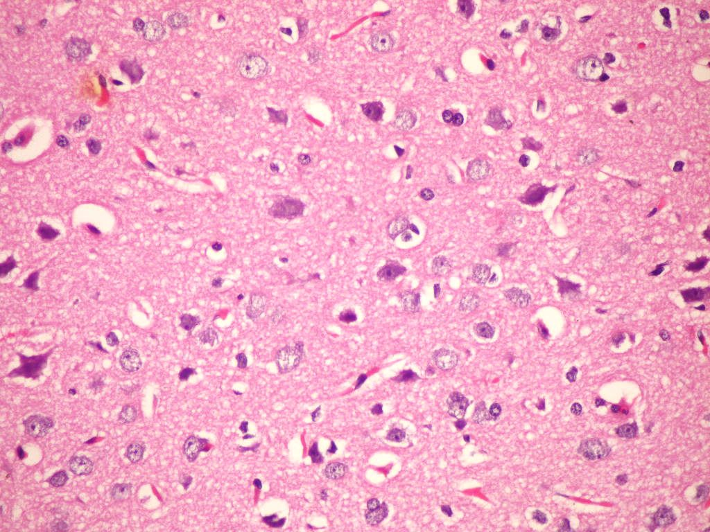  Photo (1): Brain of – ve control group fed on basal diet . (Hand EX 400). | 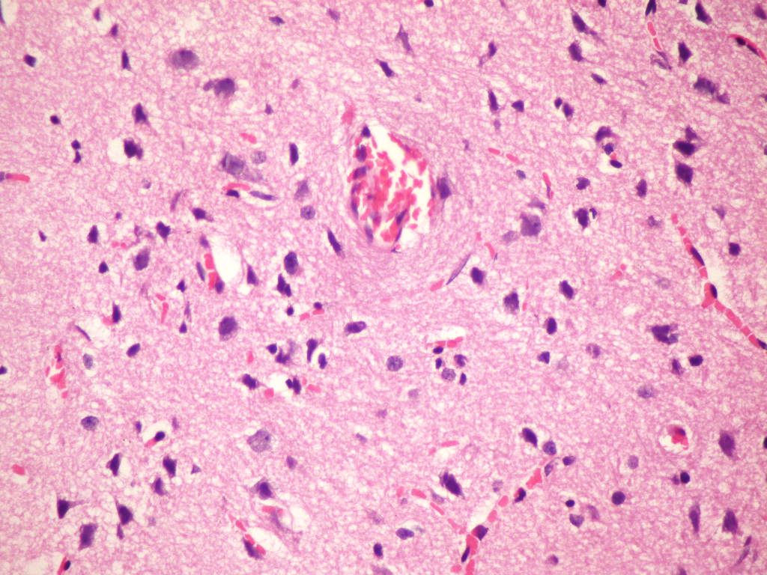  Photo (2): Brain of +ve control group fed on 15% methionine. (Hand EX 400).
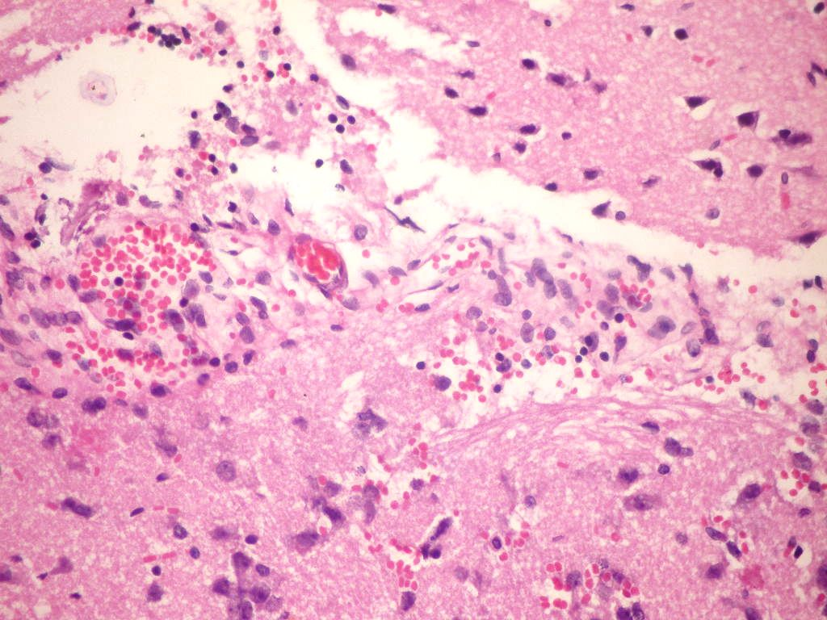  Photo (3): Brain of rat group fed on 1% methionine (Hand EX 400). | 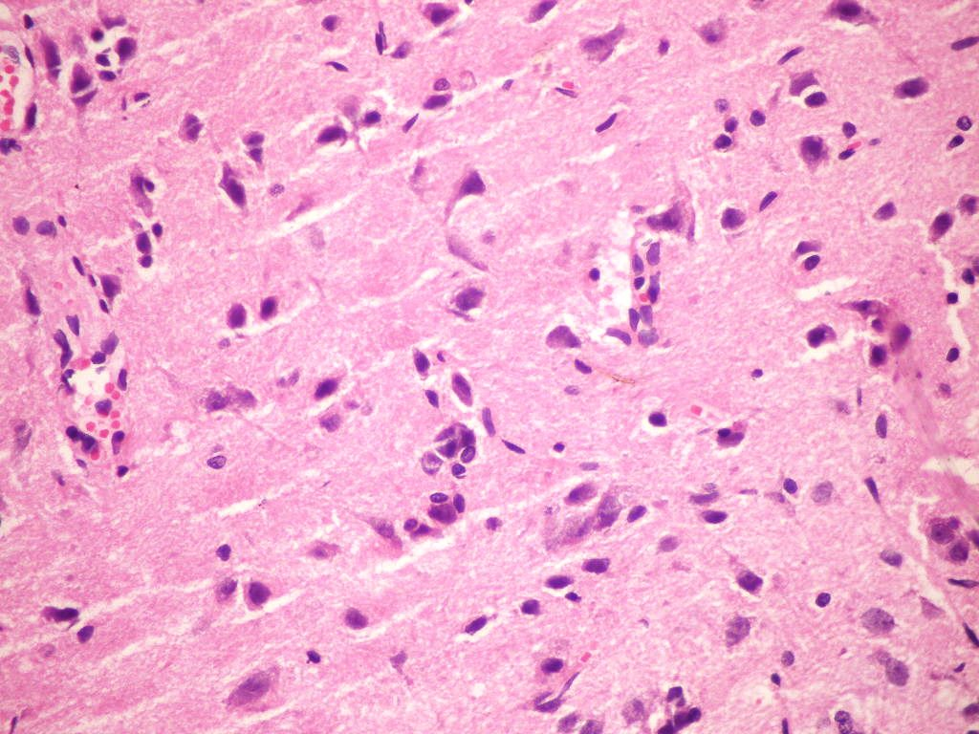  Photo (4): Brain of rat group fed on 2% methionine. (Hand E X 400)
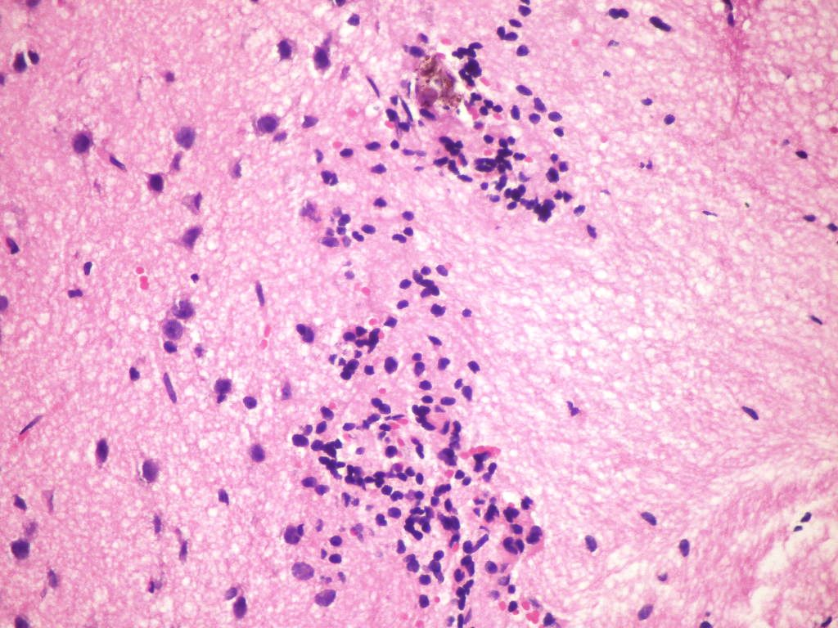  Photo (5): Brain of rat group fed on 4%methionine . (H and EX 400). | 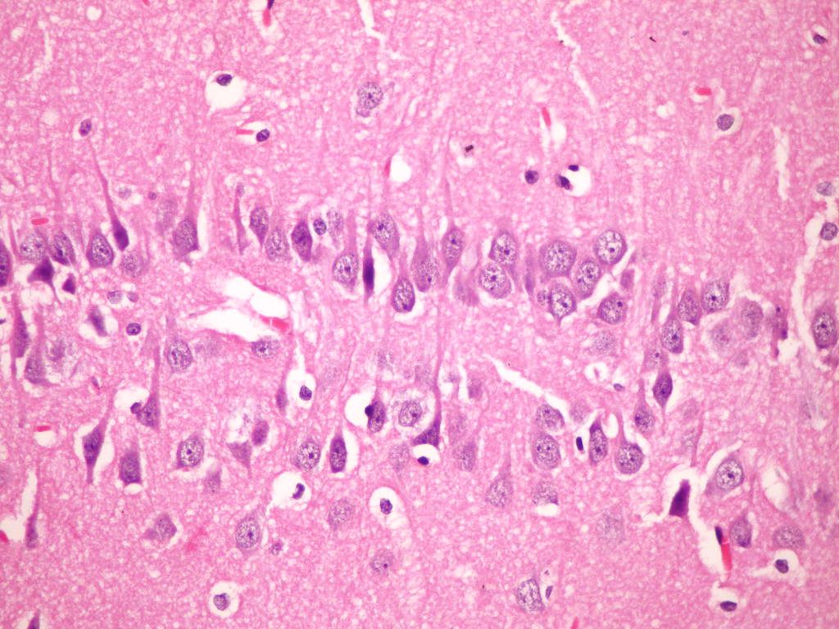  Photo (6): Hippocampus of – ve control group fed on basal diet (H and EX 400).

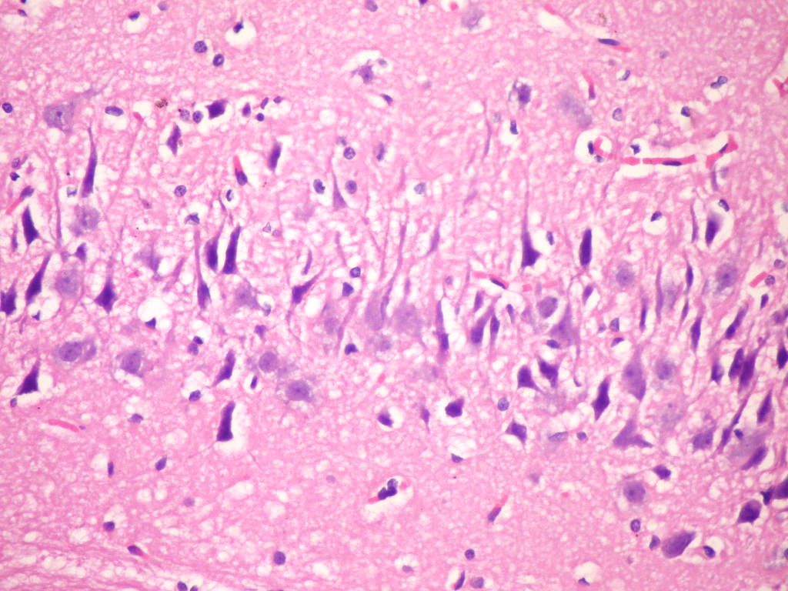  Photo(7): Hippocampus of rat from + ve control group fed on 15% methionine (H & E X 400). | 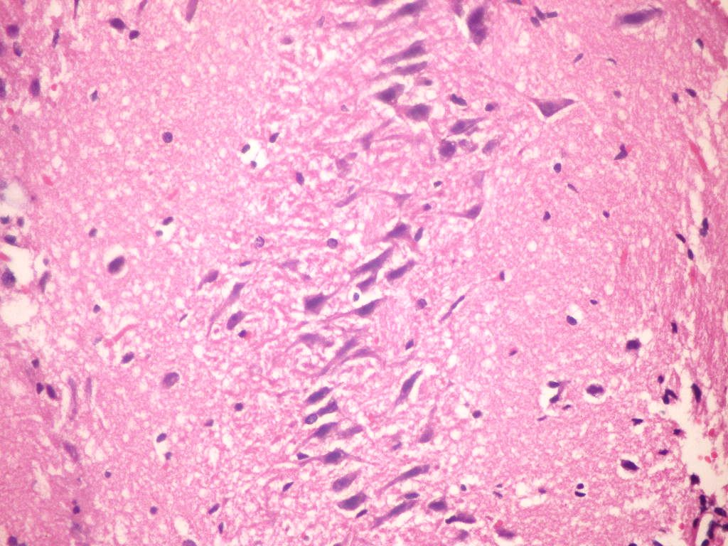  Photo(8): Hippocampus of rat group fed on 1% methionine (H and E X400).
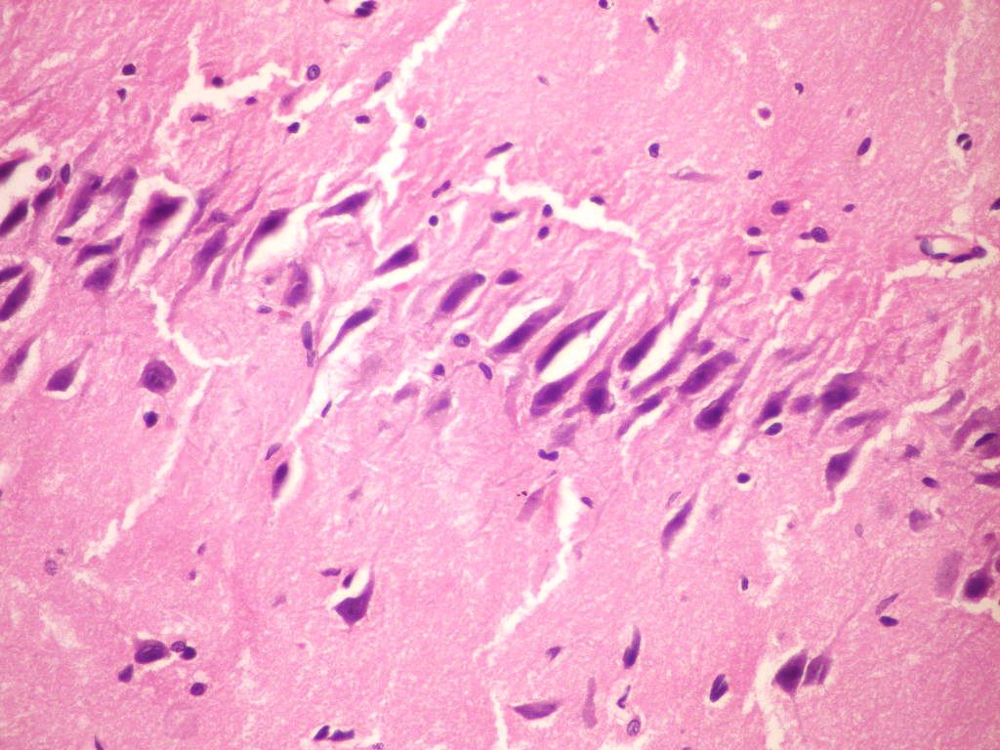  Photo(9): Hippocampus of rat group fed on 2%methionine (H and E X400). | 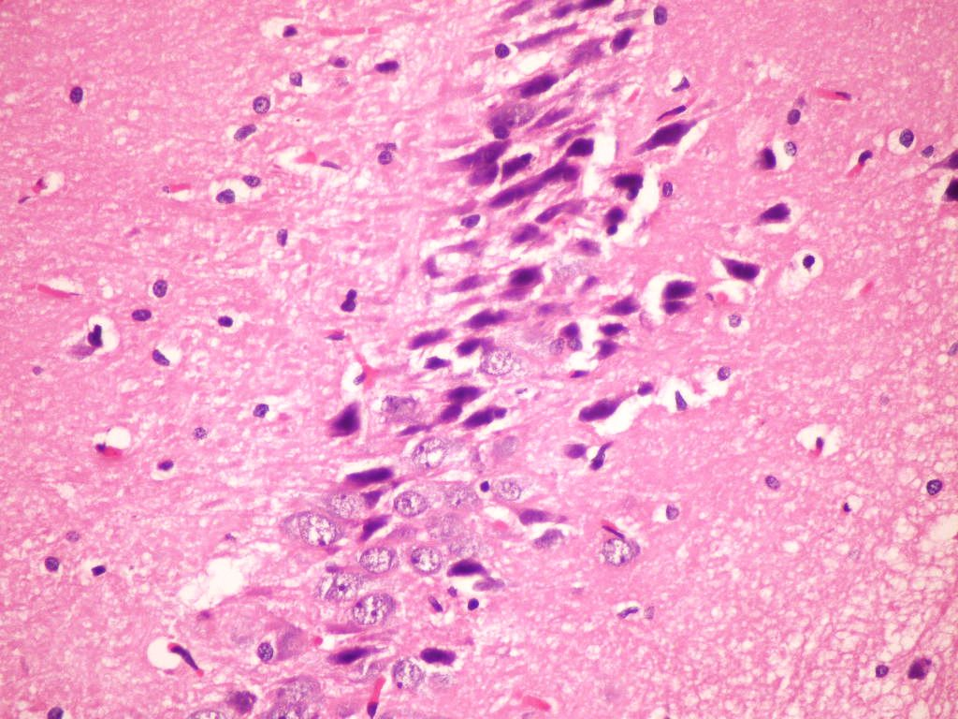  Photo(10): Hippocampus of rat group fed on 4% Methionine (H and EX400).

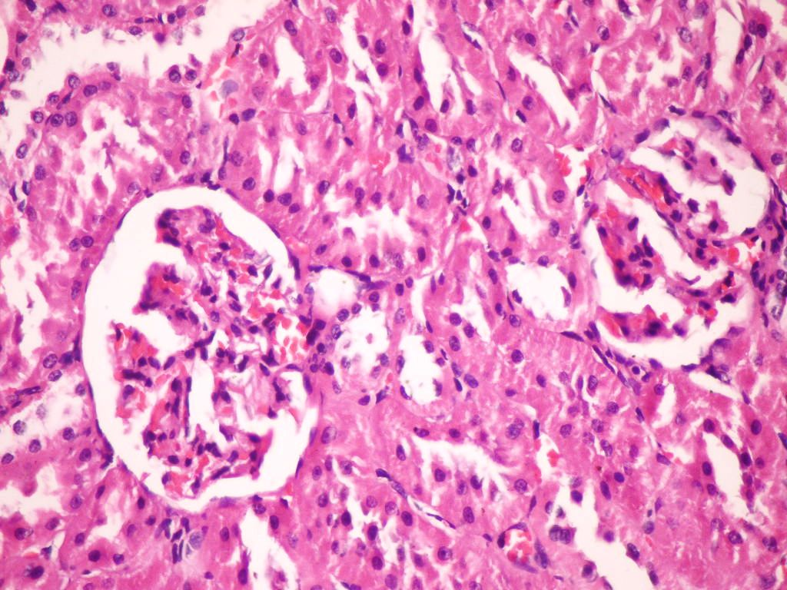  Photo (11): Kidney of– ve control group (H and E X400). | 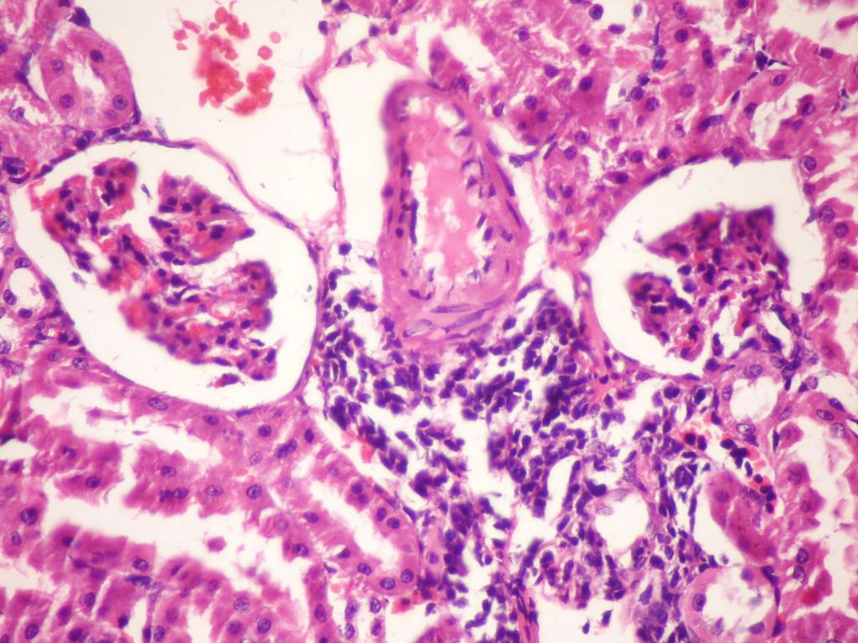  Photo (12): Kidney of +ve control group fed on 15% methionine (Hand E X400).
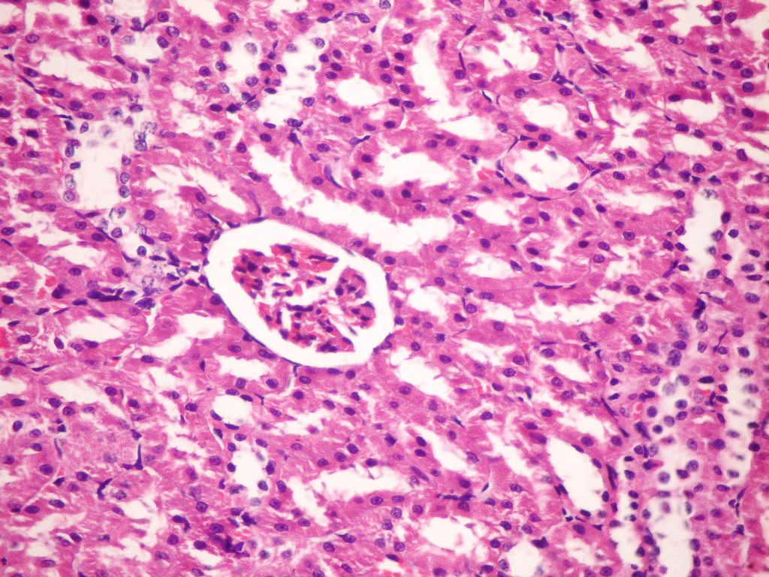  Photo(13): Kidney of rat group fed on 1%methionine (H and EX 400). | 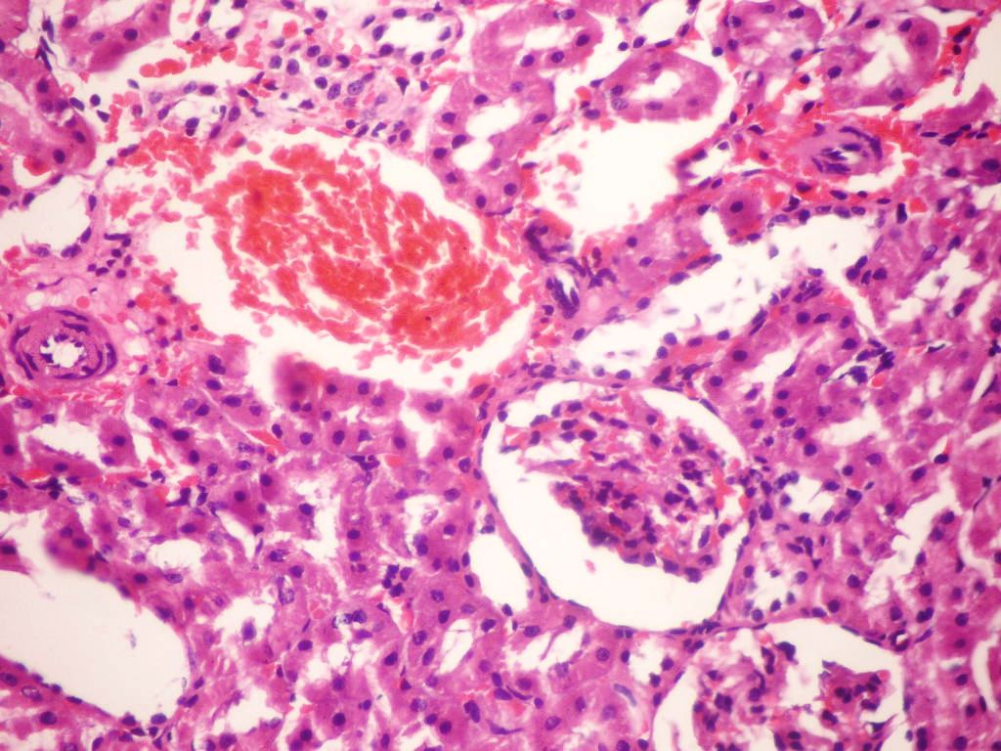  Photo (14): Kidney of rat group fed on 2% methionine (HandE X 400).
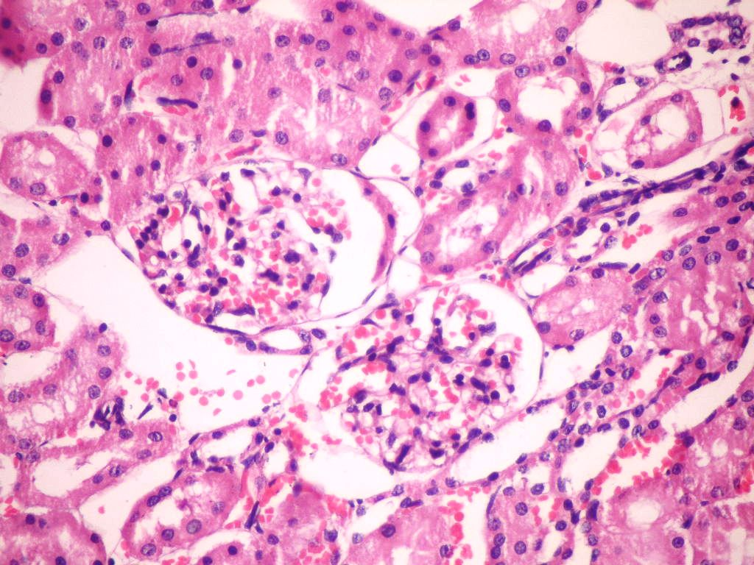
Photo(15): Kidney of rat group fed on 4% methionine (H and E X 400).

Corresponding author
Nada A. Abd El Aty
Nutrition and Food Science Department, Faculty of Home EconomicsHelwan University

4. References
Allison, Jay S, Roth and James B,(1949): The Effects of Feeding Excess DL- Methionine and Choline Choloride to Rats on A Casein Diet
Armitage and Berry (1987): Statistical methods, 7th Ed Ames, Iowa State University Press USA,39-63.
Bancroft, J.D., Stevens, A; and Turner, D. R. (1996): Theory and practice of Histological Techniques. 4 ^{th} ed. New york, Churchill, Livingstone.
Barham, D and Trinder, P, (1972): Enzymatic determination ofuric acid Analyst, 97:142.
Brush, M., W. Willman and P. P. Swanson (1947): Amino acids in nitrogen metabolism with particular reference to the role of methionine. J. Nutr., 33: 389.
Bush, A. I.; Pettingell, W. H; Multhaup, G.D; Paradis, M; Vonsattel, J. P; Gusella, J. F; Beyreuther, K., Masters, C. L. and Tanzi, R. E. (1994):Rapid induction of Alzheimer AB amyloid formation by zinc. Science, 265: 1464-1467.
Burton T., R, Dibrov A, Kashour T, Amara FM (2002): Anti-apoptotic wildtype Alzheimer amyloid precursor protein signaling involves the p38 mitogen- activated protein kinase/MEF2 pathway. Brain Res Mol Brain Res., 108: 102-120.
Canello, T; Frid, K; Gabizon, R; Lisa, S; Friedler, A; Moskovitz, J; Gasset, M; and Gabizon, R, (2010):Oxidation of Helix-3 methionines precedes the formation of PK resistant PrP, public liprary of science..1;6(7):e1000977.
Caro, P; Gomez, J; Sanchez, I; Naudi, A; Ayala, v; Lopez- Torres, M; PamPlona, R; and Barja, G, (2009): Forty percent methionine restriction decreases mitochondrial oxygen radical production and leak at complex I during forward electron flow and lowers oxidative damage to proteins and mitochondrial DNA in rat Kidney and brain mitochondria. Rejuvenation Res., 12(6) 421-34.
Chapman, B. M. R. F; Chapman, and I. A. D, Robertson. (1959): The growth and breeding of the multimammate rat, Rattus (Mastomys) natalensis (Smith) in Tanganyika territory. Proceedings of the Zoological Society of London, 133:1–9. Cottington, Christian Lamantia, Sally, P; Stabler, Robet, H; Allen, Albert Tangerman, Conrad Wagner, Steven, H; Zeisel and S, Harvery, (2002):Adverse event associated with methionine loading test…Science or Technology Service1046-50 12067919.
Domenico, (2009): Diet high in Methionine could increase risk of Alzheimers. Journal Current Alzheimer Research PA 19122
215-204-8561
Dreux, C. (1977): Iron colorimetric Method.; Ann. Biol. Clin., 35 : 275 .
Foresti, R; Clark, J. E; Green, C. J; and Motterlini, R. (1997):Thiol compounds interact with nitric oxide in regulating heme oxygenase-1 induction in endothelial cells. Involvement of superoxide and peroxynitrite anions. J Biol Chem., 272:18411–18417.
Hegeddus, M; Fekete, S; Andrásofszky, E and Hullár, I. (1998):.Effect of methionine and its derivatives on the weight gain and protein utilisation of growing rats. US National Library of MedicineNational Institutes of Health46(4):421-9.
Henry,J.B., Todd, Sanford, Davidsohn (1972): Clinical Diagnosis and Measurement by laboratory Methods., 16th ed., W.B. Saunders and Co., Philadelphia PA. P260.
Hong Zhang, XinWang, Meredin Stoltenberg, GormDanscher, Liping Huang, Zhan-YouWang, (2008): Abundant expression of zinc transporters in the amyloid plaquesof Alzheimer’s disease brain,Brain research bulletin. (77) 55–60.
Jae-Young Koh (2007):Zinc and disease of the brain. Glia, pages 1351–1361, Volume 24, Numbers 1-3.
John and Grohol (2009): What is Dementia? By National Institute on Agin
Johsen- Eliasson, R, (1987): Para la determinacion“ in vitro” dezinc en suro, plasma y orin. Intern.J. Andrology, 10:435-440.
Jose Gomez, Pilarcaro, Ines Sanchez, Alba Naudi, Marionna Jove, Manuel Portero- Otin, Monica Lopez- Torre Reinald Pamplona and Gustavo Barja, (2009): Effect of methionine dietrysupplemention mitochondrial oxygen radical generat and oxdative DNA damage in rat liver and heart. Journal of Bioenergetics and Biomembranes,41 ,3/200 :309-321.
Kranich, O; Hampricht, B; and Dringen, R, (1996): Different preferences in the utilization of aminoacids for glutathione synthesis in cultured neurons and astogligal cells derived from rat brain. NeurosciLett., 219:211–214.
Laurie, W., Woods, J. D., and Roach, G, (1958):Third World Congress of Cardiology. Brussels.
Longe, J , Led, (2005): The Gale Encyclopedia of Alternative Medicine. Detroit: Thomson/Gale.
Moos and Morgan (2004): The metabolism of Neuronal iron and its pathogenic role in Neurological. Diseas : Review, Ann NY Acad Sci. , 1012:14.
Moreira, P; Pereira, C; Santos, M. S; and Oliveira, C. (2000): Effect of zinc ions on the cytotoxicity induced by the amyloid beta- peptide. Antioxid.Redox.Signal., 2, 317-325.
Mori N and Hirayama K (2000): Long-terconsumption of methionine-supplemented diet increases iron and lipid peroxide levels in rat liver. J Nutr.,130:2349–2355.
Nobuko Mori and Kimiko Hirayama, (2000): Long-Term Consumption of a Methionine- Supplemented Diet Increases Iron and Lipid Peroxide Levels in Rat Liver,130:2349-2355.
Paglia W. N and Valentine (1967): Glutathione Peroxidase UV Method J. Lab. Clin. Med., 70: 158 – 169.
Petratos, S; Li, Q-X; Amee, J; XuHou, G; Kerr, M. L; Unabia, S. E; Hatzinisiriou, I; Marie-Isabel, D. M; and Small, D. H, (2008): The amyloid protein of Alzheimer’s disease increases neuronal CRMP-2 phosphorylation by a Rho-GTP mechanism. Brain, 131: 90-108.
Ranu Pal, Derek, B; Oien, Fatma, Y; Ersen and JackobMoskovitz, (2007): Elevated levels of brain-Pathologies associated neurodegenerative diseasese in the methionine sulfoxidereductase A Knockout mouseThe Journal of Neuroscience… 180, 4/200:1432-1106.
Reeves, P. G; Nielsen F. H; and fahmy, G .C, (1993): AIN-93 Purified diets for laboratory rodents: final reporte of committee of reformulathion of the AIN-76 A rodent diet. J. Nutr., 123:1939-51.
Reitman, A; and Frankel, S, (1957):Enzymatic GOT and GPT Method Amer J. Clin. Path., 28: 56.
Sagara J, Miura K, Bannai S. (1993): Maintenance of neuronal glutathione by glial cells. J Neurochem., 61:1672–1676.
Saido, Iwatsubo, Mann, Shimada, Ihara, Kawashima, (1995): Dominant and differential deposition of distinct beta-amyloid peptide species, A beta N3(pE),in senile plaques. Neuron.;14(2):457-66.
Schauer, R. J; A. L; Gerbes, D; Vonier, H; Meissner, P; Michl, R; Leiderer, F. W; Schildberg, K; Messmer and M, Bilzer (2004): Glutathion protects the rat liver against reperfusion injury after prolonged warm ischemia. Annsurg., 239: 220-231.
Wong, Y. q; Bingger, K. J; Howlett, G. J; and Griffin, M. D, (2010): Methionine oxidation induces anyloid fibril formation by full-length apolipoprotein A-I.US National Library of MedicineNational Institutes of Health107(5):1977-82.
Wretllnd,(2008): The Effect on Growth and the Toxicity of the Two Isomers of Methionine Basic Medical Sciencesvolume,20 page1-12.
Yoritaka Aoyama, Masashi Nakanishi AndkiyoshiAshida (1973): Effect of Methionine on Liver Lipid Content and Lipid Metabolism of Rats Fed a Protein-free Diet

5/2/2012

