Impact of Mass Bathing on water quality of Ganga River during Maha Kumbh-2010

Vijay Sharma* Sushil Bhadula and B. D. Joshi

*School of Yoga & Health, Dev Sanskriti University, Haridwar-249411, Uttarakhand, India.
Department of Zoology and Environmental Sciences, Gurukula Kangri University, Haridwar-249404, Uttarakhand, India.
Email: vijaysharma_mediplants@yahoo.com; Mobile No. 91- 9720143678

Abstract:The present study was carried out to assess the impact of mass bathing on water quality of Ganga River during Maha Kumbh-2010. Ganga water samples were collected from three selected bathing Ghats / Platforms of river Ganga and analyzed for some Physico-Chemical parameters. It was observed that all parameters were least affected at the Ghat / platform of Sapt Rishi Ashram, which is the least used for bathing by pilgrims and remains least disturbed zone among three sites, whereas almost all parameters were highly affected at Har- ki- Pauri, the site used most by the pilgrims and hence the highest disturbed zone.
[Vijay Sharma, Sushil Bhadula and B. D. Joshi. Impact of Mass Bathing on water quality of Ganga River during Maha Kumbh-2010. Nat Sci. 2012; 10(6):1-5]. (ISSN: 1545-0740). http://www.sciencepub.net/nature. 1

Keywords: Mass bathing; Water Quality; Sanitation; Environmental Management.

1. Introduction
According to Hindu mythology, Haridwar is one of the holiest places, on account of the belief that the Gods have left their footprints in Haridwar. The holy city of Haridwar is site to some of the most sacred Hindu rituals and one can always see pilgrims and devotees from round the globe gather at Haridwar to offer prayers on auspicious occasions, having a dip in the sacred Ganga River. Millions of devotees and visitors, take a dip in the holiest river Ganga during Kanwar, Ardh-Kumbh, Maha Kumbh and other festive occasions (Plate 1). It is not possible for any city municipality to make proper arrangements for lodging and other civic facilities for millions of pilgrims during festive occasions.
Haridwar city is famous for such big festive occasions like Kanwar, Ardh-Kumbh and Maha Kumbh. As a consequence of insufficient facilities, the available places, grounds, fields and riparian city forest areas are used as latrines and toilets. The municipal water points turn as quick wash places. The 4-5 Km stretch of Ganga river and river canal banks are used as bathing places and sites of holy water collection, too. The pilgrims also offer flowers, cloths, old icons of Gods and Goddess, besides last remains (ashes) of their loved ones to dispose in the river Ganga, at Haridwar.
At the beginning of year 2010 from the month of January, heavy influx of pilgrims poured in Haridwar city to attend the Maha Kumbh (14th January, 2010 to 30th April, 2010) for taking a holy dip in river Ganga to wash away their past sins. According to news papers and local administration, more than 8 million pilgrims took holy dip in river Ganga at Haridwar during Purna Kumbh (Complete Kumbh). It can be well presumed that such a massive bathing would affect the quality of water of any riverine ecosystem. Therefore, a chemical analysis of water was done to assess the impact of mass bathing.

2. Materials and Methods
In the present study, a systematic study was made during Maha Kumbh 2010 to assess the impact of mass bathing on the quality of river Ganga water with special reference to Royal Bathing dates. Three bathing Ghats (Platforms) namely Sapta Rishi Ashram Ghat, Har-Ki-Pauri and Prem Nagar Ashram Ghat of River Ganga were selected as study and sampling sites. Sapta Rishi Ashram Ghat was selected as reference site as it was the least disturbed zone during the Maha-Kumbh Mela.
Water Samples were collected from these ghats on Royal bathing days. Some selected physico-chemical parameters viz. Temperature, pH, Conductivity, TDS, DO, Turbidity, BOD, Chloride, Hardness, TSS, TS were analyzed. Out of these parameters, Temperature, pH, DO, TDS, Conductivity and Turbidity were analyzed on spot at the time of sampling using Deluxe water and soil analysis kit Model 191 E and Transparency was also measured on the spot by Sacchi disc method. While DO, BOD, Chlorides, Hardness, TSS, TS were determined in the Research laboratory using given method of APHA (1995) and Trivedi and Goel (1986).

SCENARIO OF MAHA KUMBH PERIOD IN HARIDWAR
A. Rituals of Kumbh Mela: Maha Kumbh is the biggest and the most auspicious fair, which falls once after 12 years. Kumbh Mela is like a Yogi Convention, where yogis, sadhus (saints) and pilgrims come from all over world. Many sadhus (saints) come from various holy places, the most remote forests, and mountain caves in the Himalayas. Kumbh Mela is attended by millions of people on a earth irrespective of all worldly barriers of cast, creed and region. A huge temporary city (Kumbh Nagar) is created for the millions of pilgrims that arrive for the most auspicious bathing days (Plate 2). During Maha Kumbh, millions of holy men and women (saints, monks and sadhus) take dip in holy Ganga. Rituals of Kumbh Mela include religious discussions, devotional singing, exhibitions. Kumbh Mela is the most sacred of all the Hindu pilgrims. The main bathing days are known as ‘Shahi Snans’ or ‘Royal Bathing Days’ at which main bathing ghat of Har-Ki-Pauri is reserved only for saints (sadhus) of all Akharas (Plate 4).
B. Akharas and Royal Baths (Shahi Snans): Akharas are organizations of saints which came into existence in 8th century AD when Adi Shankaracharya established seven Akharas namely Mahanirvani, Niranjani, Juna, Atal, Avahan, Agni and Anand Akhara with an aim to strengthen the Hindu religion and unite those practicing different rituals, customs and beliefs. The biggest Akhara regarding the number of Sadhus in it, is Juna, then Niranjani and then Mahanirvani. The head of an Akhara is regarded as Acharya Mahamandaleshwaras and Shree Mahants. On the Royal bathing dates, a colorful and magnificent procession of radiant saints sitting on chariots and elephants is witnessed by millions of pilgrims and local public (Plate 3). These saints, belonging to various camps take dip at holy Gangas first and then the ordinary pilgrims are allowed to take bath in the river. During the Royal Bath (Shahi Snan), millions of devotees line up along the road sides to get glimpses of the procession of ascetics parading amid tight security, as they make their way to the Ghats, for bathing.
C. Schedule of Maha Kumbh 2010: The main bathing dates at the Haridwar Kumbh were: January 14th 2010- Makar Sakranti, January 15th – Mouni Amavasya, Suryagrahan (Solar eclipse) Snan, January 20th- Basant Panchami, January 30th- Magh Poornima, February 12th – Mahashivratri (First Royal Bath), March 15th – Somwati Amavasya (Second Royal Bath), March 16th – Nav Samvatharambh Snan. March 24th – Ramnavmi Snan, March 30th – Chaitra Poornima Snan (Third Royal Bath), April 13th – Baishakhi, April 14th – Mesh Sakranti (Fourth Royal Bath).

3. Results
The results of all physico-chemical parameters are described below and also summarized in Table 1.
Temperature: Value of Temperature ranges between14.2-17.8 (⁰C). The minimum value for water temperature was recorded 14.2 (⁰C) at the bathing ghat of Sapt Rishi Ashram, during first Royal Bath. While maximum value of water temperature was recorded 17.8 (⁰C) at the bathing ghat of Prem Nagar during main Royal bath i.e. Fourth Royal Bath.
pH: The pH values was recorded between 7.6-8.2. The minimum pH value was noted 7.6 at bathing ghat of Sapt rishi during third Royal bath, while maximum pH value was noted 8.2 at bathing ghat of Prem Nagar during fourth or main Royal bath.
Transparency: Transparency ranged between 14cm to 47 cm. Highest values 47cm was at bathing ghat of Sapt rishi during III Royal Bath, while the lowest value 14cm was found at the bathing ghat of Prem Nagar during fourth Royal bath.
Turbidity: The reading of turbidity ranged between 30NTU to 125NTU. The minimum turbidity was found 30NTU at the bathing ghat of Sapt Rishi during third Royal bath, while the maximum turbidity was found 125NTU at the bathing ghat of the Har-ki-Pauri during fourth Royal bath.
TDS: Total Dissolved Solids (TDS) ranged between of 81.9-153.5 mg/l. The highest TDS (153.5mg/l) was found at Bathing ghat of Prem nagar during second royal bath while the lowest TDS (81.9mg/l) was found at the bathing ghat of the Sapt rishi during first Royal bath.
TSS: The Total Suspended Solids (TSS) ranged between 1.97- 9.4mg/l. the maximum value (9.4) of TSS was found at the bathing ghat of the Har-ki- Pauri during main Royal bath, while the minimum value (1.97) of TSS was found at the bathing ghat of the Sapt rishi during third Royal bath.
DO: Dissolved Oxygen (DO) ranged between 7.0-9.8 ppm. The Maximum DO (9.8) was found at bathing ghat of the Sapt rishi during first Royal bath, while the minimum DO (7.0) was found at the Bathing ghat of Prem nagar during Fourth Royal Bath.
BOD: Bio-Chemical Oxygen Demand (BOD) ranged between 1.21-3.6mg/l. The Minimum BOD₅ (1.21mg/l) was found at bathing ghat of Sapt Rishi during third Royal bath, while the maximum BOD₅ (3.6mg/l) was found at the bathing ghat of Prem Nagar during Fourth Royal bath.
Alkalinity: Alkalinity of the Ganga river water during Maha Kumbh ranged between 122.1-159.1mg/l. the highest value (159.1 mg/l) of the alkalinity was found at the bathing ghat of Prem Nagar during second Royal bath, while the lowest value (122.1 mg/l) was found at the bathing ghat of Sapt rishi during Fourth Royal bath.
Hardness: Hardness of the Ganga river water during Maha Kumbh ranged between 110-140.1 mg/l. the highest value of the hardness was found 140.1 mg/l at the bathing ghat of Prem Nagar during second Royal bath, while the lowest value was found 110 mg/l at the bathing ghat of Sapt rishi during First Royal bath.
Chlorides: Chlorides of the Ganga river water during Maha Kumbh ranged between 17.36-38.90 mg/l. The highest value of the chlorides was found 38.90 mg/l at the bathing ghat of Prem Nagar during Fourth Royal bath, while the lowest value was found 17.36 mg/l at the bathing ghat of Sapt Rishi Ashram during First Royal bath.

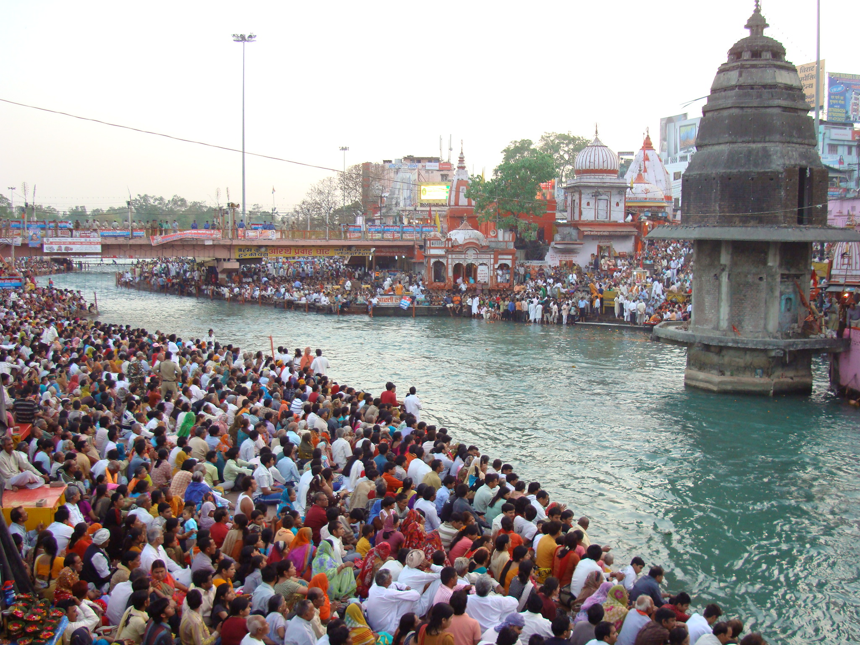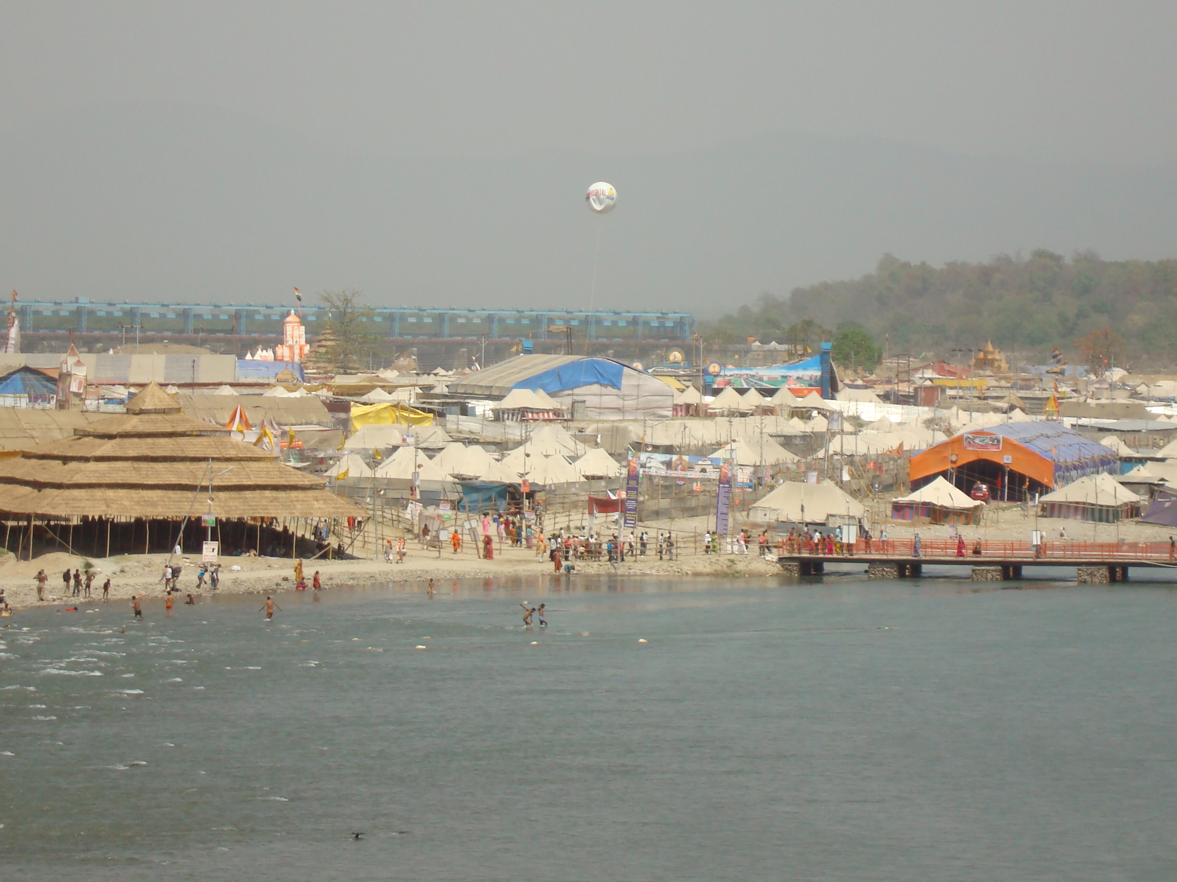
(1) (2)

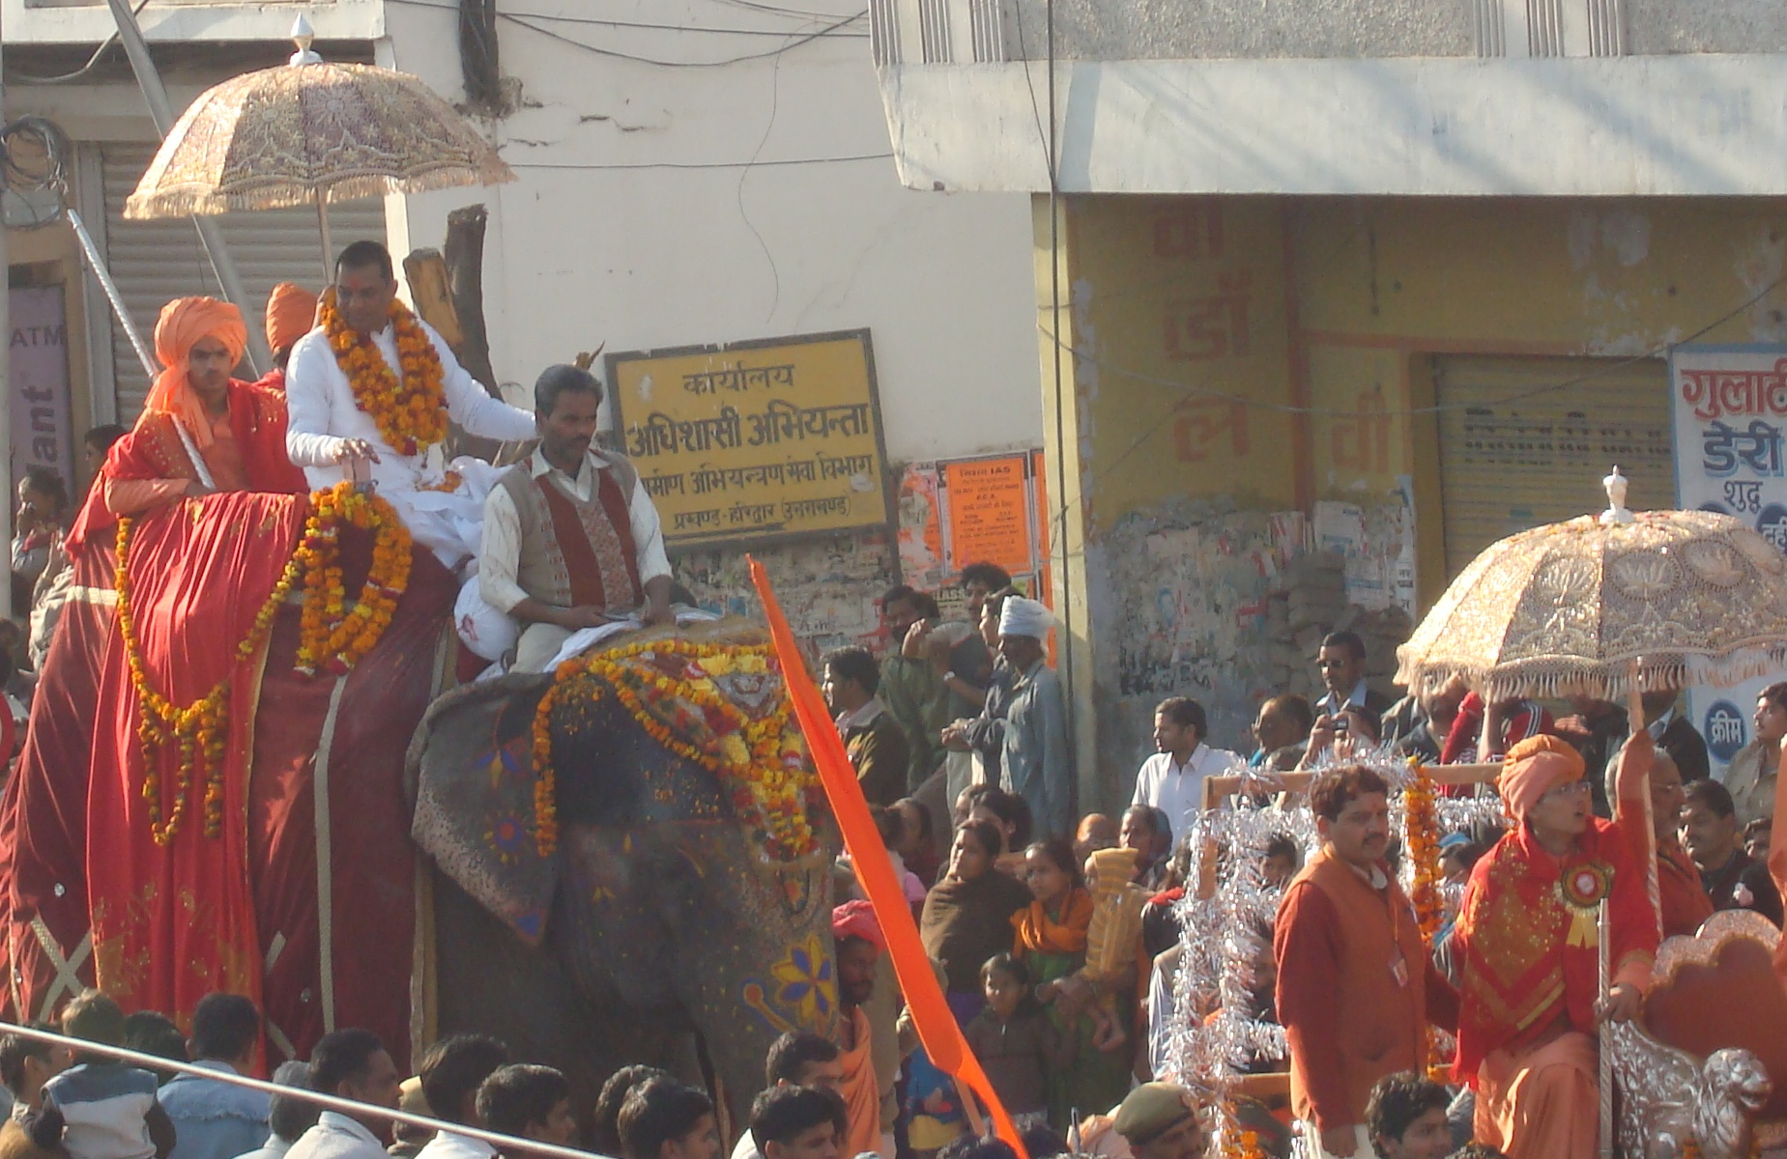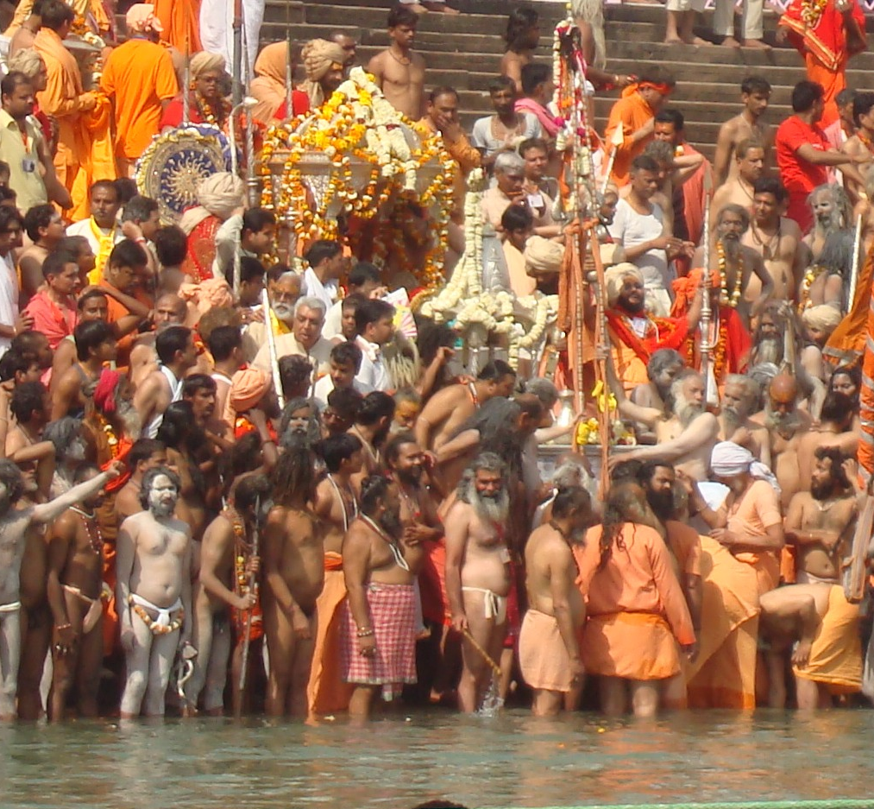
(3) (4)

Plate 1: Pilgrims waiting at the Ghat/ Plateform of Har-Ki-Pauri to have a holy dip in River Ganga, as soon as the sacred time comes, 2: A view of temporary created city (Kumbh Nagar) on the bank of River Ganga, 3: A procession of Juna Akhara marching in the city of Haridwar during Maha-Kumbh, 4: Saints waiting for the sacred time to have a holy dip in River Ganga during Royal Bath.

Table-1. Values of selected physico-chemical parameters at different sites, during Maha Kumbh-2010
Parameters Studied | Study Sites (Bathing Ghat/ Plateform)
Parameters Studied | Sapt Rishi Ghat (Ref. Site) |  |  |  | Har-Ki-Pauri |  |  |  | Prem Nagar Ashram
Parameters Studied | I-R.B | II-R.B | III-R.B | IV- R.B | I-R.B | II-R.B | III-R.B | IV- R.B | I-R.B | II-R.B | III-R.B | IV- R.B
Temp. | 14.2 | 15.0 | 15.0 | 17.5 | 14.5 | 15.2 | 15.4 | 17.7 | 14.6 | 15.2 | 15.6 | 17.8
pH | 7.7 | 7.8 | 7.6 | 7.9 | 7.9 | 8.1 | 7.9 | 8.1 | 7.9 | 7.8 | 7.91 | 8.2
Transparency | 40.0 | 30.5 | 47.0 | 20.0 | 22.0 | 19.0 | 20.0 | 15.5 | 20.0 | 17.0 | 19.0 | 14.0
Turbidity | 39.0 | 41.0 | 30.0 | 85.0 | 57.0 | 89.0 | 41.0 | 125.0 | 60.0 | 95.0 | 45.0 | 116.0
TDS | 81.9 | 92.5 | 71.8 | 91.7 | 102.7 | 111.5 | 91.5 | 114.4 | 150.0 | 153.5 | 94.6 | 117.1
TSS | 2.0 | 3.1 | 1.97 | 3.5 | 2.7 | 3.6 | 2.41 | 9.4 | 2.9 | 3.8 | 2.7 | 9.0
TS | 87.5 | 90.2 | 75.6 | 110.0 | 97.0 | 102.5 | 81.43 | 147.4 | 120.2 | 122.7 | 86.0 | 151.35
DO | 9.8 | 9.4 | 9.5 | 9.6 | 8.9 | 8.5 | 8.9 | 7.7 | 8.7 | 8.4 | 8.5 | 7.0
BOD | 1.23 | 1.7 | 1.21 | 2.48 | 2.0 | 2.4 | 1.91 | 3.45 | 2.1 | 2.8 | 2.0 | 3.6
Alkalinity | 140.14 | 145.0 | 130.2 | 122.1 | 143.47 | 156.5 | 132.5 | 125.24 | 145.1 | 159.1 | 135.0 | 127.0
Hardness | 110.0 | 117.0 | 111.0 | 114.0 | 130.0 | 139.7 | 118.0 | 123.0 | 132.0 | 140.1 | 121.0 | 122.0
Chlorides | 17.36 | 19.5 | 21.2 | 22.24 | 21.52 | 27.7 | 25.0 | 30.4 | 28.5 | 27.0 | 21.6 | 38.90

4. Discussion
This study involved monitoring of few selected physico-chemical parameters of Ganga River Water at three different Ghats / platforms during Royal bathing dates of Maha Kumbh Mela-2010. The results of the study clearly depict that mass bathing tends to disturb riverine ecology of Ganga by decreasing DO and increasing BOD, hardness and TDS (in comparison of reference site). It was noticed that due to mass bathing, Site II (Har-ki-Pauri) was badly affected by pilgrims or devotees.
Verma et al. (2010) studied the water quality of Kalpi River and pointed out that river is currently degraded by the anthropogenic activities. The mass bathing certainly degrade the quality of water as earlier reported by Bhatnagar and Sangwan (2009) in case of sacred water tank of Brahmsarovar in Kurukshetra. In a earlier report on Ganga water pollution, Mishra and Joshi (2003) also pointed out that mass bathing and other pilgrims related activities are responsible for deteriorating quality of Ganga water. Parashar et,al. (2003) assessed the water quality of Ganga river during Maha Kumbh 1998 and found drastic changes in physico-chemical as well as microbiological characters of Ganga water.
It was observed that during these festive occasions, the environmental condition are worsened considerably, creating an unpleasant scenario of littered SW attracting stray dogs and pigs as earlier reported by Sharma et, al. (2010). This unsanitary condition leads to an increase number of cases of various contagious as well as water and airborne disease, as observed in a study during Kanwar fair at Haridwar in 2008 (Saini et al., 2009). Pandey et. al, (2005) have been studied on Ganga water pollution and observed that mass bathing and other religio-touristic activities are the main cause of occurrence of Enteric disease in Varanasi City. According to news paper clippings¹⁰⁻¹¹ a rise was seen in the number of patients of water borne diseases during Kumbh and post period of Kumbh in 2010.

Acknowledgments
The authors extend their thanks to Indian Academy of Environmental Sciences, Hardwar for financial support during present study. The thanks are also acknowledged to city municipality and district tourism office for their co-operation.

Corresponding Author
Dr. Vijay Sharma,
Assistant Professor,
School of Yoga & Health,
Dev Sanskriti University, Haridwar-249411
(Uttarakhand), India.
E.mail: vijaysharma_mediplants@yahoo.com
Mobile No. 91- 9720143678

References
[1] APHA. In: Standard methods for the examination of the water and waste water. American Public Health Association, New York, 1995.
[2] Trivedi R K, Goel P K. In: Chemical and biological methods for water pollution studies. Environmental publication Karad, 1986.
[3] Verma A K, Saksena D N. Assessement of water quality and pollution status of Kalpi (Morar) River, Gwalior, Madhya Pradesh: with special reference to conservation and Management plan. Asian J. Exp. Biol. Sci., 2010; 1(2): 419-429.
[4] Bhatnagar A, Sangwan P. Impact of Mass Bathing on Water Quality. Int. J. Environ. Res., 2009; 3(2): 247-252.
[5] Mishra S, Joshi B D. Assessment of water quality with few selected parameters of River Ganga at Haridwar. Him. J. Env. Zool., 2003; 17(2): 113-122.
[6] Parashar N B, Kaushik P, Pandey S. Physico-chemical and Microbiological studies of Ganga canal at Hardwar, during Kumbh Period-1998. Him. J. Env. Zool., 2003; 17(2): 167-171.
[7] Sharma V, Saini P, Gangwar R S, Joshi B D. Assessment of municipal solid waste generation and its management in the holy city of Haridwar, Uttarakhand State, India. Waste Management, 2010; 30 (4): 725-726.
[8] Saini P, Sharma V, Joshi B D. A Random survey report about rise in water borne diseases in Haridwar city during Kanwar mela-2008. J. Environ. Bio-Sci., 2009; 23 (2): 215–219.
[9] Pandey M, Dixit V K, Katiyar G P, Nath G, Sundram S M, Chandra N, Shomvansi A K, Kar S, Upadhay V K. Ganga Water pollution and Occurrence of Enteric disease in Varanasi City. Indian Journal of community Medicine, 2005; 30 (4): 115-120.
[10] Amar Ujala Beuro, Hardwar. Durgandh se saans lena bhi hua dushwar. 17 April 2010: p-5.
[11] Amar Ujala Beuro, Hardwar. Dharmnagri par mandra raha beemariyo ka khatra. 05 May 2010: p-6.

03/08/2012

