Production of Cellulase and Pectinase from Orange Peels by Fungi

Adebare Johnson Adeleke, Sunday Ayodele Odunfa, Afolake Olanbiwonninu, Mojisola Christiana Owoseni

Department of Microbiology, University of Ibadan, Nigeria.
lekejohnson2222@yahoo.ca

Abstract: The aim of the work was to evaluate the potentials of fungi to produce pectinase and cellulase using orange peels as substrate. Fungi were isolated and identified from soil and decomposing orange peels. Fungal isolates were screened in modified Czapek-Dox media with carboxymethylcellulose and citrus pectin as the only carbon source for endoglucanase and polygalacturonase production respectively. Out of a total thirteen isolates, three highest producers of the enzymes were selected and identified as Penicillium atrovenetum, Aspergillus flavus and Aspergillus oryzae. The three isolates were further used to ferment orange peels in a solid state fermentation. The effects of incubation time, pH, temperature and nitrogen sources on the level of production of the enzymes were investigated. The three isolates produced polygalacturonase optimally on the 5th day while endoglucanase was produced optimally on the 7th day. Highest production of polygalacturonase and endoglucanase by Penicillium atrovenetum was observed at pH 5, 40ºC and at 0.2% ammonium persulfate. Maximum production of polygalacturonase and endoglucanase by Aspergillus flavus was observed at pH 5.5, 40ºC and 0.25% ammonium persulfate while Aspergillus oryzae produced the two enzymes maximally at pH 5.5, 35ºC and 0.2% ammonium persulfate.
[Adebare Johnson Adeleke, Sunday Ayodele Odunfa, Afolake Olanbiwonninu, Mojisola Christiana Owoseni. Production of Cellulase and Pectinase from Orange Peels by Fungi. Nature and Science 2012;10(5):107-112]. (ISSN: 1545-0740). http://www.sciencepub.net/nature. 12

Keywords: endoglucanase; polygalacturonase; fungi; orange peels

1. Introduction
Wastes and their disposal have become an environmental concern worldwide especially when these wastes are biodegradable to useful goods and services (Shide et al, 2004). Diminishing oil supplies and growing political instability in oil-producing nations pose a major energy threat to the world which needs to be solved by introduction of alternatives (Banerjee et al, 2010). It has been estimated that the annual production of cellulosic biomass could supply 10 times our energy needs and 100 times our food needs on a global scale (Hall, 1979). Cellulolytic wastes from agricultural practices can be used to produce important compounds such as alcohol thereby assisting in controlling environmental pollution (Omojasola and Jilani, 2008). Orange peels belong to this group of valuable biomass wastes (Mrudula and Anitharaj, 2011; Omojasola and Jilani, 2008). Orange production was predicted to approach 66.4 million tons by 2010, representing a 14% increase within 12 years (Plessas et al, 2007). Approximately 40-60% of oranges are squeezed to juice and the remainder, containing peel, segment membranes and other by-products are considered as citrus processing waste (Grohmann and Baldwin, 1992). Orange peel principally consists of cellulose (13.6%), hemi-cellulose (10%) (Ververis et al., 2007), as much as 25%–30% (dry weight) pectins (Aravantinos-Zafiris et al., 1994), chlorophyll pigments and other low molecular weight compounds like limonene and so on (Nagy et al., 1977).
In bioconversion of agro-industrial wastes such as orange peels, hydrolysis of polymers is essential for their breakdown to monomers which can further be fermented to ethanol (as an alternative to energy source) and other products. Two major polymers needed to be hydrolysed in orange peels are pectins and celluloses. The enzymatic hydrolysis of pectinolytic and cellulolytic substances requires synergistic actions of both pectinolytic and cellulolytic enzymes (Grohmann and Baldwin, 1992). These enzymes are commercially expensive.
Fungi produce pectinase and cellulase enzymes that break down cellulose and pectin into simpler forms. The ability of filamentous fungi to secrete cellulases and other hydrolyzing enzymes into their culture media has led to the harvesting of these useful enzymes (Berry and Paterson, 1990; Chinedu et al., 2008). Commercial enzymes are expensive, especially in developing countries like Nigeria, because they are produced from refined substrates and usually patented organisms. It is therefore imperative that cheaper substrates from local sources for enzyme production be investigated and that fungi with good enzyme-producing capacity be isolated locally. Reports in this area of research have been scanty in Nigeria, perhaps, due to over dependence on our crude oil reserve. This work therefore reports the use of orange peels which is readily available in our environment for the production of pectinase and cellulase enzyme complex by three fungal isolates.

2. Material and Methods
Sample Collection
Orange peels were collected from fruit traders at Agbowo in Ibadan metropolis in the south western region of Nigeria. Soil samples were also collected from the botanical garden of University of Ibadan. Orange peels were used as substrates for microbial isolation, cultivation and enzyme production. The soil sample was also used for microbial isolation.
Processing of Samples
Orange peels were left to decay naturally at room temperature for two weeks for the purpose of microbial isolation. For microbial cultivation and enzyme production, orange peels were also sundried, later oven dried, ground and stored in air tight polyethylene bags to keep them moisture-free.
Isolation of Fungi
One gram of each decaying orange peels and soil sample was weighed aseptically into 9ml of sterile distilled water separately and shaken thoroughly. From these, dilutions were subsequently made up to 10⁻⁴ and pour plating of 10⁻², 10⁻³, and 10⁻⁴ was done in sterilised potato dextrose agar (PDA). Streptomycin (100mg/l) was added to the PDA after sterilisation to prevent bacterial growth. Plates were incubated in an inverted position at 30ºC for 7 days. After incubation, the plates were observed for fungal growths. Cultures were further purified by sub-culturing 2 – 4 times to obtain pure cultures of colonies which were thereafter maintained on PDA slants at 4ºC.
Primary Screening for Pectinolysis and Cellulolysis
The media used for screening was the modified Czapek-Dox Agar (Nwodo-Chinedu et al, 2010) with sucrose replaced with equal quantity of citrus pectin to screen for pectinolysis or carboxymethylcellulose (CMC) to screen for cellulolysis. Streptomycin (100mg/l) was also added to each medium to prevent bacterial contamination. Screening was done at pH 5.4. To screen for pectinase-producing fungi, all the isolates were inoculated on petri dishes containing citrus pectin as the only carbon source and incubated at 37ºC for 24 hours. At the end of the incubation period, plates were stained with 50mM iodine to view the clear zones around the colonies (Yogesh et al., 2009).
For cellulase-producing fungi, the isolates were inoculated on petri dishes containing media with carboxymethylcellulose (CMC) as the only carbon source and incubated at 29 ±1ºC for 48 hours after which they were stained with congo red for 15 minutes to visualize clearance zones according to the method of Omojasola and Jilani (2008).

Secondary Screening
The fungal strains which showed considerable clearing zones in both pectin containing and CMC containing agar were selected for secondary screening by estimating the polygalacturonase and carboxymethylcellulase production. The medium used was modified Czapek-Dox liquid medium. The selected fungal strains were each inoculated into both citrus pectin containing and CMC containing modified Czapek-Dox liquid media. Using a flamed and cooled cork borer (5mm), discs of fungal hyphae from growing edge of actively growing culture were cut on petri dishes. With a flamed and cooled transfer needle, two discs were introduced into 100ml of sterile modified Czapek-Dox liquid media in 250ml Erlenmeyer flasks. The flasks were covered with sterile cotton wool and incubated in the dark at 29 ± 1ºC for 7 days. After incubation, the cultures were harvested by filtration through Whatman No.1 filter paper. The filtrate was stored at 4ºC and used as the crude enzymes for quantitative polygalacturonase and carboxymethylcellulase assays. Isolates with the highest enzyme activities were selected for further experiments.

Production of Cellulases and Pectinases in Solid State Fermentation
To prepare the inoculum, two discs of respective fungal hyphae were mixed with 10ml of sterile distilled water and a suspension was made. The fermentation medium contained 5g of processed orange peels mixed with 4mls of Czapek-Dox mineral solution inside a 250ml Erlenmeyer flask and sterilized at 121ºC for 30 minutes. Cultivation was carried out by adding 1ml of the inocula. Then, the flasks were incubated at 29º ± 1ºC.
The effects of incubation time, pH, temperature and nitrogen sources were tested to determine optimized condition for cellulase and pectinase production. After incubation, culture filtrates were made to undergo polygalacturonase and endoglucanase assays. The fermentation medium was analysed for polygalacturonase and endoglucanase.

Assays
Polygalacturonase Activity (PG): PG activity was determined by measuring the release of reducing groups from citrus pectin using the 3, 5, dinitrosalicyclic acid reagent (DNSA) assay (Miller, 1959). The reaction mixture containing 0.8ml 1% citric pectin (Sigma) in 0.2M acetate buffer, pH 5.0 and 0.2ml of crude enzyme solution was incubated at 50ºC for 10min (Silva et al., 2002). One unit (U) of enzyme activity was defined as the amount of enzyme which releases 1µmol of galacturonic acid per minute.
Endoglucanase Activity: The procedure followed the 0.5ml assay described by Jeffries (Jeffries, 1996). Crude enzyme solutions were diluted in 0.05M citrate buffer, pH 4.8. The enzyme diluted in buffer and 1% CMC (0.5ml each) was mixed well and incubated for 30min at 50ºC. 3ml of DNSA was added and the tubes were placed in boiling water bath for 5min. The tubes were cooled and the reducing sugar (glucose) was determined (Miller, 1959). This was determined by measuring the absorbance at 540nm using Lambda 25 UV/Vis Spectrophotometer. In accord with the International Union of Biochemistry, one enzyme unit (U) equals to 1µmol of glucose released per minute.

3. Results
Screening for Cellulase and Pectinase Producing Fungi
Thirteen fungal isolates obtained were at first tested for endoglucanase and polygalacturonase production on agar plates using carboxymethylcellulose and citrus pectin respectively as the sole carbon sources. Isolates were designated as O1, O2, O3, O4, O5, P1, P4, P5, S1, S2, S3, S4 and S5. Isolate O3 did not grow on both media after 48 hours while isolate S1 only grew on the medium containing cellulose. Colony and clearance zone diameters could not be measured for isolate P5 due to its mode of growth. Clearance zone index for each isolate was calculated by dividing the diameter of the clearance zone by the diameter of the colony (fig. 1). Seven isolates with considerably high clearance zone indexes for both enzymes were screened in a submerged fermentation for quantitative estimation of their synthesized endoglucanase and polygalacturonase. Three isolates, S2, S4 and P1, relative to others, showed consistency in their high production of the 2 enzymes and their endoglucanse activities were 15.31U/ml, 13.11U/ml and 13.02U/ml while polygalacturonase activities were 11.58U/ml, 12.12U/ml and 10.17U/ml respectively (fig. 2). These three isolates which were identified as Penicillium atrovenetum, Aspergillus flavus and Aspergillus oryzae according to their morphology were then selected for further experiments.
Production and Assay of Enzymes Obtained from Solid State Fermentation Experiments.
Penicilium atrovenetum expressed maximum polygalacturonase activities on day 5 at pH 5 at 40ºC with ammonium persulfate (0.2%) as the best nitrogen source. Maximum endoglucanase activities were obtained on day 7 at pH 5 at 40ºC with ammonium persulfate (0.2%) (Fig.3-7). Maximum production of polygalacturonase by Aspergillus flavus was obtained on day 5 at pH 5.5 at 40ºC with ammonium persulfate (0.25%) as the best nitrogen source while its maximum yield of endoglucanase was obtained on day 7 at pH 5.5 at 40ºC with 0.25% of ammonium persulfate (Fig.3-7). Aspergillus oryzae produced polygalacturonase maximally on day 5 at pH 5.5 at 35ºC with 0.2% of ammonium persulfate incorporated in the basal medium while maximum endoglucanase production was obtained on day 7 at pH 5.5 at 35ºC and also with ammonium sulphate (0.2%) (Fig.3-7). Of the nitrogen sources tested, ammonium oxalate gave the second best results following ammonium persulfate.

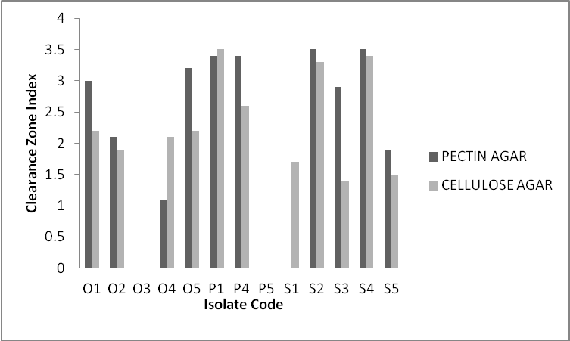
Figure. 1: Primary screening of isolates on pectin and cellulose agar.

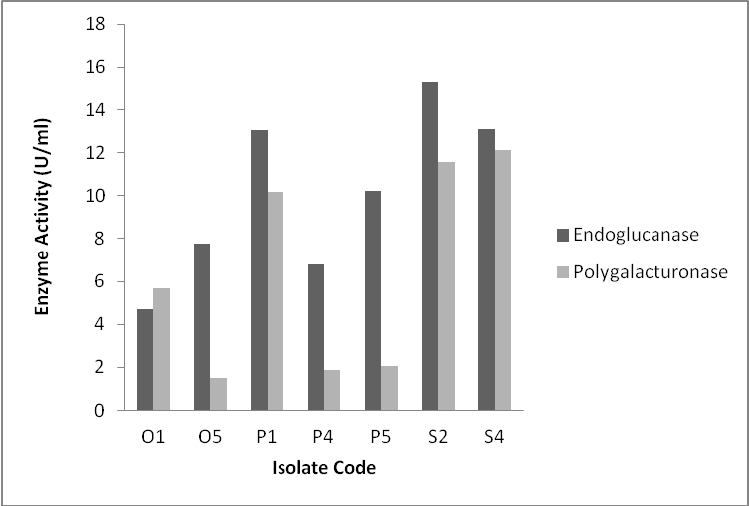
Figure.2: Secondary screening of isolates using submerged fermentation.

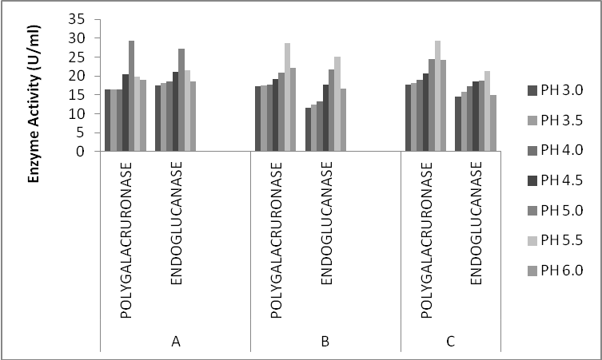
Figure 3: Effect of pH on enzymes production.
A (Penicillium atrovenetum), B (Aspergillus flavus), C (Aspergillus oryzae)

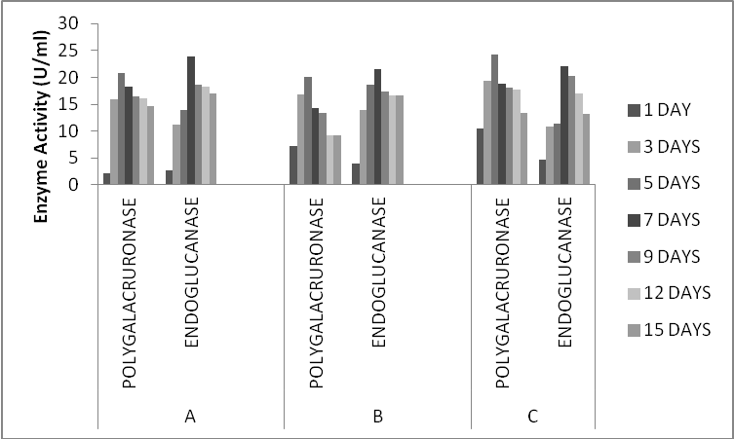
Figure 4: Effect of incubation time on enzymes production.
A (Penicillium atrovenetum), B (Aspergillus flavus), C (Aspergillus oryzae)

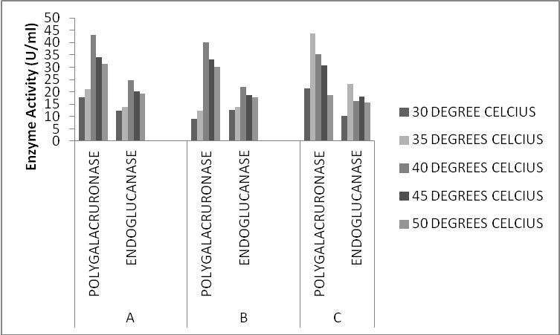
Figure 5: Effect of temperature on enzymes production.
A (Penicillium atrovenetum), B (Aspergillus flavus), C (Aspergillus oryzae)

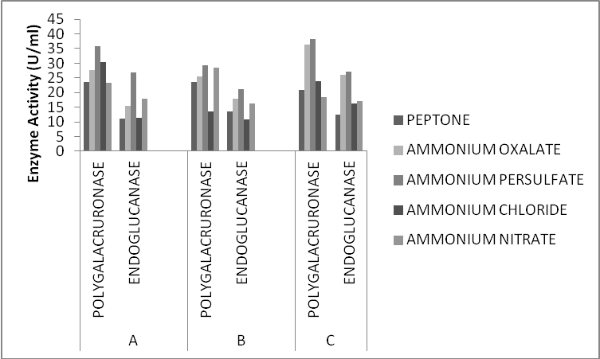
Figure 6: Effect of nitrogen source on enzymes production.
A (Penicillium atrovenetum), B (Aspergillus flavus), C (Aspergillus oryzae)

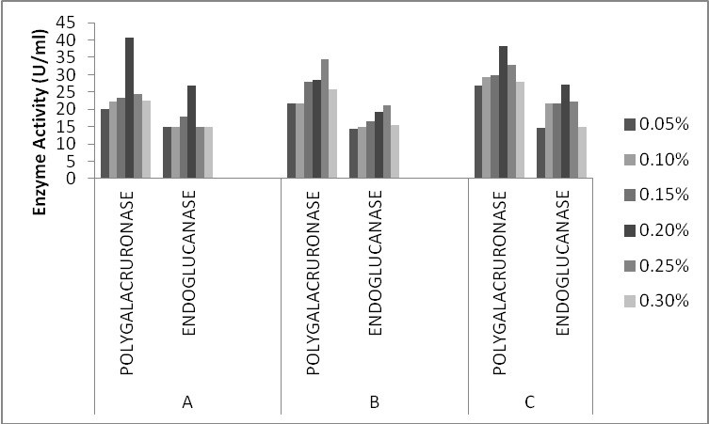
Figure 7: Effect of ammonium persulfate concentration on enzymes production.
A (Penicillium atrovenetum), B (Aspergillus flavus), C (Aspergillus oryzae)

4. Discussions
Citrus pectin and carboxymethylcellulose were used to screen for pectinolytic and cellulolytic fungi respectively. Carboxymethylcellulose was a more favourable carbon source for screening the cellulolytic fungi (Shahriarinour et al., 2011). Two screening procedures employed were to select isolates with the highest ability to produce the enzymes. Samira et al. (2011) did likewise to indicate cellulase activities of some bacterial isolates. The primary screening was a qualitative one to visualise the hydrolysis of the carbon sources on plates. Diameters of clear zones around the colonies were measured and the ratios of clear zone diameters to the colony diameters were calculated for a comparative assessment of the activities of the isolates. Isolates varied in their reaction to this test. The secondary screening was a more quantitative method used to determine the enzyme activities of the isolates. Three isolates, S2, S4 and P1, relative to others, showed consistency in their high production of the two enzymes and their endoglucanse activities were 15.31U/ml, 13.11U/ml and 13.02U/ml while polygalacturonase activities were 11.58U/ml, 12.12U/ml and 10.17U/ml respectively. The three isolates were later designated based on morphology as Penicillium atrovenetum, Aspergillus flavus and Aspergillus oryzae. Penicillium and Aspergillus are among the most studied cellulolytic and pectinolytic fungi (Sukumaran et al., 2005; Favela-Torres et al., 2006). Though strains of Penicillium sp. are perhaps best known for their use in pharmaceutical industry for the synthesis of penicillin and griseofulvin, Fawole and Odunfa (1992) previously showed that Aspergillus, Fusarium, Penicillium and Rhizopus showed high pectolytic activities. Strains of Penicillium chrysogenum has also been reported to produce significant levels of cellulolytic enzymes (Nwodo-Chinedu et al., 2007).
Mixture of orange bagasse and wheat bran was the best substrate for the production of pectinase in solid state fermentation using a Penicillium sp. (Silva et al., 2002). Industrially, use of orange peel powder can be highly economical. Dhillon et al. (2004) reported the use of citrus peel in semisolid fermentation for pectinase production. Parameters varied in this current solid state fermentation of orange peels include incubation time, pH of the basal medium, incubation temperature and nitrogen source. The three isolates produced polygalacturonase optimally on the 5th day while endoglucanase was produced optimally on the 7th. Highest production of polygalacturonase and endoglucanase by Penicillium atrovenetum was observed at pH 5, 40ºC and at 0.2% ammonium persulfate. Maximum production of polygalacturonase and endoglucanase by Aspergillus flavus was observed at pH 5.5, 40ºC and 0.25% ammonium persulfate while Aspergillus oryzae produced the two enzymes maximally at pH 5.5, 35ºC and 0.2% ammonium persulfate.
It is noteworthy that the comparison of enzyme levels produced by different organisms during different experiments by reseachers is not straightforward since distinct culture conditions and enzyme activity determinations have been used. However, Banu et al. (2010) presented similar observations for polygalacturonase production by Penicillium viridicatum, Trichoderma longibrachiatum produced highest amounts of glucose on day 7, pH 5 but at 45ºC, optimum glucose using Aspergillus niger was produced at pH 4.5 on day 5 and 45ºC while using Saccharomyces cerevisiae, optimum glucose production was produced at pH 4.5 on day 3 and at 45ºC (Omojasola and Jilani, 2008). Mrudula and Anitharaj (2011) reported an optimum production of pectinase on orange peels by Aspergillus niger at 50ºC, pH 5, 96th hour, 1:2(v/w) moisture, 2.5ml inoculums size and in the presence of sucrose and triton-X-100. Varying times of optimum incubation time can be justified by the submission of Patil and Dayanand (2006) that the period of fermentation depends upon the nature of medium, fermenting organisms, concentration of nutrients and the process physiological conditions. Most of the fungi investigated for pectinase production showed optimum growth in the range of 45 to 60ºC (Freitas et al., 2006; Rubinder et al., 2002). The pH of the medium will also limit the growth of the culture or exert influence upon catalytic activity of the enzyme. Maximum polygalacturonase production was observed in the medium with the acidic initial pH values within a range of 4 to 6 (Aminzadeh et al., 2007). Observation in this current study showed optimum pH for enzymes production within 5 to 5.5.
The source of nitrogen in the growth medium has a very important role in microbial growth and enzyme production (Mrudula and Anitharaj, 2011). Ammonium persulfate supported highest microbial enzymes production in this study. This is similar to the report of Banu et al., (2010) in Penicillium chrysogenum. Other researchers have reported many other nitrogen sources as the best; for instance, ammonium sulphate (Patil and Dayanand, 2006), combination of yeast extract and ammonium sulphate (Mrudula and Anitharaj, 2011), Ammonium oxalate gave the second best nitrogen source following ammonium persulfate in this work.

5. Conclusion
Enzymes are currently used in several different industrial products and processes and there is ever increasing demand to replace traditional chemical processes with advanced biotechnological processes involving microorganisms and enzymes. Hence, new areas of application are constantly being researched into. Interestingly, a large variety of microorganisms have the ability to produce enzymes both intracellularly and extracellularly. Some of the factors which make microbial enzymes strongly attractive in many industrial processes include its eco-friendly nature, reduced energy requirement and easy availability of raw materials for their production. The use of waste materials in our environment as substrates for the production of enzymes by microorganisms is a promising step to solve issues of environmental pollution which are normally caused by these wastes.
Diminishing oil supplies and growing political instability in oil-producing nations pose a major energy threat to the world which needs to be solved by introduction of alternatives. Countries like USA and Brazil are leading manufacturers of bioethanol from crop plants. Diverting crop plants for this purpose poses a risk of food shortage to the entire world population which is increasing in a geometric rate. The concept of producing biofuel which is a renewable source of energy from waste materials is fast gaining the attention of many researchers worldwide. Such wastes which are majorly agricultural and forest residues have as their components cellulose, starch, lignin, xylan and pectin. Use of these cellulosic wastes for biofuel production includes a hydrolysis step with the aid of enzymes. Commercial enzymes used for this purpose are rather expensive. The good news is that several microbes are capable of metabolizing these substances as carbon and energy sources by producing a vast array of enzymes.
In this work, cellulolytic and pectinolytic fungi were isolated from soil and decaying orange peels and the best three fungal isolates designated as Penicillium atrovenetum, Aspergillus flavus and Aspergillus oryzae were selected for production of cellulase and pectinase in a solid state fermentation of orange peels. Polygalacturonase and endoglucanase assays were done to estimate the secreted cellulase and pectinase by the fungi and cultural conditions which supported highest production of the enzymes were studied. This research work thereby suggests the use of orange peels which is readily available in our environment for the production of pectinase and cellulase by the three fungal isolates studied in this work.
However, further research would be carried out to examine the physico-chemical properties of the enzymes produced and their effectiveness in the hydrolysis of the peels to fermentable sugars for ethanol production.

Acknowledgements:
Authors are grateful to the Department of Microbiology and the Interdisciplinary Research Laboratory, University of Ibadan for providing laboratory supports during the course of this work.

Corresponding Author:
Adebare Johnson Adeleke
Department of Microbiology, University of Ibadan
Oyo State, Nigeria
E-mail: lekejohnson2222@yahoo.ca

References
- Aminzadeh S., Naderi-Manesh H. and Khadesh K. (2007). Isolation and characterization of polygalacturonase produced by Tetracoccosporium sp. Iran J. Chem. Eng. 26(1): 47 – 54.
- Aravantinos-Zafiris, G., Oreopoulou, V., Tzia, C. and Thomopoulos, C.D. (1994). Fibre fraction from orange peel residues after pectin extraction. Lebensm-Wiss u-Technol, 27, 468–471.
- Banerjee S., Mudliar S., Sen R., Giri B., Satpute D., Chakrabarti T. and Pandey R.A. (2010). Commercialzing lignocellulosic bioethanol: technology bottlenecks and possible remedies. Biofuels, Bioproducts and Biorefining, 4: 77 – 93.
- Banu A.R., Devi M.K., Gnanaprabhal G.R., Pradeep B.V. and Palaniswamy M. (2010). Production and characterization of pectinase enzyme from Penicillium chysogenum. Indian Journal of Science and Technology, 3(4): 377 – 381.
- Berry D.R. and Paterson A. (1990). Enzymes in food industry. In : Enzyme Chemistry, Impact and applications, 2nd edition. Eds. Suckling C.J. 306 – 351.
- Chinedu N.S., Nwinyi O.C. and Okochi V.I. (2008). Growth and cellulase activity of wild type Aspergillus niger ANL301 in different carbon sources. Canadian Journals of Pure and Applied Sciences, 2(2): 357 – 362.
- Dhillon S.S., Gill R.K., Gill S.S. and Singh M. (2004). Studies on the utilization of citrus peel for pectinase production using Aspergillus niger. Inter. J. Environ., 61: 199 – 210.
- Favela-Torres E., Volke-Sepulveda T. and Viniegra-Gonzalez G. (2006). Production of hydrolytic depolymerising pectinases. Food Technol. Biotechnol., 44(2): 221 – 227.
- Fawole O.B. and Odunfa S.A. (1992). Pectolytic moulds in Nigeria. Letters in Applied Microbiology, 15: 266 – 268.
- Freitas P.M.N., Martin D., Silva R. and Gomes E. (2006). Production and partial characterization of polygalacturonase production by thermophilic Monascus sp. N8 and by thermotolerant Aspergillus sp. N12 on solid state fermentation. Brazilian Journal of Microbiology, 37: 302 – 306.
- Grohmann K. and Baldwin E.A. (1992). Hydrolysis of orange peels with pectinase and cellulase enzymes. Biotechnology Letters, 14(12): 1169 – 1174.
- Hall D. O. (1979). Solar Energy Use Through Biology-Past, Present, and Future. Solar Energy, 22: 307 - 328.
- Jeffries T.W. (1996). Production and applications of cellulase laboratory procedures handbook. US Army Materials Laboratories, 1 – 10.
- Miller G.L. (1959). Use of dinitrosalicylic acid reagent for determination of reducing sugars. Anal Chem, 31: 426 – 428.
- Mrudula S. and Anitharaj R. (2011). Pectinase production in solid state fermentation by Aspergillus niger using orange peel as substrate. Global Journal of Biotechnology & Biochemistry, 6(2): 64 – 71.
- Nagy S., Shaw P. and Veldhuis M.K.. (1977). Citrus Science and Technology, vol. 1, The AVI Publishing Company, Inc., Westport, CT, pp. 74–427
- Nwodo-Chinedu S., Okochi V.I., Smith H.A., Okafor U.A., Onyegeme-Okerenta B.M. and Omidiji O. (2007). Effect of carbon sources on cellulase (EC 3.2.1.4) production by wild-type Penicillium chrysogenum PCL501. African Journal of Biochemistry, 1: 6 – 10.
- Nwodu-Chinedu S., Eni A.O., Adeniyi A.I. and Ayangbemi J.A. (2010). Assessment of growth and cellulase production of wild-type microfungi isolated from Ota, Nigeria. Asian Journal of Plant Sciences, 9(3): 118 – 125.
- Omojasola P.F. and Jilani O.P. (2008). Cellulase production by Trichoderma longi, Aspergillus niger and Saccharomyces cerevisiae cultured on waste materials from orange. Pakistan Journal of Biological Sciences, 11(20): 2382 – 2388.
- Patil S.R. and Dayanand A. (2006). Exploration of regional agrowastes for the production of pectinase by Aspergillus niger. Food Technol. Biotechnol., 44(2): 289 – 292.
- Plessas, S.; Bekatorou, A.; Koutinas, A.A.; Soupioni, M.; Banat, I.M.; Marchant, R. (2007). Use of Saccharomyces cerevisiae cells immobilized on orange peel as biocatalyst for alcoholic fermentation. Bioresour. Technol., 98, 860-865.
- Rubinder K., Chandha B.S., Singh S. and Saini H.S. (2002). Amylase hyper production by deregulated mutants of the thermophilic fungus Thermomyces lanuginosus. J. Ind. Microbiol. Biotechnol., 29: 70 – 74.
- Samira M., Mohammea R. and Gholamreza G. (2011). Carboxymethyl-cellulase and filter-paperase activity of new strains isolated from Persian Gulf. Microbiology Journal, 1(1): 8 – 16.
- Shahriarinour M., Wahab M.N.A., Ariff A. and Mohamad R. (2011). Screening, isolation and selection of cellulolytic fungi from oil palm empty fruit bunch fibre. Biotechnology, 10(1): 108 – 113.
- Shide E.G., Wuyep P.A. and Nok A.J. (2004). Studies on the degradation of wood sawdust by Lentinus squarrosulus. (mont). Singer. Afr. J. Biotechnol, 3: 395 – 398.
- Silva D., Martins E. Da Silva. and Da Silva R., Gomes E. (2002). Pectinase production by Penicillium viridictum RFC3 by solid state fermentation using agricultural waste and agro-industrial by-products. Brazilian Journal of Microbiology, 33: 318 – 324.
- Sukumaran R.K., Singhania R.R. and Pandey A. (2005). Microbial Cellulases --- Production, application and challenges. Journal of Scientific & Industrial Research, 64: 832 – 844.
- Ververis C., Georghiou K., Danielidis D., Hatzinikolaou D.G., Santas P., Santas R. and Corleti V. (2007). Cellulose, hemicelluloses, lignin and ash content of some organic materials and their suitability for use as paper pulp supplements. Bioresource Technology 98: 296–301
- Yogesh K., Vamsi K., Amal B., Nikhil G., Soham T., Prasad P., Girish G., Mayank G, Amol J., Adarsh M., Joshi B. and Mishra D. (2009). Study of pectinase production in submerged fermentation using different strains of Aspergillus niger. International Journal of Microbiology Research, 1(2): 13 – 17.

4/20/2012

