Nitric oxide levels in sustained virological response to peglyated-interferon-alpha-2b plus ribavirin before and after treatment in Egyptian patients with chronic hepatitis C

El-Shahat A. Toson¹, Mahmoud M. EL-Bendary², Hatem A. El-mezayen^{3,*} and Heba A. Sahyon¹

¹Chemistry Department (Biochemistry Division), Mansoura University, Egypt
²Tropical Medicine Department, Mansoura University, Egypt
³Chemistry Department (Biochemistry Division), Helwan University, Egypt
Email: hatem_mezayen@yahoo.com

Abstract: Background: Hepatitis C virus (HCV) infects an estimated 200 million persons worldwide and thus represents a viral pandemic. Egypt has a high prevalence of HCV especially genotype 4a. The standard pharmacological treatment for HCV infection is pegylated-interferon (INF) α and ribavirin. NO is one of the most versatile mediators in the control of viral infections as well as in the pathogenesis of many human infectious and inflammatory diseases. NO has a role in host defense in the normal liver, but may act in cancer promotion by stimulating aberrant differentiation of the cells and angiogenesis, and inducing tissue DNA damage. The role of nitric oxide (NO) in infectious diseases is gaining attention because of its antiviral effects. Method: Fifty two patients with chronic HCV genotype 4 treated with pegylated interferon (IFN) alpha-2a plus ribavirin underwent blood tests, assessment of serum level of NO and serum GGT before and after 6 months of treatment. Results: The pre-treatment serum NO level was significantly higher [28.97 (16.41 – 43.08) µmol/L] when compared to sustained virological responders (SVR) [8.55 (4.15 – 13.18)] and relapsers [5.14 (5.14 – 12.82)]. Also, the serum GGT (U/L) level was significantly higher in pretreatment [23.20 (9.88 – 75.50)] compared to SVR [17.11 (2.94 - 45.47)] and relapsers [21.85 (9.88 - 75.15)]. In ROC analysis, the serum NO was discriminate F1 versus F2F3 by area under curve 0.6. In conclusion: In patients with chronic hepatitis C, nitric oxide levels may be associated with the outcome of pegylated-IFN-α 2b plus ribavirin treatment.
[Elshahat A. Toson, Mahmoud M. EL-Bendary, Hatem A. El-mezayen and Heba A. Sahyon. Nitric oxide levels in sustained virological response to peglyated-interferon-alpha-2b plus ribavirin before and after treatment in Egyptian patients with chronic hepatitis C. Nature and Science 2011;(9):57-63]. (ISSN: 1545-0740). http://www.sciencepub.net

Keywords: HCV, pegylated-INF-α2b, ribavirin, nitric oxide, GGT, SVR, relapsers.

INTRODUCTION
Hepatitis C virus (HCV) infects an estimated 200 million persons worldwide and thus represents a viral pandemic (Trujillo et al., 2004). Approximately 85% of patients acutely infected with HCV progress to chronic liver disease with persistence of HCV-RNA for more than 6 months (National Institutes of Health, 2002). Among patients with chronic HCV infection, 15 - 20% progress to end-stage liver disease (Liang et al., 2000) and approximately 1 - 4% of these will develop hepatocellular carcinoma. Egypt has the highest prevalence HCV genotype-4 with more than 19% of the population infected and chronic HCV representing one of the top five leading causes of death (Zekri et al., 2007). The standard pharmacological treatment for HCV infection is pegylated-interferon (INF) α and ribavirin. Unfortunately, more than 50% of patients with chronic HCV infection either will (Non-responders) or will relapse when therapy is stopped (Liang et al., 2000). The response to combination therapy depends on several factors including the genotype of the virus, the serum level of HCV-RNA before treatment, fibrosis stage, and the host immune response (Fried et al., 2002 and McHutchison and Poynard, 1999).
The earliest host responses to viral infections are non-specific and involve the induction of cytokines, among them, IFNs. Interferons have been found to induce the production of nitric oxide (NO) (Reiss and Komatsu, 1998). There is an increasing evidence that NO is one of the most versatile mediators in the control of viral infections as well as in the pathogenesis of many human infectious and inflammatory diseases. This makes it reasonable to consider this multifunctional molecule as a potential player in HCV pathogenesis (Reiss and Komatsu, 1998). Nitric oxide (NO) is synthesized from L-arginine by nitric oxide synthase in various cells. NO is increasingly recognized to have important biological effects on mammalian cells, such as vasodilatation, neurotransmission, immune targetting, hormone production, gene expression, and modulation of tissue injury (Moshage et al., 1995). There is an increasing evidence that NO is one of the most versatile mediators in the control of viral infections as well as in the pathogenesis of many human infectious and inflammatory diseases. This makes it reasonable to consider this multifunctional molecule as a potential player in HCV pathogenesis (Reiss and Komatsu, 1998). It is conceivable that in the intrahepatic microenvironment of chronic viral hepatitis an important source of NO exists (Sanz-Cameno et al., 2002). NO has a role in host defense in the normal liver, but may act in cancer promotion by stimulating aberrant differentiation of the cells and angiogenesis, and inducing tissue DNA damage (Ahn et al., 1999). There is a controversy regarding the production of NO in chronic HCV patients with studies reporting an increase (Pata et al., 2003 and Hassan et al., 2002), a decrease (Lee et al., 2001), or no change in its level (Lake-Bakaar et al., 2001 and Tavares et al., 2005). The effect of either IFN-α or ribavirin on NO production and the possible role of NO in the efficacy of both drugs are not clear (George et al., 2003and Hokari et al., 2005).
In goal of the present study was to investigate the possible relation between serum nitric oxide in Egyptian HCV patients that received IFNα-2b and ribavirin before treatment and in sustained virological response patients compared with relapser patients. Moreover, this marker may be valuable for the assessment of the extent of liver status in these patients especially relapsers one.

MATERIALS AND METHODS
Patients:
This study was conducted on 52 patients (37 male and 15 female; aged 21 - 48 years) who start INF therapy and after 6 months of stopping the therapy therapy; as well as, another relapsers group of 25 patients who become positive to HCV-RNA again after 6 months of stopping the tharepy.
All patients were anti-HCV positive by two different third generation enzyme-linked immunosorbent assay (ELISA) tests, had detectable serum HCV-RNA by polymerase chain reaction (PCR), had alanine aminotransferase (ALT) serum levels higher than the upper limit of normal at least at one occasion within the 6 months before the start of treatment, had a histological diagnosis of chronic hepatitis within the last 6 months before the start of treatment and had at least one available stored serum sample at the start of treatment (W0), at week 72 (W72) (24 weeks after the end of treatment). The criteria for exclusion were; age (under 18 years), presence of hepatitis B surface antigen or anti-human immunodeficiency virus antibodies in serum, patients with known contraindication to either INF-α or ribavirin, and patients subjected to any condition that has been reported to affect NO production (e.g. diabetes, nitrate drugs) were excluded from the study. Other causes of chronic liver disease, severe cirrhosis, severe systemic illness and pregnancy. Patients who had previously undergone a course of an immunosuppressive treatment were also excluded.
All patients were gave their contest to participate in this study and signed an informed contest form.
The study was conducted according to the ethical guidelines at Mansoura University Hospital according to Helsinki declaration and was approved by hospital's authorized representative. Patients were treated by IFN-α 2b at the dose of 1.5 µg/kg body weight weekly subcutaneously, and ribavirin (800 – 1200 mg according to the weight of patients) for 48 weeks according to virological response to treatment. Sustained virological response to treatment was defined by the absence of detectable serum HCV-RNA by qualitative PCR 24 weeks after the end of treatment.

Serum HCV markers
Anti-HCV antibodies were measured using two third-generation ELISA tests (Ortho Diagnostics, Raritan, NJ, USA and Abbott Diagnostics, Chicago, IL, USA). Serum HCV-RNA level was detected by the Amplicor Monitor quantitative assay (Roche Molecular Systems, Alameda, CA, USA).

Measurement of Serum NO
The sera of patients were sampled at each visit and stored for assessment of total nitrite before the initiation of therapy and 6 months after. Blood samples were collected, left to clot for 20 minutes, and centrifuged (5 minutes at 2000 rpm). Serum was isolated and stored at -80 ºC till the time of the assay. Nitric oxide was assayed colorimetrically by measuring the accumulation of its stable degradation product, total NO using Montgomery, et al., 1961 (Biodiagnostic, Egypt).

Measurement of Serum Gamma-glutamyl Transferase
Gamma-glutamyl transferase (GGT) activity was determined by the method of Persijn et al., (1976) (Vitro Scient., Germany) according by manufacture instructions.

Histological Analysis
Liver biopsy was performed in every case within 6 months before the onset of treatment. Histological analysis of liver lesions was performed by a single pathologist (NS) without knowledge of any clinical or biochemical information. Liver fibrosis was estimated prospectively following the criteria established by the METAVIR classification (Bedossa and Poynard, 1996). Fibrosis was scored as follows: F0, no fibrosis; F1, portal fibrosis; F2, periportal fibrosis or rare portal septa; F3, fibrous septa with architectural distortion but with no obvious cirrhosis (bridging fibrosis).
Statistical analysis: Results were expressed as percentages or mean ± SD. Correlation tests were conducted using the Pearson test, all comparisons being two-tailed. The one tailed p values tables were used for statistical analyses. The one tailed p - values tables were used for statistical analyses. A difference was said to be significant (*), and highly significant (**), when the corresponding level of probability (p) was ≤ 0.05 and ≤ 0.01, respectively. In addition, the difference was said to be extremely significant (***) when the P value was ≤ 0.001. The overall diagnostic accuracy of all serum biomarkers was calculated by areas under receiver operating characteristic (ROC) curves. Statistical analysis was conducted with SPSS 19.0 software (SPSS Inc., Chicago, IL, USA).

RESULTS
Basic data of the studied groups
The study included 52 patients (37 male, 15 female) and their age ranged from 21 to 45 years (table 1). There were 32 patients categorized as low viral load and 20 patients as high viral load. The stage of liver fibrosis was distributed as follow: no fibrosis (F0): n = 0; portal fibrosis without septa (F1): n = 27 (52 %), few septa (F2): n = 16 (31 %) and numerous septa without cirrhosis (F3): n = 9 (17%). All patients had chronic infection with HCV-genotype 4 and treated by INF-α-2b and ribavirin. Only forty two patients (responders) were responding to the therapy after 48 weeks treatment (end of response). Only twenty five patients (48.1%) who complete the HCV-RNA test six months after the end of the treatment period and they all become sustained virological responders (SVR). In addition, 25 patients grouped as relapsers were tested with the same parameters as SVR in order to make a comparison with the former group. Also, control group (n = 50) was age and sex matched was selected for final comparison between it and successful treated patients (SVR).
Relation between serum NO and stage of liver fibrosis
Serum NO was assessed before the INF treatment and compared with the histological fibrosis (Fig. 1). There was no significant correlation between NO and the fibrosis stage (p = 0.29). The overall diagnostic value of all parameters defined by the areas under the receiver operating characteristics (ROC) curves. As shown from table 2, nitric oxide level discriminating F1 versus F2/F3 and AUC was 0.6 with positive predictive value of 75% and cut-off value was 33.85 µmol/L. while, this parameter levels discriminating F3 versus F1/F2 and AUC was 0.5 with positive predictive values of 84.4% and cut-off value was 27.95 µmol/L (table 3).
Relation between serum GGT and stage of liver fibrosis
As listed in table 2, GGT level discriminating F1 versus F2/F3 and AUC was 0.515 with positive predictive value of 60% and cut-off value was 29.19 U/L (Fig. 2). However, GGT levels discriminating F3 versus F1/F2 and AUC was 0.612 with negative predictive values of 75% and cut-off value was <= 22.24 U/L (table 3, Fig. 2).

Table 1: Basic data of sustained responders
Patients (n = 52)
28 (21 – 45) | Median (range) | Age (years)
37 (71%) | Male (n, %) | Sex
15 (29%) | Female (n, %)
20 (38.5%) | High | Viral load
32 (61.5%) | Low
42.50 (28.00 – 128.00) | Median (range) | Serum ALT (U/L)
42.49 (25.00 – 113.00) | Median (range) | Serum AST(U/L)
4.20 (3.70 – 4.90) | Median (range) | Albumin (g/dl)
15.45 (11.30 – 18.60) | Median (range) | Hemoglobin (g/L)
5.45 (2.12 – 5.18) | Median (range) | Red blood cells count (x10¹²/L)
6.95 (3.20 – 13.70) | Median (range) | White blood cells count (x10⁹/L)
226 (114 – 324) | Median (range) | Platelets count (x10⁹/L)
27 (52 %) | F1 | Stage of fibrosis
16 (31 %) | F2 | (METAVIR system)
9 (17%) | F3

Table 4: Levels of NO and GGT in patients with different virological response expressed by median (range)
 | Nitric oxide (µmol/L)  Median (range) | GGT (U/L)  Median (range) | ALT/AST ratio  Median (range)
Pretreatment (n = 52) | 28.97 (16.41 – 43.08)¶ | 23.20 (9.88 – 75.50)¥ | 1.20 (0.60 – 3.64)^{NS}
Sustained virological response (n = 25) | 8.55 (4.15 – 13.18)^{NS} | 17.11 (2.94 - 45.47)^{NS} | 1.19 (0.65 – 1.67)^{NS}
Relapsers (n = 25) | 5.14 (5.14 – 12.82)£ | 21.85 (9.88 - 75.15)^{NS} | 1.2 (0.36 – 3.15) ^{NS}
¶ p < 0.0001 compared with SVR NS non-significant compared with relapser £ p < 0.0001 compared with pretreatment ¥ p = 0.001 compared with SVR NS non-significant compared with relapser
^{NS} non-significant compared with pretreatment ^{NS} non-significant compared with SVR

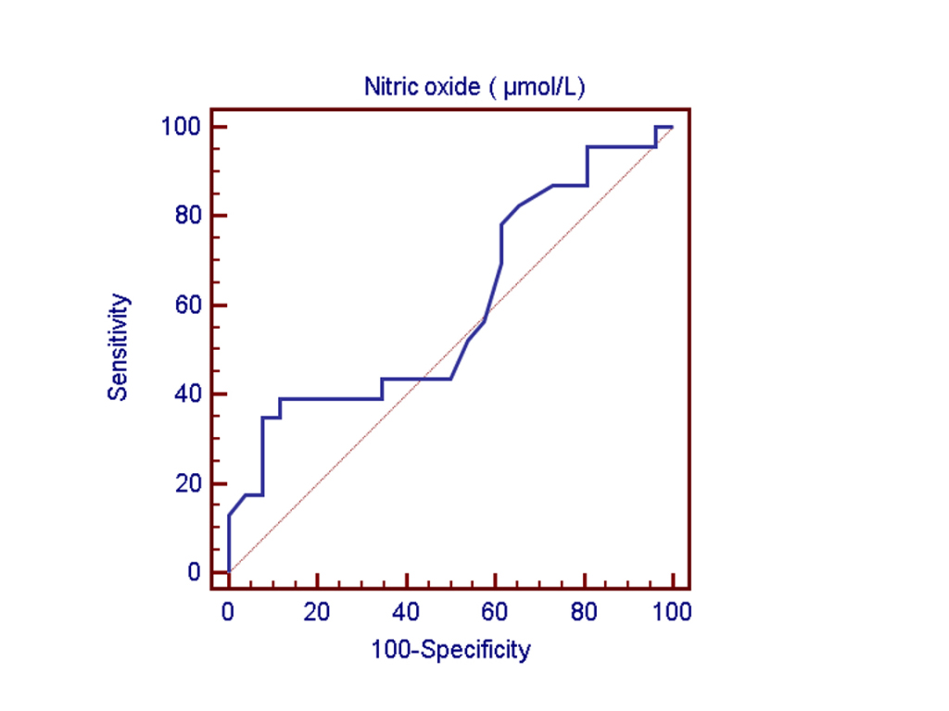
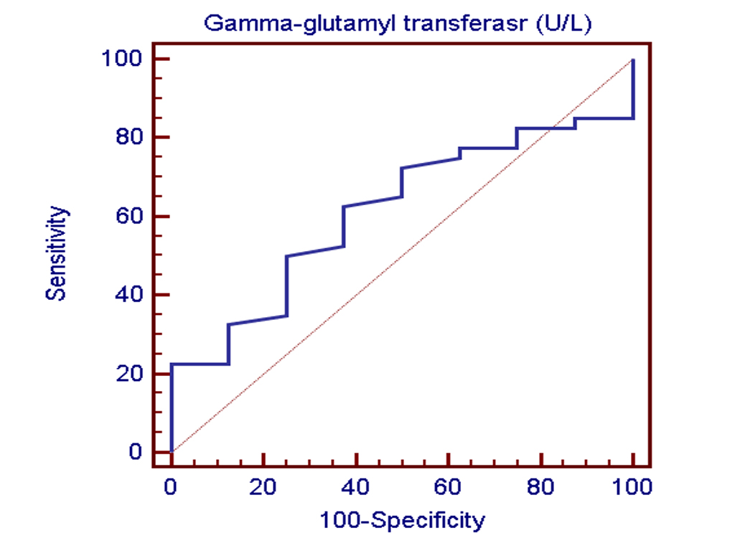
F1versus F2F3 F3 versus F1F2

Figure 2: Receiver operating characteristics curves testing ability of serum NO and GGT to differentiate between different fibrosis stages
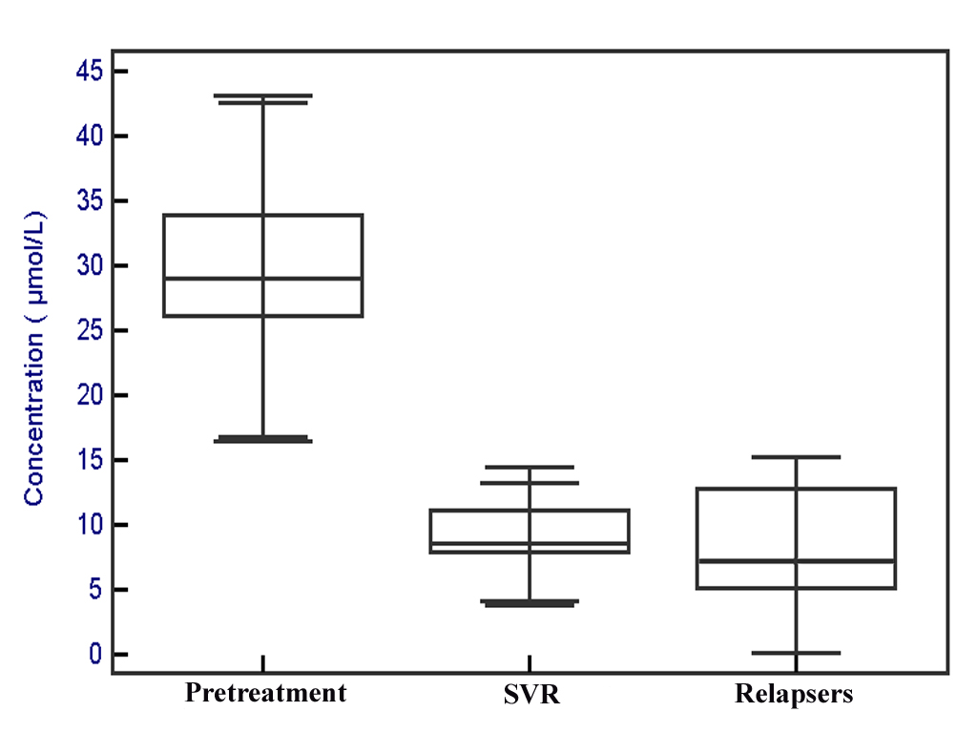
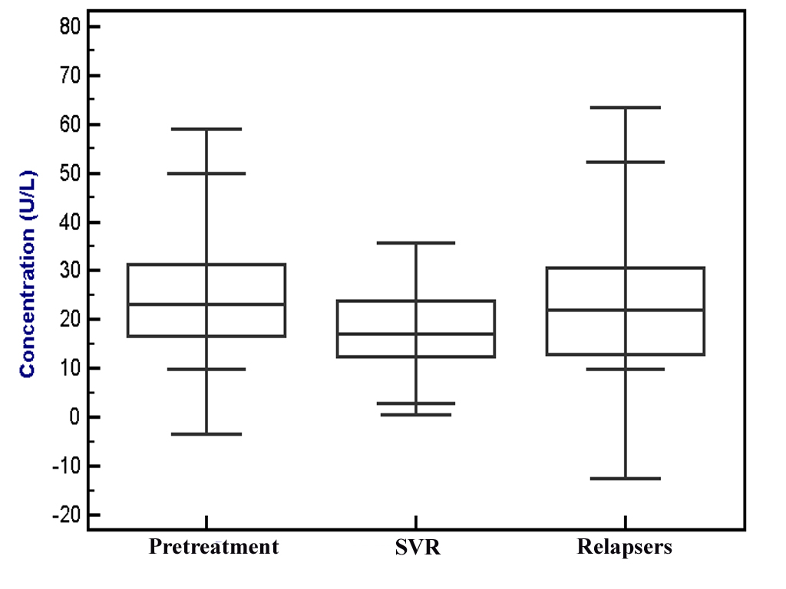

NO GGT

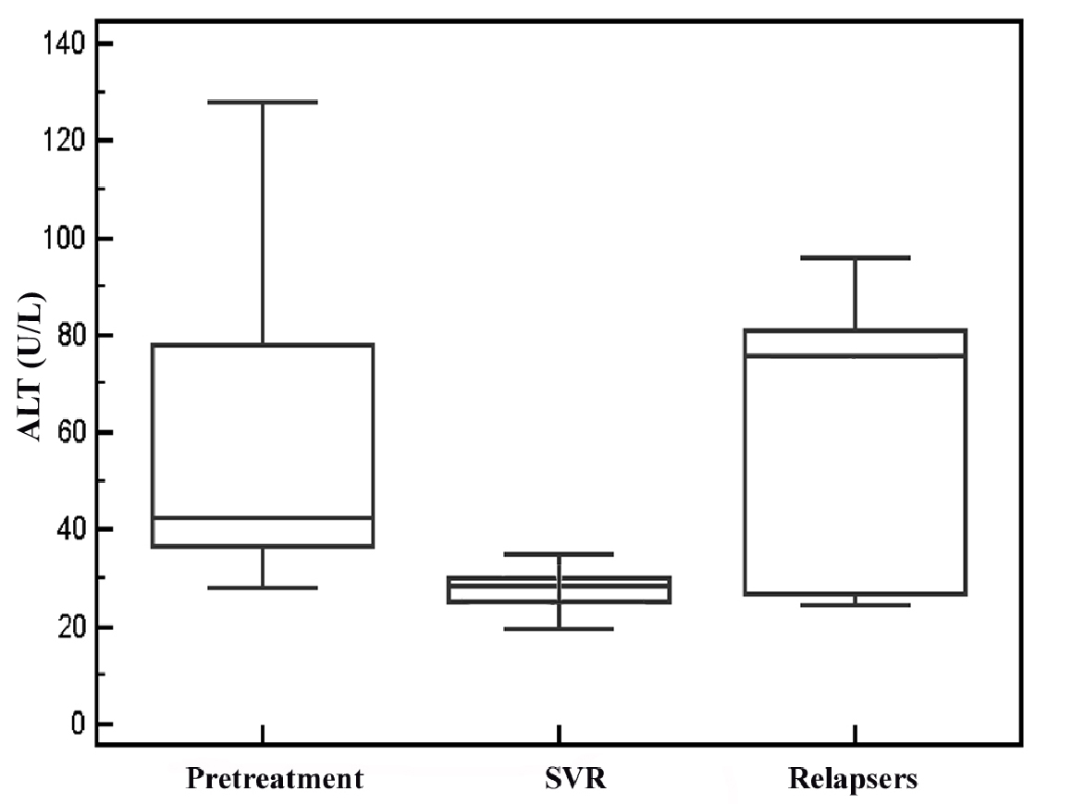
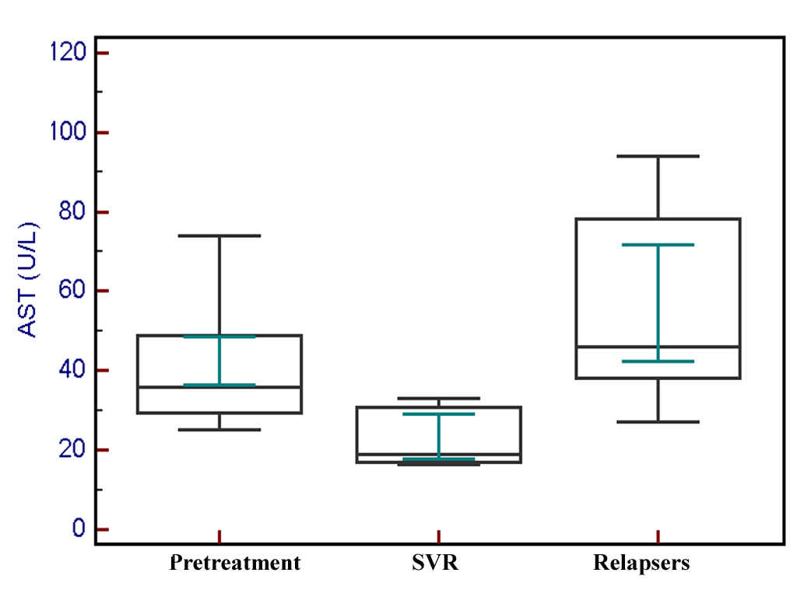

ALT AST

Figure 3: Evolution of serum NO (µmol/L), GGT (U/L), AST (U/L) and ALT (U/L) in pretreatment, sustained virological response and relapsers groups of HCV patients groups who treated with INF

Relation between serum markers in different groups
As shown in table 4, there was a significant decrease in the serum NO, GGT and ALT/AST ration level in SVR and relapsers group (p = 0.0001 and 0.001 respectively). Also, the mean ALT and AST concentrations were decreased in SVR and increased again in the relapsers group (Fig. 3). Similarly, the GGT was decreased in SVR group and increased again in the relapsers group (table 4). The levels of these parameters was non significant in SVR groups when compared with relapser one.

DISCUSSION
Egypt has a high prevalence of HCV especially genotype 4a. Hepatitis C virus is a leading cause of hepatocellular carcinoma (HCC) and chronic liver disease in Egypt (Rahman et al., 2001 and Habib et al., 2001). The current standard therapy for HCV infection is a combination of pegylated interferon (IFN-alpha) parenterally administered once weekly and daily oral ribavirin, with an overall response rate of about 40 - 60% (Fried et al., 2002 and Gale et al., 2005). The response to combination therapy depends on several factors including the genotype of the virus, the serum level of HCV-RNA before treatment, fibrosis stage, and the host immune response (Fried et al., 2002 and McHutchison et al., 1999). Patients with slowly progressing fibrosis had better responses to IFN-α treatment than those with rapidly progressive fibrosis (Myers et al., 2003). Interestingly, several recent studies showed that pegylated IFN-α plus ribavirin treatment significantly reduced the rate of fibrosis progression in patients with chronic HCV (Poynard et al., 2000 and Poynard et al., 2002).
Previous studies reported a normal, increased or decreased nitrite concentration in the serum of patients with chronic HCV hepatitis (Hokari et al., 2005, Hokari et al., 2002 and Osman et al., 2007). The reason for these discrepancies remains to be explained. Ibrahim et al., 2010 reported that, a significant positive correlation between serum NO and virological response, serum NO being higher in responders to pegylated IFN-α plus ribavirin therapy than in non-responders. The presence of a natural variation in the immune response among patients is reflected on NO production. The patients who were able to produce NO in response to IFN-α plus ribavirin therapy represented the responders and vice versa. In line with this concept, Mihm et al., 1997 reported a significant variation in the serum nitrite levels among non treated chronic HCV patients and patients treated with IFN-based therapy. In our study, serum NO level was measured 6 months after INF therapy and in SVR as well as relapser and was increased in pretreatment group than the SVR and relapsers so this may due to the viral load on the liver that increases its production.
The mechanism of increased pre-treatment levels is unknown but may be related to IFN stimulated genes (ISGs). ISG-encoded proteins establish a general antiviral state within the cell (Sen, 2001). Interferons achieve their potent antiviral effects through the regulation of hundreds of IFN-stimulated genes (ISGs). Interferons induce ISG transcription by activating the Jak-STAT pathway (Darnell et al., 1994). Induction of ISGs was also found in pretreatment liver biopsies of many patients with chronic viral C hepatitis, again demonstrating that HCV infection can lead to activation of the endogenous IFN system (Chen, 2005).
Notably, patients with preelevated expression of ISGs tended to respond poorly to therapy when compared with patients with low initial expression (Chen, 2005). The cause of this differential response to therapy is not understood. Are patients with elevated initial expression refractory to further stimulation of ISGs by exogenous IFN? Does the administration of IFN to patients with low initial ISG values lead to ISG expression levels exceeding those found in the other group, possibly explaining a successful therapy in low-ISG patients? Are there specific ISGs important for viral clearance that are not activated in nonresponders? (Brodeskyet al., 2005). The elevated NO levels, on the contrary, are associated with better response to IFN therapy with the probability of the inverse relation between the ISGs and NO with regard to the antiviral response. Another study reported no role of NO in virological response to TNF- α in HCV patients because the levels of NO either in plasma or in extracts of liver tissue were varied minimally between responders and NR to INF-α monotherapy (George et al., 2003)..
At the molecular level, the antimicrobial activity of NO was originally thought to result from mutation of DNA, inhibition of DNA repair and synthesis, inhibition of protein synthesis, alteration of proteins by S-nitrosylation, ADP-ribosylation or tyrosine nitration, or inactivation of enzymes by disruption of Fe-S clusters, zinc fingers or haeme groups or by peroxidation of membrane lipids (Bogdan et al., 2000). The effect of either IFN-α and/or ribavirin on NO production is not clear. It has been found that IFN-α 2b treatment for HCV patients increased the blood mononuclear cell NOS enzyme activity and iNOS antigen and mRNA expression speculating that induced NO production may be related to the antiviral action(s) of IFN-α (Sharara et al., 1997). Another study reported that ribavirin lowered NO production and concluded that the increasing numbers of SR to IFN-α plus ribavirin combination over IFN-α monotherapy may be attributable to ribavirin’s prevention of IFN-α-mediated increase of NO in the milieu of cytotoxic lymphocytes (Kast, 2003). There is a shortage of data addressing the effect of combined drugs on NO production. A significant increase in total urinary nitrite concentration was reported in SR compared to relapsers in chronic HCV patients treated with IFN-α plus ribavirin (Stanzial et al., 2003). A recent study reported no change in serum NO (measured at the end of therapy) in SR compared with non treated patients (Lluch et al., 2009).
In our study, the decrease in the GGT, ALT and AST level in the SVR and relapsers groups indicates the antifibrotic effect of INF and better liver status.

Conclusion
Our results allowed us to hypothesize a role of NO in the efficacy of INF-α plus ribavirin therapy and the possible future consideration of researching an NO-based therapy to improve the therapeutic outcome of chronic HCV genotype-4 hepatitis.

Corresponding author:
Dr/ Hatem A. El-mezayen
Chemistry deparment, Helwan University
Cairo, Egypt
Mobile: 002 0100 5874449

REFERANCES
- Bedossa P, Albrecht J. Impact of interferon alfa-2b and ribavirin on progression of liver fibrosis in patients with chronic hepatitis C. HEPATOLOGY 2000;32:1131-1137.
- Bedossa P, Poynard T: An algorithm for the grading of activity in chronic hepatitis C. The METAVIR Cooperative Study Group. Hepatology 1996, 24(2):289-293
- Bogdan C, Rollinghoff M, Diefenbach A. Reactive oxygen and reactive nitrogen intermediates in innate and specific immunity. Curr Opin Immunol 2000; 12:64-76.
- Brodsky LI, Wahed AS, Li J, Tavis JE, Tsukahara T, Taylor MW. A novel unsupervised method to identify genes important in the anti-viral response: application to interferon/ribavirin in hepatitis C patients. PLoS ONE 2006;2:e584.
- Byeongwoo Ahn, Beom Seok Han, Dae Joong Kim and Hiroshi Ohshima. Immunohistochemical Localization of inducible nitric oxide synthase and 3-nitrotyrosine in rat liver tumor induced by N-nitrosodiethyleamine. 1999; 20(7): 1337-1344.
- Chen L, Borozan I, Feld J, et al. Hepatic gene expression discriminates responders and nonresponders in treatment of chronic hepatitis C viral infection. Gastroenterology 2005; 128:1437–1444.
- Darnell JE Jr, Kerr IM, Stark GR. Jak-STAT pathways and transcriptional activation in response to IFNs and other extracellular signaling proteins. Science 1994;264:1415–1421.
- Fried MW, Shiffman ML, Reddy KR, et al. Peginterferon alfa-2a plus ribavirin for chronic hepatitis C virus infection. N Engl J Med 2002; 347:975-982.
- Fried MW, Shiffman ML, Reddy KR, et al. Peginterferon alfa-2a plus ribavirin for chronic hepatitis C virus infection. N Engl J Med 2002; 347:975-982.
- Gale M Jr, Foy EM. Evasion of intracellular host defence by hepatitis C virus. Nature 2005; 436:939-945.
- George M, Baluch M, Van Thiel DH. Plasma and hepatic tissue levels of thrombomodulin, tissue factor, NFkappaB and nitric oxide in responders and nonresponders to IFN alpha therapy. J Viral Hepat 2003; 10:360-366.
- George M, Baluch M, Van Thiel DH. Plasma and hepatic tissue levels of thrombomodulin, tissue factor, NFkappaB and nitric oxide in responders and nonresponders to IFN alpha therapy. J Viral Hepat 2003; 10:360-366.
- Habib M, Mohamed MK, Abdel-Aziz F, et al. Hepatitis C virus infection in a community in the Nile Delta: risk factors for seropositivity. Hepatology 2001; 33:248-253.
- Hassan MI, Kassim SK, Ali HS, Sayed el DA, Khalifa A. Evaluation of nitric oxide (NO) levels in hepatitis C virus (HCV) infection: relationship to schistosomiasis and liver cirrhosis among Egyptian patients. Dis Markers 2002;18:137-142.
- Hokari A, Zeniya M, Esumi H, Ishikawa T, Kurasima Y, Toda G. Role of nitric oxide (NO) in interferon-alpha therapy for hepatitis C. J Infect 2005; 51:47-53.
- Hokari A, Zeniya M, Esumi H, Kawabe T, Gershwin ME, Toda G. Detection of serum nitrite and nitrate in primary biliary cirrhosis: possible role of nitric oxide in bile duct injury. J Gastroenterol Hepatol 2002; 17:308-315.
- Kast RE. Ribavirin in cancer immunotherapies: controlling nitric oxide augments cytotoxic lymphocyte function. Neoplasia 2003; 5:3-8.
- Lake-Bakaar G, Sorbi D, Mazzoccoli V. Nitric oxide and chronic HCV and HIV infections. Dig Dis Sci 2001; 46:1072-1076.
- Liang TJ, Rehermann B, Seeff LB, Hoofnagle JH. Pathogenesis, natural history, treatment, and prevention of hepatitis C. Ann Intern Med 2000; 132: 296-305.
- Lluch P, Cortina B, Vila JM , et al. Unchanged plasma levels of dimethylarginines and nitric oxide in chronic hepatitis C. Scand J Gastroenterol 2009; 44: 224-228.
- McHutchison JG, Poynard T. Combination therapy with interferon plus ribavirin for the initial treatment of chronic hepatitis C. Semin Liver Dis 1999; 19 Suppl 1:57-65.
- Mihm S, Fayyazi A, Ramadori G. Hepatic expression of inducible nitric oxide synthase transcripts in chronic hepatitis C virus infection: relation to hepatic viral load and liver injury. Hepatology 1997; 26:451-458.
- Mohamed Ibrahim, Wafaey Gomaa, Yehia Ibrahim, Hazem El Hadad, Mohamed Shatat, Ashraf Abdel Aleem, Mohamed Essawy, Yasser M Fouad . Nitric Oxide Levels and Sustained Virological Response to Pegylated-Interferon alpha2a plus Ribavirin in Chronic HCV Genotype 4 Hepatitis: a Prospective Study. 2010 Vol.19 No 4, 387-392
- Montgomery , H. A . C and Dymock, J . F . (1961) Analyst, 86, 414
- Moshage H, Kok B, Huizenga JR, Jansen PLM. Nitrite and nitrate determinations in plasma: a critical evaluation. Clin Chem 1995;41:892-896.
- Myers RP, Patel K, Pianko S, Poynard T, McHutchison JG. The rate of fibrosis progression is an independent predictor of the respons to antiviral therapy in chronic hepatitis C. J Viral Hepat 2003;10:16 –22.
- National Institutes of Health. (2002) Consensus Development Conference on Hepatitis C. Hepatology 36: S3_S120.
- Osman HG, Gabr OM, Lotfy S, Gabr S. Serum levels of bcl-2 and cellular oxidative stress in patients with viral hepatitis. Indian J Med Microbiol 2007; 25:323-329.
- Pata C, Yazar A, Altintas E, et al. Serum levels of intercellular adhesion molecule-1 and nitric oxide in patients with chronic hepatitis related to hepatitis C virus: connection fibrosis. Hepatogastroenterology 2003; 50:794-797.
- Persijin, JP and van der Slike, W. (1982): A new method for the determination of gamma glutamyletranspeptidase in serum. J. Clin. Chem. Clin, Biochem. 14: 421 – 427.
- potential noninvasive predictors of IFN treatment in patients with HCV
- Poynard T, McHutchison J, Davis GL, Esteban-Mur R, Goodman Z,
- Poynard T, McHutchison J, Manns M, Trepo C, Lindsay K, Goodman
- Rahman El-Zayadi A, Abaza H, Shawky S, Mohamed MK, Selim OE, Badran HM. Prevalence and epidemiological features of hepatocellular carcinoma in Egypt-a single center experience. Hepatol Res 2001;19:170-179.
- Reiss CS, Komatsu T. Does nitric oxide play a critical role in viral infections? J Virol 1998; 72:4547-4551.
- Sanz-Cameno P, Medina J, Garcia-Buey L, Garcia-Sanchez A, Borque MJ, Martin-Vilchez S, et al. Enhanced intrahepatic inducible nitric oxide synthase expression and nitrotyrosine accumulation in primary biliary cirrhosis and autoimmune hepatitis. J Hepatol 2002;37:723-9.
- Sen GC. Viruses and interferons. Annu Rev Microbiol 2001;55:255–281.
- Sharaby AF, Sharaf H, Zakaria MS: Immunomodulators, sFas and Fas-L as
- Sharara AI, Perkins DJ, Misukonis MA, Chan SU, Dominitz JA, Weinberg JB. Interferon (IFN)-alpha activation of human blood mononuclear cells in vitro and in vivo for nitric oxide synthase (NOS) type 2 mRNA and protein expression: possible relationship of induced NOS2 to the anti-hepatitis C effects of IFN-alpha in vivo. J Exp Med 1997; 186:1495-1502.
- Stanzial AM, Benoni G, Cuzzolin L, et al. Urinary nitrite/nitrate concentrations and total antioxidant capacity in patients with chronic hepatitis C in therapy with interferon and ribavirin. J Chemother 2003; 15:584-590.
- Tavares FN, Goncalves PL, Porto SA, Pereira FE, Ribeiro-Rodrigues R. Nitric oxide levels are not changed in saliva of patients infected with hepatitis C virus. Rev Soc Bras Med Trop 2005; 38:453-455.
- Trujillo-Murillo KDEL C, Garza-Rodriguez Mdel L, Martinez- Rodriguez HG, Barrera-Saldana HA, Bosques-Padilla F, Romos-Jimenez J and Rivas-Estilla AM (2004): Experimental models for hepatitis C virus (HCV): new opportunities for combating hepatitis C. Ann. Hepatol., 3(2):54-62.
- Z, Ling MH, et al. Impact of pegylated interferon alfa-2b and ribavirin on liver fibrosis in patients with chronic hepatitis C. Gastroenterology 2002;122:1303-1313.
- Zekri AR, Haleem HA, Esmat GE, Bahnassy AA, El-Din HM, Hafez MM,

10/10/2011

