Improving Herbicides Efficacy of Topik and Traxos on Wheat Plants and Associated Weeds by Adjuvants Arkopal

Tagour, R. M. H. ¹, G. M. Abd El-Hamed ¹ and I. M. EL-Metwally ²

¹Weed Research Central Laboratory, Agricultural Research Center, Giza, Egypt

²Botany Dept., National Research Center, Giza, Egypt
*im_elmetwally@yahoo.com

Abstract: Two field experiments were carried out during winter seasons of 2008/2009 and 2009/2010 at the Experimental Station of Agricultural Research Center, El-Serw Station Damietta Governorate, Egypt to study the effect of additives on the efficacy of Topik (Clodinafop-propargyl) and Traxos (Pinoxadin+Clodinafop+Safener) herbicides (with or without Arkopal N100) on weeds and wheat plants. The results indicated that all weed control treatments significantly reduced fresh, dry weight and caused significant increases in photosynthetic pigments after 75 days from sowing, yield, yield attributes and grain protein percent. In addition anatomical structure is a significant leaf dysfunction constitutes a part of the killing action of the specific herbicide on target weeds. Traxos at 500 cm³ tank-mixed with Arkopal N100 at 4 and 8 % followed by Topik at 140g tank-mixed with adjuvant at 4%, Traxos at 375 cm³ tank-mixed with adjuvant at 8%, Topik at 140 and 105g tank-mixed with adjuvant at 8%, Traxos at 375 cm³ and Topik at 126 g tank-mixed with adjuvant at 4% treatments, respectively recorded the highest reduction of weeds and recorded the highest values of photosynthetic concentrations as well as, increased significantly produced higher number of spike/ m², grain yield , straw yield, crop index and grain protein % when compared with unweeded control in both seasons. On the other side, the lowest effective on the other self characters were by using Traxos at 500 cm³ alone and Topik at 140g alone and hand weeding twice at 30 and 45 days after sowing respectively gave less effective when compared with all other treatments and unweeded control in both seasons. While, a non significant effect due to weed control treatments 1000 grain weight, phosphorus and potassium percentage in grain .
[Tagour, R. M. H., G. M. Abd El-Hamed and I. M. EL-Metwally Improving herbicides efficacy of Topik and Traxos on wheat plants and associated weeds by adjuvants Arkopal Nature and Science 2011; 9(11):176-183]. (ISSN: 1545-0740). http://www.sciencepub.net.

Keywords: herbicides; Topik Traxos; wheat plants; adjuvants Arkopal

1. Introduction
Increasing wheat grain yield is an important national goal to face the continuous increasing food needs of Egyptian population. Wheat production in Egypt increased from 2.08 in 1983 to 7.37 million ton in 2007. This increase was achieved by increasing wheat area from 1.83 to 2.71 million fed/year and grain yield from 1.50 to 2.71 ton / fed., (Aermae, 2007). Which is far below the yield level obtained in other wheat growing countries of the world like Germany (7.28 t ha⁻¹), Mexico (4.4 t ha⁻¹) and Egypt (6.25 ton ha⁻¹) (FAO, 2000).
Weed reduced crop yield through competition for moisture, nutrients, sunlight and space. Shad, (1987) reported that wheat grain yield losses due to weed interference accounted by 17-25 %. Moreover, during harvest and dockage this reflected on reducing quantity and/or quality and reducing the economic return. Nisha et al. (1999) pointed out reduction in wheat yield due to weed infestation reached to 30.7%. Campagna et al. (2008) stated that Traxos herbicide was selective and effective against the most important grasses weeds. While, Pourazar and Baghestani (2010) reported that clodinafop-propargyl had the best efficacy on the grassy weeds in wheat. Pinoxaden at 450 ml/ha plus adjuvant 0.5% is acted well with respect to grass weed control.
Several workers have demonstrated that the addition of adjuvants to herbicides caused an increase, a decrease or no change on the herbicidal efficacy (Walia and Gill, 1984). Adjuvants may also improve a herbicides efficacy so that the concentration or total amount of herbicide required to achieve a given effect is reduced (WSSA, 1982). Some adjuvants alter the formulation so that they more completely and evenly cover plant surfaces thereby keeping the herbicide contact with plant tissues rather than beading up and rolling off. Other increases the formulations penetration through the cuticles wax, cell walls and /or stomata openings. In some situations an adjuvant may enhance the formulations ability to kill the targeted species without harming other plants (i.e. enhance its selectivity (Hess and Foy 2000). In this way adding an appropriate adjuvant can lower total costs of weed control (Green, 1992; Green and Hazen, 1998 and Green, 2001)
Nonyl phenol and related compounds are used as surfactants (surface-active agents). Surfactants reduce the surface tension of water and form a bridge between two chemicals that don't readily mix (Witt, 1988). They are used to increase the amount of a spray solution that remains on leaf surfaces, to make the spray droplets stick better to the leaf (Cserhati, 1995). Nonyl phenol inhibited growth and caused a loss of chlorophyll in some weeds. On sometimes caused damage in the chloroplasts of these plants (the site of photosynthesis) (Prasad, 1989).
Thus the present work was conducted in order to evaluate the possibility improving activity of weed control through enhancing herbicidal efficiency, thereby reducing the recommended rate of Traxos and Topik with adjuvant (nonyl phenol polyglycol ether).

2. Materials and Methods:
Two field experiments were carried out during winter seasons of 2008/2009 and 2009/2010 in the Experimental Station of Agricultural Research Center, El-Serw, Station Damietta Governorate, Egypt.

Table ( 1) : Mechanical and chemical analyses of the Experimental soil
Particle size distribution |  |  |  |  | OM  % | Total  N  % | Available  N  ppm | Available  P  ppm | Available  K  ppm | PH of soil  Susp 1:25 | EC  ds/m  at 25cº
Coarse sand  % | Fine  sand  % | Silt  % | Clay  % | Texture
1.55 | 10.70 | 22.4 | 85.0 | Clayey | 1.20 | 0.038 | 8.30 | 32.0 | 520 | 8.7 | 3.6

The Experimental treatments can be described as follows:
1-Unweeded control
2- Hand weeding twice at 30 and 45 days after sowing (DAS).
3- Topik 15% WP at the rate of 140 g/fed.
4-Traxos 4.5% EC at the rate of 500 cm³/fed
5- Topik 15%WP at 140 g/fed tank- mixed with adjuvant Arkopal N100 at 4% of spray solution.
6- Topik 15%WP at 105 g/fed tank-mixed with adjuvant Arkopal N100 at 4% of spray solution.
7- Traxos 4.5%EC at 500 cm³/fed tank-mixed with adjuvant Arkopal N100 at 4% of spray solution.
8- Traxos 4.5%EC at 375 cm³/fed tank-mixed with adjuvant Arkopal N100 at 4% of spray solution.
9- Topik 15%WP at 140 g/fed tank-mixed with adjuvant Arkopal N100 at 8% of spray solution.
10- Topik 15%WP at 105 g/fed tank-mixed with adjuvant Arkopal N100 at 8% of spray solution.
11- Traxos 4.5%EC at 500 cm³/fed tank-mixed with adjuvant Arkopal N100 at 8% of spray solution.
12- Traxos 4.5%EC at 375 cm³/fed tank-mixed with adjuvant Arkopal N100 at 8% of spray solution.
The wheat grains variety Sakha-93 obtained from the Agriculture Research Center, Giza, and sown at rate of 60 kg/fed. Grains were sown in 15 November in both seasons. The Topik (Clodinafop-propargyl) herbicide alone or mixed with adjuvant Arkopal N100 (Nonly phenol polyglycol ether) treatments were application at 30 days after the first irrigation of wheat plants, while Traxos (Pinoxadin+clodinafop+safener) alone or mixed with adjuvant Arkopal N 100 (Nonyl phenol polyglycol ether) treatments were application after 15 days of the first irrigation of wheat using knapsack sprayer (200 liter water/fed). Topik and Traxos herbicides for control the annual grass in wheat fields. The experimental design was randomized complete blocks with three replications, plot area was 16 m² (4x4m). All the normal agricultural practices of growing wheat recommended for the region were followed. During the growing seasons, the following data were recorded:

A-Weeds:
Weeds were hand pulled 75 DAS from one square meter chosen at random from each plot, to determine number, fresh of total weeds. After drying at 70 ºC for 72 hours, dry weight of each group as well as total weeds was recorded.
B- Photosynthetic pigments:
Concentrations of photosynthetic pigments in wheat leaves (mg/g fresh weight) were determined in both seasons at 75 DAS from the flag leaf of stem. Pigments were extracted with 100% methanol according to Mackinney (1941).
C- Yield and yield attributes of wheat:
At harvest, samples of one square meter were taken randomly from the central area of each plot to determine the number of spike/ m² and weight of 1000 grain (grain index). All wheat plants of each plot were harvested to determined grain yield (ardab per feddan, one ardab = 155 kg and fed =0.42 ha)) and straw yield and crop index% (Grain yield /fed divided on Straw yield /fed).
D- Chemical composition of grain wheat:
Samples of grain were oven dried, grounded finely and stored for chemical analysis. The grounded materials were digested in sulphoric acid and hydrogen peroxide as described by A. O. A. C. (1980). Nitrogen was determined in grain yield and its values were multiplied by 5.70 to calculate protein content. Phosphorus and potassium percentages in grains were determined according to Cottenie et al. (1982).
E- Anatomical studies:
Samples specimens of weeds leaves (Polypogon monspeliensis) were taken at two weeks after herbicides application in the first season. The specimens were killed and fixed in FAA, dehydrated in alcohol series followed by xylene and embedded in paraffin wax (52-54 C.m.p.). Cross sections 15-20μm thick were prepared by a rotary microtome, stained in saffranin-light green combination, cleared in clove oil and mounted in Canada balsam Gerlach (1977). The sections were examined microscopically.
Statistical analysis: The data were statistically analyzed according to Snedecor and Cochran (1967).

3. Results and Discussion:
Two dominant grasses species accompanied with wheat plants in this work were: beard grass (polypogon monspeliensis,L.) (98%)) and canary grass (Phalaris minor Retz.) (2%). The previous finding indicates that the infestation of wheat fields with the two grasses creates a hard competition between them.

A - Weeds:
Data presented in Table (2) revealed that all weed control treatments decreased significantly the number, fresh and dry weights of total grass of wheat weeds as compared to the unweeded control at 75 DAS in both seasons. The highest efficiency in decreasing number fresh and dry weights of total grass weeds was obtained by Traxos at 500 cm³ tank-mixed with adjuvant at 4 and 8 % followed by Topik at 140 g tank-mixed with adjuvant at 4%, Traxos at 375 cm³ tank-mixed with adjuvant at 8% and Topik at 140 and 105 g tank-mixed with adjuvant at 8%, respectively. These treatments reduced dry weight of weeds than unweeded check by 85.5, 79.3, 78.2, 77.1, 76.0 and 74.9 % in the first season and 77.1, 75.8, 74.0, 73.5, 73.1 and 72.2 % in the second season, respectively. The high effectiveness of Topik and Traxos herbicides treatments against wheat annual grass weeds could be attributed to the high susceptibility of both grasses to the herbicidal activity of the two herbicides in the inhibition Acetyl Co Enzyme Carboxylase (ACCase), the enzyme catalyzing the first committed step in fatty acids synthesis. Inhibition of fatty acid synthesis presumably blocks the production of phospholipids used in building new membranes required for cell growth (WSSA, 1994). In addition, addition of adjuvants to herbicides had capacity to give synergistic herbicidal effects with herbicides used as reflected by the higher reduction in weed growth. The same conclusion was mentioned by Frabboni and Russo (2008), Campagna et al. (2008) and Pourazar and Baghestani (2010) they indicated that Traxos characterized activity against grasses, flexibility, selectivity on wheat and effective against the most important grasses weeds.

Table (2): Effect of weed control treatments on the total number, fresh and dry weight of weeds g/ m² after 60 days from sowing of wheat plants during 2008/2009 and 2009/2010 seasons
Characters  Treatments |  | Total  number  of weeds / m² |  | Total fresh  weight of weeds(g/ m²) |  | Total dry  weight of  weeds (g / m²)
 |  | 2008/9 | 2009/10 | 2008/9 | 2008/10 | 2008/9 | 2009/10
1-Unweeded control | - | 29.0 | 35.3 | 232.7 | 291.1 | 17.9 | 22.3
2-Hand weeding twice | - | 14.0 | 15.0 | 114.8 | 129.8 | 7.0 | 8.5
3-Topik WP 15% at 140 g / fed | - | 12.0 | 14.6 | 98.6 | 125.0 | 5.5 | 8.2
4- Traxos EC 4.5% at 500 cm³/ fed | - | 12.0 | 14.3 | 96.5 | 119.7 | 5.4 | 7.6
5- Topik WP 15% at 140 g / fed | 4% | 9.6 | 12.0 | 81.4 | 96.8 | 3.9 | 5.8
6- Topik WP 15% at 105 g / fed | 4% | 11.6 | 13.3 | 94.6 | 110.5 | 5.0 | 7.0
7- Traxos EC 4.5% at 500 cm³ / fed | 4% | 8.0 | 10.6 | 67.0 | 89.3 | 2.6 | 5.1
8- Traxos EC 4.5% at 375 cm³/ fed | 4% | 11.0 | 13.0 | 93.4 | 109.8 | 4.8 | 7.0
9- Topik WP 15% at 140 g / fed | 8% | 10.3 | 11.6 | 87.4 | 98.6 | 4.3 | 6.0
10- Topik WP 15% at 105 g / fed | 8% | 11.6 | 12.3 | 88.6 | 102.3 | 4.5 | 6.2
11- Traxos EC 4.5% at 500 cm³ / fed | 8% | 9.3 | 11.0 | 78.4 | 93.6 | 3.7 | 5.4
12- Traxos EC 4.5% at 375 cm³ / fed | 8% | 10.3 | 11.3 | 85.1 | 97.2 | 4.1 | 5.9
L.S.D. at 5% |  | 1.90 | 1.92 | 10.55 | 12.67 | 0.86 | 1.18

Overall, pinoxaden at 375 ml/ha plus adjuvant 0.5% is acted well with respect to grass weed control. Strachan (1995), Singh (2004), Muhammad et al. (2007), Delchev (2008), Khalid et al. (2009), Zhu et al. (2010), Haile and Girma (2010) and Pourazar and Baghestani (2010) indicated that clodinafop-propargyl had the best efficacy on the grass in wheat field. Also, Strachan (1995) found that the recommended dose of the adjuvant Topik had a primarily impact on the grass weeds in wheat. In addition, addition of adjuvants to herbicides Traxos and Topik at any rates in this work can improve a herbicides efficacy and keeping the herbicides contact with plant tissues rather than beading up and rolling off. The present results are in general agreement with those of Kucharski et al. (2009) and Knezevic et al. (2009 and 2010) they indicated that the application of herbicides with adjuvants caused increase in weed control efficacy in comparison with herbicides used alone.

B- Photosynthetic pigments:
Data presented in Table (3) indicated that the three photosynthetic pigments were responded significantly to all herbicidal treatments, compared with unweeded treatment at 75 DAS in both seasons.
Table (3) showed that weed control treatments increased significantly the concentrations of chlorophyll (a), chlorophyll (b), chlorophyll (a+b) and carotenoids in comparison with unweeded control in both seasons. The highest values of photosynthetic concentrations were obtained with Traxos at 500 cm³ tank-mixed with adjuvant at 4 and 8 % followed by Topik at 140 g tank-mixed with adjuvant at 4%, Traxos at 450 cm³ tank-mixed with adjuvant at 8 % and Topik at 126 g tank-mixed with adjuvant at 8 % treatments, respectively.
On the other side, the lowest values of photosynthetic concentrations of chlorophyll (a), chlorophyll (b), chlorophyll (a+b) and carotenoids (mg/g fresh weight ) of wheat plants recorded Traxos at 500 cm³ alone and Topik at 140g alone as well as unweeded control in both seasons. These results are in harmony with those obtained by Gaweesh et al. (1992) who indicated that the herbicide significantly increased the content of chlorophyll ( a and b ) of wheat blades and carotenoids in tissues of wheat flag leaves. While, Mosalem and Shady (1992) mentioned that the herbicide had significant effect on dry matter accumulation, leaf area index, chlorophyll (a and b) in wheat plant. Competition between weeds and wheat plants caused a growth reduction of wheat plants because of an insufficient supply of water, nutrients and light. Photosynthetic pigments are the important growth parameters in wheat plants. The various physiological and biochemical processes affected herbicides, among these processes photosynthetic (Rao, 1981).

Table (3): Effect of weed control treatments on photosynthetic pigments concentration (mg/g fresh weight) of wheat plants at 75 days from wheat sowing ( 2008/2009 and 2009/2010 seasons).
Characters  Treatments |  | Chlorophyll  (a) |  | Chlorophyll  (b) |  | Chlorophyll  (a +b) |  | Carotenoids
 |  | 2008/9 | 2009/10 | 2008/9 | 2009/10 | 2008/9 | 2009/10 | 2008/9 | 2009/10
1-Unweeded control | - | 1.13 | 1.27 | 0.40 | 0.45 | 1.54 | 1.90 | 0.14 | 0.17
2-Hand weeding twice | - | 1.85 | 1.95 | 0.41 | 0.46 | 2.26 | 2.41 | 0.17 | 0.19
3-Topik WP 15% at 140 g / fed | - | 2.00 | 2.03 | 0.45 | 0.48 | 2.42 | 2.50 | 0.18 | 0.21
4- Traxos EC 4.5% at 500 cm³/ fed | - | 2.09 | 2.24 | 0.55 | 0.48 | 2.64 | 2.73 | 0.20 | 0.24
5- Topik WP 15% at 140 g / fed | 4% | 2.72 | 2.73 | 0.78 | 0.93 | 3.50 | 3.69 | 0.37 | 0.50
6- Topik WP 15% at 105 g / fed | 4% | 2.22 | 2.38 | 0.62 | 0.62 | 2.84 | 3.00 | 0.25 | 0.31
7- Traxos EC 4.5% at 500 cm³ / fed | 4% | 2.87 | 2.92 | 0.91 | 1.05 | 3.74 | 3.98 | 0.45 | 0.55
8- Traxos EC 4.5% at 375 cm³/ fed | 4% | 2.53 | 2.50 | 0.63 | 0.69 | 3.16 | 3.19 | 0.28 | 0.32
9- Topik WP 15% at 140 g / fed | 8% | 2.58 | 2.65 | 0.68 | 0.77 | 3.26 | 3.43 | 0.34 | 0.43
10- Topik WP 15% at 105 g / fed | 8% | 2.55 | 2.61 | 0.64 | 0.77 | 3.19 | 3.39 | 0.28 | 0.36
11- Traxos EC 4.5% at 500 cm³ / fed | 8% | 2.87 | 2.84 | 0.79 | 0.97 | 3.66 | 3.81 | 0.43 | 0.50
12- Traxos EC 4.5% at 375 cm³ / fed | 8% | 2.67 | 2.68 | 0.74 | 0.88 | 3.41 | 3.56 | 0.35 | 0.45
L.S.D. at 5% |  | 0.99 | 1.03 | 0.18 | 0.22 | 1.06 | 0.74 | 0.06 | 0.11

C- Yield and yield attributes of wheat:
Results in Table (4) indicated that all weed control treatments increased significantly the number of spike/m², grain and straw yield and crop index percentage over the unweeded control, except crop index in both seasons. However, the highest increase in number of spike/m², grain and straw yield/fed and crop index were obtained with Traxos at 500 cm³ tank-mixed with adjuvant at 4 or 8 % comparison with unweeded control in both seasons. Traxos at 500 cm³ tank-mixed with adjuvant at 4 and 8 %, Topik at 140 g tank-mixed with adjuvant at 4%, Traxos at 375 cm³ tank-mixed with adjuvant at 8 %, Topik at 140 g tank-mixed with adjuvant at 8 % treatments gave the highest values of grain yield /fed. The increment in grain yield/fed over the unweeded check due to superior treatments were amounted by 73.7 and 67.7% in the first season and 71.8 and 69.9 in the second season, respectively. While the lowest values of the previous characters were recorded with Topik at 140 g alone and Traxos at 500 cm³ alone after unweeded control in both seasons. Such as superiority for Traxos and Topik with adjuvant treatments mainly due to the higher weed control efficiency then the competition ability of weeds was poor which gave a competitive advantage to the wheat plants in utilizing the necessary demands of nutrients and water, leading to increasing the wheat growth resulted in the higher grain and straw yield as well as the crop index. The results of the present investigation are in harmony with those obtained by Rapparini and Giminani (2008), Frabboni and Russo (2008) and Campagna et al. (2008) they reported that the Traxos herbicide markedly produced higher grain and straw yield of wheat compared to unweeded control. Meanwhile, Walia et al. (2003), Muhammad et al. (2007), Delchev (2008), Khalid et al. (2009), Pourazar and Baghestani (2010), Zhu et al. (2010) and Haile and Girma (2010) indicated that the Topik herbicide gave high grain yield with highest stability in wheat. However, Kucharski et al. (2009), Knezevic et al. (2009) and Knezevic et al. (2010) who indicated that application of herbicides with adjuvants caused the increase of yield in comparison with plots treated with herbicide alone.

D- Chemical composition of wheat grains:
As shown in Table (5) all weed control treatments had insignificant effect on all chemical traits except crude protein percentage of wheat grain in both seasons. The highest values of crude protein of grain percentage were obtained by Traxos at 500 cm³ tank-mixed with adjuvant at 4 and 8 %, followed by Topik at 140 g tank-mixed with adjuvant at 4%, Traxos at 375 cm³ tank-mixed with adjuvant at 8%, Topik at 140 and 105 g tank-mixed with adjuvant at 8%, respectively in compared with unweeded control in both seasons.

Table (4): Effect of weed control treatments on wheat yield and its attributes ( 2008/2009 and 2009/2010 seasons).
Characters  Treatments |  | Number  of  spike/m² |  | Weight of  1000  grain (g) |  | Grain  yield  (ardab/ fed). |  | Straw  yield  (ton/ fed) |  | Crop  index  %
 |  | 2008/9 | 2009/  10 | 2008/9 | 2009/  10 | 2008/9 | 2009/  10 | 2008/9 | 2009/  10 | 2008/9 | 2009/  10
1-Unweeded control | - | 314.0 | 316.6 | 34.5 | 33.9 | 10.68 | 10.77 | 3.19 | 3.14 | 50.25 | 51.54
2-Hand weeding twice | - | 337.0 | 334.0 | 39.8 | 38.1 | 14.78 | 14.66 | 3.33 | 3.33 | 66.47 | 66.0
3-Topik WP 15% at 140 g / fed | - | 340.0 | 341.3 | 37.7 | 37.1 | 15.42 | 15.50 | 3.38 | 3.39 | 68.31 | 68.55
4-Traxos EC 4.5% at 500 cm³/ fed | - | 341.0 | 343.0 | 38.1 | 37.6 | 15.75 | 15.84 | 3.40 | 3.42 | 69.51 | 69.24
5-Topik WP 15% at 140 g / fed | 4% | 352.0 | 355.3 | 40.0 | 40.4 | 17.28 | 17.57 | 3.51 | 3.52 | 73.87 | 74.30
6-Topik WP 15% at 105 g / fed | 4% | 346.0 | 343.3 | 38.8 | 38.4 | 15.77 | 15.99 | 3.43 | 3.45 | 70.38 | 69.44
7-Traxos EC 4.5% at 500 cm / fed | 4% | 363.6 | 362.6 | 41.6 | 41.1 | 18.55 | 18.50 | 3.66 | 3.65 | 76.02 | 76.00
8- Traxos EC 4.5% at 375 cm³/ fed | 4% | 347.0 | 347.0 | 39.7 | 39.2 | 16.34 | 16.60 | 3.44 | 3.47 | 71.26 | 69.85
9-Topik WP 15% at 140 g / fed | 8% | 348.3 | 348.6 | 40.4 | 40.0 | 17.01 | 17.09 | 3.49 | 3.49 | 73.47 | 73.31
10-Topik WP 15% at 105 g / fed | 8% | 348.0 | 348.3 | 39.8 | 39.4 | 16.76 | 16.71 | 3.47 | 3.48 | 72.05 | 72.15
11-Traxos EC 4.5% at 500 cm/ fed | 8% | 354.6 | 357.0 | 41.3 | 40.8 | 17.91 | 18.03 | 3.60 | 3.56 | 74.53 | 75.89
12-TraxosEC 4.5% at 375 cm / fed | 8% | 350.0 | 351.0 | 40.4 | 40.0 | 17.20 | 17.33 | 3.50 | 3.51 | 73.58 | 74.05
L.S.D. at 5% |  | 15.86 | 11.27 | N.S | N.S | 0.76 | 0.54 | 0.12 | 0.09 | 3.38 | 2.45

These results may be due to the less competition for nutrients, water and light through limiting weeds infestation with herbicidal treatments due to increasing uptake of different nutrients. On the other side, the lowest values of crude protein of grain were obtained in unweeded treatment in both seasons. The same conclusion was mentioned by Gaweesh et al. (1992) whom indicated that herbicide significantly increased the content of chlorophyll (a and b) per unit area of wheat blades and carotenoids in tissues of wheat flag leaves. These results increased the mobilization of protein stored in leaves and stems and also, promoted translocation of the nitrogenous degradation compounds towards the grain. While, El-Metwally (2002) found that all weed control treatments significantly increased the crude protein percentage in wheat grain.

Table (5) Averages of crude protein, phosphorus and potassium percentages in wheat grains as affected by weed control treatments (2008/2009 and 2009/2010 seasons).
Characters  Treatments |  | Crude protein  % |  | Phosphorus  % |  | Potassium  %
 |  | 2008/9 | 2009/10 | 2008/9 | 2008/10 | 2008/9 | 2009/10
1-Unweeded control | - | 8.35 | 8.46 | 0.189 | 0.190 | 0.546 | 0.545
2-Hand weeding twice | - | 8.41 | 8.50 | 0.192 | 0.194 | 0.552 | 0.550
3-Topik WP 15% at 140 g / fed | - | 8.49 | 8.53 | 0.195 | 0.194 | 0.565 | 0.554
4- Traxos EC 4.5% at 500 cm³/ fed | - | 9.64 | 9.95 | 0.192 | 0.195 | 0.561 | 0.558
5- Topik WP 15% at 140 g / fed | 4% | 10.85 | 10.96 | 0.205 | 0.206 | 0.602 | 0.599
6- Topik WP 15% at 105 g / fed | 4% | 10.08 | 10.20 | 0.202 | 0.202 | 0.574 | 0.577
7- Traxos EC 4.5% at 500 cm³ / fed | 4% | 11.42 | 11.31 | 0.208 | 0.204 | 0.605 | 0.604
8- Traxos EC 4.5% at 375 cm³/ fed | 4% | 10.12 | 10.33 | 0.206 | 0.203 | 0.561 | 0.579
9- Topik WP 15% at 140 g / fed | 8% | 10.42 | 10.59 | 0.207 | 0.203 | 0.597 | 0.592
10- Topik WP 15% at 105 g / fed | 8% | 10.26 | 10.48 | 0.206 | 0.204 | 0.585 | 0.585
11- Traxos EC 4.5% at 500 cm³ / fed | 8% | 11.23 | 11.26 | 0.207 | 0.204 | 0.603 | 0.601
12- Traxos EC 4.5% at 375 cm³ / fed | 8% | 10.76 | 10.88 | 0.205 | 0.202 | 0.601 | 0.598
L.S.D. at 5% |  | 0.91 | 0.99 | NS | NS | NS | NS

E- Anatomical structure of Polypogon monspeliensis leaf:
Figure (1) shows the effect of herbicides on leaf anatomy of Polypogon monspeliensis weed. Traxos at 500 cm³ or Topik at 140 g tank-mixed with adjuvant 4% adversely affect the anatomical structure of Polypogon monspeliensis leaves. Therefore, it could be concluded that a significant leaf dysfunction constitutes a part of the killing action of the specific herbicide on target weeds. With impaired photosynthetic capacity due to a reduced mesophyll volume and photosynthates translocation as a result of reduced treachery elements, the weed thus become more susceptible to the action of the herbicide.
In the senescent stage, treachery elements were found to be more severely-affected in Traxos at 500 cm³ and Topik at 140g tank-mixed with adjuvant 4% treated leaves. Same observations were noticed by Saad El-Din et al.(2003) it is realized that spraying of weed plants with the herbicide resulted in abnormal leaves where the thickness of midvein was decreased by 39.9% blow the control. The midvein of such treatment had one small vascular bundle against three normal vascular bundles in control plant. Moreover, the diameter of vessels was decreased by 22.1% blow the control.
It could be concluded that application of Traxos at 500 cm³ tank-mixed with adjuvant at 4 and 8 % followed by Topik at 140g tank-mixed with adjuvant at 4%, Traxos at 375 cm³ tank-mixed with adjuvant at 8%, Topik at 140 and 105g tank-mixed with adjuvant at 8%, Traxos at 375 cm³ and Topik at 105 g tank-mixed with adjuvant at 4% treatments, respectively increased to efficacy control and recorded the highest values of photosynthetic concentrations as well as, increased significantly the number of spike/ m², grain yield and straw yield/fed, crop index and crude protein in grains.

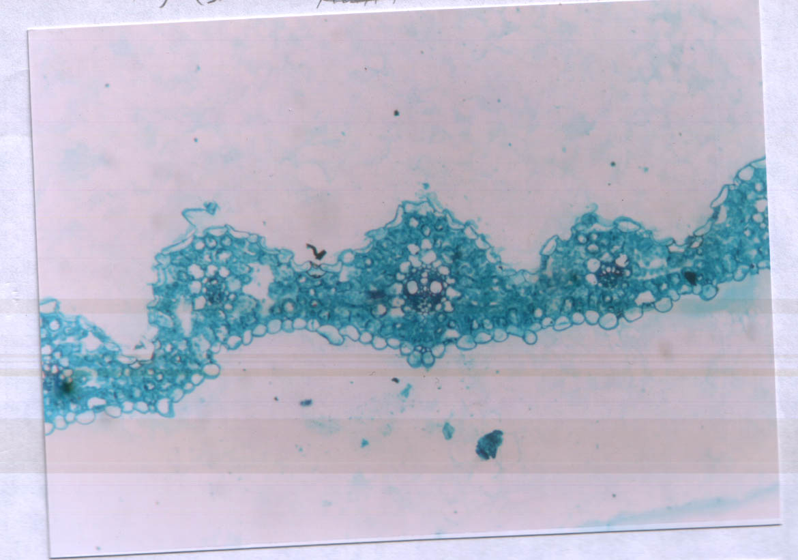
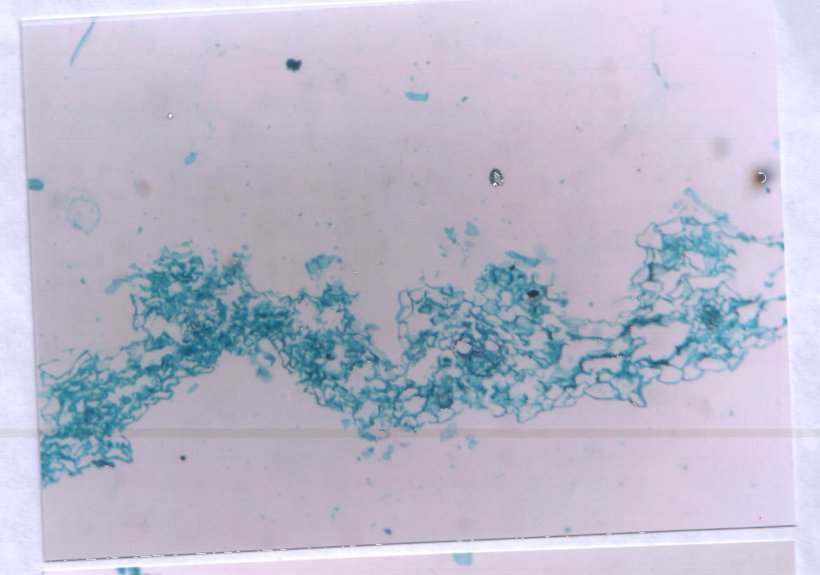
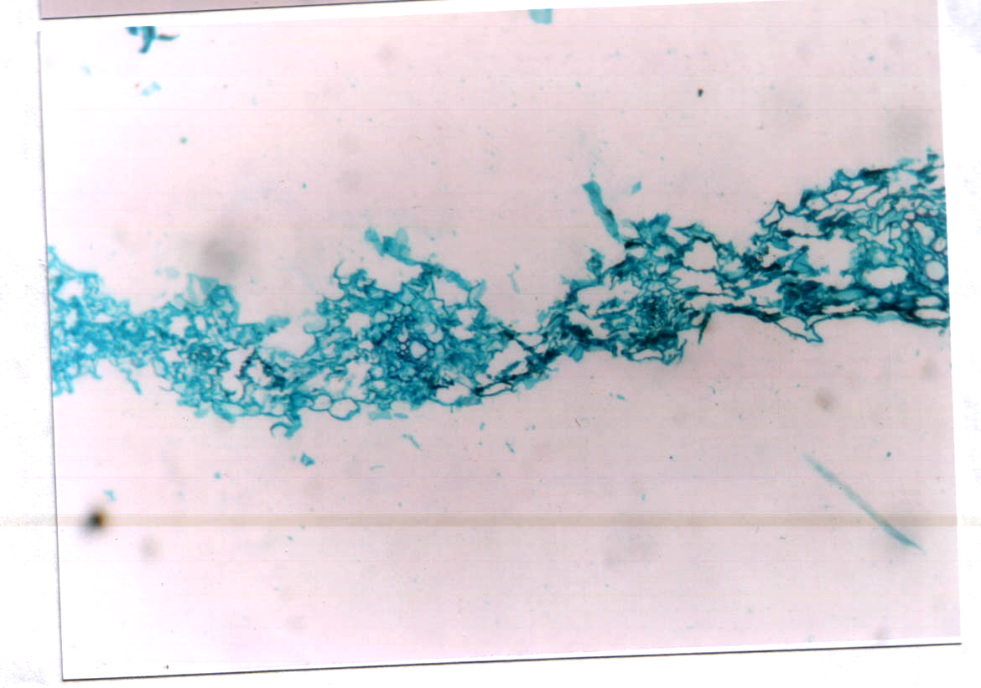
ogo
P
M
P
X
M

(a)
(b)
(c)

Figure (1): Cross sections in Polypogon monspeliensis leaves. (a), control ; (b), Traxos at 500 cm³ with 4% adjuvants-treated in the pre-death of leaves ; (c), Topik at 140 g with 4% adjuvants-treated in the pre-death of leaves. M, mesophyll ; P, phloem ; X, xylem. All X100.

Corresponding author

I. M. EL-Metwally

Botany Dept., National Research Center, Giza, Egypt
im_elmetwally@yahoo.com

References:

Aermae (2007). Agricultural Economic Report Ministry of Agriculture, Egypt.
A. O. A. C. (1980). Association of official agriculture chemists “Official methods of analysis” 13 th Ed. Washington, Dc, USA.
Campagna, C.; F. Berta and A. lari (2008). Traxos: new grass killer herbicide for post-emergence application in wheat. Giornate Fitopatologiche 2008, Cervia (RA), 12-14 marzo, 1: 383-390.
Cottenie, A.; M. Verloo; L. Kiekens; G. Velghe and Camerlynck (1982). Chemical analysis of plant and soils. Lab. Agrochem. State Univ., Ghent, Belgium. Pp. 15-17.
Cserhati, (1995). Alkyl ethoxylated and alkylphenol ethoxylated nonionic surfactants: Interaction with bioactive compounds and biological effects. Environ. Health Persp, 103 : 358-364.
Delchev, G. (2008). Changes in selectivity and stability of some herbicides in durum wheat under the influence of different meteorological condition. Rastenie'dni Nauki, 45 (6) : 554-558.
EL-Metwally, I. M. (2002). Performance of some wheat cultivars and associated weeds to some weed control treatments. Zagazig J. Agric. Res. (Egypt) 29 (6): 1907- 1927.
FAO. (2000). FAO Production Year Book, 54: 74-75.
Frabboni, L. and V. Russo (2008). Efficacy of pinoxaden in southern areas. Informatore Agrario, 64 (5): 77.
Gaweesh, S. S. M.; F. E. M. EL-Quesni and S. H. EL-Gayar (1992). Effect of foliar application with Bromoxynil, micro nutrients and gibberllic acid on associated weeds, growth, yield and chemical composition of wheat. Bull Fac. of Agric. Univ. of Cairo, 43 (3): 895 – 916.
Gerlach, D. (1977). Botanische mikrotechnik. Eine Einführung Thieme Verlag, Stuttgart, Germany.
Green, J. M.(1992). Increasing efficiency with adjuvants and herbicide mixtures. Proc. of the First Intern. Weed Control Congress. Melbourne. AU., 187-192.
Green, J. M. and J. I. Hazen (1998). Understanding and using adjuvants properties to enhance pesticide activity. In: McMullan. P. M. (ed.) Adjuvants for agrochemicals: Challenges and Opportunities. Proceedings of the Fifth International Symposium for Agrochemicals. Chemical Producers Distributors Association. Memphis. 1N., 25-36.
Green, J. M. (2001). Herbicide adjuvants. In: UC Davis WRIC Weed Science School. September, 26-28. 2001. Woodland. CA.
Haile, D. and F. Girma (2010). Integrated effect of seeding rate, herbicide dosage and application timing on durum wheat (Triticum aestivum L. var Durum) yield, yield components and wild oat (Avena fatua L.) control in South Eastern Ethiopia. Momona Ethiopian J. Sci., 2 (2) : 12-26.
Hess, F. D. and C. L. Foy (2000). Interaction of surfactants with plant cuticles. Weed Techn., 14:807-813.
Khalid U.; L. Abbas and M. A. Khan (2009). Impact of physical and chemical weed control on wheat yield and yield components. Pakistan J. of Weed Sci.Res., 15 (4) : 237-243.
Knezevic, S. Z.; A. Datta; J. Scott and L. D. Charvat (2009). Adjuvants influenced saflufenacil efficacy on fall-emerging weeds. Weed Techn., 23 (3): 340-345.
Knezevic, S. Z.; A. Datta; J. Scott and L. D. Charvat (2010). Application timing and adjuvant type affected saflufenacil efficacy on selected broadleaf weeds. Crop Prot., 29 (1) : 94-99.
Kucharski, M.; B. Naraniecki, and K. Domaradzki (2009). Oxyethylated glycerol fraction from biodiesel fuel system as ecological adjuvant material for herbicides. Progress in Plant Prot., 49 (2): 900-903.
Mackinney, G. (1941). Absorption of light by chlorophyll solution. J. Biol. Chem., 140: 315 – 322.
Mosalem, M. E. and M. F. Shady (1992). Effect of weed control and nitrogen fertilization under different plowing on wheat (Triticum aestivum L). Proc. 5th Conf. Agron., Zagazig, 13-15 Sep., 2 : 1084-1097.
Muhammad, A.; H. Manzoor; H. Ghulam and Abdul Rashid (2007). Efficacy of different herbicides for weed control in wheat crop. Pakistan J. Weed Sci. Res., 13 (1-2): 1-7.
Nisha, C.; S. Harpal; H. P. Tripathi; N. Chopra and H. Singh (1999). Critical period of weed crop competition in wheat (Triticum aestivum L). Indian J. of Weed Sci., 31 [3 – 4] : 151-154.
Pourazar, R. and N. A. Baghestani (2010). Investigating efficacy of Behpik and Current herbicides on grassy weeds in wheat fields of Khuzestan province. Proc. of 3rd Iranian Weed Science Congress, Vol., 2: key papers, weed management and herbicides, Babolsar, Iran, 17-18 February 2010 pp: 290-293.
Prasad, R. (1989). Effects of nonylphenol adjuvant on macrophytes. Chap. 6 in Chow, P.N.P. et al. (eds.) Adjuvants and agrochemicals Vol. 1. Mode of action and physiological activity. Boca Raton FL:CRC Press.
Rao, V. S. (1981). Principles of Weed Science (A Reference cum-Textbook) Oxford and EBH Publishing Co., New Delhi, Bombay, Calcutta.
Rapparini, G. and E. Giminiani, (2008). Two new graminicides in wheat and barley. Informatore Agrario, 64 (5): 74 -76.
Saad EL-Din, S. A.; S. H. El-Gayer and S. A. Mohamed (2003). The influence of adding morphactin to the herbicidal action of bromoxynil on the growth, chemical composition and anatomical structure of cherd plant. J. Agric. Sci. Mansoura Univ., 28(9): 6679-6689.
Shad, R. A. (1987). Status of weed science activities in Pakistan. Progressive Farming, 7 (1) : 10-16.
Singh, R. (2004). Influence of irrigation levels and diclofop-methyl on weed growth and yield of wheat (Triticum aestivum L.). Annals of Agric. Res. Indian, 25 (2): 306-311.
Snedecor, G. W. and W. G. Cochran (1967). Statistical Methods. Iowa State Univ., USA, Press, Ames 593.
Strachan, P. (1995). Topik- a new graminicides for cereals. Morley Bulletin, 97: 1-2.
Walia, U. S.; L. S. Brar and J. Seema (2003). Integrated effect of planting methods and herbicides on Phalaris minor and wheat. Indian J. of Weed Sci., 35 (3/4): 169 – 172.
Walia, U.S. and H. S. Gill (1984). Efficiency of substituted urea herbicides against Phalaris minor in wheat as influenced by surfactants. Indian J. of Weed Sci., 16 (4) : 255-261.
Witt, J. M. (ed.) (1988). Chemistry, biochemistry, and toxicology of pesticides. Corvallis, OR: Oregon State University Extension service.
WSSA (Weed Science Society of America) (1982). Adjuvants for Herbicides. Weed Science Society of America. Champaign. 144 pgs.
WSSA (Weed Science Society of America). (1994): Herbicide Handbook 7th Ed. Champaign, lllinois, USA.
Zhu, W. D.; H. Y. Hong; L. Lin; W. S. Hui and D. Zhao (2010). Control effect of the mixture herbicide of fluroxypyr with Topik or Puma super on weeds in wheat fields. J. of Triticeae Crops, 30 (4) : 778-782.

11/12/2011

