Simulation Based Analysis of Proactive and Reactive Protocols in MANET with Varying Packet Size

Tilak Raj ¹*, Himanshu Sharma ¹, Vikas Gahlot ²*

- Department of Electronics & Communication Engineering, M.M.U., Mullana, INDIA
- Department of Electronics & Communication Engineering, Mahabir Polytechnic Institute, Kurukshetra, INDIA
*tilakgoyal@gmail.com¹; vikasgahlot@gmail.com²

Abstract: - A mobile Adhoc Network (MANET) is a collection of wireless nodes that are capable of changing on a continual basis. These types of networks have no physical links between the nodes. It is a multihop process because of the limited transmission range of energy constrained wireless nodes. Thus in such a multihop network system each node (also known as router) is independent, self-reliant & capable of routing the packet over the dynamic network topology, therefore routing becomes very important and basic operation of adhoc network. Many routing protocol have been proposed & developed for accomplishing this task. The intent of this work is to study three adhoc routing protocols STAR, DSR and AODV based on IEEE 802.11 are surveyed & characteristic summary of these protocols is presented. The performances of above protocols are analysed on throughput, End to End delay by varying packet size on the basis of increasing nodes in the network using Qualnet 5.0.2 network simulator.
Nature and Science 2011;9(9):35-38]. (ISSN: 1545-0740). http://www.sciencepub.net.

Keywords: Simulation; Based Analysis; Proactive and Reactive Protocol; MANET

I. INTRODUCTION
A mobile adhoc network (MANET) [1] [2][3] is a collection of nodes which are able to connect on wireless medium forming an arbitrary and dynamic network. Adhoc networking is concept in computer communication, which means that users wanting to communicate with each other form a temporary network, without any form of centralized administration.
Each node participating in the network acts both as host and a router [4] and must therefore is willing to forward packets for other node. For this purpose, a routing protocol is needed.
An adhoc network has certain characteristics, which imposes new demands on the routing protocol. The most characteristics are the dynamic topology, which is a consequence of node mobility. Nodes can change position quite frequently, which means that using a routing protocol which quickly adapts topology changes. Many different approaches are reported to handle this problem in recent years, but it is very difficult to decide which one is best routing algorithm. It is also reported in the performance analysis of different routing protocol [5, 6 and 7] in literature.
In this work the comparison of STAR a table driven and AODV, DSR on demand routing protocol is analyzed, compared and presented. The performance of these protocols is analyzed with varying packet size and number of nodes in the networks by studying data throughput and end-to-end delay by using Qualnet 5.0.2 simulator [8].

A. Routing protocols: Classification in brief
Routing is the process of finding a path from a source to some arbitrary destination on the network. The broadcasting is inevitable and common operation in adhoc network. It consists of diffusing a message from a source node to all the nodes in the network. Broadcast can be used to diffuse information to the whole network. It is also used for route discovery protocols in adhoc network. The routing protocols can be categorized as proactive, reactive and hybrid according to the way the mobile hosts exchange routing information.
- Proactive or Table driven routing protocols
- Destination Sequenced Distance Vector routing (DSDV) [9].
- Source Tree Adaptive Routing (STAR).
- Reactive or On-demand routing protocols
- Ad-hoc On demand Distance Vector (AODV) [10].
- Dynamic Source Routing (DSR) [11].
- Hybrid Protocols
- Temporally Ordered Routing Algorithm (TORA) [14].
- Zone Routing protocol (ZRP) [15].
The proactive protocols also known as table driven protocol periodically disseminate routing information among all the hosts in the network, so that every host has the up-to date information for all possible routes. The reactive protocol also known as On-demand routing protocol operate on a need basis, discover and maintain only active routes that are currently used for delivery data packets. Hybrid routing protocols maintain a virtual routing infrastructure, apply proactive routing mechanism in certain region of a network and reactive routing in the rest of the network.

1. STAR- Source Tree Adaptive Routing:
STAR protocol for adhoc network is a proactive table driven routing protocol. The STAR [12] protocol is based on the link state algorithms. Each router maintains a source tree, which is a set of links containing the preferred paths to destinations. This protocol has significantly reduced the amount of routing overhead disseminated into the network by using a least overhead routing approach [LORA] to exchange routing information. It also supports optimum routing approach (ORA) is required. This approach eliminated the periodic updating procedure present in the link state algorithm by making update dissemination conditional. Therefore STAR will scale well in large network since it has significantly reduced the bandwidth consumption for the routing updated while at the same time reducing latency by using predetermined routes. However, this protocol may have significant memory & processing overheads in large and highly mobile networks[13], because each node is required to maintain a partial topology graph of the network, (it is determined from the source tree reported by its neighbours), which charge frequently may as the neighbours keep reporting different source trees.

2. AODV- Ad-hoc On Demand Distance Vector:
AODV is a reactive and “on-demand” routing protocol, the routes are established only when needed to reduce traffic load. AODV supports the unicast, broadcast and multicast scheme. AODV requires host to maintain only active routes. An active route is a route used to forward at least one packet within the past active time out period. When a host needs to reach a destination and does-not have an active route, it broadcasts a route request (RREQ), which is flooded in the network. A route can be determined when RREQ is received either by the destination itself or by an intermediate host with an active route to that destination. A route reply (RREP) is unicast back to the originator of RREQ to establish the route. Each host that receives RREQ caches a route back to the originator of the request, so that the RREP can be sent back. The main advantage of AODV protocol is that routes are established on demand and destination sequence numbers are used to find the latest route to the destination. The connection setup delay is less.

3. DSR- Dynamic Source Routing:
The Dynamic Source Routing belongs to the class of reactive (on demand) routing protocol based on the concept of source routing. This protocol allows nodes to dynamically discover a source route across multiple network hops to any destination. DSR has no periodic routing messages, thereby reduces the network bandwidth overhead conserving battery power and avoiding large routing updates throughout the ad-hoc network. The protocol consists of two major phases: Route Discovery & Route Maintenance.
When a mobile node wants to send a packet to its destination, it checks its route cache ether it has any route to the destination. If it has an unexpired route, it will use this route to send packet to the destination. Otherwise, it will initiate a route discovery procedure by broadcasting a route request (RREQ). Each node hears the route request packet, checks whether it knows the route to the destination. If it does-not it adds its own address to the route record of the packet & forwards the packet along its outgoing links.
A route reply is generated an either the route request reaches the destination itself or an intermediate node which contain in its route cache unexpired route to destination. If the node generating the route reply to the destination, it places the route record contained in the route request is to the route reply. If the responding node is the intermediate node, it will append its cached route to the route record and then generate route reply. To return the route reply, the responding node must have a route to the initiator.

II.SIMULATION SETUP
The Qualnet 5.0.2 simulator is used for the analysis. The IEEE 802.11 for wireless LAN’s is used as the MAC Layer protocol. In the scenario UDP (User Datagram Protocol) connection is used and over it data traffic of constant bit rate (CBR) is applied between source & destination. The numbers of nodes are raised to analyze the performance of AODV, DSR and STAR routing protocols.

Table1. Transmission Parameters
Parameter | Value
Area | 1500m x 1500m
Simulation Time | 60s
Channel frequency | 2.4 GHz
Data Rate | 2.4 Mbps
Path Loss Model | Two Ray Model
Mobility Model | Random way point
Packet Sizes | 256 bytes, 512 bytes, 1024 bytes
No. of nodes | 4,8,12,16,20

PERFORMANCE METRICS:
Throughput: - Throughput is the average rate of successful data packets received at destination. It is usually measured in bits per second (bit/s or bps) and sometimes in data packets per second.
End to End delay: - A specific packet is transmitting form source to destination and calculate the difference between send time and received time. Delays due to route discovery, queuing, propagation and transfer time are included in the delay metric.

III. SIMULATION RESULTS & DISSCUSSION
The Qualnet 5.0.2 network simulator is used to analyze the parametric performance of Dynamic Source Routing (DSR), Ad-hoc On-Demand Distance Vector Protocol (AODV) and Source Tree Adaptive Routing (STAR) routing protocols. The performance is analyzed with varying packet size, while rest of all other parameters like simulation time, area of network is kept constant. Traffic used is Constant Bit Rate (CBR) between source and destination. These results are shown in figures from 1 to 6.

Throughput: - With the varying number of nodes and packet size the throughput is analyzed. It is observed that for all the routing protocols throughput is constant from node 4 to 12 but in case of AODV and STAR it decreases sharply from node 12 to 20 for all packet size i.e. 256 bytes, 512 bytes and 1024 bytes as shown in fig. 1,2 and 3. The performance of STAR is similarly as that of AODV, but the performance of DSR is very good, throughput for this protocol is almost constant, whether the number of nodes is increasing.

End to End Delay: - When a packet is transmitted from source to destination it takes time to reach. From the nodes 0 to 12 the End to End delay increasing for all protocol in all packet sizes but in case of AODV it increases rapidly from node 12 to 16 and then decreases as shown in fig. 4,5 and 6. Overall End to End delay of DSR and STAR protocol is less as compared to AODV.

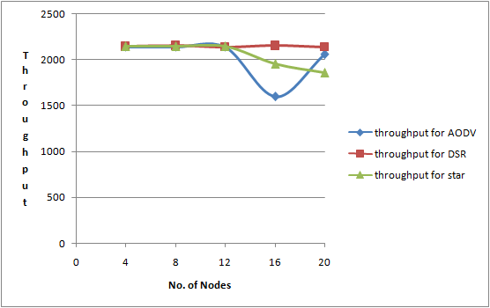
Fig.1 Throughput vs. No. of Nodes for packet sizes 256 bytes

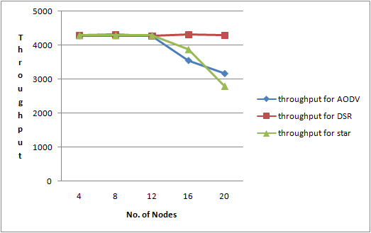Fig.2 Throughput Vs No. of Nodes for Packet sizes 512 bytes

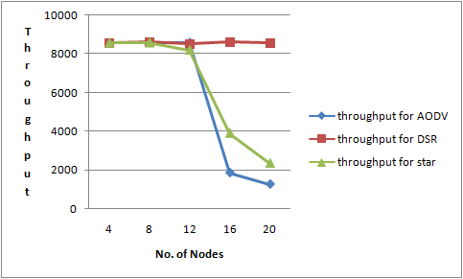
Fig. 3 Throughput Vs No. of Nodes for Packet sizes 1024 bytes

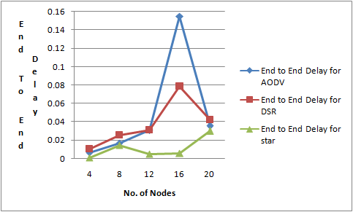Fig. 4 End to End Delay Vs No. of Nodes for Packet sizes 256 bytes

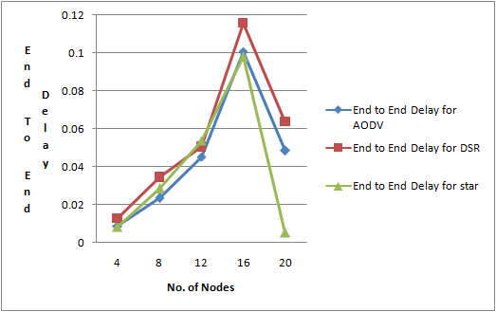
Fig. 5 End to End Delay Vs No. of Nodes for Packet sizes 512 bytes.

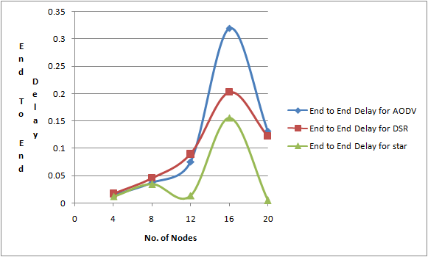
Fig. 6 End to End Delay Vs. No. of Nodes for Packet sizes 1024 bytes

IV. CONCLUSION
It is observed that DSR performs better then AODV and STAR in terms of throughput for all packet sizes i.e. 256 bytes, 512 bytes and 1024 bytes as shown in fig. 1,2 and 3. The throughput of AODV and STAR is decreases while in case of DSR it is constant. It is also observed that End to End delay in case of AODV is very high for all packet sizes. End to End delay of STAR protocol as shown in fig. 4, 5 and 6 is less as compared to DSR but its throughput is less as compared to DSR. So, by comparing both throughput and end to end delay DSR is more suitable protocol for routing purposes in MANET.

V. REFERENCES
- Imrich Chlamtae, Macro Conti, Jennifer J.-N. Liu. Mobile ad hoc networking: imperatives and challenges, School of Engineering, University of Texas at Dallas, Dallas, TX, USA, b Istituto IIT, Consiglio NAzionale delle Ricerche, Pisa, Itlay, c Department of Computer Science, University of Texas at Dallas, Dallas, TX, USA, Ad hoc Networks I (2003).
- Charles E. Perkins, “Mobile Ad-Hoc Networks”, Addison-Wesley, 2000.
- Elizabeth M.Royer, University of California, Santa BarbaraChai-Keong Toh, Georgia Institue of Technology, A Review of Current Routing Protocols for Ad Hoc Mobile Wireless Networks.
- C.-K. Toh. Ad hoc Mobile Wireless Networks: Protocols and Systems, Prentice Hall PTR. 2002:55-77.
- N.S. Yadav, and R.P Yadav, 2007, Performance , Comparison and Analysis of Table-Driven and On-Demand Routing Protocols for Mobile Ad-hoc Networks, International Journal of Information Technology, Vol.4 No. , pp 101-109.
- A.A Pirzada, C. McDonald, and A. Datta, 2006. Performance Comparison of Trust-Based Reactive Routing Protocols IEEE Transactions on Mobile Computing Vol. 5 No. 6 pp. 695-710.
- Elizabeth Belding, Royer, Routing approaches in mobile ad-hoc networks, in: S. Basagni, M. Conti, S. Giordano, I.Stojemenvoic (Eds), Ad Hoc Networking, IEEE Press Wiley, New York, 2003.
- Qualnet Simulator www.scalable-networks.com.
- Perkins C, Bhagwat P, “Highly Dynamic Destination- Sequenced Distance- Vector Routing (DSDV) Routing”, SIGCOMM’94 Computer Communication Review, vol 24, no. 4, p 234-244, October 1994.
- Layuan, Li Chunlin, Yaun Peiyan “Performance evaluation and simulation of routing protocols in ad hoc networks”, February 2007, Computer Communication.
- D. Johnson, Y. Hu, and D. Maltz. The Dynamic Source Routing Protocol (DSR) for Mobile Ad Hoc Networks for IPv4. RFC 4728 (Experimental), Feb. 2007.
- Parma Nand, Dr.S.C.Sharma, Rani Astya,”Traffic Load based Performance Analysis of DSR, STAR & AODV Adhoc Routing Protocol”. International Journal of Advanced Computer Science and Applications, vol.1 , no.4, October 2010.
- Vikas Gahlot, Rajender Kumar, Anuj Goel,” An Application Based Energy Efficient Management for Wireless Networks”, New York Science Journal, vol.3, no.9, p.p. 128 to 133, 2010
- Pallav Khatri, Monika Rajput, Alankar Shastri and Keshav Solanki,” Performance Study of Ad-hoc Reactive Routing Protocols”, Journal of Computer Science 6(10), p.p. 1130-1134, 2010
- Sree Ranga Raju, Kiran Runkana, Jitendranath Mungara,” ZRP versus AODV and DSR: A Comprehensive Study on ZRP Performance”, International Journal of Computer Applicaions (0975-8887) vol. 1, no.12, 2010.

8/5/2011

