Regeneration status and phytosociology in Quercus leucotrichophora (A. Camus) and Pinus roxburghii (Sarg.) mixed forests in two different aspects influenced by forest fires in community managed forests of Kumaun Central Himalaya, India.

Nabin Raj Joshi and Ashish Tewari

Department of Forestry and Environmental Science, Kumaun University, Nainital, India
*Corresponding author: E-mail-: nabin2001@gmail.com

Abstract: Forest fire frequencies, aspect, phytosociological analysis, regeneration status and population structure of three community managed forests locally called as Van Panchayat at Almora, in Kumaun Central Himalaya were studied. The sites were divided into two different aspects i.e. South West (SW) and North West (NW).The Van Panchayats are dominated by Quercus leucotrichophora (Banj oak) and Pinus roxburghii (Chir pine) mixed forest. The total basal cover of trees ranged between 4.44 m²ha⁻¹ and 257.62 m²ha⁻¹.Total tree density varied from 160indha⁻¹ to 910ind ha⁻¹. Sapling density from 220 Ind ha⁻¹ to 610 indha⁻¹ and seedling density from 10 ind ha⁻¹ to 530 ind ha⁻¹, the species diversity varied from 0.40 to 0.9, while the concentration of dominance varied from 0.02 to 0.58 for tree layer respectively among all aspects. Pinus roxburghii was the dominant species in south-western aspect and Quercus leucotrichophora in north-western aspect.
[Nabin Raj Joshi and Ashish Tewari. Regeneration status and phytosociology in Quercus leucotrichophora (A. Camus) and Pinus roxburghii (Sarg.) mixed forests in two different aspects influenced by forest fires in community managed forests of Kumaun Central Himalaya, India. Nature and Science 2011; 9(9):160-166] (ISSN:1545-0740). http://www.sciencepub.net.

Key words: Aspect, Diversity, Forest fire, Regeneration, Community, Van-Panchayat.

INTRODUCTION
The Central Himalaya, accounts for 8.68% of the total Indian Himalayan area (59436 km²) and harbours rich biodiversity due to geographical and geological peculiarities subtending a wide range of vegetation types (Rikhari et.al., 1997). The Himalayan biodiversity is severely threatened by natural and anthropogenic means. The various disturbances present in the area are eroding this rich biological diversity day by day and has led to the expansion of xerophytic conditions (Singh and Singh, 1987). The majority of the population in the region is agricultural and pastoral. Forests present around the agricultural fields are highly degraded due to continuous anthropogenic disturbances. A large number of cattle are kept for manure production. Villagers frequently graze their cattle in the adjoining forest which increases the pressure beside fodder and fuel wood extracted from oak forest and accidental fires (Singh and Singh, 1984). Forest biodiversity is the main source of livelihood of the people of Uttrakhand. Agriculture is the main occupation around which all human activities are centered and is mainly managed at the cost of the surrounding natural forest. Thus the biodiversity of the forests is under great anthropogenic pressure (Jeet Ram et al, 2004). The exploitive management practices and the biotic stress exerted by hill population in relation to oak species have encouraged the pine in various ways (Saxena and Singh, 1984). Much of the area now occupied by pine was originally under the potential natural vegetation of oaks (Champion and Seth, 1968). Conversion of oak forests to pine is still proceeding on larger scale this trend may lead to severe reduction in the oak forest area in the region. A reversal of this trend requires a thorough evaluation of current management practices including local people participation. Conservation of biological resources under community based conservation system is a key tool to lessen the depletion of biodiversity. Various programmes have been implemented for the conservation of biological resources in the Indian Himalaya under the protected area network. The active participation and involvement of local people either at community or individual level is essential towards conservation of the forest and other natural resources.
Because of its aggressiveness and capacity to colonize disturbed areas, chir pine (Pinus roxburghii) is spreading at the expanse of Banj oak (Qurecus leucotrichophora) forests the latter being under immense biotic pressure(Singh et al,1984), recently, chir pine has also been planted as monoculture in many areas. However, plantations involved high costs in comparison to natural regeneration. It is, therefore desirable that a forest is allowed to regenerate naturally without large inputs of material and labour. Inorder to develop proper management chir pine forests at low inputs, it is necessary to document its regeneration status under current management practice. From the view point, this study was done on phytosociological analysis, population structure, and regeneration status, species diversity, species richness of constituent species of the forest occurring along elevational gradients. Some outstanding contributions on phytosociology (Knight 1975, Saxena and Singh, 1982, Rahlan et al. 1982).
Uttrakhand the newly created state in central Himalaya, forest fire are common as a result of which vast tracts of forest land in the 1,000-1,800 m range are covered by fire –adapted chir pine (Pinus roxburghii) forests. As per the National Remote Sensing Agency (NRSA) Hyderabad report, in one of the greatest forest fires in the region in 1999, around 22.64 % (5085.6sq. km) forest area was affected by the fires; about 1225 sq.km. Forest area got severely burnt. The extent of fire was more in dense forest suffered greater damage due to these fires. Prior to the above in another big episode in 1995, forest fires affected 19.32% of the total forest cover of the state (Saxena, 2002 based on NRSA report). Almost all fires are man-caused (intentional or accidental). Local people of the region burn burn chir pine forests in controlled way during summers to enhance the growth of the succulent herbaceous fodder during monsoon. In addition to this grazier, school boys and forest personnel also causes forest fires for various purposes. Accidental fires takes place mainly in during burning of crops remains in agricultural fields located near forests in April- May, flames that escape during controlled burning done by department a live cigarette or bidi butt thrown by a careless passerby, motor road repairs, cooking and campfire activities of pilgrims and tourists etc.
Among disasters, the forest fire has been emerging as the most common disaster since last decade, disturbing the bio-diversity, the ecology and environment of a region. The forests of Western Himalayas are more frequent vulnerable to forest fire as compared to those in Eastern Himalayas. In 1995 forest fire had destroyed more than 3.75 million hectares of forest wealth in Uttaranchal alone. Of the total inventoried forest area of the country, on an average 8.92% is affected by frequent fire and 44.25% by occasional fire. Today, the most forest fires are the result of human neglect. The best way to control a forest fire is to prevent it from spreading by creating Fire Breaks in the shape of small clearings of ditches in the forests. Burning of forests and grasslands add also to already serious threat of global warming and pollution and may be a global source of methyl bromide, which is ozone, depleting substance. In India there is as yet no proper action plan to control forest fires. In Himalayan states, the involvement of the people under Joint Forest Management may certainly be helpful in preventing forest fires by using the modern fire fighting methods.
Fire is a common feature in Indian Himalayan forests every year, causing incalculable damage to the forest wealth and ecosystem. High proportions of fires are attributed to man made reasons either deliberately or accidentally. Normal fire season in India is from the month of February to mid- June. Human induced fires are common in early summer months in the forests of Uttrakhand. The local people deliberately set fires in Chir Pine (Pinus roxburghii) forests to promote growth of understorey herbaceous species comprehensively used for fodder by local people.
Van Panchayat (Forest Council or Forest committee) were introduced to Kumaun in 1920’s following agitation against British expansion of control over forest areas. The landmark Van Panchayats act 1931 handed over control of designed community forests to elected Van Panchayat (VP) members in place of state forest department. The van panchayat probably represents one of the largest experiments in common property management in collaboration with the state (both State Forest Department and State Revenue Department). It has a legal backing and has an elected body, called forest committee or forest council which holds responsibility of using and managing village forest resources. How ever the various activities are under the control and supervision of the rules of the Revenue department, and the State Forest Department is supposed to provide technical inputs. In a way the village forest is a kind of natural resources used by definite user groups (the village people) and is liable to degradation due to over use. Depending on the number of households in a village, there are generally 5-9 elected members in Van panchayat, who elect a ‘Sar panch’ from among themselves. The Sar Panch is the elected head of the village forest committee or VP and has the following responsibilities: (a) to convence and preside overall meetings of VP (b) Keep watch over the finances and bring any irregularity in finance in notice of VP (c) Look after the legal matters (d) supervise and control the staff and establishments maintained by VPs. Elections are held after 5 years .At least one schedule caste and /or women member should be elected to the committee(Singh el al, 2003).

MATERIALS AND METHOD
Site Description
The present study has been carried out in the Three Van Panchayat forest situated between 29°32.98'-29°34.32' N latitudes and 79°41.44'-79°43.2' E longitude of Lamgara Developmental Block of Almora District (Uttarakhand). The basic climate pattern is governed by the monsoon rhythm. The annual rainfall varied from 832.0 mm to 921.9 mm, mean maximum temperature from 16.7°C to 32.6°C and the mean minimum temperature from 5.8°C to 19.5°C (Jina, 2008). Rock types mainly comprises of schist, micaceous quartizimeta morphism, plutonic bodies of granodiorites and granites (Valdiya, 1980). The vegetation type mainly comprises Himalayan moist temperate Oak forest, subtropical pine forest. The dominated tree species of the Van Panchayat are Quercus leucotrichophora, Pinus roxburghii, Rhododendron arboreum, and Myrica esculenta.

METHODS
Three Van Panchayats with two aspects South-West (SW) and North-West (NW) were selected with in each aspect trees were analyzed by placing randomly 10, 100m² circular quadrats, the size and number of samples was determined following Saxena and Singh (1982). Sapling and seedling were studied in 10, 5×5 m² quardrats placed randomly. The vegetation data were calculated for density, frequency, abundance (Curtis and McIntosh, 1950). Importance value index for trees was determined as the sum of the relative density relative frequency, relative dominance (Curtis, 1959). Individuals of the tree species were divided in to three classes, Trees were consider to be individual >30cm cbh (Circumference at breast height), Sapling 10-30cm cbh and seedling <10cm cbh (Saxena and Singh, 1984). Species richness was determined following Whittaker (1972). Species diversity was computed by using Shannon-Wiener's Index (Shannon-Weaver, 1949) and Concentration of dominance (CD) was calculated following Simpson (1949).
The study was carried out during December 2009- June 2010. Participatory Rural Appraisal (PRA) following Martin (1995) were conducted to gather the relevant information regarding to the forest fire frequencies with focus on the season of fire, guidelines for the interviews and group discussions were developed to facilitate the collection of information. Altogether six community-level discussion groups were held in different localities representing an average of ten persons in each discussion group. Additional 21 key informants like ‘Sar panch’, plant collectors, cultivators, Shepard, gram pradhan and district forest office staffs were purposively selected for interviews (Huntington 2000). Consent was granted by the local people for the dissemination of their traditional knowledge.

RESULTS
Tree layer:
South western aspect
The total tree density ranged between 160 to 670 ind ha⁻¹ and total basal area ranged between 4.44 and 118.63 m² ha-¹ among south-western aspects (Table-2). The highest tree density was that of Pinus roxburghii (610 ind ha⁻¹) at south-west facing aspect, where the lowest tree density was that of Myrica esculenta (10 ind ha⁻¹) at south-west aspect. Pinus roxburghii was the most dominant species in term of the total basal area and IVI (i.e. 46.52 m² ha⁻¹ and 300%) at south-western aspect respectively. Species diversity value for trees varied from 0.58 to 0.40 where as the concentration of dominance value and species richness ranged from 0.02 to 0.5 and 2 to 4 on south western aspect.

North western aspect
The total tree density ranged between 160 to 910 ind ha⁻¹ and total basal area ranged between 20.43 and 257.62m² ha⁻¹ among north-western aspects (Table-2). The highest tree density was that of Quercus leucotrichophora (720 indha⁻¹) at north-west facing aspect, where the lowest tree density was that of Myrica esculenta (50 ind ha⁻¹) at north-west aspect. Quercus leucotrichophora was the most dominant species in term of the total basal area and IVI (183.63 m²ha⁻¹) at north -western aspect. Species diversity value for trees varied from 0.53 to 0.9 where as the concentration of dominance value and species richness ranged from 0.12 to 0.37 and 2 to 4 on this aspect (Table-3).

Sapling layer:
South western aspect
The total sapling density ranges from 290 to 360 (ind ha-¹) at south west aspect. Pinus roxburghii shows the maximum density in this aspect i.e. (360ind ha-1). The most dominant species was Pinus roxburghii (IVI=300%) and the total basal area was highest for the same species (14.15 m² ha⁻¹) at north-western aspect (Table-2). Species diversity value for sapling layer varied from 0.46 to 0.95 which was highest on north-west aspect and lowest on South east where as the concentration of dominance value ranged from 0.03 to 0.31 at north-west and south-western aspect and species richness ranged from 1 to 2 (Table-3).

North western aspect
The total sapling density ranges from 260 to 610 (ind ha⁻¹) at north west aspect. Quercus leucotrichophora shows the maximum density in this aspect i.e. (500ind ha⁻¹). The most dominant species was Quercus leucotrichophora and the total basal area was highest for the same species (18.31m² ha⁻¹) in this aspect (Table-2). Species diversity value for sapling layer varied from 0.83 to 0.95 which was highest on north-west aspect and lowest on south eastern aspect where as the concentration of dominance value ranged from 0.03 to 0.13 at north-west and aspect and species richness ranged from 3 to 4 (Table-3).

Seedling layer:
South western aspect
The total seedling density varied from 20 to 130 ind ha⁻¹ at south-western aspect. The seedling density was highest for Pinus roxburghii at the south western aspect (120ind ha⁻¹) and lowest for Myrica esculenta (20 ind ha⁻¹). Species diversity value for seedling layer varied from 0.12 to 0.52 on south western aspect while the concentration of dominance and species richness value ranged from 0.0005 to 0.38 and 1 to 2 on this aspect respectively (Table-3).

North western aspect
The total seedling density varied from 30 to 530 ind ha⁻¹ at north-western aspect. The seedling density was highest for Quercus leucotrichophora at this aspect (430 ind ha⁻¹) and lowest for Rhododendron arboreum (10 ind ha⁻¹). Species diversity value for seedling layer varied from 0.19 to 1.02 on this aspect while the concentration of dominance and species richness value ranged from 0.009 to 0.13 and 2 to 4 on this aspect respectively (Table-3).

Regeneration
The population structure of the all species for all aspect is given in Figure 1. The number of seedlings and saplings of Quercus leucotrichophora were quite higher among north-western aspect, and were present only on north western aspects, while Pinus roxburghii was encountered in both south western and north western aspects. Majority of trees was of the younger size class of 31-60 cm (Fig. 1).The amount of fuel load was recorded highest in the south-western aspect of all three Van-Panchayat forests and was recorded highest 3.3 kg/m² in south-western sites of Guna Van-Panchayats forest .

DISCUSSION
The total tree density (160 to 910 ind ha⁻¹) reported in the present study falls within the range of values 280-1680 ind ha⁻¹ reported earlier by (Singh et.al., 1994), (Jina 2006), (Kharkwal, 2009) for different central Himalayan oak and pine forest. In the six aspects the density of Quercus leucotrichophora seedling was highest followed by sapling and young trees indicating an expanding type of population pattern. The total number of seedlings among the south-western aspect experiencing every year fire was found very low (270 ind ha⁻¹), while it is nearly four times higher (860 ind ha⁻¹) in the north-western aspect where frequency of fire is once in a five year. It is interesting that the previous researches on chir pine forests indicates that pine is good reproducer not only in its own forest but also in other forest (Saxena and Singh, 1982) and is invading the oak forest area due to which the replacement of the oak forest by pine has become a common and ever-increasing phenomenon (Saxena and Singh, 1984). From this study it is clear that if the forests are managed properly the regeneration of banj-oak will occur particularly in good seed years. The total basal area of the present study for tree layer varied from 4.44m² ha⁻¹and 257.62m² ha⁻¹ which have been reported earlier by Saxena and Singh (1982), Upreti, (1985), Ralhan et al. (1982) for young forests. Species diversity values varied from 0.40 to 0.9 for tree layer, concentration of dominance from 0.02 to 0.58. These values are generally comparable with the values reported earlier for sub-tropical forests (Rawat and Chandhok, 2009, Srivastawa et. al., 2008, Kharkwal, 2009). These facts suggest that forest types of the study area are highly representative in their composition. The distribution, ecosystem functions and occurrence of species had been affected by human intervention (Singh and Singh, 1987). Among human influence, commercial exploitation, agricultural requirements, forest fire, and grazing pressure, reckless lopping is the important source of disturbance (Singh and Singh, 1992). Pinus roxburghii which is reported to invade most of the oak forest as a consequence of disturbance in terms of tree removal and burning has failed to establish itself in the present forest. It appears that although some individuals of Pinus roxburghii reached the periphery of the forests, subsequently to a major disturbance, it could not regenerate in the relatively undisturbed conditions thereafter (Singh, et al 1987). Repeated disturbances release carbon directly in to the atmosphere. Deforestation is a major anthropogenic cause of net carbon release to the atmosphere, next only to fossil fuel emissions (Pandey, 2002). Forests of Uttarakhand are huge natural resource that could be tapped to eradicate rural poverty. It could be managed in a way to contribute more significantly towards rural livelihoods than at present. It is not possible to conserve these forests in a sustainable way without participation of the community this would enable them to save the Forest Biodiversity, Biomass and carbon stocks in the community managed Frosts of Uttarakhand Himalaya.

Acknowledgements
Authors are thankful to Department of Forestry and Environmental Science, for providing necessary facilities and encouragement. Authors are also thankful to members of the Van Panchayat for their support in the field data collection and co-operation throughout the study period.

Table-1 Site description
Aspect | Fire Frequency | Elevation (m) | Dominant Vegetation
South West | Every Year | 1771 | Pinus roxburgii, Myrica esculenta
North West | Once in 5 year | 1903 | Quercus leucotrichophora,
South West | Every Year | 1818 | Pinus roxburghii
North West | Once in 5 year | 1890 | Quercus leucotrichophora
South West | Every year | 1830 | Pinus roxburghii
North West | Once in 5 year | 1856 | Quercus leucotrichophora

Table-2 Result table
Van Panchayat (VP) | Fire frequency | Tree |  |  |  | Sapling |  |  | Seedling
Dhaili VP | Every year fire | Density  (ind ha⁻¹ ) | TBA  (m² ha⁻¹) |  | IVI (%) | Density  (ind ha⁻¹) | TBA  (m² ha⁻¹) | IVI  (%) | Density  (indha⁻¹)
Aspect | Species
SW | Pinus roxburghii | 230 | 46.52 |  | 300 | 360 | 7.14 | 300 | 110
 | Myrica esculenta | - | - |  | - | - | - | - | 20
Total |  | 230 | 46.52 |  | 300 | 360 | 7.14 | 300 | 130
Toli VP |  | Tree |  |  |  | Sapling |  |  | Seedling
Aspect | Every year fire | Density  (ind ha⁻¹ ) | TBA  (m² ha⁻¹) |  | IVI (%) | Density  (ind ha⁻¹) | TBA  (m² ha⁻¹) | IVI  (%) | Density  (indha⁻¹)
SW | Pinus roxburghii | 150 | 3.12 |  | 249.7 | 360 | 14.15 | 300 | 120
 | Myrica esculenta | 10 | 1.32 |  | 50.2 | - | - | - | -
Total |  | 160 | 4.44 |  | 299.9 | 360 | 14.15 | 300 | 120
Guna VP |  | Tree |  |  |  | Sapling |  |  | Seedling
Aspect |  | Density  (ind ha⁻¹) | TBA  (m² ha⁻¹) | IVI (%) |  | Density  (ind ha⁻¹) | TBA  (m² ha⁻¹) | IVI  (%) | Density  (indha⁻¹)
SW | Pinus roxburghii | 610 | 11.7 | 288.42 |  | 190 | 6.70 | 240.9 | 20
 | Myrica esculenta | 10 | 0.1 | 11.5 |  | 30 | 1.47 | 58.9 | -
Total |  | 670 | 11.8 | 299.5 |  | 220 | 8.17 | 299.7 | 20

Van Panchayat (VP) | Fire frequency | Tree |  |  |  |  | Sapling |  |  |  |  | Seedling
Dhaili VP |  | Density  (ind ha⁻¹ ) | TBA  (m²ha⁻¹) |  | IVI (%) |  | Density  (indha⁻¹) |  | TBA  (m² ha⁻¹) |  | IVI  (%) | Density  (ind ha⁻¹)
Aspect | Species
NW | Quercus leucotrichophora | 140 | 13.61 |  | 203.56 |  | 500 |  | 18.31 |  | 226.5 | 430
 | Rhododendron arboreum | - | - |  | - |  | 30 |  | 0.10 |  | 18.2 | 10
 | Myrica esculenta | - | - |  | - |  | 50 |  | 1.79 |  | 36.1 | 30
 | Pinus roxburhgii | 60 | 6.72 |  | 96.40 |  | 30 |  | 0.44 |  | 19 | 60
 | Pinus wallichiana | - | - |  | - |  | - |  | - |  | - | -
Total |  | 200 | 20.33 |  | 299.96 |  | 610 |  | 20.64 |  | 299.8 | 530
Toli VP |  | Tree |  |  |  |  | Sapling |  |  |  |  | Seedling
Aspect | Once in 5 year | Density  (ind ha⁻¹ ) |  | TBA  (m² ha⁻¹) |  | IVI (%) | Density  (indha⁻¹) | TBA  (m² ha⁻¹) |  |  | IVI  (%) | Density  (ind ha⁻¹)
NW | Quercus leucotrichophora | 50 |  | 7.80 |  | 168.7 | 200 | 7.18 |  |  | 198.62 | 210
 | Pinus roxburghii | 110 |  | 31 |  | 131.2 | 60 | 2.44 |  |  | 86.47 | 90
Total |  | 160 |  | 38.8 |  | 299.9 | 260 | 9.62 |  |  | 285.9 | 300
Guna VP | Once in 5 year | Tree |  |  |  |  | Sapling |  |  |  |  | Seedling
NW | Quercus leucotrichophora | 720 |  | 183.63 |  | 224.1 | 220 |  |  | 7.90 | 162.47 | -
 | Pinus roxburghii | 60 |  | 12.15 |  | 29.29 | 50 |  |  | 4.97 | 87.2 | 30
 | Myrica esculenta | 50 |  | 21.84 |  | 38.04 | 30 |  |  | 1.26 | 37.07 | -
 | Rhododendron arboreum | 80 |  | 39.99 |  | 8.5 | - |  |  | - | 12.8 | -
Total |  | 910 |  | 257.62 |  | 299.9 | 300 |  |  | 14.13 | 299.5 | 30

Table-3 Species diversity (SD) species richness (SR) and concentration of dominance (CD) on different aspect.
Aspect | Parameters | Vegetation layer
 |  | Tree | Sapling | Seedling
SW(Dhaili pine) | SD | 0.40 | 0.48 | 0.50
SW(Dhaili pine) | CD | 0.02 | 0.05 | 0.35
 | SR | 2 | 2 | 2
SW(Toli Pine) | SD | 0.08 | 0.46 | 0.45
SW(Toli Pine) | CD | 0.055 | 0.01 | 0.035
SW(Toli Pine) | SR | 2 | 1 | 1
SW(Guna pine) | SD | 0.42 | 0.65 | 0.12
SW(Guna pine) | CD | 0.50 | 0.04 | 0.0005
 | SR | 2 | 2 | 1
NW(Dhaili oak) | SD | 0.53 | 0.95 | 0.94
NW(Dhaili oak) | CD | 0.12 | 0.13 | 0.83
NW(Dhaili oak) | SR | 2 | 4 | 4
NW(Toli Oak) | SD | 0.666 | 0.883 | 1.02
NW(Toli Oak) | CD | 0.25 | 0.07 | 0.09
 | SR | 2 | 3 | 3
NW(Guna Oak) | SD | 0.9 | 0.83 | 0.39
NW(Guna Oak) | CD | 0.87 | 0.31 | 0.009
 | SR | 4 | 4 | 2

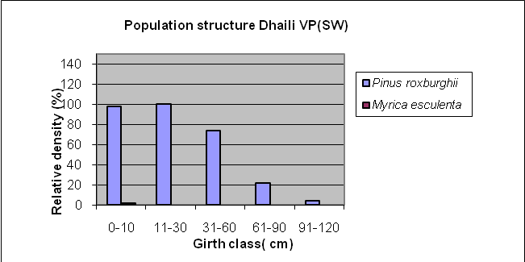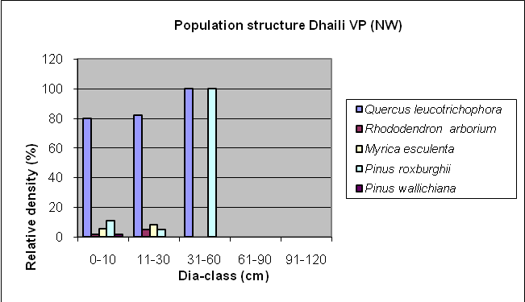

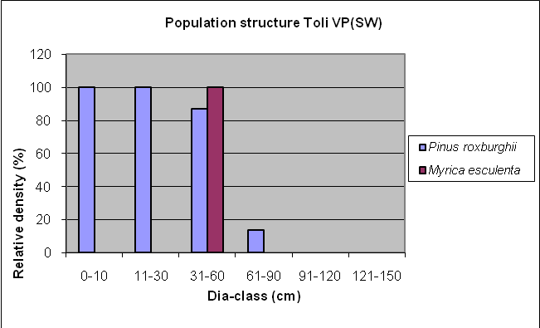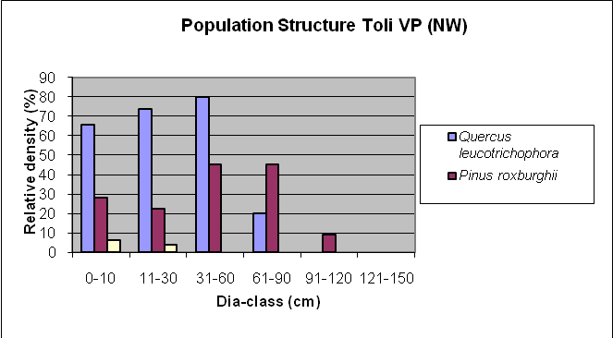

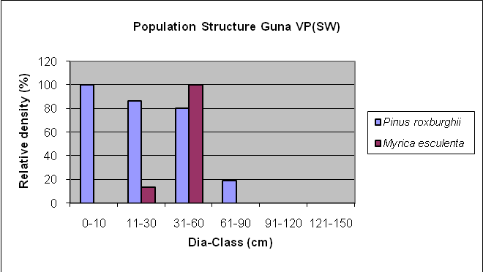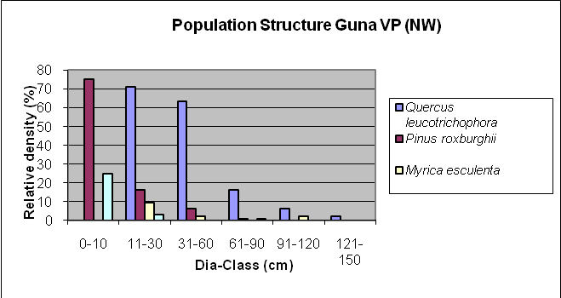

Figure- 1 Population structures of dominant species on six different strata and different aspects ; the relative density(%) is on y-axis and the diameter classes on x-axis; 0-10cm = Seedlings, 11-30cm = Saplings, Trees = 31-60 cm, 61-90 cm, 91-120 cm,121-150 cm.

REFERENCES
- Arnold and Stewart, 1991. Common Property Resource Management in India, Oxford Forestry Institute, Oxford, p.14.
- Batjes, N. H., 1996. Total carbon and nitrogen in the soils of the world. Eur. J. Soil Sci., 47, 151–163.
- Champion, H.G. and Seth, S.K., 1968. A revised survey of the forest types of India. Govt. India Publ. Division, New Delhi, 404pp.
- Curtis J.T., 1959. The vegetation of Wiscousin. An Ordination of plant community. University Wisconsin Press, Madison, Wisconsin. 657pp.
- Curtis J.T., McIntosh, R.P., 1950. The interrelations of certain analytic and synthetic phytosociological characters. Ecol., 31: 438-455.
- Jina, B.S., 2006. Monitoring and Estimation of Carbon Sequestration in Oak and Pine Forest of Varying level of Disturbances in Kumaun Central Himalaya. Ph.D. Thesis, Kumaun University, Nainital.
- Jina, B.S., Sah, P., Bhatt, M.D. Rawat, Y.S., 2008. Estimating Carbon Sequestration rates and total carbon stockpile in degreded and non-degreded sites of oak and pine forest of Kumaun Central Himalaya. Ecoprint 15: 75-81.
- Kharkwal, G., 2009. Qualitative analysis of tree species in evergreen forests of Kumaun Himalaya, Uttarakhand, India. African Journal of Plant Science. 3 (3), 49-52.
- Pandey, D.P., 2002. Global climate change and carbon management in multifunctional forests. Current science. 83 (5): 593-602.
- Post, W. M., Pengh, T. H., Emanuel, W., King, A. W., Dale, V. H. and Delnglis, 1990. The global carbon cycle. Am. Sci., 78, 310–326.
- Ralhan, P.K., A.K. Saxena and J.S. Singh., 1982. Analysis of forest vegetation in and around Nainital in Kumaun Himalaya. Proc. Indian Natl. Science Acad, 48:122-138.
- Ramachandran, A., Jayakumar, S., Haroon, R. M., Bhaskaran, A. and Arockiasamy, D. I., 2007. Carbon sequestration: estimation of carbon stock in natural forests using geospatial technology in the Eastern Ghats of Tamil Nadu, India. Current Science, 92 (3):321-331.
- Rawat, V.S, Chandhok, A., 2009. Phytosociological Analysis and Distribution patterns of tree species: A case study from Govind Pashu Vihar, National Park, Uttarakhand. New York Science Journal, 2(4):58-63.
- Rikhari, H.C. Adhikari, B.S. and Rawat, Y.S., 1997. Woody species composition of temperate forests along an elevational gradient in Indian central Himalaya. Jour. of Tropical Forest Science 10(2):197-211.

- Saxena, A.K., Singh, J.S., 1982. A Phytosociological Analysis of woody species in Forest Communities of a Part of Kumaun Himalaya. In Vegetation, 50: 3-22.
- Saxena, A.K., Singh, S.P. and Singh, J.S., 1984. Population structure of forest of Kumaun Himalaya. Implications for management. Journal of Environment management 19: 307-324.
- Shannon, C.E. and. Weaver, W., 1963. The Mathematical Theory of Communication. University of Illinois Press, Urbana. Singh, V., 2009. Biomass stock and Carbon Sequestration rates in banj oak (Quercus leucotrichophora, A. Camus.) forest under different disturbance regimes in Central Himalaya. Ph.D. Thesis, Kumaun University, Nainital.
- Singh, J.S. and Singh S.P., 1984. An integrated Ecological study of Eastern Himalaya with Emphasis on Natural Resources (Vols I-III) (Nainital: Kumaun University) 378pp.
- Singh J.S, Singh S.P., 1987. Forest vegetation of the Himalaya. Bot Rev. 52: 80 – 192.
- Singh, J.S. and S.P. Singh, 1992. Forest of Himalaya: Structure, Functioning and Impact of Man, Gyanodaya Prakashan, Nainital, India.
- Singh, S.P., Adhikari, B.S. and. Zobel, D.B., 1994. Biomass productivity, leaf longevity and forest structure in Central Himalaya, Eco. Monog., 64:401-421.
- Singh,R.S., Ralhan, P.K. and Singh, S.P. 1987. Phytosociology and Population Structure of Oak-Mixed Forest in a part of Kumaun Himalaya, Environment & Ecology, Vol 5, No 3, 1987 ISSN 0970-0420.
- Simpson E.H., 1949.The measurement of diversity. Nature 1949; 163 – 88.
- Singh,S.P., R. Thadani and M.Kumaiyan (2003). Eds. National Biodiversity Stratrgy and Action Plan for Western Himalayas India Final report.
- Srivastava, A.K., Tewari, A., Shah, S. and Tewari, B., 2008. Species composition an. Regeneration pattern along a transect perpendicular to a river course in foot hill Deciduous tropical forest of Kumaun. Indian Journal of forestry 31(1) 7-12.
- Upreti, N., 1982. A study on phytosociology and state of regeneration of oak forests of Nainital, Ph.D. Thesis, Kumaun University, 481 pp.
- Valdiya, K.S., 1980. Geology of Kumaun Lesser Himalaya. Wadia institute of Himalayan Geology, Dehradun, 291 p.
- Whittaker, R.H., 1972. Evolution and measurement of species diversity. Taxon 21: 213-251.

24/08/2011

