Geochemical Characteristics of the Charnockitic and Associated Granitic Rock, Akure Area, Southwestern Nigeria.

Ademeso Odunyemi Anthony ^{1*}, Alabi Kayode ^{1,}

- Department of Geology, Adekunle Ajasin University, Akungba-Akoko, Nigeria
tonyademeso@gmail.com

Abstract: The geochemical characteristics of the charnockitic and associated granitic rocks of Akure area were studied. Field and petrographic characteristics had earlier been reported. The granitic rock within the hybrid (xenoliths) plotted in QAP diagram as tonalite while those outside plotted as granite indicating possible absorption of some of the minerals of the xenoliths. The charnockitics plotted as quartz-diorite while the hybrid plotted as tonalite. The major element geochemistry shows similarity between the granitic rock and the hybrid while the charnockitic is distinct. Middleton discriminating diagram plotted the charnockitics inside the eugeosynclinal sandstone region, the hybrid plotted inside and outside while the granitic plotted outside. Garrels and Mackenzie discriminating diagram plotted the charnockitics as sedimentary/metasedimentary, the granitic as igneous and the hybrid as both. These indicate that the charnockitic magma most likely had sedimentary parentage, the granitic an igneous and the hybrid which seems to possess dual parentage probably resulted from the hybridization of the two rock types. [Ademeso Odunyemi, Alabi Kayode. Geochemical Characteristics of the Charnockitic and Associated Granitic rock, Akure Area, Southwestern Nigeria. Nature and Science 2011:9(8):194-198]. (ISSN:1545-0740). http://www.sciencepub.net.

Key words: Goechemistry, Hybrid rock, Discriminating diagram, QAP, Charnockitic rock

1. Introduction
Some preserved traits of deformation in the charnockitic rocks of Akure area were reported and it was concluded that the rocks have experienced deformation (Ademeso, 2009). The field and petrographic relationships between the charnockitic and the associated granitic rocks of the same area was also reported (Ademeso, 2010). In the report, a model of emplacement that suggested the hybridization of the charnockitic and the associated granitic rocks at the contact was presented. In conclusion, the charnockitic rocks were said to be (a) younger than the granitic rocks, (b) of the Pan-African age and (c) of igneous origin. As a follow-up to these, the geochemical characteristics of the rock types were studied to further (i) the knowledge of the rock types and (ii) the understanding of their relationship. Hubbarb presented the geochemistry of the charnockitic rocks of Wasimi and Oke-Patara, southwestern Nigeria (Oyawoye, 1964). Weed and Pirsson presented the result of the geochemical analysis of granite from Elk Peak, Montana U.S. (Turner and Verhoogen, 1960). Tyrrell presented the result of the geochemical analysis of Pitchson Sill, Arran, Scotland (Turner and Verhoogen, 1960). A generalized classification of the Nigerian charnockitic rocks on the basis of the SiO₂ content was reported (Olarewaju, 1987). SiO₂ range of 45.69-55%, which represents basaltic to intermediate rocks, corresponds to fine-medium variety of the rock type while 59.21-69.84%, which represents acid rocks, corresponds to the coarse variety. It was further reported that fine-medium grained variety is characterized by higher TiO₂, FeO_{T}, MgO and CaO values and lower K₂O/Na₂O ratio (<1) while the coarse grained variety has lower FeO_{T}, MgO and CaO values and higher K₂O/Na₂O ratio (>1). Also, the AFM diagram was believed to have classified the charnockitic rocks into two with calc-alkaline trend pointing to the coarse type while the tholeiitic trend corresponds to the fine-medium grained (Olarewaju, 1987).
The charnockitic rocks of Akure intruded into the gneiss-migmatite-quartzite complex and the older granite suite. The study area lies within longitudes 5⁰ 00'E and 5⁰ 17'E and latitudes 7⁰ 10'N and 7⁰ 20'N in the southwestern part of Nigeria (Fig.1).
The major rock types in the area as classified by Adekoya et al. (2003) are (a) The gneiss-migmatite-quartzite complex; (b) The schist belts which are low to medium grade supracrustal and meta-igneous rocks; (c) The Pan African granitoids (Older Granites) and other related rocks such as charnockitic rocks and syenites; and (d) Minor felsic and mafic intrusive.

2. Materials and methods
Outcrops of the granitic rock (Pgr 1) on the eastern part of the study area (outside the region of the hybrid rocks) were studied. The rock types were sampled for laboratory analysis. Thin sections were prepared and studied with the petrographic microscope. Photomicrographs were taken with digital camera and the modal content of the rocks were analysed with the aid of “ImageJ” (Ademeso, 2010). The modal compositions of the rock types were then plotted in the QAP diagram. The samples of the three rock types were analysed for their major and minor chemicals species with the aid of AAS and flame photometer. The results were plotted in the discriminating charts of Garrels and Mackenzie (1971) and Middleton (1960).

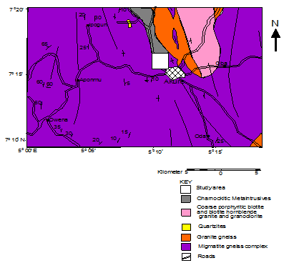
Figure.1: Geological Map of Akure showing study Area (Adapted from Ademeso, 2009)

3. Results
3.1 Field description
The record in Ademeso (2009) serves for this report. The outcrops of the granitic rocks fringing the eastern side of the study area (Fig.2) occur as hills and domes. They contain phenocrysts of potash feldspar in groundmass of quartz, feldspar, biotite and hornblende.

3.2 Petrography
The petrography is as reported in Ademeso (2009). The porphyritic granite (Pgr 1) consists of quartz, K-feldspar, biotite, plagioclase, hornblende, pyroxene and mymerkite as major minerals (Fig.3). The average modal composition is 39%, 24%, 21%, 11%, 3%, 2% and 1% respectively. Culling from Ademeso (2009), the porphyritic granite (xenolith) consists of plagioclase, quartz, biotite, hornblende, mymerkite as major minerals and apatite as accessory. The average modal composition is 35%, 31%, 19%, 4% and 12% respectively. The charnockitic rocks contain plagioclase, hypersthene, biotite, quartz, hornblende, muscovite and orthoclase as major minerals while zircon is accessory with modal composition of 32%, 16%, 16%, 16%, 11%, 5%, 3% and 1% respectively. The hybrid rock contains biotite, quartz, plagioclase, hornblende, hypersthene, orthoclase, pyroxene, muscovite, mymerkite and accessory garnet with the following modal composition 36%, 24%, 20%, 10%, 3%, 3%, 2%, 1%, 1% and 0.5% respectively. The QAP diagram was plotted with the average modal compositions (Fig.4).

3.3 Geochemistry
The result of the geochemical studies showed the SiO₂ content of the charnockitic rocks ranging between 57.66 and 58.24%, porphyritic granite between 68.51and 69.24% and the hybrid between 67.86 and 69.31% (Table 1). Generally, the geochemical compositions of the hybrid and the porphyritic granite are comparable with those of pitchstone sill, Scotland and granite, Elk Peak, Montana (Turner and Verhoogen, 1960). The SiO₂ contents are however lower in the studied rocks. In the same vein, the geochemical compositions of the charnockitic rocks are comparable with those of the charnockitic rocks of Oke Patara and Wasimi, southwestern Nigeria (Oyawoye, 1964). The
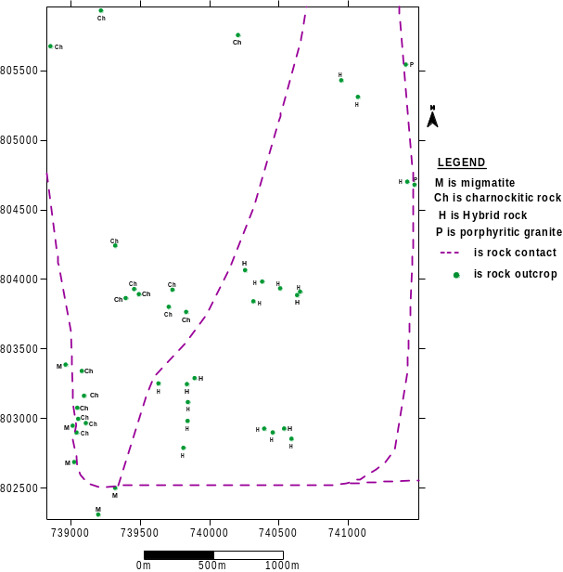
Figure 2: Plots of outcrops locations in the study area (coordinates converted to UTM with Transfo and plotted in Surfer 8) (from Ademeso, 2010). Note: Rock contacts are inferred.

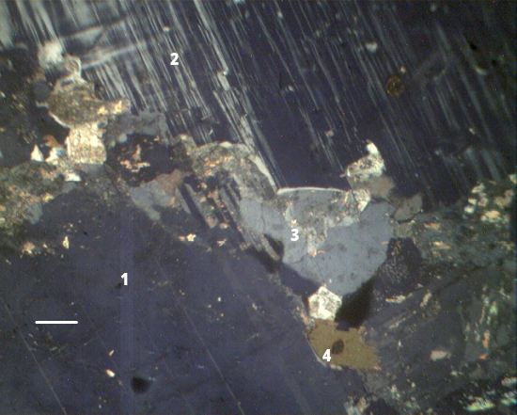
Figure 3a: Photomicrograph of Porphyritic granite (Pgr 1) showing plagioclase (1), K-feldspar (2), quartz (3) and biotite (4). Bar Scale is 1µm.
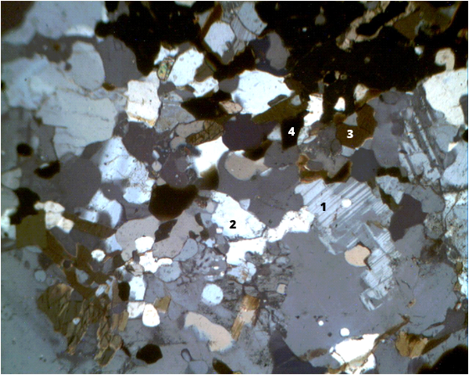
Figure 3b: Photomicrograph of Porphyritic granite (xenoliths) showing plagioclase (1), quartz (2), biotite (3) and hornblende (4).
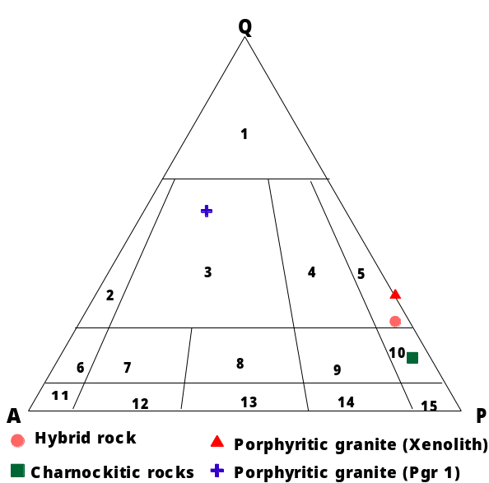
Figure 4: QAP diagram for the rock types

percentages of Al₂O₃ for the charnockitic rocks fall between 15.68 and 16.21%, for porphyritic granite, it falls between 14.23 and 14.57% and for the hybrid between 14.05 to 14.68%. The results show a close similarity between the porphyritic granite and the hybrid. The K₂O versus Na₂O discrimination diagram (Middleton, 1960) plotted from the results placed the charnockitic rock inside the eugeosynclinal sandstone portion, the porphyritic granite outside the portion and the hybrid falling inside and outside of the portion (Fig.5). The discriminating diagram that relates Na₂O/Al₂O₃ versus K₂O/Al₂O₃ (Garrels and Mackenzie, 1961) places the charnockitic rocks in the sedimentary and metasedimentary area, the porphyritic granite in the igneous area and the hybrid falling into both parts (Fig.6).

4. Discussion
1

The classification of the three rock types in the QAP diagram indicates that they are substantially different from each other petrologically. In the same vein, the differences in the petrological characteristics of the three rock types can be further inferred by relating the outcome of QAP classification to the fabric of the rocks.
Olarewaju (2006) discovered low percentages of TiO₂, FeO_{T}, MgO and CaO for coarse grained charnockitic rocks while the fine grained types have higher values. This indicates that since the percentages of these species for samples LxMy (the hybrid) are lower than those of the coarse grained charnockitic rocks, they are likely not to be fine grained charnockitic rocks. In like manner, the K₂O/Na₂O ratio for the coarse grained charnockitic rocks is less than those for the samples of the other rock types particularly the hybrid, contrary to the report of Olarewaju (1987) that the coarse grained charnockitic rocks have higher ratio. This implies that the fine grained rock (hybrid) cannot be said to be of charnockitic class. The discriminating diagram that related the species Na₂O/Al₂O₃ with K₂O/Al₂O₃ places the charnockitic rock in the sedimentary/metasedimentary area, the granite in the igneous while some of the hybrid fell into the sedimentary and others into the igneous (Fig.5). The discriminating diagram that related the species K₂O with Na₂O shows the plot of the charnockitic rocks falling into the eugeosynclinal sandstone area, the porphyritic granite falling outside the area and the hybrid falling inside and outside of the area (Fig.6). The implication is that the charnockitic rocks might have originated from a magma that was generated from a sedimentary parentage.

Table 1: Major element geochemistry of the porphyritic granite, charnockitic and hybrid rocks
Sample Code | L1 M1 | L2 M1 | L2 M2 | L2 M3 | L2 M5 | L3 C1 | L3 C2 | L4 P1 | L5 P2 | L6 P3
Major oxides in %
TiO₂ (%) | 0.42 | 0.40 | 0.41 | 0.44 | 0.45 | 0.86 | 0.79 | 0.42 | 0.40 | 0.46
SiO₂ (%) | 67.86 | 68.51 | 69.31 | 68.55 | 68.51 | 57.66 | 58.24 | 68.51 | 69.24 | 68.67
Al₂O₃ (%) | 14.26 | 14.68 | 14.05 | 14.38 | 14.36 | 15.68 | 16.21 | 14.23 | 14.57 | 14.28
MnO (%) | 0.05 | 0.05 | 0.06 | 0.05 | 0.05 | 0.11 | 0.10 | 0.05 | 0.05 | 0.06
Fe₂O₃ (%) | 3.62 | 3.37 | 3.26 | 3.42 | 3.45 | 7.86 | 7.21 | 3.40 | 3.21 | 3.39
P₂O₅ (%) | 0.12 | 0.13 | 0.16 | 0.15 | 0.14 | 0.32 | 0.33 | 0.16 | 0.17 | 0.15
MgO (%) | 1.11 | 1.01 | 1.12 | 1.11 | 1.31 | 3.20 | 3.10 | 1.12 | 1.11 | 1.13
CaO (%) | 2.62 | 2.45 | 2.34 | 2.51 | 2.48 | 5.82 | 5.35 | 2.55 | 2.42 | 2.49
Na₂O (%) | 3.62 | 3.75 | 3.82 | 3.72 | 3.68 | 3.42 | 3.46 | 3.62 | 3.74 | 3.69
K₂O (%) | 4.02 | 4.23 | 4.35 | 4.26 | 4.21 | 3.21 | 3.30 | 4.06 | 4.31 | 4.22
Total | 97.750 | 98.603 | 98.940 | 98.630 | 98.683 | 98.192 | 98.146 | 98.172 | 99.258 | 98.57
(LOI = LOSS ON IGNITION)
Note: Sample codes LxMy are hybrid rocks, LxCy are charnockitic rocks while LxPy are porphyritic granite.

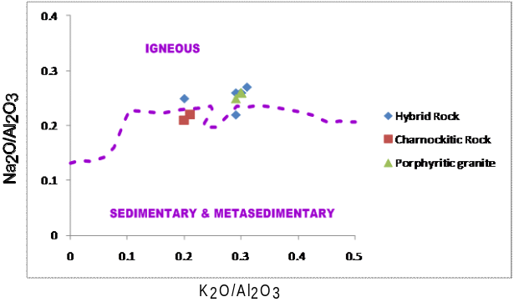Figure 5: Discriminating diagram relating K₂O/Al₂O₃ and Na₂O/Al₂O₃ for the rock types (after Garrels and Mackenzie, 1971)
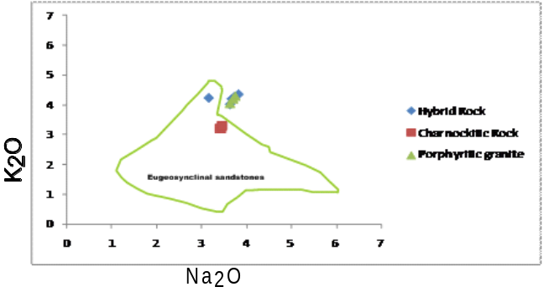
Figure 6: Discriminating diagram relating K₂O and Na₂O for the rock types (after Middleton, 1960)

This may also explain the observed occurrence of the rock type within the amphibolite facies country rock in Nigeria in contrast to what obtains in other parts of the world where they occur within granulite facies terranes as reported by Olarewaju (2006). The AFM diagram plotted all the rock types in the calc-alkaline portion (Fig.7). Olarewaju (1987) reported that the coarse grained charnockitic rocks plotted as calc- alkaline while the fine grained plotted as tholeiitic. If the fine grained hybrid plotted as calc-alkaline, it implies therefore, that it has probably lost the textural characteristics of the charnockitic rock. The fine grained rock that shares similar geochemical characteristics with the porphyritic granite however exhibits completely different field and petrographic as well as fabric characteristics. This is an indication that it has acquired characteristics that differentiates it from the two other rock types. This is consistent with the inferences drawn from the discussions on the QAP diagram plot as well as the conclusions of Ademeso (2010). It is therefore believed that the fine grained rock in this study area most likely evolved from the hybridization of the charnockitic rock and the porphyritic granite.
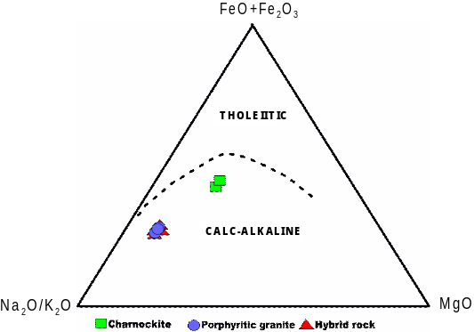

Figure 7: AFM diagram for the rock types.

5. Conclusions
Conclusively, the fine grained rock in this study area is believed to have originated from charnockitic magma that has been contaminated substantially by the pre-existing porphyritic granite and therefore, it will be more appropriate to refer to it as a hybrid. It is also believed that the charnockitic rock is of a sedimentary parentage noting that the magma from which it was emplaced might have been generated from the sediments that were deposited in the basins from which the nearby Ife-Ilesa schist belt was formed. The porphyritic granite on the other hand most likely originated from an igneous magma. Ademeso (2010) concluded that the porphyritic granite was emplaced earlier than the fine grained hybrid and the charnockitic rocks. If the granitic rocks which are generally believed to be of Pan African age was emplaced earlier than the charnockitic and the fine grained hybrid rocks and the magma that emplaced them has its’ source in the basin from which the Ife-Ilesa schist belt was formed, then the report of Rahaman (1988) that the schist belts suffered metamorphism during the Pan African orogeny might have been further substantiated.

6. Recommendations/Suggestion
It is however suggested that REE and chronological studies of the rock types be carried out to further confirm their relationships.

Correspondence to:
Ademeso, O. A.
Department of Geology,
Adekunle Ajasin University
Akungba-Akoko, Ondo State. Nigeria.
Telephone: +2348034738470;
+2348125226711
Emails: tonyademeso@gmail.com

References
[1] Ademeso, O.A. (2009): Deformation traits in the charnockitic rocks of Akure area, Southwestern Nigeria. Asian Journal of Earth Sciences 2(4), 2009, pp 113-120.
[2] Ademeso, O.A. (2010): Field and Petrographic Relationships between the Charnockitic and Associated Granitic Rock, Akure Area, Southwestern Nigeria. World Academy of Science, Engineering and Technology 71. pp. 626-630.
[3] Oyawoye, M. O. (1964): The contact relationship of charnockite and biotite gneiss at Bauchi, Northern Nigeria. Geol. Mag. 10, No. 2. pp 138-144.
[4] Turner, F.J., and Verhoogen, J. (1960): Igneous and Metarmorphic Petrology, 2nd edition, McGraw-Hill, New York. 10523. 694p.
[5] Olarewaju, V.O. (1987): Charnockite-Granite Association in S.W. Nigeria: Rapakivi granite type and charnockitic plutonism in Nigeria”. J. Afri. Earth Sci., 6, No. 1. pp 67-77.
[6] Adekoya, J.A., Kehinde-Phillips, O.O. and Odukoya, A.M. (2003): Geological distribution of mineral resources in southwest Nigeria. In: A. A. Elueze (Ed.) Prospects for investment in mineral resources of southwestern Nigeria. pp 1-13.
[7] Garrels, R.M. and Mackenzie, F.T. (1971): Evolution of Sedimentary Rocks. Publ. by W. W. Norton and Co. Int. New York. p394.
[8] Middleton, E.V. (1960): Chemical Composition of Sandstone. Bull Geol. Soc of America. Vol 71. pp1011 – 1026.
[9] Olarewaju, V. O. (2006): The charnockitic intrusive of Nigeria. In: Oshin, O. (Ed.), The Basement Complex of Nigeria and its Mineral Resources. Akin Jinad & co, Ibadan, Nigeria. Pp 45-70.
[10] Rahaman M.A. (1988): Recent advances in the study of the basement complex of Nigeria. In: Precam. Geol. Nig., GSN Publication, pp11-43.

3/6/2011

