“Antioxidative Activity and Flavonoid Composition from Lepidium sativum”

Jyoti Agarwal & D.L. Verma

Department of Chemistry, S.S.J. Campus, Kumaun University, Almora 263601, Uttrakhand, India
e-mail: j.jyotichemistry@rediffmail.com

ABSTRACT - Lepidium sativum (Family Brassicaceae), a small annual herb and a vegetable producing plant of low-reaches of Kumaun Himalaya. It has been identified as a traditional medicinal plant of Kumaun Himalayan hills and has been reported to have enormous biological activities, cardiotonic, Hypotensive, bronchiodilator, antimicrobial, antiprotozoal, antibiotic and hypoglycemic. The extract of the plant has highly been reported to have antioxidative property. Antioxidative activity –guided fractionation of aqueous extract of the plant gave two nobel antioxidants, quercetin – 3-O- β-glucosyl (1 → 6) – β – galactoside and quercetin – 3 – O – β – glucosyl (1 → 6) – β – glucoside. The antioxidative potential of both compounds was measured by the recent ABTS free radical peak spiking method in HPLC. The compound, quercetin – 3 – O – glucosyl ( 1 → 6) glucoside was found more antioxidative compared to quercetin 3 – O – glucosyl ( 1 → 6) galactoside.
(Jyoti Agarwal & D.L. Verma, Antioxidative Activity and Flavonoid Composition from Lepidium sativum. Nature and Science 2011;9(7):21-25]. (ISSN:1545-0740). http://www.sciencepub.net.

Key Words: Lepidium Sativum, Antioxidant Activity, Quercetin Glycosides.

INTRODUCTION
Flavonoids, a polyphenolic heterocyclic compounds and an integral constituents of food, fodder and a prominent antioxidative compounds, have been associated to cure many diseases associated to oxidative stress. The antioxidant ability of flavonoids resides mainly in their tendency to donate hydrogen atoms and thereby scavange the free radicals generated during lipid peroxidation (Jovanovic et al; 1994; Shui and Peng, 2004).
Catechol grouping flavonoids, the ortho-dihydroxyl group bearing in the B-ring have been identified as a high antioxidative contributor because these have high tendency to delocalise phenoxide free radical and metallic chelation tendency (Arora et al; 1997). Quercetin, a frequent constituent of vegetables, fruits, fodder and grasses, and an ortho-dihydroxy group bearing flavonol, has been reported to have enormous biological activities (Riet Jens et al; 2005).
Present chemical investigation reveals the presence of nobel antioxidative flavonoids from a Himalayan vegetable producing medicinal plant, Lepidium sativum (Chopra et al, 1956). Lepidium sativum (family Brassicaceae), is a small herb with 30 to 50 cm in height and bears laciniate-pinnate entire leaves. Flowering of the plant has been observed in the month of may to July. The extracts of Lepidium sativum have previously been screened for various biological activities, cardiotonic, hypotensive, antimicrobial, bronchiodilator, hypoglycemic and allelopathic (Katar and Akulyan, 1971; Singh et al, 1984; Carbajal et al 1991; Hasegawal et al 1992, Alcalade et al, 2005; Osuna et al; 2006). Glucosinolates, a class of naturally occurring thioglycosides, have been identified as a principle constituents of Lepidium sativum (Fahey et al, 2001). Imidazole alkaloids and essential oil composition of the plant have been investigated (Maier et al, 1998; Mirza and Navaei, 2006). Quercetin and some uncharacterised flavonoid aglycones have been reported from the plant (Justeen, 2000).

MATERIAL AND METHODS
- Authentification of plant material :
Aerial parts of Lepidium sativum was collected from the rural wheat crops fields of Almora and its adjacent hills, ranging altitudes 1700-1800 m and the herbarium of its leaves and twig has been prepared and deposited as a sp. No. 209 in the Department of plant chemistry, Kumaun University Campus, Almora – 263 601 (UK) India. Its identification has been carried out from BSI, Dehradun and finally by Prof. Y.S. Pangati, Professor Emeritus of taxonomy in the Department of Botany, Kumaun University at DSB Campus, Nainital, Uttarakhand (India)
2. 5 Kg. air dried and powdered aerial parts of Lepidium sativum was extracted with distilled water for six days by cold percolation method. The H₂O extract was filtered out and evaporated to dryness under reduced pressure at 55⁰C until only H₂O layer (60 ml) remained. It was partitioned with CH₂Cl₂ – H₂O (1:1). After removal CH₂Cl₂ soluble, the H₂O soluble was concentrated under reduced pressure and it was chromatographed on XAD-7 CC using H₂O as an initial eluting solvent. On eluting CC with H₂O-MeOH, (1:1) a broad brown-black band was visualized and it was eluted and collected separately. The eluted fraction was evaporated to dryness and residue was chromatographed on cellulose (Merck) CC and eluted initially with H₂O and then increasing polarity with acetic acid. On eluting CC with 40% HOAc, three dark purple fluoresencent bands, representing fractions, FRAC – I, FRAC – II and FRAC – III were observed and each was eluted and collected separately in order to decreasing mobility, by monitoring with UV (360 mm) light.
3. Evaluation of antioxidative activity of FRAC – I, II and III : The methanolic solution of each fraction was screened for antioxidative activity against DPPH free radical at 518 nm in UV – VIS spectrophotometer. The reducing capacity of each fraction was measured against the decrease in peak heights of DPPH and % inhibition of peak height was calculated.
4. Identification of Catechol grouping flavonoids from FRAC – I, II and III by 2 DPC methods :
The methanolic solution of FRAC – I, II and III were evaluated for total numbers of catechol grouping flavonoids, a major contributors in the determination of antioxidative activity, by 2 DPC using BAW (n – BuOH – AcOH – H₂O,4:1:5,v/v upper layer) & 30% HOAc as a developing solvents and ammonical solution of AgNO₃ and methanolic solution of NA (Naturstoffreagenz-A) as a spraying reagents.

RESULTS AND DISCUSSION
The peak heights of DPPH have been observed to be reduced up to 10%, 50% and 90-95% by FRAC – I, II and III, respectively. Determining the Rf values of flavonoid positive compounds on 2DPC with BAW and 30% HOAc, it was concluded that the fraction I, II and III have been identified to contain monosaccharide, disaccharide and trisaccharide, respectively derivates of quercetin and Kaempferol. FRAC – II, a major contributor of antioxidative activity, afforded three spots of catechol grouping flavonoids on PC. FRAC – III, a least contributor of antioxidative activity, is defficient with Catechol –grouping flavonoids. FRAC-I, a five flavonoids, two catechol - grouping and three non-catechol group bearing fraction gave 50% antioxidative activity.
Methanolic solution of FRAC-II, a three catechol-grouping flavonoids bearing fraction, and a major contributor of antioxidative activity,was characterised for major antioxidant peaks by HPLC method using formic acid : water (1 : 1) as an eluting solvent and shim Pak VD – ODS column (250 mm x 4.5 mm).
The characterisation of antioxidant peaks was made by spiking with free radical, ABTS⁺. Two major antioxidants which had retention time between 25 and 31 min, were isolated and identified as follows:
1. Compound (1), Rt 28, was identified as a flavonoid glycoside on the basis of its positive colour reactions with FeCl₃, Mg+ HCl and ∝-naphthol. Complete acid hydrolysis of 1 with 2NHCl gave quercetin (CoPC), glucose (CoPC) and galactose (CoPC). Enzymatic hydrolysis of 1 with β-glucosidase gave quercetin – 3-o-galactoside (CoPC) and glucose (CoPC). ¹HNMR of 1 in DMSO-d₆ (400-MHz) gave five peaks in aromatic region at δ 6.20 (1H,d,J=2.0 Hz), δ 6.40 (1H, d, J = 2 Hz), δ 6.80 (1H,D, J=8.5 Hz), δ 7.52 (1H, d, J=2.0 Hz) and δ 7.68(1H,dd,J=2.0& 8.5Hz) for H-6, H-8, H-5¹, H-2¹and H-6¹ , respectively of quercetin. In aliphatic region two doublets appeared at δ 5.33 (1 H, d, J=8.0 Hz) and δ 4.06 (1H, d, J = 7.5 Hz), were attributed to galactose (β- configuration) and glucose (β-configuration) respectively and are linked to each other by 1 → 6 linkage (Overend, 1972; Altona and Haasnoot, 1980). FAB-MS(–) of (1) gave a molecular ion at m/e 625 (M – H)⁻ and other prominent peaks were observed at m/e 463 (m/e 625 – glucose] and m/e 301 [m/e 463-galactose], suggesting the release of galactose and glucose from quercetin. Finally the structure of 1 has been confirmed as Quercetin - 3 - β - glucosyl (1 → 6) β-galactopyranoside on the basis of ¹³CNMR (DMSO-d₆):
Carbon No. | Shift
C – 2 | 156.2
C – 3 | 133.5
C – 4 | 177.4
C – 5 | 161.3
C – 6 | 98.7
C – 7 | 164.2
C – 8 | 93.6
C – 9 | 156.2
C – 10 | 104.1
C – 1^{ʺ} | 102.2
C – 2ʺ | 71.4
C – 3ʺ | 73.4
C – 4^{ʺ} | 68.3
C – 5^{ʺ} | 73.9
C – 6^{ʺ} | 67.3
C – 1^{ייי} | 103.2
C – 2^{ייי} | 74.2
C – 3^{ייי} | 76.8
C – 4^{ייי} | 70.0
C – 5^{ייי} | 76.8
C – 6^{ייי} | 61.0

Compound (2), Rt,30, a dark purple fluorescent on PC under UV light, was identified as flavonol glycoside on the basis of colour reactions with FeCl₃, Mg+HCl and ∝-naphthol. The chromatographic behaviour, colour reactions, UV and MS data of 2 were found similar to those reported to compound 1.

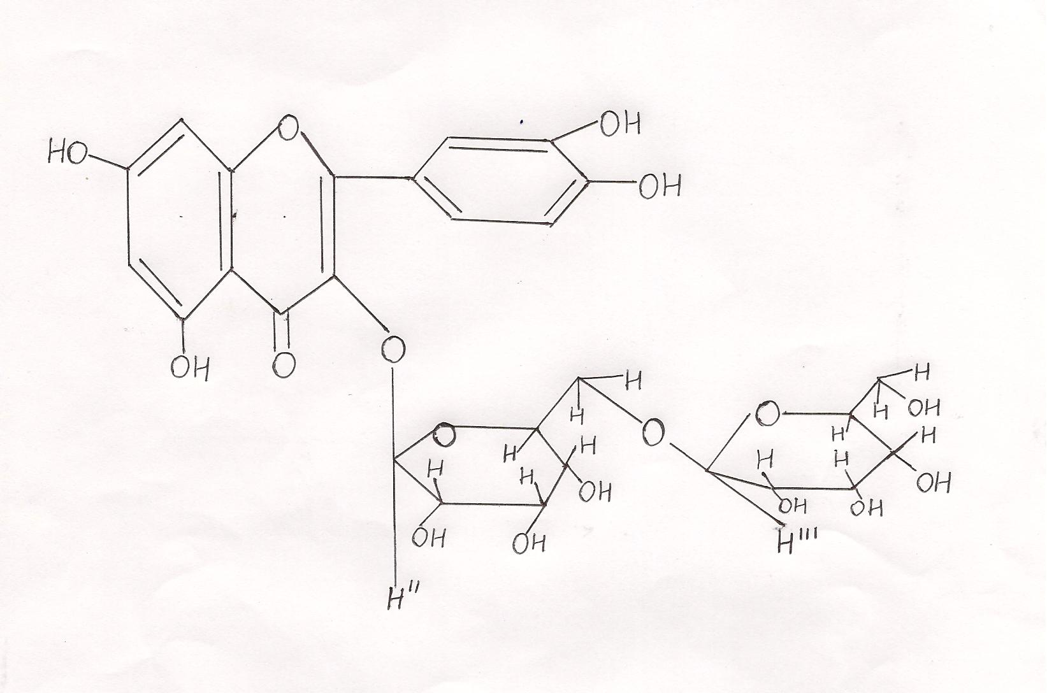

Complete acid hydrolysis of 2 with 2NHCl gave quercetin (CoPC) and glucose (CoPC). Enzymatic hydrolysis of 2 with β-glucosidase gave quercetin -3-O-β-D- glucoside (CoPC) and glucose (CoPC). ¹HNMR of 1 in DMSO-d₆, 400 MHz, gave five signals in aromatic region at δ 6.20 (1H, d, J = 2.0 Hz), δ 6.40(1H,d,J=2.0 Hz), δ 6.80(1H,d,J= 8.5 Hz), δ 7.52 (1H, d, J = 2.0 Hz) and δ 7.68 (1H, dd, J=2.0 Hz and 8.5 Hz) for the H-6, H-8, H-5ᶥ, H-2ᶥ and H-6ᶥ, respectively of quercetin. In aliphatic region two doublets were observed at δ 5.28 (1H, d, J = 7.5) and δ 4.02 (1H, d, J = 7.8) were attributed to H-1ʺ (glucose) and H-1ייי (glucose) respectively, and the glycosidic linkage between two glucose moieties was characterized as 1 → 6 (Overend 1972; Altona and Haasnoot, 1980). Finally, the structure of 2 was confirmed as Quercetin – 3 – O – β – glucosyl (1 → 6) – β-glucopyranoside on the basis of ¹³CNMR (in DMSO-d₆).

¹³CNMR of 2 in DMSO-d₆
C – 2 | 156.2 | C – 1^{ʺ} | 100.7
C – 3 | 133.3 | C – 2ʺ | 73.3
C – 4 | 177.2 | C – 3ʺ | 76.5
C – 5 | 161.1 | C – 4^{ʺ} | 69.6
C – 6 | 98.7 | C – 5^{ʺ} | 76.3
C – 7 | 164.6 | C – 6^{ʺ} | 68.0
C – 8 | 93.7 | C – 1^{ייי} | 103.0
C – 9 | 156.4 | C – 2^{ייי} | 74.0
C – 10 | 103.8 | C – 3^{ייי} | 76.3
C – 1^{l} | 121.0 | C – 4^{ייי} | 69.7
C – 2^{l} | 115.2 | C – 5^{ייי} | 76.4
C – 3 ^{l} | 144.8 | C – 6^{ייי} | 60.7
C – 4 ^{l} | 148.5
C – 5 ^{l} | 116.1
C – 6 ^{l} | 121.7

The peak heights of compound 1 and 2 significantly reduced to 85% and 95%, respectively after reaction with the methanolic solution of ABTS free radical. Thus, it has been concluded that the compound 2 has high antioxidative potential compared to 1.

ACKNOWLEDGEMENT:
The Authors are indebted to authorities of CDRI Lucknow, for recording ¹HNMR spectra and also to Head Deptt. Of Chemistry SSJ Campus, Kumaun University, Almora (Uttrakhand), India for providing necessary research facilities.

CORRESPONDENCE TO:
Ms. JYOTI AGARWAL
965/G-3, SHALIMAR GARDEN EXTN-1, SAHIBABAD, GHAZIABAD- 201 005 (U.P.), INDIA
+91-0-99101 36028
+91-0-99103 26589
Email: j.jyotichemistry@rediffmail.com

REFERENCES
- Acevedo, A.J.G., Munoz – lopez, J.L. and Martinez – Cortes, G. (1993) In vitro antimicrobial activity of various plant extracts, used by Purepecha against some enterobacteriaceae, Int. J. of Pharmacognosy, 31 (1) p. 61 – 64.
- Alcalade-Marcano, D., Vangas, N. and Pire, A. (2005) “Effect of vegetable extracts and synthetic fungicides on the micellial growth of in vitro Selerotium rolfsii and Thielaviopsis basicola”, Revista-de-la-Facultad-de-agronomia-universidal-del-Zulia, 22(4) Pag. 315-323.
- Altona, C. And Haasnoot, C.A.G. (1980) Org. Mag. Resonance, 417.
- Arora, A., Nair, M.G. and Strasburg, G.M. (1997) structure-activity relationships of a series of flavonoids in a liposomal system, Free Radical Biology and Medicine, 24 (9), p. 1355-1363.
- Bors, W., Heller, W., Michel, C and Saran, M. (1990) Flavonoids as Antioxidants: Determination of radical-scavenging efficiencies, Meth. Enzymol., 186, 343-355.
- Burow, M., Bergner, A., Gershenzon, J. and Wittstock, U. (2007) Glucosinolate hydrolysis in Lepidium sativum and identification of the thiocyanate-forming protein, Plant Molecular Biology, 63(1), pag. 49-61.
- Carbajal, D., Casaco, A., Arruzazabala, L., Gonzalez, R and Fuentes, V. (1991) “Pharmacological screening of plant decoctions commonly used in cuban folk medicine”, Journal of Ethnopharmacology, 33, 1-2, Pag. 21-24.
- Chopra, R.N., Nayar, S.L. and Chopra, I.C. (1956) “Glossary of Indian medicinal Plants”, CSIR Publication, New Delhi, India.
- Fahey, J.W., Zalcmann, A.T. and Talalay, P. (2001) The chemical diversity and distribution of glucosinolates and isothiocynates among plants, Phytochemistry, 56, page 5-51.
- Fursa, N.S., Litvineko, V.I. and Krivenchuk, P.E. (1970) Flavonol glycosides of Lepidium latifolium and Lepidium draba, Rastitel’nye Resursy, 6, 567-571.
- Hasegawa, K., Mizutani J., Kosemura S. and Yamamura S. (1992) Isolation and Identification of lepidimoide, a new allelopathic substance from mucilage of germinated cress seeds, Plant physiology (USA), 100(2), Page 1059-1061.
- Jovanovic, S.V., Steenken, S., Tosic, M., Maryanovic, B. and Simic, M.G. (1994) Flavonoids as Antioxidants, J.Am. Chem. Soc., 116, 4846 – 4851.
- Justeen, U. (2002) Negative atmospheric pressure chemical ionisation low-energy collision activation mass spectrometry for characterisation flavonoids in extracts of fresh herbs, J. of chromatography, Vol. 902 (2), p. 369 – 379.
- Katar, Y.B.T. and Akulyan, L.G. (1971) “The control spectrum and herbicidal activity of trichothecin”, Doklady Akademii Nauk Armyanskoi, SSR., 53 (5), p 283-285.
- Kuhnau, J. (1976) The flavonoids, a class of semi-essential food components : their role in human nutrition, World. Rev. Nutr. Diet., 24, 117-191.
- Mabry, T.J. Markham, K.R. and Thomas, M.B. (1970)The systematic Identification of Flavonoids, Springer Verlag, p. 1 – 310.
- Maier, U.H., Gundlach, H. and Zenk, M.H. (1998) Seven imidazole alkaloids from Lepidium sativum, Phytochemistry, 49(6), Pag. 1791-1795.
- Markham, K.R. (1982) Techniques of Flavonoid Identification, AP London.
- Mirza, M. and Navaei, M.N.(2006) Essential oil composition of Lepidium sativum L., Iranian Journal of Medicinal and Aromatic Plants, 21(4), pag. 481-488.
- Osuna, L. Tapia-Perez, M.E., Figueroa, O., Jimenez, F.E., Garduno, R.M.L., Gonzalez, G.M.T., Carranza, R.P. and Cruz Vega D.E., (2006) “Micropropagation of Lepidium virginicum (Brassicaceae) a plant with antiprotozoal activity”, In vitro cellular and Developmental biology plant 42(6), Pag. 596-600.
- Overend, W.G. (1972) In carbohydrate chemistry and Biochemistry, (eds. W. Pigman and D. Horton), AP, New York, P. 308.
- Rice-Evans, C.A., and Miller, N.J. (1976) Antioxidant activities of flavonoids as bioactive components of food, Biochem. Soc. Trans., 24, 790-795.
- Riet Jens, M.C.M., Ivonne, Boersma, G. Marelle; Woude, Vander Hester, Jeurissen M.F. Suzanne, Schutte, E. Maiaike and Alink, M. Gerrit (2005) Flavonoids and alkenylbenzenes; Mechanism of Mutagenic action and carcinogenic risk, Mutation Research, 574, pag. 124-138.
- Shui, G. and Peng, L.L. (2004) An improved method for the analysis of major antioxidants of Hibiscus esculentus Linn., J. of Chromatography, 1048, p. 17-24.
- Singh, S., Dube, N.K., Tripathi, S.C. and Singh, S.K. (1984) “Fungitoxicity of some essential oils against Aspergillus flavus”, Indian Perfumer, 28, 3-4, Pag. 164-166.

4/23/2011

