Autocrine growth regulation of keloid and normal human dermal fibroblasts

Abd-Al-Aziz H. Abd-Al-Aziz¹, El sayed M.E. Mahdy², Hanaa A. Amer³, Wafaa G. Shoshah ² and Omyma M. EL Shishtawy ²

1. Ain Shams University, Plastic Surgery Department, Egypt.
2. Helwan University, Chemistry Department, Egypt.
3. Ain Shams University, Clinical Pathology Department, Egypt.
ahanafy57@yahoo.com, elsayedmahdy@ymail.com, hanaahmedamer@yahoo.com, wafaashousha@yahoo.com, omyma_mohamed_sayed@yahoo.com.

Abstract: Dermal fibroblasts were examined for autocrine control. Four experiments were done on each keloid and normal human dermal fibroblasts to study the effects of fibroblasts conditioned medium at 25% & 50% concentration on passage two (P2) cultured fibroblast. In each experiment, growth was quantitated by cell count, protein and Deoxyribonucleic acid (DNA) assays. The conditioned medium in our experimental models resulted in increase in the cell yields in the conditioned medium groups. There was definite increase in the cell population with the 25% and 50% conditioned medium over the experimental time period with both normal skin and keloid fibroblasts. The amount of protein & DNA per million cells is increased in cultured keloid fibroblasts and decreased with cultured normal dermal fibroblasts. The study showed that the autoscreation of culture keloid fibroblasts contain both mitogenic and metabolic signals that increase the cell count, protein and DNA content per million cells.
[Abd-Al-Aziz H. Abd-Al-Aziz, El sayed M.E. Mahdy, Hanaa A. Amer, Wafaa G. Shoshah and Omyma M. EL Shishtawy. Autocrine growth regulation of keloid and normal human dermal fibroblasts. Nature and Science 2011;9(4):138-143]. (ISSN: 1545-0740). http://www.sciencepub.net.

Key words: autocrine control; keloid fibroblasts; normal human dermal fibroblasts; cell count; protein assays; DNA assays.

1. Introduction
Keloid is one of the most challenging clinical problems, especially in plastic surgery practice. The term keloid was originally described in the 1800s as “cheloid,” which is derived from the Greek root “chele,” which means “crab claw.” (Brissett and Sherris, 2001) A.E. Brissett and D.A. Sherris, Scar contractures, hypertrophic scars, and keloids, Facial Plast Surg (2001), pp. 263–272. (9((. Keloids are unique to humans and are characterized by an overabundant extracellular matrix (ECM) deposition, especially collagen in the dermal region of the skin and by an abnormal response of fibroblasts to growth modulators (Raghow, 1994; Tredget et al., 1997). Keloid tends to occur in darker-skinned races with a familial tendency (Eryilmaz and Uygur, 2010). These abnormal scars may follow surgery, ear piercing, burns, lacerations, abrasions, tattoo placement, vaccinations, insect bites, and any inflammatory process such as acne, varicella, or folliculitis (English and Shenefelt, 1999). In addition to the disfigurement keloid scar may inflict on patients, they can be complicated by pruritus, tenderness, burning, secondary infection, ulceration, and restriction of motion (Sherris et al., 1995; Shaffer et al., 2002).
The treatment of keloid scarring remains one of the most difficult challenges in plastic surgery. Several therapeutic modalities were described. These include surgery, silicone gel-sheets, steroid injections, compression garments, cryosurgery, radiotherapy, laser therapy, interferons, 5-fluorouracil and bleomycin. There is still no single effective treatment protocol for keloids management and no consensus on the best way to treat keloids (Mofikoya et al., 2007). Most of these treatment protocols are plagued with spectre of recurrence as well as various side effects, ranging from skin pruritus to pain (Donkor,2007; Butler et al., 2008).
Dermal fibroblasts have autocrine and paracrine functions (Igarashi et al., 1993). Fibroblasts in keloids have different properties than those seen in normal skin. In this study, we are investigating differences in the autocrine control of both cultured normal dermal and keloid fibroblasts.

2. Materials and methods
This part of the work was done in the tissue culture research laboratory, Plastic Surgery department, Ain Shams university hospital. The objective of this phase was studying the growth and microscopic characteristics of cultured normal and keloid fibroblast in vitro and using cultured cells to evaluate the effects of fibroblast conditioned medium on their growth, protein and DNA synthesis in vitro.
The fibroblasts were obtained from human normal skin and keloid scars removed surgically under anesthesia.
Two of the keloids were from the ear lobule and two from the upper arm and face. The normal skin was obtained from four patients operated upon for cosmetic surgery (breast and abdominoplasty). These specimens were collected aseptically in the operation room and transferred to the cell culture laboratory.
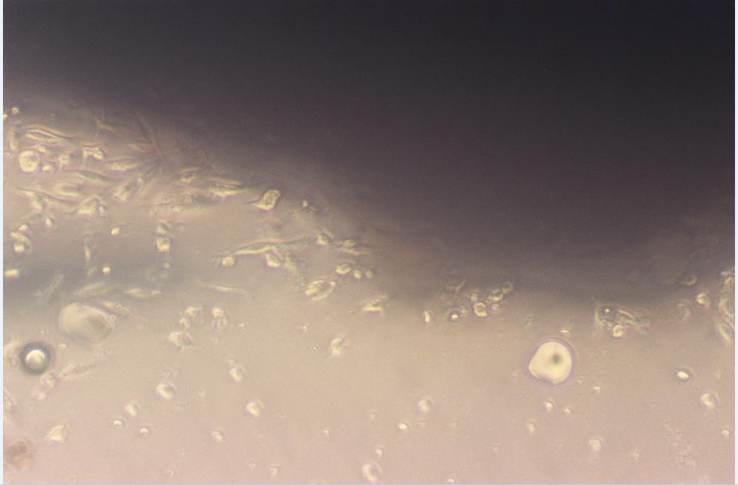
Two methods were used for fibroblast isolation and cultivation. The first is the explants culture technique according to protocol described by Keira et al. (2004). Isolation and dispersed cell culture according to protocol described by Lee et al. (2006) using different in concentration of trypsin, type of collagenase and centrifugation rate. We used high concentration of trypsin (0.3%) instead of 0.25%, collagenase NB 4 Standard Grade instead of collagenase type II and the centrifugation rate at 2000 rpm for 10 min instead of 500 ×g for 5 min.
Primary culture from each specimen was established and propagated first in a serum-containing medium (DMEM supplemented with 10% FBS), then in a serum free medium (Ultra Culture).

2.1 Preparation of Conditioned media
Conditioned media were prepared from 50% confluent passage one (P1) normal and keloid fibroblasts by using serum free medium.
Conditioned media were aseptically aspirated and stored in the refrigerator. P2 cultures were fed with different concentration of unconditioned media and conditioned media (25% & 50% v/v) every other day till the cultures were near confluent.
2.2 Methods of assay
Growth of cells in culture was assayed by cell counting using the standard hemocytometer chamber and spectrophotometric DNA& protein assays.
(1) Cell Counting
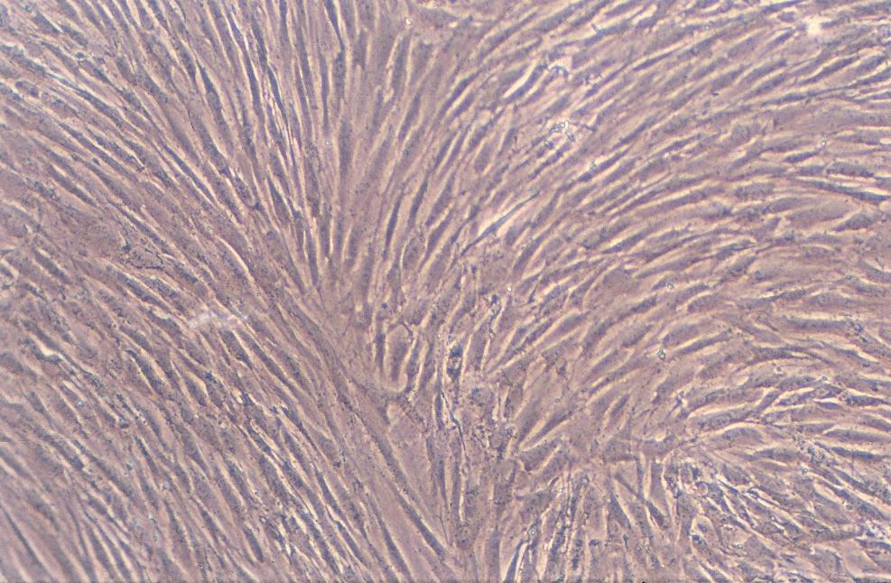
Cell count was done by using hemocytometer and the dye exclusion technique to calculate the number of viable cells.
(2) DNA ASSAY
DNA was extracted from culture cells using QIAamp DNA FFPE Tissue Kits manufactured by QIAGEN Group, Germany; 2007. The absorbance was measured at 260 nm by a spectrophotometer (Ultraspec 1000, UV/visible spectrophotometer, Amersham Pharmacia Biotech, Cambridge, England).
(3) PROTEIN ASSAY
Preparation of cell lysates from cultured cell pellets was done according to technique described by Eissa and Seada (1998). The concentration of protein was measured in cell lysate samples by the method described by Bradford (1976). A convenient standard curve can be made by using a series of dilutions of bovine serum albumin. Protein concentrations in the samples were determined spectrophotometrically at 595 nm (Ultraspec 1000, UV/visible spectrophotometer, Amersham Pharmacia Biotech, Cambridge, England).

3. Results:
In our experiments, we could successfully culture both normal human dermal and keloid fibroblasts using the explants culture technique shown in Figure 1 and the dispersed cell culture technique shown in Figure 2.
Microscopically, the gross characteristics and morphology of the cultured keloid fibroblasts were not different from those of normal fibroblasts under the culture conditions.

Figure 1. Fibroblasts proliferating from the edges of the explanted tissue to the Petri dish

Figure 2. P2 confluent fibroblast culture

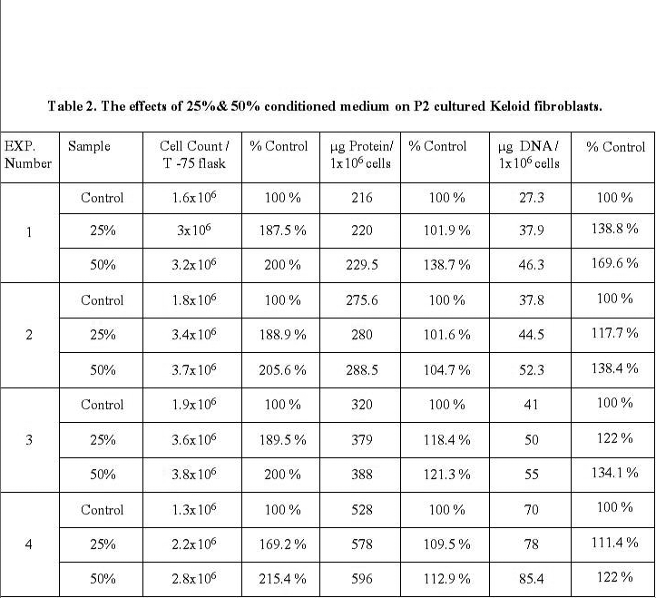
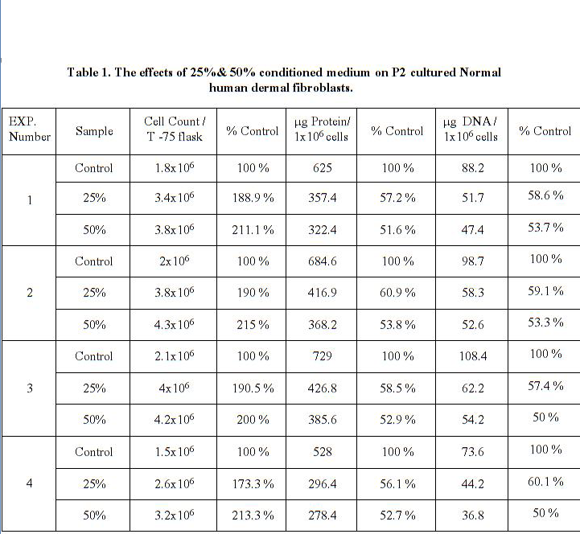

Four experiments were done on each keloid and normal human dermal fibroblasts to study the effects of fibroblasts conditioned medium at 25 & 50% concentration on P2 fibroblast. In each experiment, growth was quantitated by cell count, protein and DNA assays. The data are shown in Table 1 and Table 2 and curves are shown in Figure 3, Figure 4 and Figure 5.
Serum free conditioned medium increases cell count in both cultured normal human dermal and keloid fibroblasts (Figure 3).
Protein concentration / 1x 10⁶ cells increases in cultured keloid fibroblasts and decreases in cultured normal human dermal fibroblasts in response to their autosecreations released in serum free conditioned medium and that this effect is dose-related (Figure 4).

DNA/1x 10⁶ cells increases in cultured keloid fibroblasts treated by 25% & 50% conditioned medium and decreases in cultured normal human dermal fibroblasts (Figure 5).

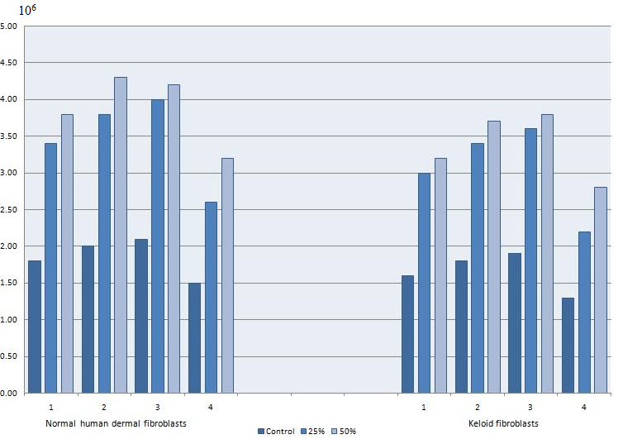

Figure 3. Cell count of cultured normal human dermal fibroblasts versus keloid fibroblasts

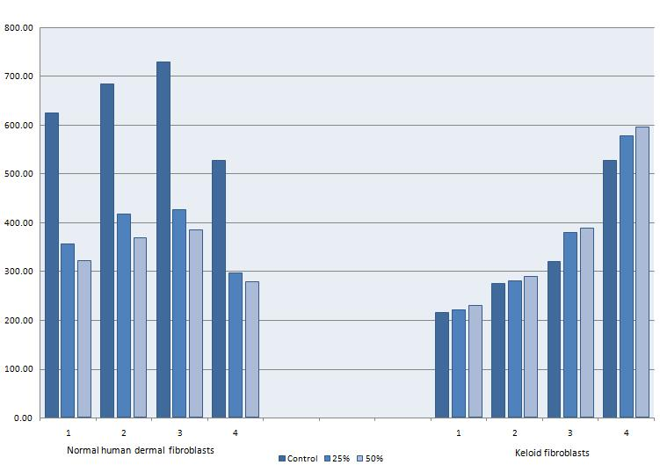

Figure 4. Protein concentrations in cultured normal human dermal fibroblasts versus keloid fibroblasts
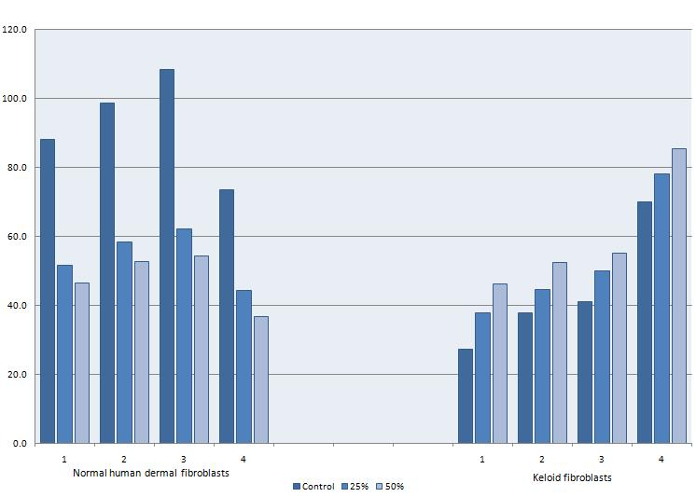

Figure (5): DNA concentrations in cultured normal human dermal fibroblasts versus keloid fibroblasts

4. Discussion
Calderon et al. (1996) evidenced that keloid fibroblasts possess an increased in vitro proliferation capacity which is consistent with a decreased apoptosis rate. Also, keloids are known to produce large amounts of ECM components that are even qualitatively different from those involved in the normal healing process (Luo et al. 2001). Matsuko et al. (1988) demonstrated a greater density of fibroblasts in keloids than in normal granulation tissue suggesting that fibroblast proliferation in vivo is increased in keloids. Kischer, (1992) has alluded to the hypercellular nature of keloids early in their development. This difference disappears in later phases of keloid development where cell numbers are the same or less than in normal scar or dermis (Mancini and Quaife, 1962).
In our study the cell yields in our conditioned medium groups were more than the control. There was definite increase in the cell population with the 25 and 50% conditioned medium over the experimental time period comparable to the control with both normal skin and with keloid fibroblasts.
Meenakshi et al. (2005) showed that Keloid fibroblasts have higher proliferation rate than normal skin fibroblasts. The rates of DNA synthesis and protein synthesis were studied in order to analyse the metabolic activity of these fibroblasts. Both these studies showed that keloid fibroblasts were metabolically more active than fibroblasts from normal skin.
In our study we confirmed the increased in metabolic activity of keloid fibroblasts. The amount of protein & DNA per million cells increased with keloid fibroblasts cultured in 25% & 50% serum free conditioned medium.
Younai et al. (1994) investigated the in vitro effects of Transforming growth factor-beta 1 (TGF-β1) on the rate of collagen synthesis in keloid fibroblasts and normal skin fibroblasts. In response to exogenous TGF-β1, keloid fibroblasts produced 12 times more collagen than normal fibroblasts. Tan et al. (1993) evaluated the effects of basic fibroblast growth factor (b.FGF) on keloid fibroblast cultures. They found that b.FGF causes a dose dependent inhibition of hydroxyproline biosynthesis, an index of collagen production. b.FGF may not play a key role in the formation of keloids, but that it may be a potential modulator in their treatment or prevention (Hanasono et al. 2003).
We did not assess the role of cytokines produced or released by cultured keloid fibroblast treated by conditioned medium. From the work done by different authors, the relative roles of TGF-β and b.FGF may explain the proliferative & metabolic effect of autocrine secretions of culture keloid fibroblast.

5. Conclusion

The in vitro culture studies allow for a defined system with well-defined parameters of cell type, cell number and the effect of autocrine secretion in different concentration on the cells. These in vitro systems are well suited for some creative designs to investigate the mechanisms underlying both normal and abnormal healing processes. The data confirmed that keloid fibroblasts were metabolically more active than fibroblasts from normal skin when treated with conditioned medium.
A study on cytokines produced by fibroblasts especially TGF-β and b.FGF may cast light on the pathogenesis and possible therapeutic approaches to keloid. This idea is suggested for future research specially because there is no suitable animal model for keloids and it is not ethical to do experimentation on living human keloid patient.

Correspondence to:
Omyma Mohammed El Shishtawy
Faculty of science
Helwan University, Egypt
Cellular phone: 002-016-8667824
Emails: omyma_mohamed_sayed@yahoo.com

References
[1] Brissett AE, Sherris DA. Scar contractures, hypertrophic scars, and keloids, Facial Plast Surg 2001: 17(4): 263–272.
[2] Raghow R. The role of extracellular matrix in post-inflammatory wound healing and fibrosis. FASEB J 1994: 8: 823-831.
[3] Tredget EE, Nedelec B, Scott PG , Ghahary A. Hypertrophic scars, keloids, and contractures. The cellular and molecular basis for therapy. Surg Clin North Am 1997: 77(3): 701–730.
[4] Eryilmaz T, Uygur S. Keloids: a rare location and review of the literature. Eur J Plast Surg 2010: 33(4): 221–223.
[5] English RS, Shenefelt PD. Keloids and hypertrophic scars. Dermatol Surg 1999: 25(8): 631–638.
[6] Sherris DA, Larrabee WF, Murakami CS. Management of scar contractures, hypertophic scars and keloidal scars. Otolaryngol Clin North Am 1995: 28(5): 1057-1068.
[7] Shaffer J, Taylor S , Cook-Bolden F. Keloid scars: A review with a critical look at therapeutic options. J Am Acad Dermatol 2002: 46: S63–97.
[8] Mofikoya BO, Adeyemo WL, Abdus-salam AA. Keloid and Hypertrophic Scars: A Review of Recent Developments in Pathogenesis and Management. Nig Q J Hosp Med 2007: 17(4): 134-139.
[9] Donkor P. Head and neck keloids: treatment by core excision and delayed intralesional injection of steroid. J Oral Maxillofac Surg 2007: 65(7): 1292-1296.
[10] Butler PD, Longaker MT, Yang GP. Current progress in keloid research and treatment. J Am Coll Surg 2008: 206(4): 731–741.
[11] Igarashi A, Okochi H, Bradham DM , Grotendorst GR. Regulation of connective tissue growth factor gene expression in human skin fibroblasts and during wound repair. Molecular biology of the cell 1993: 4(6): 637-645.
[12] Keira SM, Ferreira LM, Gragnani A, Duarte IS, Santos IAN. Experimental model for fibroblast culture. Acta Cir Bras 2004: 19: 11-16.
[13] Lee DY, Lee JH, Yang JM, Lee ES, Park KH , Mun GH. A new dermal equivalent: The use of dermal fibroblast culture alone without exogenous materials. J. Dermatol. Sci 2006: 43(2): 95-104.
[14] Eissa S, Seada LS. Quantitation of bcl-2 protein in bladder cancer tissue by enzyme immunoassay: comparison with Western blot and immunohistochemistry. Clinical Chemistry 1998: 44(7): 1423–1429.
[15] Bradford MM. A rapid and sensitive method for quantitation of microgram quantities of protein utilizing the principle of protein dye binding. Anal. Biochem 1976: 72: 248-251.
[16] Calderon M, Lawrence WT , Banes A.J. Increased proliferation of keloid fibroblasts wounded in vitro, J Surg Res 1996: 61(2): 343–347.
[17] Luo S, Benathan M, Raffoul W, Panizzon RG, Egloff DV. Abnormal balance between proliferation and apoptotic cell death in fibroblasts derived from keloid lesions, Plast Reconstr Surg 2001: 107(1): 87–96.
[18] Matsuoka LY, Uitto J, Wortsman J, Abergel RP, Dietrich J. Ultrastructural characteristics of keloid fibroblasts. Am. J Dermatopathol 1988: 10(6): 505-508.
[19] Kischer CW. The microvessels in hypertrophic scars, keloids and related lesions: a review. J. Submicrosc. Gytol. Pathol 1992: 24(2): 281-296.
[20] Mancini RE, Quaife JV. Histogenesiso fexperimentally produced keloids. J. Inuest. Dermatol 1962: 38: 143-181.
[21] Meenakshi J, Jayaraman V, Ramakrishnan KM, Babu M. Ultrastructural differentiation of abnormal scars. Annals of Burns and Fire Disasters 2005: 18(2): 83-88.
[22] Younai S, Nichter LS, Wellisz T, Reinisch J, Nimni ME, Tuan TL. Modulation of collagen synthesis by transforming growth factor-beta in keloid and hypertrophic scar fibroblasts, Ann Plast Surg 1994: 33 (2): 148–151.

[23] Tan EM, Rouda S, Greenbaum SS, Moore JH, Jr, Fox JW, Sollberg S. Acidic and basic fibroblast growth factors down regulate collagen gene expression in keloid fibroblasts. Am J Pathol 1993: 142(2): 463-470.
[24] Hanasono MM, Kita M, Mikulec, AA, Lonergan D, Koch RJ. Autocrine Growth Factor Production by Fetal, Keloid and Normal Dermal Fibroblasts. Arch facial plast surg 2003: 5(1): 26-30.

7/4/2011

