Use of dielectric properties in quality measurement of agricultural products
Mahmoud Soltani^{1*}, Reza Alimardaniand¹, Mahmoud Omid¹
- Department of Agricultural Machinery Engineering, Faculty of Agricultural Engineering and Technology, University of Tehran, Karaj, Iran
mahmoodsoltani39@yahoo.com
Abstract: A number of applications for capacitive sensor in agriculture have been used by different researchers over the past years. They measured the dielectric constant and loss factor of material which correlates well with certain quality factors of the products such as moisture content and ripeness. This paper presents an overview of various utilizations of dielectric properties in precision agriculture.
[Mahmoud Soltani, Reza Alimardaniand, Mahmoud Omid. Use of dielectric properties in quality measurement of agricultural products. Nature and Science 2011;9(4):57-61]. (ISSN: 1545-0740). http://www.sciencepub.net.
Keywords: Dielectric properties, Quality, Frequency.

- Introduction
Quality in agriculture is defined as the degree of excellence of a product or its suitability in a specific attributes. These characteristics include physical, mechanical and chemical properties, defects, nutritive values, storage time and ripeness level. Quality parameters of agricultural products are classified into the external properties such as size, color, shape and external defects, internal properties suck as sugar content, acidity, firmness and internal breakdowns.
Numerous methods of measuring quality and quality-related characteristics have been developed and tested. Recently, researches emphasize on developing non-destructive methods and sensors to qualify indices of agricultural products. One of these methods is dielectric measurements. In this method dielectric properties of products are measured and correlation between these properties and quality indices is investigated. In this paper some applications of dielectric properties in prediction of quality is reviewed.
- Dielectric properties
The dielectric properties, or permittivity, indicate the interaction of material with electric fields. The dielectric properties of usual interest are the dielectric constant and the dielectric loss factor, the real and imaginary parts, respectively, of the relative complex permittivity, ε = ε' – jε'' = |ε|e–jδ where δ is the loss angle of the dielectric. “Permittivity” is understood to represent the relative complex permittivity. The permittivity relative to free space, or the absolute permittivity divided by the permittivity of free space, ε₀ = 8.854 × 10^{–12} F/m. Often, the loss tangent, tan δ = ε˝/εَ, or dissipation factor, is also used as a descriptive dielectric parameter (Nelson & Trabelsi, 2002).
Dielectric properties can be measured by several methods which range from direct current to microwaves. Some of the most used devices and instruments to measure dielectric properties of agri-food materials encompass the parallel plate capacitor, coaxial probe, waveguide, resonant structure, inductance, capacitance- resistance meter(LCR meter), impedance analyser, and scalar and vector network analyser (Ragni et al, 2006).
- Application of dielectric properties
Afzal et al. (2010) estimated leaf moisture content by measuring the dielectric constant of leaves in five different types of crops. They used two semi-oval isolated copper plates and a Keithly 590 C-V Analyzer as the capacitance measuring instrument, which had the ability of measuring capacitance at two frequencies of 100 kHz and 1 MHz (Figure 1). They carried out experiments on five field crops of maize, sorghum, capsular bean, white bean and sunflower. According to their results, type, amount of ions and the leaf thickness affected the capacitance and produced the error in this method. They reported the coefficients of determination were higher at 100 kHz than at 1 MHz. They observed that the higher the leaf moisture, the more the data points scattered around the best-fit line, although the scattering was more uniform at 1 MHz.
Figur 1. Schematic of the capacitance measuring system (Afzal et al., 2010).
Campbell et al. (2005) designed and developed a system based on capacitive sensor for monitoring bees passing through a tunnel. They used two types of capacitive sensors, parallel plates and ring electrodes. They used a 4 Vpp sinusoidal signal at 33 kHz and bridge circuit to measure variation of capacitance that produced in sensors as a result of bee passing. They reported the ring sensor was superior for this application, while the ring sensor provided the same information on bee activity as the parallel plate sensor. Some advantages of ring sensor were its smaller electrodes, which decreased the size and easy to precisely position during manufacturing producing more symmetric voltage pulses. The designed a system was able to distinguish between entering and exiting bees and provide information on the size and velocity of each bee.
Li et al. (2003) measured moisture content of cookies using dielectric spectroscopy. They used concentric sensor head that designed for localized measurements. It had three electrically separated sensing electrodes that was used as a fringing field sensor or, when had combined with a driving plate, as a parallel-plate sensor. They used 6 volt, 10 Hz to 10 kHz frequency sweep signal and a divider circuit to measure the capacitance of sensor. They reported at the higher frequencies the sensitivity was increased, so they selected 10 kHz to calibrate the system. They calibrated system based on a linear model, where the functional dependence of capacitance on moisture content was determined. The system allowed for both online moisture content sensing and moisture distribution profile imaging.
Ragni et al. (2006) used a sine wave radio frequency oscillator with parallel plate capacitor sample probe to predict the quality of egg during storage period. They noted the suggested models enabled to classify samples of shell eggs, while they were not useful to assess with accuracy a single egg.
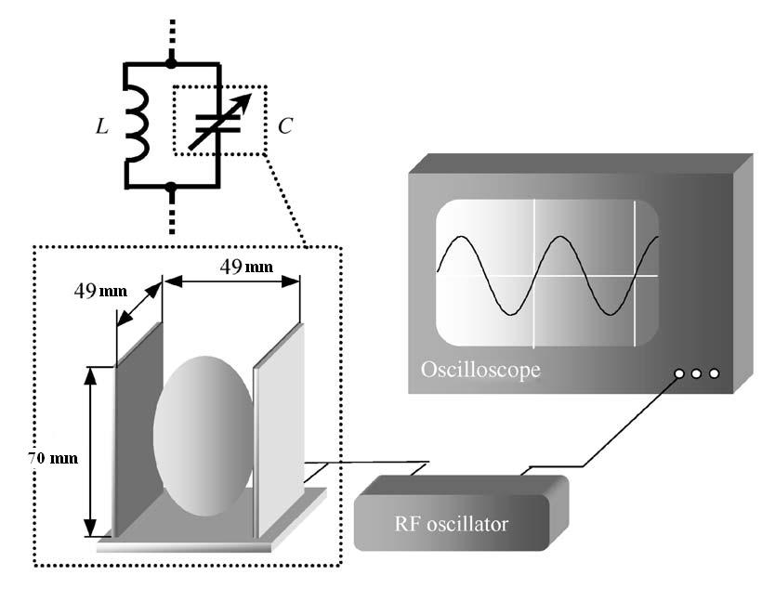
Figure 2. The system based capacitive sensor that was used to predict the egg quality (Ragni et al., 2006).
Jarimopas et al. (2005) designed and developed an electronic device with a cylindrical capacitive sensor to measure the volume of selected fruits and vegetables. They reported the electronic device volume measurements of a calibration set of 30 samples correlated very well with those produced by the water displacement method. The R² values for watermelons, large cucumbers, wax gourds and guavas were 0.999, 0.957, 0.999, and 0.99, respectively.
Nelson et al. (2007) measured the dielectric constant and loss factor with an open-ended coaxial-line probe and an impedance analyzer on external surfaces and internal tissue of four cultivars of miniature watermelons provided new permittivity data over a range of maturities at frequencies from 10 MHz to 1.8 GHz at 24 ˚C. They reported both the dielectric constant and loss factor of internal tissues decreased monotonically with increasing frequency showing the dominance of ionic conduction at lower frequencies and dipolar losses at the higher frequencies. They divided the dielectric constant and loss factor, each by soluble solids content and correlated between these parameters. The R² was obtained as 0.932.
Mizukami et al. (2006) measured moisture content of tea leaves using electrical impedance and capacitance method. They measured electrical impedance, resistance reactance, and capacitance using four stainless steel electrodes and an inductance, capacitance and resistance (LCR) meter. The LCR meter operated at a generator voltage of 1V, and it scanned 100 points in a frequency range 10 Hz–10 MHz (Figure 3).
Figure 3. A schematic illustration of the measuring system (Mizukami et al., 2006).
They reported both electrical impedance and capacitance had an effect on the moisture content of the tea leaves at a frequency of 3 kHz. The approximation of impedance and capacitance was insufficient for moisture measurement because of the high levels of standard error and low levels of correlation coefficient in a moisture range from 1.2–80% w.b. They developed a new equation, which simultaneously satisfied the two equations using impedance and capacitance. They obtained satisfying results.
Kato investigated the relationship between density and internal quality of watermelon. He proposed a new electrical method for density sorting of spherical fruits, which measured the volume of fruit by electric capacity and mass by electronic balance.
Bhatt et al. (2008) studied the electrical properties of wheat bread as functions of moisture content and storage time. They designed a system that estimated the moisture content in different zones of bread. They used multichannel ring electrodes to measure the electrical properties of various sections of beard. They reported the variations in capacitance as a function of moisture content at bread crust can be utilized not only to estimate the moisture content during storage but also help to understand the glass transition phenomenon at crust as a function of moisture content. They found resistance varied at bread crumb as an exponential equation with moisture content.

Figure 4. A devised system based on capacitive property for qualifying of watermelon (Kato, 1997).

Júnior (2008) designed a capacitive moisture meter for combines. They used an alternate voltage, a divisor voltage resistor and a capacitor as a sensor. They reported the best frequency that offered best sensitiveness to the measurement system calibration was 10 kHz. They calibrated the system for the corn in a range from 11% up to 27% of moisture.
Berbert et al. (2004) measured the dielectric properties of common bean seeds and estimated its moistue content. They proposed three models to predict the miosture content of seeds. They reported the resulting models could estimate common bean moisture content with standard errors of calibration in the range from 1.0 to 1.3 percentage points, and maximum errors from 1.9 to 3.5 percentage point’s moisture.
Trabelsi et al. (2009) measuered dielectric properties of shelled peanuts to estimate the moisture content. They carried out the experiments at temperatures ranging from 1 to 38 ˚C and frequencies ranging from 8 to 14 GHz. They obtained best result at 10 GHz frequency and proposed that equation were able to predict the misture content as functions of temprature and dielectric properties without knowledge of bulk density, also the calibration function showed the least variation with frequency.
Weidong designed and developed an on-line monitoring system to measure the moisture content of grain during drying process. They used a cylindrical capacitive sensor to measure the dielectric constant of grain that varied when the moisture content had changed. They proposed a model and predicted the moisture content of wheat and corn. They reported the largest deviation between the measured value and standard value was less than 5% which was quite satisfied with most drying operations.
Rai et al (2005) designed and developed a capacitive moisture meter for grain (wheat, paddy, sunflower, mustard and soybean). They used a rectangular parallel plates capacitor for measuring the moisture content. Their developed instrument was working satisfactorily for all practical purposes in the range of 5 - 25% of grain moisture with an accuracy of ±1%.
- Conclusion
In this paper some applications of capacitive sensor is presented. A capacitive sensor has favorable characteristics such as Robustness (capacity to resist to mechanical vibrations and eventual mechanical shocks), high speed, resistance to the bad environmental conditions, easy operation and low cost, so it used in precision agriculture. The main use of capacitive sensor is measuring of moisture content. Recently, scientists and researchers tended to qualifying of fruits and vegetables by dielectric measurements, but further researches of dielectric properties are necessary to obtain satisfactory results of sensing quality factors.
References
- Afzal A, Mousavi S. F, Khademi M. Estimation of leaf moisture content by measuring the capacitance. Journal of Agrcultural Science Technology 2010; 12: 339-346.
- Berbert P. A, Viana A. P, Dionello R. G, Carlesso V. O. Three dielectric models for estimating common bean moisture content. Drying 2004 – Proceedings of the 14th International Drying Symposium (IDS 2004). São Paulo, Brazil, 22-25 August 2004, vol. B, pp. 1502-1509.
- Bhatt C. M, Nagaraju J. Instrumentation to estimate the moisture content in bread using electrical impedance spectroscopy. Sensors & Transducers Journal 2008; 97 (10): 45-54.
- Campbell M. J, Dahn D.C, Ryan D. A. J. Capacitance-based sensor for monitoring bees passing through a tunnel. Measurement Science and Technology 2005; 16 : 2503–2510.
- Jarimopas B, Nunak T, Nunak N. Electronic device for measuring volume of selected fruit and vegetables. Postharvest Biology and Technology 2005; 35: 25–31.
- Júnior, M. L. L. Design and develop a low-cost capacitive type moisture measurement system embedded in combine: construction and electrical characteristics. ABCM Symposium Series in Mechatronics 2008; 3: 493-500.
- Kato K. Electrical density sorting and estimation of soluble solids content of watermelon. Journal of Agricultural Engineering Research 1997; 67: 161 – 170.
- Li X, Zyuzin A. S, Mamishev A. V. Measuring moisture content in cookies using dielectric spectroscopy. Proceeding of IEEE Conf. on Electrical Insulation and Dielectric Phenomena, 19-22 October 2003, Albuquerque, New Mexico, PP:459-462.
- Mizukami Y, Sawai, Y, Yamaguchi, Y. Moisture Content Measurement of Tea Leaves by Electrical Impedance and Capacitance. Biosystems Engineering 2006; 93 (3), 293–299.
- Nelson S.O, Trabelsi S. Sensing grain moisture content through dielectric properties. IEEE Sensors Applications Symposium Orlando, 2002; Florida, June 12-14.
- Nelson S. O, Guo W, Trabelsi S, Kays S. Dielectric spectroscopy of watermelons for quality sensing. Measurments science technology 2007; 18: 1887–1892. 15
- Ragni, L., Gradari, P., Berardinelli, A., Giunchi, A. and Guarnieri, A., 2006. Predicting quality parameters of shell eggs using a simple technique based on the dielectric properties. Biosystems Engineering, 94 (2), 255–262.
- Rai A. K, Kottayi S, Murty A. S. N. A low cost field usable portable digital grain moisturemeter with direct display of moisture (%). Science and Engineering Series 2005; 6(1): 97 – 104.
- Trabelsi S, Nelson S. O, Lewis M. A. Microwave nondestructive sensing of moisture content in shelled peanuts independent of bulk density and with temperature compensation Sensing and Instrumentation for Food Quality and Safety 2009; 3:114–121.
- Weidong C. On-line Monitoring System for Grain Moisture Content During Dryer Processing. 2007 International Conference on Agriculture Engineering, 591-594.

3/5/2011

