Identification and detection of a hepatitis C virus antigen in sera of patients with hepatocellular carcinoma

El-Shahat A. Toson^{1,*}, Tamer E. Mosa ² and Mohamed Maher ¹

1. Mansoura University, Chemistry Department (New Damietta), Egypt.
2. National Research Center, Cairo, Egypt
eatoson@yahoo.com

Abstract: Hepatocellular carcinoma (HCC) is a major cause of cancer death worldwide, accounting for over half a million deaths per year. Several lines of evidence indicate a strong causal association between hepatitis C virus (HCV) and HCC. The aim of the present study was to identify, purify and partially characterized one of HCV antigens in sera of HCC patients. Also, the possibility of HCV infection play a role in the development of HCC will be tested. Therefore, serum samples of 75 HCC patients and of 25 healthy individuals as a negative control were included in this study. HCV antigen was identified in these samples using western blotting and quantified using enzyme linked immunosorbent assay (ELISA). Western blot analysis showed a single immunoreactive band in sera of HCC patients infected with HCV at 27-kDa. In addition, the 27-kDa purified immunoreactive bands were eluted, mixed and characterized using various physicochemical treatments. Briefly, after such treatements the antigen was found to have protein nature. Moreover, ELISA technique was used to quantify the 27-kDa antigen. The cutoff level of ELISA above or below which the tested sera were considered positive or negative was calculated and was found to be 150 ng/L. Based on such cutoff value a total of 61 out of 75 serum samples of HCC patients were positive for HCV antigen using ELISA. However, zero out of 25 serum samples of healthy individuals were positive for HCV antigen. In addition, ELISA showed sensitivity 81% and specificity 100%. The antigen detection method showed positive predictive value 100% and negative predictive value 64%.
[El-Shahat A. Toson, Tamer E. Mosa and Mohamed Maher. Identification and detection of a hepatitis C virus antigen in sera of patients with hepatocellular carcinoma. Nature and Science 2011;9(3):24-30]. (ISSN: 1545-0740). http://www.sciencepub.net.

Key words: HCV; Hepatocellular carcinoma ; ELIS

1. Introduction
HCC is the third deadliest and the fifth most common cancer worldwide and its mortality is almost equal to its morbidity (Thorgeirsson et al., 2002). Carcinogenesis of HCC is a multi-factor, multi-step and complex process, which is associated with a background of chronic and persistent infection of HCV and hepatitis B virus (HBV) (Yu et al., 2003). Their infections along with alcohol and aflatoxin B1 intake are widely recognized as etiological agents in HCC (Tang, 2001). However, the underlying mechanisms that lead to malignant transformation of infected cells remain unclear. Therefore, early detection of cancer offers the best chance for cure; this is why regular screening for HCC is recommended (Thorgeirsson et al., 2002). The global prevalence of HCV infection is approximately 3% (170 million people). Chronic HCV infection progresses at a variable rate to cirrhosis in 15 to 20% of patients, who then have a 1 to 4% annual risk of developing HCC (Lauer et al., 2001). For these reasons the early diagnosis of HCV infection is crucial to prevent further transmission in high-risk groups and to allow for a rapid decision about its treatment (Gerlach et al., 2003). Antibody tests are unable to identify subjects in the early stage of infection, during which specific antibodies have not yet been produced, but the virus is present in the plasma, sometimes in large quantities (van der Poel et al., 1994). For HCV-RNA molecular tests, several generations of qualitative and/or quantitative HCV nucleic acid amplification technology (NAT) assays have been in use. All of such molecular tests are expensive. In addition, the identification and detection of native antigens may prove very useful tool in the diagnosis of the acute phase of infection by HCV as well as during re-infections and could pave the way for early treatment and consequently effective control of the disease (Muller-Breitkreutz et al., 1999; Poljak et al., 1997). Therefore, the aim of the present study was to identify, purify and characterize one of HCV antigens in sera of HCC patients to illustrate if HCV infection is associated with development of HCC or not.

Materials and Methods
Serum samples
Serum samples were obtained from 75 HCV-infected Egyptian patients (56 males and 19 females, aged 39 to 80 years, mean age 59.7 ± 9.5) at the Internal Medicine University Hospital, Mansoura University, Mansoura, Egypt. In addition, sera of 25 healthy volunteers (17 male and 8 female) were used as negative controls. All sera were stored at −20 ◦C until used. All patients were selected based on the pathological finding of thier previously taken liver biopsies which were positive for HCC. The HCV infection was diagnosed based on biochemical, serologic and histologic criteria. Such criteria include negative tests for hepatitis B virus (HBV; HBsAg, HBeAg, anti-HBe, anti-HBc, and anti-HBs), a positive test for anti-HCV antibody (Ortho HCV EIA: Ortho Diagnostics, Raritan, USA), HCV serotype IV (MUREX HCV SEROTYPING 1–6 assay, Abbott Diagnostics), and HCV-RNA level greater than 2000 copies per milliliter on PCR analysis (Cobas Amplicor HCV Monitor [version 2.0], Roche Diagnostics, Branchburg, USA).
An informed consent was obtained from all patients participated in the present study and they were fully informed concerning the diagnostic procedures involved and the nature of the disease. The present study was approved by the ethical committee of the Internal Medicine University Hospital, Mansoura University, Mansoura, Egypt.

Polyacrylamide gel electrophoresis and gel electroelution
25µg/well of each serum sample were mixed (v/v) with sample buffer containing 0.125M tris base, 4% (w/v) sodium dodecyl sulphate (SDS), 20% (v/v) glycerol, 10% (v/v) mercaptoethanol and 0.1% (w/v) bromophenol blue. The mixture was loaded into 10% vertical slab SDS-PAGE according to the method of Laemmli (Laemmli, 1970). A mixture of reference proteins (BioRad Laboratories, CA) was run in parallel. Gels were then stained with Coomassie blue.

Western immunoblotting
The serum samples which were separated by SDS-PAGE were transferred from the polyacrylamide gel to nitrocellulose (NC) sheet according to the method of Towbin (Towbin et al., 1979). The NC membrane was blocked using 5% (w/v) non-fat dry milk in 0.05 M Tris-buffered saline (TBS) containing 200 mM NaCl (pH 7.4). The NC paper was rinsed in TBS and incubated with anti-HCV IgG antibodies (ABC Diagnostics, New Damietta, Egypt) which raised against the purified HCV antigen with constant shaking (Attallah et al., 2003b). The NC membrane was washed 3 times (30 min each) in TBS, followed by incubation for 2 h with goat anti-rabbit IgG alkaline phosphatase conjugate (Sigma) diluted 1: 500 in TBS. After washing 3 more times with TBS (15 min each), the NC membrane was soaked in premixed NBT/BCIP substrate (ABC Diagnostics). The color was observed within 10 min, and the reaction was stopped by dipping the NC membrane in distilled water.

Purification and elution of HCV antigen
The target HCV antigen band (27-kDa) was cut and electroeluted from preparative polyacrylamide gels at 200 volts for 3 h in a dialysis bag according to Attallah et al. (Attallah et al., 2003a). After dialysis, HCV antigen was concentrated using polyethylene glycol and 40% trichloroacetic acid, then centrifuged at 10,000 rpm for 15 min. The precipitate was washed twice using diethyl ether. The excess diethyl ether was removed by gentle drying and the pellet was reconstituted in phosphate buffered saline (PBS, pH 7.2). The protein content of the purified HCV antigen was determined according to Lowry et al. (Lowry et al., 1951) and stored at −20 ◦C.

Detection of HCV antigen using ELISA:
After optimization of the reaction condition, polystyrene microtiter plate was coated with 50 µl/well of serum sample diluted 1:250 in coating buffer (pH 9.6) and was incubated overnight at 4 ºC. After washing, 50 µl/well of 1:50 diluted specific anti-HCV IgG antibody (ABC Diagnostics) in PBS-Tween 20 (PBS-T20) were added and incubated at 37 ºC for 2 h. After washing, 50 µl/well of anti-rabbit IgG alkaline phosphatase conjugat (Sigma) diluted 1:350 in 0.2% (w/v) BSA in PBS-T20, were added, and incubated for 1 h at 37 ºC. The amount of coupled conjugate was determined by incubation with p-nitrophenyl phosphate substrate (Sigma). After that the reaction was stopped by adding NaOH and the absorbance was read at 490 nm using ∑960 microplate autoreader (Metreiteck, Germany). Serial purified HCV antigen were used to establish a standard curve for quantitative determination of HCV antigen in serum. Cut-off level of ELISA concentration (150 ng/ml) above or below which the tested sample is considered positive or negative was calculated as the mean concentration of 16 serum samples from healthy volunteers ± 3 (S.D.)

Biochemical characteristics HCV antigen
The purity of the HCV antigen from serum samples was assessed using SDS-PAGE techniques. To characterize the HCV antigen, the antigen was treated with protolytic enzymes or several other chemical reagents and then its reactivity was retested using ELISA. The periodate oxidation was carried out overnight with 20 mM sodium meta-periodate at RT and the reaction was then inhibited by adding an equal volume of 130 mM glycerol. The purified HCV antigen (at 50 μg/ml) was mixed with an equal volume of 20, 60, or 180 mM β-Mercaptoethanol. In the test with protolytic enzymes, the purified antigen (0.1 mg/ml) was incubated at 37 °C with α-chymotrypsin (0.1 mg/ml; Sigma) for 5, 10, 15, 30 or 45 min. Also, the serum samples from healthy individuals were tested in parallel as controls.

Statistical analysis
All statistical analyses were done by a statistical software package (SPSS 15.0 for Microsoft Windows, SPSS Inc.). Descriptive results were expressed as mean ± SD and range or number (percentage) of patients with a condition. Differences in continuous variables were assessed using student t-test or ANOVA and X² test for categorical variables. The statistical significance (two-tailed) was assessed at the 0.05 level for the all tests. The diagnostic sensitivity, specificity, efficiency, and positive predictive values (PPV) and negative predictive (NPV) values were also calculated.

Results
Identification of a HCV antigen in HCC serum samples
SDS-PAGE:
Figure 1 showed the Coomassie Brilliant blue stained SDS-PAGE of 3 serum samples of HCC patients infected with HCV (lanes 1-3), versus those of 3 healthy non-infected controls (lanes 4-6). The resolved bands were identified only in serum samples after staining the gel by Coomassie Brilliant Blue R-250 dye.
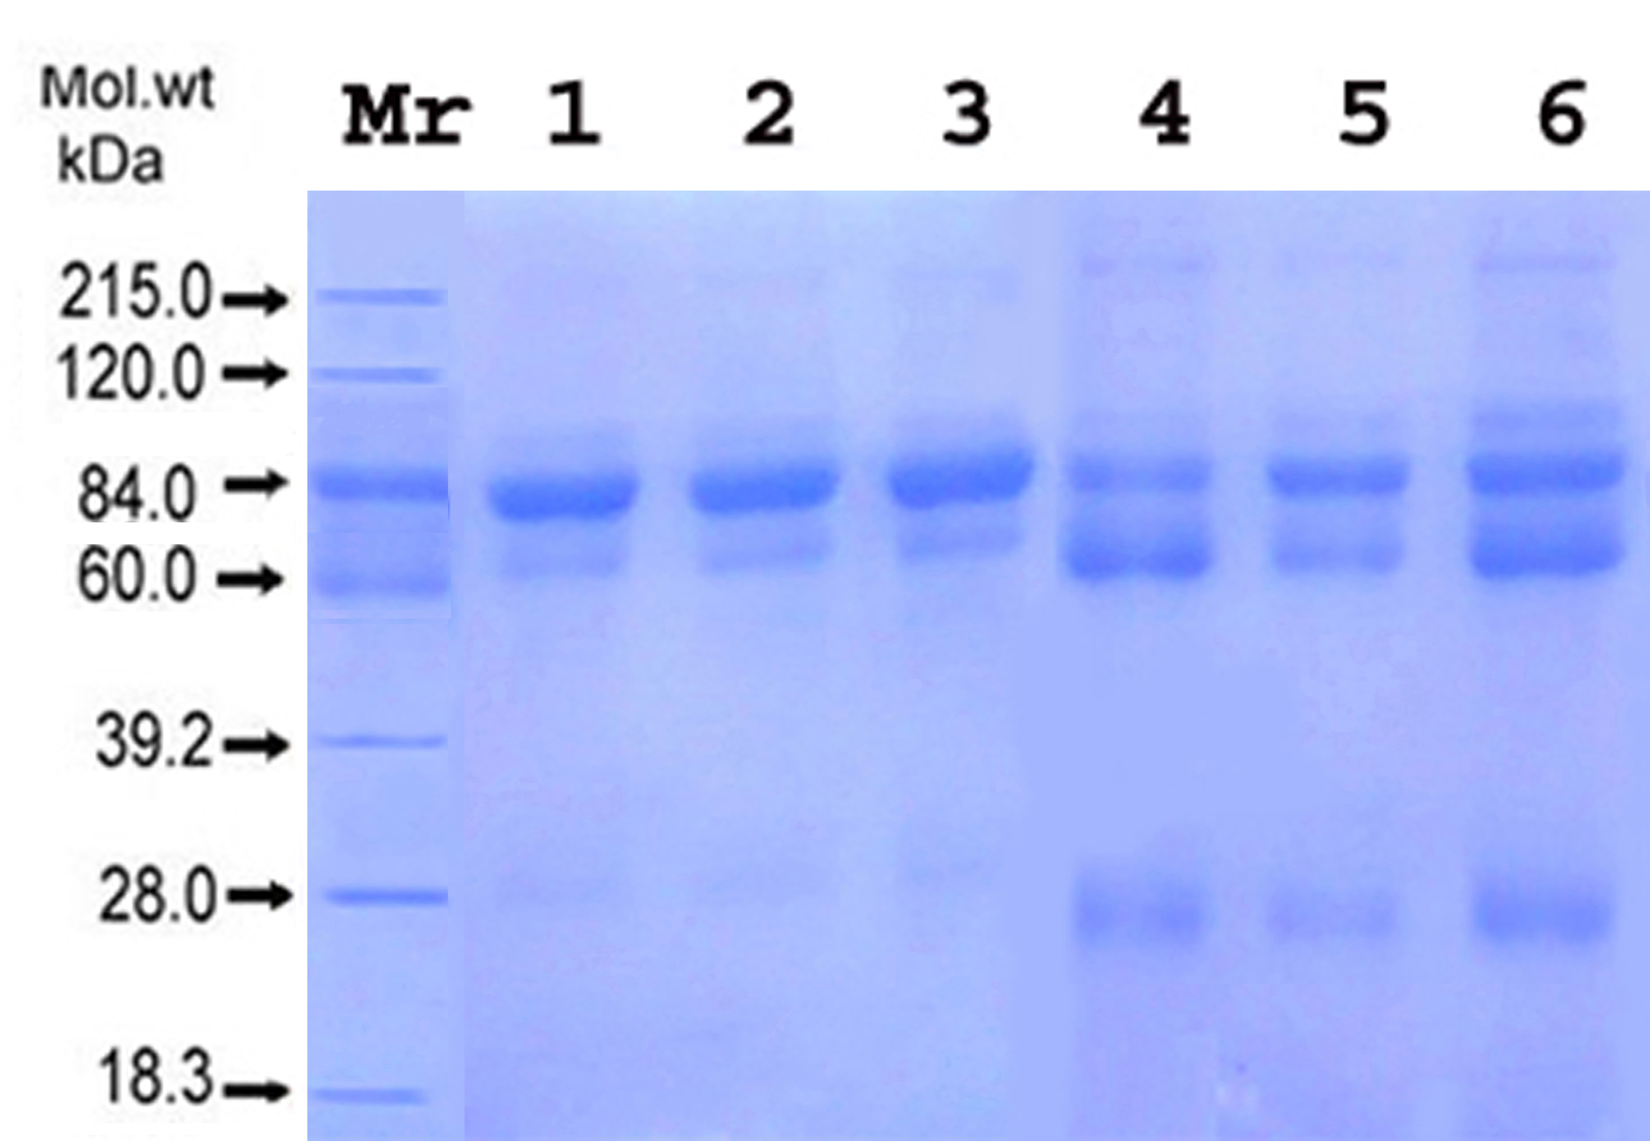
Fig. 1: Coomassie Brilliant blue stained SDS-PAGE showing the polypeptide pattern of serum samples of HCC patients. Lanes (1-3): 3 Serum samples of healthy individuals. Lanes (4-6): 3 HCC serum samples and molecular weight marker (Mr.) which includes: Myosin (215.0 kDa), phosphorylase B, (120.0 kDa), Bovine serum albumin (84.0 kDa), Ovalbumin (60.0 kDa), carbonic anhydrase (39.2 kDa), trypsin inhibitor (28.0 kDa), and lysozyme (18.3 kDa).

Western blotting
Figure 2 showed the immunoblotting patterns of 3 HCC patients infected with HCV (lanes 4-6) and 3 samples of the healthy controls (lanes 1-3). An intense sharp band was shown only in sera of HCC samples which were infected with HCV at 27-kDa. On the other hand, no reaction was found in sera of the healthy individuals.

Isolation and purification of HCV antigen by SDS-PAGE:
After immunoblotting and electroelution of the target 27-kDa HCV antigen from sera of HCC patients, the antigen was precipitated by trichloroacetic acid (TCA) and both precipitate and supernatant were tested using 16% SDS-PAGE for the presence of the target antigen or not. Figure 3 showed that the 27-kDa was found only in the precipitate indicating that the antigen is a protein.
Detection of HCV in serum using ELISA technique
Quantitation of HCV antigen in unknown samples was performed using ELISA technique. As shown in table 1 a total of 61 out of 75 HCC serum samples (81 %) were positive for the target 27-kDa HCV antigen using ELISA. However, zero out of 25 serum samples (0 %) of the healthy individuals were positive for HCV antigen. Based on the previous data, the detection rate of the target HCV antigen is highly significantly (p<0.0001) differ than that of the healthy control group. Based on the data of table 1 the sensitivity, specificity, efficiency, positive predictive value and negative predictive value were calculated to be 81%, 100%, 86%, 100% and 64% respectively. These results indicated that the ELISA technique based on the detection of the target 27-kDa is sensitive and highly specific for detection of HCV infection.
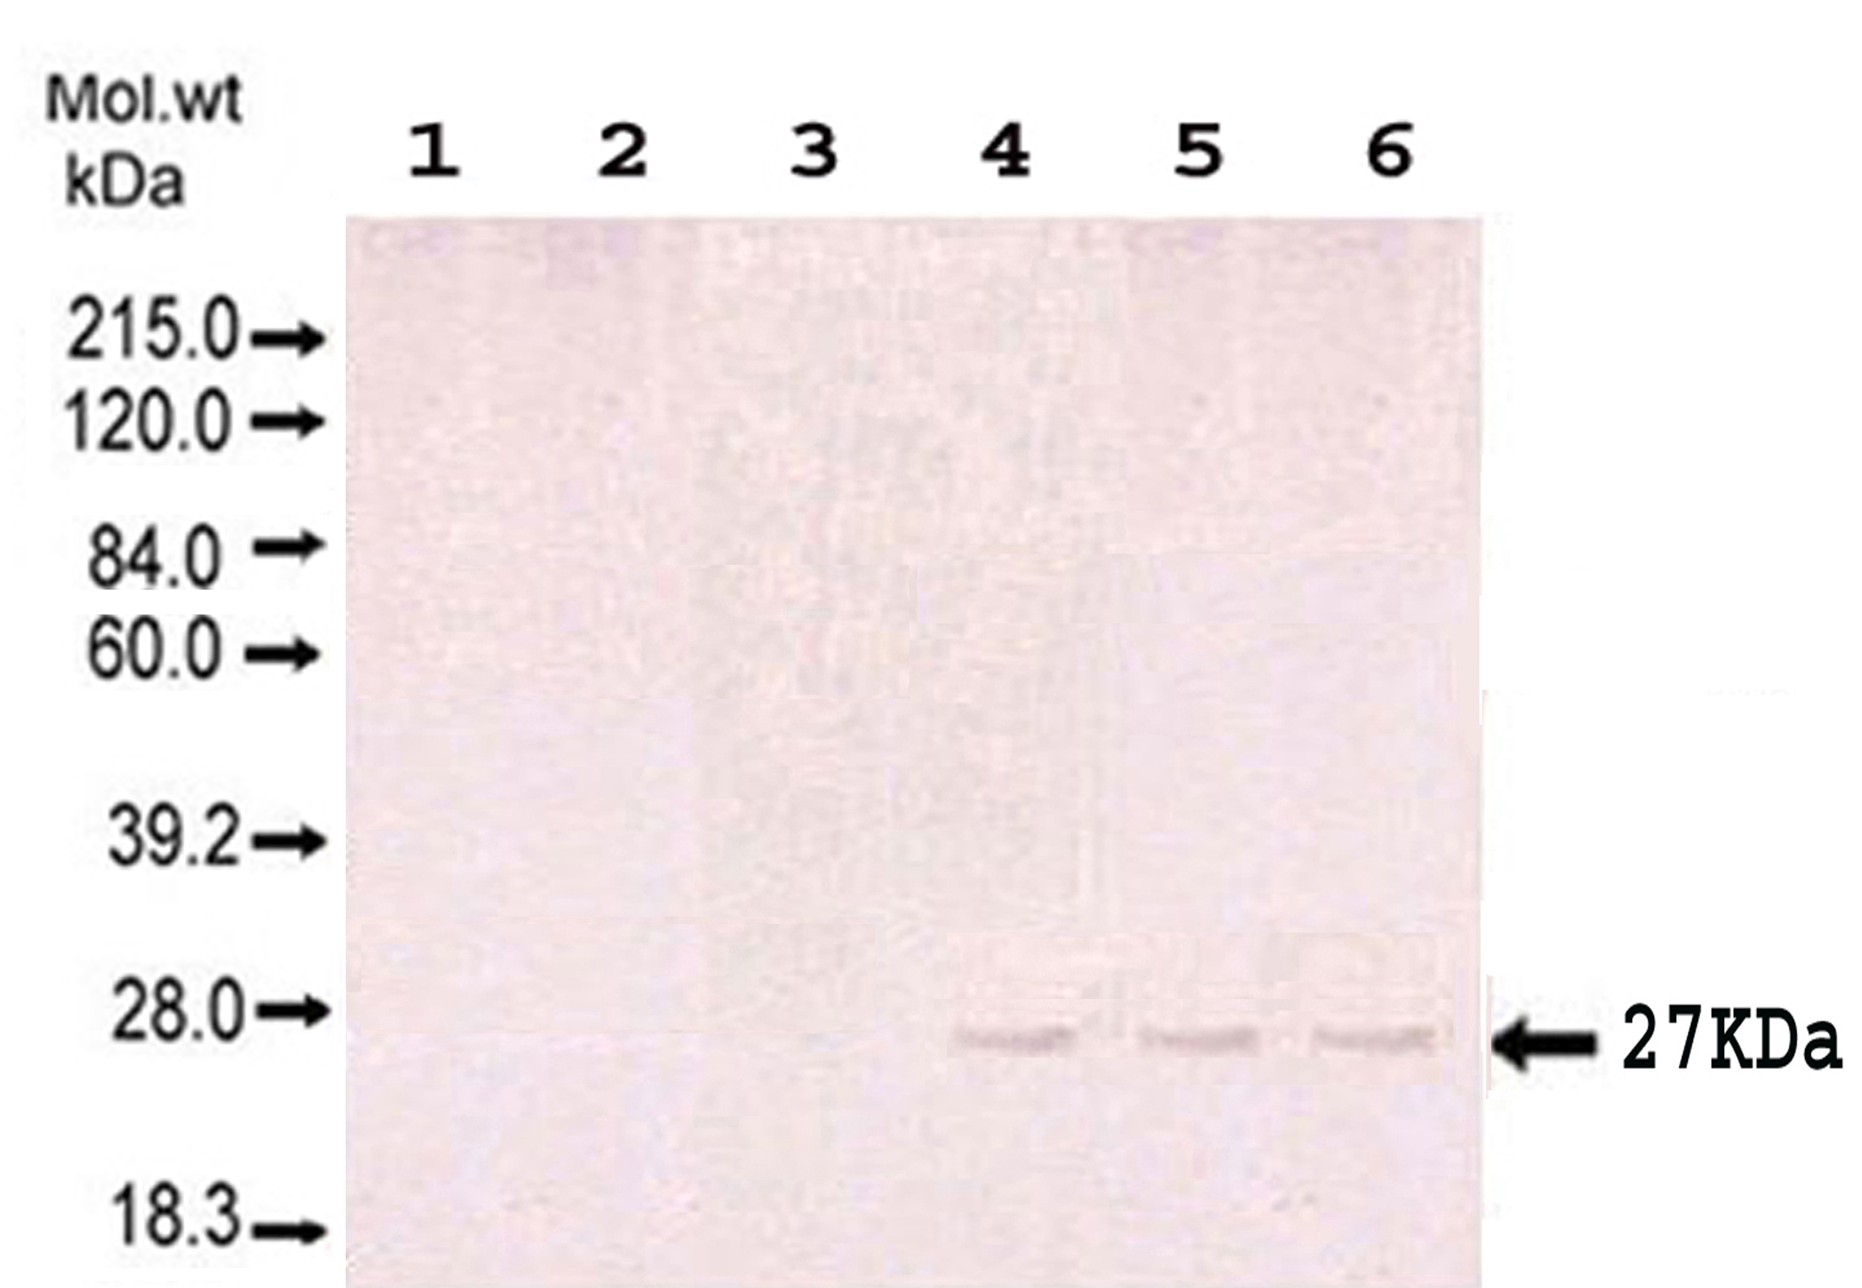
Fig. 2: Immunoblots of mono-specific antibody in serum samples of HCC patients. Lanes (1-3): 3 Serum samples of healthy individuals, Lanes (4-6): 3 HCC serum samples.

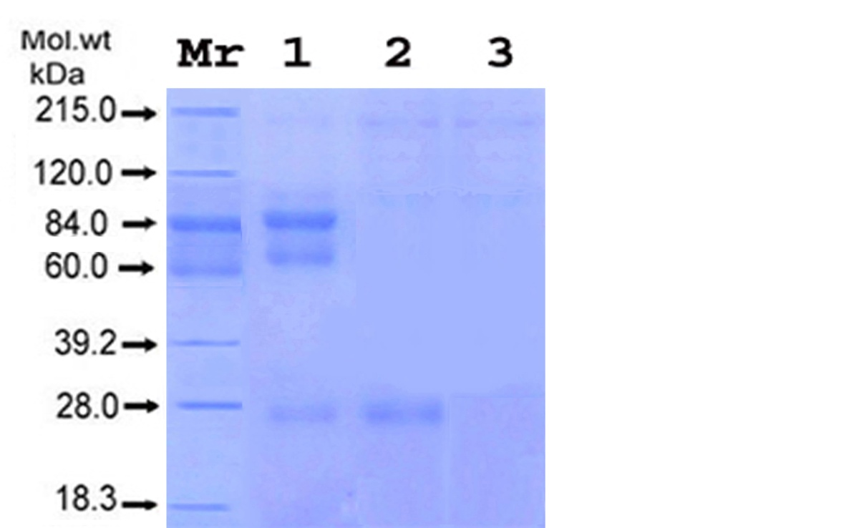

Fig. 3: Coomassie blue stain of 16% polyacrylemide gel under reducing condition in presence of SDS. Lane 1: Serum sample from HCC patient, lane 2: The trichloro acetic acid (TCA) precipitates of the purified fraction from serum samples of HCC patients. Lane 3: The TCA supernatant of the purified fraction from serum samples of HCC patients.

Table 1: Detection rate of HCV target antigen in sera of HCC patients and healthy individuals using ELISA technique.

Sens: Sensitivity, Spec.: Specificity, PPV: Positive predictive value, NPV: Negative predictive value and Effe.: Efficiency.

Effe. | NPV | PPV | Spec. | Sens. | P value | % of positivity | HCV antigen |  | No |  | Group
 |  |  |  | Sens. |  | % of positivity | Negative | Positive |  |  | Group
86% | 64% | 100% | 100% | 81% | < 0.0001 | 81 | 14 | 61 |  | 75 | Patients (HCC/HCV)
 |  |  |  | 81% |  | 0 | 25 | 0 |  | 25 | Control

Partial characterization of 27-kDa HCV antigen from HCC samples
Effect of heat:
Figure 4 A show the reactivity of the target HCV antigen using ELISA was lost starting from 56 ºC.

Effect of Periodate:
Figure 4 B illustrate the pattern of reactivity of the target antigen with its specific antibody after periodate treatement. The specific anti-HCV antibody still show high reactivity towards the target HCV serum antigen after treatement with periodate.

Effect of β Mercapto-Ethanol:
The reactivity of specific anti-HCV antibody towards
mercaptoethanol (Zero, 20, 60 & 180 mM) (Figure 4 C). As shown from such figure the antigen reactivity was lost above 60 mM β-Mercaptoethanol treatment after 1hr. the purified HCV antigen from HCC serum samples after addition of different concentrations of β–

Effect of Proteolysis:
The specific anti-HCV antibody showed high reactivity at 15 and 30 minutes after antigen treatment with α-chymotrypsin, while it was lost after antigen treatment with α-chymotrypsin for 45 minutes (Figure 4 D).

Effect of 0.2 M HCl and 0.2 M NaOH :
The reactivity of the target HCV antigen was lost after acid or alkali treatment. i.e. the concentration value of HCV antigen was lower than that of the cut-off value which is 150 ng /L (Data not shown).

DISCUSSION
The identification and detection of native antigens may prove very useful in the diagnosis of acute phase of infection by HCV as well as during reinfections and could pave the way for the disease. Monoclonal antibodies (MAb) were used for the identification of antigenic determinants of native non structural protein (NS4) (Brody et al., 1998). However, some MAb and polyclonal antibodies to recombinant proteins and synthetic HCV peptides do not react with native viral antigens (Masalova et al., 2002). A highly specific antibody to recombinant HCV-NS4 protein was generated and the target antigen was detected in sera from patients with chronic HCV using a simple and rapid dot-enzyme immunoassay with high degrees of sensitivity and specificity (Attallah et al., 2003b). In the present study, HCV antigen was identified in sera from HCC patients at 27-kDa molecular weight which contains several epitopes of both linear and conformation-dependent nature. The molecular weight (27-kDa) of the target HCV native antigen is similar to that of the HCV-NS4B protein (Konan et al., 2003). Zheng (Zheng et al., 2005) found that the expression profile of HeLa cells which are stably transfected by HCV non-structural protein 4B was identified at a molecular weight of 27-kDa by using an immunoblot analysis technique based on he use specific monoclonal antibody. I general, the NS viral sequences may represent valuable immunogens for the preparation of therapeutic or prophylactic vaccines (Leroux-Roels, 2005).
Tabll (Tabll et al., 2008) established hybridoma cells
secreting monoclonal antibodies against E1 synthetic peptide of HCV. BALB/c mice were immunized with HCV E1-synthetic peptide (GHRMAWDMM) and its pleenocytes were fused with the P3NS1 myeloma cell line. Two highly reactive and specific mAbs (10 C7 IgG2b mAb, and 10B2 IgG1 mAb) were generated. The target HCV E1 antigen was identified at approximately 38 kDa in serum of infected individuals. El Awady (El Awady et al., 2006) used Western blot to demonstrate the presence of the core and E1 target antigen in serum samples. Western blot analysis based on monospecific antibodies against core and E1 recognized the 38-kDa and 88-kDa bands respectively in the sera of all infected patients. No specific reaction was observed with the sera from uninfected individuals.

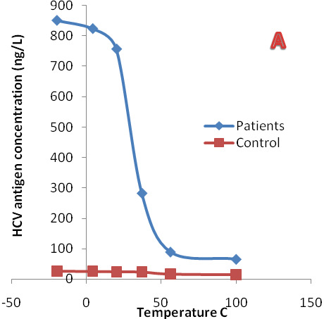
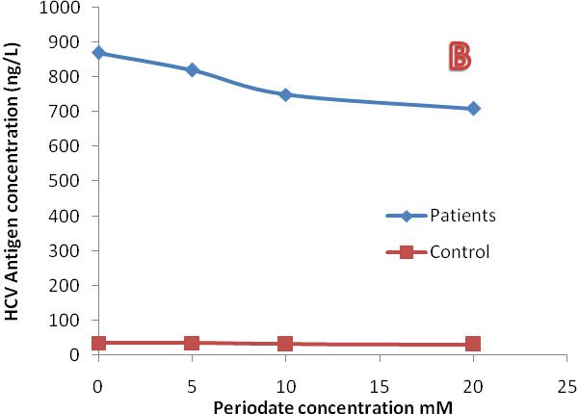
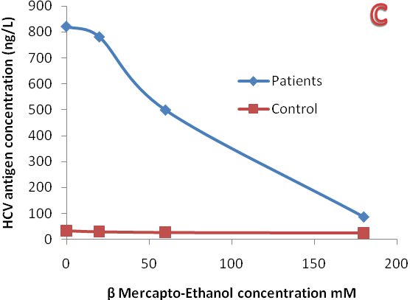
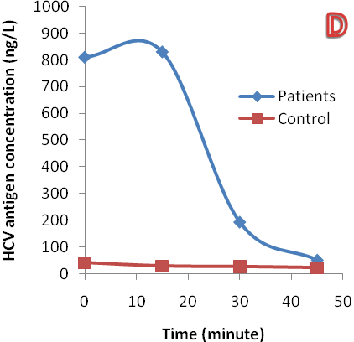
Fig. 4 Partial characteristics of HCV antigen. A: Effect of temperature, B: Effect of periodate concentration, C: Effect of β Mercapto-Ethanol and D: Effect of incubation time with α chemotrypsin.

In the present study, the purified HCV antigen from sera of HCC patients was analyzed by 16% SDS-PAGE and stained with Coomassie blue stain. The results showed that a polypeptide chain at 27-kDa was bound only in serum samples from HCC patients. In addition, enzyme linked immunosorbent assay (ELISA) format based on antisera to the purified 27-kDa HCV antigen was used for the detection of the native serum antigen in sera of Egyptian patients. Based on the a total of 61 out of 75 serum samples (81 %) of HCC patients were positive for the target HCV antigen.
However, zero out of 25 serum samples (0 %) of healthy individuals were positive for HCV antigen. These results indicate that HCV infection may be one of the major factors participating in HCC development (Anzola, 2004).
Antibody tests fail to identify HCV infected subjects before seroconversion or during the window period, when specific antibodies have not yet been produced or are in low titers. However, the virus continues to replicate and RNA can be detected in the plasma using polymerase chain reaction (PCR). In the present study, HCV antigen assay was used as a tool of HCV detection. This is due to its simplicity in use compared with PCR. Also, its high sensitivity and specificity can confirm its use.
A false negative HCV antigen result was obtained in only 14 HCC patients out of 75 patients in this study. This is may be due to the reduction of hepatocytes in the end stages of livers diseases (HCC or hepatic-cirrhosis) phenomena which is associated with lower HCV replication rates than the patients with less severe liver disease. Also, this is may be due to the role of fibrosis which became severe at the end stage of liver damage which participates in cell-to cell virus transmission.
A more detailed structural analysis of native HCV particles from infected hosts requires higher titres of virus. Unfortunately, low titre of HCV antigen will be found in serum, therefore characterization of native virus particles has been difficult. In the present study, the specific HCV antigen band (27-KDa) was identified. Using preparative gel of SDS-PAGE a large amount of the target HCV antigen was obtained, eluted and characterized using biochemical techniques which were previously illustrated in subjects and methods. The results of the characterization study showed that the reactivity of the serum HCV antigen was lost after exposure to 56 ºC or more. Also, it was lost after acid, alkali and β-mercaptoethanol treatment. On the other hand, it was maintained after periodate. Also, the HCV antigen which was treated with constant concentration of α-chymotrypsin enzyme for 15, 30, 45, and 60 minutes showed a decease in reactivity with the increase in the incubation time with the enzyme. Also the reactivity was completely lost after 60 minutes of incubation indicating a complete digestion of the simple protein antigen. In conclusion, HCV antigen was detected in serum samples of 81% of the patients which were previously infected with HCV using ELISA indicating that HCV may be one of the major factors leading to HCC development. Also, the target antigen was characterized and was found to have simple protein structure with a molecular weight of 27- KDa.
Correspondence to:
Dr/ El-Shahat A. Tosom
Faculty of science (Damietta)
Mansoura University, Egypy
Telephone: 002-050-2280518
Cellular phone: 002-010-3899211
Emails: eatoson@yahoo.com

References
Anzola M. Hepatocellular carcinoma: role of hepatitis B and hepatitis C viruses proteins in hepatocarcinogenesis. J Viral Hepat 2004;11(5): 383-393.

Attallah AM, Abdel-Aziz MM, El-Sayed AM, Tabll AA. Detection of serum p53 protein in patients with different gastrointestinal cancers. Cancer Detect Prev 2003a; 27(2): 127-131.

Attallah AM, Ismail H, Tabll AA, Shiha GE, El-Dosoky I. A novel antigen detection immunoassay for field diagnosis of hepatitis C virus infection. J Immunoassay Immunochem 2003b; 24(4): 395-407.

Brody RI, Eng S, Melamed J, Mizrachi H, Schneider RJ, Tobias H, Teperman LW, Theise ND. Immunohistochemical detection of hepatitis C antigen by monoclonal antibody TORDJI-22 compared with PCR viral detection. Am J Clin Pathol 1998;110(1): 32-37.

El Awady MK, El Abd YS, Shoeb HA, Tabll AA, Hosny Ael D, El Shenawy RM, Atef K, Bader El Din NG, Bahgat MM. Circulating viral core and E1 antigen levels as supplemental markers for HCV chronic hepatitis. Virol J 2006; 3: 67.

Gerlach JT, Diepolder HM, Zachoval R, Gruener NH, Jung MC, Ulsenheimer A, Schraut WW, Schirren CA, Waechtler M, Backmund M, Pape GR. Acute hepatitis C: high rate of both spontaneous and treatment-induced viral clearance. Gastroenterology 2003;125(1): 80-88.

Konan KV, Giddings TH, Jr., Ikeda M, Li K, Lemon SM, Kirkegaard K. Nonstructural protein precursor NS4A/B from hepatitis C virus alters function and ultrastructure of host secretory apparatus. J Virol 2003;77(14): 7843-7855.

Laemmli UK. Cleavage of structural proteins during the assembly of the head of bacteriophage T4. Nature 1970;227(5259): 680-685.

Lauer GM, Walker BD. Hepatitis C virus infection. N Engl J Med 345(1): 41-52.

Lowry OH, Rosebrough NJ, Farr AL, Randall RJ. 1951. Protein measurement with the Folin phenol reagent. J Biol Chem 2001,193(1): 265-275.

Masalova OV, Lakina EI, Abdulmedzhidova AG, Atanadze SN, Semiletov YA, Shkurko TV, Burkov AN, Ulanova TI, Pimenov VK, Novikov VV, Khudyakov YE, Fields H, Kushch AA.. Characterization of monoclonal antibodies and epitope mapping of the NS4 protein of hepatitis C virus. Immunol Lett 2002;83(3): 187-196.

Muller-Breitkreutz K, Baylis SA, Allain J. Nucleic acid amplification tests for the detection of blood-borne viruses. 5th EPFA/NIBSC Workshop, Amsterdam 1998. Vox Sang 1999,76(3): 194-200.

Poljak M, Seme K, Koren S. Evaluation of the automated COBAS AMPLICOR hepatitis C virus PCR system. J Clin Microbiol 1997,35(11): 2983-2984.

Tabll AA, Khalil SB, El-Shenawy RM, Esmat G, Helmy A, Attallah AF, El-Awady MK.. Establishment of hybrid cell lines producing monoclonal antibodies to a synthetic peptide from the E1 region of the hepatitis C virus. J Immunoassay Immunochem 2008;29(1): 91-104.

Tang ZY. Hepatocellular carcinoma--cause, treatment and metastasis. World J Gastroenterol 2001;7(4): 445-454.

Thorgeirsson SS, Grisham JW. Molecular pathogenesis of human hepatocellular carcinoma. Nat Genet 2002;31(4): 339-346.

Towbin H, Staehelin T, Gordon J. Electrophoretic transfer of proteins from polyacrylamide gels to nitrocellulose sheets: procedure and some applications. Proc Natl Acad Sci U S A 1979;76(9): 4350-4354.

van der Poel CL, Cuypers HT, Reesink HW. Hepatitis C virus six years on. Lancet 1994;344(8935): 1475-1479.

Yu AS, Keeffe EB. Management of hepatocellular carcinoma. Rev Gastroenterol Disord 2003;3(1): 8-24.

Zheng Y, Ye LB, Liu J, Jing W, Timani KA, Yang XJ, Yang F, Wang W, Gao B, Wu ZH. Gene expression profiles of HeLa Cells impacted by hepatitis C virus non-structural protein NS4B. J Biochem Mol Biol 2005;38(2): 151-160.

25/1/2011

