Meristic, Morphometric Characteristics of Frill-fin goby (Bathygobius soporator valenciennes, 1837) from Lagos Lagoon, Nigeria.

Adeboyejo, O. A.

Department of Fisheries, Faculty of Science, Lagos State University, Lagos-Nigeria.
adeboyejoakintade@yahoo.co.uk

Abstract: During the period of March 2010 to August 2010, 500 specimens of Bathygobius soporator were collected from Makoko-Iwaya area of Lagos lagoon in mainland area of Lagos state, Nigeria. The number of females were 204 while males numbered 296 giving a sex ratio of 1.45 in favour of males. The size range for males was between 6.0cm and 34.10cm total length (mean = 14.28 + 4.21 TL). However, the body weight measurement for the males ranged from 8.00 – 135.00g. The total length measurement for female was between 6.2cm and 32.5cm (mean = 15.61 + 4.38) and from 8 - 135g body weight (mean = 39.97 + 24.7). A positive correlation existed between length and weight for males ( r = 0.67) and females (0.47). The b values were 4.58 and 3.99 for males and females respectively. The condition factor (K) were (1.15 – 1.20) and (2.00 – 2.30) for male and female respectively. The gonad weight ranged between (0.10 – 4.20) and the GSI ranged between 0.21 – 26.58 (mean = 3.77 + 2.49). The food items of the species in the lagoon were Fish-fry, Worms, Shrimps, Crabs and Bulinous species.
[Adeboyejo, O. A. Meristic, Morphometric Characteristics of Frill-fin goby (Bathygobius soporator valenciennes, 1837) from Lagos Lagoon, Nigeria. Nature and Science 2011;9(3):16-23]. (ISSN: 1545-0740). http://www.sciencepub.net.

Key words: fish biology, meristic, morphometric, Lagos lagoon, Gonadosomatic index, and goby.

- Introduction
Bathygobius soporator is a bony fish that belong to the family Gobiidae. Members of this family are Signogobius ocellarus (Twinspot Goby), Pleurosicya mossambica (Toothy goby), Istigobius rigilius (orange-spotted goby), Gnatholepsis thomponi (Gold-spot goby) etc. The family are mostly small sizes, in which the two pelvic fins are united to form a cup-like sucking disc, which they use to hold on to rocks (Nelson, 1994). A few gobies occur in deep water and a few are found at the surface, but the vast majority live in rock-pools between tidal-marks where their modified pelvic fin is most useful. Many of the species enter estuaries and a number are permanently resident in freshwater. They are usually carnivorous e.g. crustaceans, small fishes, worms etc. Very few of them are used as food because of their size. Many genera and species are known to endemic tropical and subtropical regions (Hoese, 1998). Bathygobius soporator as a species of the Gobiidae family has two separate dorsal fins; the body is not very elongated. The teeth in the lower jaw are arranged in more than one row; the eyes are not prominent, or erectile; the pectoral fins are normal. The snout is rounded, the scales are of moderate size, and there being less than 50 in a row from the gill-opening to the base of the caudal fin. The body is feebly compressed; the caudal fin is shorter than the head; the upper rays of each pectoral fin are free and silk-like (figure 1). They are either bottom-dwellers or hovers in the water column, a short distance above the bottom. It is associated with a variety of substrata. The depth range includes tide-pools, or shallow waters next to shore and offshore areas down to at least 50m.
Varying sizes were obtained during a period of six months. Even though the specie is poorly represented in the open market, the area of capture has indicated their area of abundance. The scarcity may be due to the high patronage enjoyed by the fish, but it’s usually exhausted before reaching the market. The sexually immature specimens occurred in similar area to where the juveniles were found i.e. shallow water close to the shore but were also found (matured adult) in the slightly deeper waters of the lagoons many of the mature specimens were caught in the lower end of the set net, indicating that they occurred near the bottom. Behaviour typically involves intermittent swimming, with short darting when disturbed.
B. soporator is one of the most common surface inshore fishes in West Africa and deserve necessary attentions by researchers. Work on the Age and Growth of the species is however scanty; Diaz et al. (2000) studied the food and feeding habits, Miller (1986) reported that the specie dwells on or near the bottom in epibenthic ecotypes and Thresher (1984) studied the reproduction in reef fishes. This study is aimed at providing information on the age and growth, food and feeding habits and the reproductive biology on the following areas: To deter mine the growth pattern of the fish, to present the characterization [Meristic and morphometric], the condition factor (K), and determine the sex ratio and gonadosomatic index of the fish.

- Study Area
Lagos is a coastal state situated between (6⁰22” - 6⁰42”N, 2⁰42” - 4⁰20”E). Lagos state covers an area of about 3,577km² thus occupying about 0.4% of the total land area of Nigeria (Ajao, 1990). Lagos lagoon as shown in figure 1, is an expanse of shallow water which in most areas is between 0.5 – 2.0m with a maximum of 5m depth in the main body and 18 – 25m in some dredge portions of the Lagos harbour. Lagos lagoon is moderately large water body that stretches from Lagos harbor in the south, Ikorodu in North, Epe in the East and University of Lagos in West (figure 1a and b). Irvine (1931) has shown that the specie is widely distributed throughout the Gold Coast (Ghana) inshore and offshore, and also penetrating the inland waters with openings into the sea.

- Materials and Methods
3.1 Sampling: Specimens of Bathygobius soporator were obtained from well monitored fishermen at Iwaya-makoko area of Lagos lagoon, about 2km from University of Lagos campus, Lagos-Nigeria. Total length was taken from the tip of the snout to the termination of the caudal fin. Head length was taken from the tip of the snout to the posterior end of the operculum and the eye diameter was measured across the eye socket. Body depth was taken to be the distance from the ventral region and the base of the dorsal fin. Sexes of the fishes were also determined.

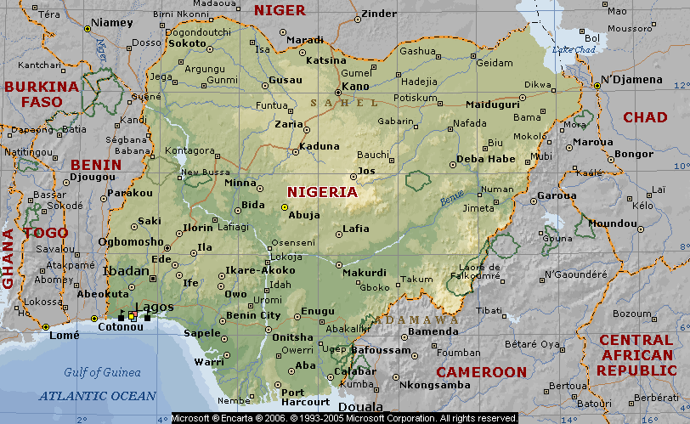
Figure 1a: Map of Nigeria Inset Lagos Lagoon,
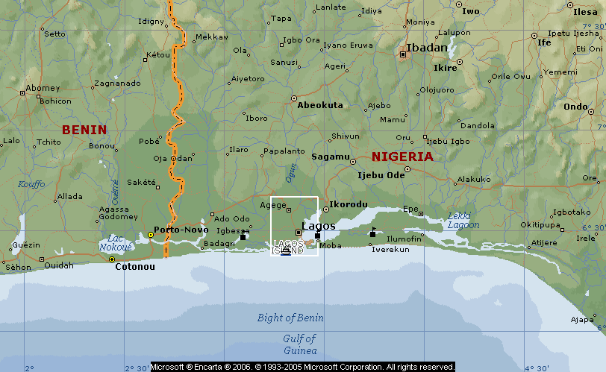
Figure 1b: Map of Lagos Lagoon,

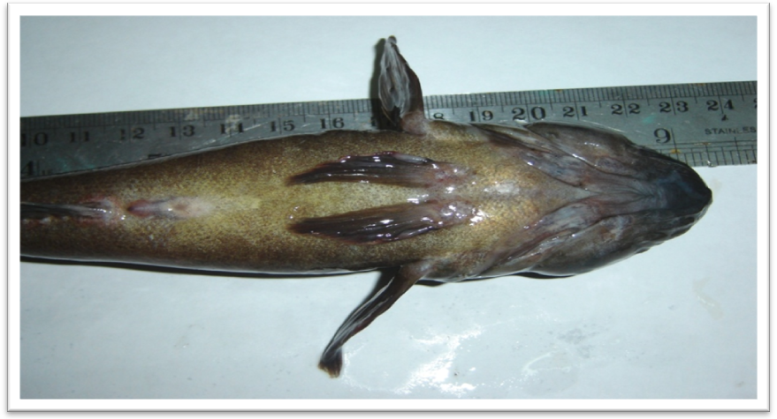
Figure 2a and b: Ventral and Dorsal view of Bathygobius soporator from Lagos lagoon, Nigeria.
Figure 2a
Figure 2b
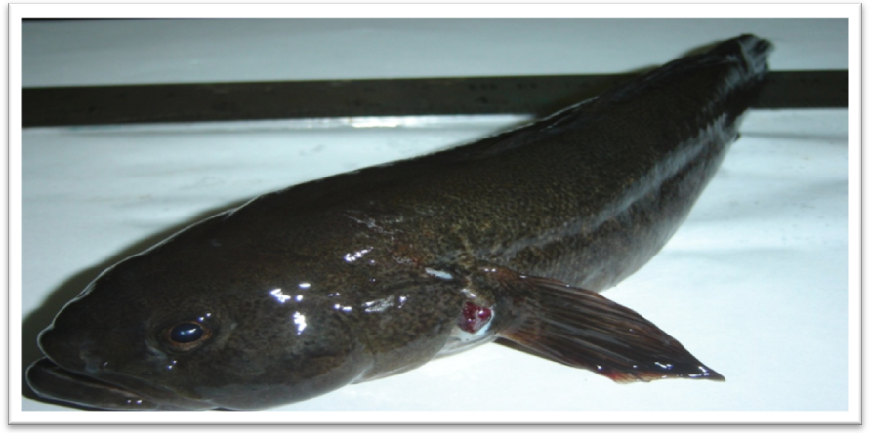

3.2 Age and growth: A total of 500 specimens of B. soporator were caught from the Lagos lagoon, with a set of barrier traps between March 2010 and August 2010. They were preserved in 10% formalin for laboratory analysis. Data on the sex, total length and body weight measurements of the specimens were recorded in the laboratory. The growth studies were based on the analysis of length frequency data of Petersen method and that of von Bertalanffy (Bagenal, 1968; Pauly, 1979; 1980).
The von Bertalanffy growth formula was expressed as:
L_{t}= L∞ {1– e^{k (t-t}₀⁾}
Where : L_{t} = length-at-age t
L∞ = length the fish would reach, if they were to grow to a very old age.
t_{o} = the age the fish would have had at length zero, if they have always grown according to the equation.
K = growth coefficient.

3.3 Lengths-Weight Relationships: The length weight relationship also known as growth index has been widely used in fish biology with several purposes like estimating the mean weight of fish, based on known (Beyer, 1987). It is also used in the conversion of length equation in weight, morphometric; inter specific and intra population comparison to assess the index of well being of fish population (Bolger and Conolly, 1989). The length-weight relationships were obtained and the linear regression analysis was determined.

The intercept (a) was expressed as:
a = {∑Y/n – (b. ∑X/n)}.

The slope (b) as:
b = ∑XY – (∑X) (∑Y) /n
∑X² – (∑X)² /n

And the correlation coefficient (r) as:
r = [∑XY – (∑X) (∑Y)/n ]²

[∑X² – (∑X)²/n] [∑Y² – (∑Y)²/n]

Where: X = lengths of fish (mm), Y = weight of fish (g), n = number of specimen

The length-weight relationships for males and female specimens were obtained and a scattered diagram was drawn to determine the statistical relationships. The relationships were expressed as: W = a + b.L
The same data was converted to Logarithms and a straight line graph was drawn and the relative slope (b) was obtained from the relationship.

Log₁₀ W = a + b log₁₀L

Condition Factor (k): Fulton’s condition factor (k) obtained for both sexes was expressed as:
K = 100W/L³

Where W = Weight of the fish (g), L = Length of the fish)
The condition factor (k) was used to compare the condition, “well-being” of both sexes.

- RESULTS
4.1 Length - weight relationship: Results obtained for Length – weight relationships in the linear regression analysis of Bathygobius soporator are shown in the relationship for both sexes below in table 1.

Table 1: Length - weight relationship of Bathygobius soporator

Sex | Normal data | Logarithm transformation
Combined sex | W = -28.36 + 4.41L (n=500; r=15.18) | W = -0.93 + 2.09L (1.17)
Male | W = -31.60 + 4.58L (14.90) | W = -0.66 + 1.85L (1.16)
Female | W = -22.67 + 3.99L (15.61) | W = -0.73 + 1.91L (1.18)

The value of b (slope) was 4.41 for combined sex which indicates that the fish becomes heavier for its length as it increases in size (figure 1). The correlation coefficient ‘r’ obtained was 0.66 and ‘a’ (intercept) obtained from equation (2) was -28.36. Positive value obtained for the intercept (r) shows that there is an increase in the body weight with increasing lengths. While the slope (b) computed from the logarithm transformation, though indicated allormetrism but shows the fact that the specie is feebly depressed and mostly of small sizes.

4.2 Length - Frequency Analysis: The length – frequency based on the specimens of Bathygobius soporator obtained from Lagos lagoon is shown in the figure 3. (Where n=500): It is clearly show that the highest percentage frequency of occurrence of 36% comes from the length class (11–17) cm which indicate that these length class is predominant in catch during the period of study.

4.3 Meristic and morphometric: All the specimens meristic and morphometric characters were summarized in table 2. Values of correlation coefficient were very low indicating low meristic features. All the fins of B. soporator were not supported with rays. The relationship studied for the meristic characters and body length (SL), showed a positive relationship, however rather low in all the features. Morphometric characters are presented in table 2. The relationship analyzed are the morphometric character and standard length (SL), the head length (HL) as well as the mean values. The most stable morphometric were the Anterior Dorsal Fin and the Pelvic Fin to the body shape. However the morphometric relations showed a tendency toward allometrism. Characterization of growth of body parts using the calculated slope (b) value from the regression equation indicated that only the head length had slope (b) value 16.28 (table 3) and 4.65 for body weight (table 3) indicating a positive allometric growth with the standard length, while other parts had (b) value of less than 3 indicating a negative allometric growth.

- DISCUSSION
As derived from the linear regression analysis, the slope (b) indicated that the body of Bathygobius soporator is feebly compressed (b= 4.41). The correlation coefficient (r =14.90) shows that there is an increase in body weights with lengths; as indicated in the positive value of (r). The significant difference recorded between L∞ and L_{max} are most probably related to the fact that several relatively large specimen were included in the samples analyzed, these fact however coincide with the result reported for Pseudotolithus elongates by Haimonvia et al. (2000). A scrutiny of the evaluated length-frequency data and length-weight relationship reveals that the growth of the fish specie is allometric. Specimen of B. soporator shows variation in sizes, from 6.0cm and 34. 1cm (mean = 14.28 + 4.21 TL) and 8.00 – 135g (BW) for males, while females were between 6.2cm and 32.5cm (mean = 15.61 + 4.38TL) and 8.00 - 135g (BW). Males were of bigger sizes than females, attaining early growth and maturity than the females. The growth of males (b = 4.58) shows positive allometrism indicating that the rate of increase in body weight is relatively higher than increase in body length, while b=3.98 for females indicates that fish becomes heavier for its length as it increases in size. Positive correlation of r= 0.90 for male and 0.97 for females indicate a strong relationship between the total length and body weight for both male and female in Lagos lagoon. The fish of length class (14 – 17cm) occurred most in May and June within study period, when they are fully matured and are ready to spawn. The length of the body parts increased with the standard length and body weight of fish. The mean head length was larger in males than females but the difference observed in both sexes could not be used as distinguishing character because the difference was not significant; statistically. Similar observation has been made in Sarotherodon galilaeus by Nzeh, (1994). The non-significant differences in the head length of the two sexes thus suggest that the populations are homogenous.

Table 2: Summary of Meristic and Morphometric features of Bathygobius soporator Lagos lagoon [n=500].

Parameters | Mean | Range | Variance | Standard deviation. | Standard Error
Total length (cm) | 15.21 | 34.10 – 6.00 | 18.32 | 4.28 | 0.19
Standard length (cm) | 12.61 | 31.00 – 3.00 | 16.71 | 4.09 | 0.18
Body weight (g) | 38.61 | 135.00 – 6.47 | 570.45 | 23.88 | 1.06
Head length (cm) | 2.87 | 5.50 – 1.00 | 1.00 | 1.00 | 0.04
Eye diameter (cm) | 0.23 | 0.60 - 0.10 | 0.01 | 1.00 | 0.004
Body depth (cm) | 2.46 | 4.50 – 1.00 | 0.47 | 0.68 | 0.03
Anterior dorsal fins | VI | VI | 0 | 0 | 0.012
Posterior dorsal fins | IX | VIII - XI | 0 | 0 | 0.035
Anal fins | X | VIII - XI | 0 | 0 | 0.033
Caudal fins | XV | XIII - XXI | 0 | 0 | 0.041
Pectoral fins | XV | XII - XVII | 0 | 0 | 0.044
Pelvic fins | V | V | 0 | 0 | 0.0
Body width (cm) | 2.26 | 4.70 – 1.00 | 0.54 | 0.73 | 0.032
Stomach weight (g) | 1.49 | 7.60 – 0.11 | 0.98 | 0.99 | 0.0

Table 3: Mean values of morphometric characters of Bathygobius soporator examined, expressed as proportion of body length (T.L.) in the length classes.

Characters | Length Class (cm)
Characters | 6.00-9.99 | 10.00-13.99 | 14.00-17.99 | 18.00-21.99 | 22.00-25.99 | 26.00-29.99 | 30.00-33.99 | 34.00-37.99
Total length (TL) | 7.88 | 11.79 | 15.70 | 19.99 | 24.46 | 26.97 | 32.13 | 34.10
Standard length (SL) | 5.94 | 9.63 | 12.87 | 16.83 | 21.24 | 24.00 | 29.23 | 31.00
Head length (HL) | 1.69 | 2.27 | 42.74 | 3.51 | 3.72 | 4.33 | 4.50 | 3.50
Eye diameter (ED) | 0.15 | 0.18 | 3.18 | 0.29 | 0.32 | 0.33 | 0.36 | 0.30
Body depth (BD) | 1.50 | 2.11 | 0.24 | 3.03 | 3.06 | 3.33 | 3.00 | 4.00
Anterior dorsal fins (ADF) | 6.00 | 6.00 | 6.00 | 6.00 | 6.00 | 6.00 | 6.00 | 6.00
Posterior dorsal fins (PDF) | 8.76 | 9.54 | 6.01 | 9.63 | 9.89 | 9.33 | 8.00 | 9.00
Anal fins (AF) | 9.12 | 9.58 | 9.48 | 9.60 | 9.56 | 9.66 | 9.00 | 10.00
Caudal fins (CF) | 14.88 | 14.95 | 9.56 | 15.00 | 14.89 | 15.33 | 15.33 | 16.00
Pectoral fins (PF) | 14.35 | 14.70 | 15.12 | 15.05 | 14.44 | 15.00 | 14.66 | 15.00
Pelvic fins(PEF) | 5.00 | 5.00 | 5.00 | 5.00 | 5.00 | 5.00 | 5.00 | 5.00
Body width (BW) | 1.38 | 1.75 | 2.40 | 2.85 | 3.36 | 3.50 | 2.80 | 4.00
Frequency of occurrence | 25 | 151 | 185 | 117 | 18 | 5 | 3 | 1
% Frequency of occurrence | 5 | 30.2 | 36 | 23.4 | 3.6 | 1 | 0.6 | 0.2

Table 4: Characterization of growth of body parts in B. Soporator in relation to weight using Linear Regression quations.

Body parts | a | b | r | Type of growth
Standard length (SL) | y = 7.35 | + 0.14 x | 0.79 | Allometry
Head length (HL) | y = -9.75 | + 16.82 x | 0.70 | Allometry
Eye diameter (ED) | y = 0.15 | + 0.0018 x | 0.54 | Allometry
Body depth (BD) | y = 1.73 | + 0.019 x | 0.66 | Allometry
Anterior dorsal fins (ADF) | y = 6.00 | + 0.0006 x | 0.05 | Allometry
Posterior dorsal fins (PDF) | y = 9.43 | + 0.0016 x | 0.049 | Allometry
Anal fins (AF) | y = 9.48 | + 0.0018 x | 0.059 | Allometry
Caudal fins (CF) | y = 14.92 | + 0.0027 x | 0.069 | Allometry
Pectoral fins (PF) | y = 14.51 | + 0.0086 x | 0.21 | Allometry
Body width (BW) | y = 1.45 | + 0.021 x | 0.68 | Allometry
Table 5: Summary of Food items in the stomach of 500 specimens of B. soporator from Lagos lagoon.

Food items |  | Specific name of items |  | Numerical method  Number % |  |  | Frequency Method  Number %
Fish-fry | Gopy spp. |  | 160 |  | 31.8 | 269 |  | 72.31
Worms | Ascaris sp. |  | 148 |  | 29.4 | 380 |  | 102.15
Shrimps | Penaeus notialis |  | 38 |  | 7.60 | 85 |  | 22.85
Crabs | Calinectes sp. |  | 74 |  | 14.70 | 121 |  | 32.53
Bulinous | Bulinous sp. |  | 83 |  | 16.50 | 138 |  | 37.10
Total |  |  | 503 |  | 100 | 344 |  | 266.93

The fish exhibit positive allometric growth especially in the body weight as reflected by the b value (4.65) obtained in the regression of the standard length against length of external body parts (table 3 & 4). This suggests that the fish becomes heavier for its length as it increases in size. However, the allometric growth pattern (b < 3) observed in respect of the other parts such as eye diameter, pectoral fin, dorsal fin, caudal fin and anal fin, indicates that as the fish stagnate in length, those other parts increases. Although the growth pattern of the body in relation to standard length was allometric. The non-significant difference in the mean condition factor of male 0.28 – 3.80 (mean 1.46 + 0.56) and female 0.27 – 4.28 (mean 1.44 + 0.56) showed that both sexes were in good condition. The values are similar to results (2.28 and 3.27) obtained by Sadiku and Oladimeji (1991). However females are in better condition than males. This may be due to the energy expended on milt production by the males that may likely be higher than the one expended on the production of eggs in females. Fagade and Adebisi (1997) opined that the difference may be due to fatness and gonadal development which was attributed to females in Chrysichthys nigrodotatus having more fat accumulation than the male.
The foods found in the stomach of B. soporator were Fish-fry, Worms, Shrimps, Crabs (Bulinous spp.). Fish frys constituted the most important food item making up 31.8% followed by Worms (29.4%) using numerical percentage analysis. While study of frequency of occurrence shows that Worms (102.15%) are the dominant food item followed by Fish frys (35%). The result of food and feeding habit in table 5 shows that fish fry are most predominant and this agrees with the findings of Adebisi (1989). One hundred and twenty-eight (25.6%) had empty stomachs. High percentage of empty stomachs (11) obtained in P. obscura correlates with this work (Ogunlaru et al.1997) and this confirm that these species are predatory and their digestion rate is rapid.
Two hundred and five (205) sex data were collected for the specimen. The distribution of the sexes shows a significant difference between the number of males and females in all the age groups. The sex ratio shows that the males are fewer than the females which could be due to the migratory pattern of the fish and sexual differences. The calculated X² test on the sex ratio gave a value of 16.93 (at 5% significance level). This was higher than the tabulated value of 3.84 (5% significance level). This showed that the males were fewer than the females. This finding may indicate that Lagos lagoon is unfavorable to the fish and with the current prevailing environmental conditions in the region of the lagoon.

Acknowledgement:
Authors are grateful to the Department of Fisheries Laboratory staff, Lagos State University, Nigeria; for their assistance during the research work and provision of reagents and especially the graduate students.

Correspondence to:
Adeboyejo, O. Akintade
Department of Fisheries
Lagos State University, Lagos-Nigeria
PMB 11419, Ikeja, Lagos, Nigeria

Selected References
[1] Adebisi, A.A. (1989). The relationships between the fecundities, Gonadosomatic indices and egg size of some fishes of Ogun River, Nigeria. Arch Hydrobiology, 79pp 167-177.
[2] Ajao, E.A., and Fagade, S.O. (1990): A study of sediment and community in Lagos lagoon. Oil and Chemical pollution 7, 85-117.
[3] Beyer, J.E. (1987). On length-weight relationship. Part 1. Corresponding the mean weight of a given length class. Fishbytes 5(1): 11-13.
[4] Bolger, T., Connolly, P.L. (1989). The selection of suitable indices for the measurement and analysis of fish condition. J. Fish. Biol. 34, 171-182.
[5] Diaz L.S., Roa A., Gareia, C.B., Acero A., Nava G. (2000). Length-Weight relationships of demersal fishes from the upper continental slope off Columbia. The ICLARM Quarterly 23(3): 23-25.
[6] Fagade, S.O. and Adebisi, A.A. (1997): On the fecundity of Chrysichthys nigrodigitatus (Lacepede) of Asejire dam, Oyo state Nigeria. Nig. J. Nat. Sci., 1: 127-131
[7]Fagade, S.O. & Olaniyan, C.I.O. (1972): The biology of the West African Shad, E. Fimbriata (Bowdich) in the Lagos lagoon, Nigeria J. Fish Biology. 4, 519-533.
[8] Haimonvia M., and Velasco G. (2000). Length-weight relationship of marine fishes from Southern Brazil. The ICLARM Quarterly 23(1): 14-16.
[9] Hoese, D. (1998) Gobies. In: W.N. Eschmeyer, J.R. Pazton, eds, Second edition-Encyclopedia of fishes. San Diego, CA: Academic Press 218pp.
[10] Irvine, F.R. (1931): The fishes and fisheries of the Gold Coast, Part III, Illustrated by A.P. BROWN ACCRA: Govt. Press.
[11] Miller, P.J. (1986): Fishes of the North Eastern Atlantic and the Mediterianean, UNESCO 3, pp. 1019-1030.
[12] Ogunlaru, A., Anetekhai, M.A., Kumolu-Johnson, C.A., Jimoh, A.A. and Whenu, O.O. (1997): Food, feeding habit and sex ratio of Channa obscura (gunther) from era swamps, Ojo, Lagos-Nigeria (Pisces, channidae. Journal of prospects in sciences 1, 70-75.
[13] Thresher, R. (1984): Reproduction in Reef fishes. Neptane City, N.J: T.F.H. Publications.

20/01/2011.

