Change Detection Analysis By Using Ikonos And Quick Bird Imageries

Eltahir. M. Elhadi. ¹², Nagi. Zomrawi²
1-China University of Geosciences Faculty of Resources, Wuhan, 430074, China,
2-Sudan University of Science and Technology Faculty of Engineering, Khartoum,Sudan,
tahirco2006@yahoo.com, nagizomrawi@yahoo.com

Abstract The application of urban satellite using for monitoring of changes specially in rapidly growing metropolitan areas not only sensible but utterly necessary. Arguments in favour of the use of satellite system are certainly the fast and accurate data access, the quick visual interpretation, the good representation on a planar surface and their great integrity of a map after the process of geometrical classification. In this paper we used maximum likelihood classification algorithm to attempt and monitor the land cover change .In this work we considered a test area, the Chenggong city in Yunnan province in the south of China. AquickBirds multi-spectral images taken on May 4, 2004 and Ikonos multi-spectral images taken on April 7, 2002, were used in this work. The two images were orthorectified and a first classification produced a map with 7 strata: water, forest, pasture & grass land, cultivated land, transportation, built up areas and unused land. The over all classification accuracy was 97% and the kappa coefficient was 0.92 (i.e. 0.92 more accurate than a random classification).The overall accuracy of land cover change map ,generated from post classification change detection methods and evaluated using several approaches ,ranged from 80 % to 90%.The results of change detection between two dates images were as follows : transportation has increased from 7.6% to 18.3% with change rate of 57.75 km².yr⁻¹, pasture & grass land has decreased from 26.3% to 8.9% with change rate of 217.5 km².yr⁻¹, built up areas has increased from 6.7% to 22.3% with change rate of 156 km².yr⁻¹, cultivated land has increased from 15.3% to 32.4% with change rate of 128.25 km².yr⁻¹, forest has decreased from 38.8% to 18.2% with change rate of 309 km².yr⁻¹ ,un used land has decreased from 25.7% to 9.5% with change rate of 145.8 km².yr⁻¹ ,and water have no changed mentioned. The results quantify the land cover change patterns in the metropolitan or urban areas and demonstrate the potential of multi temporal Quick Birds and Ikonos data to provide an accurate, economic means to map and analyze changes in land cover over time that can be used as inputs to land management and policy decisions.
[Nature and Science. 2009;7(10):25-31]. (ISSN: 1545-0740).

Keywords: change detection, highmultispectral images, maximumlikelihood classification

1. Introduction
The importance of accurate and timely information describing the nature and extent of land resources and changes over time is increasing, especially in rapidly growing metropolitan areas. Change detection is a remote sensing techniques used to monitor and map land cover change between two or more periods and is now an essential tool in growing urban areas management activities[6] .Urban growth , particularly the movement of residential and commercial land use to rural areas, was, commonly referred to as urban sprawl.
Accurate and timely information on land use and land use change at a national scale is crucial for long term economic development planning and for short-term land management. Remote sensing technology as an efficient surface investigation method was introduced in China for such purpose three decades ago. In the end of1980s, CSLA sponsored the program to analyze land use status in Northwest China using Landsat TM imagery. Later in 1996, time series of Landsat TMdata were analyzed to monitor urban expansion in 17 metropolitan areas including Beijing. Many cases of misuse of cultivated land and illegal constructions were exposed through this investigation, which urged the China government to implement a strict protect policy for cultivated land. The technique to monitor land use transitions using remote sensing imagery was tested and improved in the following years. In 1999, the newly founded MLR launched the Program of National Land Use Change monitoring through remote sensing. The objective of the Program was to investigate the transition from cultivated land to construction land in66 metropolitan areas around China using Landsat TM and SPOT imagery between 1998 and 1999. Since then, the Program has been carried out continuously for seven years and provides fundamental information on land use change at the national scale for Central Government policy making. The success of this Program demonstrates that remote sensing can act as an operational technology serving land management in China.
The very high ground resolution of Quick Birds and Ikonos data is a new step towards a detailed image of land cover, close to an aerial photograph but with the geometric quality, the homogeneity and periodicity proper to satellite imagery, and they provide a level of detail compatible with urban mapping, i.e. from 4 to 2.5 meters spatial resolution. In this research we used supervised classification which is based on comparison between the classifications maps obtain by classifying the two consider images independently.

- Study area

The research in this paper addresses the Chenggong city in Yunnan province in the south of China, as shown in Fig .1 below. A Quick Bird images taken in May 4, 2004 and Ikonos images taken in April 7, 2002 for this area were used in this work, the area lies on longitude about 24 00 00 to 25 00 00N and latitude about 101 00 00 to 102 00 00 E. This area includes a diversity of land cover classes interspersed with large areas of cultivated and farm land. Both high and law density urban development are found in the central portion while several rural lands cover types of cultivated crops land ,pasture & grass land and forest characterize the surrounding landscape.

- Materials and Methods

The spatial resolution of the satellite sensors can be characterized by the ability of defining the object boundaries [1and 8] .It is also possible to define the spatial resolution as, the area of a representative pixel on the ground.

Data and Pre-processing
Remote Sensing images used in this study include two satellite images. The first image was a Ikonos images taken in April 7, 2002. The second one was a Quick Bird images taken in May 4, 2004. The two satellite images characteristics and its centre wavelengths were shown in Table 1, below. The pre-processing of this dataset included geometric corrections .All images were geometrically corrected not only to eliminate geometric distortions present in the images but also to register the satellite images to ground data. Ground Control Points (GCPs) were extracted from vector files for the same region, using geographic features such as big and small rivers .The resampling method chosen was nearest-neighbor, which preserved original reflectance value. Fifty ground control points were chosen on the images, the points were spread quite evenly through out the image, allowing for good control. Image software allowed for easy zooming to assist in point selection. The points were registered in the header files of the image for later rectification .Once all ground control points were compiled, error checking was used to gauge the efficiency of the points used. The RMS errors for all a linear method of rectification were examined with varying accuracies, all approximately 0.5 m in displacement error. The nearest-neighbor resampling method was used in datum WGS 84 and projection UTM (49N). In order to remove or normalize the reflectance variation between images acquired at different times, relative radiometric correction was performed to yield normalize radiometric data on a common scale [9].Here, the histogram normalization, a simpler and more effective technique, was used to carry out the relative radiometric correction.For the analysis of Landsat satellite images, ERDAS Imagine 9.1software was used.
Table 1:Quick Birds and Ikonos characteristics and its centre wavelength
 | Quick Birds | Ikonos
Panchromatic band | 725.0 nm | 727.5 nm
Band 1 (blue) | 479.5 nm | 480.5 nm
Band 2 (green) | 546.5 nm | 550.5 nm
Band 3 (red) | 654.0 nm | 665.0 nm
Band 4 (nir) | 814.5 nm | 805.0 nm
Resolution (pan) | 0.61 m | 1.0 m
Resolution (multispectral) | 2.44 m | 4.0 m
4. Methodology
There are various ways of approaching the use of satellite imagery for determining land use change in urban environments. [2] divide the methods for change detection and classification into pre- classification and post- classification techniques. The pre- classification technique apply various a algorithms , including image differencing and image rationing , to single or multiple spectral bands, vegetation indices ,principal components , directly to multiple dates of satellite imagery to generate “change” vs. “no- change” maps[7]. These techniques locate changes but do not provide information on the nature of change [10].On the other hand, the Maximum Likelihood classification (MLC) method was chosen to carry out this work .Maximum likelihood classification assumes that the statistics for each class in each band are normally distributed and calculates the probability that a given pixel belongs to a specific class. Unless a probability threshold is selected, all pixels are classified .Each pixel is assigned to the class that has the highest probability (i.e. the “maximum likelihood”). There are several studies in which this supervised classification method has been utilised successfully, either directly or in combination with other methods [3,4and5]. In this type of classification, the user selects the spectral signatures defined from recognized locations in the image or “training sample.” The computer system then identifies the pixels with similar characteristics and assigns them to a class based on specific criteria. For the initial training operation of the classification methods , (100) samples as learning data set of each class , and (1300) samples as “ground truth” for each class were defined with help of ortophotos (scale 1: 10.000) and available maps. These tools helped classify a seven-class legend: water, forest, pasture & grass land, cultivated land, transportation, built up areas and unused land ,as shown in Table 2 below ,which was based on the land cover land use classification system developed by National Land use Change Program. Supervised classification was then performed using the maximum likelihood method, in which a pixel with the maximum likelihood is classified to its corresponding class. The over all classification accuracy was 97% and the kappa coefficient was 0.92 (i.e. 0.92 more accurate than a random classification). The existence of mixed pixels (pixels having more than one class in their footprint), in particular among vegetation classes, would require an analysis at a higher geometric resolution or a comparison with multitemporal data to exploit the phonological selected, the maximum likelihood classification results for Quick Bird and Ikonos images were shown in Figure. 2 and figure. 3 respectively.

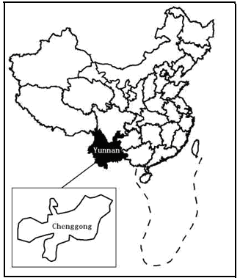
Figure1: The boundary map of China and Chenggong city

Table 2: Classes of training data

Land use class | Description
Cultivated land | including crop fields
Pasture & grass | including pasture ,natural and artificial grass ,planted and improved pasture land
Transportation | including railway ,high way ,air port ,port
Water body | including river , lake , reservoir , beach , canal , breeding plot
Unused land | including sandy land , desert ,saline land, bare land , glaciers , permanent snow
Built up area | including urban , rural ,residences ,industry, mining ,salt pan , specially used land
Forest | including forestry land , timber , fuel wood , shelter , economic forests , sparse wood lands and shrubs

Table 3: Change rate of the 7 landscape patterns from 2002 to 2004
Land cover type | 2002 |  | 2004 |  | 2002-2004 |  | Change rate  (+Gain,-Loss)  2002-2004
Land cover type | (km²) | (%) | (km²) | (%) | (km²) | (%) | ()
Transportation | 82.1 | 7.6 | 197.6 | 18.3 | -115.5 | -10.7 | +57.75
Cultivated land | 229.5 | 15.3 | 486.0 | 32.4 | -256.5 | -17.1 | +128.25
Un used land | 462.6 | 25.7 | 171.0 | 9.5 | +291.6 | 16.2 | -145.8
Built up areas | 134.0 | 6.7 | 446.0 | 22.3 | 312.0 | 15.6 | -156
Forest | 1164.0 | 38.8 | 546.0 | 18.2 | +618.0 | 20.6 | -309
Water body | 76.0 | 9.5 | 56.8 | 7.1 | +19.2 | 2.4 | -9.6
Pasture& grass | 657.5 | 26.3 | 222.5 | 8.9 | +435.0 | 17.4 | -217.5

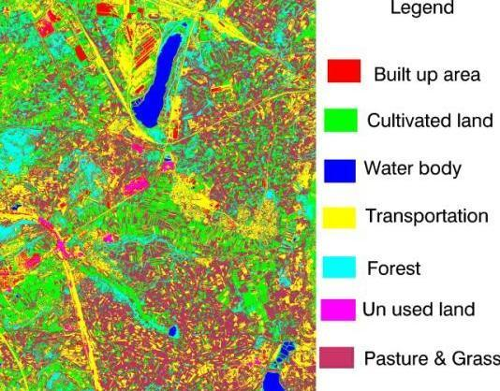

Figure 2: Maximum Likelihood classification for Quickbird image (2004).

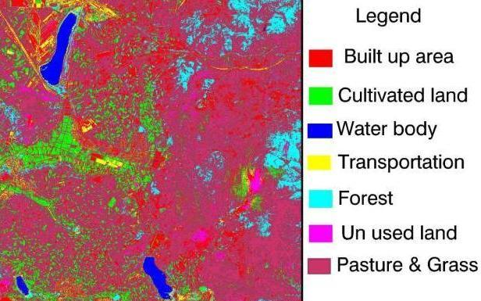

Figure 3: Maximum Likelihood classification for Ikonos image (2002).
Figure 4: The percentage diagram of land covers change from 2002 to 2004

5. Result
Table 3and Figure 4 show the values of land cover change obtained after applying the supervised classification methods according to the “ground truth” samples.The results of change detection between two dates images were as follows : transportation has increased from 7.6% to 18.3% with change rate of 57.75, pasture & grass land has decreased from 26.3% to 8.9% with change rate of 217.5, built up areas has increased from 6.7% to 22.3% with change rate of 156, cultivated land has increased from 15.3% to 32.4% with change rate of 128.25, forest has decreased from 38.8% to 18.2% with change rate of 309 ,un used land has decreased from 25.7% to 9.5% with change rate of 145.8 , and water has decreased from 9.5% to 7.1% with change rate of 9.6 during the study period.
6. Conclusion
In this work two very high resolution images were classified with the purpose to detect the land change. In this paper we found the big changed that occurred in the study area in this limited period of time, just two years, especially from pasture & grass land to cultivated land ， built up area and transportation, so I would like to say that it must be diurnal researches for cities every year if it is possible because of high and accelerating rate of urban expanding, in particular in the developing countries like China

Acknowledgement:
Many thanks to Professor Hu Guangdao at the Institute of geology and Remote Sensing ,faculty of earth resources ,china university of geosciences For providing the data .

Correspondence to:

Eltahir Mohamed Elhadi

China University of Geosciences, Faculty of Resources, Wuhan, 430074, China
Telephone: 00862763962740.
Emails:tahirco2006@yahoo.com, nagizomrawi@yahoo.com
References
[1] Colwell, R. N. 1983. Manual of Remote Sensing. American Society of Photogrammetry. Falls Church, Virginia. ISBN: 978-0-937294-41-3
[2] Ding, L., Elvidge ,C.D., and Lunetta, R. S.1998.Survey of multispecral methods for land cover change analysis . pp. 21- 39. Sleeping Bear Press,Inc.,Newyork. DOI:10.1080/01431160801961367
[3] Lee,D. S., Shan, J., and Bethel, J.S., 2003 .Class-Guided Building Extraction from IKONOS imagery .Photogrammeric Engineering & Remote Sensing,69,2: 143- 150. ISSN 0099-1112 CODEN PERSDV
[4] Gao, J., 1999. A comparative study on spatial and spectral resolutions of satellite data in mapping mangrove forests. International Journal of Remote Sensing, 14, 2823-2833. DOI: 10.1080/014311699211813.
[5] Green, E.P., Clark, C. D., Mumby, P. J., Edwards, A.J., and Ellis, A.C., 1998. Remote sensing techniques for mangrove mapping .International Journal of Remote Sensing, 5: 935-956. DOI: 10.1080/014311698215801
[6] Janssen, L. L. F., and Van der Wel, F.J.M.1994. Accuracy assessment of satellite derived land-cover data: a review.Photpgrammeric and Remote Sensing, 60: 419- 426. ISSN 0099-1112 CODEN PERSDV
[7] Jensen, J.R.2004. Digital change detection. Introductory digital image processing: A remote sensing perspective (pp. 467- 494).New Jersey: Prentice- Hall. DOI: 10.2113/gseegeosci.13.1.89
[8] Jensen, J.R., 1983. Urban /suburban land use analysis .In.R.N.Colwell(Ed.), Manual of Remote Sensing ,2nd ed., American Society of Photpgrammetry, FallChurch,VA,pp. 1571- 1666. DOI:10.1016/0924-2716(96)00018-4
[9] Paolini L, Crings F, Sobrino J A, et al .Radiometric correction effects in Landsat multi-date/multi-sensor change detection studies. International Journal of Remote Sensing, 2006, 27: 685-704. DOI: 10.1080/01431160500183057
[10] Ridd, M. K., and Liu, J. 1998.Acomparison of four algorithms for change detection in an urban environment .Remote Sensing of Environment, 63: 95- 100. DOI: 10.1016/S0034-4257(97)00112-0

8/28/2009

