Influence of explants type and plant growth regulators on In vitro multiple shoots regeneration of a Laurel from Himalaya

Gunjan Sharma and Anant Ram Nautiyal

High Altitude Plant Physiology Research Centre,
HNB Garhwal University, Srinagar-246174
Uttarakhand, India
gunjan_80sharma@rediffmail.com, arnautiyal@gmail.com

Abstract: Micropropagation in a Laurel, Bay leaf tree (Cinnamomum tamala Nees. & Ebrm.) was studied with an aim to select best explant and effect of plant growth regulators (PGRs) for multiple shooting. Various explants were isolated from three year old seedlings. Multiple shoots were induced from callus culture from petiole with nodal segment, shoot tip, shoot with inter-nodal segments and leaf explants on woody plant medium (WPM) supplemented with various plant growth regulators (BA, IBA and kinetin) alone as well as in combinations with varying degree of success in the following order: petiole with nodal segment>apical shoot>shoot with internodes>leaf. Petiole with nodal segment explant and PGRs combination of BI was found best for callogenesis (compact greenish white), shooting (4 fold) and rooting (100%). The petiole with nodal segments from the in vitro developed plantlets could be induced again to produce a large number of harvestable shoots. Harvested shoots were rooted in vitro in WPM supplemented with plant growth regulators (PGRs). Similarly BI combination of PGRs showed the significant results in callogenesis, multiple shooting and rooting regeneration in all four types of explants. The plantlets were transferred to theromocol cups after which they were replanted into poly bags and then to field. These plants survived with over 70% success under field conditions and exhibited vigorous growth. This system could be utilized for large-scale multiplication of C. tamala by tissue culture. Further observations will be continued. [Nature and Science. 2009;7(9):1-7]. (ISSN: 1545-0740).

Key words: Cinnamomum tamala, petiole with nodal segment, explants, plant growth regulators, callogenesis, multiple shooting, acclimatization

Abbreviations: I= Indole butyric acid (IBA), B= 6-Benzyladenine (BA), K=Kinetin

1. Introduction
Cinnamomum is a large genus, many species of which yield a volatile oil on distillation. The genus Cinnamomum comprises several hundred species which occur naturally in Asia and Australia (Brandis, 1998). They are evergreen trees and shrubs and most species are aromatic. Cinnamomum tamala Nees and Eberm. (Family-Lauraceae) known as tejpatra in Sanskrit (Kirtikar and Basu, 1981), is a medium-sized tree, found in India along the North-Western Himalayas, in Sikkim, Assam, Mizoram and Meghalaya (Plate 1. A). It is also found in tropical and sub-tropical Asia, Australia, Pacific region and South Asia (Showkat et al., 2004). This evergreen species occurs as associated species in transitional evergreen broad leaf forest and is confined between sub–montane broad leaf ombrophilous forest (below 1000m) and mid montane broad leaf ombrophilous forest up to 3000m (Singh & Singh, 1992). Leaves of C. tamala (tejpat) are widely used as a spice and also yield an essential oil on distillation.
The essential oil of the leaves called tejpat oil is medicinally used as carminative, antiflatulent, diuretic, and in cardiac disorders (Showkat et al., 2004). "Ayurveda" describes the use of leaves of tejpatra in the treatment of ailments such as anorexia, bladder disorders, dryness of mouth, coryza, diarrhea, nausea and spermatorhea (Kapoor, 2000). It has hypoglyacemic and hypolipidemic properties (Kar et al., 2003). It is commonly used in food industry, because of its special aroma (Chang and Cheng, 2002). The main constituents of C. tamala leaves are a-pinene, camphene, myrcene, limonene, eugenol, p-cymene, methyl eugenol, eugenol acetate and methyl ether of eugenol (Smith et al., 2002; Saino et al., 2003). Eugenol (4-hydroxy-3-methoxy allylbenzene) is one of the main constituents of cinnamon oil (Fischer and Dengler, 1990; Dighe et al., 2005). It is used as a fragrance and flavoring agent, as analgesic in dental preparations and also as an insect repellant (Fischer and Dengler, 1990; Kermasha et al., 1994; Yuwono et al., 2002). It has antibacterial and antifungal activity (Smith et al., 2002) and strong antitermitic activity (Chang and Cheng, 2002). The oil's high eugenol content also makes it valuable as a source of this chemical for subsequent conversion into iso-eugenol, another flavoring agent. Cinnamon bark oil possesses the delicate aroma of the spice and a sweet and pungent taste. Its major constituent is cinnamaldehyde but other, minor components impart the characteristic odor and flavor. It is employed mainly in the flavoring industry where it is used in meat and fast food seasonings, sauces and pickles, baked goods, confectionery, cola-type drinks, tobacco flavors and in dental and pharmaceutical preparations (FAO United Nations, 1995).
Owing to its high medicinal value and being an important ingredient of the spices the demand of C. tamala is increasing day by day and the species is being exploited from its natural pockets illegally (Ph.D observation of first author). The blatant exploitation of the species from the forest in the recent years has created serious concern about its long term health in the already diminishing natural populations. The habitat specific occurrence, poor regeneration status and short life span of seed results in the vulnerable status of the species in Uttarakhand (Ved et al., 2003; Sharma et al., 2009). Therefore there is a need to raise high quality individuals in large scale to fulfil the increasing demand on the one hand and help in conservation of the species on the other. Clonal propagation through tissue culture is an option but, no reports on in vitro propagation and vegetative propagation are available for this species. A step in this direction is present communication, which aims the establishment of in-vitro micropropagation protocol of the species.
Tissue culture has tremendous potential in this context and could be useful in overcoming the above mentioned limitations. Micropropagation protocols have been used for some other species of this genus viz., in vitro shoot multiplication in C. camphora (Babu et al., 2003; Huang et al., 1997; Kalam et al., 2005) and C. kanehirae (Chang et al., 2002). In the present study an attempt has been made, for the first time, to develop an efficient in vitro Micropropagation method of multiple shoot formation (and subsequent rooting) through callus culture, from various types of explants.

2. Material and Method
2.1 Plant material and explant preparation
Explants were collected from net house of HAPPRC nursery located at Srinagar in Pauri district of Uttarakhand state, India (560m amsl) where 2-3 year old seedlings of C. tamala were grown. Various explants viz. petiole with nodal segment, apical shoot tip, shoot with internode segment and leaf isolated from young shoots of healthy plants for culture initiation were selected. Explants were washed with tween-20 (5%, 5 min.) and successively surface disinfected with systemic fungicide, mercuric chloride (HgCl2; 0.1% w/v, 2 min), Sodium hypochlorite with 4% available chlorine (2% v/v, 5 min) and ethanol (50% v/v; 2 min) solutions. The explants were thoroughly washed with sterilized double distilled water (X4) after each surface disinfection treatment under aseptic conditions.

2.2 Explant and culture preparation
Explants were placed vertically in conical flasks containing 30 ml of Lloyd and McCown (1980) woody plant medium (WPM) as basal medium containing agar (0.8% w/v) and sucrose (3%w/v). The medium was adjusted to pH 5.6 with 1 N NaOH or 1 N HCl in all the experiments, before autoclaving (1.05kg / cm², 121⁰C; 20 min). The chemicals used were of analytical grade (Himedia, Qualigens, and Sigma) and the medium was dispensed into culture vessels (Borosil, India). All the cultures were incubated at 25±1⁰C in 16/8 hrs light/dark cycle on racks fitted with cool florescent tubes (Philips 40w; 24 and 60 µmol/m²/s irradiance inside and outside the culture flasks, respectively). Sub culturing was carried out at 3-4 week intervals.

2.3 Callus induction and organogenesis
For this purpose different plant growth regulators (PGRs) such as Indole butyric acid (I, 5μM), 6-Benzyladenine (B, 2.5μM) and Kinetin (K, 2μM) alone as well as in combination were used as supplement with woody plant medium (WPM). WPM alone was considered as control treatment. The experimental design compared explant and PGRs combination interaction for callogenesis, multiple shooting as well as rooting of the species. Induced callus was transferred after 30 days in the same type of culture medium for growth and shoot regeneration. Regenerated shoots (~ 1cm long) were separated from the callus and counted. These shoots were than transferred to the above combinations of the culture medium for elongation and multiplication for another 30 days. After 4 weeks of incubation, shoots were separated from clumps and harvested for rooting also in the same medium.

2.4 Acclimatization and transfer of plantlets to soil
Plantlets with well-developed roots were removed from the culture medium and after washing the roots gently under running tap water, plantlets were transferred to plastic pots (10 cm diameter) containing autoclaved garden soil, farmyard manure and sand (2:1:1). All were irrigated with 1/8 MS basal salt solution devoid of sucrose and inositol every 4 days for two weeks. The potted plantlets were covered with porous polyethylene sheets for maintaining high humidity and were maintained under the culture room conditions. The relative humidity was reduced gradually and after 30 days the plantlets were transplanted to nursery and kept under shade in a net house for further growth and development.

2.5 Statistical analysis
The data were statistically analyzed using the General Linear Models procedure for analysis of variance. One way ANOVA was applied to test the effect of the interaction of PGRs and explants separately. Analysis was applied for multiple shoot formation and rooting with least significant difference (LSD at 5% level of significance), which was calculated using ten replicates for every treatment (n=10).

3. Results
3.1 Influence of explant type
After 12 days of inoculation, callus induction was observed directly on the cut surface in all four types of the explants when cultured on WPM media supplemented with various combinations of plant growth regulators used with varying degree of success in the following order: petiole with nodal segment>apical shoot>shoot with internodes>leaf (Table 1). Petiole with nodal segment was found best explant for callusing and multiple shooting. Similarly apical shoot and shoot with internode were found relatively good for same in contrast to leaf explant that produced least callus and multiple shooting in all the six PGR combinations with control.

3.2 Influence of PGRs
The explant selection was the most critical feature in callus induction. The texture and type of callus depend on explant type as well as on the combination of growth regulators. The callus formed in media containing BI combination was compact and greenish white in all the four explants; IK combination formed compact and light green callus observed in petiole with nodal segment and apical shoot explant, while friable and white colored callus was obtained in shoot with internode and leaf explant; media supplemented with I showed compact light green colored callus in petiole with nodal segment, apical shoot and shoot with internode whereas in leaf explant friable and white colored callus was obtained; K supplemented media showed compact greenish white callus in petiole with nodal segment and apical shoot, compact light green callus in shoot with internode and friable light green callus in leaf explant; compact greenish white callus was found in petiole with nodal segment and apical shoot, compact light green in shoot with internode and friable light green callus in leaf explants when supplemented with B, in comparison to control in which friable, light green and white colored callus in all the explants was formed. Thus explant type had significant effect on callus induction (Table 1, Plate 1. B & C).
Various combinations of PGRs had significant effects on callus, shoot and root regeneration. Explants cultured on PGRs-free basal medium (control) produced friable callus with no considerable shooting. Callus induction was markedly enhanced by BI combination which produced very good amount of compact and greenish white callus in all the explants except leaf explant. B, K and I alone were also found relatively far better than IK combination with respect to control. Compact callus type was obtained in almost all the explant and PGRs treatments except leaf explant and control, in which friable white and light green color callus was formed from which less number of shoot were obtained (Table 1).
Approximately over a period of 60 days initiation of shooting was observed in all type of explants from callus (Plate 1. D-F). A significant improvement was observed in all the explants by PGRs treatments. In case of petiole with nodal segment explant 4 fold multiple shooting (4.0±0.0 shoot/explant) with 100 % rooting was observed (Plate 1. G); in B, K, I and IK the same explant showed 2 to 3 fold multiple shooting (3.5±0.71, 3.1±0.72, 3±0.67 and 2.4±0.52 shoots/explant respectively) as well as rooting (3.5±0.52, 2.1±0.48, 2.6±0.52 and 1.8±0.63 rooting/explant respectively) in comparison to control (1.7±0.48 shooting and 1.4±0.52 rooting). The results of petiole explant on various PGRs are significantly different at P<0.001 level of significance. Similar results were also found in other explants- apical shoot, shoot with internode and leaf explants, that showed same trend of results in respect of the PGRs used over control and the differences are statistically significant at P<0.001 level significance for both multiple shooting as well as rooting (Table 2 & 3).

3.3 Acclimatization
Thus, observations from the present investigations clearly suggest that responses to organogenesis in C. tamala are influenced by explant type and specific hormonal combinations in the medium. After 30 days of acclimatization in culture condition 90 % plantlets survived. Subsequently plantlets were transplanted to nursery and kept under shade in a net house for further growth and development. After 30 days these plants displayed 70% survival under field conditions and exhibited vigorous growth (Plate 1. H).

Table 1. Effect of different PGRs combination on callus induction, multiple shoot regeneration and rooting % on various explants
SI No. | Explants | Hormone combination | Callus formation | Kind of callus | Callus color | No. of shoots /explant | Rooting %
1 | Petiole with nodal segment | Control | + | Friable | Light green | 1.7 | 82
2 | Petiole with nodal segment | I | ++ | Compact | Light green | 3 | 87
3 | Petiole with nodal segment | K | +++ | Compact | Greenish white | 3.1 | 87
4 | Petiole with nodal segment | B | +++ | Compact | Greenish white | 3.5 | 97
5 | Petiole with nodal segment | IK | ++ | Compact | Light green | 2.4 | 75
6 | Petiole with nodal segment | BI | +++ | Compact | Greenish white | 4 | 100
7 | Apical shoot | Control | + | Friable | White | 1.5 | 67
8 | Apical shoot | I | ++ | Compact | Light green | 2.4 | 88
9 | Apical shoot | K | ++ | Compact | Greenish white | 2.3 | 87
10 | Apical shoot | B | +++ | Compact | Greenish white | 3.3 | 85
11 | Apical shoot | IK | ++ | Compact | Light green | 2.2 | 68
12 | Apical shoot | BI | +++ | Compact | Greenish white | 3.6 | 89
13 | Shoot with internode | Control | + | Friable | White | 0.8 | 50
14 | Shoot with internode | I | ++ | Compact | Light green | 2.1 | 81
15 | Shoot with internode | K | ++ | Compact | Light green | 2.5 | 80
16 | Shoot with internode | B | ++ | Compact | Light green | 3 | 73
17 | Shoot with internode | IK | + | Friable | White | 1.3 | 77
18 | Shoot with internode | BI | +++ | Compact | Greenish white | 3.4 | 74
19 | Leaf | Control | + | Friable | White | 0.4 | 0
20 | Leaf | I | + | Friable | White | 1.2 | 67
21 | Leaf | K | + | Friable | Light green | 1.3 | 77
22 | Leaf | B | + | Friable | Light green | 1.5 | 73
23 | Leaf | IK | + | Friable | White | 1 | 60
24 | Leaf | BI | ++ | Compact | Greenish white | 2.2 | 77
I=Indole Butyric Acid (5μM), K=Kinetin (2μM), B=Benzyladenine (2.5μM), LSD-Least Significant Difference, + =Poor callus, ++ =Good callus, +++ =Very good callus
Table 2. Multiple shooting per explant on various explants using different combination of PGRs
 | Plant growth regulators
Explants | Control | I | K | B | IK | BI | P value (LSDat5%)
Petiole (nodal) | 1.7±0.48 | 3±0.67 | 3.1±0.72 | 3.5±0.71 | 2.4±0.52 | 4.0±0.0 | <0.001(0.50)
Apical tip | 1.5±0.53 | 2.4±0.52 | 2.3±0.48 | 3.3±0.48 | 2.2±0.78 | 3.6±0.52 | <0.001(0.49)
Shoot (Internode) | 0.8±0.63 | 2.1±0.74 | 2.5±0.53 | 3±0.47 | 1.3±0.48 | 3.4±0.52 | <0.001(0.50)
Leaf | 0.4±0.52 | 1.2±0.63 | 1.3±0.67 | 1.5±0.71 | 1±0.82 | 2.2±0.63 | <0.001(0.59)
P value (LSDat5%) | <0.001 (0.48) | <0.001 (0.56) | <0.001 (0.54) | <0.001 (0.42) | <0.001 (0.59) | <0.001 (0.55)
Table 3. Rooted shoots on various explants using different combination of PGRs
 | Plant growth regulators
Explants | Control | I | K | B | IK | BI | P value (LSDat5%)
Petiole (nodal) | 1.4±0.52 | 2.6±0.52 | 2.7±0.48 | 3.4±0.52 | 1.8±0.63 | 4.0±0.0 | <0.001(0.43)
Apical shoot | 1.0±0.47 | 2.1±0.32 | 2.0±0.0 | 2.8±0.63 | 1.5±0.71 | 3.2±0.42 | <0.001(0.42)
Shoot (Internode) | 0.4±0.52 | 1.7±0.48 | 2.0±0.67 | 2.2±0.63 | 1.0±0.67 | 2.5±0.53 | <0.001(0.51)
Leaf | 0 | 0.8±0.79 | 1.0±0.67 | 1.1±0.32 | 0.6±0.69 | 1.7±0.48 | <0.001(0.49)
P value (LSDat5%) | <0.001 (0.38) | <0.001 (0.48) | <0.001 (0.46) | <0.001 (0.47) | <0.01 (0.59) | <0.001 (0.36)
Table 4. Comparisons of shooting (Numbers/10 explant), rooted shoots and percent rooting response of four different explant type and six PGRs combinations in C. tamala
 |  | Treatments
Explants |  | Control | I | K | B | IK | BI
Petiole | Shoots | 17 | 30 | 31 | 35 | 24 | 40
 | Rooted shoots | 14 | 26 | 27 | 34 | 18 | 40
 | % Rooting | 82 | 87 | 87 | 97 | 75 | 100
Apical shoot | Shoots | 15 | 24 | 23 | 33 | 22 | 36
 | Rooted shoots | 10 | 21 | 20 | 28 | 15 | 32
 | % Rooting | 67 | 88 | 87 | 85 | 68 | 89
Shoot | Shoots | 8 | 21 | 25 | 30 | 13 | 34
 | Rooted shoots | 4 | 17 | 20 | 22 | 10 | 25
 | % Rooting | 50 | 81 | 80 | 73 | 77 | 74
Leaf | Shoots | 4 | 12 | 13 | 15 | 10 | 22
 | Rooted shoots | 0 | 8 | 10 | 11 | 6 | 17
 | % Rooting | 0 | 67 | 77 | 73 | 60 | 77

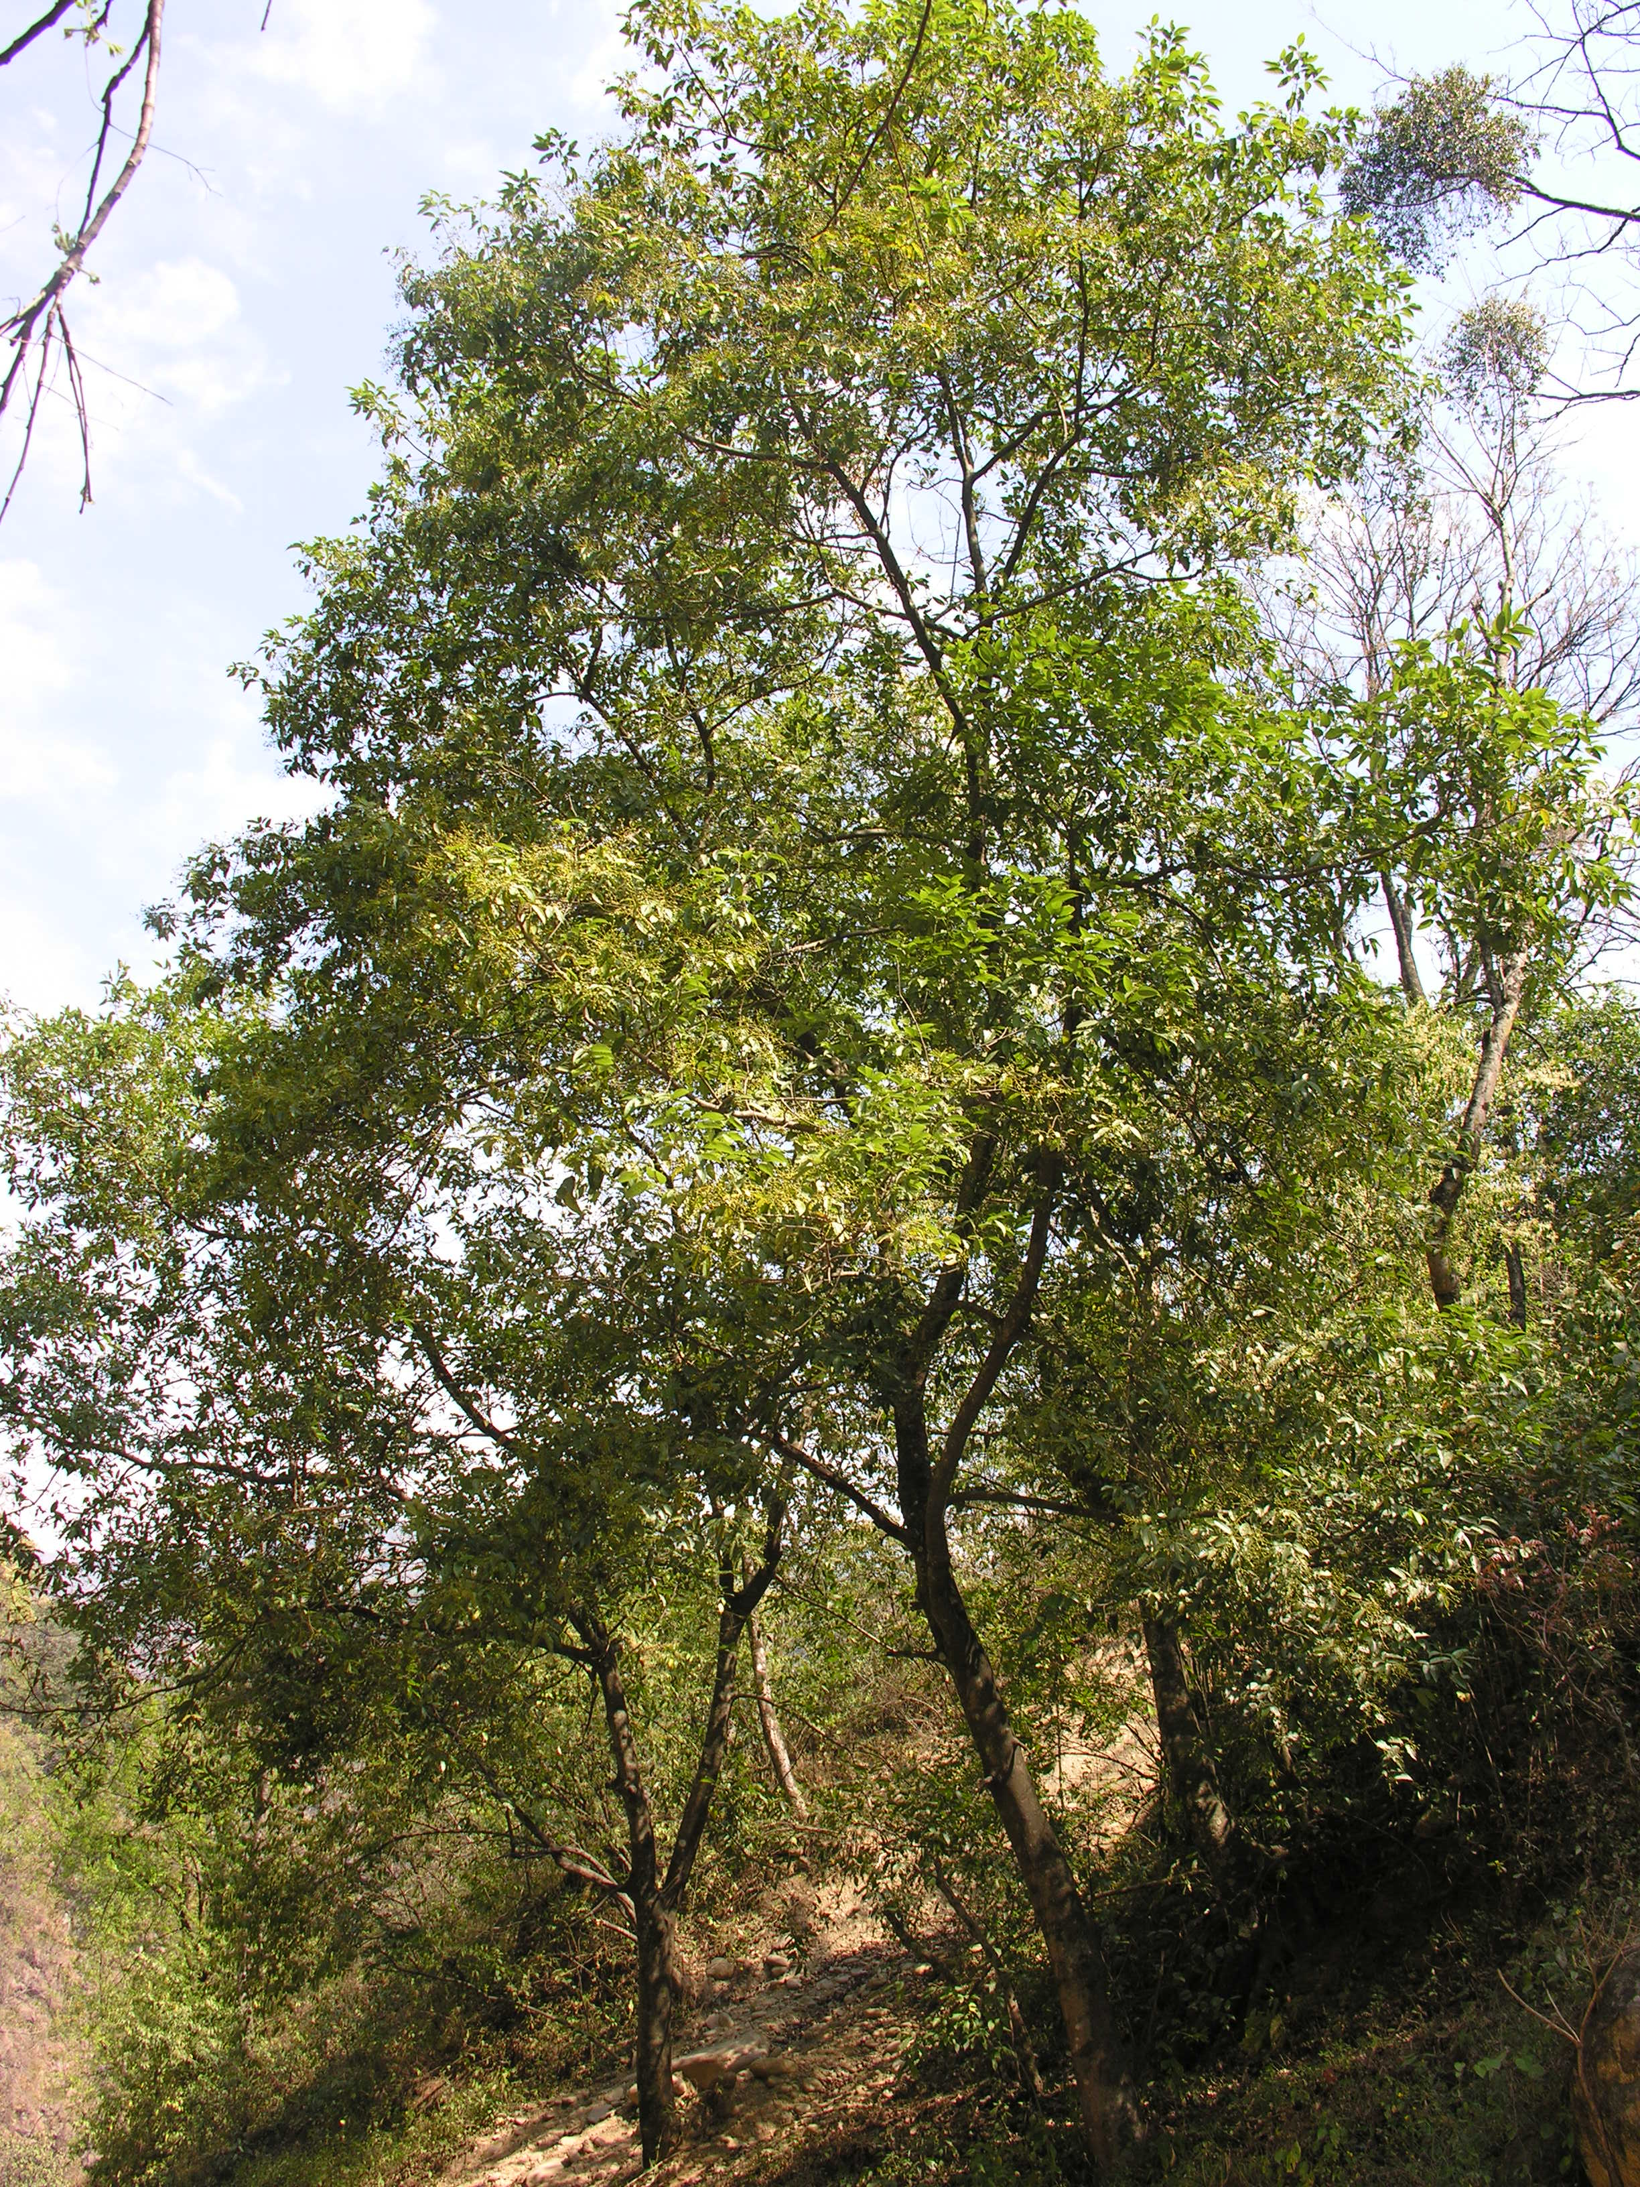A 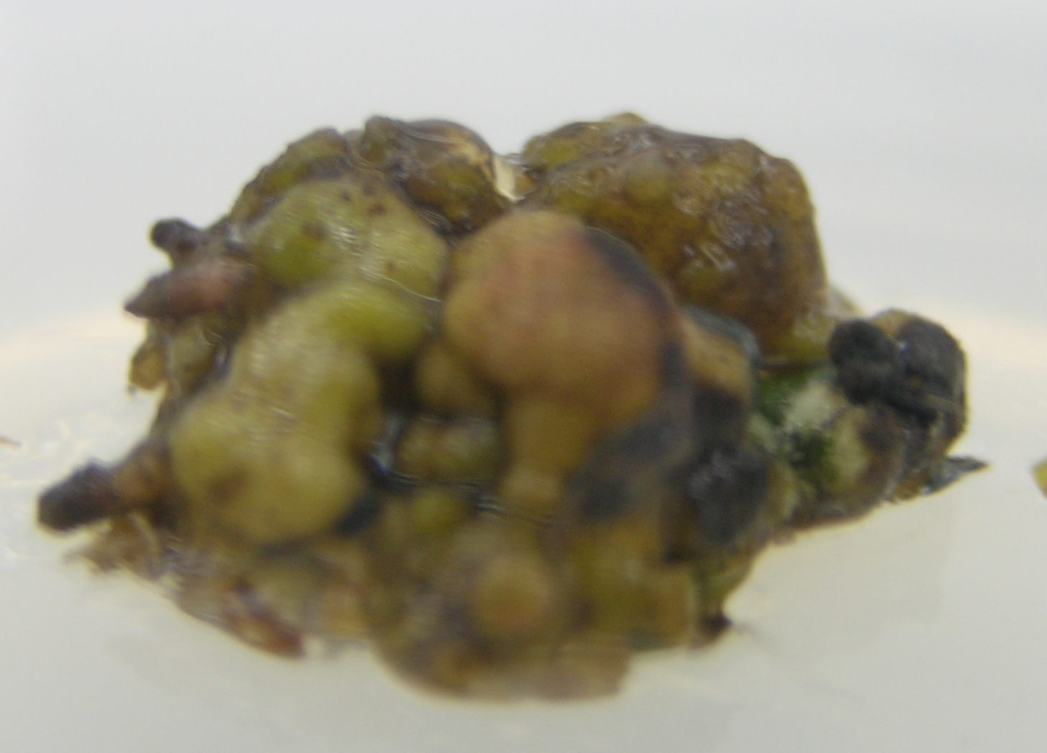B 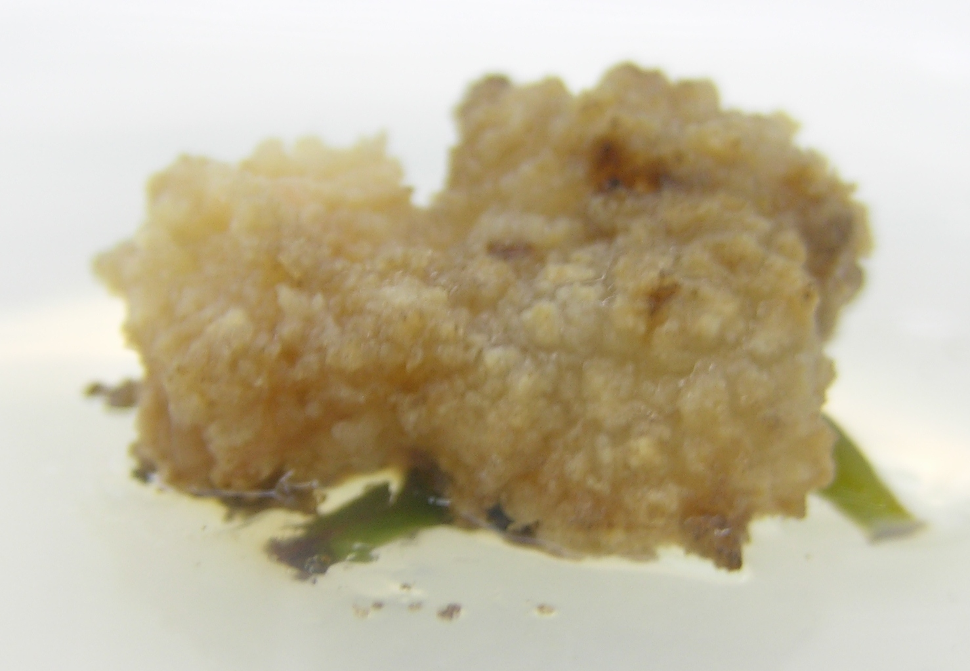C 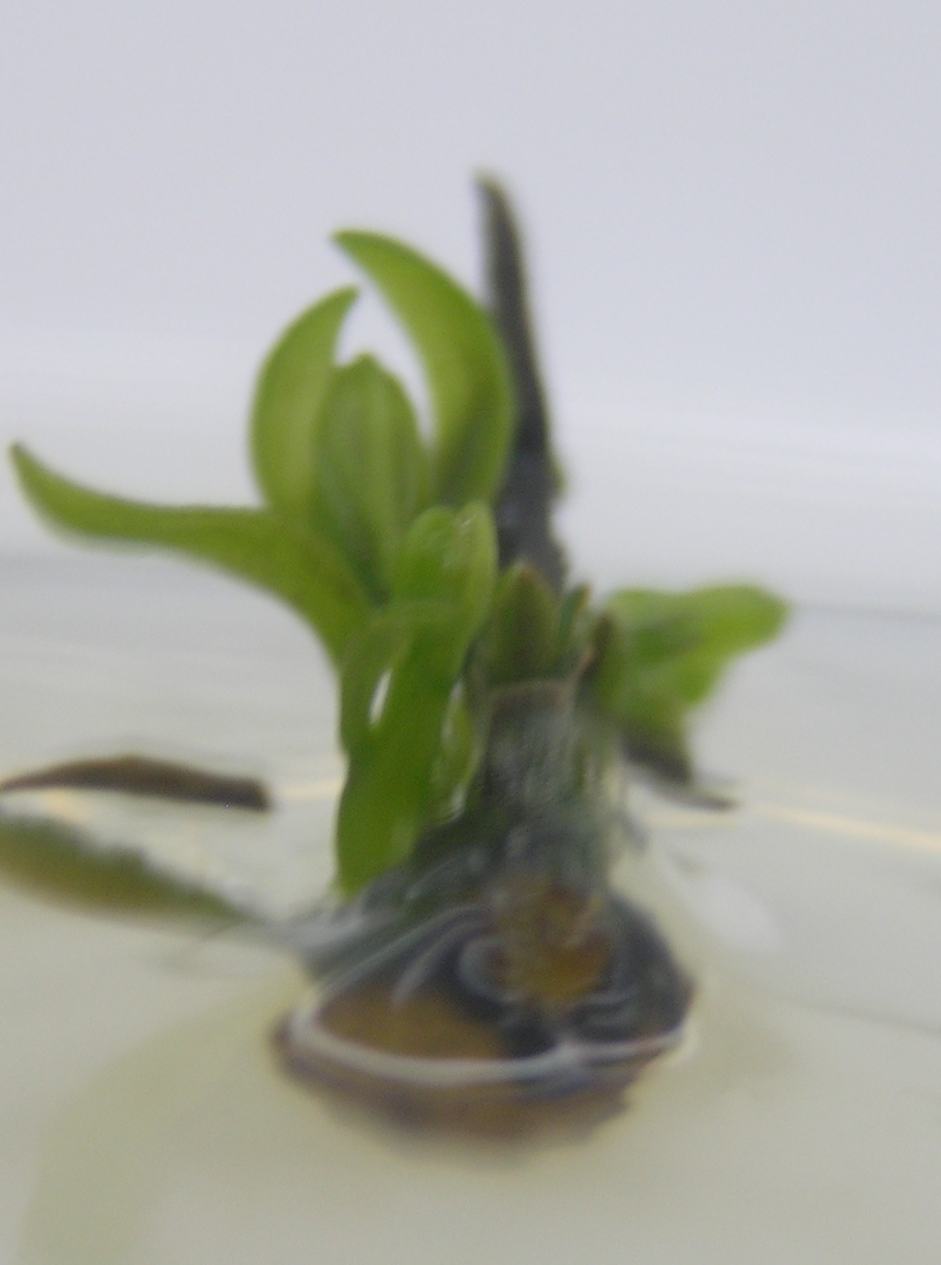D
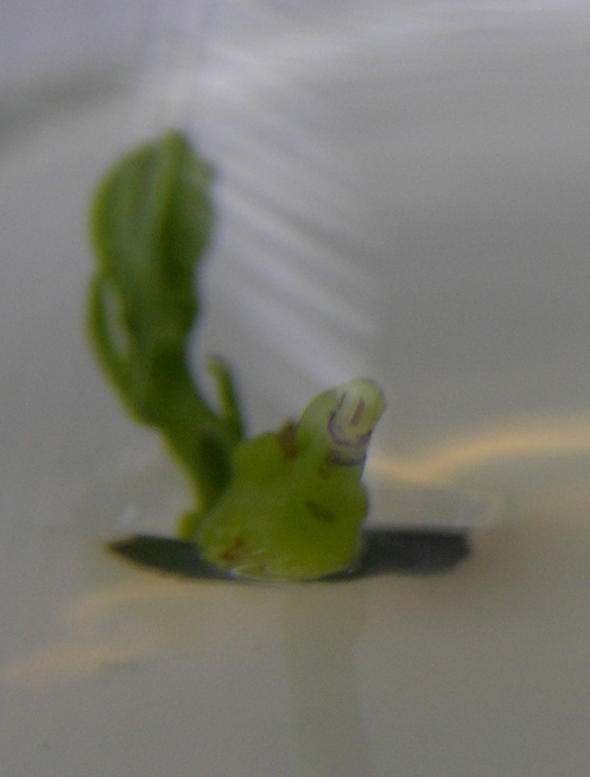E 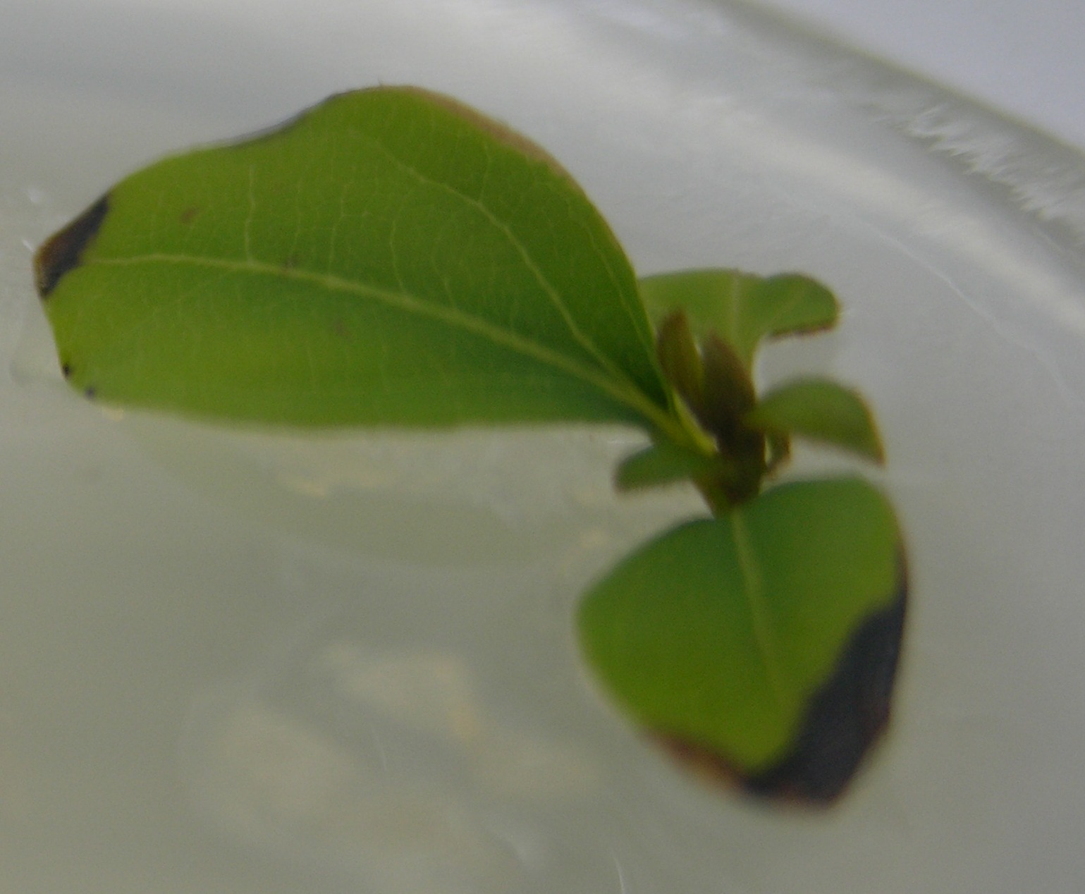F 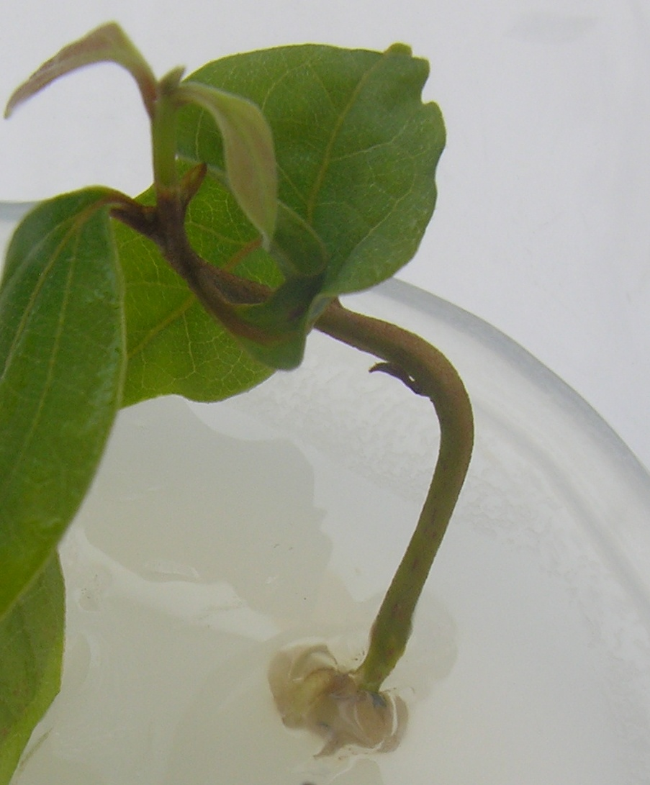G 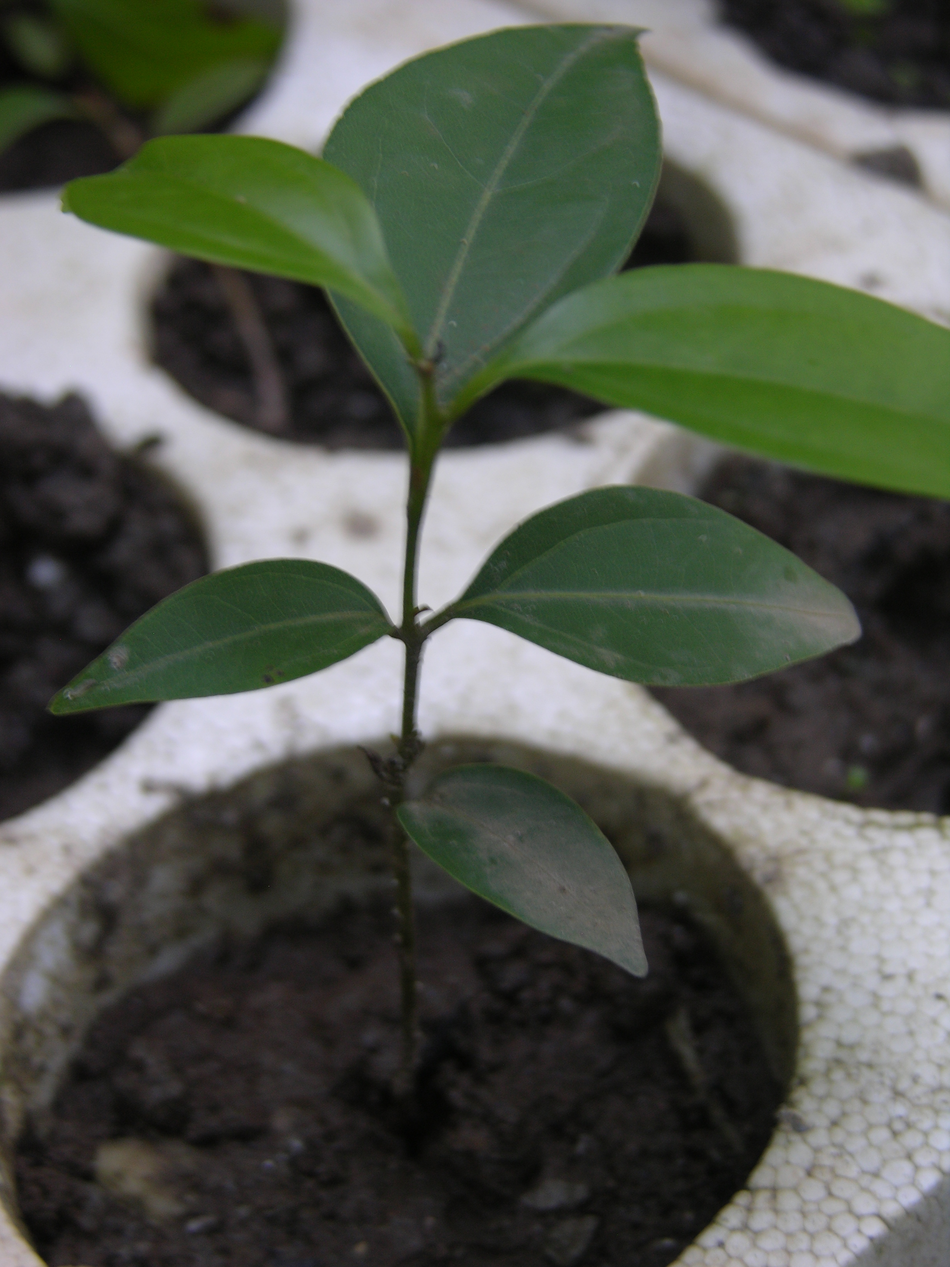H
Plate 1. (A-G)
A. A mature tree of Cinnamomum tamala
B. Compact greenish white colored callus
C. Friable white colored callus
D. Multiple shooting from callus
E & F Separated shoots from callus
G. Rooting in shoots
H. Acclimatization of plantlets of Cinnamomum tamala in soil

4. Discussion
The procedure described here is the first successful plant regeneration system for C. tamala through indirect organogenesis using a range of explants and PGRs combinations. Thus, the results of the present investigation reflect the existence of a large inter-explant variability in callusing responses of the target taxa. Such variable responses for different explant types have also been reported in other species (Pereira et al., 2000; Dhar and Joshi, 2005). Such variations can be attributed to the physiological condition of the explant, which is determined by genetic factors (Baroncelli et al., 1978; Nagarathna et al., 1991).
The present investigation has shown that the response of C. tamala to Micropropagation seems to be dependent more precisely on the explant type as well as on the PGRs treatments. The petiole with nodal segment was found the best source of explant both for callogenesis (Table 1) as well as multiple shooting with good rooting (Table 4) in all PGRs in comparison to other explants used. Similarly high regeneration capacity of petiole with nodal segment explant in comparison of other explants has also been reported in other species of this genus (for eg. C. camphora Babu et al., 2003). Leaf explant performed poorly with all type of treatments in present experiment. Similar results were found in C. camphora and C. verum from leaf explant (Soulange et al., 2007). Therefore, explant type had significant effect on callus induction, shoot and root regeneration. Such types of variation in response to different explant type have been reported earlier (Luo and Jia, 1998; Rout et al., 1999; Manjkhola et al., 2005).
In C. tamala, a combination of BA and IBA was found to be suitable for induction of callus, multiple shooting and rooting in all type of explants in contrast to other treatments (Table 4). Efficacy of BA for shooting and IBA for rooting has also been found for plantlet regeneration in C. kanehirae (Chang et al., 2002), combination of BA and IBA for multiple shoot induction in Arnebia euchroma (Manjkhola et al., 2005) and for somatic embryogenesis in Quercus semecarpifolia (Tamta et al., 2009). Data from the current study provide strong evidence that growth regulator requirements for callus induction vary depending on the source of the explant. This possibly results from the variation in morphological and biochemical characters of different explant types, which affects cytokinin uptake and competence of cells to initiate callus or shoots.

5. Conclusion
In conclusion, the present investigation reports an efficient and easy-to-handle protocol for organogenesis through callus for Cinnamomum tamala. Petiole with nodal segment is the best explant source for the species and very good callus can be induced in WPM medium supplemented with Benzyladenine (2.5μM) and Indole butyric acid (5μM) combination. In the context of best explant selection, the maximum 4 fold shooting and 100 % rooting was found in petiole with nodal segment explant. The sequentially decreasing order was found in apical shoot, shoot with internode and leaf explant and the differences were statistically highly significant in all the PGRs treatments. Similarly in the best PGRs selection experiment, BI combination was found superior in all the explants. The successively decreasing order was found in Benzyladenine, Kinetin, Indole butyric acid alone and Indole butyric acid+ Kinetin combination and control treatments in all the explants with highly significant results.
Following the procedure described here, approximately 4 well rooted plantlets can be developed from a single explant, within 4-5 months without harvesting or damaging the source material. This protocol could be useful in multiplying an elite stock of the species within a limited time. The importance of developing the callus line has increased over the years because of active compound production, and the possibility of genetic transformation in the pharmaceutical sector. The present callus regeneration system may also be important for advance studies on genetic improvement and, in the future, also has considerable potential as an alternative means for production of known and new secondary metabolites.

Acknowledgements:
This study was financed by the National Medicinal Plants Board, Government of India.

Correspondence to:
Prof. Anant Ram Nautiyal
Director
High Altitude Plant Physiology Research Centre,
HNB Garhwal University, Srinagar,
Pauri Garhwal- 246174 Uttarakhand, India,
Email:arnautiyal@gmail.com, gunjan_80sharma@rediffmail.com

References
- Brandis dietrich. Indian Trees: an account of trees, shrubs, woody climbers, bamboos and palms indigenous or commonly cultivated in the British Indian Empire. Bishen Singh Mahendra Pal Singh Dehra Dun India 1998: 533.
- Kirtikar and Basu Indian Medicinal Plants. Second Edition, Published by Lalit- Mohan Basu, India, 1981; 3:2146–2147.
- Showkat RM, Mohammed A, Kapoor R. Chemical composition of essential oil of Cinnamomum tamala Nees and Eberm. leaves. Flavour and Fragrance Journal 2004; 19:112–114
- Singh JS, Singh SP. Forests of Himalaya. Gyanodaya Prakashan, Nainital, INDIA 1992; 31.
- Kapoor LD. CRC Handbook of Ayurvedic Medicinal Plants CRC Press, Inc. Boca Raton, Florida, 2000;117
- Kar A, Choudhary BK, Bandyopadhyay NG. J Ethnopharmacolgy 2003; 84:105– 108
- Chang Shang-Tzen, Cheng Sen-Sung. Antitermitic Activity of Leaf Essential Oils and Components from Cinnamomum osmophleum J. Agric. Food Chem. 2002; 50(6):1389–1392.
- Smith RL, Adams TB, Doull J, Feron VJ, Goodman JI, Marnett LJ, Portoghese PS, Waddell WJ, Wagner BM, Rogers AE, Caldwell J, Sipes IG. Food Chem Toxicol 2002; 40:851–870.
- Saino F, Ghizzoni C, Gionfriddo F, Colombo E, Servillo L, Castaldo D. Determination of estragole, safrole and eugenol methyl ether in food products. Food Chemistry 2003; 81:469–475.
- Fischer IU, Dengler HJ. J Chromatogr 1990; 525:369–377.
- Dighe VV, Gursale AA, Sane RT, Menon S, Patel PH. Quantitative Determination of Eugenol from Cinnamomum tamala Nees and Eberm. Leaf Powder and Polyherbal Formulation Using Reverse Phase Liquid Chromatography. Chromatographia 2005; 61: 443–446.
- Kermasha S, Goetghebeur M, Dumont J. Lebensm-Wiss Technol 1994; 27(6):578–582.
- Yuwono M, Siswandono, Hafid AF, Poernomo AT, Agil M, Indrayanto G, Ebel S. Analytical Profiles and Drug Substance and Excipients. Academic Press, Elsevier Science (USA) 2002; 29:149-177.
- FAO - Food and Agriculture Organization of the United Nations. Chapter 2 - CINNAMOMUM OILS (INCLUDING CINNAMON AND CASSIA). "Flavours and fragances of plant origin" NON-WOOD FOREST PRODUCTS 1 FAO - Food and Agriculture Organization of the United Nations M-37, ISBN 92-5-103648-9, (c) FAO 1995.
- Ved DK, Kinhal GA, Ravikumar K, Prabhakaran V, Ghate U, Sankar RV, Indresha, JH. CAMP report: Conservation assessment and management prioritisation for the medicinal plants of Jammu and Kashmir, Himachal Pradesh and Uttaranchal. Shimla, Himachal Pradesh, FRLHT, Bangalore, 2003.
- Sharma G, Nautiyal BP, Nautiyal AR. Seedling emergence and survival in Cinnamomum tamala under varying micro-habitat conditions: conservation implications. Tropical Ecology 2009; 50(1): 201-209.
- Babu KN, Sajina A, Minoo D, John CZ, Mini PM, Tushar KV, Rema J, Ravindran PN. Micropropagation of camphor tree (Cinnamomum camphora) Journal Plant Cell, Tissue and Organ Culture 2003; 74, (2):179-183 (5).
- Huang Li-Chun, Huang Bau-Liang, Toshio Murashige. A micropropagation protocol for Cinnamomum camphora. In Vitro Cellular & Developmental Biology - Plant 1998; 34:2
- Kalam AMA, Shinso Y, Futoshi I, Shoji Y, Nobuo Y. Large-scale Clonal Propagation of Cinnamomum camphora (L.) Nees and Eberm. Bulletin of the Utsunomiya University Forests 2005; 41:101-109.
- Chang SH, Ho CK, Tsay JY. In Vitro Culture of Cinnamomum kanehirae Hay. Taiwan Journal of Forest Science 2002; No. 53
- Lloyd G, McCown B. Commercially feasible micropropagation of mountain, laurel,Kalmia latifolia, by use of shoot tip culture. Comb Proc Int Plant Prop Soc 1980; 30: 421-427.
- Pereira AMS, bertoni BW, Gloria BA, Araiyo ARB, Janauario AH, Loureno MV, Franca. Micropropagation of Pathomorphe umbellate via direct organogenesis from leaf explants. Plant Cell Tissue Organ Culture 2000; 60:47-53.
- Dhar U and Joshi M. Efficient plant regeneration protocol through callus for Saussurea obvallata (DC.) Edgew. (Asteraceae): effect of explant type, age and plant growth regulators. Plant Cell Rep 2005; 24: 195-200.
- Baroncelli S, Buittiet S, Bennici M, Foroughi W, Mix G, Gaul H, Tagliasacchi AM, Loiero M, Giorgi B. Genetic control of in vitro and in vivo growth of hexaploid wheat. Z Pflanzenzuecht 1978; 80:109-116.
- Nagarathna K C, Prakash H S, Shetty H S. Genotypic effects on the callus formation from different explants of pearl millet B lines. Adv. Plant Sci 1991; 4:82-86.
- Soulange JG, Ranghoo-Sanmukhiya VM and Seeburrun SD. Tissue Culture and RAPD Analysis of Cinnamomum camphora and Cinnamomum verum, Biotechnology 2007; 6 (2): 239-244.
- Luo JP, Jia JF. Callus induction and plant regeneration from hypocotyl explants of the forage legume Astragalus adsurgens. Plant Cell Rep. 1998; 17: 567-570.
- Rout GR, Saxena C, Samantaray S, Das P. Rapid plant regeneration from callus culture of Plumbago zeylancea. Plant Cell Tiss. Organ Cult 1999; 56: 47-51.
- Manjkhola S, Dhar U, Joshi M. Organogenesis, embryogenesis, and synthetic seed production in Arnebia euchroma- A critically endangered medicinal plant of the Himalaya. In Vitro Cell Dev. Biol. – Plant 2005; 41: 244-248.
- Tamta S, Palni LMS, Vyas P, Bisht MS. Conservation through in vitro method: A case of plant regeneration through somatic embryogenesis in Quercus semecarpifolia Sm. Journal of American Science 2009;5(1): 70-76.

7/2/2009

