COMMUNICATION

Chromatographic application of Fullerene Compounds on
Poly(4-methyl-5- vinylthiazole) Stationary Phase

Sheau-Long Lee

Department of Chemistry, Chinese Military Academy, Taiwan, R.O.C
Leesheaulong@gmail.com

ABSTRACT: The poly (4-methyl-5-vinylthiazole) stationary phase can be used HPLC chromatographic separation for C60 and C70 Fullerene compounds under normal phase. In comparison to commercial Diol-Phase, poly(4-methyl-5-vinylthiazole) stationary phase can provide better separation of C60 and C70.

Key words：Fullerene, poly (4-methyl-5-vinylthiazole) stationary phase

INTRODUCTION
C60 and C70 Fullerene compounds were originally found in 1996 by Kroto, Smalley and Curl [1]. The separation of these compounds studied by Ajie [2] and Howard [3] revealed RP-18 column in HPLC is not in efficient. However, Den proposed Sock-Ball chromatographic mechanism to synthesize five different sock-stationary phases for separation of C60 and C70 Fullerene compounds in carbon soot [4~6] can obtain good approach. I proposed a poly (4-methyl-5- vinylthiazole) stationary phase with coupling agentγ- Methacryloxypropyl trimethoxysilane in which one side connecting with silica jel and another side with 4-methyl-5-vinylthiazole. Not only the proposed phase has the characteristics of stationary, it also can be used in reverse phase. In comparison to RP-18 [7], poly (4-methyl-5-vinyl thiazole) can even function better.

MATERIALS AND METHODS
C60 and C70 were bought from STREM. RunningHPLC to get separation of C60 and C70 include using Waters 600E, Waters U6k Injector, Waters Lambda Max LC, Spectrophotometer model 481 and SISC Chromatography Data System. All Injector Columns were operated in 25℃. The column size is 4.6mm I.D. × 250mm made in Japan G. L. Science. Diol-Phase column was made in USA.

RESULTS
Poly (4-methyl-5-vinylthiazole) stationary phase column can provide better separation of C60 and C70. Table I shows the K (Capacity Factor K value) values for mobile phase under the condition of n-hexane / dichloromethane(80:20). The separations of C60 and C70 were depicted in Figure 1 and Figure 2.

REFERENCES
- Kroto,H.W.;Heath,J.R; O’Brien, S.C.; Curl,R.F.and Smalley., Narure,1985,318,162.
- Ajie.H, Alvarez.M.M, Anz.S.J,etc., J. Phys.Chem. 1990,94,8630.
- Howard.J.B, Mckinnon.J.T, Makarovsyky.Y, Lafleur.A.L, and Johnson.M.E, Nature 1991,352,139
- Chang.C.S, Wen.C.H, and Den.T.G, Chemistry (Chin. Chem. Soc.), 1996,54,2,1.
- Chang.C.S, and Den.T.G, Chemistry (Chin. Chem. Soc.), 1996,54,3,29.
- Chang.C.S, and Den.T.G, Chemistry (Chin. Chem. Soc.), 1997,55,1,37.
- Sheau-Long Lee, Tschau-Gan Den, Xinmiao.Liang, Jutta. Lintelmann and Antonius Kettrup, J. High Resol. Chromatogr., 1995, Vol.18,P.671.

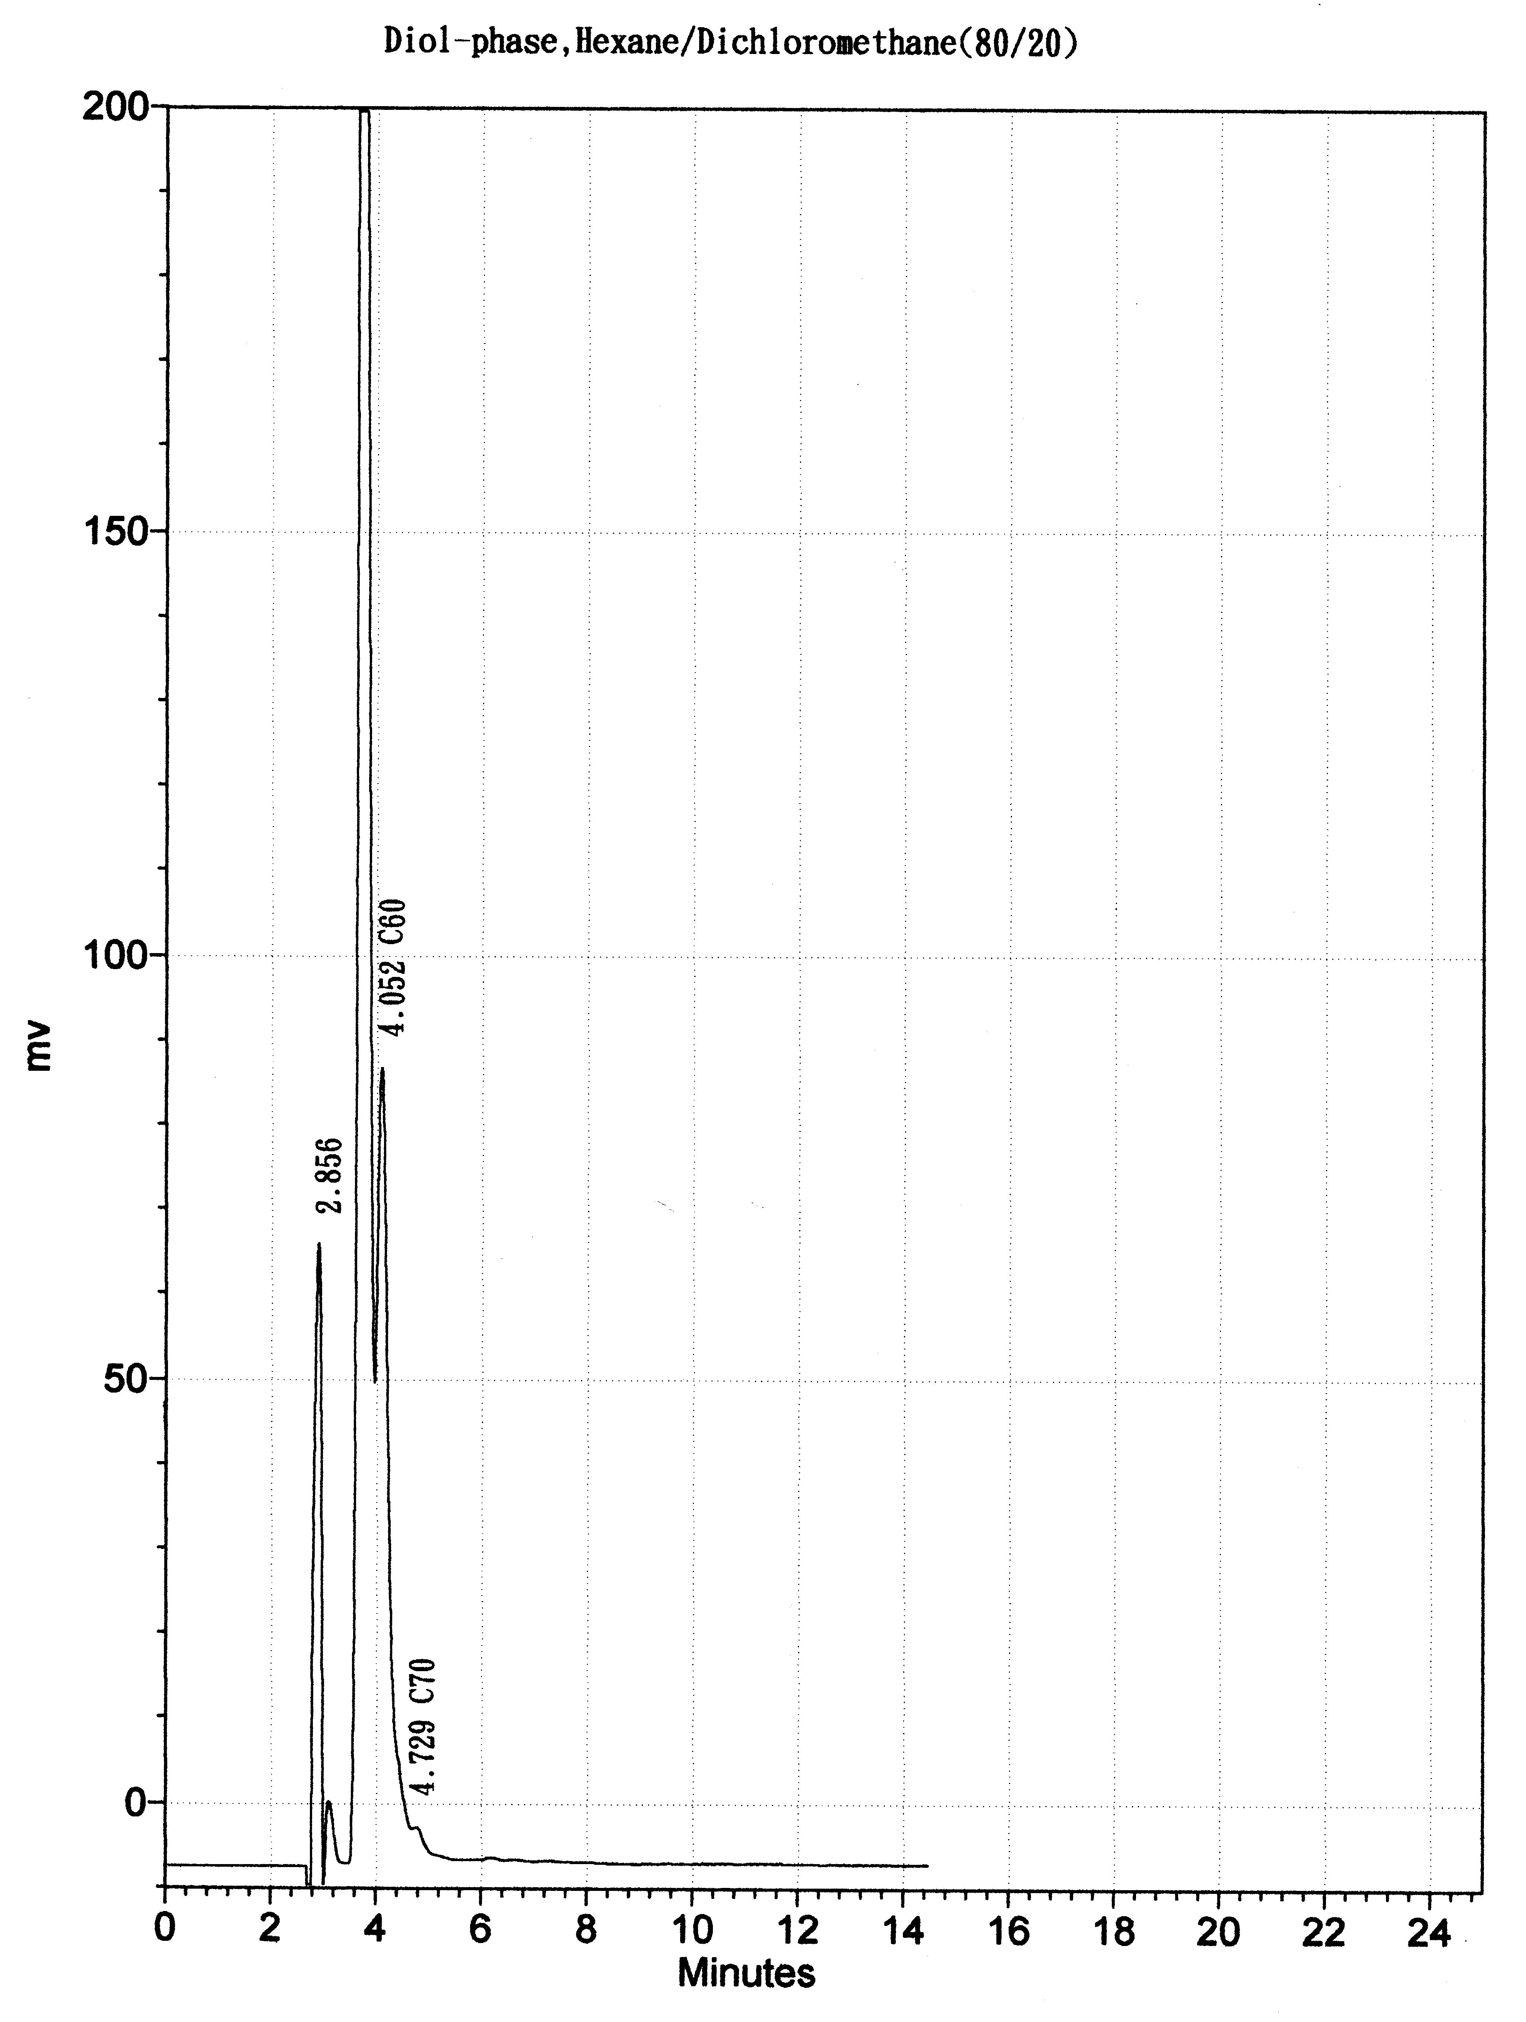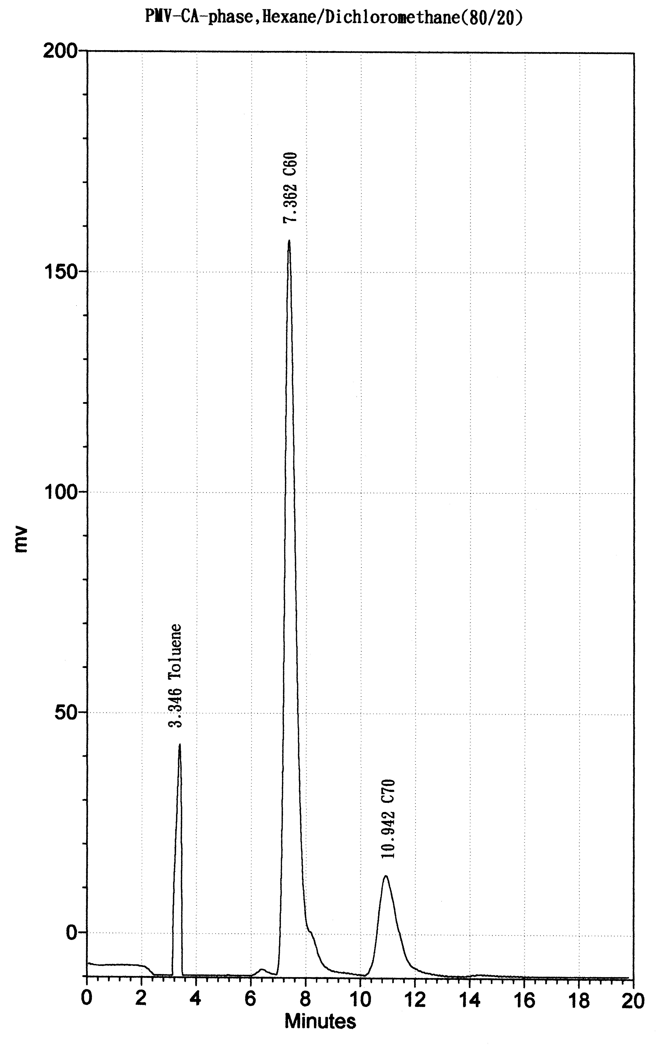

Figure 1. The Chromatography of C60,C70 on Diol-Phase and PMV-Phase
( Mobile Phase: n-Hexane/Dicholoromethane 80/20 )

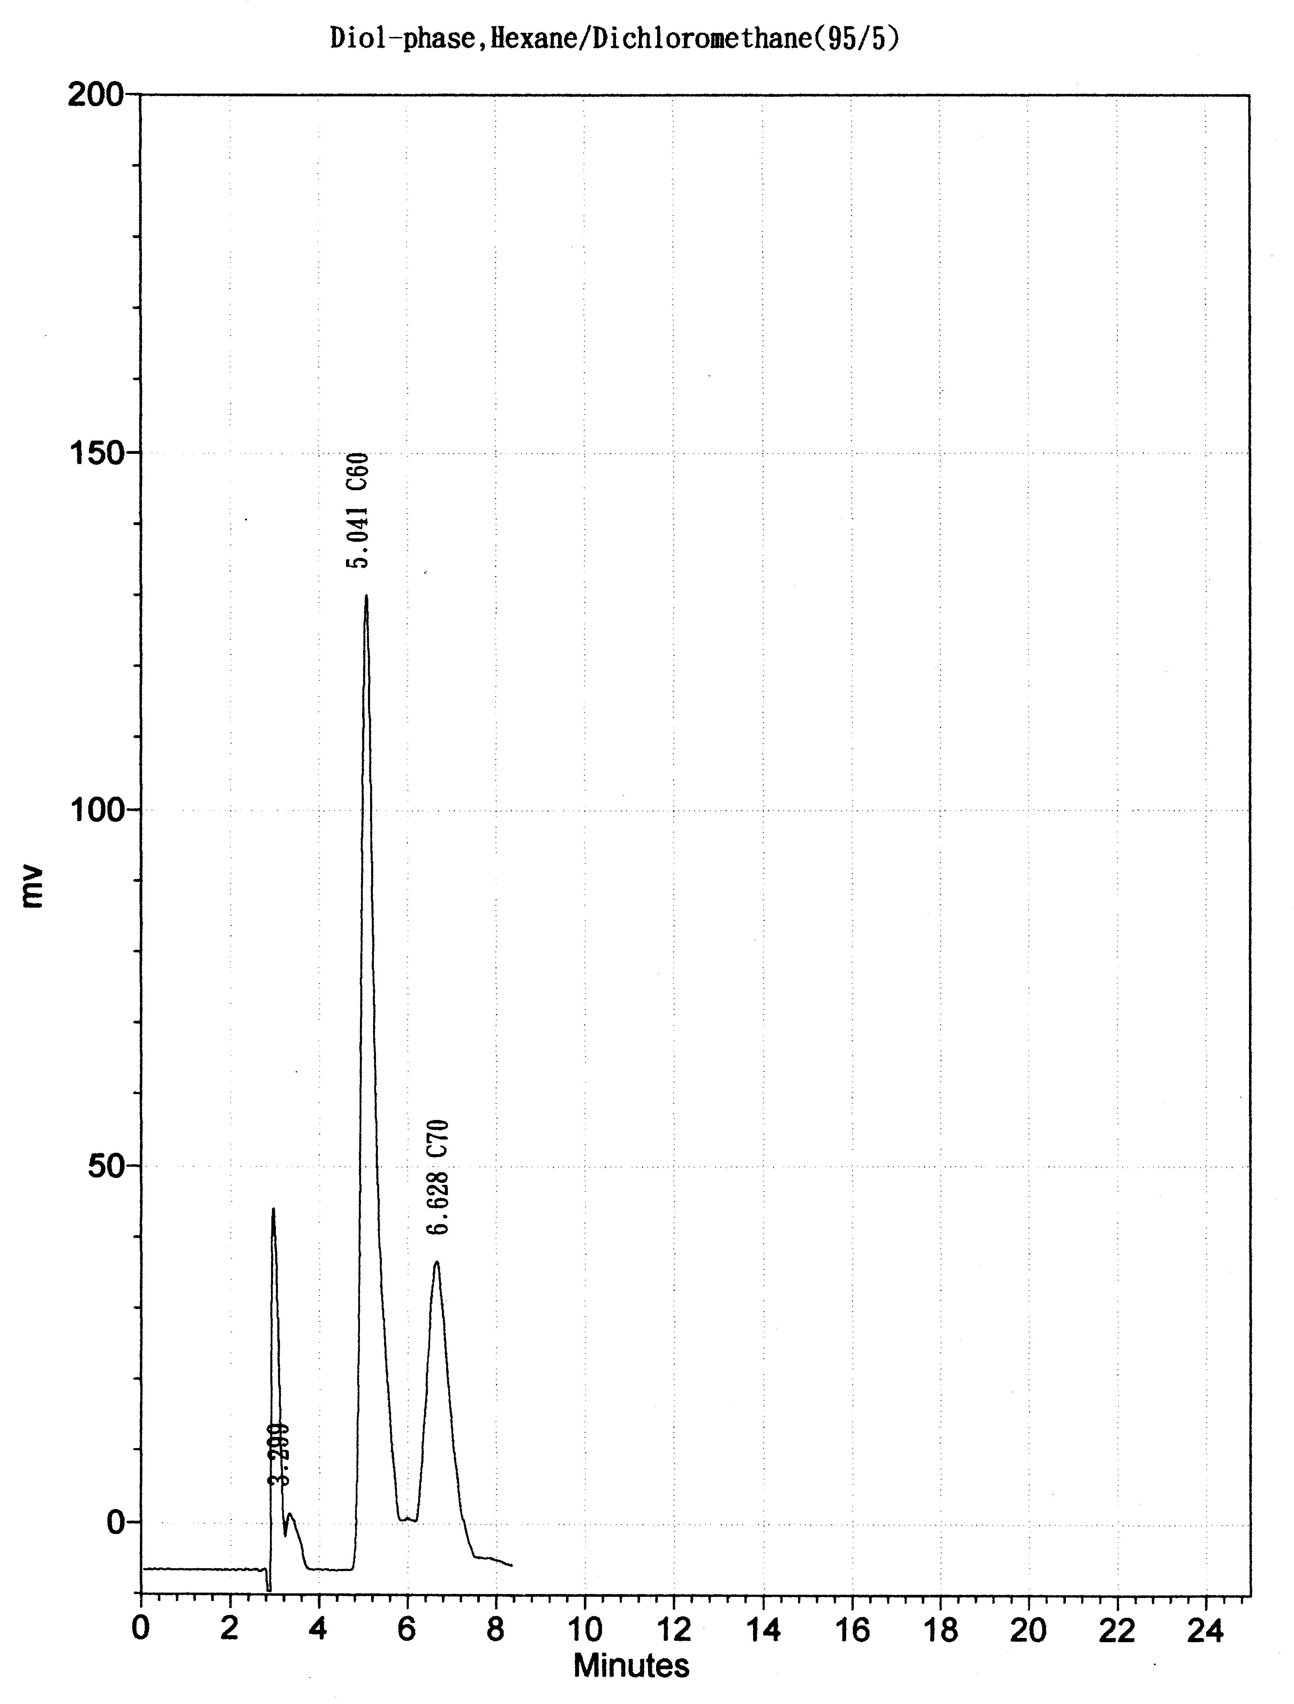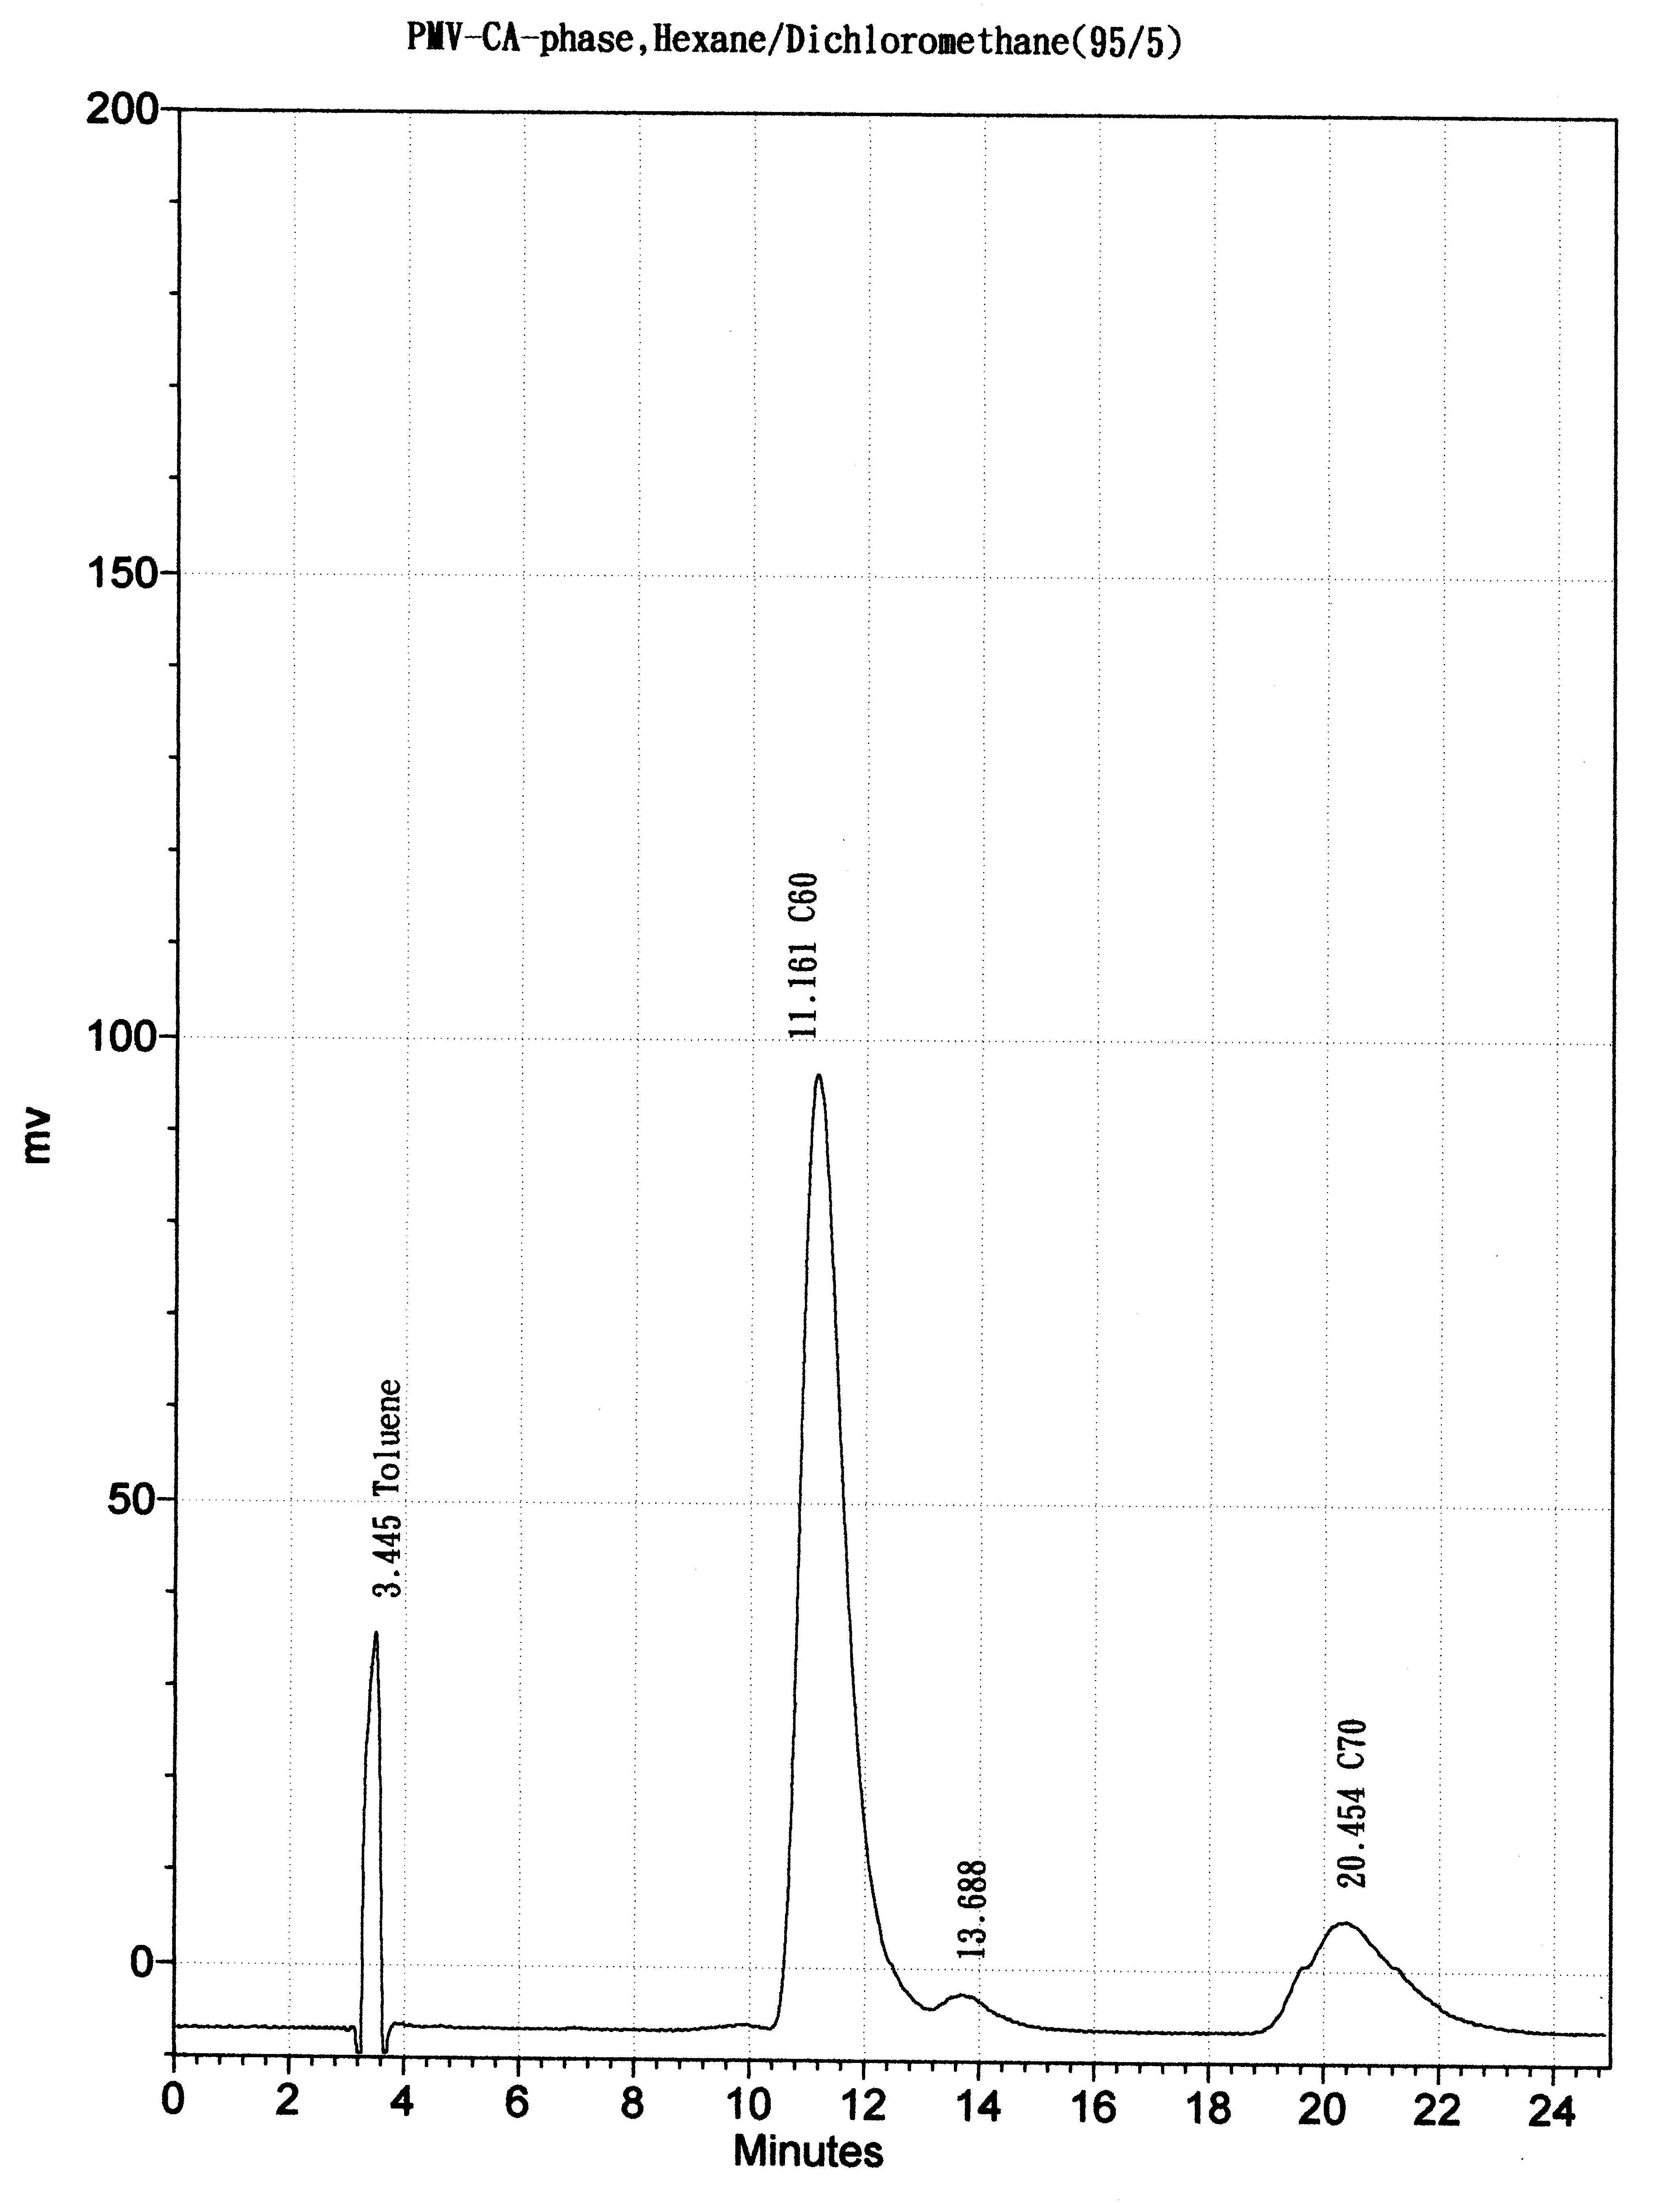

Figure 2. The Chromatography of C60,C70 on Diol-Phase and PMV-Phase
( Mobile Phase: n-Hexane/Dicholoromethane 95/5 )

Table I
Capacity Factor K values for Diol-phase and PMV-phase in 80/20 and 95/5 Hexane/Dichloromethane Mobile Phase for C60 and C70

 | Diol-phase |  |  | PMV-phase
sample | Hexane/Dichloromethane |  |  | Hexane/Dichloromethane
 | 80/20 | 95/5 |  | 80/20 | 95/5
 | K₁ | K₂ |  | K₁ | K₂
C₆₀ | 0.4187 | 0.575 |  | 1.200 | 2.240
C₇₀ | 0.6558 | 1.071 |  | 2.270 | 4.937

