The Characteristic Frequencies in Cell Induced
Magnetic Fluctuation

¹Hsien-Chiao Teng, ¹Chi-Cheng Lie, ²Shen Cherng
¹Department of Electrical Engineering, Chinese Military Academy, Fengsang, Taiwan 830, ROC
²Department of Electrical Engineering, Cheng Shiu University, Niau Sung, Taiwan 833, ROC
scteng@cc.cma.edu.tw; cherngs@csu.edu.tw

Abstract: To exam the cellular responding frequencies buried in the cell-induced magnetic fluctuations (CIMF), we exposed the mouse osteoblast cell line system to the 50 Hz extremely low frequency (ELF) magnetic field and the rat liver epithelial cell line system to the 7Hz ELF magnetic field. CIMF can couple with geomagnetic fluctuation to create cell-induced geomagnetic fluctuation (CIGF). It was computed their power density spectrum of CIGF and revealed the characteristic frequencies in extremely low signal-to-noise ratio (SNR) circumstances. The gap junction intracellular communication (GJIC) within both the mouse osteoblast cells and rat liver epithelial cells under the exposure of different intrinsic ELF magnetic fields were 20% in difference to the contrary. Furthermore, it was found the 7Hz cellular responding frequency in CIGF may cause 20% GJIC in difference to the contrary if we exposed the rat liver epithelial cells into 2.4GHz electromagnetic field. In this article, we concluded the mouse osteoblast cell line system responded 50 Hz at intrinsic frequency in CIGF to the reaction of external 50 Hz ELF magnetic field but the rat liver epithelial cell line system responded 7Hz at intrinsic frequency in CIGF to the reaction of external 7Hz ELF magnetic field exposure. In contrast, the rat liver epithelial cells responded 7 Hz at intrinsic frequency in CIGF to the reaction of external 2.4GHz electromagnetic field exposure, which is the application of our novel antenna design suitable for the WLAN and IEEE 802.11 a/b protocol. The wireless communication design is requested application in 2.4GHz (2.4-2.484 GHz) and 5.2 GHz (5.15-5.35 GHz) bands to fit the Bluetooth IEEE 802.11/ a/b protocol, which may cause the cellular response in our study. [Nature and Science. 2004;2(4) (Supplement): 22-27].

Key words: extremely low frequency (ELF); gap junctional intracellular communication (GJIC)

INTRODUCTION
There are two major studies of the biological systems responded to the reaction of the electromagnetic field in the past twenty years. One is the cellular response and the other is genetic response. Since the energy provided by the electromagnetic field even is less than thermal energy [Adair,1991], scientists presume that the genetic response of the biological system to the reaction of electromagnetic field may indirectly associate with the genetic mutant and recombination [Aldinucci et al., 1998]. However, cellular response to the reaction of electromagnetic field may be reliant to the correlation between multi-enzyme complex and the pathways of cell-metabolism procedures. In physics point of view, surface electrical current of the cell monolayer in a culture dish can initiate cell-magnetic fluctuation. By using power density spectrum of the couple of geo-magnetic and cell-magnetic fluctuation for cell system, the signal to noise ratio (SNR) of characteristic frequencies can be computed [Teng, 2003]. The external extremely low frequency (ELF) magnetic field may perturb the surface current distribution and cause the cellular response. Gap junctional intracellular communication (GJIC) is an indicator to express the cell’s response affiliated with many pathological endpoints [Upham et al., 1998; Trosko et al. 1990; 2001], such as cell aging, apoptosis, proliferation and differentiation, are associated with the modulation of GJIC. To measure GJIC modulation, scrape loading dye transfer of Lucifer yellow [Upham et al., 1998] was used. The degree of modulation of GJIC can then show the cellular response to the ELF reaction.

MATERIAL AND METHOD
For the diameter of the culture dish used was 3.5 cm, we used a simple 5-cm radius helical coil, which is wrapped with 200 turns 0.45-mm diameter cooper string around a plastic cylinder tube connected to the function generator for input ELF signals. The whole system was placed in an incubator. The incubator controlled the environment at 5% CO₂ at 98% relative humidity. Another sham field chamber was exactly same as the ELF incubator only with no exposure to the ELF. The cell culture dishes were placed perpendicular to the input ELF. The function generator generated the ELF signal through the solenoid applied to the mouse osteoblast cells in the center of the solenoid for sixty minutes.

Cell Culture
The rat liver epithelial cell line was obtained from the Fisher Scientific (WB344). It was derived from normal liver and maintained in D-medium (Formula 78-5470EF, GIBCO, Grand Island, NY), supplemented with 10% fetal bovine serum (GIBCO) and 50 µg/ml gentamicin (QualityBiological,Inc.). Mouse osteoblastic MC3T3-E1 cell line was obtained from D.T. Yamaguchi, Research Service and Geriatrics Research, Education, and Clinical Center, VAMC, West Los Angeles, California, USA and maintained in D-medium same as rat liver epithelial cell line. The cells were incubated at 37˚C in a humidified atmosphere containing 5% CO₂ and 95% air and were fed or trypsinized every two to three days. Cells in culture for seven days can be used for experiments.

GJIC Assay: The scrape load/dye transfer (SL/DT) technique was used to measure the GJIC within cells [Upham et al., 1998]. After exposure to ELF at intrinsic frequency, the cells were rinsed with phosphate buffered saline (PBS), and a PBS solution containing 4% concentration lucifer yellow fluorescence dye is injected into the cells by a scrape using a scalpel blade. Afterwards the cells were incubated for 3 min and extra cellular dye was rinsed off and fixed with 5% formalin. We then measured the area of the dye migrated from the scrape line using digital images taken by an epifluorescent microscope and quantitated with Nucleotech image analysis software for the GJIC images.

Math Model for the Reaction Mechanism
The electron-transfer in DNA was observed to determine the biochemical pathways [Eynard et al.1998]. Theoretically, it should not be distinguishable between the physical signal and the intercellular power supply for electron-transfer in DNA. We proposed the model that the power in cell should be provided from the stochastic electromagnetic process. The source of the process is the signal dependent noise. In the process of stochastic resonance, noise influences the signal and the signal feedbacks to the noise. The energy involved in the beginning of the creation of biochemical signal pathway is very small. However, after it goes through several times feedback, enough energy can cause the associated acceptors proper conformational change for signal transduction. In the time sequence, the related physical signal can be assumed as a transit signal from blind source [Streit, 1999]. The life time of the signal is in the range of 10⁻¹² second. We believe the Faraday law is still value in the process. Accordingly, the cell induced geo-magnetic fluctuation (CIGF) [Teng et al., 2003] can express the phenomena of stochastic bioelectromagnetic process.
Mathematically, we consider quadratic potential system, the potential is as follow:
$U(x,t)=−\frac{a}{2}x^{2}+\frac{b}{4}x^{4}−εx\text{cos}ω_{s}t$，where $ε$ is the amplitude of the signal and$ω_{s}$is the signal frequency
$U(x,t)=U_{0}\left[−2{\left[\frac{x}{c}\right]}^{2}+{\left[\frac{x}{c}\right]}^{4}\right]−U_{1}\left[\frac{x}{c}\right]\text{cos}ω_{s}t$, where$U_{0}=a^{2}4b$ (=0 and $U_{1}=εc$)
Consider the motion of equation
$\overset{˙}{x}=−\frac{∂U(x,t)}{∂x}+D^{12}ξ(t)$,
where constant D is the variance of the noise,$\left\langle ξ(t)\right\rangle =0$,$\left\langle ξ(t)ξ(t+τ)\right\rangle =δ(τ)$, two minimum values of the potential well can be determined [Jung et al. 1991]. Due to the thermodynamic second law, the system tends to be in minimum energy and maximum entropy state. Assume the transition rate between these two minimum states is W(t), then, according to Kramers Rate formula,
$W(t)=\frac{a}{\sqrt{2}π}\text{exp}\left[−2(U_{0}+U_{1}\text{cos}ω_{s}t)/D\right]$, when D=U₀, the resonance frequency will be happened at$ϖ=\frac{\sqrt{2}{\text{πω}}_{s}e^{2}}{a}$. At this time, if the cellular response happens at$ϖ$, where “a” is a constant, the associated potential well can be determined and the auto-correlation and Power Density Spectrum can be calculated. Based on the model, the magnetic fluctuation provides the energy and affects the conformation of the associated proteins in the cell, the activity of the proteins should be changed [Aldinucci et al., 1998] and then affects the physiological endpoints, which can be expressed from GJIC modulation assay.

Proposed Design of 2.4GHz antenna
The proposed antenna is excited using a 50 ohm microstrip line. The design was shown in Fig 1, which demonstrates the geometry and dimensions of antenna applied in 2.4 GHz {Xu et al., 2003}. This design was proposed to create an artificial environment of similar wireless communication frequency-band in 2.4GHz (2.4-2.484 GHz) to fit the Bluetooth IEEE 802.11/ a/b protocol so that the cells can be developed in 2.4GHz electromagnetic field [Wong et al. 2003].

Simulation of 2.4GHz Electromagnetic field
Due to the antenna must provide the 2.4 GHz electromagnetic field; we designed a novel jacket antenna to fit the loading of cell culture dish. The HFSS simulation design is shown in Figure 2.

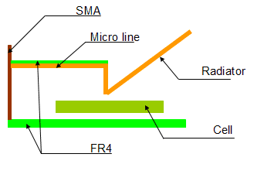

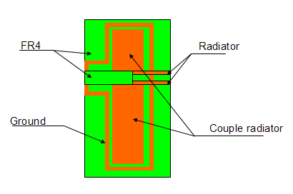

Figure 1: Design of the jacket antenna (patent is in application)

The 3D drawing of the proposed antenna is illustrated in Figure 3.
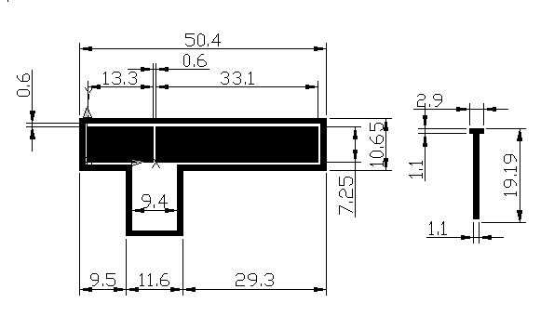
Figure 2: Size of the proposed antenna

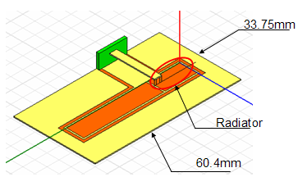
Figure 3: The 3D drawing of the proposed antenna

In Figure 4, it is shown the return loss of the proposed antenna.

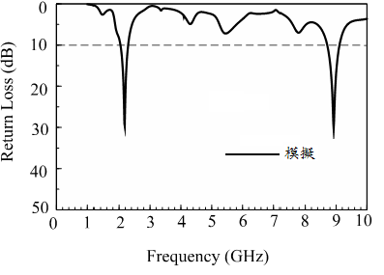
Figure 4: Return Loss of the proposed jacket antenna

From the antenna return loss, we see the bandwidth and 50 ohm impedance match. The image of the protocol antenna is illustrated in Figure 5

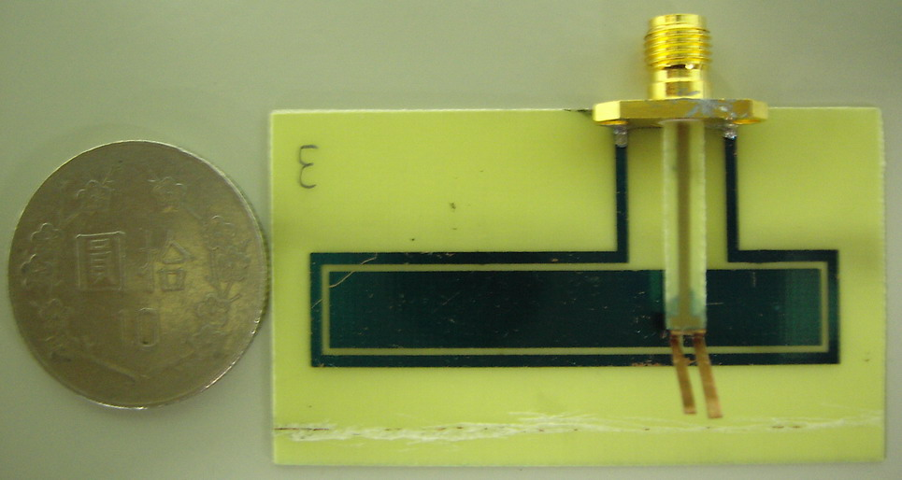

Figure 5 (a): Jacket antenna true size top view

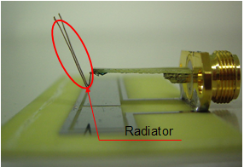

Figure 5 (b): Jacket antenna in 3D view

EXPERIMENTAL RESULTS
In Figure 6、Figure 7、and Figure 8 demonstrated the diffusion of the dye of the GJIC within osteoblast cells in 50 Hz ELF AC magnetic field and Figure 9、Figure 10、and Figure 11 are in control. In Figure 12 and Figure 13 depicted the diffusion of the dye of the GJIC within rat liver cells in 7 Hz ELF AC magnetic field and in control. Table 1 shows diffusive area amount of the GJIC assay of the cells in 50 Hz ELF AC magnetic field and Table 2 shows diffusive area amount of the GJIC assay of the cells in 7Hz ELF AC magnetic field. The dye diffusive amount is averagely the same with the 7 Hz ELF AC magnetic field treatment when we exposed the rat liver epithelial cells into 2.4 GHz environment. In Figure 14, we can seethe cellular response in rat liver epithelial cells to 7Hz ELF AC magnetic field. FOC means fraction of control. If FOC is less than zero, it is an inhibit reaction. Oppositely, if FOC is bigger than zero, it is a stimulation reaction.

Figure 6: The diffusive dye of the GJIC of the osteoblast cells in 50 Hz ELF treatment (a)

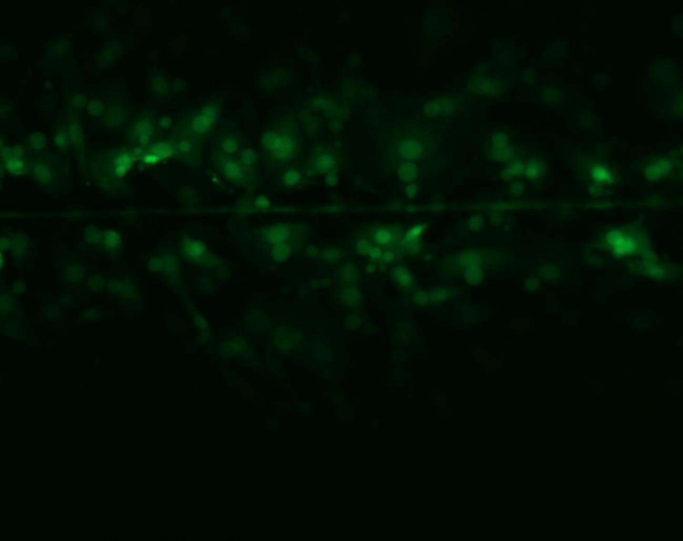

Figure 7: The diffusive dye of the GJIC of the osteoblast cells in 50 Hz ELF treatment (b)

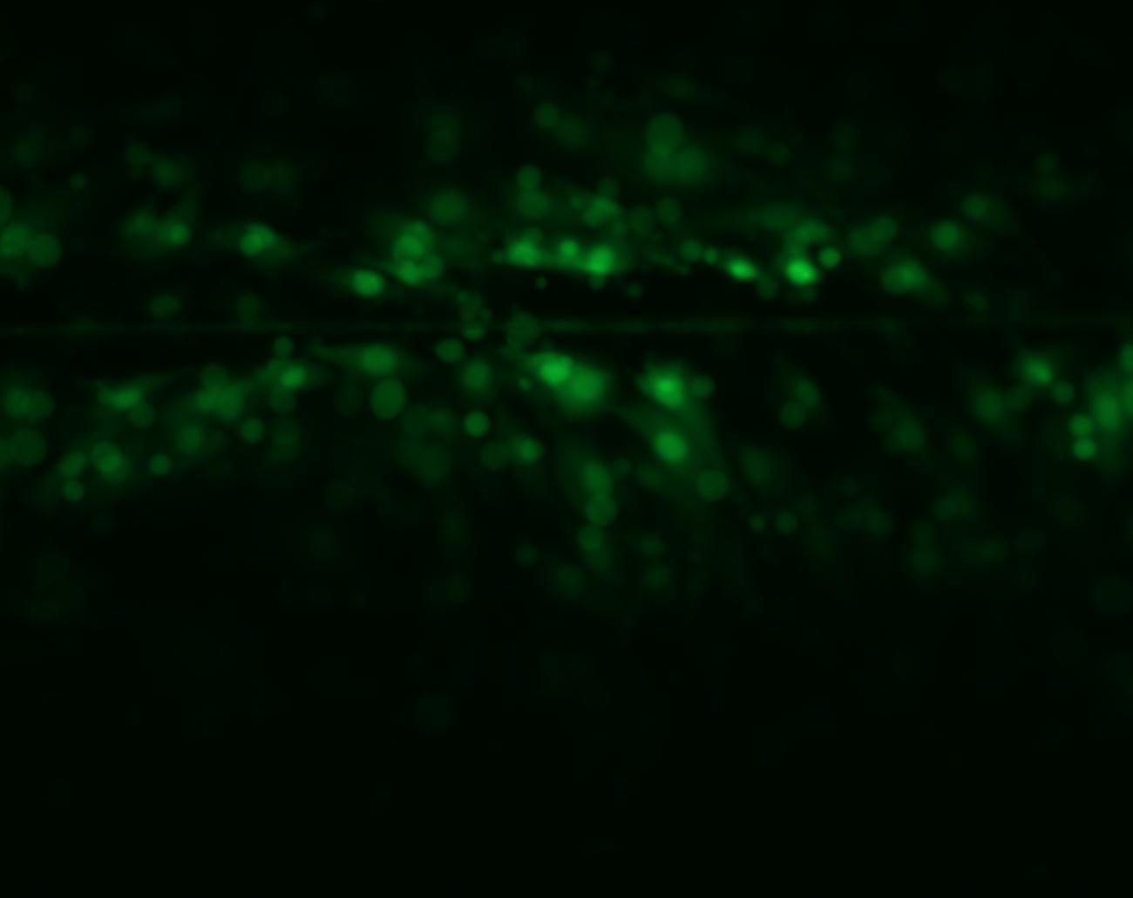

Figure 8: The diffusive dye of the GJIC of the osteoblast cells in 50 Hz ELF treatment (c)

Table 1.The diffusive area (mm²) of the dye of the GJIC within osteoblast cells in ELF 50Hz.

GJIC | Figure 6 | Figure 7 | Figure 9
Diffusive area | 168869 | 144343 | 164042

Figure 9: The diffusive dye of the GJIC of the osteoblast cells in control

Figure 10: The diffusive dye of the GJIC of the osteoblast cells in control

Figure 11: The diffusive dye of the GJIC of the osteoblast cells in control

Table 2. The diffusive amount of the dye of the GJIC within osteoblast cells in control

GJIC | Figure 9 | Figure 10 | Figure 11
Diffusive area | 169466 | 128780 | 112756

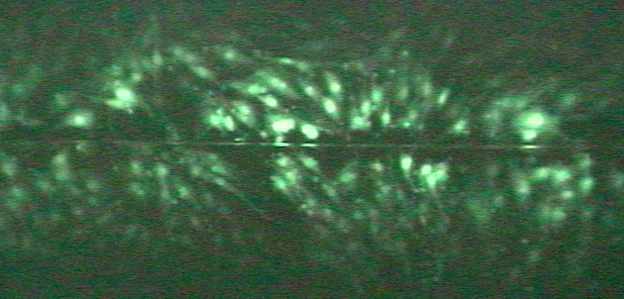

Figure 12: The diffusive dye of the GJIC of the rat liver epithelial cells in control

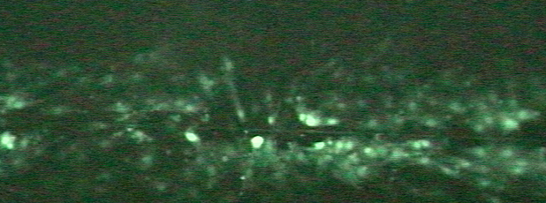

Figure 13: The dye diffusive area of the GJIC of the rat liver epithelial cells in 7Hz ELF AC magnetic treatment
7Hz 25Hz 35Hz

Figure 14: The FOC result of the GJIC Assay for rat liver epithelial cell line system

CONCLUSION
We concluded that the cell induced current in vitro under the influence of geomagnetic fluctuation with input signal must perturb original cell-induced magnetic fluctuation, then, the cellular response intrinsic ELF modulated the GJIC within Mouse Osteoblast Cells. In addition, this report demonstrated the characteristic signal SNR for cell system which is 7Hz for rat liver epithelial cells and 50Hz for mouse osteoblast cell line system. The major concern for this report, not only was the geomagnetic fluctuation being affected the cell line system, but also challenged whether GJIC described the biological effect correlated to cellular response as ELF signals though the SNR, which might be so low as to 200 to 300 times less than noise. Our study showed that we were able to obtain the corresponding degree of modulation of GJIC for recognizing biological effects. The cellular responding intrinsic frequencies may be buried in geomagnetic fluctuations..

Correspondence to:
Hsien-Chiao Teng
Department of Electrical Engineering
Chinese Military Academy, Fengshan, Taiwan 833
Republic of China
Email: scteng@cc.cma.edu.tw
Telephone: 011886-7747-9510 ext 134

REFERENCES
- Adair RK. Constraints on biological effects of weak extremely low frequency electromagnetic fields. Physical Review A 1991;43:1043-7.
- Aldinucci C, Pessina GP. Electromagnetic fields enhance the release of both interferon γ and interleukin-6 by peripheral blood mononuclear cells after phytohaemagglutinin stimulation. Bioelectrochemistry and Bioenergetics 1998;44: 243-9.
- Eynard N, Rodriguez F, Trotard J, Teissie J. Electrooptics Studies of Escherichia coli Electropulsation: Orientation,Permeabilization, and Gene Transfe. Biophysical Journal 1998;75:2587–96.
- Streit RL, Willett PK. Detection of Random Transient signals via hyperparameter estimation. IEEE Transaction on Signal Processing 1999;47(7):1823-34.
- Trosko JE, Chang CC, Madhukar BV. Modulation of Intercellular Communication during Radiation and Chemical Carcinogenesis. Radiation Research, 1990;123:241-51.
- Teng HC, Cherng S. Mouse Osteoblast Cell Sensitivity to the AC Magnetic Field at 14 Hz. Nature and Science 2003;1(1):27-31.
- Jung P, Haggi P. Amplification of small signals via stochastic resonance. Physical Review A 1991;44(12):8032-42.
- Trosko JE, Chang CC. Role of stem cells and gap junctional intercellular communication in human carcinogensis. Radiation Research, 2001;155:175-80.
- Upham BL, Deocampo ND, Wurl B, Trosko JE. Inhibition of Gap Junctional Intracellular Communication by perfluorinated fatty acids is dependent on the chain length of the fluorinated tail. Int J Cancer 1998;78:491-5.
- Wong KL, Su SW, Kuo YL. A printed ultra-wideband diversity monopole antenna. Microwave Opt Technol Lett 2003;38:257-9.
- Xu P, Fujimoto K. L-shaped self -complementary antenna, in 2003 IEEE Antennas Propagat Soc Int Symp Dig 2003;3:22-7.

