The Non-Stationary Analysis of Osteoblast
Cellular Response to the reaction of ELF magnetic Field

¹Hsien-Chiao Teng, ²Shen Cherng
¹Department of Electrical Engineering, Chinese Military Academy, Fengshan, Taiwan 830, Republic of China
²Department of Electrical Engineering, Chengshiu University, Niaosong, Taiwan 833, Republic of China
scteng@cc.cma.edu.tw; 011886-7747-9510 ext 134

Abstract: Cellular response to the external extremely low frequency (ELF) electromagnetic field is a non-stationary process. The time and frequency resolution problems and the background noise result the difficulty for analysis. Signal of cellular reaction to the ELF reaction can change with the time. All frequency components exist at all the times. Therefore, the signal where in time the spectral frequency components become visible is worth to investigate. This report provided the study of what cellular response signal frequency band and what existed cellular response signal time interval of osteoblast cell line system under the exposure of ELF electromagnetic field. Conclusively, 14±2Hz cellular response frequency band existed at the first 0.0005 second to elapse for 0.001 second in general and 20% gap junctional intracellular communication (GJIC) modulation within osteoblast cells was observed after 40 minutes exposure of ELF electromagnetic field. [Nature and Science. 2004;2(4) (Supplement): 4-7].

Key words: extremely low frequency (ELF); gap junctional intracellular communication (GJIC); non-stationary process

1. Introduction

We are in the environment of ELF Electromagnetic field. There have been of considerable discussion concerning the human cellular reaction to the external ELF signals. No clinical evidence has shown any human health effect and no mechanism can clearly explain every observed biological effect [Takebe et al., 1999]. This report describes the study of the Osteoblast cellular response to the reaction of external ELF magnetic field signal. Theoretically, four different types of cellular responding signals, deterministic, stochastic, fractal and chaotic signals are categorized for biological system [1,2]. A deterministic signal is one whose values in the future can be predicted if enough information about its past is known and stochastic signal is impossible to predict an exact future value even if one knows it’s entire past history. Fractal signals have the property that they look very similar at all levels of magnification, which is referred as scale-invariance. Chaotic signals are deterministic signals with sensitive dependence on some conditions that cannot be predicted exactly in the future. Experimentally, gap junctional intracellular communication (GJIC) within the cells may induce the signals from varying surface current [3]. In a cell, six connexin 43 subunits oligomerze in the Golgi apparatus into a connexon, called hemi channel and be transported to plasma membrane of the cell. Before pairing process, hemi channels are closed to avoid leakage of cellular contents and entry of extra-cellular materials. During the pairing of connexons and aggregation into plaques at the plasma membrane, connexin 43 is phosphorylated at least twice and connexons are attracted to those located on the adjacent cells. Two connexons join in an end-to-end manner to form a complete channel. The channel aggregate into large gap junction plaques open to connect two cells for cell-to-cell communication and is called gap junctional intracellular communication (GJIC), which can be modulated by environmental factors, such as ELF signals. Since the function of the GJIC, cultured cells coupled together in vitro except the stem cells and cancer cells [2]. In this article, we will introduce a concept to recognize the non-stationary magnetic fluctuation process caused by the cellular response of the reaction of ELF magnetic field and clarify the correlation aspects for both time and frequency somewhat arbitrarily. For frequency aspects, we present one idea around the notion of local regularity. For time aspects, we present a list of domains. The magnetic field fluctuations created by the induced GJIC surface current of the osteoblast cell system is basically a non-stationary process. We also introduce the scrape loading dye transfer technique to identify the GJIC modulation by observing the diffusive range of the fluorescence [4,5]. The varied diffuse range of Lucifer yellow fluorescence expresses the cellular response under the exposure of external ELF magnetic field at intrinsic-resonance frequency ω. Since GJIC is affiliated with many pathological endpoints [4,5], GJIC modulation can be a good factor to evaluate the cellular response of the reaction of external ELF magnetic field.

2. Theory

Mathematically, the sequence V(t) can be written as V(t) = { V₁,V₂,……….V_{N-1}, V_{N} }. We are able to calculate the SNR spectrum of V(t). Relying on surface electrical current distribution induced within osteoblast cells causees GJIC modulation [3]. Wavelet Mathematical transformations can be applied to V(t) to obtain further information from the process. In the following, we will use osteoblast cells induced magnetic fluctuation as V(t). Most of the signals in practice are time domain signals. In our case, signal information is hidden in the frequency content of V(t). The frequency spectrum of V(t) is basically the spectral components of the signal. The frequency spectrum of a (signal) process shows what frequencies exist in the process. However, if the process is not stationary, we have to know which signal corresponds to which frequency band, and if we put all of them together and plot them on a 3-D graph, we will have time in one axis, frequency in the second and amplitude in the third axis. Accordingly, we use『wavelet transformation』to determine which frequencies exist at which time in osteoblast cells induced cellar responding magnetic fluctuation V(t) of the reaction of ELF magnetic field.
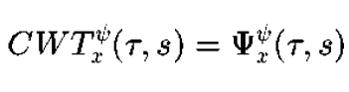
Let measured cellar responding magnetic fluctuation x (t) be a V(t) andτbe a period of sample time, we can get
$Ψ_{V}^{ψ}(τ\text{,s})=\frac{1}{\sqrt{s}}\int{V(t)ψ^{}(\frac{t−τ}{s})\text{dt}}$ and 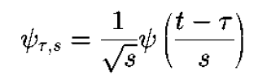
We presume「Meyer Wavelet」as the good fit mother wavelet for the transformation. Different mother wavelets may result shift of the location of the intrinsic signal in time domain V(t).

3. Cell Culture

The osteoblast cell line in vitro was obtained from D.T. Yamaguchi, Research Service and Geriatrics Research, Education, and Clinical Center, VAMC, West Los Angeles, California, USA It was maintained in D-medium (Formula 78-5470EF, GIBCO, Grand Island, NY, USA), supplemented with 10% fetal bovine serum (GIBCO) and 50 µg/ml gentamicin (Quality Biological, Inc., Gaithersburg MD, USA). The cells were incubated at 37˚C in a humidified atmosphere containing 5% CO₂ and 95% air and were fed or trypsinized every two to three days.

4. Bioassay of GJIC
The scrape load/dye transfer (SL/DT) technique was used to measure the GJIC within cells. After exposure to ELF at intrinsic frequency, the cells were rinsed with phosphate buffered saline (PBS), and a PBS solution containing 4% concentration Lucifer yellow fluorescence dye is injected into the cells by a scrape using a scalpel blade. Afterwards the cells were incubated for 3 min and extra cellular dye was rinsed off and fixed with 5% formalin. We then measured the area of the dye migrated from the scrape line using digital images taken by an epifluorescent microscope and quantitated with Nucleotech image analysis software [3,4,5] for the GJIC images. Since GJIC is affiliated with many pathological endpoints [3,4], we use GJIC as a scale factor to evaluate the ELF reaction for cell system. Scrape loading dye transfer of Lucifer yellow is used to measure gap junction intracellular communication (GJIC) modulation under the exposure of ELF magnetic field. The intrinsic resonance detected in SNR spectrum of the mouse osteoblast cells system is very likely to be a chaotic signal, which is not fully predictable.

5. Results
Figure 1 depicted the plot of V(t). Figure 2 depicted the 3D fitting curve of wavelet transformation such as to confirm the existence of intrinsic frequency situated. In contrary, 3D schematics drawing of WT are shown in Figure 2 and Figure 3. Figure 5 and Figure 6 show the GJIC fluorescent images. Since the GJIC of cells was quantified with the measurement of the average distance of dye migration, GJIC was reported in this article as a fraction of the control (FOC) in Figure 4. An FOC value equals to 1.0 indicates normal GJIC. The FOC value more than 1.0 indicates excitation.

Figure 1. V(t) schematic drawing

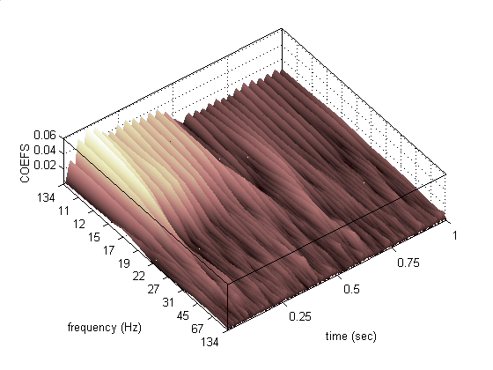

Figure 2. 3D schematic drawing of WT of V after exposure of ELF at 14 Hz

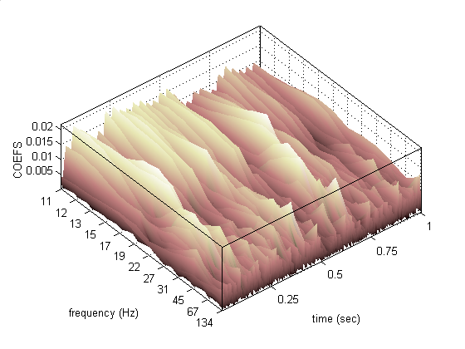

Figure 3. 3D schematics drawing of WT of V in control

14Hz 35Hz 60Hz

Figure 4. FOC schematic drawing

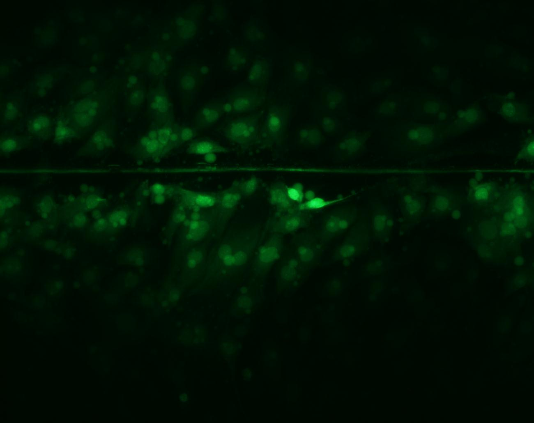

Figure 5. Osteoblast cells GJIC in control

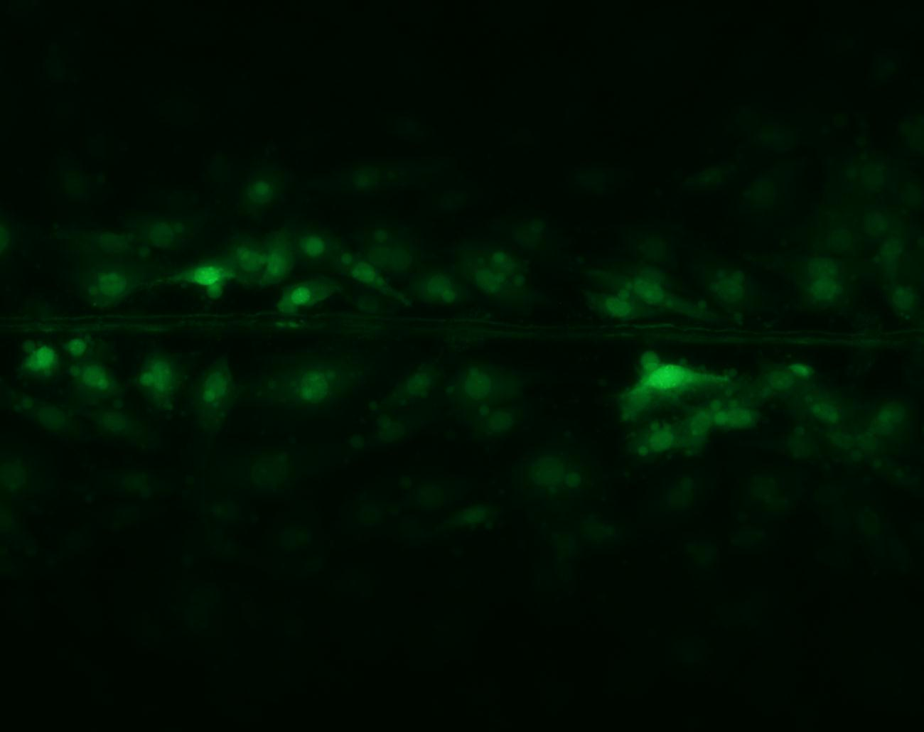

Figure 6. Osteoblast cells GJIC after ELF at 14 Hz

6. Discussion

Experimental results depicted that the GJIC within cells relates to both the background noisy magnetic field fluctuation and the intrinsic ELF signal. In the paper by Basically, WT (wavelet transformation) we used has a good time and poor frequency resolution at higher frequencies, and good frequency and poor time resolution at lower frequencies. Graphically, in figure 1, has shown a frequency band at 14 Hz in the time interval between 0.05 seconds to 0.5 seconds. Since 14Hz is in the lower frequency band, the time range need be relocated. Further discrete WT investigation is necessary for the detail. Fortunately, GJIC supports the result of the existence of the intrinsic frequency at 14Hz. We are in prepare to discuss where in time the spectral component 14 Hz is appeared and how long the spectral component 14 Hz is elapsed within osteoblast cells in the next journal.

7. Conclusion

The main feature of our research introduced is that the cellular response relating to the change of GJIC being in 14 Hz frequency band. The magnetic fluctuation expression for cell induced GJIC has been identified by specific external ELF ac magnetic field signal at 14 Hz, which modulates the GJIC 20% within the cells. Based on the application of WT, which predicts the existence of the intrinsic ELF signal, our study depicted that we were able to obtain the confirmation that the external ELF ac magnetic field can modulate 20% GJIC promotion within the cells at 14 hertz.

Correspondence to:
Hsien-Chiao Teng
Department of Electrical Engineering
Chinese Military Academy, Fengshan, Taiwan 833
Republic of China
Email: scteng@cc.cma.edu.tw
Telephone: 011886-7747-9510 ext 134

References
[1] Bruce EN. Biomedical signal processing and signal modeling. NEW YORK: JOHN WILEY & SONS 2001.
[2] Hart F. Cell culture dosimetry for low frequency magnetic fields. Bioelectromagnetics 1996;17:48-57.
[3] Takebe H, Shiha T, Kato M, Masada E. Biological and health effects from exposure to power-line frequency electromagnetic fields. Ohmsha IOS press, Ohmsha, Ltd., Tokyo, Japan. ISBN 4-274-90402-4. 1999.
[4] Trosko JE, Chang CC. Role of stem cells and gap junctional intercellular communication in human carcinogensis. Radiation Research 2001;155:175-80.
[5] Upham BL, Deocampo ND, Wurl B, Trosko JE. Inhibition of gap junctional intracellular communication by perfluorinated fatty acids is dependent on the chain length of the fluorinated tail. Int J Cancer 1998;78:491-5.

