Robust H∞ Filtering for LPV Discrete-Time
State-Delayed Systems

Junling Wang, Changhong Wang, Huijun Gao

( Department of Control Science and Engineering, Harbin Institute of Technology,
Harbin, Heilongjiang, China, jun_ling@tom.com)

Abstract: This paper examines the problems of robust H∞ filtering design for linear parameter-varying discrete-time systems with time-varying state delay. We present parameter-dependent robust H∞ filters, which are derived using appropriately selected Lyapunov-Krasovskii functional. The resulting filters can be obtained from the solution of convex optimization problems in terms of parameterized linear matrix inequalities, which can be solved via efficient interior-point algorithms. The admissible filters guarantee a prescribed H∞ noise attenuation level, relating exogenous signals to the estimation error for all possible parameters that vary in compact sets. A numerical example illustrates the feasibility of the proposed methodologies. [Nature and Science, 2004,2(2):36-44]

Key words: Robust H∞ filtering; linear parameter-varying systems; parameterized linear matrix inequality; state-delay

1 Introduction

Stability analysis and control synthesis problems of linear parameter-varying (LPV) continuous-time systems where the state-space matrices depend on time-varying parameters, whose values are not known a priori, but can be measured in real time, have received considerable attention recently [1-6]. In contrast to continuous-time cases, discrete-time LPV systems [7-9] received relatively less attention despite their importance in digital control and signal processing applications.
On another front of systems control research, time delay often appears in many control systems either in the state, the control input, or the measurements. Time-delay is, in many cases, a source of instability. The stability issue and the performance of LPV systems with delay are, therefore, of theoretical and practical importance. Recently, much attention has been devoted to the analysis and synthesis problems of LPV time-delay systems. To mention a few, [5] investigated L₂-L₂ control problems for LPV systems with parametervarying delay and [6] proposed delay-independent and delay-dependent stability conditions for LPV systems with constant delay. However, it is worth noting that the filter obtained for LPV time-delay systems are still very limited, especially for LPV discrete time-delay systems.
H∞ estimation has been widely studied during the past decades. One of its main advantages is the fact that it is insensitive to the exact knowledge of the statistics of the noise signals. This estimation procedure ensures that the L₂-induced gain from the noise signals to the estimation error will be less than a prescribed level, where the noise signals are arbitrary energy-bounded signals. However, less study [8-10] has been done for the design of H∞ filters for LPV systems.
This paper is interested in the H∞ filtering problem for LPV discrete-time systems that include time-varying state delay. Using parameter-dependent Lyapunov-Krasovskii functional, we obtained a new H∞ performance criterion that depended on parameter and the magnitude of delay-varying. Then we further modified the obtained criterion by adopting the idea [4, 11] of decoupling between the positive matrices and the system matrices, which is enabled by the introduction of addition slack variable to obtain another parameterized linear matrix inequalities (PLMIs) representation. The corresponding filter designs are finally cast into convex optimization problems, which can be solved via the efficient interior-point algorithms [12]. The obtained filters design procedure is shown, via a numerical example, to be effective.
The notation used throughout the paper is fairly standard. The superscript “T” stands for matrix transposition, $R^{n}$denotes the n dimensional Euclidean space, $R^{m×n}$ is the set of all $m×n$ real matrices, and the notation $P>0$ for $P∈R^{n×n}$ means that P is symmetric and positive definite. In addition, in symmetric block matrices or long matrix expressions, we use * as an ellipsis for the terms that are introduced by
symmetry and $\text{diag}\left\{\right\}$ stands for a block-diagonal matrix.

2 Problem Formulation

Consider the following LPV discrete-time state-delayed system presented in state-space form by:

(1)

where $x(k)∈R^{n}$ is the state; $y(k)∈R^{m}$ is the measured output; $z(k)∈R^{p}$ is the signal to be estimated; $ω(k)∈R^{l}$ is the noise input; $ρ(k)$ is a vector of time-varying parameters which belongs to a compact set ; is time-varying delay. It is assumed that there exist two positive constants d_{m} and d_{M} such that the following inequality holds
d_{m}≤d(k)≤d_{M} , ∀k≥0 (2)
The system matrices $A(⋅)$, $A_{d}(⋅)$, $B(⋅)$, $C(⋅)$,$C_{d}(⋅)$,$D(⋅)$,$H(⋅)$, $H_{d}(⋅)$, $L(⋅)$are known functions of $ρ(⋅)$. For simplicity, $ρ_{k}$denotes the time-varying parameter vector $ρ(k)$ throughout the paper.
Here we are interested in designing an estimator or full-order filter described by:
$x_{F}(k+1)=A_{F}(ρ_{k})x_{F}(k)+B_{F}(ρ_{k})y(k)$, $x_{F}(0)=0$ (3)
$$z_{F}(k)=C_{F}(ρ_{k})x_{F}(k)+D_{F}(ρ_{k})y(k)$$

Augmenting the model of (1) to include the states of the filter, we obtain the filtering error system as follows:

(4)

where

$ξ(k)={\left\{x^{T}(k),x_{F}^{T}(k)\right\}}^{T}$, $e(k)=z(k)−z_{F}(k)$ (5)
$\bar{A}(ρ_{k})=\left[\begin{matrix}A(ρ_{k}) & 0 \\ B_{F}(ρ_{k})C(ρ_{k}) & A_{F}(ρ_{k})\end{matrix}\right]$, ${\bar{A}}_{d}(ρ_{k})=\left[\begin{matrix}A_{d}(ρ_{k}) \\ B_{F}(ρ_{k})C_{d}(ρ_{k})\end{matrix}\right]$
$\bar{B}(ρ_{k})=\left[\begin{matrix}B(ρ_{k}) \\ B_{F}(ρ_{k})D(ρ_{k})\end{matrix}\right]$,
$\bar{C}(ρ_{k})=\left[\begin{matrix}H(ρ_{k})−D_{F}(ρ_{k})C(ρ_{k}) & −C_{F}(ρ_{k})\end{matrix}\right]$,
${\bar{C}}_{d}(ρ_{k})=H_{d}(ρ_{k})−D_{F}(ρ_{k})C_{d}(ρ_{k})$,
$\bar{D}(ρ_{k})=L(ρ_{k})−D_{F}(ρ_{k})D(ρ_{k})$, $K=\left[\begin{matrix}I & 0\end{matrix}\right]$
and I denotes an identity matrix with an appropriate dimension.
Our objective is to develop a robust H∞ filter of the form (3) such that for all admissible parameter trajectories:
(a) The filtering error system (4) is asymptotically stable.
(b) The filtering error system (4) guarantees, under zero-initial condition,
${\left\|e\right\|}_{2}≤γ{\left\|ω\right\|}_{2}$ (6)
for all nonzero $ω∈l_{2}[0,∞)$ and a given positive constant $γ$.

3 Robust H∞ Filtering Analysis

In this section, we will derive new H∞ performance criterions for filtering analyses and syntheses of system (1).
Theorem 1: Consider the system of (1). For a prescribed $γ>0$, if there exist matrices
$0<Q^{T}=Q∈R^{n×n}$,
$0<P^{T}(ρ)=P(ρ)∈R^{2n×2n}$

that satisfy the following PLMI

(7)

for all nonzero $ω∈l_{2}[0,∞)$ and parameter trajectory, the filtering error system (4) is asymptotically stable with an H∞ noise attenuation level $γ$. Where .
Proof: Construct a Lyapunov-Krasovskii functi-
onal as:

(8)
$$V_{1}:=ξ^{T}(k)P(ρ_{k})ξ(k)$$
where , $Q>0$
Define $ΔV:=V(ξ(k+1))−V(ξ(k))$, and along the trajectory of system (4) under the zero disturbance input, we have

(9)
(10)
where
(11)
(12)
Then
(13)
(14)
Therefore, from (9)-(14) we can obtain that , where

Using the Schur complement [14], LMI (7) implies$Μ<0$. Then from the Lyapunov-Krasovskii stability theorem, we can conclude that the filtering error system (4) is asymptotically stable.
Now, to establish the H∞ performance for the filtering error system, assume zero-initial condition and consider the following index

$J:=\sum_{k=0}^{∞}{\left[e^{T}(k)e(k)−γ^{2}ω^{T}(k)ω(k)\right]}$ (15)
Under zero initial condition, $V(ξ(k))|_{k=0}=0$and we have
$\begin{aligned}J≤\sum_{k=0}^{∞}{\left[e^{T}(k)e(k)−γ^{2}ω^{T}(k)ω(k)\right]}+V(ξ(k))|_{k=∞}−V(ξ(k))|_{k=0} \\ =\sum_{k=0}^{∞}{\left[e^{T}(k)e(k)−γ^{2}ω^{T}(k)ω(k)+ΔV(ξ(k))\right]}=\sum_{k=0}^{∞}{λ^{T}(k)Ξλ(k)}\end{aligned}$ (16)
where

By Schur complement, PLMI (7) guarantees $Ξ<0$, therefore $J≤0$ and ${\left\|e\right\|}_{2}≤γ{\left\|ω\right\|}_{2}$. The proof is completed.
Remark 1: It should be noted that the conditions presented in Theorem 1 contain product terms between Lyapunov matrices and system matrices, such that condition (7) is a bilinear matrix inequality when (5) is
considered. In the following, we will present an

improved version of Theorem 1 by introducing a slack variable to decouple these product terms, which is more easily tractable for handling the filtering problems.
Theorem 2: Consider the system of (1).
For a prescribed $γ>0$, if there exist matrices $0<Q^{T}=Q∈R^{n×n}$,
$0<P^{T}(ρ_{k})=P(ρ_{k})∈R^{2n×2n}$,$W∈R^{2n×2n}$, satisfying

(17)

for all nonzero $ω∈l_{2}[0,∞)$ and parameter trajectory, the filtering error system (4) is asymptotically stable with an H∞ noise attenuation level $γ$.
Proof: we will prove the theorem by showing the equivalence between (7) and (17). If (7) holds, (17) is readily established by choosing $W=W^{T}=P(ρ_{k+1})$. On the other hand, if (17) holds, we can explore the facts $W^{T}+W−P(ρ_{k+1})>0$so that W is a nonsingular matrix. In addition, we have
$(P(ρ_{k+1})−W)^{T}P^{−1}(ρ_{k+1})(P(ρ_{k+1})−W)≥0$, which imply that
$−W^{T}P^{−1}(ρ_{k+1})W≤P(ρ_{k+1})−W^{T}−W$.
Therefore we can conclude from (17) that

(18)

Performing congruence transformation to (18) by yields (7), and then the proof is completed.
In the LMI (17), $W$is additional slack variable, i.e., we don’t set any restriction on these two matrices. In such a way, LMI (17) exhibits a kind of decoupling between the system matrices and the positive matrices (there is no product between them).

4 Robust H∞ Filtering Design

In this section, based on Theorem 2, we will develop linear filter of form (3) assuring robust H∞ performance for discrete-time state-delayed LPV system (1).
The following theorem provides sufficient conditions for the existence of delay-dependent H∞ filters.
Theorem 3: Consider the system of (1). For a prescribed $γ>0$, an admissible H∞ filter of the form (3) exists for all nonzero $ω∈l_{2}[0,∞)$ and parameter trajectory, if there exist matrices $E∈R^{n×n}$, $F∈R^{n×n}$,
$U∈R^{n×n}$, ${\bar{P}}_{1}^{T}(ρ)={\bar{P}}_{1}(ρ)∈R^{n×n}$,
${\bar{P}}_{3}^{T}(ρ)={\bar{P}}_{3}(ρ)∈R^{n×n}$, ${\bar{P}}_{2}(ρ)∈R^{n×n}$,
$0<Q^{T}=Q∈R^{n×n}$, ${\bar{A}}_{F}(ρ)∈R^{n×n}$,
${\bar{B}}_{F}(ρ)∈R^{n×m}$, ${\bar{C}}_{F}(ρ)∈R^{p×n}$ and
${\bar{D}}_{F}(ρ)∈R^{p×m}$that satisfy the following inequalities

(19)

$\left[\begin{matrix}{\bar{P}}_{1}(ρ_{k}) & \\ {\bar{P}}_{2}^{T}(ρ_{k}) & {\bar{P}}_{3}(ρ_{k})\end{matrix}\right]>0$ (20)
Proof: First let some matrix variables in Theorem 2 be partitioned as
$V:=W^{−1}=\left[\begin{matrix}V_{\text{11}} & V_{\text{12}} \\ V_{\text{21}} & V_{\text{22}}\end{matrix}\right]$ (21)
Introduce matrices
(22)
Define and introduce the following matrix variables

$\begin{aligned}E:=W_{\text{11}}, F:=V_{\text{11}}^{−1}, U:=V_{\text{11}}^{−T}V_{\text{21}}^{T}W_{\text{21}}, {\bar{A}}_{F}(ρ):=W_{\text{21}}^{T}A_{F}(ρ)V_{\text{21}}V_{\text{11}}^{−1}, {\bar{B}}_{F}(ρ):=W_{\text{21}}^{T}B_{F}(ρ), \\ {\bar{C}}_{F}(ρ):=C_{F}(ρ)V_{\text{21}}V_{\text{11}}^{−1}, {\bar{D}}_{F}(ρ):=D_{F}(ρ)\end{aligned}$ $\bar{P}(ρ):=\left[\begin{matrix}{\bar{P}}_{1}(ρ) & \\ {\bar{P}}_{2}^{T}(ρ) & {\bar{P}}_{3}(ρ)\end{matrix}\right]=J_{V}^{T}\left[\begin{matrix}P_{1}(ρ) & \\ P_{2}^{T}(ρ) & P_{3}(ρ)\end{matrix}\right]J_{V}$ (23)

Then performing congruence transformation to (17) by $J_{2}$, it can be readily established that (19)-(20) are equivalent to (17).
Therefore, from Theorem 3 we can conclude that the filter with a state-space realization
$(A_{F}(ρ),B_{F}(ρ),C_{F}(ρ),D_{F}(ρ))$ defined in (23)
guarantees that the filtering error system (4) has an H∞ noise attenuation level $γ$.
Remark 2: Notice that the PLMI conditions (19)- (20) correspond to infinite-dimensional convex problems due to their parametric dependence. Using the gridding technique and the appropriate basis functions [3], infinite-dimensional PLMIs can be transformed to finite-dimensional ones, which can be solved numerically using convex optimization techniques.Hence, by
choosing appropriate basis function such that

$\bar{P}(ρ)=\left[\begin{matrix}{\bar{P}}_{1}(ρ) & \\ {\bar{P}}_{2}^{T}(ρ) & {\bar{P}}_{3}(ρ)\end{matrix}\right]=\left[\begin{matrix}\sum_{j=1}^{n_{f}}{f_{j}(ρ)}{\bar{P}}_{1j} & \\ \sum_{j=1}^{n_{f}}{f_{j}(ρ)}\bar{P_{2j}^{T}} & \sum_{j=1}^{n_{f}}{f_{j}(ρ)}\bar{P_{3j}}\end{matrix}\right]0$ (24)

PLMIs can be approximated.
Remark 3: Theorem 3 casts the full-order robust H∞ filtering problem for system (1) into PLMIs feasibility test, and any feasible solution to (19) and (24) will yield a suitable filter. If we can find admissible robust H∞ filters for system (1) in the light of PLMIs (19) and (24) have feasible solutions, then the filter matrices can be calculated from the definition (23). However, there seem to be no systematic ways to determine the matrices $V_{\text{21}}$and $V_{\text{22}}$needed for the filter matrices. To deal with such a problem, first of all, let us denote the filter transfer function from $y(k)$ to $z_{F}(k)$ by
$T_{z_{F}y}=C_{F}(ρ)(\text{zI}−A_{F}(ρ))^{−1}B_{F}(ρ)+D_{F}(ρ)$ (25)
Substituting the filter matrices with (23) and considering the relationship $U=V_{\text{11}}^{−T}V_{\text{21}}^{T}W_{\text{21}}$ yields

$\begin{aligned}T_{z_{F}y}={\bar{C}}_{F}(ρ)F^{−1}V_{\text{21}}^{−1}(\text{zI}−W_{\text{21}}^{−T}{\bar{}A}_{F}(ρ)F^{−1}V_{\text{21}}^{−1})^{−1}W_{\text{21}}^{−T}{\bar{}B}_{F}(ρ)+{\bar{D}}_{F}(ρ) \\ ={\bar{C}}_{F}(ρ){\left[{\text{zW}}_{\text{21}}^{T}V_{\text{21}}F−{\bar{A}}_{F}(ρ)\right]}^{−1}{\bar{B}}_{F}(ρ)+{\bar{D}}_{F}(ρ) \\ ={\bar{C}}_{F}(ρ)[\text{zI}−U^{−T}{\bar{A}}_{F}(ρ)]^{−1}U^{−T}{\bar{B}}_{F}(ρ)+{\bar{D}}_{F}(ρ)\end{aligned}$
Therefore, an admissible filter is given by
$A_{F}(ρ)=U^{−T}{\bar{A}}_{F}(ρ)$, $B_{F}(ρ)=U^{−T}{\bar{B}}_{F}(ρ)$, $C_{F}(ρ)={\bar{C}}_{F}(ρ)$, $D_{F}(ρ)={\bar{D}}_{F}(ρ)$ (26)

Remark 4: Note that (19) and (24) are PLMIs not only over the matrix variables, bust also over the scalar $γ^{2}$. This implies that the scalar $γ^{2}$ can be included as one of the optimization variables for LMI (19) and (23) to obtain the minimum noise attenuation level. Then the minimum guaranteed cost of robust delay-dependent H∞ filter can be readily found by solving the following convex optimization problem:
Minimize $γ^{2}$ subject to (19) and (23)

over $E$, $U$, $F$, ${\bar{A}}_{F}(ρ)$, ${\bar{B}}_{F}(ρ)$, ${\bar{C}}_{F}(ρ)$, ${\bar{D}}_{F}(ρ)$, $γ^{2}$, ${\bar{P}}_{1}(ρ)$, ${\bar{P}}_{2}(ρ)$, ${\bar{P}}_{3}(ρ)$, $Q$ (27)

Remark 5: It can be shown that the time-varying delay of LPV system (1) is constant delay for .

5 An Illustrative Example

Consider the following discrete-time LPV system with a state-delay.

(28)

$$z(k)=\left[\begin{matrix}1 & 2\end{matrix}\right]x(k)$$

where $ρ_{1}=\text{sin}k$and $ρ_{2}=\text{cos}k$ are time-varying parameters satisfying
$−1≤ρ_{1}≤1$, $−1≤ρ_{2}≤1$
Our objective is to design robust H∞ controllers. First choose appropriate basis functions $f_{1}(ρ)=1$, $f_{2}(ρ)=ρ_{1}$, $f_{3}(ρ)=ρ_{2}$
Gridding the parameter space uniformly using $9×9$grids. The minimum noise attenuation level obtained by solving convex optimization problem for
different are shown in Table 1.
From Table 1, we can see that the effect of the delay-varying magnitude on the attainable the minimum

Table 1 The minimum guaranteed cost
for different delay size
 | Minimum Guaranteed Cost γ*
1 | 0.8169
2 | 1.1667
3 | 1.4454
4 | 1.6902

guaranteed cost. The minimum noise attenuation level for , and the corresponding parameter-dependent filter matrices are given by

, ,
(29)

The minimum noise attenuation level $γ^{}=0\text{.}\text{8169}$for , and the corresponding parameter-dependent filter matrices are given by

$A_{F}(ρ)=\left[\begin{matrix}\text{-0}\text{.}\text{0221-0}\text{.}\text{0160}ρ_{1}+0\text{.}\text{0011}ρ_{2} & 0\text{.}\text{2878}+0\text{.}\text{0083}ρ_{1}+0\text{.}\text{0011}ρ_{2} \\ \text{-0}\text{.}\text{1962}+0\text{.}\text{0059}ρ_{1}+0\text{.}\text{0002}ρ_{2} & \text{-0}\text{.}\text{0187}+0\text{.}\text{4920}ρ_{1}\text{-0}\text{.}\text{0034}ρ_{2}\end{matrix}\right]$, $B_{F}(ρ)=\left[\begin{matrix}0\text{.}\text{0197}+0\text{.}\text{0215}ρ_{1}−0\text{.}\text{0030}ρ_{2} \\ 0\text{.}\text{9969-0}\text{.}\text{0039}ρ_{1}+0\text{.}\text{0014}ρ_{2}\end{matrix}\right]$, $C_{F}(ρ)=\left[\begin{matrix}1\text{.}\text{0016}+0\text{.}\text{0245}ρ_{1}−0\text{.}\text{0009}ρ_{2} & 2\text{.}\text{0125-0}\text{.}\text{0002}ρ_{1}−0\text{.}\text{0056}ρ_{2}\end{matrix}\right]$, $D_{F}(ρ)=−0\text{.}\text{0047}−0\text{.}\text{0221}ρ_{1}+0\text{.}\text{0277}ρ_{2}$ (30)

Then we analyze the disturbance attenuation level of the filtering error system by connecting the two obtained filters to the original system. Figures 1 and 2 present the simulation curves of estimating the signal z(k) by the two filters respectively. Here we assume ω(k) to be
$ω(k)=\left\{\begin{matrix} 2, \text{20}≤k≤\text{30} \\ −2,\text{ 5}0≤k≤\text{60} \\ 0, e\text{lse}\end{matrix}\right.$ (31)
From the figure we can see that ω(k) drives z_{F}(k) to deviate from z(k). However, when ω(k) is zero, the deviation tends to be zero due to the asymptocally stability of the filter error system. Now we will further analyze the H∞ performance. Fig. 3 and 4 give the changing curves of the disturbance signal and the filtering error signal. From (31) and Fig. 3, we obtain that

${\left\|ω\right\|}_{2}=\sqrt{\sum{ω^{T}(k)ω(k)}}=9\text{.}\text{3808}$ and
, then it can be easily established that ; And Fig.4 shows that ${\left\|e\right\|}_{2}=\sqrt{\sum{e^{T}(k)e(k)}}=1\text{.}\text{9536}$, then it can be easily established that
$\frac{{\left\|e\right\|}_{2}}{{\left\|ω\right\|}_{{}_{2}}}=0\text{.}\text{2083}<γ^{}=0\text{.}\text{8169}$, therefore, the H∞ filters can guarantee the prescribed noise disturbance attenua-
tion level.

6 Concluding Remarks

In this paper, robust H∞ filters design is proposed for LPV discrete-time systems with constant and time-varying state delay. The filtering problems have been solved and cast into convex optimization problems in terms of PLMIs, which can be solved via efficient interior-point algorithms. A numerical example has shown the feasibility applicability of the proposed designs.

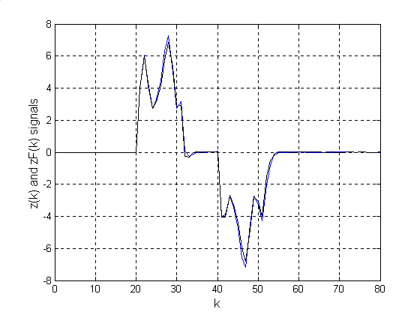
Figure 1 z(k) and z_{F}(k) signals of filter error
system with time-varying state delay

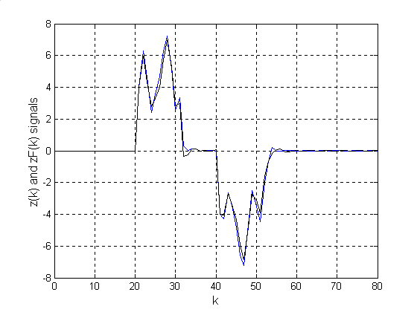
Figure 2 z(k) and z_{F}(k) signals of filter error
system with constant delay
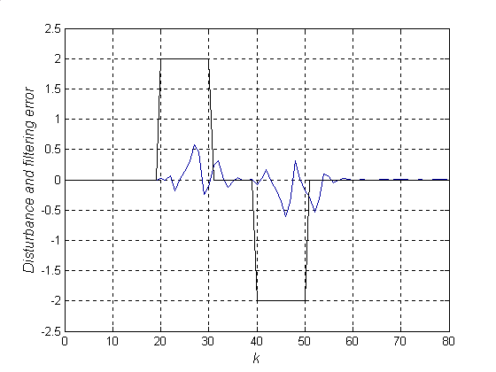
Figure 3 Disturbance and filtering error
(Time-varying delay case)
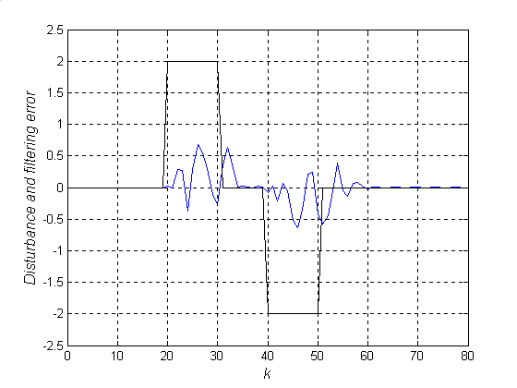
Figure 4 Disturbance and filtering error
(Constant delay case)

Acknowledge
This work was partly supported by the National Natural Science Foundation of China under contract: 69874008.

Correspondence to:
Room 317, Inertial Navigation Center
Department of Control Science and Engineering
Harbin Institute of Technology
Harbin, Heilongjiang, China
E-mail: Jun_ling2003@yahoo.com.cn
Telephone: 01186-451-86415710

References
[1] Shamma JS, Athans M. Analysis of gain scheduled control for nonlinear plants. IEEE Trans. Automatic Control , 1990;35:898-907.
[2] Apkarian P, Gahinet P. A convex characterization of gain-scheduled H∞ controllers. IEEE Trans. Automatic Control , 1995,40:853-864.
[3] Apkarian P, Adams RJ. Advanced gain-scheduling techniques for uncertain systems. IEEE Trans. Control System Technology, 1998, 6:21-32.
[4] Bara GI, Daafouz J, Kratz F. Parameter-dependent control with $γ$-performance for affine LPV systems. Proceedings of the 40th Conference on Decision & Control, Florida USA, 2001,2378-2379.
[5] Wu F, Grigoriadis KM. LPV systems with parameter-varying time delays: analysis and control. Automatica, 2001, 37:221-229.
[6] Zhang XP, Tsiotras P, Knospe C. Stability analysis of LPV time-delayed systems. Int. J. Contr., 2002, 75:538-558.
[7] Mahomoud MS. Linear parameter-varying discrete time-delay systems: stability and l₂ –gain controllers. Int. J. Contr., 2000,73:481-494.
[8] Mahomoud MS. Discrete-time systems with linear parameter-varying: stability and H∞ -filtering. Mathematical analysis and applications, 2002,369-381.
[9] Hoang NT, Tuan HD, Apkarian P, Hosoe S. Gain-scheduled filtering for parameter-dependent digital systems. Proceedings of the 41th Conference on Decision & Control, Las Vegas, Nevada USA, 2002,4191-4196.
[10] Mahomoud MS, Boujarwah AS. Robust H∞ filtering for a class of LPV systems. IEEE Trans. Circuits and Systems-I: Fundamental Theory and Applications, 2001, 48:1131-1138.
[11] Apkarian P, Adams RJ. Continuous-time analysis, eigenstructure assignment, and H₂ synthesis with enhanced linear matrix inequalities (LMI) characterizations. IEEE Trans. Automatic Control, 2001, 12:1941-1946.
[12] Gahinet P, Nemirovskii A, Laub AJ, and Chilali M. LMI control toolbox User’s Guide, Natick, MA: The Math. Works, Inc., 1995.
[13] Moon Y S, Park P, Kwon WH, Lee YS. Delay-dependent robust stabilization of uncertain state-delayed systems. Int. J. Contr., 2001 ,74:1447-1455.
[14] Boyd SP, El Ghaoui L, Feron E, Balakrishnan V. Linear matrix inequalities in system and control theory [M]. Philadelphia: SIAM, 1994.

