Evaluation of Human Telomerase Activity as a Novel Tumor Marker for Hepatocellular Carcinoma
Afaf Abdel Hady, Faten El Shanawany, Mona M. Hassan, Amgad Anas*, Ibrahim Mostafa*, Ahmed Abdel Hadi **
Departments of Clinical Chemistry, Hepatology and GIT* and Pathology** Theodor Bilharz Research Institute
Abstract: Objectives: Liver cancer is the most common neoplasm and the most common cause of cancer death within the world. Early detection of hepatocellular carcinoma (HCC) will increase the potential for curative treatment and improves survival. Telomerase is reactivated in various types of malignant tumors and may contribute to the development of HCC. To explore its clinical implications for early diagnosis of HCC, we analyzed its activity in peripheral blood mononuclear cells (PBMC).The diagnostic accuracy of telomerase activity and other conventional tumor markers such as serum α-fetoprotein (AFP) and prothrombin induced by vitamin K antagonist (PIVKA-II) were evaluated to select the most reliable diagnostic and prognostic markers in HCC. This study was conducted on 25 healthy controls, 25 cirrhotic patients and 30 patients with HCC. All patients had been diagnosed with HCV-associated chronic liver disease. Methods: Serum PIVKA-II and AFP were measured by enzyme linked immunosorbent assay (ELISA),while telomerase activity in peripheral blood was estimated by polymerase chain reaction- enzyme- linked immunosorbent assay ( PCR- ELISA method). Results: Mean telomerase activity, PIVKA-II and AFP levels were significantly higher in HCC patients as compared to both cirrhotic patients and controls, also a significant elevation in cirrhotic patients were found as compared to controls. Positive correlation was found between telomerase activity and size of hepatic focal lesions. Also, a positive correlation was found between both telomerase activity and PIVIKA-II and between the pathological grades of HCC. In HCC the sensitivity/specificity (88.2/79.6) of telomerase activity was much higher than both PIVIKA-II (80.5/69.3) and AFP (72.6/61.5). Conclusion: The usefulness of telomerase activity assay in HCC diagnosis and it's superiority to other tumor marker were recorded. Therefore, telomerase activity is a novel, available detector and prognostic marker for HCC diagnosis.
[Afaf Abdel Hady, Faten El Shanawany, Mona M. Hassan, Amgad Anas, Ibrahim Mostafa, Ahmed Abdel Hadi. Evaluation of Human Telomerase Activity as a Novel Tumor Marker for Hepatocellular Carcinoma. Life Science Journal 2010;7(4):153-161]. (ISSN: 1097-8135).
Key words: hepatocellular carcinoma; telomerase; PIVKA-II; molecular diagnostic marker; telomerase PCR ELISA.

Introduction:
Hepatocellular carcinoma (HCC) is a major challenge in contemporary medicine. The incidence of HCC is increasing and it is becoming more and more significant both clinically and epidemiologically. Now HCC represents the fifth most common cancer in the world and the third most frequent cause of mortality amongst oncological patients¹. It is responsible for more than 500 000 deaths with over 600 000 new cases yearly worldwide².More than 95% of HCC patients present underlying hepatopathy in particular of viral etiology. The majority of the cases (>85% ) have liver cirrhosis, which masks symptoms of cancer progression. The clinical course of HCC is mostly asymptomatic. Suspected focal liver changes are often detected incidentally while monitoring the patient’ s condition during ultrasound (US) examination, and often are too large and too advanced for the tumor to be subjected to potentially effective and radical therapy³. So far, it is necessary to concentrate on the earliest possible diagnosis, particularly sensitive detection of resectable focal liver changes preferably when tumors are less than 2 cm in diameter⁴. The first serological assay for detection and clinical follow up of patients with HCC was alpha fetoprotein (AFP) ⁵. Numerous data have proved that significantly higher AFP serum levels accompany various liver diseases (viral hepatitis, liver cirrhosis, liver tumors: primarily HCC and hepatoblastoma, also metastasis in 5% -10% cases), which diminish its specificity as a golden standard serum marker for HCC⁶. Since the first description by Liebman et al. in 1984,prothrombin induced by vitamin K absence or antagonist -II ( PIVKA –II ), also referred to as des-gamma-carboxy prothrombin ( DCP), has been found to be another useful tumor marker for HCC⁷. Recent study demonstrated that the diagnostic accuracy of PIVKA-II seemed to be higher compared to AFP⁸. It has been proved that significant concentrations of serum PIVKA-II in 50%--60% of all HCC patients, but in only 15%-30% of early HCC cases⁹. Clinical utility of PIVKA-II was further investigated in view of correlation between several factors such as tumor size, intrahepatic metastases, and histological activity of tumor tissue.^{10, 11} These two markers (AFP and PIVKA-II ) which are supposed to be produced independently by HCC may serve complementarily in the diagnosis of HCC.^{12,13,} Although the modalities such as ultrasonography and conventional tumor markers are important for detection of HCC, they are still not sensitive enough to detect HCC at the early stage.¹⁴
Hepatoma tissues synthesize and secrete valuable molecular markers such as AFP-beta1-mRNA, IGF-II-mRNA, telomerase, etc into blood. The analyses of these circulating hepatoma-specific biomarkers are useful to early diagnosis of HCC or monitoring metastasis or postoperative recurrence of HCC.^{15, 16} Telomerase is a ribonucleoprotein enzyme composed of two key components: a catalytic component (human telomerase reverse transcriptase, hTERT) and a RNA template. It helps to stabilize telomere length in human stem cells, reproductive cells and cancer cells by adding TTAGGG repeats onto the telomeres using its intrinsic RNA as a template for reverse transcription, and it is a limiting component in telomerase activity.^{17,18} During the early stages of carcinogenesis, cells undergo extensive proliferation until telomere length becomes critically shortened.^{19,20} Telomere shortening is an early event in multistep hepatocarinogenesis, occurring in preneoplastic lesions of dysplastic nodules.²¹ Shortened telomeres have been reported to induce chromosomal instability in hepatocytes, especially important in viral-related hepatocarcinogenesis.^{22,23} It has been suggested that detection of cancer-related gene expressions in serum is very useful for diagnosis and follow-up of cancer patients. hTERT mRNA in serum was detected in breast cancer but not in benign diseases, suggesting that hTERT is available for cancer diagnosis.²⁴ Overexpression of telomerase is associated with HCC development, and its abnormality in liver tissues or in peripheral blood could be a useful marker for diagnosis and prognosis of HCC .²⁵ In the present study, we mainly focused on the comparison of telomerase activity in peripheral blood with serum AFP, and PIVKA-II to select the most reliable early diagnostic and prognostic markers in HCC. A correlation between AFP, PIVKA-II and telomerase activity and tumor size and histopathological grades was performed.
Patients and Methods:
This study was conducted on 55 patients; 30 patients with biopsy proven hepatocellular carcinoma and 25 patients with biopsy proven liver cirrhosis. They were selected from attendants of the out and inpatients clinic of Theodor Bilharz Research Institute. Twenty five healthy age and sex matched controls were enrolled in this study.
All casses were subjected to the following:
I. Full history taking with special stress on jaundice, blood transfusion and bilharziasis.
II. General and abdominal clinical examination.
III. Ultrasonographic examination of the liver was done to assess its size and echo pattern in order to expose any pathology such as liver cirrhosis and to detect focal masses. The site and size of any detected mass were recorded. The portal tract as well as the portal and splenic veins were also measured.
IV. Percutaneous liver needle biopsy was done for all patients. Patients not fit for biopsy were excluded from the study. The specimens were processed and embedded into paraffin blocks, cut at 5 um thick sections and stained with Hx and Eosin.
V. Laboratory tests:
A) Routine laboratory tests including:
1- Complete blood picture.
2-Liver function tests (serum albumin, bilirubin, AST, ALT, Alkaline phosphatase and prothrombin time) were measured by conventional methods.
3- Serological markers for hepatitis B (HbsAg and HbcAb) by ELISA of Boehringer Mannheim and hepatitis C (HCV Ab) by Murex version111.
B) Specific laboratory tests:
1. Determination of AFP level: by ELISA method (Chieregatti, 1990).²⁶
2. Measurement of PIVKA-II level (Amiral etal, 1991)²⁷: by Asserachro PIVKA-II ELISA Kit (Diagnostica Stago).
3. Assessment of telomerase activity: The protein extracts (2μl) from peripheral blood mononuclear cells (PBMCs), were analyzed by using Telomerase PCR ELISA (Telomerase PCR ELISA, Boehringer Mannheim).^{28,29} In brief, 50 μl containing 25 μl reaction buffer, 2 μl of protein extract and 2 μl of primers telomeric repeats .The PCR condition was as follows: incubation for 30 min at 25°C for primer extension. The mixture was then incubated at 94°C for 5 min to induce telomerase inactivation. The reaction mixture was then subjected to 30 PCR cycles at 94°C for 40 sec, 50 °C for 40 sec, and 72°C for 90 sec (72°C, 10 min for the final step). An aliquot of the PCR product was denatured, hybridized to a digoxigenin (DIG)-labelled telomeric repeat-specific probe and bound to a streptavidin-coated 96 well plate. Finally, the immobilized PCR product was detected with an anti-DIG-peroxidase antibody and visualized by tetramethyl benzidine substrate (colour reagent). The absorbance (A) of telomerase was measured at a wavelength of 450 nm (reference wavelength 620 nm) within 30 minutes of addition of the stop reagent. The cell extract was heated to 65˚C for 10 minutes as a negative control.
Sampling procedure:
Under aseptic conditions, fasting venous blood sample (12 ml) was withdrawn by clean venipuncture from the antecubital vein: 2 ml on EDTA for blood picture; 3 ml to separate serum for routine laboratory tests on the collection day and aliquot of serum was stored at -20 °C for AFP level measurement; 2 ml on citrate to separate citrated plasma for PIVKA-II level measurement; 5 ml on heparin (for anticoagulant ) and 2.5 ml of ficoll to be centrifuged at 2000 /min for 20 minutes at 4 °C, peripheral blood mononuclear cells (PBMCs) were collected from the ficoll/plasma interface. The cells were then washed three times in normal saline and pelleted by using low-speed centrifugation for 10 minutes. The samples were immediately aliquoted and stored at -80 °C for determination of telomerase activity.
Statistical Analysis:
Data were processed using SPSS version 17 software program. Means and standard deviations were computed for clinical data. T-test analysis was done between means of two groups. Analysis of variance was done between measured of variables more than two groups and receiver-operator characteristic (ROC) curve used. P value equal to or less than 0.05 was considered the threshold for significant.
Results:
Results were summarized, statistically analyzed and tabulated in tables (1-5), and graphically presented in figures (1-5). Thirty hepatocellular carcinoma patients, 25 cirrhotic patients and 25 control cases were included in this study. The clinical data of all patients were illustrated in table 1. Mean telomerase activity, PIVKA-II and AFP levels were significantly higher in HCC patients as compared to both cirrhotic patients and controls with a significant elevation in cirrhotic patients as compared to controls (table 2, fig.1). The mean telomerase activity and PIVKA-II values were found to be significantly higher in poorly differentiated grade III HCC compared to moderately differentiated grade II HCC and well differentiated grade I HCC ( (table 4, fig. 5 & 3). As regards the size of the focal lesions, it was found that telomerase activity was significantly higher in patients with lesions 5-10 cm than in those with lesions below 5 cm. By using correlative studies, statistical significant correlation could be found between the mean telomerase activity in relation to the size of the hepatic focal lesions (table 5). No correlation was found between telomerase activity, PIVKA-II and AFP in the studied groups. In HCC, the sensitivity/specificity (88.2/79.6) of telomerase activity was much higher than both PIVIKA-II (80.5/69.3) and AFP (72.6/61.5). Combination of AFP and PIVKA-II yielded increasing sensitivity/specificity 82.6%/77.6% and accuracy 87.8%, while both AFP and telomerase increasing sensitivity (90.4%), specificity (82.3%) and accuracy (89.9%) (Fig. 4 &Table 3).
Discussion:
Hepatocellular carcinoma (HCC) is the most common form of primary hepatic malignancy. Although recent advances in imaging diagnosis such as real time ultrasonography, computed tomography and magnetic resonance imaging have changed the diagnostic strategy for early diagnosis of HCC, determination of tumor markers for HCC at regular intervals is still a common practice. Nowadays it is believed that early HCC diagnosis is presently considered feasible in 30%-60% of the cases in the developed countries. Tumors smaller than 2 cm in diameter represented < 5% of cases in 1990s, whereas now they represent up to 30% of cases in Japan.⁴ Significantly more effective surveillance strategies lead to earlier HCC detection and earlier qualification for effectively curative radical surgery, with very good postoperative survival rates.⁹
The current study enrolled 30 patients with biopsy proven hepatocellular carcinoma and 25 patients with biopsy proven liver cirrhosis and 25 healthy age and sex matched controls. We mainly focused on the comparison of telomerase activity in peripheral blood with serum AFP, and PIVKA-II to select the most reliable early diagnostic and prognostic markers in HCC. A correlation between AFP, PIVKA-II and telomerase activity and tumor size and histopathological grades was performed.
It has been confirmed on numerous occasions that AFP serum concentration increases in parallel with HCC tumor size. For this reason AFP has to be considered 'the golden standard' for HCC serum markers. However, the usefulness of AFP testing for the population at risk should be seriously questioned. AFP diagnostic values for this assay are undoubtedly poor. AFP specificity varies from about 76% to 96% and increases with elevated cut-off value. Simultaneous sensitivity decrease much more from about 25% for potentially respectable of less than 3 cm in diameter to about 50% for lesions of >3 cm in diameter.^{30, 31} 2o%-30% AFP sensitivity coincides with cut- off >100 μg/L, which means that 70%-80% of liver tumors, normally respectable are non-detectable and unfortunately do not undergo treatment or are subjected to it too late.³² Therefore new biomarkers with better sensitivity and specificity than AFP to complement the imaging diagnosis are needed.³³
Since the first description by Liebman et al. in 1984,prothrombin induced by vitamin K absence or antagonist -II ( PIVKA –II ), also referred to as des-gamma-carboxy prothrombin ( DCP), has been found to be another useful tumor marker for HCC. It was demonstrated that there is excessive synthesis of prothrombin precursors by human HCC tissue and that it might be a contributing factor to the production of DCP by HCC.⁷ Several case control studies have shown sensitivities of PIVKA-II of 28% to 89% and specificities of 87% to 96% in the diagnosis of HCC.^{34-36, 37, 38} In some studies, PIVKA-II was more sensitive than AFP,^{36,37,38} whereas, in other studies, AFP was more sensitive.^{34,35} A recent study of 1377 HCC patients and 355 non- HCC controls with chronic hepatitis or cirrhosis showed that the accuracy of PIVKA-II was inferior to AFP, particularly for small tumors.³⁹ Various factors may influence the performance of HCC biomarkers, including ethnicity, cutoff value, patient demographics, cause of underlying liver disease, presence of cirrhosis, tumor stage and tumor biology and so on.^{40,41}
In the present study, both AFP and PIVKA-II showed statistically significant higher levels in HCC patients compared to cirrhotic and control groups. . In HCC, the sensitivity/specificity of PIVKA-II (80.5/69.3) and accuracy (70.3%) were higher than AFP (72.6/61.5, 69.8%).Combination of both AFP and PIVKA-II yielded increasing sensitivity/specificity 82.6%/77.6% and accuracy 87.8%. In agreement with the current study, has been postulated that PIVKA-II is a useful marker for detecting HCC, especially in small HCC and may have correlations with known staging systems, especially in combination with AFP.^{42, 43} In contrary to our findings, recent study reported that AFP was more sensitive than PIVKA-II and AFP-L3% for the diagnosis of early stage HCC at a new cutoff of 10.9 ng/ml ⁴⁴ while others concluded that PIVKA-II was not superior to AFP in the early detection of HCC and that neither AFP alone, PIVKA alone, nor the combination of both was sufficiently accurate to be used for early HCC diagnosis and monitoring recurrence after curative resection.⁴⁵
Hepatoma tissues synthesize and secrete valuable molecular markers such as AFP-beta1-mRNA, IGF-II-mRNA, Telomerase, etc into blood. The analyses of these circulating hepatoma-specific biomarkers are useful to early diagnosis and monitoring metastasis or postoperative recurrence of HCC.^{15, 16} Telomerase is a ribonucleoprotein enzyme composed of two key components: a catalytic component (human telomerase reverse transcriptase, hTERT) and an RNA template.²⁵ In this assay, telomerase activity showed statistically significant higher levels in HCC patients compared to cirrhotic and control groups. . In HCC, the sensitivity/specificity (88.2/79.6) was much higher than both PIVIKA-II (80.5/69.3) and AFP (72.6/61.5). Combination of both AFP and telomerase is increasing sensitivity (90.4%), specificity (82.3%) and accuracy (89.9%). The mean telomerase activity was found to be significantly higher in poorly differentiated HCC compared to moderately differentiated HCC and well differentiated HCC. As regards the size of the focal lesions, it was found that telomerase activity was significantly higher in patients with lesions 5-10 cm in diameter than in those with lesions below 5 cm. By using correlative studies, statistical significant correlation could be found between the mean telomerase activity in relation to the size of the hepatic focal lesions .No correlation was found between telomerase activity, PIVKA-II and AFP in the studied groups. To some extent, these results are consistent with a previous studies which concluded that although the measurement of telomerase activity in peripheral blood is a useful and potential approach to establish a practical diagnostic/predictive marker of HCC, it would be imprudent to state that telomerase activity is a specific molecular marker for circulating malignant hepatoma cells.^{46, 47} Other recent studies reported that in HCC, serum hTERT mRNA showed higher sensitivity/specificity values than AFP, PIVKA-II and AFP mRNA .There was a positive correlation of hTERT mRNA between tumor tissue and serum and this proved that serum hTERT mRNA is derived from tumor hepatoma cells.⁴⁸ In a study done by Bong et al., on 49 HCC patients showed long telomere, high telomerase activity and positive correlation with hTERT mRNA and more advanced tumor stage.⁴⁹
In conclusion, in HCC patient's telomerase activity, is more specific marker and is related more closely to the degree of histologic differentiation and tumor size of HCC than AFP and PIVKA-II. Therefore, telomerase activity might be a useful tumor marker in early diagnosis of HCC and the monitoring of recurrence after curative resection. We recommend testing of AFP with telomerase, as in combination they showed higher overall accuracy.

Table (1): Clinical , sonographic, hispathological data of cirrhosis and HCC groups.
 | Cirrhosis | HCC
Number | 25 | 30
Age (years)  Mean±SD  Gender, M/F | 47.7±8.95  20/5 | 52.3±7.63  26/4
Viral serological markers  HBsAg positive  HBcAb positive  HCVAb positive  HBsAg, HCVAb positive | 2  5  14  6 | 1  4  19  7
Sonographic findings  Liver pattern  Size  normal  enlarged  shrunken | 6  0  14 | 7  21  2
Focal lesion  Number:  single  multiple |  | 19  11
Size < 2 cm  2-5 cm  5-10 cm |  | 6  11  13
Ascites | 3 | 7
Histopathological Differentiation  Grade I  Grade II  GradeIII |  | 10  12  8

Table (2): Tumor markers: AFP, PIVKA-II and Telomerase in control, cirrhosis and HCC groups
 | AFP  (ng/ml) | PIVKA-II  (ng/ml) | Telomerase  Optical density (units)
 | mean±SD | mean±SD | mean±SD
Control (n=25) | 3.05±1.2 | 1.26±0.5 | 0.39±0.14
Cirrhosis (n=25) | 13.5±5.9 | 1.44±1.o7 | 0.43±0.26
HCC (n=30) | 98.8±95.42^{ab} | 2.29±1.0 3^{ab} | 2.08±0.98^{ab}
ª Significant difference from control P < 0.0 1
^{b} significant difference from Cirrhosis P < 0.01

Table (3): Accuracy of AFP, PIVKA, Telomerase and combined markers in HCC group
 | AFP | PIVKA-II | Telomerase | AFP+  PVIKA-II | AFP+ Telomerase
Cut off value for HCC | >10ng/ml | >1.3 ng/ml | >0.7 unit | Combined | Combined
Sensitivity | 72.6% | 80.5% | 88.2% | 82.6% | 90.4%
Specificity | 61.5% | 69.3% | 79.6% | 77.6% | 82.3%
PPV | 67.4% | 77.4% | 85.7% | 73.7% | 85.3%
NPV | 62.3% | 66.7% | 58.7% | 55.9% | 70.1%
False negative | 23.6% | 41.7% | 49.2% | 14.9% | 11.6%
Over all accuracy | 69.8% | 70.3% | 73.5% | 87.8% | 90.1%
PPV = Positive predictive value NPV=Negative predictive value
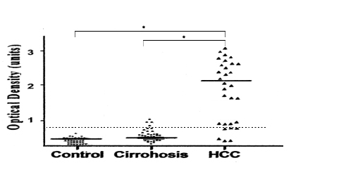
Table (4): Tumor markers in patients with different grades of HCC
Variables | Grade I  N=10 | Grade II  N=12 | Grade III  N=8
AFP  mean±SD (ng/ml) | 83.55±8.69 | 95.25±10.50 | 116.80±25.6
PIVKA-II  mean±SD (ng/ml) | 1.68±0.09 | 2.19±0.06ª | 2.68±0.08^{ab}
Tolomerase  mean±SD  unit of activity | 1.08±0.059 | 1.65±0.086ª | 2.38±0.095^{ab}

Fig. 1: AFP, PIVKA-II and Teolmerase in control, cirrhosis and HCC groups
ª p < 0.01 grade I versus grade II &III
^{b} p < 0.01 grade II versus grade III

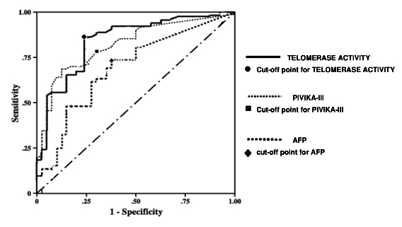

Fig.(2): Comparison of telomerase activity in peripheral blood from HCC, cirrhosis and normal controls. Arbitrary cut-off level = 0.7 units

(5): Tumor markers in patients with HCC in relation to size of tumor.
Variables | < 2 cm | 2-5 cm | 5-10 cm
Variables | N= 6 | N=11 | N=13
AFP  mean±SD  ng/ml | 89.73±106.28 | 96.37±79.46 | 110±88.50
PIVKA-II  mean±SD  ng/ml | 2.o7±0.74 | 2.45±0.89 | 2.16±0.62
Telomerase  mean±SD  unit of activity | 1.69±0.32 | 2.07±0.56 ª | 2..52±0.54 ^{ab}
ª Significant difference from tumor size (<2cm) P<0.01
^{b} Significant difference from tumor size (2-5) P<0.01

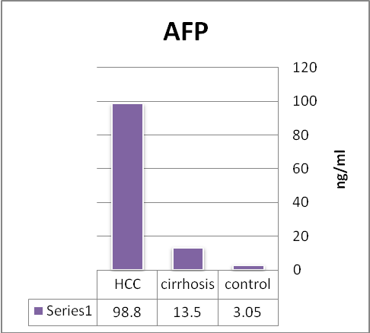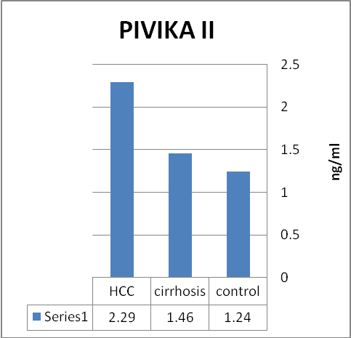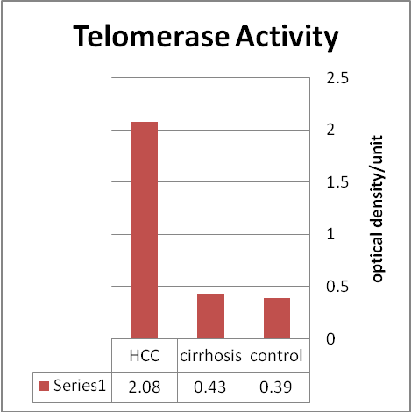
Fig.(3): Relationship between the histopathological staging of hepatocellular carcinoma (HCC) and peripheral telomerase activity.
ª P < 0.01 grade I versus grade II &III
^{b} P < 0.01 grade II versus grade III
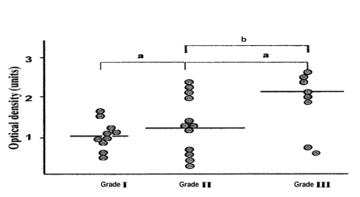

Fig.(4): Receiver-operator characteristic curve analysis curves were representing, AFP, PIVIKA–III and telomerase respectively obtained by importing quantified raw data and the sensitivity/specificity values were calculated. Each line has a cutoff point for a marker.

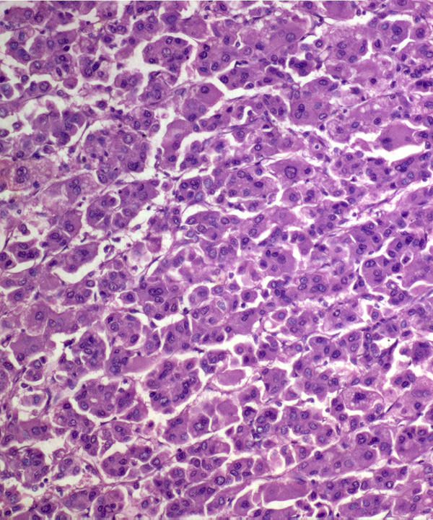
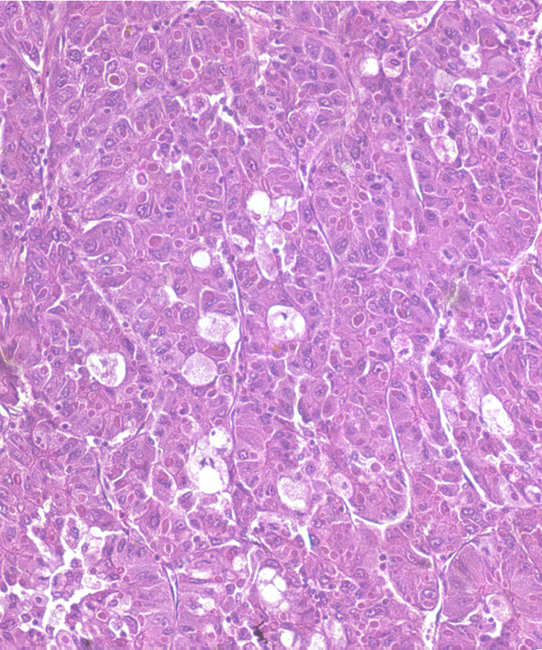
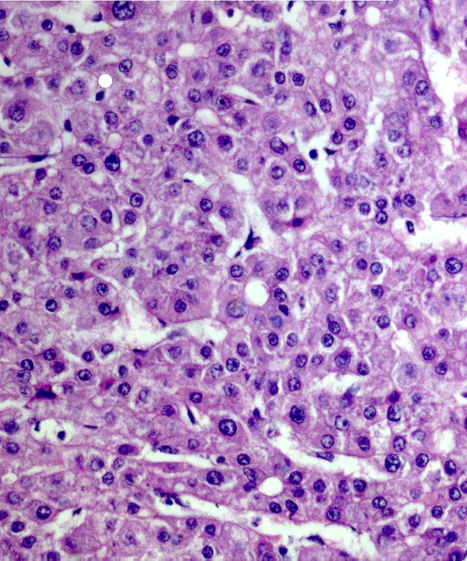

Poor differentiated HCC Moderate differentiated HCC Well differentiated HCC
Fig. 5: Histopathological stages of HCC, well differentiated, moderate differentiated and poor differentiated (hemotoxlin and eosin, original magnification x400).

References:
      - Bosch FX, Ribes J, Cleries R, Diaz M. Epidemiology of hepatocellular carcinoma. Gin Liver Dis 2005; 9: 191-211.
- Parkin DM, Bray F, Ferlay J, Pisani P. Global cancer statistics, 2002. CA Cancer J Gin 2005; 55: 74-108.
- Liovet JM, Burroughs A, Bruix J. Hepatocellular carcinoma. Lancet, 2003; 362: 1907-1917.
- Liovet JM, Bruix J. Novel advancements in the management of hepatocellular carcinoma in 2008. J Hepatol 2008; 48 Suppl 1: S20-.S37.
- Okuda K, Kot oda K and Obata H. Clinical observations during a relatively early stage of hepatocellular carcinoma, with special reference to serum AFP levels. Gastroenterology, 1975. 69, 226.
- Soresi M, Magliarisi C, Campagna P, Leto G, Bonfissuto G. Usefulness of alpha-fetoprotein in the diagnosis of hepatocellular carcinoma. Anticancer Res 2003; 23: 1747-1753.
- Liebman HA, Furie BC, Tong MJ, Blanchard RA Lo KJ, Lee SD, Coleman MS, Furie B. Des-γ-carboxy (abnormal) prothrombin as a serum marker of primary hepatocellular carcinoma. N Engl J Med 1984; 310:1427- 1431.
- Volk ML, Hernandez JC, Su GL. Lok AS, Marrero JA. Risk factors for hepatocellular carcinoma may impair the performance of biomarkers: A comparison of AFP, DCP, and AFP-L3. Cancer Biomarkers 2007:79-87.
- Weitz IC, Liebman HA. Des-gamma-carboxy (abnormal) prothrombin and hepatocellular carcinoma: a critical review. Hepatology 1993; 18: 990-997.
- Kasahara A. Hayashi N, Fusamoto H, Kawada Y, Imai Y, Yamamoto H, Hayashi E, Ogihara T, Kamad T. Clinical evaluation of plasma des--y-carboxy prothrombin as a marker protein of hepatocellular carcinoma in patients with tumors of various sizes. Dig Dis Sci 1993; 38:2170-2176.
- Suehiro T, Matsumura T, Itasaka H, Taketomi A, Yamamoto K, Sugimachi K. Des-gamma-carboxy prothrombin and proliferative activity of hepatocellular carcinoma. Surgery 1995, 117:682-691.
- Takahashi S, Kitamoto M, Takaishi H, et al. Fujiyama S, Izuno K, Gohshi K, Shibata Sato T. Clinical usefulness of des-gamma- carboxy prothrombin assay in early diagnosis of hepatocellular carcinoma. Dig Dis Sci 1991;36:1787-1792.
- Aoyagr Y, Oguro M, Yanagi M, Mita Y, Suda T, Suzuki Y, Hata K, Ichii K, Asakura H. Clinical significance of simultaneous determinations of alpha-fetoprotein and des-gamma-carboxy-prothrombin in monitoring recurrence in patients with hepatocellular carcinoma. Cancer 1996; 77. l78l-1786.
- Srivastava S, Gopal-Srivastava R: Biomarkers in cancer screening: a public health perspective.J Nutr 2002; 132(suppl 8):2471S–
- Takahashi S, Kitamoto M, Takiashi H, et al. Expression of telomerase component genes in hepatocellular carcinoma. Eur J Cancer 2000;36:496–502.
- Miura N, Shiota G, Nakagawa T, et al. Sensitive detection of hTERT mRNA in the serum of patients with hepatocellular carcinoma. Oncology 2003;64:430–4.
- Nakayama J, Tahara H, Tahara E, et al. Telomerase activation by hTERT in human normal fibroblasts and hepatocellular carcinomas. Nat Genet 1998;18:65-68.
- Nakamura TM, Morin GB, Chapman KB, et al. Telomerase catalytic subunit homologs from fission yeast and human. Science 1997;277:955-959.
- Ishikawa F. Telomere crisis, the driving force in cancer cell evolution. Biochem Biophys Res Commun 1997;230:1-6.
- Murnane JP, Sabatier L. Chromosome rearrangements resulting Murnane from telomere dysfunction and their role in cancer. Bioassays 2004;26: 1164-1174. 21-
- Oh BK. Chae KJ, Park C, et al. Telomere shortening and telomerase reactivation in dysplastic nodules of human hepatocarcinogenesis. J Hepatol 2003;39:786-792.
- Laurent-Puig P, Legoix P, Bluteau 0, et al. Genetic alterations associated with hepatocellular carcinomas define distinct pathways of hepatocarcinogenesis. Gastroenterology 2001, 120: 1763-1773.
- Oh Bk, Kim H, Park Y, et al. High telomerase activity and long telomeres in advanced hepatocellular carcinoma with poor prognosis. Laboratory investigation 2008, 88: 144-152.
- Hicks JL, Iacobuzio-Donahue CA, et al. Meeker AK,. Telomer length abnormalities occur early in the initiation of epithelial carcinogenesis.Clin Cancer Res 2004;10:3317–3326.

25. Farazi PA, Glickman J, Jiang S, et al. Differential impact of telomere dysfunction on initiation and progression of hepatocellular carcinoma Cancer Res 2003;63:5021–5027
26- CHIEREGATTI A. The soluble sandwich approach for immunoassays, methodological and instrumental implication. Ann. Bioi. Clin. 1990; 48 : 393.
27. AMIRAL J., GROSLY M., PLASSARY V., MIMILLA F. AND CHAMBRETTE B. Development of a monoclonal immuoassay for the direct measurement of Desgamma-Carboxy-Prothrombin on plasma. XIIIth congress of ISTH- AMSTREDAM- THE NETHERLANDS- July 6. Thromb. Haemostasis 1991; 65 : 648.
28. Bosserhoff AK, GlaBl A, Stolz W, Buetmer R. Detection of telomerase activity in skin, melanocytic nevi, and melanoma by telomerase PCR ELISA. Biochemica 1997; 3: 16-18.
29. Swant SG, Antonacci R. Pandita T. Detection of telomerase activity in HeLa cells after treatment with ionizing radiation by telomerase PCR ELISA. Biochemica 1997; 4: 22-4.
30. Lovet JM and Bruix J. Novel advancements in the management of hepatocellular carcinoma in 2008. J Hepatol 2008; 48 Suppl: S20-S37.
31. Kokudo N and Makuuchi M . Evidence-based clinical practice guidelines for hepatocellular carcinoma in japan : the J-HCC guidelines .. J Gastroenterol 2009 ; 44 supppl 19: 119-121 .
32. Piotr Stefaniuk , Janusz Cianciara and Alicja Wiercinska-Drapalo . Present and future possibilities for early diagnosis of hepatocellular carcinoma. World j Gastroenterol 2010 january 28 ;16(4):418-424 .
33. Stravitz RT , Heuman DM and Chand N . Surveillance for hepatocellular carcinoma in patients with cirrhosis improves outcome . Am J Med 2008 ;121:119-126 .
34. Aoyagi Y , Oguro M and Yanagi M . Clinical significance of simultaneous determinations of alpha-fetoprotein and des-gamma-carboxy prothrombin in monitoring recurrence in patients with hepatocellular carcinoma. Cancer 1996 ;77:1781-6
35. Nomura F , Ishijma M , Kuwa K et al . Serum des-gamma carboxy prothrombin levels determined by a new generation of sensitive immunoassays in patients with small-sized hepatocellular carcinoma. Am J Gastroenterol 1999; 94:650-654.
36. Mita Y , Aoyagi Y , Yanagi M , et al. The usefulness of determining des-gamma-carboxy prothrombin by sensitive enzyme immunoassay in the early diagnosis of patients with hepatocellular carcinoma . Cancer 1998; 82:1643-1648.
37. Marero JA , Su GL , Wei W , et al . Des-gamma-carboxy prothrombin can differentiate hepatocellular carcinoma from non malignant chronic disease in American patients . Hepatology 2003; 37:1114-1121.
38. Lamertz R , Runge M, Stiebber P , et al . Use of serum PIVKA II (DCP) determination for differentiation between benign and malignant liver disease. Anticancer Res 1999;19:2489-2493 .
39. Nakmura S , Nouso K , Sakaguchi K , et al . Sensitivity and specificity of des-gamma-carboxyprothrombin for diagnosis of patients with hepatocellular carcinomas varies according to tumor size. Am J Gastroenterol 2006 : 101:2038-2043.
40. Toyoda H , Kumada T , Osaka Y , et al . Staging hepatocellular carcinoma by a novel scoring system (BALAD score) based on serum markers . Clin Gastroenterol Hepatol 2006 ; 4:1528-1536 .
41. Volk ML , Hernadez JC , Su Gl , et al . Risk factors for hepatocellular carcinoma may impair the performance of biomarkers: a comparison of AFP, DCP and AFP-L3 . Cancer Biomark 2007; 3:79-87.
42. Baek YH, Lee JH, Jang JS, Lee SW, Han JY, Jeong JS, Choi JC, Kim HYand Han SY . Diagnostic role and correlation with staging systems of PIVKA-II compared with A . Hepatogastroenterology. 2009 May-Jun; 56(91-92):763-7.
43. Yoon YJ, Han KH and Kim do Y. Role of serum prothrombin induced by vitamin K absence or antagonist-II in the early detection of hepatocellular carcinoma in patients with chronic hepatitis B virus infection. Scand J Gastroenterology. 2009; 44(7):861-6
- Nguyen MH, Befeler AS, Roberts LR, Reddy KR, Harnois D, Llovet JM, Normolle D and Dalhgren J. Alpha-fetoprotein, des-gamma carboxyprothrombin, and lectin-bound . ,Gastroenterology , 2009 Jul;137(1):110-8 .
- Do Young Kim , Yong Han Paik , Sang Hoon Ahn , Young Jun Youn , Jong Won Choi , Ja Kyung kim , Kwan Sik Lee , Chae Yoon Chon . PIVKA II is useful tumor marker for recurrent hepatocellular carcinoma after surgical resection. Oncology 2007; 72(suppl 1):52-57.
- Ryo Nakashi^{o1,*}, Mikiya Kitamot^{o1}, Hidetoshi Tahar^{a2}, Toshio Nakanish^{i1}, Toshinori Id^{e2}, Goro Kajiyam^{a1} .Significance of telomerase activity in the diagnosis of small differentiated hepatocellular carcinoma. International Journal of Cancer 1997; 74; 141-147.
- Tatsuma T, Goto S, Kitano S, Lin YC, LeeCM, Chen CL: Telomerase activity in peripheral blood for diagnosis of hepatoma. J. Gastroenterol Hepatol 2000; 15: 1064–1070.
- Norimasa Miura, Yoshiko Maeda, Takamasa Kanbe,et al. Serum human telomerase transcriptase messenger RNA as a novel tumor marker for hepatocellular carcinoma 2009; http://clincancerres.aacrjournals.org/content/11/9/3205.
- Bong-kyeong Oh, Haeroung Kim, Young Park, Jeong Euo Yoo, et al. High telomerase activity and long telomer in advanced hepatocellular carcinoma with poor prognosis . Laboratory Investigation 2008; 88: 144-152.
11/1/2010

