Physiological Formation of Mosquitocidal Toxin by a novel Bacillus thuringiensis isolate under Solid State Fermentation

M.S.Foda,^{*1 ,} Fawkia M. El-Beih,² Maysa E. Moharam.¹ Nora N.A.El-Gamal¹
¹Microbial Chemistry Department, National Research Center, Dokki, Giza, Egypt.
²Faculty of Science, Ain Shams University, Cairo, Egypt.

*foda302002@yahoo.com

Abstract: Sixty eight cultures were isolated from soil of different locations in El-Sharkia governorate that were cultivated by cereals, rice, clover, cotton, and maize crops. Based on the LC₅₀ and LC₉₀ values, the Egyptian isolate No 4 was selected for further study due to its lower LC₅₀ and LC₉₀ than the international Bacillus thuringiensis var.israelensis (Bti) upon bioassay against second instars larvae Culex pipiens. The Egyptian isolate No 4 is defined morphologically and biochemically as Bacillus thuringiensis. Physiological factors affecting growth and toxin biosynthesis in B. thuringiensis isolate No 4 in comparison to Bti under solid state fermentation were studied. Talcum powder and silica gel were the best carriers yielding highest mosquitocidal activity for Bacillus thuringiensis No.4 and Bacillus thuringiensis var.israelensis, respectively.The highest mortality were obtained upon utilization of kidney beans (3%) and black eyed beans (6%) as base solid substrate for B. thuringiensis isolate No 4 and B. thuringiensis var.israelensis, respectively. Toxicity increased with extended the incubation period up to 9 days for both of tested organisms. Highest values for growth and toxicity were obtained in cultures with initial moisture content adjusted at 60% (w/w) for both organisms. Mosquitocidal toxin activity were fairly stable within a wide range of increasing aeration level up to a ratio of 10g culture/250ml conical flask and 10g culture/500ml for growth and toxicity of Bacillus thuringiensis var.israelensis, and Bacillus thuringiensis isolate No 4, respectively.
[M.S.Foda, Fawkia M. El-Beih, Maysa E. Moharam. Nora N.A.El-Gamal. Physiological Formation of Mosquitocidal Toxin by a novel Bacillus thuringiensis isolate under Solid State Fermentation. Life Science Journal 2010;7(4):144-152]. (ISSN: 1097-8135).

Key Words: Bacillus thuringiensis, isolation, characterization, mosquitocidal toxin, physiology, solid state fermentation.

1. Introduction

The first realistic possibility for using Bacillus as a mosquito control agent was offered in 1977 with the isolation of Bacillus thuringiensis var. israelensis (Bti) Goldberg and margalit (1977).This strain possessed a high level of toxicity for mosquito and black fly larvae. Since 1980, the use of Bacillus thuringiensis var. israelensis formulation for mosquito control has greatly increased in California, Florida in the United States and various tropic countries Aronson et al. (1986).
According to Rawlins (1989), the advantages of Bacillus thuringiensis var. israelensis are its temperature tolerance, family specificity, handled easily and when stored at room temperature, formulations are stable for long periods. However, in the aquatic environment, larvicidal activity is short lived.
Bacillus thuringiensis and Bacillus sphaericus are being used widely as larvicidal bacteria for mosquito control, this microbial pesticides are eco-friendly and specific to the target organisms (Armengol et al., 2006).
Lonc et al. (2004) recommended a successful model of control strategy based on currently integrated methodologies with emphasis on preventive treatment of aquatic larvae with microbial insecticides was conducted. Bacillus thuringiensis var. israelensis-based formulation replaced chemicals to control Culex pipiens
According to Mudget (1986) solid-state fermentation, or alternatively called semi-solid fermentation, SSF may be briefly defined as that in which microbial growth and product formation take place on the surface of solid substrates. This type of fermentation, SSF, is distinguished from submerged fermentation by the fact that microbial growth occur at or near the surface of solid materials with low moisture content as contrasted to that taking place in continuous aqueous phase in case of submerged fermentation.
In spite of the extensive application of SSF technology in production of different microbial products, yet only very meagre information has so far been published on the possible use of SSF technology in the production of bioinsecticides e.g. B. thuringiensis. Foda et al (2002).
In the present investigation a series of experimental studies were carried out to investigate the possible use of SSF methodology for production mosquitocidal toxins from the local isolate of B. thuringiensis No.4 as well as from the International strain B. thuringiensis var.israelensis for comparative purposes.

2. Materials and Methods:
Microorganisms
The International strain Bacillus thuringiensis var. israelensiswas kindly obtained from prof. F.G. Priest, School of Life Sciences, Heriot Watt University, UK A new Bacillus thuringiensis isolate namely B.t.No.4 was isolated from soils of El-Sharkia Governorate ,Egypt.

Media
1. Media used for isolation of Bacillus thuringiensis from soil
A) L- agar acetate medium (Morris et al., 1988): This medium was used as a selective medium for isolation of Bacillus thuringiensis after addition of 0.25 M acetate buffer. It consisted of (g/L); 10 peptone, 5 yeast extract, 10 sodium chloride, 20 Agar.
Acetate buffer: a) Sodium acetate 2.5 M, b) Acetic acid 2.5 M. Add (a) to (b) until pH 6.8, filter sterilized. Add 100 ml of acetate buffer to L-agar medium.
2. Synthetic media used for cultivation of the pure organisms and their activation prior to physiological studies
a) Nutrient Broth medium: (g/l): 5 peptone, 3 beef extract, for solidification 25 g agar were added.
b) Luria- Burtani(LB) medium: (g/l) peptone 10, yeast extract 5, sodium chloride 10.
c) NYSM broth medium: nutrient broth, yeast extract 0.5 g/l
Trace elements, (g/100ml): Manganese chloride 0.09, Calcium chloride 1.03, Magnesium chloride 2.o3.
1 ml of the filter sterilized trace elements solution was added to 100 ml of the medium.
3. Media used in solid state fermentation (SSF).These media were used for the study of potency of mosquitocidal toxin production, growth and sporulation of B. thuringiensis under SSF conditions. These types of media are mainly composed of three components namely an inert carrier, solid nutrient sources and an inorganic salt solution.
a) The inert carrier materials were either of organic nature e.g. Wheat bran and rice hull or some inorganic clay materials e.g. talcum powder, celite and silica gel
b)The mineral salt solution: The following composition were used (KH₂PO₄,0.5g/L,MgSO₄.7H₂O 0.25g/L, CaCl₂ 0.1g/L, FeSO₄.5H₂O 0.01 g/L) at appropriate concentration Foda et al (2002).
c) The main nutrient solid source: This was represented by some high protein content agroindustrial by-products that are locally available in Egypt. These include dried fodder yeast, feather meal and offal’s meal which is a byproduct of chicken slaughter house residues being dried and thoroughly minced. The SSF were carried out in 250 ml conical flasks. The SSF medium composed of 10 ml mineral salt solution added to 10g of solid substrate-inert carrier mixture, thoroughly mixed and autoclaved Foda et al (2003).

Gel electrophoresis
Dissociating polyacrylamide gel electrophoresis (SDS-PAGE) was carried out according to a protocol proposed by Laemmli (1970).

Subunit molecular weight estimation by SDS-PAGE
The method of Weber and Osborne (1969) was used to determine the apparent (subunit) molecular weight of proteins dissolved or extracted in the presence of SDS. Electrophoretic mobilities were calculated relative to the mobility of the bromophenol blue marker band in 12% and 5% polyacrylamide slab gel. The following proteins were used as molecular weight standards: β-galactosidase (116 KDa), Bovine serum albumin (66.2 KDa), Ova albumin (45 KDa), Lactate dehydrogensae (35 KDa), β-lactoglobulin (18.4 KDa).

Bioassay of bacterial toxins against Mosquitoes larvae.
Bioassay of locally isolated Bacillus thuringiensis was carried out as described by Priest and Youstin (1991).Toxicity was determined with laboratory reared Culex pipiens serial dilutions in distilled water. The range of concentration of full grown whole culture (FWC) which killed 50% and 90% of the larvae were identified. Then further toxicity tests were done in the range recorded to evaluate precisely the LC₅₀ and LC₉₀ values for each highly promising bacterial culture. The corrected mortality was then plotted against culture dilution of cells/ml on log paper to determine LC₅₀ andLC₉₀ values for each highly promising bacterial cultures. The bacterial dilutions were placed in small cups in duplicates along with 10 second instar larvae. Appropriate controls were run simultaneously using distilled water instead of cultures. The cups kept at room temperature 27±2°C. The mortality percentage was recorded by counting the number of living larvae and corrected by using appropriate control and applying Abbott's formula (Abbott, 1925). The medium lethal concentrations LC₅₀ of potent isolates was computed through probit analysis within 95% confidence limits using propan program.
Abbott's formula:
Observed mortality % - Corrected mortality %
Observed mortality % - Corrected mortality%
Corrected mortality % = --------------------------- x 100
100-Control mortality %

3. Results:

1. Isolation of Mosquitocidal Toxin Producers from Bacilli isolated from the Egyptian environments
Sixty eight isolates were obtained from soils of five locations in El-Sharkia Governorate. Among these isolates, isolate No 4. obtained from location cultivated with wheat was the only isolate giving 100% mortality up to culture dilution 10⁻⁵. Accordingly this isolate obtained from El-Sharkia Governorate was selected for further investigation.

2. Determination of LC₅₀ and LC₉₀ values of the Egyptian isolate No.4 obtained from El-Sharkia Governorate soils.
LC₅₀ and LC₉₀ of isolate No.4 and Bacillus thuringiensis var. israelensis are bioassayed against second instar larvae of Culex. pipiens revealed that the Egyptian isolate No.4 is highly toxic than the reference strain (Table 1).

3. Identification of the Egyptian isolate No.4 isolated from El-Sharkia Governorate
The morphological features of colonies exhibited a white colour and the colonies shape have a typical features of Bacillus thuringiensis. Microscopic examination of the cells indicated the presence of different types of crystals developed after 3 days of incubation. The formation of crystals inside the sporangium with oval spores as shown in Figures (1& 2), while Figures (3&4) describe the shape of crystals of B. thuringiensis var. israelensis.
Some biochemical tests were carried out for the identification of the Egyptian isolate No.4 obtained from El-Sharkia Governorate(`Table 2).
Molecular taxonomy of organism No 4:
In order to further identify the taxonomical position of the organism No 4 isolated from soils of EL-Sharkia governorate in Egypt, the crystalline protein formed by this culture were analyzed by SDS-PAGE technique. Thus the method of Weber and Osborne (1969) was used to determine the applied subunit molecular weight of proteins extracted in the presence of SDS. Standard bacterial cultures namely Bacillus sphaericus No(1), International strain Bacillus sphaericus 2362 No (2), and Bacillus thuringiensis var. israelensis No(3) were used as standard cultures in SDS-PAGE run. The standard cultures were obtained from Prof Dr Fergus Priest, Heriot- Watt University, Scotland. The obtained results showed clearly the presence of intimate similarities between SDS-PAGE pattern of the apparent (subunit) molecular weight of proteins detected in case of Bacillus sphaericus No(1)and the standard Bacillus sphaericus international strain 2362 rows r3, r4, r5, r11 (Table 3). The two Bacillus sphaericus are apparently belong to the same serotype 5A5B and having the same molecular weight of proteins subunits (Fig 5). On the other hand, SDS-PAGE chromatogram indicated the high degree of relatedness between proteins subunits of Bacillus thuringiensis israelensis and that of Bacillus thuringiensis organism No (4) isolated in the present studies. Further studies may be needed before arriving to decisive conclusion.

4. Comparative physiological studies on production of Bacillus thuringiensis (Bt) under conditions of solid substrate fermentation (SSF).

4.1 Comparison between different carrier materials.
Some selected natural materials of organic and inorganic nature were tested as supports and medium - containing agent when incorporated in the solid medium for growth, sporulation, and toxin production of the Egyptian isolate Bacillus thuringiensis No.4 in comparison with B. thuringiensis var. israelensis. The results in Tables (4&5) indicated that talcum powder and silica gel were the best carriers yielding highest mosquitocidal activity. Thus they were selected as the carriers of Bacillus thuringiensis No.4 and Bacillus thuringiensis var.israelensis, respectively.

4.2. Selection of suitable base solid substrate
A group of finely grinded agroindustrial by-products that are rich in proteins and locally available, as well as powdered leguminous seeds were used as solid substrates and as the main source of nutrients under SSF conditions. These included fodder yeast, feather meal, offal's meal and grinded seeds of soy beans, kidney beans, lentils and yellow splite pea. Each of these substrates was used at a concentration of 6% w/w. The results are summarized in Tables (6 &7) The highest mortality were obtained upon utilization of kidney beans and black eyed beans as base solid substrate for B. thuringiensis isolate No.4 and B.thuringiensis var. israelensis, respectively.

4.3. Effect of incubation period
The extent of growth and mortality were determined after 3,6,9,12 days of incubation at 30°C .The results are shown in Figure (6), toxicity increased with extended the incubation period up to 9 days for both of tested organisms. No further increase was obtained upon extended incubation under the SSF conditions.

4.4. Effect of substrates (kidney beans and black eyed beans) concentration
Different concentrations ranging between 1.5 to 24 % w/w of kidney and black eyed beans used as a sole nutrient source with talcum powder and silica gel as an inert carriers as a growth media for Bacillus thuringiensis isolate No. 4 and Bacillus thuringiensis var.israelensis, respectively in the presence of moisture content 50% (w/w) under SSF conditions. The obtained results were shown in Figure (7).Progressive increase in the toxicity was obtained up to concentration 3% of kidney beans for growth of B. thuringiensis No.4 and concentration 6% of black eyed beans for growth of Bacillus thuringiensis var. israelensis.

4.5. Effect of initial moisture content of the medium
The percentage of moisture in the medium was varied between 20% to 80% (w/w) as final concentration. Results are in illustrated in Figure (8).The highest values for growth and toxicity were obtained in cultures with initial moisture content adjusted at 60% (w/w) for both organisms. At higher moisture contents the cultures exhibited fast and progressive decrease in growth parameters and toxicity(mortality%).

4.6. Effect of extent of aeration
The influence of aeration level was studied by using conical flasks with different sizes ranging between 50 ml to 1000 ml capacities The results are shown in Figure (9), the growth parameters and the level of mosquitocidal activity were fairly stable within a wide range of increasing air space available in the experimental flasks (up to a ratio of 10g culture/250ml conical flask and 10g culture/500ml for growth and toxicity of Bacillus thuringiensis var. israelensis, and Bacillus thuringiensis isolate No.4, respectively.

Table (1): LC₅₀ and LC₉₀ (p≤ 0.05) of Bacillus thuringiensis No.4 and Bacillus thuringiensis var. israelensis against 2 ^{nd} instar larvae of Culex. pipiens.
Isolate | LC₅₀  by μl (p≤ 0.05) | LC₉₀  by μl (p≤ 0.05) | Slope ± S.E.
Egyptian isolate No.4 | 142.4  (55.5 –220.7) | 448.8  (290.8 – 1085. 2) | 2.5 ± 0.7
Reference strain (B. thuringiensis israelensis) | 220.4  (97.8-335.8) | 825.9  (516.6-2697.7) | 2.3± 0.6

Table(2): The biochemical tests for identification of the Egyptian isolate No.4 obtained from soil of El-Sharkia Governorate.

Biochemical tests | B .thuringiensis var. israelensis | Egyptian isolate B. thuringiensis No.4
Tolerance to NaCl 2%  5%  7%  10%  Degradation of adenine  Hydrolysis of urea  Hydrolysis of casein  Hydrolysis of Starch  Hydrolysis of gelatin  Utilization of citrate  Methyl red test  Vogesproskauer test  Catalase test  Nitrate reduction test | +  +  -  -  +  +  +  +  +  -  -  -  -  - | +  +  -  -  +  +  +  +  -  -  -  -  -  -

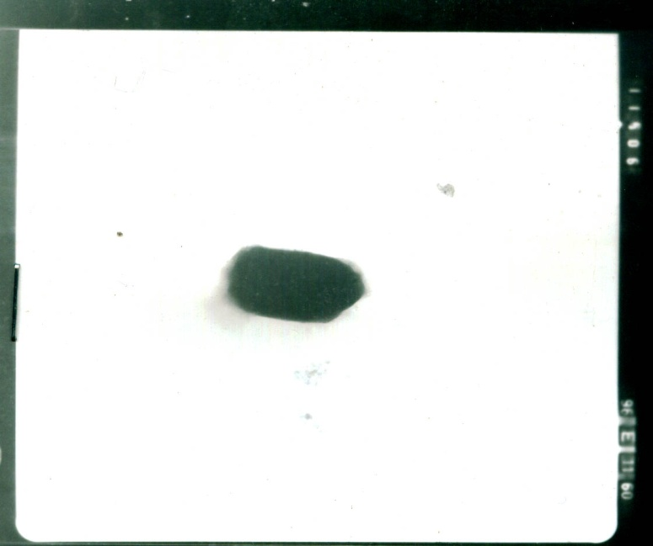
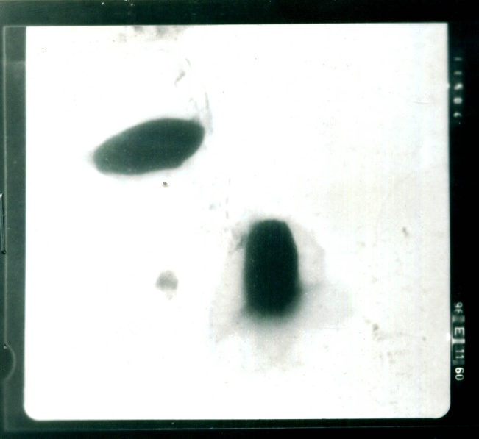

A
A B
Fig (1): Electron micrograph showing shapes of crystals of the Egyptian B. thuringiensis isolate No.4 isolated from El-Sharkia Governorate soil.
A. E.M. Showing two crystals after 3 days of incubation (X20.000).
B. E.M. Showing one crystal after 3 days of incubation (X20.000).

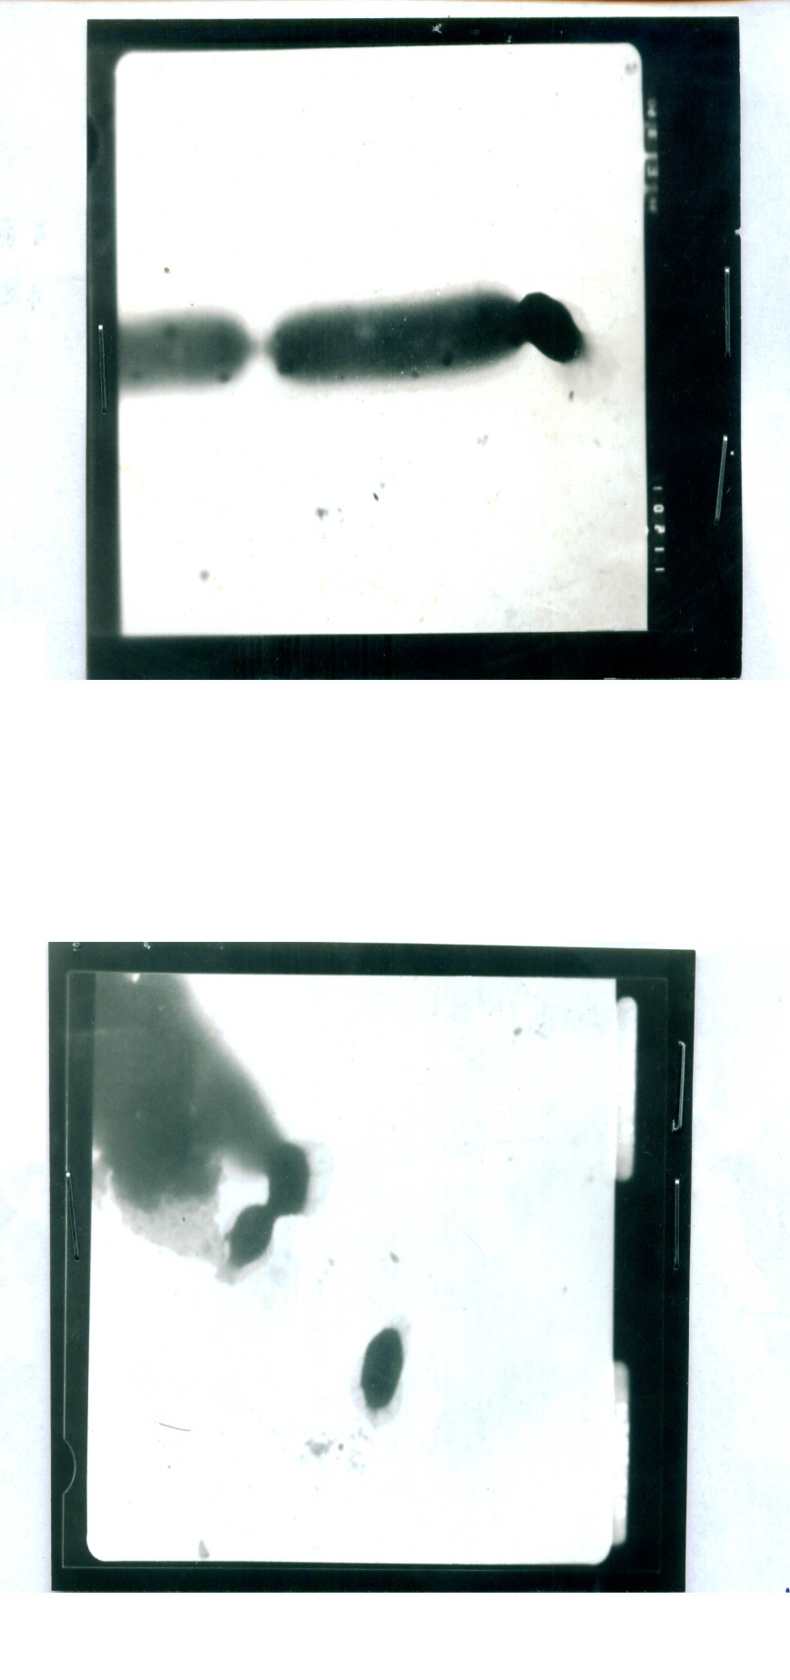
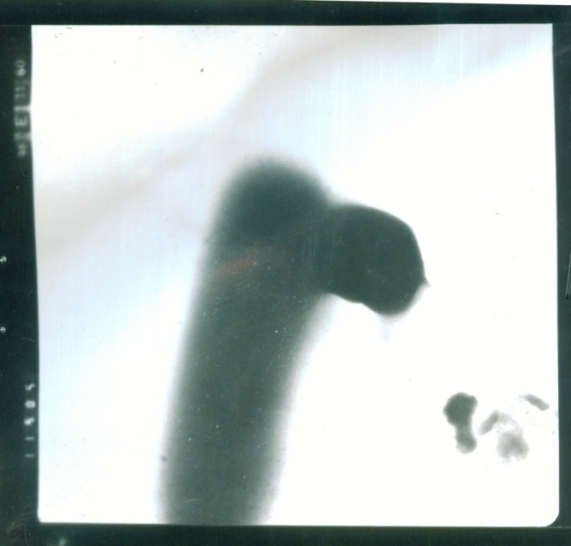

Fig (2): E.M. of the Egyptian isolate B. thuringiensis No.4 showing spore and crystals(X 5000).
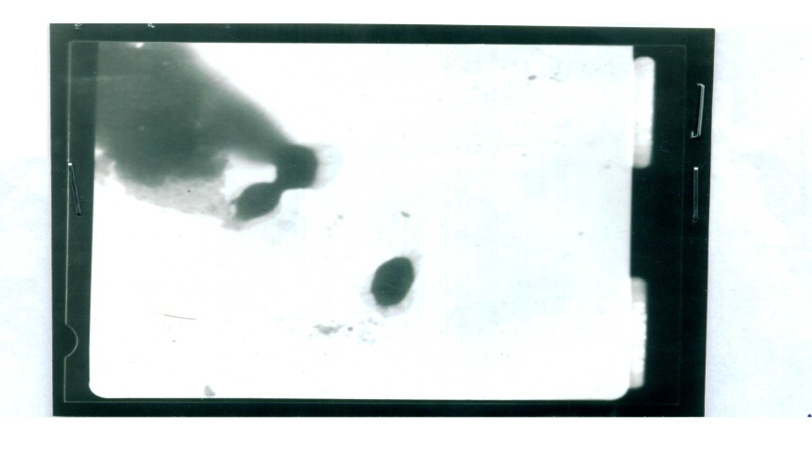

Fig (3): E.M. showing two spores and crystal of B. thuringiensis var.israelensis (X10.000).

Fig (4): E.M. Showing crystal of B. thuringiensis var.israelensis(X5000).
Table (3): R_{f} values for different proteins subunits of SDS-PAGE of organism No (4) Bacillus thuringiensis in comparison with standard bacterial cultures.
Lanes: | 2 | 1 | M | 3 | 4
Rows | (M.W.) | (M.W.) | (M.W) | (M.W) | (M.W)
r1 |  |  | 116
r2 |  |  | 66.2 | 70.662 | 70.662
r3 | 63.203 | 63.203 |  | 63.203 | 63.203
r4 | 58.734 | 58.734
r5 | 53.125 | 53.125 |  | 51.51 | 51.51
r6 |  |  | 45
r7 |  |  |  | 40.492 | 40.493
r8 |  |  | 35
r9 |  |  |  | 32.070 | 32.071
r10 |  |  |  | 23.916 | 23.916
r11 | 21.778 | 21.778
r12 |  |  | 18.4

Table (4): Effect of various carriers on growth parameters and mosquitocidal activity of B. thuringiensis No.4 under solid state fermentation conditions. The bioassay was carried out against second instar Culex pipiens larvae, using diluted culture (10⁻⁶).
Carrier Used | Final pH at Harvest Time | (Mean ± S.D.) Plate Count |  | (Mean ± S.D.)  Mortality % after
Carrier Used | Final pH at Harvest Time | CFU/g Product  ( × 10⁻⁶ ) | Spore/g Product  ( × 10⁻⁶ ) | 48 hr
Orange Peels | 4.5 | 3.50 ± 1.05 | 1.50 ± 1.52 | 10.00 ± 0.00
Beans Peels | 6.4 | 1.33 ± 0.51 | 0.67 ± 0.8 | 8.33 ± 1.83
Wheat Bran | 7.0 | 13.50 ± 2.17 | 8.17 ± 1.17 | 62.33 ± 6.89
Sugar-beet | 7.3 | 1.50 ± 1.05 | 1.17 ± 1.17 | 14.17 ± 4.92
Corn Cobs | 4.2 | 62.83 ± 2.04 | 51.67 ± 2.07 | 73.33 ± 4.08
Rice Husk | 7.6 | 68.67 ± 5.75 | 64.50 ± 5.43 | 41.50 ± 5.96
Rice Hull | 7.3 | 10.17 ± 0.60 | 10.00 ± 0.26 | 6.00 ± 8.94
Celite | 4.8 | 70.67 ± 5.79 | 51.17 ± 3.49 | 80.29 ± 6.50
Talcum Powder | 7.2 | 77.50 ± 5.01 | 63.50 ± 5.75 | 99.17 ± 10.68
Silica Gel | 6.0 | 30.83 ± 3.37 | 19.67 ± 3.83 | 70.33 ± 3.27

Table(5): Effect of various carriers on growth parameters and mosquitocidal activity of standard B.thuringiensis var. israelensis .under solid state fermentation conditions. The bioassay was carried out against second instar larvae of Culex pipiens using diluted culture(10⁻⁶).
Carrier Used | Final PH at Harvest Time | (Mean ± S.D.) Plate Count |  | (Mean±S.D.)  Mortality % after
Carrier Used | Final PH at Harvest Time | cfu/g Product  ( × 10⁻⁶ ) | Spore/g Product  ( × 10⁻⁶ ) | 48 hr
Orange Peels | 4.5 | 1.00 ± 1.26 | 1.17 ±1.60 | 6.67 ± 8.16
Beans Peels | 6.3 | 1.67 ± 2.73 | 2.00 ±2.10 | 6.67 ± 7.53
Wheat Bran | 6.1 | 4.67± 1.63 | 3.17 ±1.17 | 8.33 ± 7.53
Sugar-beet | 4.8 | 3.67± 1.51 | 0.50 ±0.84 | 7.50 ± 7.58
Corn Cobs | 7.3 | 2.50± 2.74 | 1.50 ±1.38 | 5.00 ± 5.48
Rice Husk | 7.4 | 30.67±1.75 | 22.83±3.06 | 6.67 ± 8.16
Rice Hull | 4.4 | 4.17 ± 1.47 | 3.33 ±1.37 | 25.83 ±5.64
Celite | 8.5 | 70.50±4.64 | 21.00±4.05 | 78.00 ±4.47
Talcum Powder | 7.0 | 7.50 ± 1.76 | 4.00 ± 2.10 | 67.83 ±9.91
Silica Gel | 7.5 | 57.33±5.65 | 32.83±1.94 | 99.33 ±3.27

Table (6): Effect of nutrient substrate on growth and toxin production of B. thuringiensis No.4 under solid state fermentation conditions against 2nd instar larvae of Culex pipiens,using diluted culture 10⁻⁶.
Nutrient. | Final PH at Harvest Time | (Mean ± S.D.) Plate count |  | (Mean ± S.D.) Mortality % after
Nutrient. | Final PH at Harvest Time | Viable  Count× 10⁻⁶ | Spore  Count × 10⁻⁶ | 24 hr | 48 hr
Black eyed beens | 7.6 | 33.17 ± 2.23 | 22.50 ± 3.89 | 63.67 ± 2.88 | 67.50 ± 5.24
Kidney beans | 8.8 | 58.33 ± 1.97 | 47.00 ± 13.89 | 87.33 ± 4.08 | 99.17 ± 0.98
Soy beans | 8.0 | 32.33 ± 1.63 | 25.67 ± 3.14 | 52.33 ± 2.16 | 61.83 ± 1.94
Lentils | 8.2 | 62.67 ± 1.21 | 54.33 ± 3.39 | 89.83 ± 3.31 | 97.17 ± 4.02
Yellow splite pea | 7.9 | 47.33 ± 1.51 | 31.67 ± 1.63 | 68.17 ± 4.79 | 78.00 ± 2.68
Sesame seed meal | 7.8 | 41.50 ± 1.38 | 21.33 ± 1.21 | 83.67 ± 3.50 | 84.50 ± 3.02
Cotton seed meal | 7.7 | 43.67 ± 3.08 | 35.00 ± 2.76 | 73.17 ± 1.94 | 74.00 ± 1.55
Offals meal | 7.3 | 41.83 ± 1.60 | 34.33 ± 4.93 | 43.17 ± 2.48 | 52.83 ± 3.13
Father meal | 7.8 | 81.00 ± 0.89 | 66.83 ± 15.80 | 71.67 ± 2.73 | 73.00 ± 2.45
Fodder yeast | 7.9 | 51.83 ± 2.48 | 33.17 ± 2.64 | 55.83 ± 5.64 | 55.83 ± 5.85

Table (7): Effect of nutrient substrate on growth and toxin production of B. thuringiensis var.israelensis under solid state fermentation conditions against 2nd instar larvae of Culex pipiens, using diluted culture 10⁻⁶.
Nutrient. | Final PH at Harvest Time | (Mean ± S.D) Plate Count |  | (Mean ± S.D)  Mortality % after
Nutrient. | Final PH at Harvest Time | Viable  Count × 10⁻⁶ | Spore  Count× 10⁻⁶ | 24 hr | 48hr
Black eyed been | 8.0 | 27.83 ± 1.17 | 21.17 ± 0.75 | 88.33 ± 2.58 | 99.20 ± 0.84
Kidney bean | 8.3 | 32.00 ± 1.10 | 26.67 ± 2.34 | 40.67 ± 5.50 | 51.83 ± 1.94
Soy bean | 7.8 | 42.50 ± 1.38 | 31.50 ± 1.05 | 72.00 ± 2.10 | 79.17 ± 5.64
Lentils | 7.5 | 20.83 ± 5.64 | 16.50 ± 3.62 | 17.00 ± 6.32 | 24.17 ± 3.43
Yellow splite pea | 8.2 | 14.00 ± 2.83 | 11.50 ± 1.05 | 16.67 ± 5.16 | 24.33 ± 4.80
Sesame seed meal | 8.0 | 21.33 ± 1.21 | 16.17 ± 2.04 | 30.67 ± 5.50 | 36.67 ± 6.06
Cotton seed meal | 7.8 | 34.50 ± 1.76 | 21.67 ± 2.34 | 15.83 ± 3.76 | 27.83 ± 5.49
Offals meal | 7.8 | 12.33 ± 2.58 | 10.33 ± 1.37 | 14.00 ± 3.22 | 20.00 ± 6.32
Father meal | 8.2 | 20.67 ± 5.47 | 18.67 ± 2.16 | 29.17 ± 4.67 | 34.33 ± 3.50
Fodder yeast | 8.0 | 26.83 ± 3.31 | 21.67 ± 1.03 | 77.83 ± 6.46 | 82.67 ± 6.86

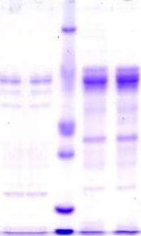
1 2 M 3 4
KDa

116

66.2

45

35

18.4

+

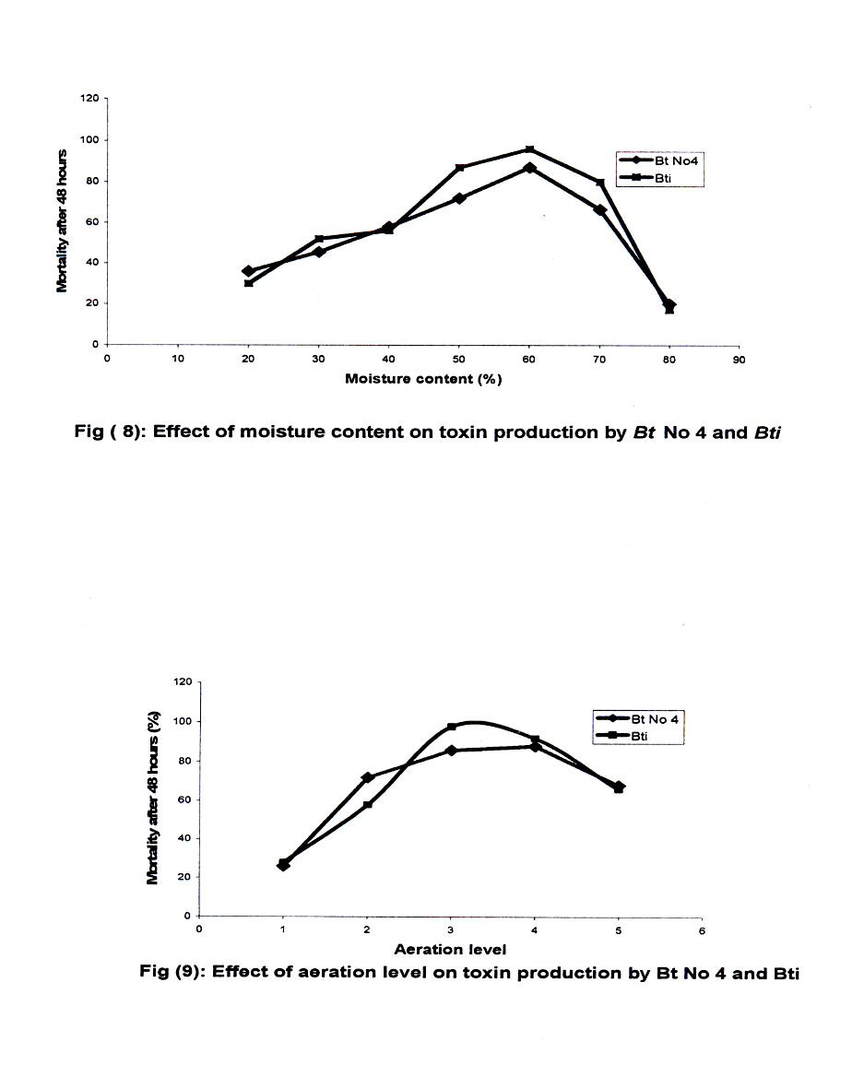
Fig (5): Mobility of protein subunits for standard bacterial cultures and Bacillus thuringiensis culture isolated from El-Sharkia Governorate of Egypt.

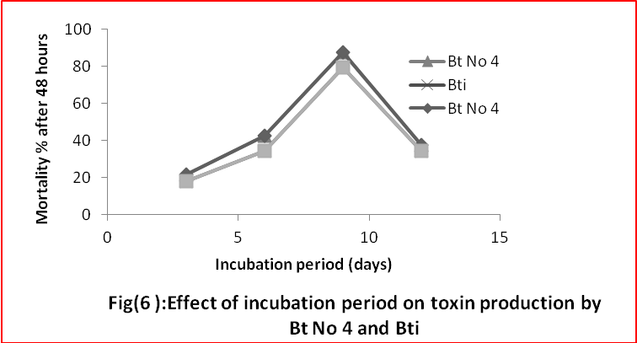
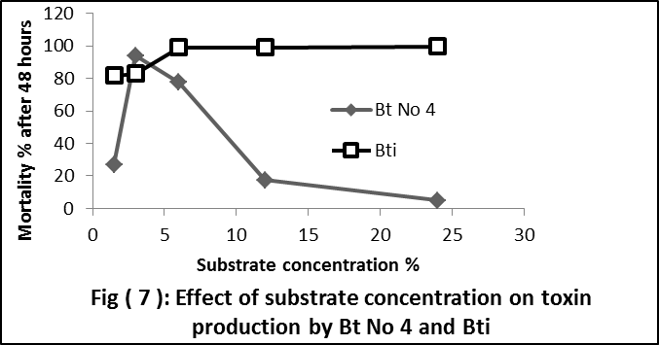

4. Discussion:
Sixty eight isolates were obtained from five locations of El-Sharkia Governorate using the enrichment approach reported by Morris et al. (1988), only one isolate No.4 was selected for its highest toxicity among the other isolates screened. It has different types of crystals and it was identified as a typical isolate of B. thuringiensis.
In the present work, special attention was given to search for new media that are suitable with low-priced and locally available in Egypt for B. thuringiensis production on a large scale. The goal stemmed from the fact that the feasibility of economic production of spores and crystals of B. thuringiensis is dependant to a large extent on production costs and availability of raw materials.
Some of Egyptian isolates of B. thuringiensis were grown on economic media containing 4% of fodder yeast on tap water, and incubated under shaking conditions for four days. (Zayed and Bream. 2004).The biological activities of these isolates against Culex pipiens were tested to determine their effectiveness against field and laboratory strains of its 3rd larval instar. All isolates of Bt were more pathogenic to laboratory strains, causing up to 84% larval mortality. The insecticidal activities of these isolates were extended to the pupae stage causing a significant effect on pupae mortality in both strains tested. A pronounced effect on adult emergence was noticed with remarkable adult malformations. The reproductive performance of females was affected significantly by all isolates applied. (Zayed and Bream. 2004).
Growth, sporulation, synthesis of delta-endotoxins, and toxicity against the larvae of Aedes aegypti and Culex pipiens were studied during fermentation of Bacillus thuringiensis H14 in a 20-L fermentor (Sarrafzadeh et al. 2005).
Solid state fermentation technology was selected for toxin production to increase the production feasibility under the Egyptian conditions as well as the reduction of the production costs as compared to the submerged fermentation. Capalbo et al. (1994) reported the development of novel bioreactores for SSF purposes the production of bacterial insecticides. They devised two column bioreactores namely an aerated fixed bed and a fluidized bed fermentors for SSF of Bt. They intended to carry out a comparative study on those two types of bioreactores including parameters and variable to solve the questions addressed and encountered in SSF methodology including heat and mass transfer, aeration extent, sterility level as well as yield and productively of this approaches. Capalbo (1995) reviewed the aspects of the fermentation process and risk assessment of Bt production in developing countries. He concluded that several factor make the local production of Bt highly appropriate for pest control in developing nations. He reported that Bt can be cheaply produced on a wide variety of low cost, organic substrates. Foda et al. (2002) devised a novel approach for production of B. thuringiensis subsp. aizawai H-133 through SSF technology using ground soybean seeds as a substrate in the presence of talcum powder as an inert carrier material. They studied in detail factors affecting growth and sporulation of the organism under SSF conditions to evaluate the possible use of this biotechnology for bioinsecticides production at lower costs to combat major insect pests in Egypt.
Finally, it is of interest to note that the present work represent the first report that apply solid state fermentation as a promising biotechnology for the production of safe mosquitocidal toxins from the novel B. thuringiensis isolate No 4 and B.thuringiensis var. israelensis. This novel fermentation approach is expected to be highly feasible, cost- effective and inexpensive for production of biopesticides in developing countries.
5. References:

- Abbott,W.S(1925):Amethod ofcomputing effectiveness of insecticide. J. Econ. Entomol., 18, 265-267.
- Armengol, G., Hernandez, J., Velez, J.G., Orduz, S. (2006): Long lasting effects of a Bacillus thuringiensis serovar. israelensis experimental tablet formulation for Aedesaegypti (Diptera: Culicidae) control. Journal of Economic Entomology 99, 1590-1595.
- Aronson, A.I.; Beckman, W. and Dunn, P. (1986):Bacillus thuringiensis and related pathogens, Microbiol Rev. 50: 1.
- Capalbo, D.M.F. (1995):Fermentation process and risk assessment. Mem.Inst. Oswaldo Cruz, 90 (1) 135.
- Capalbo, D.M.F.; Moraes, I.O. and Moraes; R.O. (1994): Development bioreactor for semi-solid fermentation purposes: Bacterial insec fermentation. In Development In Food Engineering. Proc.Int.Congress Food 6th 1993 ( pub. 1994 ). Yano, T.; Natanno,R. and Nakamura,K. ( Mackie, Glasgow, UK.
- Foda, M.S.; Ismail, I.M.K.; Moharam, Maysa E. and Sadek, Kh. H.A. (2002): A novel Approach for Production of Bacillus thuringiensis by solid state Fermentation Egypt J. Microbiol. 37(2), 135-155.
- Foda. M. S., EL-Bendary, M. A. and Moharam. M. E. (2003): Salient parameters involved in mosquitocidal toxins production from Bacillus sphaericus by semi – solid substrate fermentation. Egypt. Microbiol., 38, 229 – 246.
- Goldberg, L. Margalit, G.A. (1977): Bacterial spore demonstrating rapid larvicidal activity against Anopheles sergentii, Uranotaeniaunguiculata, Culex univitattus, Aedes aegypti, Culex pipiens. Mosquito News 37, 355-358.
- Laemmli, U.K. (1970). Cleavage of structural proteins during the assembly of the head of bacteriophage T4.Nature 227, 680 685.
- Lonc,-E;Rydzanicz,-K;Gomukiewicz,-B.(2004): Environmental monitoring and control strategy of urban mosquito Culicinae (Diptera: Culicidae) populations in Wrocaw. Wiadomosci-Parazytologiczne. 2004; 50(3): 571-578.
- Morris, O.N.; Converse, V. and Kanagaratnam, P. (1988): Isolation, characterization and culture of Bacillus thuringiensis from soil and dust from grain storage bins and their toxicity for Mamestraconfigurata( Lepidoptra : Noctuidea ). Can. Entomol., 130: 515 - 537.
- Mudget, R. E. (1986): Solid state fermentations. In: Manual of Industrial Microbiology (Demain, A. L., Solomon, N. A., eds.), pp, 66-83. American society for Microbiology).
- Priest, F.G., and Yousten, A.A. ( 1991):Entomopathogenic bacteria for biological control. Workshop help in Brazil, May.
- Rawlins, S,C. (1989).Biological control of insect pests affecting man and animals in the tropics.CRC Crit. Rev. Microbiol. 16, 235-249.
- Sarrafzadeh,-M-H; Guiraud,-J-P; Lagneau,-C; Gaven,-B; Carron,-A; Navarro,-J-M. (2005): Growth, sporulation, delta -endotoxins synthesis, and toxicity during culture of Bacillus thuringiensis H14. Current-Microbiology. 2005; 51(2): 75-81.
- Weber, K., and Osborn, M. (1969): The Reliability of Molecular Weight Determinations by Dodecyl Sulfate-Polyacrylamide Gel Electrophoresis. J. Biol. Chem. 244, 4406–4412 .
- Zayed,-M-E; Bream,-A-S. (2004): Bioassay of some Egyptian isolates of Bacillus thuringiensis against Culexpipiens(Diptera:Culicidae).Agri.Biolog.Sci.. 2004; 69(3): 219-228. 11/4/2010

