Eusyllinae, Anoplosyllinae, and Exogoninae (Polychaeta: Syllidae) for the Mediterranean Coasts of Egypt, Together the Description of One New Species

F. A. Abd-Elnaby*¹ and G. San Martín²

¹National Institute of Oceanography and Fisheries, Alexandria, Egypt
² Departamento de Biología (Zoología), Facultad de Ciencias, Universidad Autónoma de Madrid, calle Darwin, 2, 28049 Madrid, Spain.
*faiza_abdelnaby@yahoo.com

Abstract: In this paper, 18 species of the subfamilies Exogoninae, Anoplosyllinae, and Eusyllinae (Syllidae, Polychaeta) are reported from the Mediterranean Egyptian coasts, 8 of them are new records for the area: Odontosyllis fulgurans (Audouin and Milne Edwards, 1833); Syllides japonicus Imajima, 1966; Salvatoria clavata (Claparede, 1863); Salvatoria euritmica (Sardá, 1984); Sphaerosyllis glandulata Perkins, 1981; Parapionosyllis labornica Cognetti, 1965; Sphaerosyllis sp.; and Prosphaerosyllis sp. Five species were reported previously in the area. Four species are new records for Mediterranean Sea: Palposyllis prosostoma Hartmann-Schröder, 1977; Paraehlersia weissmaniodes (Augener,1913); Streptosyllis compoyi Brito, Núñez and San Martín, 2000; and Exogone africana Hartmann-Schröder, 1974); P. weissmaniodes and Exogone africana are two widely distributed Indo-Pacific species, so they could be considered as Lessepsian migrants. Finally, one new species is described, Parapionosyllis aegyptia.
[F. A. Abd-Elnaby and G. San Martín. Eusyllinae, Anoplosyllinae, and Exogoninae (Polychaeta: Syllidae) for the Mediterranean Coasts of Egypt, Together the Description of One New Species. Life Science Journal 2010;7(4):132-139]. (ISSN: 1097-8135).

Keywords: Eusyllinae, Anoplosyllinae, Exogoninae, Taxonomy, Mediterranean, Egypt, New species.

1. Introduction:
Syllidae represent one of the most diverse and systematically challenging families of Polychaeta (Glasby, 2000; Rouse & Pleijel, 2001; San Martín, 2003, 2005; San Martín & Hutchings, 2006; Aguado & San Martín, 2009). It is a widely distributed group, found from the intertidal zone to the abyssal plains all over the world (Glasby, 2000), but less common at depth, with some species symbiotic or parasitic on other marine invertebrates (Martín and Britayev, 1998).
This family is currently divided into 5 subfamilies (Aguado& San Martín 2009): Eusyllinae Malaquin, 1893; Exogoninae Langerhans, 1879; Autolytinae Langerhans, 1879; Syllinae Grube, 1850; and the recently erected Anoplosyllinae Aguado and San Martín , 2009.
To detect newly recorded or new species we will depend on accurate taxonomic identifications and the local biodiversity. The possible existence of complexes of species, whose identity is blurred under one common specific name are present (Aguado and San Martín, 2007).
Knowledge about Polychaetes in the Egyptian waters is still far from complete; as result of less taxonomical studies and less sufficient data about this group. This paper is the second report about Egyptian Syllids, collected from the Northwestern Coast of Egypt through Salsabeel cruise, Autumn 2008 and Spring 2009, also from Gamasa (Spring 2009), under the frame work organized by National Institute of Oceanography and fisheries branch Alexandria, and from Port Said Harbour (Spring 2008), to study the benthic invertebrates. While the first report about syllid and sabellid species in the Northwestern coast of Egypt, were done by Selim (2008a & b respectively), Abd- Elnaby (2009) also studied polychaetes in Gamasa.
Generally, scarce attention has been given to the polychaetes in Egyptian waters. Fauvel (1927) recorded 8 syllid species from the Suez Canal waters of which 6 belonging to genus Syllis. On his work on the polychaetes collected from the fishery grounds near Alexandria, Fauvel (1937) gave a checklist of polychaetes were recorded in this area.
Only 16 species of Syllidae were recorded in that paper. More recently, Selim (1978) reported two syllids species in the Eastern Harbour of Alexandria, namely Syllis (Typosyllis) variegata and Trypanosyllis zebra. Later, the same author (Selim, 1996) added 6 syllid species from Alexandria coast (Branchiosyllis exilis, Syllis gracilis, S. hyalinae, S. mediterranea, S. prolifera and S. variegate). Finally, Abd-Elnaby (1999) recorded 7 syllid species, and later (2005) 21 species from Alexandria coast.
The Syllidae of the neighbouring areas were studied by several authors; from Aegean Sea by Çinar & Ergen (2002); Çinar (2003); and Çinar (2005); from Israel and the Gulf of Elat by Ben-Eliahu (1977a & 1977b), and anteriorly Fauvel (1955, 1957), from Cyprus by Ben-Eliahu (1972), Çinar (2003a& b) and Çinar & Ergen (2003); Lebanon by Aguado & San Martín (2007), and from Turkey by Ergen (1976). A checklist, distribution, and ecological features of Syllidae and other polychaetes from Greece can be reported in Simboura & Nicolaidou (2001), also from Cyprus by many authors, the most recent one Musco et al. (2005), and the biogeographic revision on Syllidae from the Mediterranean Sea (East and West areas) was carried out by Musco & Giangrande (2005).
During the present study 18 species were recorded, 11 of which are new records for the Egyptian waters. Four species are considered as new species for Mediterranean Sea. Three species are considered as new species, although two of them are under process of description, and one species is described here as new for Science. In this paper, detailed description is given also of some interesting species

2. Materials and methods
Two cruises were carried out on the Northwestern Mediterranean coast of Egypt; on two stations (El Hammam, El Alamein), during Autumn 2008 and Spring 2009, and also one collection Spring 2008. The stations are; Port Said Harbour (station 1), in which samples were collected during Spring 2008, and Gamasa (station2, Spring 2009), depth ranging from 0 .25m to 20 m. (Fig. 1). Sediment samples were collected by a Van Veen grab; while, samples from Port Said Harbour were collected by knife and net used for collecting fauna. Sediment samples were washed up and sieved through o.3 µm sieve, then sorted under Stereomicroscope. Specimens of Syllidae were extracted and fixed in 10 % formaldehyde in sea water-solution. Examinations and identification were done by using compound microscope. Drawings were made by a camera lucida. The specimens were Preserved in the Marine Reference Collection Center of National Institute of Oceanography and Fisheries, Alexandria, under Code Number (N. Sp. 2/8/3).
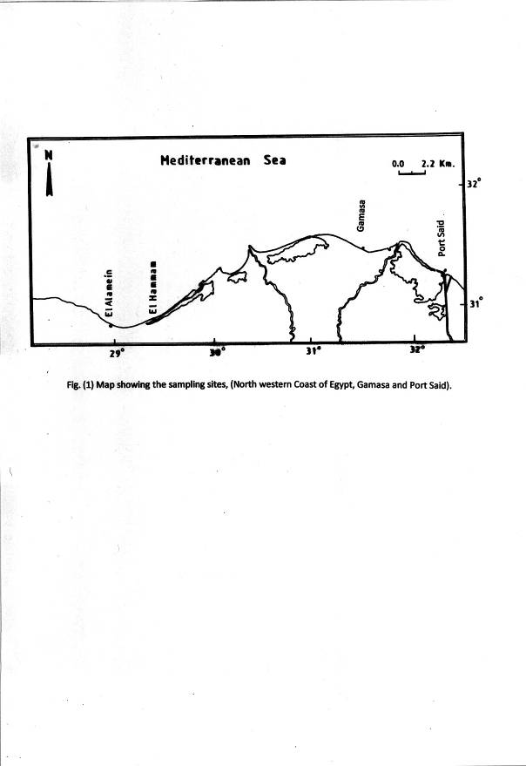

3. Results
In the present study, 18 species belonging to the subfamilies Exogoninae, Anoplosyllinae and Eusyllinae (Syllidae, Polychaeta) were recorded and identified from the Mediterranean Egyptian coasts, 8 of them considered new records for the Egyptian Mediterranean waters: Odontosyllis fulgurans (Audouin and Milne Edwards, 1833); Syllides japonicus Imajima, 1966; Salvatoria clavata (Claparede, 1863); Salvatoria euritmica (Sarda, 1984); Sphaerosyllis glandulata Perkins, 1981; Parapionosyllis labronica Cognetti, 1965; Sphaerosyllis sp.; and Prosphaerosyllis sp.; the two later are new species in process of description, although a description of both without any specific name is given by San Martín (2003). Five species were reported previously from different places of Egypt. In addition, four species are considered as a new records for the Mediterranean Sea (Palposyllis prosostoma Hartmann-Schröder, 1977; Paraehlersia weissmaniodes (Augener,1913); Streptosyllis compoyi Brito, Núñez and San Martín, 2000; and Exogone africana Hartmann-Schröder, 1974). Finally one species Parapionosyllis aegyptia is described as new species. The locations, dates , depth, number of specimens and geographical distribution are presented in Table (1).
The most important species will be described in details.

Table(1): Showing the Polychaete species recorded in the present study, Location, Date, Depth, Bottom, Number of specimens, and Distribution.
Name of the species | Location | Depth  (m) | Date | No. | Bottom | Distribution
**Palposyllis prosostoma Hartmann-Schröder, 1977 | Gamasa | 13.7 | Spring 2009 | 1 | S-M | At
**Paraehlersia weissmaniodes (Augener,1913) | Port Said | 0.25 | Spring 2008 | 3 | F | At
****Brevicirrosyllis weismanni Langerhans, 1879 | El Alamein | 20.0 | Autumn 2008 | 1 | C-S | At, Med
***Odontosyllis fulgurans (Audouin and Milne Edwards, 1833) | Port Said | 0.25 | Spring 2008 | 1 | F | Cos
**Streptosyllis compoyi Brito, Núñez and San Martín, 2000 | Elhammam | 20.0 | Autumn 2008 | 1 | C-S | At
***Syllides japonicus Imajima, 1966 | Elhammam | 20.0 | Spring 2009 | 2 | C-S | At, Med, P
***Salvatoria clavata ( Claparède, 1863). | Elhammam | 20.0 | Spring 2009 | 1 | C-S | Cos
***Salvatoria euritmica (Sardá, 1984) | Elhammam | 8.0 | Spring 2009 | 1 | C-S | At, Med, P
****Salvatoria vieitezi San Martín 1984 | El Alamein | 20.0 | Autumn 2008 | 2 | C-S | At, Med, P
***Sphaerosyllis glandulata Perkins, 1981 | Gamasa | 13.7 | Spring 2009 | 1 | S-M | At, Med
****Sphaerosyllis taylori Perkins, 1981 | Elhammam | 20.0 | Spring 2008 | 1 | C-S | At, Med
***Sphaerosyllis sp. | El Alamein | 20.0 | Autumn 2008 | 1 | C-S | At
***Prosphaerosyllis sp. | Elhammam | 8.0 | Spring 2009 | 1 | C-S | At
**Exogone africana Hartmann-Schröder,1974 | Port Said | 0.25 | Spring 2008 | 2 | F | At
*Parapionosyllis aegyptia n. sp. | El Alamein | 20.0 | Autumn 2008 | 2 | C-S | n. sp.
****Parapionosyllis brevicirra Day, 1954 | El Alamein | 20.0 | Autumn 2008 | 2 | C-S | At, Med
****Parapionosyllis elegans (Pierantoni, 1903) | El Alamein | 20.0 | Autumn 2008 | 2 | C-S | At, Med
***Parapionosyllis labronica Cognetti, 1965 | Gamasa | 13.7 | Spring 2009 | 1 | S-M | At, Med
At= Atlantic Ocean, P= Pacific Ocean, Med= Mediterranean, Cos= Cosmopolitan, S-M= Sandy
mud, C-S= Coarse Sand, F= Fouling
*= New species, **= New record for Mediterranean Sea, ***= New record for Egyptian waters, ****= Recorded before from Egyptian waters

Paraehlersia weissmaniodes (Augener, 1913)
(Fig. 2 A-J)

Ehlersia ferrugina non Langerhans. Böggemann & Westheide, 2004: 418, fig. 6. Paraehlersia weissmanioides San Martin & Paraehlersia weissmanioides San Martin & Hutchings, 2006: 312, figs. 43A-C, 47A-I, 48 A-F, 49 D-F.
Material examined. Port Said 0.25 m depth, Spring 2008, one specimen.
Description. Body broad anteriorly, tapered posteriorly, 11 mm long, 0.2 mm wide, with 41 chaetigers (fig. 2 A). Prostomium oval (75 μm), 4 eyes in trapezoidal arrangement, and 2 anterior eye-spots; lateral antenna 162.5 μm long, midian antenna 150 μm long. Palps broad (87.5 μm), basally fused. Dorsal tentacular cirri 147.5-162.5 μm long, ventral tentacular cirri about one third in length of dorsal tentacular cirri. Antennae, tentacular and anterior dorsal cirri; elongated, indistinctly articulated; articulation variable with short and long articles, up to 22 articles; dorsal cirri becoming progressively smoother posteriorly. Infracirral papillae not seen. Parapodia conical, slightly elongate. Ventral cirri digitiform, slightly longer than parapodial lobes. Parapodia with 12-15 falcigerous compound chaetae; blades strongly bidentate, with fine spines on margin (fig. 2 B), 2-3 distalmost ones longer than remaining (30-42.5 μm) (fig. 2 C). Most dorsal compound chaetae, spiniger-like, blades (75 μm long) on midbody, and about 93 μm on posterior parapodia with fine spines on margin (figs. 2 C, E), absent on most posterior parapodia; indistinctly bidentate. Compound falcigers becoming wider progressively along body, with stronger proximal tooth, slightly hooked (fig. 2G). Dorsal simple chaetae appear from chaetiger 19, truncate, bifid with short spines margin (fig. 2 F, H). Ventral simple chaetae on posterior parapodia, thick, with few long spines on margin, strongly bidentate, proximal tooth large, slightly hooked, and distal one shorter than proximal one (fig. 2 J).
Anterior parapodia with 2-3 slender aciculae, two of them distally rounded with small bending tip and one straight (fig. 2D); from proventricular segments onwards, acicula solitary, with oblique, short tip (fig. 2 I). Pharynx through 6 segments; pharyngeal tooth anteriorly located. Proventricle, rectangular through 4 segments with about 21 muscle cell rows.
Distribution: Australia, Seyhelles. New report for the Mediterranean Sea.
Remarks: The Egyptian specimen is similar to Australian ones; it is likely an Indo-Pacific migrant through Suez Canal.

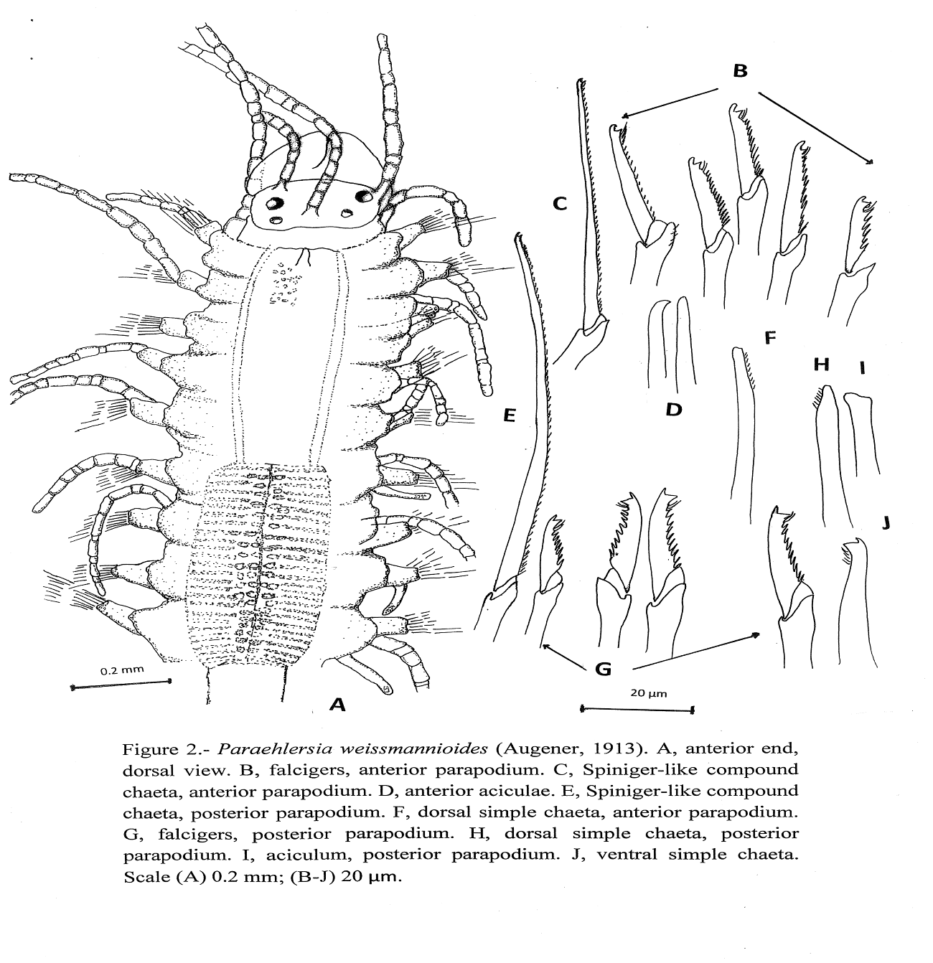

Exogone africana Hartmann- Schröder, 1974
(Fig. 3 A-I)

Exogone verugera africana Hartmann- Schröder,1974a:137, figs. 164-168; 1979; 108, figs.164-168.
Exogone africana San Martín, 2005: 143, fig. 90 a-f.
Material examined. Port Said, 0.25 m depth, on fouling, Spring 2008, 2 specimens.

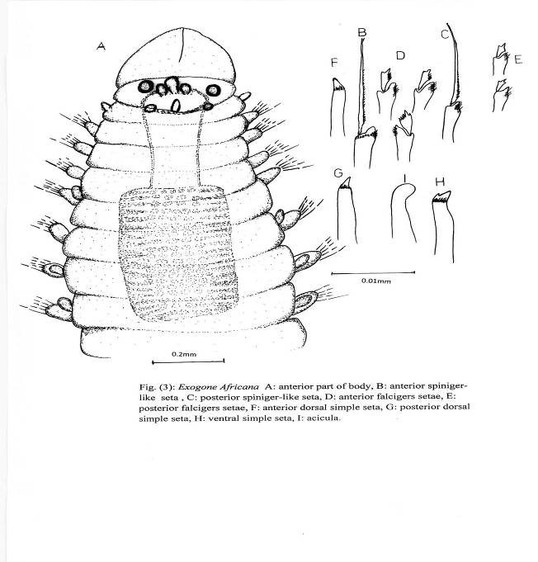

Description. Body small, slender, relatively broad anteriorly, 3 mm long, 0.23 mm wide, 28 chaetigers. Prostomium oval (fig.3 A); 4 eyes in trapezoidal arrangement. Antennae short, oval, close to each other, inserted between anterior to eyes; median antenna slightly longer and thicker than lateral one.
Palps broad, longer than prostomium, totally fused, with a dorsal furrow (fig. 3A).

Peristomium shorter than subsequent segments; one pair of small, papilliform tentacular cirri. Dorsal cirri similar to antennae and tentacular cirri, slightly longer than lateral antennae, present on all segments. Compound chaetae of two types on all parapodia: 1-2 spiniger-like, with long blades 31 µm long (fig. 3 B) on anterior parapodia, slightly short on posterior one (25-27.5 µm), distally bifid, with short marginal spines (fig. 3 C), and 4 compound chaetae with short falcigerous blades about 7.5 µm, bidentate, subdistal tooth long and distal tooth short, moderate marginal spines (fig. 3 D); posterior falcigers smaller, three in number, blades about 5µm long (fig. 3 E). Dorsal simple chaetae from anterior segments, with rounded tips (fig. 3 F), subdistally serrated, thicker posteriorly with pointed tip (fig. 3 G). Ventral simple chaetae on posterior parapodia, sigmoid, thick, with some short spines on base of teeth, bidentate, subdistal tooth longer and thicker than distal tooth (fig. 3 H). Acicula solitary, slender, distally rounded (fig. 3 I). Pharynx long, through 4 segments; pharayngeal tooth located on anterior rim. Proventricle occupying 4 segments with 18 muscle cell rows. Pygidium with 2 long anal cirri.
Distribution: Circumtropical. First report to the Mediterranean Sea.
Parapionosyllis aegyptia n. sp.
(Fig. 4 A-G)

Material examined. El Alamein 20 m depth, Autumn 2008. Holotype and Paratype, coarse sand.
Description. Holotype 3.5 mm, 0.15mm wide 29 chaetigers (fig. 4 A). Prostomium ovate, wider than long; 2 pairs of eyes, anterior pair larger than posterior ones, arranged in trapezoidal arrangement, and 2 small anterior eye-spots. Antennae spindle-shaped to bowling-pin shaped, longer than prostomium; median antenna (77.6 μm) slightly longer than lateral ones (67.5 μm), arising between anterior eyes; lateral antennae arising on anterior margin of prostomium (right one missing on holotype). Palps basally fused, shorter than prostomium. Peristomium with 2 pairs of bowling-pin shaped tentacular cirri, smaller than antennae. Parapodia somewhat elongated (32.5 μm). Dorsal cirri bowling-pin shaped, from 36- 45μm in length anteriorly to 65μm on posterior parapodia. Ventral cirri digitiform, shorter than parapodial lobes.
Anterior parapodia with 7 compound falcigers, unidentate with hooked tips and serrated margin (fig. 4 B); about 10 μm long; shafts becoming posteriorly thick with long curved acute tip, blades with serrated margin on 2 most dorsal ones, and 4-5 unidentate curved, smooth (fig. 4 D). Superior dorsal simple chaetae thin with pointed tip, present in all parapodia, except first one (fig. 4 C), become thicker

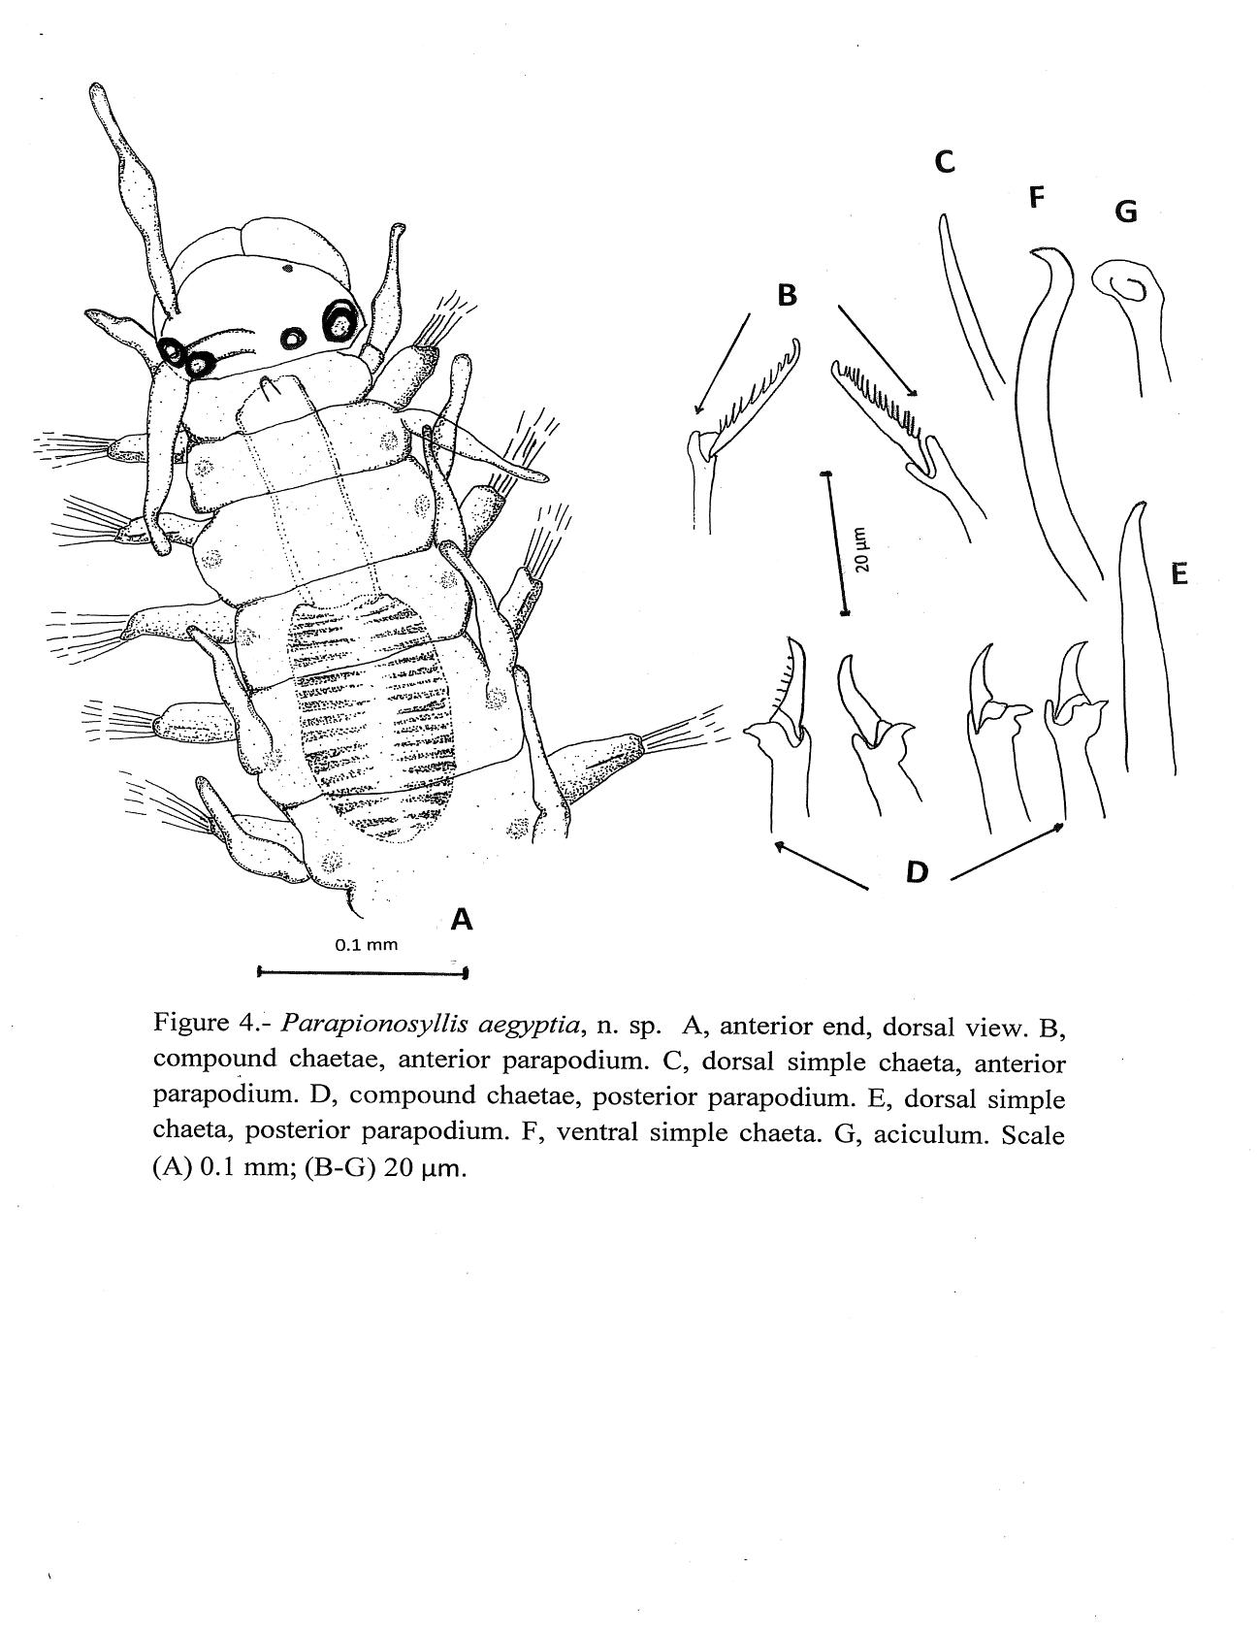
posteriorly (fig. 4 E). Ventral simple chaetae unidentate, sigmoid (fig. 4 F). Acicula solitary, bent with hollow rounded tip (fig. 4 G). Pharynx extending through 3.5 setigers; mid dorsal tooth on anterior edge. Proventricle extending through 2.5 segments, with 17 rows of muscle cells. Glands small, with granular material, pair on each segment, present from first chaetiger.
Remarks. About 16 species are recognized as Parapionosyllis, 6 of them recorded in the Mediterranean Sea. The most similar species is P. labronica also found in this collection; both species have posterior compound chaetae with thick shafts, distally curved, and short, unidentate blades, smooth or almost smooth. However, the anterior compound chaetae of Parapionosyllis aegyptia are more elongated and provided with somewhat longer spines on margin, and the dorsal simple chaetae are different, being smooth and unidentate in P. aegyptia and provided with a sub-distal, thick spine and others shorter, in P. labronica. The remaining Mediterranean species are clearly different of these two species, because they have longer compound chaetae (see San Martín, 2003); also, other species of other seas also have more elongated compound and different dorsal simple chaeta.

Etymology. The species is named after the country in which has been found, Egypt.

4. Discussion
The number of Syllids recorded on Egyptian waters reach about 60 species, a low number when compared with the 190 Syllid species were reported by Musco and Giangrande (2005) from the whole Mediterranean waters, which represents the 31.6 % of the total Mediterranean Syllidae. Also, many other species may possibly remain unreported because of the most coastal area of Egypt are unexplored and many studies are still needed.
Tovar- Hernández et al. (2002) referred to the dominance and diversity of syllid members in carbonate sediments, this observation was confirmed by Selim (2008), where El Hammam and El Alamein coasts contain carbonate bottom sediments.
Most of the studied species are well known, common and widely reported for Mediterranean and Atlantic Ocean. The analysis of samples resulted into 18 species,11 of them new record for the Egyptian Mediterranean waters. Four species were reported previously, (Brevicirrosyllis weismanni Langerhans, 1879; Parapionosyllis elegans (Pierantoni, 1903); P.brevicirra Day, 1954 and Sphaerosyllis taylori Perkins, 1981, from many Mediterranean coastal areas and one more (Salvatoria vieitezi San Martín 1984) from the Suez Canal. Two of the studied syllids are considered apparently cosmopolitan: Salvatoria clavata, and Odontosyllis fulgurans. In addition, 11 species were known before from Spainish coasts, only 4 species were previously recorded in Greece, 9 from North West Italian, 9 from Turkish Aegean and 6 from Cyprus. Also four species are considered as a new record for Mediterranean Sea: Palposyllis prosostoma Hartmann-Schröder, 1977; Paraehlersia weissmaniodes (Augener, 1913); Streptosyllis compoyi Brito, Núñez and San Martín, 2000; and Exogone africana Hartmann-Schröder, 1974.
According to geographic distribution through literature there are 9 species belong to Atlantic-Mediterranean category and one species (Salvatoria vieitezi) was recorded before from Suez Canal (Selim, 2009), and four species are new for Mediterranean, that means they are Lessepsian migrants; 3species are amphi-Atlantic, Sphaerosyllis taylori, Shphaerosyllis glandulata and Salvatoria vieitezi. Two species are considered cosmopolitan species, Odontosyllis fulgurans and Salvatoria clavata and five species are considered Atlantic-Pacific categories.
In spite of it, many new recorded species usually discovered by way in new researches, still more not recorded until now, more studies requisite to be done along the Mediterranean and Red Sea coasts of Egypt to cover this point.
The present study showed richness of Eusyllinae, Anoplosyllinae and Exogoninae species inhabiting Egyptian water benthic assemblage.

Corresponding author
F. A. Abd-Elnaby
National Institute of Oceanography and Fisheries, Alexandria, Egypt
*faiza_abdelnaby@yahoo.com

5. References:
- Abd-Elnaby, F. A. 1999. Composition and Distribution of Some Bottom Fauna Associations Along the Alexandria Coast, Mediterranean Sea. M.Sc. Thesis, Faculty of Science, Alex. Univ. 272pp.
- Abd- Elnaby, F. A. 2005. Systematic and Environmental Studies on Polychaetes from Alexandria Marine Water. Ph. D. Thesis, Suez Canal University. pp: 330.
- Abd-Elnaby, F. A. 2009. Polychaete Study in Northeastern Mediterranean Coast of Egypt. World Journal of Fish and Marine Sciences. 1 (2): 85-93.
- Aguado, M. T. and San Martín, G. 2007. Syllidae (Polychaeta) from Lebanon with Two New Reports from the Mediterranean Sea. Cahiers de Biologie Marine. 48: 207-224.
- Aguado, M. T. and San Martín, G. 2009. Phylogeny of Syllidae (Annelida, Phyllodocida) Based on Morphological Data. Zoologica Scripta. 38 (4): 379-402.
- Ben-Eliahu, M. N. 1972. Litoral Polychaeta from Cyprus. Tethys. 4: 85-94.
- Ben-Eliahu, M. N. 1977a. Polychaete Cryptofauna from Rims of Similar Intertidal Vermetid Reefs on the Mediterranean Coast of Israel and in the Gulf of Elat: Syllinae and Eusyllinae (Polychaeta: Errantia: Syllidae). Israel Journal of Zoology. 26: 1-58.
- Ben-Eliahu, M. N. 1977b. Polychaete Cryptofauna from Rims of Similar Intertidal Vermetid Reefs on the Mediterranean Coast of Israel and in the Gulf of Elat: Exogoninae and Autolytinae (Polychaeta: Errantia: Syllidae). Israel Journal of Zoology. 26:59-99.
- Brito, M. C., Núñez, J. and San Martín, G. 2000. The Genus Streptosyllis Webster and Benedict, 1884 (Polychaeta: Syllidae Eusyllinae) from Canary Islands, with the Description of a New Species Bulletin of Marine Science. 67(1): 603-615.
- Böggemann, M. and Westheide, W. 2004. Interstitial Syllidae (Annelida: Polychaeta) from Mahé (Seychelles). Journal of Natural History. 38: 403-446.
- Çinar, M. E. 2003a. Ecology of Syllidae (Annelida: Polychaeta) from Northern Cyprus (Eastern Mediterranean Sea). Bulletin of Marine Science. 72: 795-811.
- Çinar, M. E. 2003b. Ecological Features of Syllidae (Polychaeta) from Shallow-Water Benthic Environments of the Aegean Sea, Eastern Mediterranean. Journal of Marine Biological Association of United Kingdom. 83: 737-745.
- Çinar, M. E. 2005. Syllis ergeni: a New Species of Syllidae (Annelida: Polychaeta) from Izmir Bay (Aegean Sea, Eastern Mediterranean Sea). Zootaxa. 1036: 43-54.
- Çinar, M. E. & Ergen, Z. 2002. Faunistic Analysis of Syllidae (Annelida: Polychaeta) from the Aegean Sea. Cahiers de Biologie Marine. 43: 171-178.
- Çinar, M. E., Ergen, Z. 2003. Eusyllinae and Syllinae (Annelida:Polychaeta) from Northern Cyprus (Eastern Mediterranean Sea) with a Checklist of Species Reported from the Levant Sea. Bulletin of Marine Science. 72: 769-793.
- Çinar, M. E., Ergen, Z. and Benli, H.A. 2003. Autolytinae and Exogoninae (Polychaeta: Syllidae) from Northern Cyprus (Eastern Mediterranean Sea with a Checklist of Species Reported from the Levant Sea. Bulletin of Marine Science. 72: 741-767.
- Ergen, Z. 1976. Taxonomy and Ecology of Polychaeta in Izmir Bay and Its Vicinity. Scientific Rapport Series of the Faculty of Science, Ege University. 209: 1-73.
- Fauvel, P. 1927. Rapport sur les Annélides Polychètes Errantes, Cam,bridge Expedition to the Suez Canal, 1924. Transations of the Zoological Society of London. 22 : 411-440.
- Fauvel, P. 1937. Les fonds de peche pres d’Alexandrie, XI. Annelides polychetes. Notes Mem. Fish. Res. Dir., Cairo. 19: 1-60.
- Fauvel, P. 1955. Contribution a la Faune des Annélides Polychètes des côtes d’Israel. Bulletin of the Sea Fisheries Research of the Station of Haifa. 10: 3-12.
- Fauvel, P. 1957. Contribution a la Faune des Annélides Polychètes des côtes d’Israel. II. Bulletin of the Research Council of Israel. 6: 213-219.
- Glasby, C. 2000. Family Syllidae. p. 161-167, in Polychaetes and Allies: The southern Synthesis. Fauna of Australia. Vol. 4a Polychaeta, Myzostomida, Pogonophora, Echiura, Spuncula, ed. P. L. Beesley. G. J. B. Ross and C. J. Glassby Melbourne. CSIRO publishing. 465pp.
- Hartmann-Schröder, G. 1974. Zur Kenntnis des Eulitorals der Afrikanischen West-Kuste zwischen Angola und Kap der Gutten Hoffnung und der Afrikanischen Ost-Kuste von Sudafrika und Mocambique unter Bessonderer Berucksichtigung der Polychaeten und Ostracoden. Mitteilungen aus dem Hamburgischen Zoologischen Museum und Institut. 69: 95-228.
- Hartmann-Schröder, G. 1977. Teil 2. Die Polychaeten der Tropischen Nordwestküste Australiens (Zwischen Port Samson in Norden und Port Hedland in Süden) Mitteilungen aus dem Hamburgischen Zoologischen Museum und Institut. 76: 75-218.
- Martín, D. and Britayev, T. 1998. Symbiotic polychaetes: Review of Known Species. Oceanography and Marine Biology: An Annual Review. 36: 217-340.
- Musco, L. and Giangrande, A. 2005. " Mediterrnean Syllidae (Annelida Polychaeta) Revisited: Biogeography, Diversity and Species Fidelity to Environmental Features", Marine Ecology Progress Series. 304: 143-153.
- Musco, L., Çinar, M.E. & Giangrande, A. 2005b. A new Species of
- Sphaerosyllis (Polychaeta, Syllidae, Exogoninae) from the Coasts of Italy and Cyprus (Eastern Mediterranean Sea). Italian Journal of Zoology. 72: 161-166.
- Rouse, G. W. and Pleijel, F. 2001. " Polychaetes" . Oxford University. Press, New York. 1-354.
- San Martín, G. and Hutchings, P. 2006. Eusyllinae (Polychaeta, Syllidae) from Australia with the Description of a New Genus and Fifteen New Species. Records of the Australian Museum, 58: 257-370.
- San Martín, G. 2003. Annelida, polychaeta II: Syllidae. In Ramos M. A., Alba J., Bellés Y.; Gosálbez J.; Guerra A.; Macpherson E.; Martin F.; Jerrano J. and Templado J. (eds) Fauna Ibérica. Museo Nacional de Ciencias Naturales, CSIC, Madrid. 21: 1-554.
- San Martín, G. 2005. Exogoninae (polychaeta: Syllidae) from Australia with the Description of a New Genus and Twenty- Two New Species. Recods of the Australian Museum. 57: 39-152.
- Selim, S. A. H. 1978. Systematic and Distributional Studies of Polychaetes in the Eastern Harbour, Alexandria. M. Sc. Thesis, Faculty of Science, Alexandria University, Egypt, 402pp.
- Selim, S. A. H. 1996. On Some Syllid polychaetes from Alexandria waters, Egypt. J. Egypt Ger. Soc. Zool. 21 (D): 51-73.
- Selim, S. A. 2008a. Eusyllinae and Exogoninae (Polychaeta: Syllidae). New Records from the Egyptian Mediterranean Coastal Waters. Egyptian Journal of Aquatic Research. 34(3) : 160-180.
- Selim, S. A. 2008b. New records of Sabellid Species (Polychaeta: Sabellinae) from the Coastal Egyptian Waters. Egyptian Journal of Aquatic Research. 34 (1): 108-125.
- Selim, S. A. 2009. Polychaete Fauna of the Northern Part of the Suez Canal (Port-Said-Toussoum). Egyptian Journal Aquatic Research. 35 (1): 69-88.
- Simboura, N. & Nicolaidou, A. 2001. The Polychaetes (Annelida, Polychaeta) of Greece: Checklist, Distribution and Ecological Characteristics. Monographs on Marine Science nº4, Marine Centre for Marine Research: Athens. 115 pp.
- Tovar- Hernández, M. A., Granados- Barbara, A. and Solis- Weiss, V. 2002. Typosyllis papillosus, a New Species (Annelida: Polychaeta: Syllidae) from the Southwest Gulf of Mexico", Proceedings of the Biological Society of Washington. 115 (4): 760- 768.

9/25/2010

