Effect of Palatal Surface Contouring Techniques on the Swallowing Function of Complete Denture Wearers.

Tamer Abou-Elsaad ¹, Ahmad Habib², Mohamed Elkhodary ², and Abd-Allah Salem²
¹Phoniatric Unit, ORL Department, Faculty of Medicine, Mansoura University, University, Mansoura, Egypt.
² Mansoura, Egypt Department of Removable Prosthodontics, Faculty of Dentistry, Mansoura

Abstract: This study is aimed to investigate the effect of two different surface palatal contouring techniques; namely arbitrary versus functional on swallowing activity of maxillary complete denture wearers. Ten completely edentulous healthy male patients with their ages ranged between 46-65 years were selected for this study according to definite inclusion-exclusion criteria. The swallowing function was evaluated pre- and postdenture state by using Videofluoroscopy. The patient was asked to swallow different bolus consistencies (thin and thick liquids, semisolid and solid) in small and large volumes. The swallowing measures selected for this study were: (1) Temporal measures of bolus and hyoid movements during swallowing; (2) Oropharyngeal residue; (3) Laryngeal penetration/aspiration observation and (4) Oropharyngeal Swallow Efficiency score. The results revealed a statistically significant increase in temporal measures of swallowing after denture insertion compared to predenture state regardless the palatal surface contouring technique. Functional contouring of maxillary denture palatal surface demonstrated a statistically significant general decrease in durations of bolus and hyoid movements (except at duration of hyoid maximum elevation) during swallowing, and led to a more efficient swallowing compared to dentures with arbitrary contoured palate. It can be concluded that the difficulty of swallowing with an artificial prosthesis should be addressed before the patient first makes use of the denture to eat and drink. Functional contouring of the palatal polished surface is recommended for completely edentulous patients. A further research may be useful to study the effect of functionally contoured palate in completely edentulous patients with oro-pharyngeal dysphagia due to neurological etiologies.
[Tamer Abou-Elsaad, Ahmad Habib, Mohamed Elkhodary, Abd-Allah Salem. Effect of palatal surface contouring techniques on the swallowing function of complete denture wearers. Life Science Journal 2010;7(4):114-118]. (ISSN: 1097-8135).

Keywords: surface palatal; arbitrary; maxillary; edentulous healthy; patient; dysphagia; etiology

1. Introduction:
Intra-oral presence of newly constructed denture may be associated with some initial difficulties in speech, mastication and swallowing. (Roessler, 2003). Contouring the facial, lingual, and palatal polished surfaces have been comparatively ignored during construction of conventional denture. These surfaces are usually carved into an “ideal” form without sufficient consideration for the position and function of cheeks, tongue, and lips which are always in contact with dentures. The arbitrary shaping of the polished surfaces may have an adverse effect on the success of the prosthesis. These prostheses are frequently in disharmony with the patient’s anatomy and physiology of mandibular motion, resulting in impaired comfort and function (Jacob, 1998). The functionally constructed dentures are more comfortable and stable than conventionally constructed dentures (Lott and Levin, 1966). However, the precise effect of functional contouring of denture polished surfaces on the swallowing activity of completely edentulous patient was not clearly investigated. This prospective study was aimed to investigate the effect of different palatal contouring techniques of maxillary complete denture; namely arbitrary (conventional) versus functional palatal contouring on swallowing activity of complete denture wearers.

2. Subjects and Methods:
Ten completely edentulous healthy male patients were selected for this study with their ages ranged between 46-65 years (mean= 56 years) from Prosthodontic Department, Faculty of Dentistry, Mansoura University. All patients were completely edentulous for at least 6 months with no previous denture experience. The patients were selected free from any medical or surgical history of swallowing problem. All patients were of Angel’s class I maxillomandibular relation with available inter-arch space. The residual alveolar ridges were free from severe undercuts.

I - Prosthetic Procedures:
For each patient, the following procedures were done:
- After maxillary and mandibular final impression, the maxillary master cast was duplicated for each subject. A tentative maxillary and mandibular record blocks were constructed, and adjusted for contour, height and orientation respectively. The maxillary master cast was mounted on the articulator by using maxillary facebow.
- Vertical and horizontal relation was recorded by using a standard method based on the physiologic technique developed by shanahan (1955) (fig. 1). Then the mandibular master cast was mounted on the articulator.
- After arrangement of acrylic resin artificial teeth, waxing up was done according to Renner and Blakeslee (1978). According to the palatal polished surface contour; the dentures were grouped as follow:
  - Arbitrary dentures: where the palatal polished surface was arbitrary
  - contoured. The trial dentures were processed into heat cured acrylic resin,
  - finished and polished. Swallowing function was evaluated before and after two weeks of denture insertion (accommodation period).
  - Functional dentures: After 2 weeks of rest interval (without denture), the arbitrary contoured palatal polished surface was replaced by functionally contoured one constructed by swallowing technique using soft wax according to Lott and Levin (1966) and Shaffer and Kutz (1972) (fig. 2 and fig 3).
The waxed functional contoured palatal polished surface was then converted into auto-polymerized acrylic resin. Swallowing evaluation was then done after 2 weeks of denture insertion.

Iii- Swallowing Evaluation:
Evaluation of each patient’s swallow was done in three states; predenture state, arbitrary (conventional) denture state, and functional denture state. All patients were evaluated through a specially designed diagnostic protocol (Abou-Elsaad and Kotby, 2003). The protocol included: patient’s interview, clinical examination, and videofluoroscopic evaluation of oro-pharyngeal swallowing. Each subject was asked to swallow three swallows of each of the following (Abou-Elsaad, 2003): (a) 3 and 10 ml thin liquid barium (20% barium sulfate [Prontobario H.D.®] and 80% water ); (b) 3 and 10 ml thick liquid barium (50 % barium and 50% water); (c) 3 and 10 ml semisolid (pudding mixed with barium powder) and (d) ¼ of cookie (coated with pudding + barium powder). The patient was asked to hold the bolus in his mouth and then swallow the whole bolus once only. For cookie swallow the patient was asked to chew and swallow once ready. The videofluoroscopic images were then transferred to the computer by using a TV card (Life-View model) for later analysis. The images were analyzed using EO software program (Version 1.36, 2003) which place numbers (to the hundredth of a second) consecutively on each video frame for subsequent frame-by-frame analysis. The following temporal measures of swallowing events were recorded in accordance with bolus and hyoid movements:

A- Temporal measures of the bolus movement during swallowing:
(1) Oral transit duration (OTD):
From the initiation of posterior bolus movement to arrival of the bolus head at the ramus of the mandible (fig 4).
(2) Oral clearance duration (OCD):
From initiation of posterior bolus movement to arrival of bolus tail at ramus of mandible.
(3) Pharyngeal transit duration (PTD):
From arrival of bolus head at ramus of the mandible to bolus head enter upper esophageal sphincter (UES).
(4) Pharyngeal clearance duration (PCD):
From arrival of bolus head at ramus of the mandible to bolus tail through UES.
(5) Total swallow duration (TSD):
By summing both oral transit and pharyngeal clearance durations.
(6) Masticatory duration (MD):
From once the patient masticate the bolus to beginning of posterior movement of the bolus.

B- Temporal measures of hyoid movement during swallowing:
(1) Pharyngeal response duration (PRD):
From beginning of maximum hyoid movement to hyoid return to rest.
(2) Duration of hyoid maximum elevation (DOHME):
From first frame showing maximum hyoid elevation to last frame showing maximum hyoid elevation (Fig. 5).
(3) Duration of hyoid maximum anterior excursion (DOHMAE):
From first frame showing maximum anterior hyoid movement to last frame showing maximum anterior hyoid movement (Fig. 6).
Three additional measurements were determined:
(1) Oro-pharyngeal residue:
A three-point scale (0= no residue, 1= coating, 2= pooling) was used to assess the amount of residue in the oropharynx.
(2) Penetration/aspiration observation:
Penetration means the bolus enters the airway down to the level of the vocal folds (Fig. 7). Aspiration means the bolus enters the airway below the level of the vocal folds.
(3) Oro-pharyngeal Swallow Efficiency (OPSE) score (Rademaker et al., 1994):
Percent bolus swallowed (minus % oropharyngeal residue + % amount aspirated) on the first swallow attempt on a bolus divided by TSD. Normal OPSE score is 50 or better (100 % swallowed in 2 seconds or less).
Frequency, mean and standard deviation were used to describe data. To test for significance of change, the non-parametric Wilcoxon signed rank test was used to compare quantitative data in the same group. While the non-parametric McNemar test of change was used to compare qualitative data in the same group. P value was considered significant if less than 0.05.

3. Results:
I- Comparisons among pre-denture, arbitrary and functional contoured dentures in temporal measures of bolus and hyoid movements during swallowing: (tables 1, 2, 3, 4) Statistically significant decreases were detected in all temporal measures of bolus and hyoid movements during swallowing in predenture state when compared to arbitrary denture with different bolus consistencies and volumes (p < 0.05). Similarly, statistically significant decreases were detected in all temporal measures of bolus and hyoid movements during swallowing in pre-denture state when compared to functional denture (p < 0.05) except in pharyngeal response duration at large volume thick liquid, semisolid and solid bolus consistencies where there were statistically non-significant differences detected ( p > 0.05). Statistically significant decreases were detected in all temporal measures of bolus and hyoid movements during swallowing in functional denture when compared to arbitrary denture dentures with different bolus consistencies and volumes (p < 0.05) except at duration of hyoid maximum elevation where statistically significant differences could not be detected in any bolus consistency and volume ( p > 0.05).
II- Comparisons among pre-denture, arbitrary and functional contoured dentures in Oro-pharyngeal residue:
There were statistically non-significant differences in oropharyngeal residue between pre-denture state and after dentures insertions and also between arbitrary and functional dentures with different bolus consistencies and volumes (p > 0.05).
III- Comparisons among pre-denture, arbitrary and functional contoured dentures in penetration / aspiration observation: (table 5). There were statistically significant laryngeal penetrations in large volume thin and thick liquid bolus consistencies in pre-denture state when compared with both arbitrary and functional dentures (p < 0.05). On the other hand, no penetration/aspiration was observed in both arbitrary and functional dentures with different bolus consistencies and volumes.
IV- Comparisons among pre-denture, arbitrary and functional contoured dentures in Oro-pharyngeal Swallow Efficiency (OPSE) score: (table 6) There were statistically significant higher OPSE scores in predenture state when compared to both arbitrary and functional dentures (p < 0.05), and in functional denture when compared to arbitrary one (p < 0.05) with different bolus consistencies and volumes.

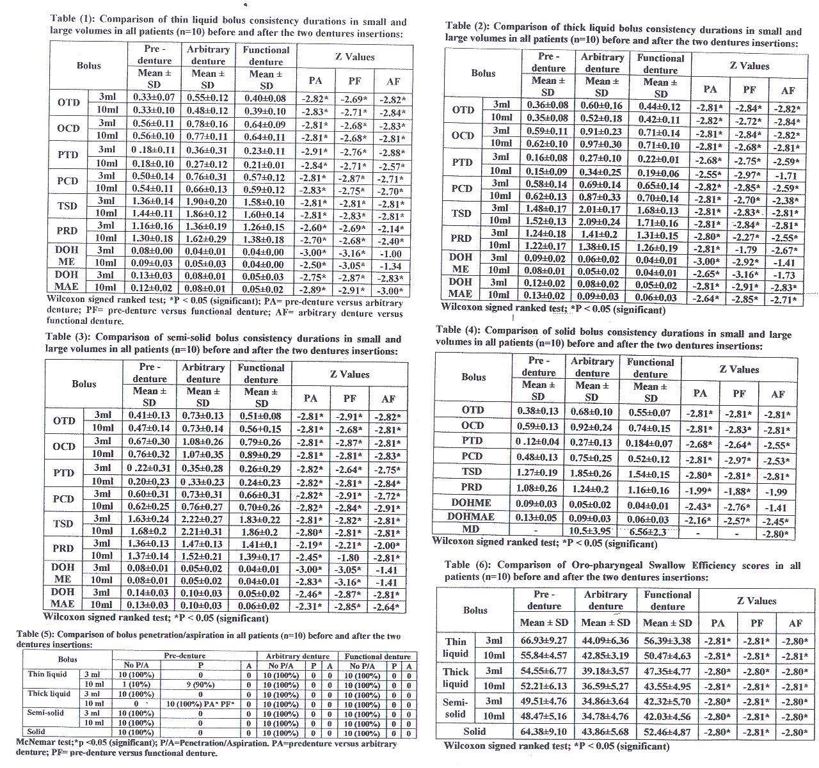

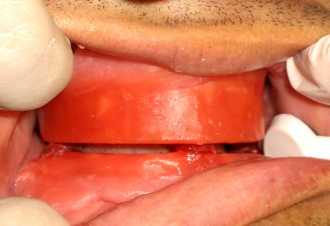  Fig. (1): Three cones of soft wax were placed over lower wax occlusal rim. The height of soft wax cones was reduced by asking the patient to swallow his saliva repeatedly. | 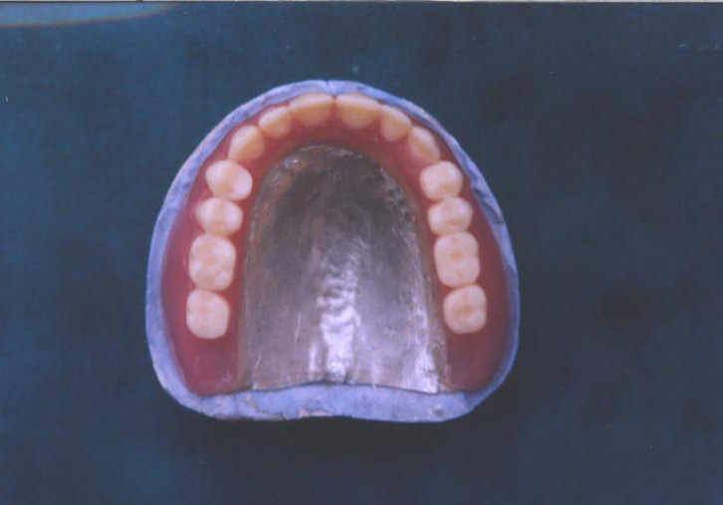  Fig. (2): Tinfoil was adapted on the palatal surface of the duplicate maxillary master cast and sealed to the denture palatal edges | 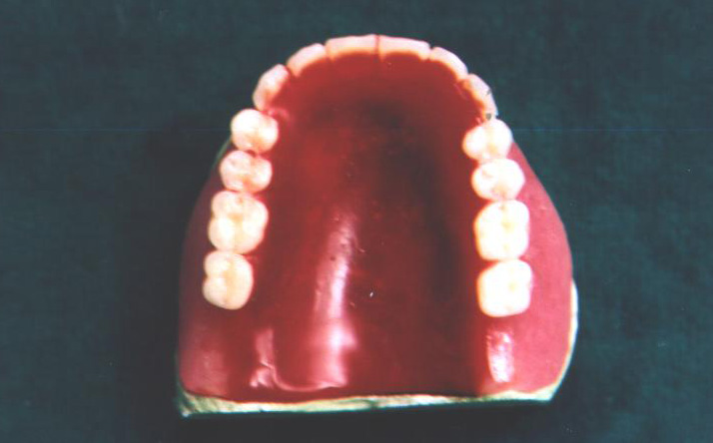  Fig. (3): Waxed palate after functional contouring by the swallowing technique.
Fig. (4): Head of the bolus reach the angle of the mandible. | Fig. (5): Maximum hyoid elevation. | Fig. (6): Maximum anterior hyoid excursion.
Fig. (7): Laryngeal penetration

4. Discussion:
The palatal mucosa together with the tongue area plays an important role in recognition of food (Oomi, 1959). Covering of the hard palatal mucosa by the maxillary complete denture might influence the movement of bolus from the oral cavity to the pharynx. Similarly, alteration in mandibular position by the presence of the denture can influence the tongue function (Lowe et al., 1977). Hence, the propulsive force for bolus transport is changed with oral denture. This could explain the prolonged oral and pharyngeal temporal measures (OTD, OCD, PTD and PCD) with different bolus consistencies and volumes after the two dentures insertions in relation to pre-denture state. This is in agreement with Kodaira et al., (2006) findings who observed a generalized prolongation of oral propulsion time when the palatal mucosa is covered. On the other hand, the oral and pharyngeal temporal measures (OTD, OCD, PTD, PCD and PRD) were decreased in case of functional denture when compared to arbitrary denture with different bolus consistencies and volumes. This could be explained that the technique of construction of the palatal polished surface in functional denture is based on tongue movement. Hence, the tongue has a more freedom to perform the kinetic function. Alternatively, construction of the arbitrary denture is based on the configuration of the hard palate with no respect to the tongue movement. Thus, arbitrary denture may decrease the tongue motor skills that might influence the lingual forces necessary for bolus formation and transport. This is in agreement with the study conducted by Koshino et al. (1997) who found that arbitrary denture decreases the motor skills of the tongue. They also found that the masticatory performance was highly correlated to tongue motor skills. This could explain the shorter masticatory duration in case of functional denture in our study when compared to arbitrary denture.
Normally, the start of the pharyngeal response is related to the onset of hyoid movement (Logemann, 1983). As stated before, the presence of complete denture influences the tongue movement, which is one component of the functional chain of the vocal tract that consists of tongue and hyoid bone (Kotby and Haugen, 1970). This could explain the delay in the onset of the hyoid movement by the presence of complete denture. The UES and the hyoid bone are anatomically and mechanically related to each other (Jacob et al., 1989). Thus, the delay in the onset of the hyoid bone may cause a delay in relaxation and opening of UES, thus delaying the bolus transport from the pharynx to the esophagus. This could explain the prolonged PRD after arbitrary denture insertion when compared to pre-denture state with different bolus consistencies and volumes. On the other hand, the increase in volume and consistency of the bolus, increase tongue forces and hence, leading to an increase in the velocity of bolus transport from the pharynx to the esophagus (Dantas et al., 1990).This may compensate the prolonged effect of complete denture insertion on PRD in functional denture and explaining the non significant differences between it and the pre-denture state in PRD at large volumes thick liquid, semisolid, and solid consistencies.
During edentulate swallowing the tongue is jammed between the alveolar ridges (Hattori, 2004). This might make the tongue to travel a longer distance, hence longer duration for the hyoid movement in edentulate swallowing than swallowing with denture. This could explain the shorter DOHME and DOHMAE with different bolus consistencies and volumes after denture insertions in relation to pre-denture state.
Similarly, the DOHMAE was decreased in case of functional denture when compared to arbitrary one. This may be due to the more natural tongue movement at the swallow onset after functional denture. On the other hand, the DOHME showed no significant differences between arbitrary and functional dentures. This may be due to hyoid maximum elevation may be more related to occlusal vertical dimension which is maintained after denture insertion rather than change in the tongue movement during swallowing. This is in agreement with Hattori (2004) who reported that differences of occlusal vertical dimension had strong relevance to displacement of hyoid bone without denture compared with denture. Clearance of the oro-pharyngeal residue depends partly on the continued contact between the dorsum of the tongue and the hard palate during oral stage of swallowing and between the tongue base and the posterior pharyngeal wall during pharyngeal phase of swallowing (Logemann, 1983) which were not affected by the presence of maxillary complete denture in this study. This could explain the non significant differences in oro-pharyngeal residue between pre-denture state and after denture insertion and between the two types of dentures with different bolus consistencies and volumes. These findings are in agreement with Yoshikawa et al.'s, (2006) study who found no significant differences between pre-denture state and after denture insertion in the oropharyngeal residue. Laryngeal penetrations were consistent with large volume thin and thick liquid boluses and was absent at small volume liquid boluses in predenture state. This may be due to deterioration of coordinated swallowing movements; as elevation of the hyoid bone, that resulted from the loss of occlusal support in the pre-denture state. Further more, the large volume bolus requires an increase of the magnitude of structure movement, which if deteriorated may reveal abnormality of function (Dantas et al., 1990). These findings support those of Yoshikawa’s et al (2006) study who found a significant laryngeal penetration with large volume liquid bolus in edentulous subjects. In this study, semisolid and solid boluses did not show any laryngeal penetration due to their cohesive nature; hence a less risk than liquid boluses to flow into the air way.
5. Conclusions:
Insertion of denture using different palatal contouring techniques demonstrated a general increase in durations of bolus movement and lower OPSE scores compared to the pre-denture state during swallowing of different bolus consistencies and volumes. This could account for the common clinical observation of the difficulty of swallowing after insertion of a new denture without any previous experience. On the other hand, functional denture demonstrated a general decrease in durations of bolus movement and higher OPSE scores compared to the arbitrary denture during swallowing of different bolus consistencies and volumes. This may be attributed to the physiologic nature of the technique, which produces palatal part more compatible with the tongue musculature, and neuromuscular memory of the patient.

Recommendations:
Functional contouring of the palatal polished surface is recommended for completely edentulous patients. However, the difficulty of swallowing with an artificial prosthesis should be addressed before the patient first makes use of the denture to eat and drink. A further research may be useful to study the effect of functionally contoured palate in completely edentulous patients with oro-pharyngeal dysphagia due to neurological etiologies.

References:
- Abou-Elsaad T (2003): Effect of diet variables on the biomechanical measures of swallowing in stroke patients. International congress series journal, vol. 1240c: 683-688.
- Abou-Elsaad T and Kotby MN (2003): Efficacy of behavior readjustment therapy for orop-haryngeal dysphagia. International congress series Journal, 1240C: 669-675.
- Dantas R, Kern M, Massey B, Dodds W, Karilas P, Brasseur J, Cook I, and Lang I. (1990): Effect of swallowed bolus variables on oral and pharyngeal phase of swallowing. Am J Physiol. 258: G675-G681.
- Hattori F (2004): The relationship between wearing dentures and swallowing function in elderly: videofluoroscopic study. Kokubyo Gakkai Zasshi, 4(1): 102-111.
- Jacob RF. (1998): The traditional therapeutic paradigm: Complete denture therapy. J. Prosthet. Dent., 79:6-13.
- Jacob P, Kahrilas P, Logemann J, Shah V, and Ha T (1989): Upper esophageal sphincter opening and modulation during swallowing. Gastroenterology, 97:1469-1478.
- Kodaira Y, Ishizaki K, Sakurai K (2006): Effect of palate covering on bolus propulsion time and its contributing factors. J Oral Rehabilit, 33(1): 8-16.
- Kotby MN, Haugen LK (1970): The mechanics of laryngeal function. Acta Otolaryngologica (Stockholm), 70: 203-211.
- Koshino H, Hirai T, Ishijima T, Ikeda Y (1997): Tongue motor skills and masticatory performance in adult dentates, elderly dentates, and complete denture wearers. J. Prosthet. Dent., 77(2): 147-152.
- Logemann J. (1983): Anatomy and physiology of normal deglutition in: Evaluation and treatment of swallowing disorder. Edited by J. Logemann. San Diego, College Hill Press. P 9-36.
- Lott F and Levin B (1966): Flange technique anatomic and physiologic approach to increase retention, function, comfort, and appearance of dentures. J. prosth. Dent., 16:394-413.
- Lowe AA, Gurza SC, Sessle BJ (1977): Regulation of genioglossus and masseter muscle activity in man. Arch. Oral Biol., 22: 579-584.
- Oomi M (1959): Studies on the distribution of sensory spot in the oral cavity. Shikwa Gakuho., 59: 843-853.
- Rademaker AW, Pauloski BR, Logemann JA, Shanahan TK (1994): Oropharyngeal swallowing efficiency as a representative measure of swallowing function. J. Speech Hear Res. 37:314-325.
- Renner RP and Blakeslee RW (1978): Basic wax contouring for complete dentures. J.prosth. Dent., 40: 343-348.
- Roessler MD (2003): Complete denture success for patients and dentists. Int. D. J., 53(5 suppl.): 340-345.
- Shaffer FW and Kutz RA (1972): phonetic and swallowing to determine palatal contours of dentures. J. prosth Dent., 28: 360.
- Shanahan TEJ (1955): Physiologic jaw relations and occlusion of complete dentures. J. Prosthet. Dent., 5:319-324.
- Yoshikawa M, Yoshida M, Nagazaki T, Tanimoto K, Tsuga K, Akagawa Y (2006): Influence of aging and denture use on liquid swallowing in healthy dentulous and edentulous older people (clinical investigation). J. Am. Geriatr. Soc., 54(3):444-449.

9/23/2010

