Influence of resin-tags on shear-bond strength of butanol-based adhesives

M. Atef¹, H. Ragab¹, and W. El-Badrawy²
¹Misr University for Science and Technology, Cairo, Egypt, ²University of Toronto, Toronto, ON, Canada
mohatef16@hotmail.com

Abstract: Objectives: The aim of this in vitro study was to assess micro-shear bond strength (µSBS) of tertiary-butanol-based adhesive under moist and dry conditions and correlate the results to resin-tags surface-area. Methods: Thirty-extracted human molars were used. Flat dentin surfaces were prepared on buccal and occlusal surfaces ready for bonding. Specimens were randomly divided into three-groups; G1: Prime&BondNT, applied to moist dentin (control), G2: XPBond, applied to moist dentin, and G3: XPBond, applied to dry dentin. Etch&Rinse technique was used for both adhesives as per manufacturer's instructions. For G3, dentin was air-dried for 10s before XPBond application. Three-microcylinders of composite-resin (TPH A2 shade, Dentsply) were bonded to buccal dentin of each specimen for µSBS testing, while 2mm composite-resin was bonded to occlusal dentin for tags surface-area analysis. Curing was performed for 40s (LED, Bluephase, Ivoclar/Vivadent). All specimens were stored in distilled water at 37°C for 24h. µSBS testing was performed using testing machine (Model LRX-plus; Lloyd-Instruments Ltd., Fareham, UK) and data were recorded using software (Nexygen-MT Lloyd Instruments). Each specimen was then sectioned mesio-distally to expose resin–dentin interface, examined at 1500X using Environmental-Scanning-microscope, and tags surface-area were calculated. Data were analyzed by Pair-wise Newman-Keuls multiple comparison and regression-analysis (P<0.05). Results: G2 (29.06MPa) showed insignificantly higher µSBS than G1 (25.45MPa), while G3 (17.3MPa) showed significantly the lowest µSBS. G3 produced significantly highest tags surface-area (200.4µm²) compared to G1 (149.4 µm²) and G2 (94.54 µm²). Conclusion: - Butanol-based adhesive bonded to moist dentin, produced high µSBS and hybrid layer with short resin-tags that showed a perfectly infiltrated and sealed dentin-resin interface, - bonding to dry dentin showed lower µSBS, - there was significant correlation between tags surface-area and µSBS for G1&G2, - no correlation was found for G3. Acknowledgement: Dentsply/Caulk. The purpose of this in vitro study was to compare micro-shear bond strength (µSBS) of a tertiary-butanol-based adhesive to a 2-step etch and rinse one, under moist and dry conditions and correlate the results to resin-tags surface-area.
[M. Atef, H. Ragab, and W. El-Badrawy. Influence of resin-tags on shear-bond strength of butanol-based adhesives. Life Science Journal 2010;7(4):105-113]. (ISSN: 1097-8135).
Keywords: resin-tag; shear-bond; butanol-based adhesives; micro-shear bond strength (µSBS)

Introduction
The type of solvent used in dentin adhesives strongly influences their clinical application protocol. While acetone-based systems only work well on a moist dentin surface, acid-etched dentin with excess water shows detrimental effects, referred to as the “over-wet phenomenon”¹. On the other hand, water-based systems are not so sensitive with regard to dentin moisture content, as they have inherent rewetting properties, but require a longer evaporation time. If the solvent is not completely evaporated before light-curing the adhesive, flaws can weaken the hybrid layer probably causing premature restoration failure². A new type of solvent for adhesives, namely tertiary-butanol was claimed to be less sensitive to residual dentin moisture and allow full resin penetration under a wide range of dentin conditions. Manufacturers claim that these adhesives contain phosphate esters that may chemically bond with the mineral apatite component of dentin and enamel³. Together with the formation of a hybrid layer and chemicalbonding to dentin substrate,resin tags may become a key factor in the bonding oftert-butanoladhesives.Therefore, the purpose of this in vitro study was to compare micro-shear bond strength (µSBS) of a tert-butanol-based adhesive to a 2-step etch and rinse one, under moist and dry conditions and correlate the results to resin-tags surface-area.
Materials and Methods:
Flat bonding sites were prepared on the buccal and occlusal surfaces of thirty extracted human molars. Teeth were sectioned using a water cooled diamond disc and rotary instrument (Diamond instruments, DiaTessin,Switzerland), to expose the superficial buccal and occlusal dentin. Specimens were randomly divided into three-groups according to the adhesives and conditions of use (Table 1, 2).

Table 1: Materials used in this study
Material | Type | Composition | Composite | Manufacturer
Prime& Bond NT | 2-step Etch& rinse, Acetone solvent | PENTA UDMA, resin5-62-1, resin-T, resin-D, bis-phenol A dimethacrylate, acetone, nano-scale filler cetylaminehydrofluoride | TPH resin composite  (Microhybrid) | DentsplyDetrey, Konstanz, Germany
XPBond | 2-step Etch& rinse, t-butanol solvent | PENTA, TCB resin, UDMA, TEGDMA, HEMA, nanofiller, camphorquinone, DMABE, butylatedbenzenediol, tertiary butanol | TPH resin composite  (Microhybrid) | DentsplyDetrey, Konstanz, Germany

Table 2: Grouping, conditions of use, and material application
Grouping | Adhesive used and substrate condition | Application and Curing
G1 (control): | Prime&BondNT applied to moist dentin | Conditioner gel 36% is applied for 15 s, rinsed for 15 s and blot-dried with cotton.  Application of P&B for 20 s, leave surface undisturbed for 20 s, gently air-dried for 5 s, and light cured for 10 s (LED, Bluephase, Ivoclar/Vivadent).
G2 | XPBond, applied to moist dentin | Conditioner gel 36% applied for 15 s, rinsed for 15 s and blot-dried with cotton.  Application of XP for 20 s, leave surface undisturbed for 20 s, gently air-dried for 5 s, and light cured for 10 s
G3 | XPBond, applied to 10 s air-dried dentin | Conditioner gel 36% applied for 15 s, rinsed for 15 s and - dried for 10 s (to simulate over-drying).  Application of XPBond for 20 s, leave undisturbed for 20 s, gently air-dried for 5 s, and light cured for 10 s

After application of the adhesive systems, three-microcylinders of composite resin were bonded to the buccal dentin bonding sites of each ground tooth for µSBS testing. Each tooth also, had a 2mm composite resin block bonded to the exposed bonding site on the occlusal dentin for resin tag surface-area evaluation. All specimens were stored in distilled water at 37°C for 24h. Micro-shear bond testing was performed first using testing machine (Model LRX-plus; Lloyd-Instruments Ltd., Fareham, UK). Data were recorded using software (Nexygen-MT Lloyd Instruments). Each specimen was then sectioned mesio-distally to expose resin–dentin interface, soaked in 0.5 N HCl for 20 s followed by 5% NaOCl for 2 min to reveal the hybrid layer, then examined at 1500X using Environmental Scanning Electron Microscope (ESEM, Quanta200). Resin tags’ surface-area was calculated using XT Document software (Netherland). Data were analyzed by Pair-wise Newman-Keuls multiple comparison and regression-analysis (P<0.05).
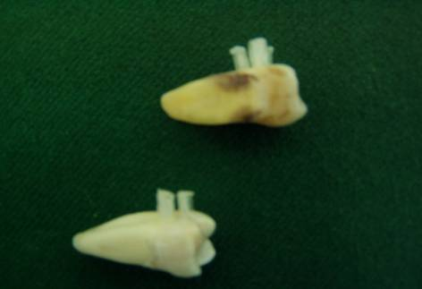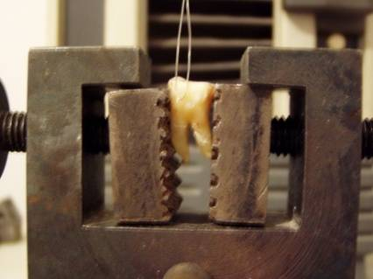
Figure 1: a, specimen with micro-cylenders bonded to buccal surface; b, µSBS compartments

Results:
- µSBS results
XP group with moist dentin attained statistically significant highest bond strength (29.06 MPa). Intermediate bond strength was obtained with P&B group (25.45 MPa), while XP group with dry dentin showed the statistically significant lowest bond strength (17.3 MPa (table 3).
Table (3) Descriptive statistics of µSBS in MPa for all groups (p < 0.05).
 | P&B (G1) | XP moist dentin (G2) | XP dry dentin (G3)
Mean | 25.45ª | 29.06ª | 17.31^{b}
Std. Deviation | 3.531 | 4.039 | 3.311
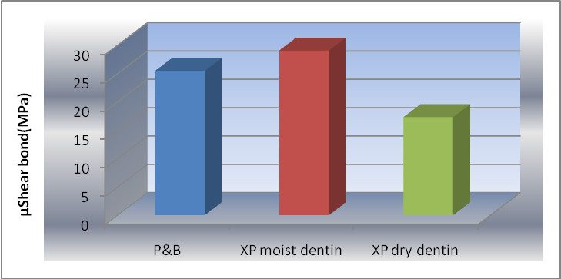
Figure (2) Column chart of µSBS mean values (MPa) for all groups

- Resin tag surface area Results
XP group with dry dentin attained statistically significant highest tags area (200.4 µm²). Intermediate tags area was obtained with P&B group (149.4 µm²), while XP group with moist dentin showed the statistically significant lowest tags area (94.54 µm²).

Table (4) Descriptive statistics of tags area (µm²) for all groups
 | P&B (G1) | XP moist dentin (G2) | XP dry dentin (G3)
Mean | 149.4^{b} | 94.54^{c} | 200.4ª
Std. Deviation | 26.09 | 20.06 | 38.00

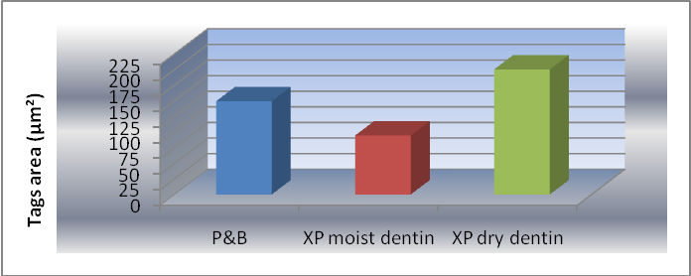
Figure (3) Column chart of tags area (µm²) mean value for all groups

- Correlation results
A statistically significant correlation was found between tags area and bond strength for Prime & Bond and XP-Bond with moist dentin as revealed by regression statistics. There was no correlation between tags area and bond strength for XP-Bond with dry dentin as revealed by regression statistics.

Table (5) Correlation of tags area and bond strength for all groups
Regression Statistics | Correlation coefficient R | R Square | P-value
Prime & Bond | 0.8585 | 0.7370 | 0.0286*
XP moist dentin | 0.9653 | 0.9318 | 0.0018*
XP dry dentin | 0.62480 | 0.3904 | 0.185 ns
*; significant (p < 0.05)

- ESEM evaluation
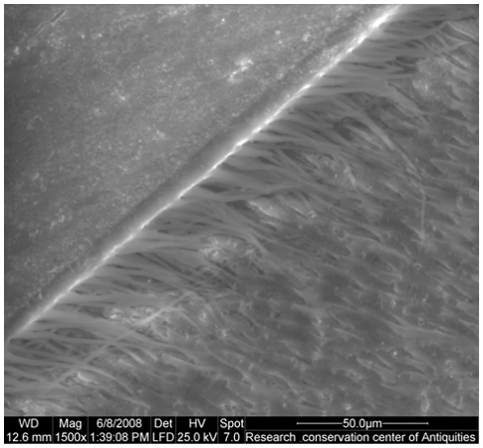 | 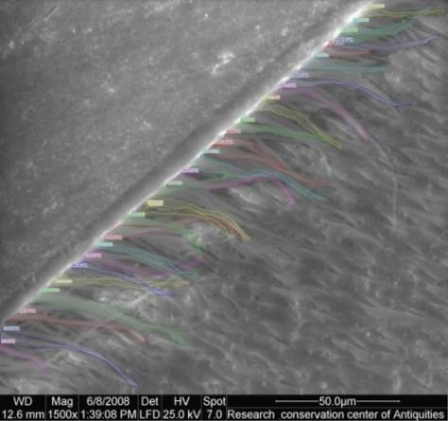
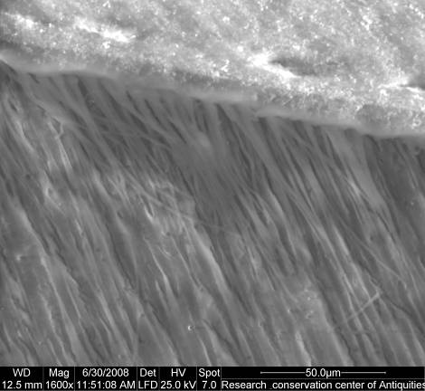 | 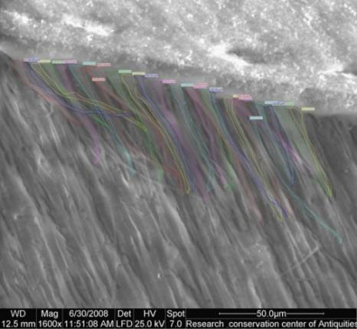
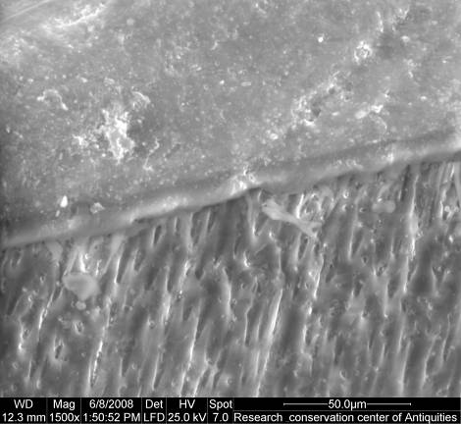 | 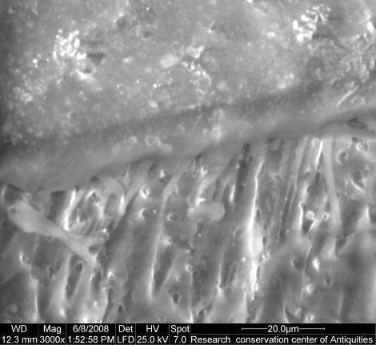
Figure 4: Prime&Bond NT with moist dentin (G1) a-e: ESEM micrographs showed a distinct adhesive layer, well and homogenously infiltrated hybrid layer (Magnification X1500). F: Dense, sealed hybrid layer (Magnification X3000).

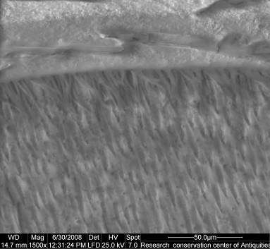 | 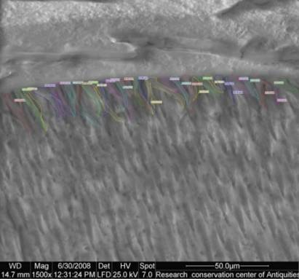
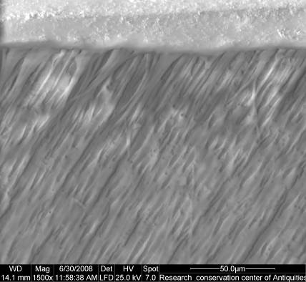 | 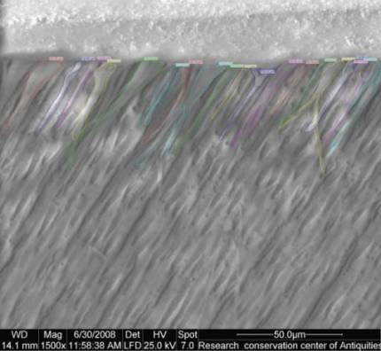
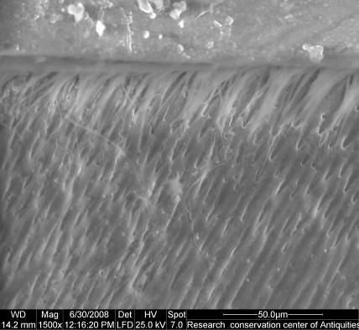 | 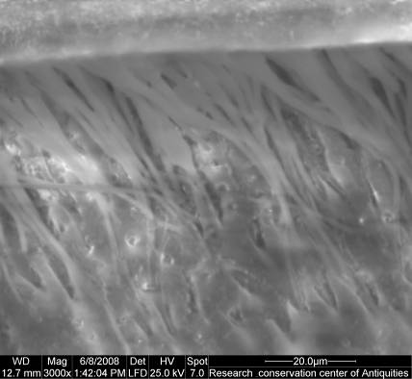
Figure 5: XP bond with moist dentin (G2): a-e: ESEM micrographs showed a distinct adhesive layer, a well and homogenously infiltrated hybrid layer with less resin tag area (Magnification X1500). f: Dense sealed hybrid layer (Magnification X3000).

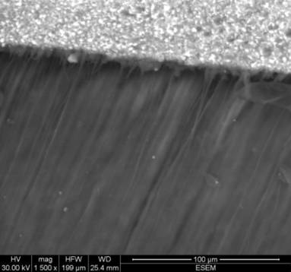 | 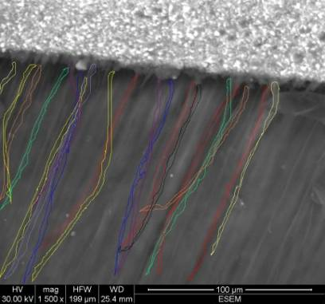
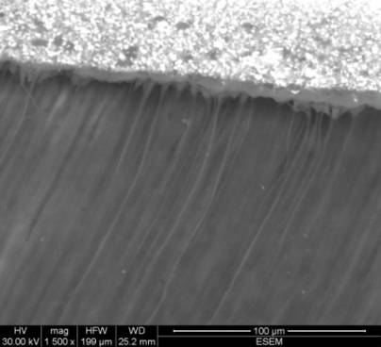 | 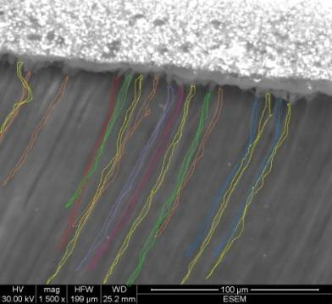
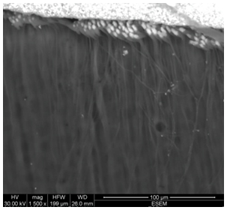 | 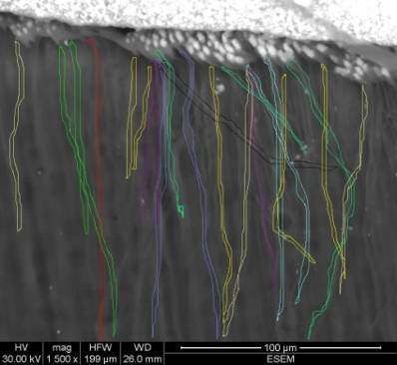
Figure 6: XP with dry dentin (G3) a-f: ESEM micrographs showed a distinct adhesive layer, infiltrated hybrid layer with areas of detachment from the underlying dentin. Long resin tags were observed. Hybrid layer seal was imperfect (Maginfication X1500).

Discussion
Micro-shear bond strength testing (µSBS)allows the measurements on small areas, making it possible to assess the adhesion strength of the resin composite to the clinically relevant dentin. The technique eliminates most of the cohesive resin or dentin fracture seen in more traditional shear strength test procedures that are due to nonuniform stress distributions.⁴Monomers of adhesive systems are carried by a solvent which is usually water, ethanol, acetone, or a combination of those⁵. Compared to Prime&Bond NT, in XP BOND acetone is replaced by tert-butanol. This solvent has a higher boiling point than acetone. Hence, tert-butanol is advantageous in daily practice by allowing the use of a dappen dish and the increase of the resin content.Moreover, it is totally miscible with both water and with the polymerisable resins³. It therefore helps the resin-containing adhesive to wet a moist tooth surface and produce dense, sealed hybrid layer thatwas recognizable in ESEM micrographs. Although Acetone has high vapor pressure, which is about four times as high as that of ethanol, it is highly volatile which reduce its shelf life. Tert-butanol has similar vapor pressure as ethanol, but better stability towards chemical reaction with monomers².This may explain the high micro-shear bond strength of XP wet-bonded specimens.Tert-butanol is claimed to be less technique sensitive due to an improved ability to diffuse through partially collapsed demineralized dentin⁶.This could be attributed to the H-bonding capacity of a solvent which has been shown to be important to re-expand the shrunken demineralized collagen network after dehydration². Numerous publications have shown that collapsed air-dried dentin matrices do not always expand when bonding agents are applied^{7, 8, and 9}.Most monomers used in adhesive dentistry have h-values below those of dried dentin¹⁰.Thus, such resins cannot expand dried, acid-etched dentin. This is why dry bonding to acid-etched dentin seldom gave shear bond strengths over 5 MPa¹¹. In this study, shear bond strength of dry bonded dentin was significantly lower than wet bonded dentin specimens; however, micro-shear bond strength values were 17MPs. This could be credited to H-bonding capacity of tert-butanol solvent which breaks stabilizing H-bonds and other forces that keep the collagen in shrunken state. As seen in SEM micrographs of dry bonded dentin, the adhesive layer showed areas of detachment from underlying dentin which indicates incomplete resin infiltration or retention related to these areas. This may explain the lower micro-shear bond strength values. This was in contradiction to a previous investigation which stated that “The morphology of the hybrid layer when XP BOND was applied on dried dentin was not very distinct from the morphology corresponding to the application of the same adhesive on moist dentin.”¹²The micro-shear bond strength of conventional etch and rinse systems has been theoretically modeled by Pashley et al as the sum of strength contributed by the resin tags, the hybrid layer and surface adhesion¹³. For etch and rinse adhesives, resin tag formation contribute quantitatively up to one-third of the total shear bond strength¹⁴.Even though significantly lower tag area was reported with both adhesives in moist condition, there was significant correlation between resin tag area and micro-shear bond strength.This could be related to the quality of the hybrid layer as shown in SEM micrographs and not the quantity of resin tags. Although resin tag area was significantly highest with XP dry bonding,no correlation was found between resin tag area and shear bond strength which may confirm the same finding.

Conclusion:
- The type of solvent strongly influences the clinical application protocol of etch-and-rinse adhesive systems.
- Butanol-based adhesive bonded to moist dentin, produced high µSBS that was not considerably different from that of the P&BNT, with hybrid layer that showed a perfectly infiltrated, sealed dentin-resin interface with relatively short resin-tags.
- Butanol-based adhesive bonded to dried dentin was able to infiltrate the demineralized collagen layer and produce long resin tags, however, hybrid layer was not perfectly sealed which may explain the lower bond strength values.
- There was significant correlation between resin-tags surface-area and µSBS for moist substrate bonding for the two tested adhesives. However, no correlation was found for dry substrate bonded to tert-butanol based adhesive.

References:
- Pashley DH, Tay FR, Yiu C, Hashimoto M, Breschi L, Carvalho RM, and Ito S. Collagen degradation by host-derived enzymes during aging. J Dent Res 2004; 83:216-221.
- Kirsten L. Van Landuyt, Johan Snauwaert, Jan De Munck, MarleenPeumans, Yasuhiro Yoshida, André Poitevin, Eduardo Coutinho, Kazuomi Suzuki, Paul Lambrechtsand Bart Van Meerbeek.Systematic review of the chemical composition of contemporary dental adhesives. J Biomaterials 2007; 28(26): 3757-3785.
- Densply clinical manual:Scientific Compendium.DENTSPLY DeTrey GmbH 2006; 02-27.
- Shono Y, Ogawa T, Terashita M, Carvalho RM, Pashley EL, Pashley DH. Regional measurement of resin-dentin bonding as an array. J Dent Res 1999; 78: 699-705.
- Peumans M, Kanumilli P, De Munck J, Van Landuyt K, Lambrechts Pand Van Meerbeek B. Clinical effectiveness of contemporary adhesives: a systematic review of current clinical trials, Dent Mater 2005;21:864–881.
- Van DijkenJW, Sunnegardh-Gronberg K and LindbergA, Clinical long-term retention of etch-and-rinse and self-etch adhesive systems in non-carious cervical lesions. A 13 years evaluation. Dent Mater 2007; 23: 1101–1107.
- Pashley DH, Agee KA, Nakajima M, Tay FR, Carvalho RM, Terada RSS, Harmon FJ, Lee K-W, Rueggeberg FA. Solvent-induced dimensional changes in EDTA-demineralized dentin matrix. J Biomed Mater Res 2001; 56: 273-281.
- Sugizaki J. The effects of various primers on dentin adhesion of resin com-Hybrid layer review 19 ponents. Jpn J Conserv Dent 1991;34:228-265.
- Nakaoki Y, Nikaido T, Pereira PNR, Inokoshi S, Tagami J. Dimensional changes of demineralized dentin treated with HEMA primers. Dent Mater 2000;16:441-446.
- Pashleyd, Tayf, Carvalhor, Rueggebergf, Ageek, Carrilho M, Donnellya, and Godoyf. From dry bonding to water-wet bonding to ethanol-wet bonding. A review of the interactions between dentin matrix and solvated resins using a macromodel of the hybrid layer Am J Dent, 2007; 20(1).
- Pashley DH. Dentin bonding: Overview of the substrate with respect to adhesive materials. J Esthet Dent 1991; 3: 46-50.
- Pashley DH, Ciucchi B, Sano H. Dentin as a bonding substrate. Dtsch Zahn Z 1994;49:760-763.
- Perdigão J (2005).
- Pashley DH, Ciucchi B, Sano H, Carvalho RM, Russell CM. Bond strength versus dentine structure: A modelling approach. Archs Oral Biol 1995; 40: 1109-1118. 22
- Spreafico D, Semeraro S, Mezzanzanica D, Re D, Gagliani M, Tanaka T, Sano H, Sidhu SK. The effect of air-blowing step on the technique sensitivity of four different adhesive systems. J Dent 2006;34:237-244.

10/14/2010

