Study of the Influence of Environmental Tobacco Smoke To Trachea and Lung of the Animal Model

¹Shuling Wang, ¹Tianqi Wang, ²Shen Cherng

¹College of Basic Medical Science Zhengzhou University, Zhengzhou, Henan, China
²Department of Computer Science and Information Engineering, Chengshiu University, Niaosong, Kaohsiung, Taiwan, China

Abstract: The environmental tobacco smoke (ETS) can influence the expression of androgen acceptor (AR) in organs of trachea and lung of animals of Wistar Rats. The rising of AR expression could be one of the mechanisms of smoking pathogenesis. Moreover, discontinuing ETS can not make the ascension of the AR back to normal level for the animals.
[Shuling Wang, Tianqi Wang, Shen Cherng. Study of the Influence of Environmental Tobacco Smoke To Trachea and Lung of the Animal Model. Life Science Journal 2010;7(4):83-87]. (ISSN: 1097-8135).

Key Words: Environmental tobacco smoke (ETS), androgen acceptor (AR), pathogenesis

Introduction
World Health Organization's (WHO) indicated the population of smoker being approximately 13 hundred million in the world. The investigation demonstrated [1] male smoker is about 66% [2]. The environmental tobacco smoke (ETS) can produce 6000 different kinds of chemical substance [1, 2, 3]. Major parts of the substances can be harmful and being as carcinogen. ETS is acting direct or the indirect role at many kinds of disease as well as the developing process, such as respiratory disorders, lung cancer, chronic bronchitis and asthma. Recently, multi-aspects research seeing from the immunity function, cell apoptosis, and oxidized damage and so forth, have carried on the discussion to the smoking pathogenesis mechanism. It is well known that ETS can affect the shape and function of testis [4]. However, a pathogenesis mechanism proposed that AR consists of eight exons with coding nucleoprotein being composed of 918 amino acids [5] is related to ETS. Androgen can diffuse into both target and non-target organs. But, it only functions in target organs. Similar like steroid hormone, AR is also a transcriptional factor. AR, if excited by Androgen, can recognize the target factor in a specific segment in DNA and combine with it to adjust the gene transcription expressing a new protein as well as changing the function of the cell [5]. In this article, we use RT-PCR and immunostaining LAB-SA to exam the AR expressing in tracheal sac and lung of the mice.

Material and Method
36 Wistar healthy male mice with body weight 180-220g provided by the Henan Province experimental animal center were randomly divided into three groups, group A was for ETS exposure, group B for being as control group, and group C as natural ETS exposure group. Each group has two cages. Each cage was raised six mice. An ETS room, 1740mm×1100mm×1500mm was constructed by acrylic plate with a 2mm×3 mm air hole on top for exposing tobacco smoke and air. Group A was in ETS exposed 60 minutes, twice a day for the first 38 days and changed to being in exposure for once a day 60 minutes for another 38 days. In group A, the ETS was provided by burning “Hongxi Cigarette” in a bundle of five pieces of 84mm cigarettes in every fifteen minutes for four times. Basic components of a cigarette consist of 17mg tar, 1.1mg smoke alkali. The antibody of AR is taken anti-AR carboxyl group end multi-peptide fragment to affine purified multi-clone immune body from the rabbit which is the product of Santa Cruz Corporation. The SP series driving fluid reagent box and DAB reagent box were the products from Beijing Zhongshan Biological Technology Limited Company. In control group B, no ETS was provided. In natural group C, same ETS exposure was provided but the animals being sacrificed one month later after quitting ETS exposure. The animals in group A should be in surgical treatment on the day of 76th at abdominal cavity ketamine (3mg/kg) injection for taking organs of trachea and lung being fixed in 4% formaldehyde solution for 24 hours. For group C, similar sample collection procedures with group A were performed 30 days later after 76 days ETS exposure. Tissue sample in preparation: Using ethyl alcohol gradient for dehydration of tissue sample embedded with paraffin wax ( low melting point) in 3~4μm slice, and then, processed with the chrome alum gelatin on glass slide being ready for staining.
Method of immunohistochemistry staining (immunostaining) of AR: Taking PBS as negative group in contrary to be in comparison of the organ of testicle for lab-animal as positive group. Normal and the benign prostate gland proliferation of the sample in situ RT-PCR, AR mRNA signal can be with purple pellet in positive group mainly located in the nearness karyotheca cytoblastema. Report from Liang Lijian research [5] revealed AR could be possible found in both cytoblastema and nucleus. Obvious yellowish brown pellet appears in intranuclear area. We can take the cytoplasma or the cell as the positive expression to determine the AR positive cell with the HPIAS-1000 high resolution pathology chart article analysis system for averaging gradation and luminosity. SPSS 10 software was used for t-test analysis and depicted with average ± STD (x±s).

Results
Yellowish brown pellets can be observed on both pseudostratified cilium cylinder epithelium cells and chondrocytes in the organ of trachea of the rats. We can also observe the yellowish brown pellets in the trachea pseudostratified cilium cylinder epithelium cells in organ of lung of the rats, most of them are in kytoplasm and a few in cell nucleus. In contrary, we can not observe the yellowish brown pellets in control group (replacement of anti-staining by PBS).

1. The AR expression in the organ of trachea of male rats
In Table 1, the AR expressions are listed for all animal groups. In comparison with Figure 1 and Figure 2, AR expression in group A is higher than in group B (P<0.01). However, no obvious difference can be observed between group C and A (P>0.05).

2. The AR expression in the organ of lungs of male rats
AR can only expressed in the organ of trachea of the rats, however, no expression in the organ of lung of pulmonary alveoli. The AR expression are listed in Table 2. In comparison with the figure 4 (control), AR expression in group A is higher than in group B(P<0.05 or P<0.01) but no difference with Group C (P>0.05). No positive cells were observed in Figure 7 and 8.

Table 1. The AR expression in the organ of trachea of the rats (x±s)
groups n mean ash density mean optical density
Control B 12 99.9±7.75 0.293±0.05
ETS A 12 87.0±9.60** 0.358±0.06**
Natural C 12 90.6±6.28^{**Δ} 0.346±0.03^{**Δ}
In comparison with control ** P<0.01; with group C **ΔP>0.05

Table 2. The AR expression in the organ of lung of the rats (x±s)
groups n mean ash density mean optical density
Control B 12 140.5±6.04 0.114±0.015
ETS A 12 134.4±5.92* 0.143±0.023**
Natural C 12 135.1±5.29^{*Δ} 0.139±0.017^{**Δ}
In comparison with control * P<0.05; ** P<0.01; with group C *Δ and **ΔP>0.05
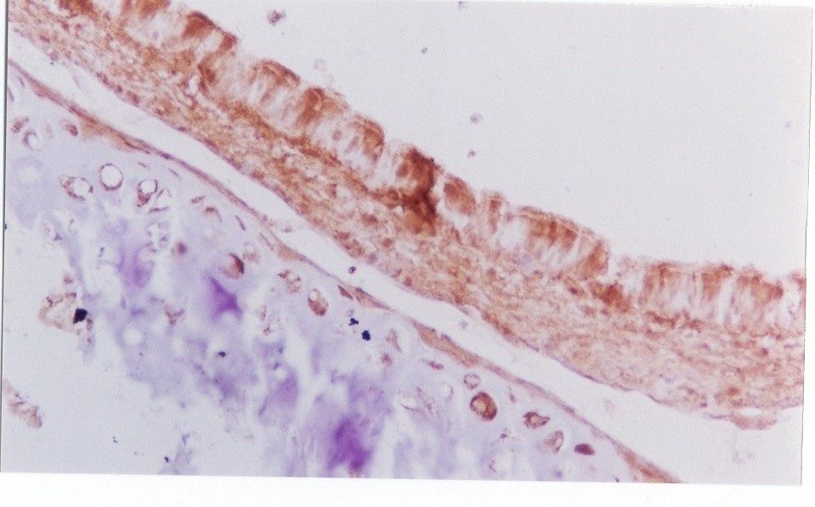

Fig 1. The AR expression in the organ of trachea of the rats in control group B, Immunostaining ×200

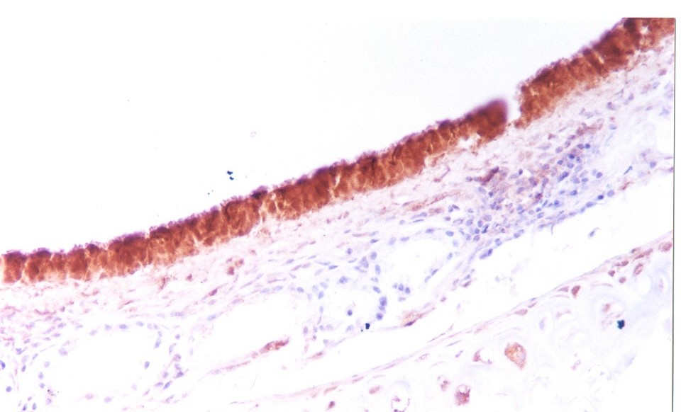

Fig 2. The AR expression in the organ of trachea of the rats in group A, Immunostaining ×200

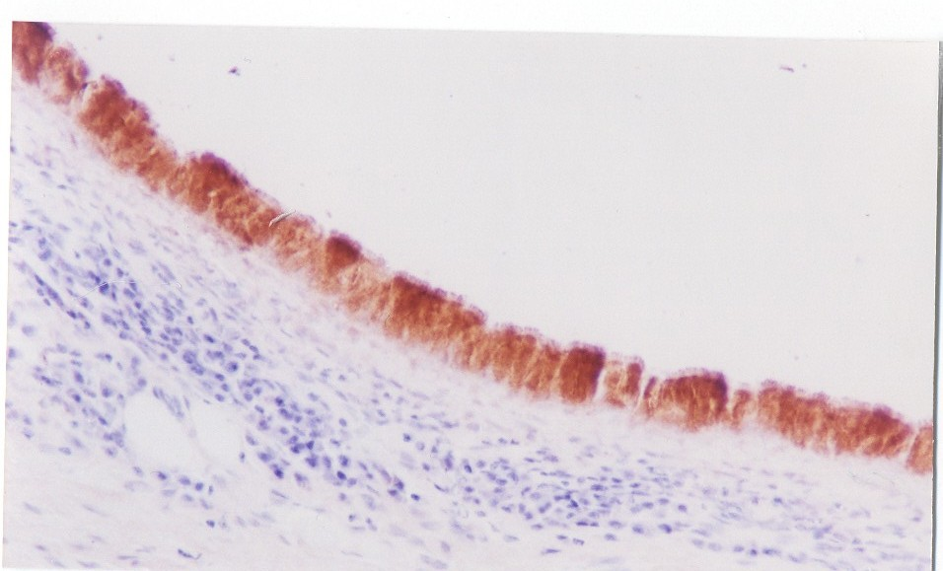

Fig 3. The AR expression in the organ of trachea of the rats in group C, Immunostaining ×200

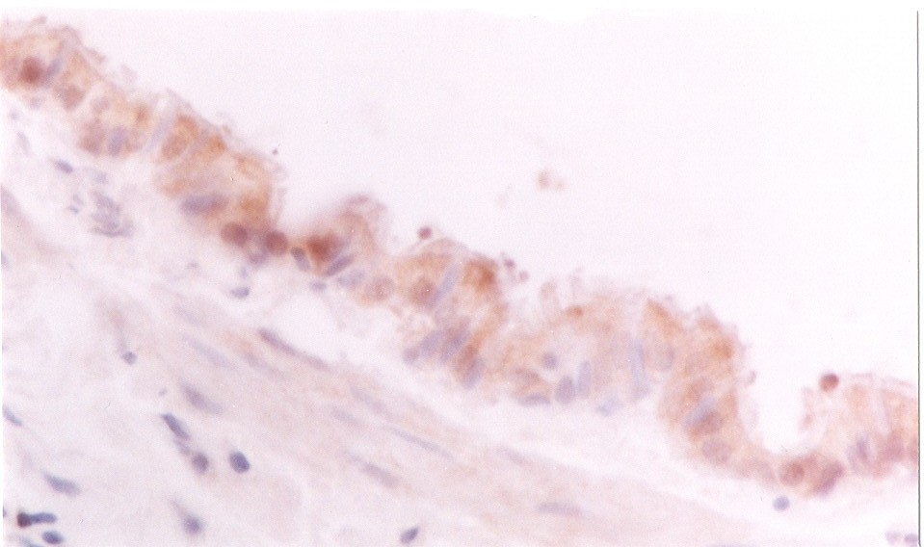
Fig 4. The AR expression in the normal organ of lung of the rats, Immunostaining ×400
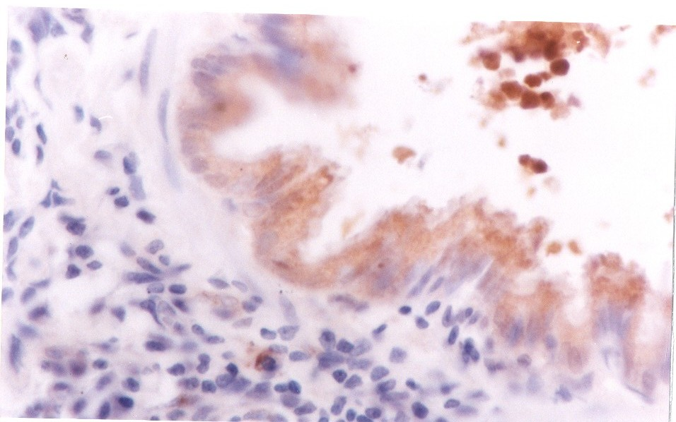

Fig 5. The AR expression in the organ of lung of the rats after ETS exposure, Immunostaining ×400

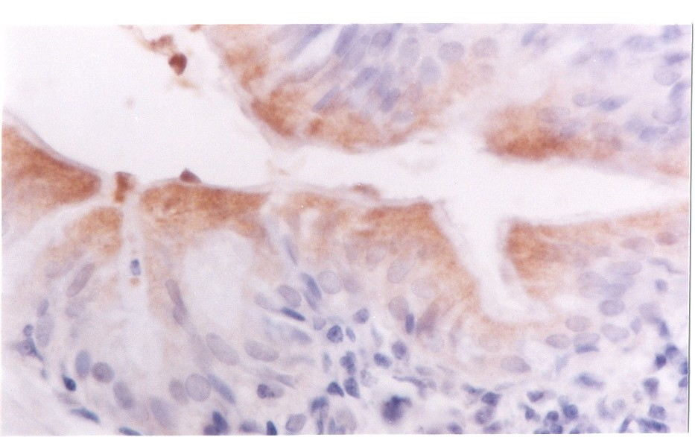
Fig 6. In Group C, AR expression in the organ of lung of the rats, Immunostaining ×400

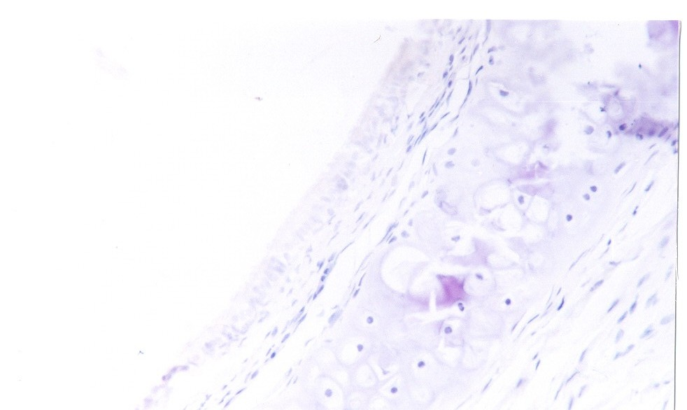

Fig 7. Negative Control Replace PBS to the antistaining in the organ of trachea of the rats of ETS, Immunostaining × 100

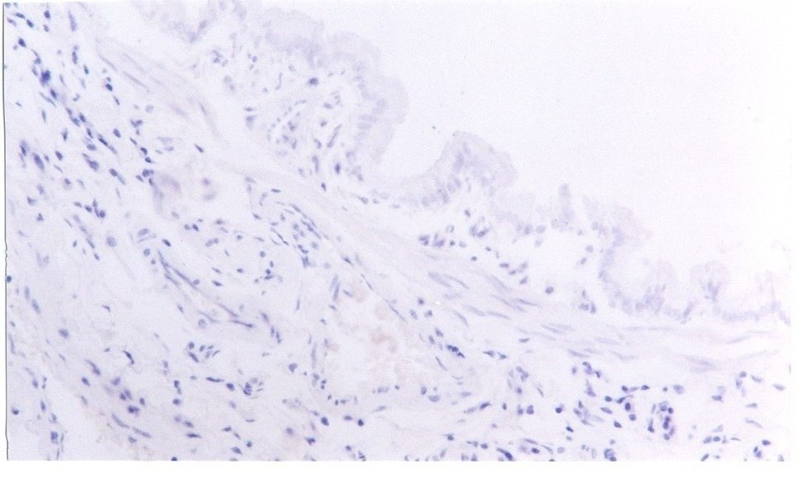
Fig 8. Negative Control Replace PBS to the antistaining in the organ of lung of the rats of ETS, Immunostaining × 100

Discussion and Conclusion
The experimental results have shown that the AR expression in the organ of lung and trachea of the rats upon ETS exposure is obvious stronger than in control. The report of Wei Sha Li et al. [6] demonstrated smoking may reduce the blood serum androgen standard. Our research revealed the similar result [7]. Extrapolating the low standard of the androgen may possibly cause AR in high expression because the androgen automatically makes the adjustment of AR expression [8]. Thus, ETS can reduce the blood serum androgen standard in the trachea and lung is very obvious. Liang Shu et al. [9] reported the AR expression for lung cancer patients can be high to 61.7%, also, AR expression of the adenocarcinoma of the lung is higher than lung cancer [10]. AR may participate the carcinogenesis in early stage. The natural did not show too much difference with the experimental group may result that quitting smoke can not help to reduce the expression of the AR in a short time period. However, the mechanism of the promotion of the AR expression and why the target should be the organs of lung and trachea would still be unknown and further research should be conducted.

References
- Yang Gonghuan, Ma Jiemin, Liu Nae The investigation of the smoked and passive smoking population in China. Chinese epidemiology magazine 2005; 26:77-83
- Stephen I. Rennard. Cigarette smoke in research. Am J Respir Cell Mol Biol, 2004, 31:479-480
- Zhong Chuan, Jiang Sanliang, Qiu 1. Lindgren, T., et al., Urinary cotinine concentration in flight attendants, in relation to exposure to environmental tobacco smoke during intercontinental flights. International Archives of Occupational and Environmental Health, 1999. 72(7): p. 475-479.
- Das, S.K., Harmful health effects of cigarette smoking. Molecular and Cellular Biochemistry, 2003. 253(1): p. 159-165.
- Zhong Chuan, Jiang Sanliang, Qiu shudong: The application of RT-PCR technology for exam AR mRNA in paraffin slide Anatomy Development. 1998, 4(3): 245~246
- Liang lijian, Lu Mingde, Huang Jiefu.: Naked mouse liver cancer transplant model for study of the anti-androgen treatment. Journal of Chinese Medicine.1998, 7(4): 299~300
- Wei Sha Li, Zhou Shengjian, Wang Yao, Effect of Smoking to the male seminal parameter, function of the sperm and influence of testosterone research. Chinese male scientific magazine. 2000, 14(4): 237~239
- Sulin Wang, Xiufang Chen, Shen Cherng. The Endocrine Disorder by Smoking Inhalation. Life Science Journal 2005, 2(1):37-39
- Yao Genhong, Zhou Yayi, Xu Zhihong : Researrch of Androgen control. Research of Life Science, 5(3):202-205
- Boix L, Castells A, Bruix J et al.:Androgen receptors in hepatocellular carcinoma and surrounding liver: relationship with tumor size and recerrence rate after surgical resection. J Hepatology. 1995, 22: 216~218

8/8/2009

