Gas Chromatography – Mass Spectroscopic analysis of Lawsonia inermis Leaves

¹Hema R., ¹S. Kumaravel, ²S. Gomathi and ³C. Sivasubramaniam

¹Food Testing Laboratory, Indian Institute of Crop Processing Technology, Thanjavur
²Dept. of Biochemistry, KSR College of Arts and Science, Tiruchengode
³Dept. of Environmental and Herbal Sciences, Tamil University, Thanjavur
e-mail: hema.scientist@gmail.com

Abstract: Due to uniqueness of Lawsonia inermis leaf property in curing different ailments this part was selected for the study. Hence the present investigation was carried out to determine the possible chemical components from Lawsonia inermis leaves by GC-MS. This analysis revealed that Lawsonia inermis leaves contain mainly á-D-Glucopyranoside, methyl (51.73%) and 1,4-Naphthalenedione, 2-hydroxy- [Synonyms: Henna] (19.19%), which were used in curing skin ailments caused due to Environmental Pollution of Air and Water.
[Hema R., S. Kumaravel, S. Gomathi and C. Sivasubramaniam. Gas Chromatography – Mass Spectroscopic analysis of Lawsonia inermis Leaves. Life Science Journal 2010;7(4):48-50]. (ISSN: 1097-8135).

Keywords: Lawsonia inermis, GC-MS analysis, 1,4-Naphthalenedione, 2-hydroxy- (Henna), Skin ailments caused due to Environmental Pollution of Air and Water.

Introduction:
Lawsonia inermis is commonly known as Henna. Henna has been used since the Bronze Age to dye skin (including body art), hair, fingernails, leather, silk and wool. In several parts of the world it is traditionally used in various festivals and celebrations. There is a mention of henna as a hair dye in Indian court records around 400 CE, (Auboyer et. al., 2002) in Rome during the Roman Empire, and in Spain during Convivienca. (Fletcher et. al., 1992) It was listed in the medical texts of the Ebers Papyrus (Bryan et. al., 1974) and by Ibn Qayyim al-Jawziyya (14th c CE (Syria and Egypt) as a medicinal herb. (Ibn Qayyim al-Jawzīyah et. al., 1998).
For skin dyeing, a paste of ground henna (either prepared from a dried powder or from fresh ground leaves) is placed in contact with the skin from a few hours to overnight. Henna strains can last a few days to a month depending on the quality of the paste, individual skin type, and how long the paste is allowed to stay on the skin. Henna also acts as an anti-fungal agent. (Ibn Qayyim al-Jawzīyah et. al., 1998).
Henna’s coloring properties are due to lawsone, a burgundy organic compound that has an affinity for bonding with protein. Lawsone is primarily concentrated in the leaves, especially in the petioles of the leaf. Lawsone content in leaves is negatively associated with the number of seeds in the fruits. (Bosoglu et. al., 1998).
Pre-mixed henna body art pastes may have ingredients added to darken stain, or to alter stain color. The health risks involved in pre-mixed paste can be significant. The United States Food and Drug Administration (FDA) considers these to be adulterants and therefore illegal for use on skin. (Singh et.al., 2005).
Some pastes have found to include: Silver nitrate, Carmine, Pyrogallol, disperse orange dye, and Chromium. (FDA, 2009) These have been found to cause allergic reactions, chronic inflammatory reactions, or late-onset allergic reactions to hairdressing products and textile dyes. (Kang et. al., 2006; Dron et. al., 2007).
The FDA has not approved henna for direct application to the skin. It is unconditionally approved as a hair dye, and can only be imported for that purpose. (Federal Register, 2009)
Natural henna stains only a rich red brown. Products sold as "black henna" or "neutral henna" do not contain henna, and may be derived from indigo (in the plant Indigofera tinctoria) or Cassia obovata, and may contain unlisted dyes and chemicals. (Singh et. al., 2005).
"Black henna" may contain p-phenylenediamine (PPD), that can stain skin black quickly but can cause severe allergic reactions and permanent scarring. The FDA specifically forbids PPD to be used for that purpose. PPD can cause severe allergic reactions, with blistering, intense itching, permanent scarring, and permanent chemical sensitivities.
Estimates of allergic reactions range between 3% and 15%. Henna does not cause these injuries. Henna boosted with PPD can cause lifelong health damage. PPD sensitivity is lifelong, and once sensitized, the use of synthetic hair dye can be life-threatening.

Materials and Methods:
Plant material – Lawsonia inermis was collected in IICPT, Thanjavur Dist. of Tamilnadu.
Plant Sample Extraction
5 gm powdered plant material was soaked in 20ml of Absolute alcohol overnight and then filtered through Whatmann filter paper No.41 along with 2gm Sodium sulfate to remove the sediments and traces of water in the filtrate. Before filtering, the filter paper along with sodium sulphate was wetted with absolute alcohol. The filtrate is then concentrated by bubbling nitrogen gas into the solution and was concentrated to 1ml. The extract contains both polar and non-polar phytocomponents.
GC-MS Analysis: GC-MS analysis was carried out on a GC Clarus 500 Perkin Elmer system and gas chromatograph interfaced to a mass spectrometer (GC-MS) instrument employing the following conditions: Column Elite-1 fused silica capillary column (30mm×0.25mm ID ×1 μMdf, composed of 100% Dimethyl poly siloxane), operating in electron impact mode at 70 eV; Helium (99.999%) was used as carrier gas at a constant flow of 1ml/min and an injection volume of 2 μl was employed (split ratio of 10:1); Injector temperature 250°C; Ion-source temperature 280°C. The oven temperature was programmed from 110°C (isothermal for 2 min.), with an increase of 10°C/min, to 200°C, then 5°C/min to 280°C, ending with a 9 min. isothermal at 280°C. Mass spectra were taken at 70 eV; a scan interval of 0.5 seconds and fragments from 45 to 450 Da. Total GC running time was 36 min.
Identification of Components: Interpretation on mass spectrum GC-MS was conducted using the database of National Institute Standard and Technology (NIST) having more than 62,000 patterns. The spectrum of the unknown component was compared with the spectrum of the known components stored in the NIST library. The Name, Molecular weight and Structure of the components of the test materials were ascertained.

Results and Discussion:

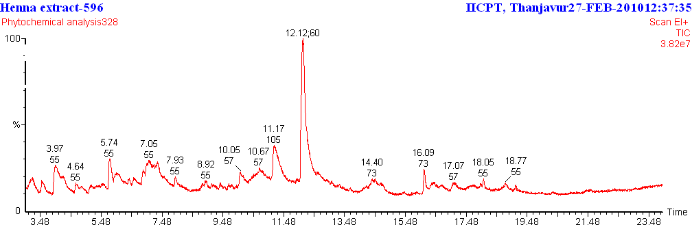

Table 1: Components Identified in Lawsonia inermis
No. | RT | Name of the compound |  | Molecular Formula | MW | Peak Area %
1 | 3.97 | 2H-Pyran-2,6(3H)-dione |  | C5H4O3 | 112 | 16.97
2 | 5.74 |  | 4H-Pyran-4-one, 2,3-dihydro-3,5-dihydroxy-6-methyl- | C6H8O4 | 144 | 6.34
3 | 6.86 |  | Benzene, (ethenyloxy)- | C8H8O | 120 | 2.55
4 | 11.17 | 1,4-Naphthalenedione, 2-hydroxy-  [Synonyms: Henna] |  | C10H6O3 | 174 | 19.19
5 | 12.12 | á-D-Glucopyranoside, methyl |  | C7H14O6 | 194 | 51.73
6 | 16.09 | n-Hexadecanoic acid |  | C16H32O2 | 256 | 3.21

Six compounds were identified in Lawsonia inermis by GC-MS analysis .The active principles with their Retention time(RT), Molecular formula, Molecular weight (MW) and Concentration (%) are presented in (Table 1 and Fig 1).The prevailing compounds were á-D-Glucopyranoside, methyl (51.73%) and 1,4-Naphthalenedione, 2-hydroxy- [Synonyms: Henna] (19.19%).

References
- Auboyer, Jeannine, London: Phoenix, Daily life in ancient India: from 200 BC to 700 AD., 2002
- Fletcher R., New York City, Moorish Spain, 1992
- Bryan, Cyril P, G. Elliot Smith, Chicago: Ares Publishers, Ancient Egyptian medicine: the Papyrus Ebers, 1974
- Ibn Qayyim al-Jawzīyah, Muhammad ibn Abī Bakr, Penelope Johnstone. Cambridge: Islamic Texts Society, Medicine of the prophet. Trans, 1998
- Bosoglu A, Birdane F, Solmaz H, "The effect of Henna (Folium lawsoniae) paste in ringworm in calves". Indian Veterinary Journal 75 (1), 1998, 83–84
- Singh, M., Jindal, S. K., & Singh, D., "Natural Variability, Propagation, Phenology and Reproductive Biology of Henna", Henna: Cultivation, Improvement, and Trade. Jodhpur: Central Arid Zone Research Institute, 2005, 13–18
- "Temporary Tattoos & Henna/Mehndi", Food and Drug Administration, 18 September 2006, http://www.fda.gov/Cosmetics/ProductandIngredientSafety/ProductInformation/ucm108569.htm, Retrieved 3 August 2009.
- Kang IJ, Lee MH, "Quantification of para-phenylenediamine and heavy metals in henna dye". Contact Dermatitis 55 (1), 2006, 26–9
- Dron P, Lafourcade MP, Leprince F, "Allergies associated with body piercing and tattoos: a report of the Allergy Vigilance Network". European Annals of Allergy and Clinical Immunology 39 (6), 2007, 189–92
- Listing of Color Additives Exempt from Certification, Federal Register, 30 July 2009
- Singh, M., Jindal, S. K., Kavia, Z. D., Jangid, B. L., & Khem Chand, "Traditional Methods of Cultivation and Processing of Henna. Henna, Cultivation, Improvement and Trade". Henna: Cultivation, Improvement, and Trade. Jodhpur: Central Arid Zone Research Institute, 2005, 21–24.

8/1/2010

