Sorption Energies Estimation Using Dubinin-Radushkevich and Temkin Adsorption Isotherms
Itodo A.U.¹and Itodo H.U²
¹Department of Applied Chemistry, Kebbi State University of Science and Technology, Aliero, Nigeria
²Department of Chemistry, Benue State University, Makurdi, Nigeria
itodoson2002@yahoo.com
Abstract: In this study, we add to scholarly knowledge in simple terms, the forces or energy defining certain adsorption phenomenon, using isotherm models. GCMS measurement of equilibrium phase atrazine after adsorption onto Sheanut shells (SS) acid derived activated carbon were fitted into the D-R and Temkin isotherm relationships for energy data estimation. Sorption energy value (B_{D}), mean free energy (E_{D}) and heat of sorption (B). They were estimated as 0.7600mol²KJ⁻², 0.8111 kjmol⁻¹ and 0.790Jmol⁻¹ respectively. The parameter predicting the type of adsorption was evaluated B_{D} , B < 20kJ/mol and E_{D}<8 which is an indication that physisorption (Non specific adsorption) dominates chemisorption and ion exchange. The D-R model with a higher correlation coefficient values, R² = 0.979 proves a better choice in explaining sorption energies. Generally, sheanut shells can be used as alternative precursors for activated carbon production via the two steps and acid treatment schemes.
[Sorption Energies Estimations Using Dubinin-Radushkevich and Temkin Adsorption Isotherms. Life Science Journal 2010;7(4):31-39]. (ISSN: 1097-8135).
Key words: Dubinin-Radushkevich , Temkin, Adsorption, GCMS, Isotherm, Sorption energy

- Introduction
It was reported that quality evaluation of activated carbon with adsorption capacity, intensity ,thermodynamics and kinetics parameters among others are as vital as the estimation of certain energy parameters namely mean free energy, sorption energy etc. An approximation from such energy parameter gives a clue as to the type of adsorption in question.
Previous studies showed that the herbicide, atrazine disrupt the production and functionality of human hormones and a higher incidence was reported for cases of cancer in humans and laboratory animals (Zhongren et al., 2006). The use of active carbon was prescribed by USEPA as the best available technology for the removal of atrazine from drinking water. Many studies have revealed adsorption of atrazine using conventional activated carbon granules and fibres.
A chemical activation using activating agents is a new generation of adsorption fibre development sorbents obtained with this method provides higher yield, high surface area, high mesopores volumes and some unusual pore surface chemistries (Zhongren et al., 2006; WHO, 1999; Hertrick et al., 2000).The sorption of herbicide aqueous phase by activated carbon has been reported (Agdi et al.,2000;WHO,1999; Zhongren et al., 2006). This present study reports atrazine sorption, not in a micro quantity but within range that could account for both the topical and systemic poisoning reportedly associated with atrazine (Raymond, 2003).
Basics of adsorption : Adsorption is actually a mechanism in which the forces of interaction between surface atoms and the adsorbate molecules are similar to Van der Waals forces that exist between all adjacent molecules .There are both attractive forces and repulsive forces with the net force depending on the distance between the surface of the adsorbent and the adsorbate molecule (Cooney,1999).
In other words,adsorption is a process in which a soluble chemical (the adsorbate) is removed from a fluid (liquid or gas) by contact with a solid surface (the adsorbent).It is the trapping of impurities by strong physical bond within the porous structure of Carbon. It is one of the many processes used to purify, concentrate, or separate component (Glenn,1993) and competes with other processes like evaporation, solvent extraction, distillation, sublimation, drying, sedimentation, filteration, screening, ion exchange, centrifugation, and absorption (Glenn,1993).It is used in industry for product separation and waste treatment. In general, adsorption is the process by which a component moves from one phase to another while crossing some boundary. It was found that the observed effect of adsorption was achieved within porous solids and that adsorption was the result of interactive forces of physical attraction between the surface of porous solids and component molecules being removed from the bulk phase (Arun, 2002).
Improved Adsorption via Surface Activation: The surface of an adsorbent is typically composed of various surface functional groups (SFG). Adsorption of organic adsorbate is greatly dependent on the amount and nature of surface oxide groups (Cooney, 1999). Surface functional groups (carbon/oxygen) are created by oxidation occurring during the activation process of an adsorbent. Some of the common basic functional groups created are lactones, quinones, and carboxylates (Arun, 2002). Some of the common acidic functional groups created are phenolic, hydroxyl, carbonyl, and carboxylic acids (Arun, 2002). The presence of oxygen-containing basic groups such are a key factor in promoting irreversible adsorption (Vidic et al., 1993).Strongly dissociated adsorbates are weakly adsorbed when compared to nondissociated adsorbates (Cooney, 1999). The more non polar an adsorbate, the higher the adsorption capacity. This is attributed to the fact these adsorbate molecules tend to prefer the adsorbent surface rather than being in the solution (Cooney, 1999). It has also been shown that an increase in the molecular weight of the adsorbate will generally enhance adsorption until the size of the adsorbate is larger than the pore size of the adsorbent. Typically, aromatic compounds are more adsorbable than aliphatic compounds of similar molecular size and branched-chain molecules are generally more adsorbable than straight-chain molecules (Cooney, 1999). In addition, solubility of the adsorbate is also an important factor. In general, the lower the solubility of the adsorbate, the higher the adsorption capacity since the forces of attraction between the adsorbate molecules and the adsorbent surface molecules will be greater than the forces of attraction between the adsorbate and the solvent molecules (Cooney, 1999).
Types of Adsorption based on Energy values
1. Chemisorption: This is a shorter way of writing chemical adsorption. It is also called specific adsorption and limited to monolayer coverage of the substrate. Here, a covalent bond is formed between the adsorbate and adsorbent. The enthalpy of chemisorption is within the range of 200kJ/Mol (Atkins, 1999)
2. Physisorption: This stands for physical adsorption. It is also called non specific adsorption which occur as a result of long range weak Van der Waals forces between adsorbates and adsorbents. The energy released when a particle is physisorbed is of the same magnitude as the enthalpy of condensation. The enthalpy of physisorption is measured by monitoring the rise in temperature of a sample of known heat capacity. Typical values of in the region of 20kJ /Mol (Atkins, 1999).
Chemisorption occurs at high temperatures with a significant activation energy, which involves strong bonds and is not reversible. The heat of adsorption is typically high in chemisorption and is similar to heat generated during a chemical reaction. There are several factors that impacts physical adsorption (LaGrega et al., 1994; Cooney, 1999). The major factors which affect physical adsorption include the surface area of the adsorbent, pore structure of the adsorbent, surface chemistry of the adsorbent, nature of the adsorbate, pH of the solution, and the presence of competing adsorbates. It is due to these factors, physical adsorption is considered to be a complex phenomena. Surface area of the adsorbent is one of the most important factors on which adsorption greatly depends. The surface area is comprised of two types, the external surface area and the internal surface area (pore walls). When molecules are larger than the pore diameter, lesser adsorption would take place because of steric hindrances.
Adsorption isotherm: Isotherm are empirical relationship used to predict how much solute can be adsorbed by activated carbon (Steve and Erika, 1998). Chilton et al.,(2002) defined Adsorption isotherm as a graphical representation showing the relationship between the amount adsorbed by a Unit weight of adsorbent (eg activated carbon) and the amount of adsorbate remaining in a test medium at equilibrium. It maps the distribution of adsorbable solute between the liquid and solid phases at various equilibrium concentration (Chilton et al., 2002).The adsorption isotherm is based on data that are specific for each system and the isotherm must be determined for every application. An adsorption isotherm beside providing a panorama of the course taken by the system under study in a concise form indicate how efficiently a carbon will allow an estimate of the economic feasibility of the carbons’ commercial application for the specific solute (Chilton et al., 2002).
Dubinin-Radushkevich isotherm: This isotherm model was chosen to estimate the characteristic porosity of the biomass and the apparent energy of adsorption. The model is represented by the equation 1 below:
qe = q_{D} exp (- B_{D} [RT ln (1 + 1/Ce) (1)
Where, B_{D} is related to the free energy of sorption per mole of the sorbate as it migrates to the surface of the biomass from infinite distance in the solution and q_{D} is the Dubinin-Radushkevich isotherm constant related to the degree of sorbate sorption by the sorbent surface (Horsfall et al., 2004;Itodo et al.,2009b). The linear form of equation is given as 2;
ln qe = ln q_{D} - 2B_{D} RT ln (1 + 1/Ce) (2)
A plot of ln qe against RT ln (1 + 1/Ce) for modified sorbents, yielded straight lines and indicates a good fit of the isotherm to the experimental data. The apparent energy (E_{D}) of adsorption from Dubinin-Radushkevich isotherm model can be computed using the relation given as 3 below (Horsfall et al., 2004).
E_{D}= √1/2B_{D} (3)
Temkin adsorption Isotherm: The Temkin was tested for equilibrium description at room temperature. The model was respectively represented by equations 4 and 5 below. Therefore, by plotting qe versus ln Ce , enables the determination of the constants A and B.B is the Temkin constant related to heat of sorption (J/mol), A is the Temkin isotherm constant (L/g), R the gas constant (8.314 J/mol K), b is Temkin isotherm constant and T is the temperature (K). (Nunes et al., 2009; Hameed,2009).
q_{e} = B ln (A+C_{e}) (4)
Where B = RT/b (5)
Aim of this work: In this present work, chemically activated carbon was formulated to adsorb atrazine traces from water. This research was based on an initial qualitative study based on atrazine sorption as earlier predicted by FTIR analysis (Itodo et al.,2009a). The specific objectives include; Generation of activated carbon thereby adding values to the wastes. Sorption energy studies, (Evaluation of the mean free and sorption energies as would be predicted by Temkin isotherm and R-D isotherm models.

- MATERIALS AND METHODS
Choice of equipment: The gas chromatographic technique is at best a mediocre tool for qualitative analysis. It is best used with other technique to answer the question of what is present in a sample. Besides the simplicity of the instrument, ease of operation, GC also provides the answer to how much? It is an excellent quantitative analytical tool in quantifying micrograms in a litre or one volume in millions of volumes (Robert and Eugene, 2004).The sample herbicide (containing atrazine) is a multicomponent mixture containing atrazine (test sample) and other organochlorine moieties, which are very similar to atrazine. Secondly, the GC column has a very high efficiency which was claimed to be in excess of 400,000 theoretical plates. The column is about 100m long, a very dispersive type of stationary phase retaining the solute approximately in order of increasing boiling point. Helium carrier gas was selected since it can realize high efficiencies with reasonable analysis time (Raymond, 2003). Techniques of external standardization entails the preparation of standards at the same levels of concentration as the unknown in the same matrix with the known. These standards are then run chromatographically under ideal conditions as the sample. A direct relationship between the peak size and composition of the target component is established and the unknown was extrapolated graphically
Sample treatment and preparations: The method of sample treatment by Fan et al., (2003); Itodo et al .,(2009a&b) were adopted. The samples were washed with plenty of water to removes surface impurities and sundried, then, dried in an oven at 105^{O}C overnight ( Omonhenle et al., 2006). The samples were separately pounded/ grounded followed by sieving with a <2mm aperture sieve. The less than 2mm samples were stored in airtight containers. About 3g of each pretreated biosolid (< 2mm mesh size) were introduced into six (6) different clean and pre weighed crucibles. They were introduced into a furnace at 500^{O}c for 5 minutes after which they were poured from the crucible into a bath of ice block. The excess water was drained and the samples were sun dried. This process was repeated until a substantial amount of carbonized samples were obtained (Gimba et al., 2004). The carbonized sample was washed, using 10% HCl to remove surface ash, followed by hot water wash and rinsing with distilled water to remove residual acid (Fan et al., 2003) the solids were then sun dried, then, dried in the oven at 100^{O}C for one hour . Accurately weighed 2g each of already carbonized samples were separately mixed with 2cm³ of each 1M activating agent (H₃PO₄ and ZnCl₂). The samples were introduced into a furnace, heated at 800^{O}c For 5 minutes. The activated samples were cooled with ice cold water. Excess water was drained and samples were allowed to dry at room temperature (Gimba et al., 2004,). The above procedure was repeated for different residual time (5min and 15 min).Washing of the above sample was done with 10% HCl to remove surface ash, followed by hot water and rinsing with distilled water to remove residual acid (Fan et al, 2003). Washing was completed when pH of the supernatant of 6-8 was ascertained (Ahmedna et al., 2000). The sample were dried in an oven at 110^{O}C overnight and milled or grounded, followed by filtration to different mesh size and stored in air tight container.
Atrazine standard solution for equilibrium studies: For the sorption/equilibrium studies, several concentrations viz; 10, 20, 30, 40 and 50g/L Herbicide equivalent of 5, 10, 15, 20 and 25g/L Atrazine was prepared by respectively dissolving 0.25, 0.5, 0.75, 1.0 and 1.25g of herbicide into a conical flask, poured gently into a 25cm³ volumetric flask, homogenized and made to the mark with chloroform (i.e. 5,000ppm – 25,000ppm atrazine).A three point calibration curved based on external standard method was prepared with the GC/MS run.
Batch equilibrium experiment: 5g of substrate was diluted to the mark of 100cm³ volumetric flask. This concentration of 50g/L herbicide is equivalent to 25g/L or 25,000ppm atrazine stock. 10cm³ of the atrazine solution was interacted with 0.1g of each sorbent and allowed to stand for 12hours. The mixture was filtered and the filtrate was analyzed with a gas chromatography (coupled with a mass spectrophotometer detector) for atrazine equilibrium phase concentration (Min and Yun, 2008; Agdi et al., 2000). The amount of atrazine at equilibrium, q_{e} was calculated from the mass balance equation given in equation 6 by Hameed et al. ,(2006).
q_{e} = (C_{O} –C_{e}) V/W (6)
where C_{o} and C_{e} are the initial and final Dye concentrations (mg/L) respectively. V is the volume of dye solution and M is the mass of the acid catalyzed Poultry waste sorbent (g). while t is the equilibrium contact time, when q_{e} = qt, equation 6 will be expressed as equation 7 below:
q_{t} = (C_{o} - C_{t})v/w (7)
where q_{e} = q_{t} and C_{t} is the concentration at time,t. The percent dye removal (RE %) was calculated for each equilibration by the expression presented as equation 8
R E(%) = (C₀ ₋ C_{e} )/Co x 100 (8)
Where RE (%) is the percent of dye adsorbed or removed. The % removal and adsorption capacities were used to optimize the activation condition. The test were done at a constant temperature of 27±2⁰C.(Rozada et al.,2002). The equilibrium concentration of atrazine (herbicide), q_{e} and Adsorption efficiency (% Removal) were estimated. The extent of atrazine removal (by difference) from chloroform spiked with 25g/L of atrazine was expressed as equation 3 (Hameed et al., 2006).
- Results
The chromatogram shown as Figure 1 stands for unadsorbed sorbate out of the 5g/dm³ atrazine which was interacted with SS/A sorbent. The chromatogram was characterized by a baseline disturbance. This is caused by either hydrocarbon impurities or by impure carrier gas (Robert and Eugene, 2004).The former could be linked to the fact that the sorbate concentration (5g/dm³) is too low for the 0.1g carbon dose. Unoccupied pore size could as well, lead to desorption of the sorbate with a resultant poor percentage removal (46.08%).

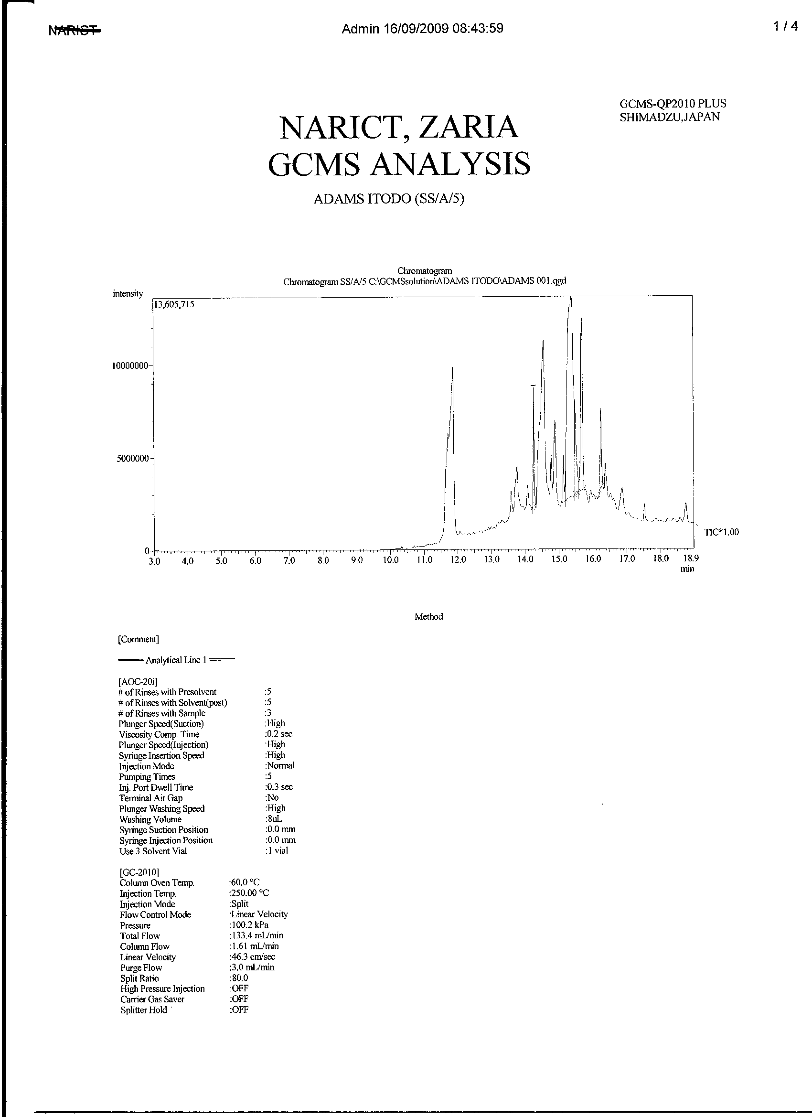
Figure 1: GC/MS chromatogram of equilibrium concentration atrazine after adsorption onto SS/A/5gL⁻¹ sorbent (Carrier gas-Helium 100.2kpa,Column temperature –60ºc,Injection temperature-250ºc,Injection volume—1µL,Flow rate-1.61mL/min, Injection method- split, Linear velocity- 43.6cm/sec.)
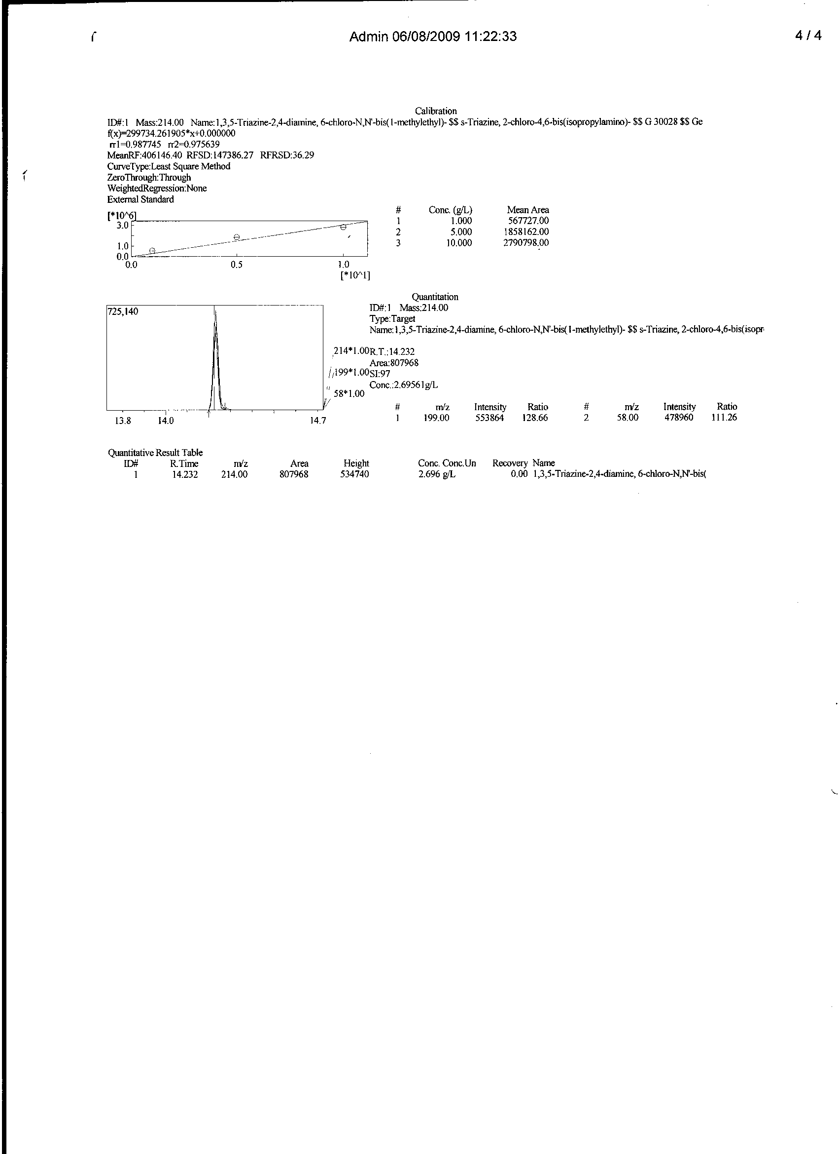
Figure 2: GC/MS chromatogram, quantitative measurement and spectral information of equilibrium phase atrazine after adsorption onto SS/A/5gL⁻¹ sorbent

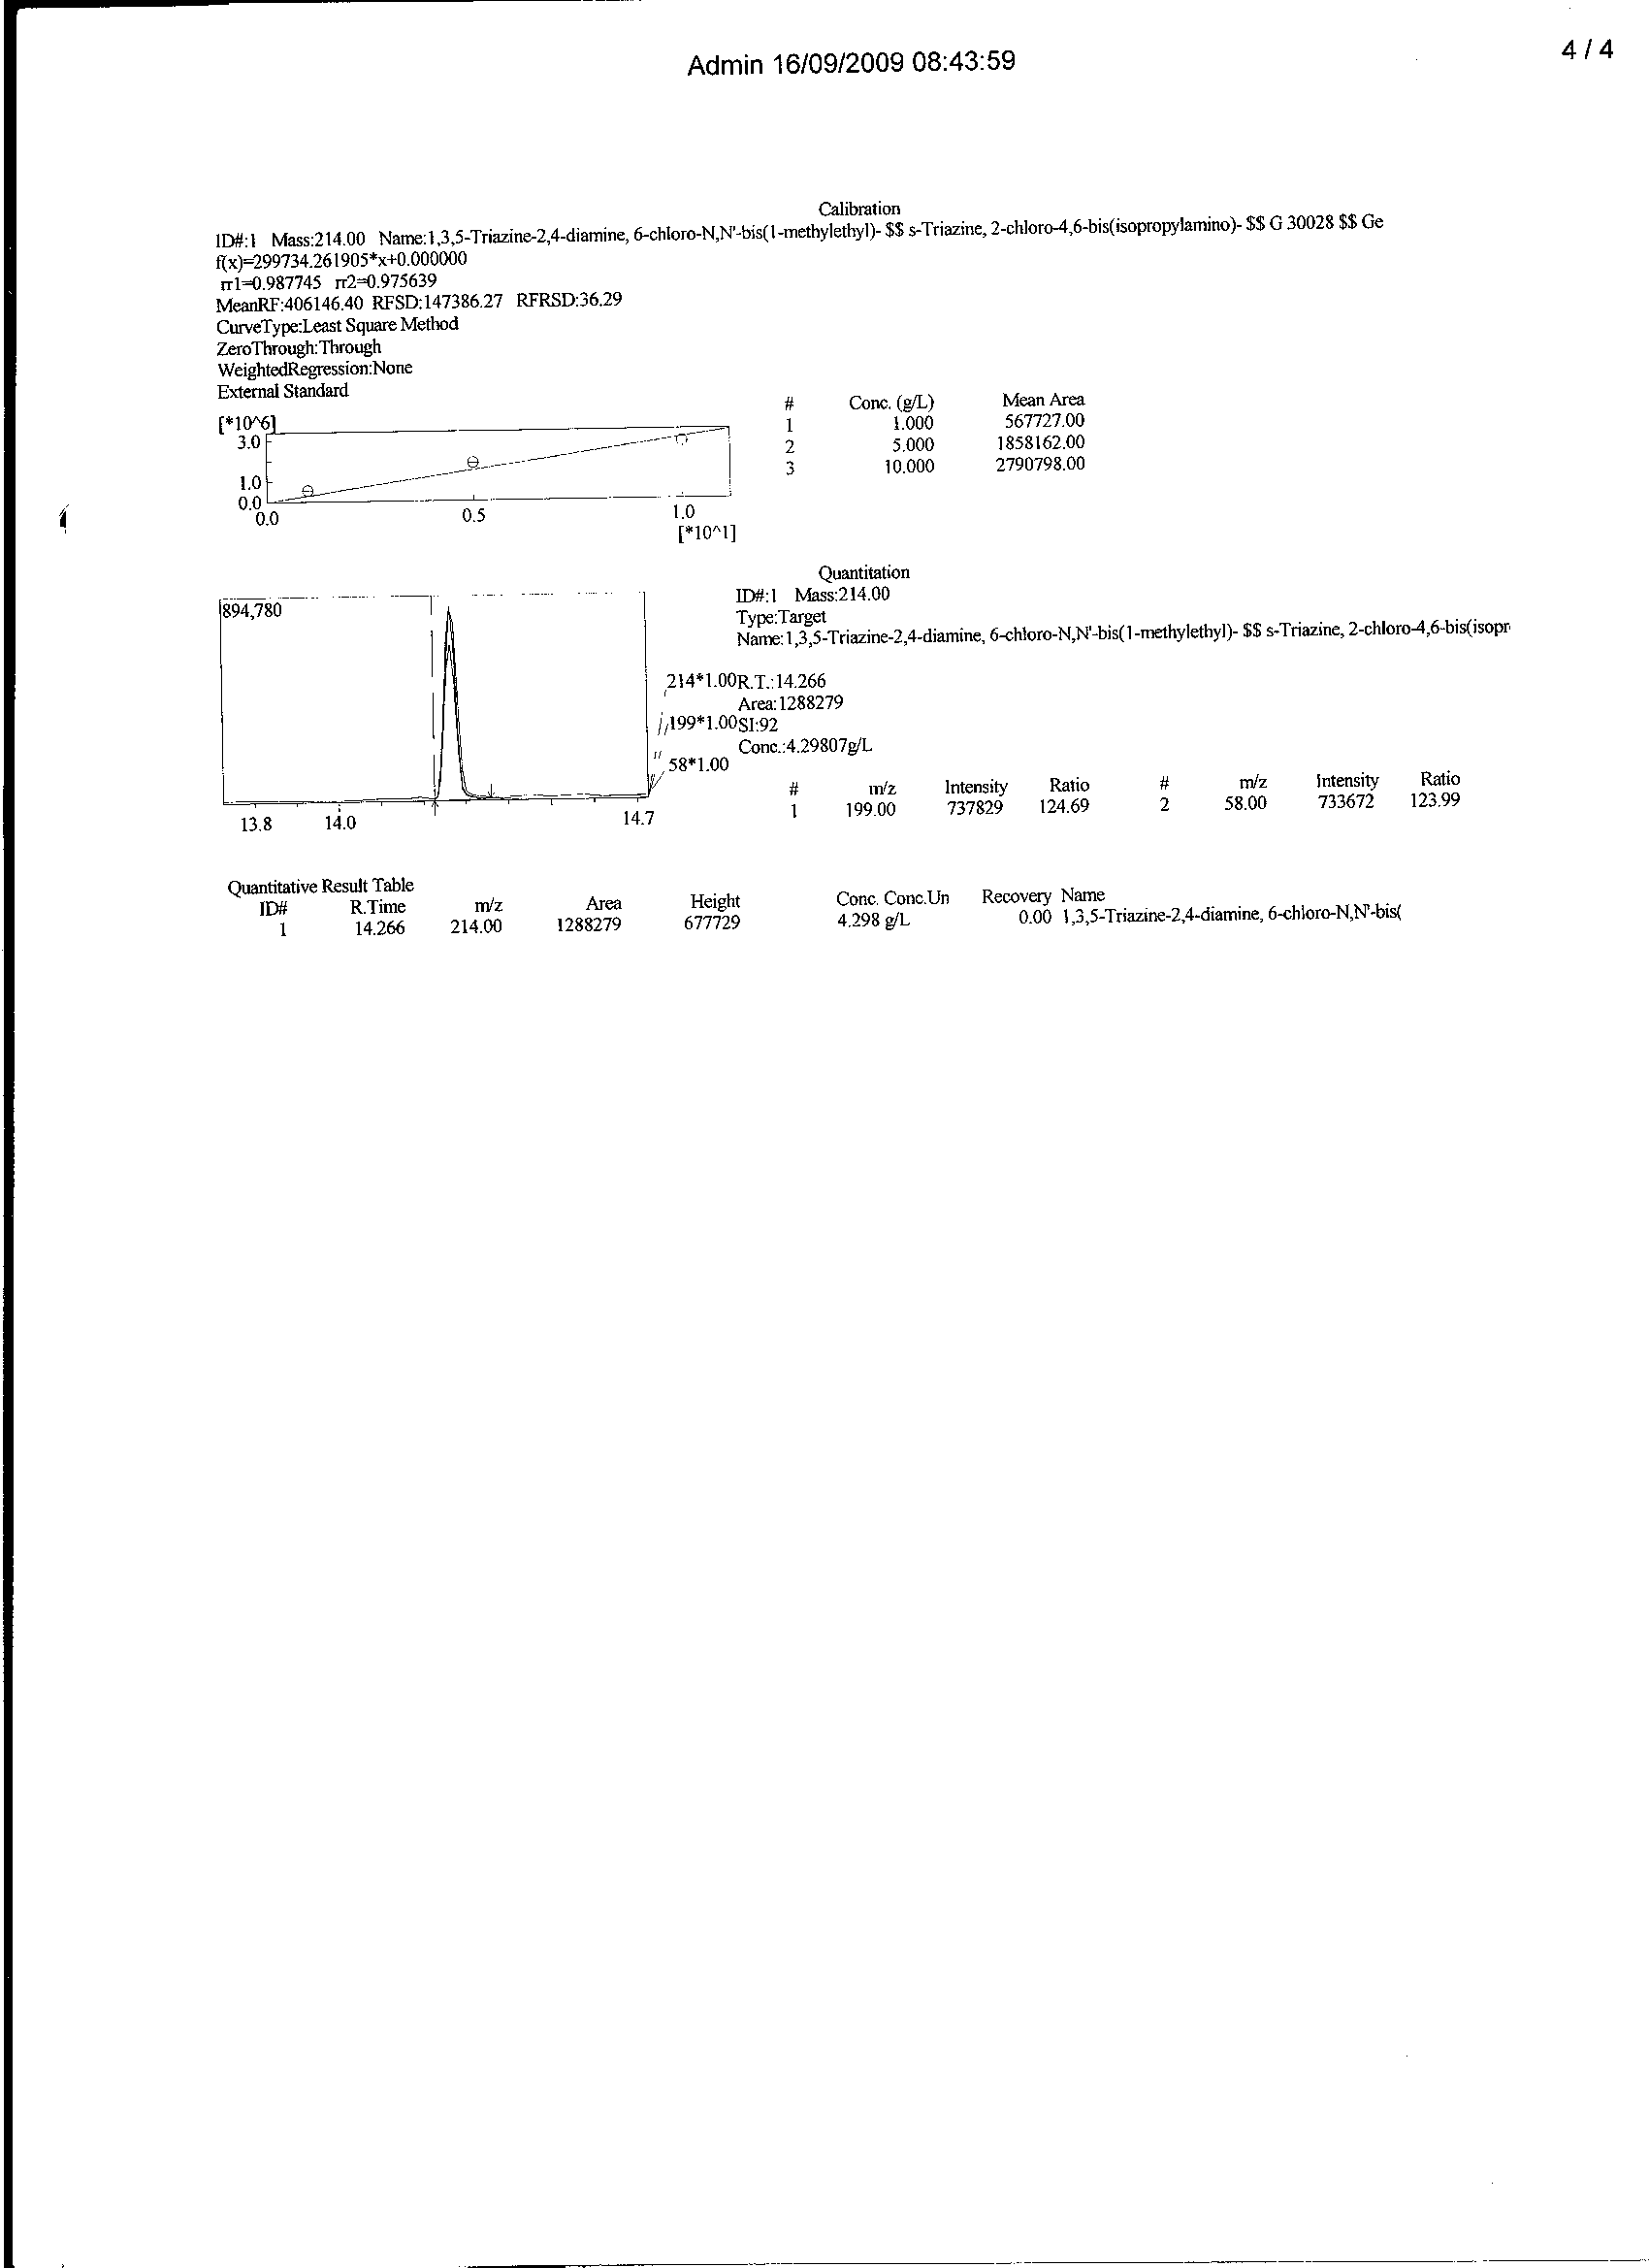
Figure 3: GC/MS chromatogram, quantitative measurement and spectral information of equilibrium phase atrazine after adsorption onto SS/A/10gL⁻¹ sorbent
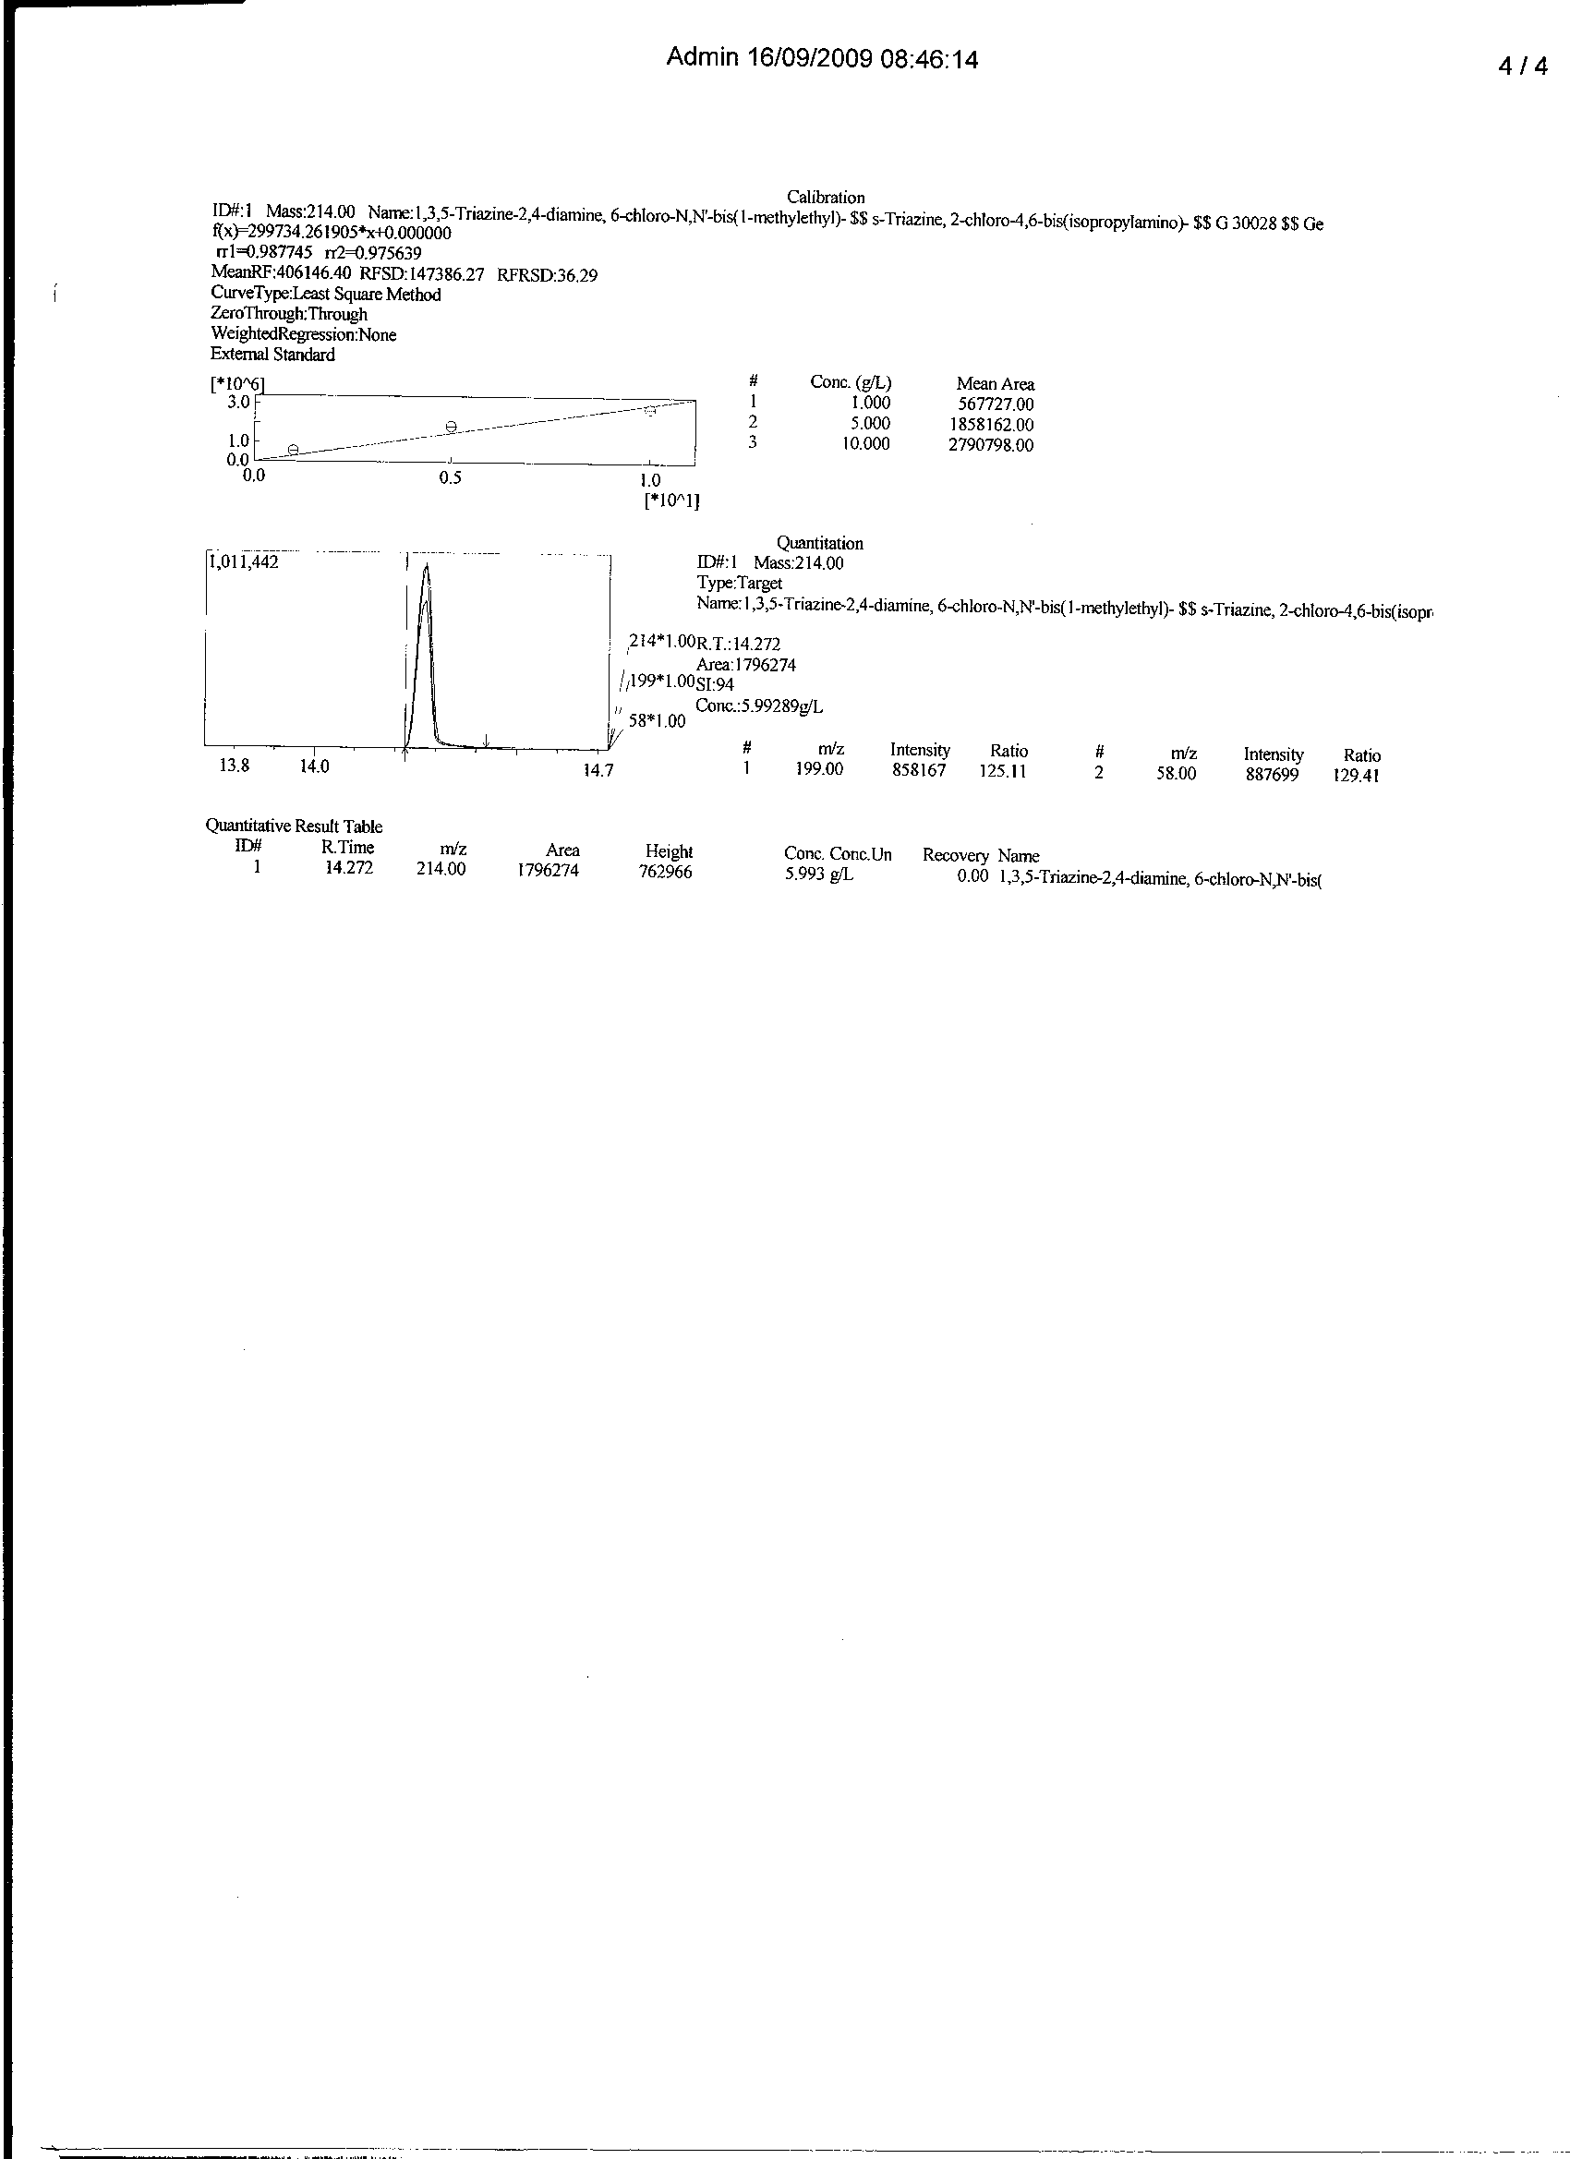
Figure 4: GC/MS chromatogram, quantitative measurement and spectral information of equilibrium phase atrazine after adsorption onto SS/A/15gL⁻¹ sorbent

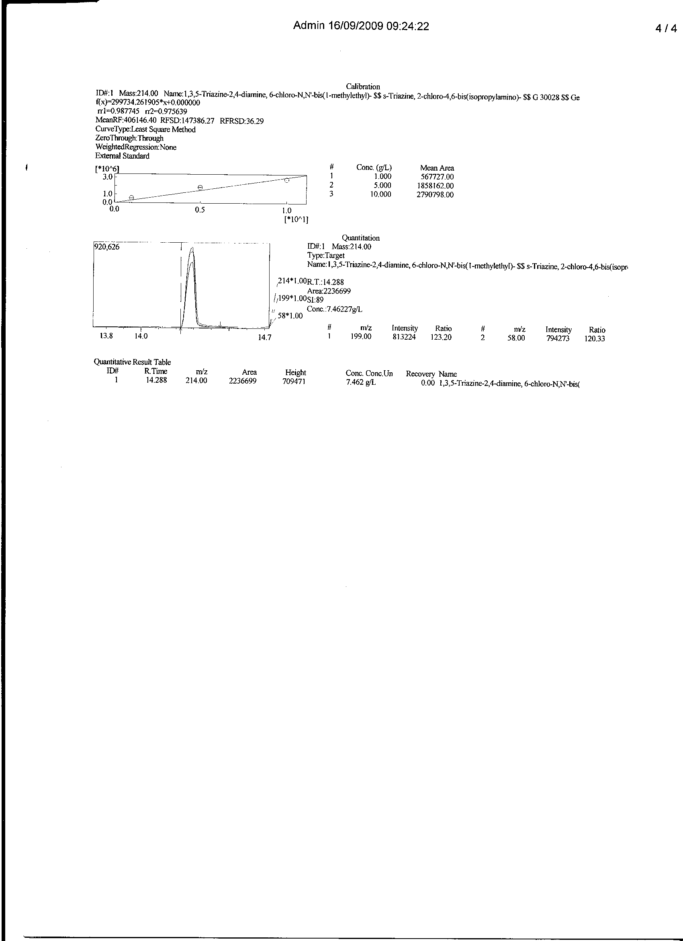
Figure 5: GC/MS chromatogram, quantitative measurement and spectral information of equilibrium phase atrazine after adsorption onto SS/A/20gL⁻¹ sorbent

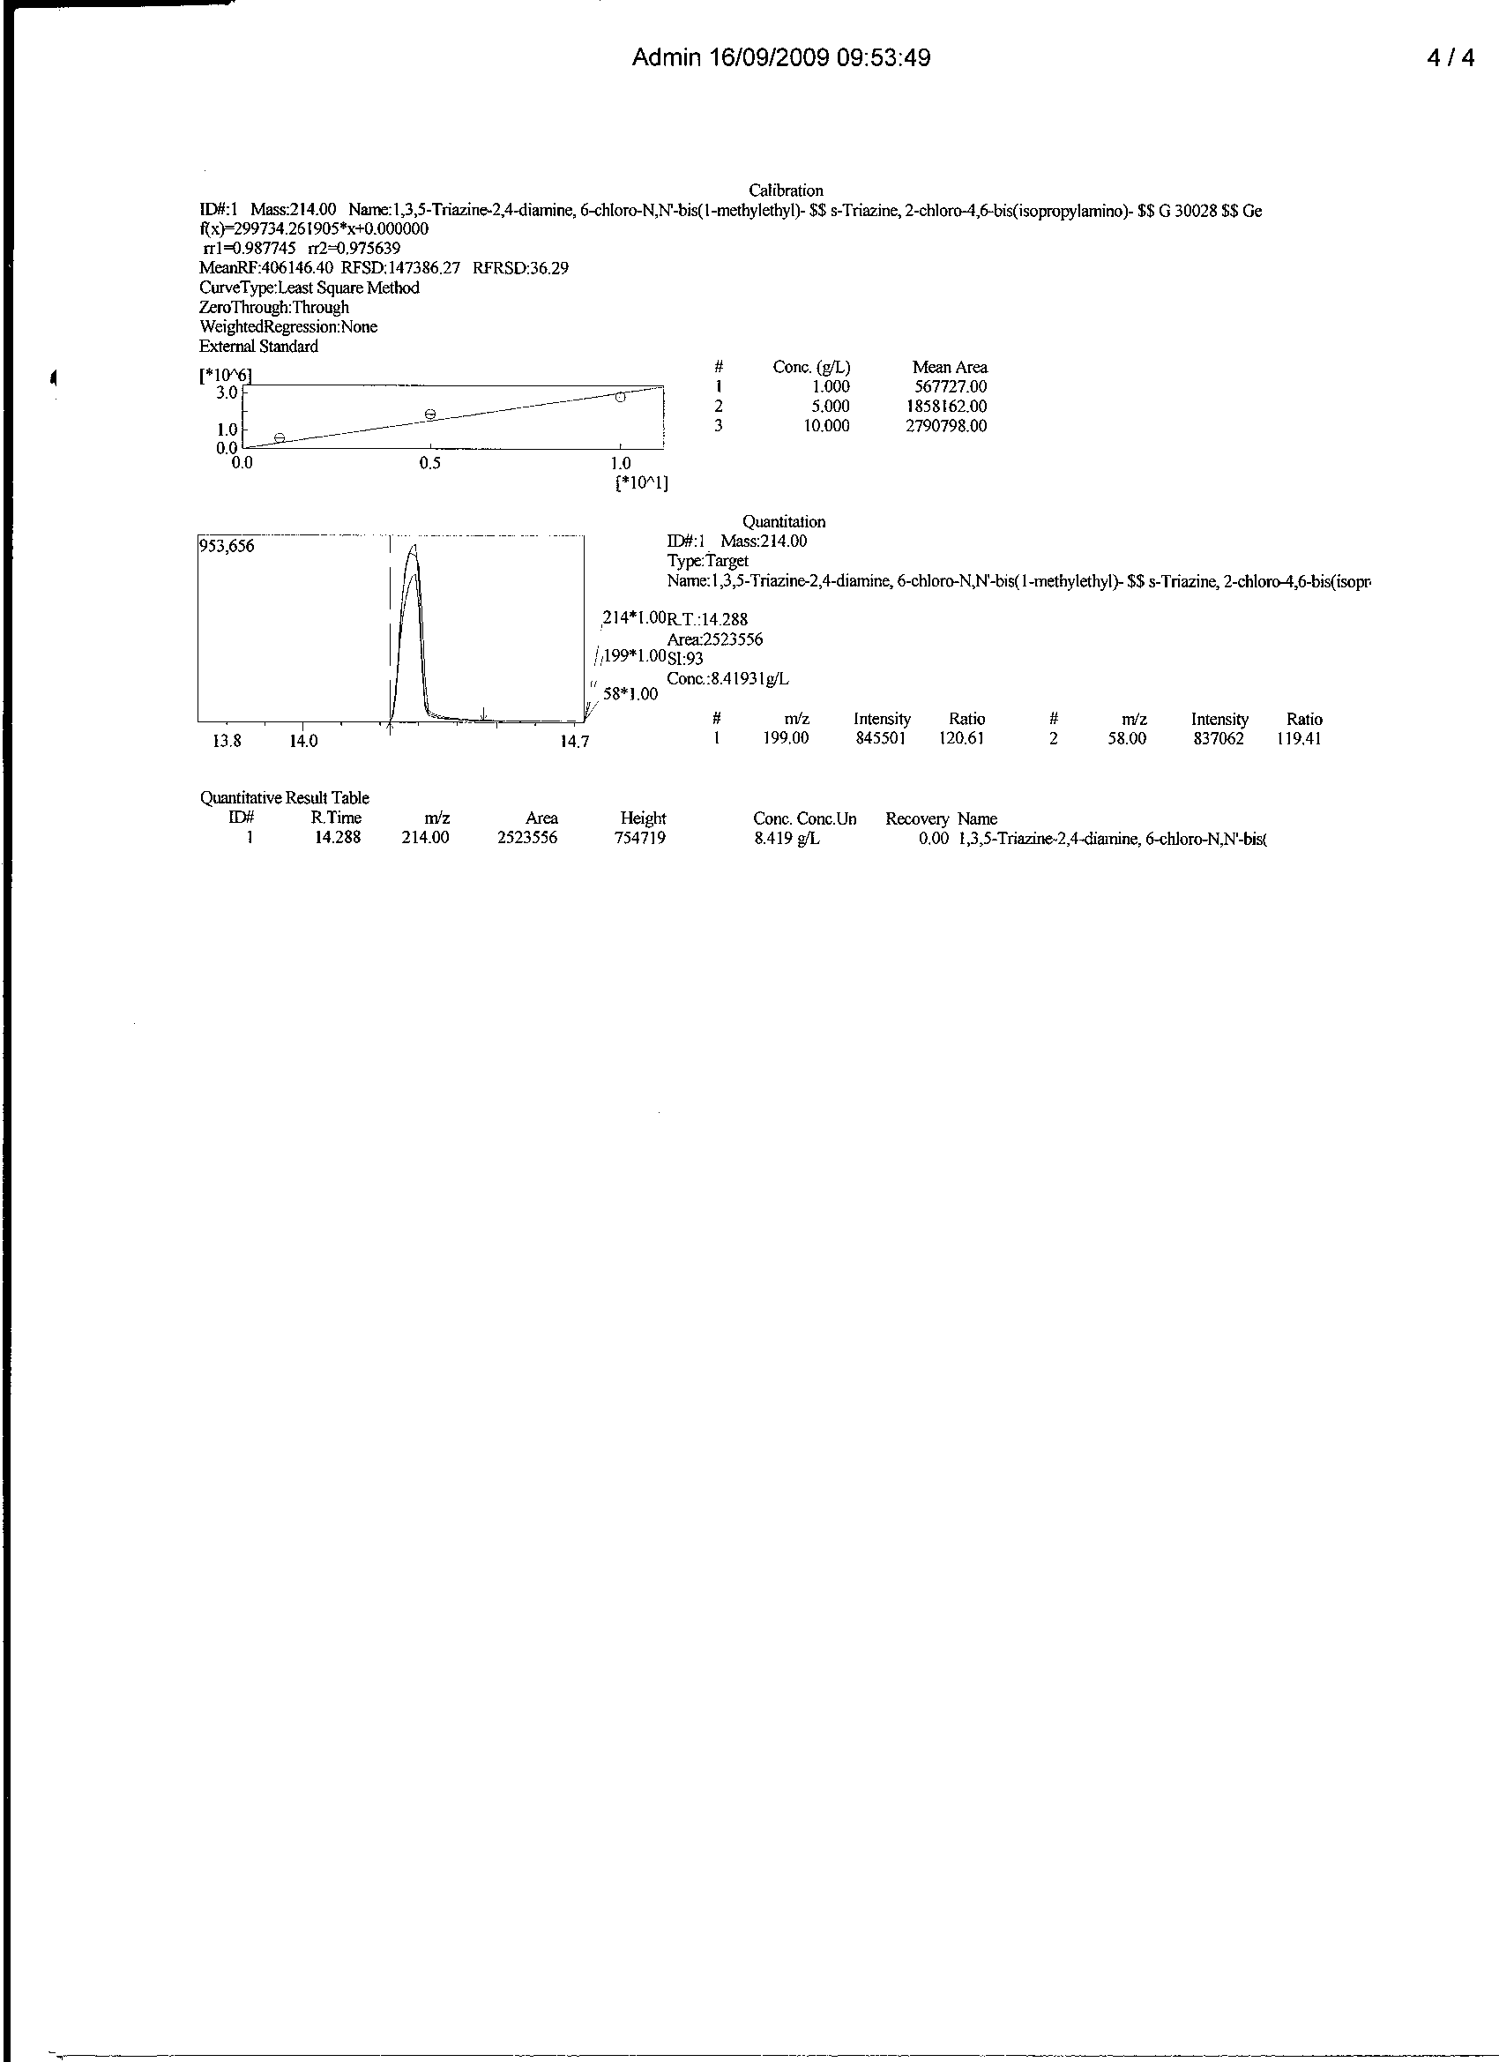
Figure 6: GC/MS chromatogram, quantitative measurement and spectral information of equilibrium phase atrazine after adsorption onto SS/A/25gL⁻¹ sorbent

Equilibrium experimental data from Figures 2 to 6 were treated as Table 1

Table 1: Adsorption experimental data of atrazine uptake by fixed mass of SS-Sorbents at different initial sorbate concentration, using GC/MS
Sorbent | Co (g/dm³) | Ce (g/dm³) | Ca (g/dm³) | % RE | Ads.m  (mg.10⁻³) | q_{e}  (mg/g x 10⁻³) | Kc | ΔG  (kJ/mol)
SS/A/5 | 5 | 2.696 | 2.304 | 46.08 | 0.0230 | 0.230 | 0.854 | +393.941
SS/A/10 | 10 | 4.298 | 5.702 | 57.02 | 0.0570 | 0.570 | 1.327 | -705.381
SS/A/15 | 15 | 5.993 | 9.007 | 60.047 | 0.0901 | 0.901 | 1.503 | -1016.670
SS/A/20 | 20 | 7.462 | 12.558 | 62.69 | 0.1254 | 1.254 | 1.680 | -1294.989
SS/A/25 | 25 | 8.419 | 16.581 | 66.324 | 0.1658 | 1.658 | 1.969 | -1691.330
SS/A/15 -Sheanut shells, treated with H₃PO_{4,}activated for 15 minute dwell time, SS/A/25 -Sheanut shells, treated with H₃PO_{4,}activated for 25 minute dwell time

- Discursion
Effect of initial atrazine concentration on removal efficiency
Table 1 presents the role played by initial sorbate concentration and its effect on sorption efficiency. The highest percentage atrazine removal was observed with the interaction of 0.1g atrazine with 10Cm³ of a 25g/L atrazine solution. Hence, out of 25g/L, 20g/L, 15g/L, 10g/L and 5g/L initial atrazines concentration, a total of 16.581, 12.538, 9.007, 5.702 and 2.696g/L atrazine was attracted onto the sheanut shell (SS) bioadsorbent. These accounts for a 66.324, 62.69, 60.007, 57.020 and 46.080% removal efficiency respectively. Findings in this research showed that for the selected time (1hour interaction) and within the 0.1g sorbent dose on 10Cm³ sorbate solution, (i) Adsorption efficiency increases with initial sorbate concentration.
(ii) Adsorption within the low sorbate concentration (5 – 10g/dm³) range could possibly be followed by desorption. Hence, a less than 50% adsorption was investigated.
(iii) Adsorption of fairly high concentrated atrazine (15 – 25g/L) could be governed by a multilayer adsorption with resultant intraparticle attraction. In light of this, sorption efficiency or percentage sorbate uptake is greater than 60%.
Sorption isotherm modeling
The regression equation and R² values for Dubinin-Radushkevich model was observed that this isotherm also gave very good description of the sorption process, over the range of concentration studied. The apparent energy of adsorption and Dubinin-Radushkevich isotherm constants are shown on Table 2 and obtained from the plot of type in figure 7. The high values of q_{D} shows high sorption capacity. The values of the apparent energy of adsorption also depict physisorption process.

Table 2 - Temkin and R-D adsorption experimental GC/MS data for atrazine uptake by chemically modified SS-sorbent.
ISOTHERMS | Relationship  (Y=) | R² | Parameters  ( constant ) | Values.
Temkin | 0.790x _ 0.947 | 0.927 | b (Unitless)  B(J/mol)  A(Lg⁻¹) | 3158.794  0.790  3.316
R-D | -9.466x-2.360 | 0.979 | q_{D} (mgg⁻¹) | 4.37x10⁻³
 |  |  | B_{D} (Mo1² KJ⁻²) | 0.7600
 |  |  | E_{D}(kjmo1-2) | 0.8111

The two isotherms experimental data on Table 2 were used to estimate certain energy parameters. The Dubinin-Radushkevich, (R-D) isotherm model is more general than the Langmuir isotherm as its deviations is not based on ideal assumptions such as equipotential of sorption sites, absence of steric hindrances between sorbed and incoming particles and surface homogeneity on microscopic level (Monika et al,. 2009). The estimated constant, B_{D}, related to adsorption energy was presented as 0.7600 mol²kJ². This constant gives an idea about the mean free energy which was valued as E_{D}= 0.811 kJmol⁻¹. E_{D} is a parameter used in predicting the type of adsorption. An E_{D} value < 8 kJmol⁻¹ is an indication of physisorption (Monika et al., 2009).

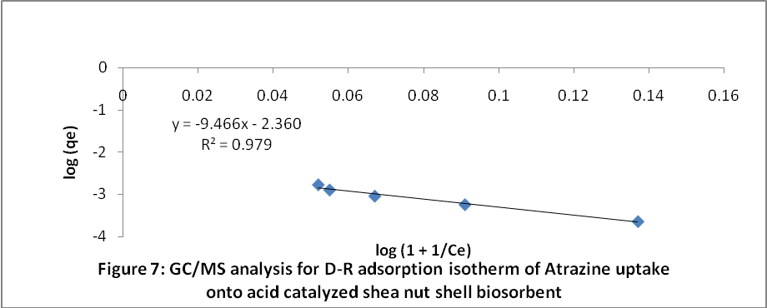

The R-D Theoretical saturation capacity, q_{D} and the Langmuir maximum adsorption capacity, q_{m} were both estimated as q_{D} = 4.37x10⁻³mgg⁻¹ and q_{m} = 0.772x10⁻³ mgg⁻¹. No known and proven reference could make us conclude that the theoretical saturation capacity, q_{D} is always higher than the maximum adsorption capacity as the case was made evidence in this research.
The Temkin constant related to heat of sorption, B was estimated as 0.790 J/mol. The unit less quantity, b (3158.794) and Temkin constant, A (3.3159 Lg⁻¹) were in good agreement with values presented by Hameed, (2009) on the Evaluation of papaya seed as a non conventional low cost adsorbent for removal of dye.

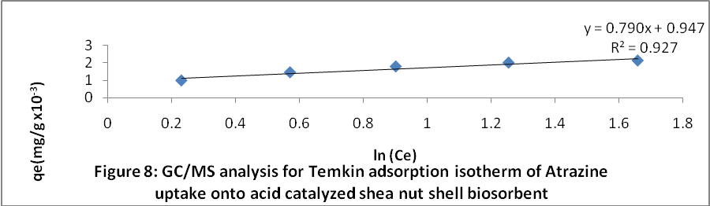

In the energy parameter models, R-D and Temkin were used to present sorption energy value (B_{D}), mean free energy (E_{D}) and heat of sorption (B). They were estimated as 0.7600mol²KJ⁻², 0.8111 kjmol⁻¹ and 0.790Jmol⁻¹ respectively, the parameter predicting the type of adsorption was evaluated as E_{D} which is an indication of physisorption dominates chemisorption, ion exchange etc. The R-D model with a higher correlation coefficient values, R² = 0.979 proves a better choice in explaining sorption energies. Besides the E_{D} validation test, The mean free and energy values and heat of sorption values (in kJ/mol) were lower than 20KJ/mol. This ,according to Atkins,(1999) is characteristics for physisorption. In their report, physisorption is also called non specific adsorption which occur as a result of long range weak Van der Waals forces between adsorbates and adsorbents. The energy released when a particle is physisorbed is of the same magnitude as the enthalpy of condensation. The enthalpy of physisorption was however measured by monitoring the rise in temperature of a sample of known heat capacity to give typical values of in the region of less than 20kJ /Mol (Atkins, 1999).He also argued that Chemisorption is a specific adsorption and limited to monolayer coverage of the substrate. Here, a covalent bond is formed between the adsorbate and adsorbent. The enthalpy of Chemisorption is within the range of 200kJ/Mol (Atkins, 1999).Reports (Unpublished) on surface coverage in this experiment fitted best into the Freundlich Isotherm (sorption on heterogeneous surface).Hence, adsorption is not restricted to monolayer coverage as purposed for Chemisorption.
Conclusion
Generally, sheanut shells can be used as alternative precursors for activated carbon production via the two steps and acid treatment method. On the same fashion, sorption quantification was feasibly observed for a multicomponent system (Herbicide) with a gas chromatography coupled with mass spectrophotometer as detector when the simulated concentration was established via the external standard method. A physorption type of adsorption was predicted for the process.
Acknowledgements:
Authors are grateful to the instrumental unit of NARICT, Zaria for the GCMS analysis
Corresponding Author: Dr. Itodo Udoji Adams
Department of Applied Chemistry, Kebbi state University of Science and Technology, P.M.B 1144, Aliero, Kebbi state, Nigeria
E-mail: itodoson2002@yahoo.com
TEL: +2348073812726, +2348039503463
References
1. Agdi K, Bouaid A, Martin E, Fernandez H, Azmani A, Camara C. Removal of atrazine from environmental water by diatomaceous earth remediation method. Journal of Environmental monitor 2000; 2: 420-423.
2. Arun S. Adsorption of organic pollutants onto Natural adsorbent. MSc Thesis. Department of Chemical engineering, Mississippi State University 2002: 32-35
3. Atkins P. Physical chemistry 6th Edn. Oxford University press, London, 1999: 857- 864.
4. Chilton N, Jack N, Losso N, Wayne E, Marshall R. Freundlich adsorption isotherm of Agricultural by product based powered Activated carbon in Geosmin water system. Bioresoruce Technology 2002; 85 (2): 131-135
5. Cooney DO. Adsorption Design for Wastewater Treatment. First Edn. Lewis. Publishers, CRC Press LLC, Boca Raton, Florida,1999
6. Fan M, Marshall W, Daugaard D, Brown C. Steam activation of chars produced from oat hulls Bioresource technology 2003; 93 (1):103-107
7. Gimba C, Ocholi O, Nok A. Preparation of A.C from Agricultural wastes II. Cyanide binding with activated carbon matrix from groundnut shell. Nig journal of scientific research 2004; 4 (2): 106-110.
8. Glenn MR. Activated carbon application in the food and pharmaceutical industries. First Edn.Technomic Publishing coy. inc., USA, 1993; 177-179
9. Hameed BH. Evaluation of papaya seed as a non conventional low cost adsorbent for removal of MB. Hazardous materials 2009;162:939-944.
10. Hameed BH, Din AM, Ahmad AL. Adsorption of methylene blue onto Bamboo based activated carbon: kinetics and equilibrium studies. Hazardous materials. 2006;137(3):695- 699
11. Horsfall M, spiff AI, Abia AA . Studies on the influence of mercaptoacetic acid (MAA) modification of cassava (manihot sculenta cranz) waste biomass on the adsorption of Cu²⁺ and Cd²⁺ from aqueous solution. Korean Chemical Society 2004; 25(7): 969-976.
12. Itodo AU, Abdulrahman FW, Hassan LG, Maigandi SA, Happiness, UO. Estimation of the type of adsorption, sorbent saturation capacities and heat of sorption of poultry droppings activated carbon animalis. International journal of Natural and Applied sciences 2009a;5(1)92-97
13. Itodo AU, Happiness UO, Obaroh IO, Usman A, Audu SS. Temkin, R-D, Langmuir and Freundlich adsorption Isotherms of industrial dye uptake unto H₃PO₄ catalyzed poultry waste bioadsorbent. Journal of Science and Technology research 2009b; 8(1):52-56.
14. LaGrega M, Buckingham P, Evans J, Environmental Resources Management Group. Hazardous Waste Management. McGraw-Hill Inc., New York, 1994.
15.Malik, R; Ramteke, D. and Wate, S. Adsorption of Malachite green on groundnut shell waste based activated carbon. Waste management. 2006; 27 (9): 1129-1138.
16.Min C, Yun Z. Rapid method for analysis of organophosphorus pesticide in water:Bulletin application note. Agilent Technology, USA 2008;19-21.
17. Monika J, Garg V, Kadirvelu k. Chromium (VI) removal from aqueous solution, using sunflower stem waste. J. Hazardous materials 2009;162:365 – 372.
18.Nunes A, Franca SA, Olievera LS. Activated carbon from waste biomass: An alternative use for biodiesel production solid residues. Bioresource Technology 2009;100:1786 -1792.
19. Omomnhenle, S; Ofomaja, A. and Okiemen, F.E. Sorption of methylene blue by unmodified and modified citric acid saw dust. Chemical society of Nigeria 2006; 30 (1 & 2): 161- 164.
20. Raymond, P.W. Principle and practice of chromatography. First edition. Chrom. Edn. Bookseries, 2003;19 – 26. Retrieved from http://www.library4science.com/enla.html.
21. Robert, L. and Eugene, F. Modern practice of chromatography. 4th Edn. Wiley interscience. John Wiley and sons Inc. New Jersey, 2004; 425
22. Rozada F, Calvo F, Garcia A., Martin V, Otaro M. Dye adsorption by sewage sludge based activated carbon in batch and fixed bed system. Bioresource technology 2003; 87 (3): 221 – 230.
23. Steve K, Erika T, Reynold, T., Paul M. Activated carbon :A unit operations and processes of activated carbon. Environmental engineering 2nd edn. PWS Publishing Co. 1998; 25, 350, 749
24.Vidic RD, Suidan, MT, Brenner RC. Environmental Science and Technology 1993; 27(10), 2079.
25. WHO. International Agency for Research for Cancer. Monograph on evaluation of carcinogenic risks to human: Atrazine. WHO, Geneva.1999; 73: 59.
26. Zhongren Y, James E, Kishore R, Gary B, Marv P, Ding L, Benito M. Chemically Activated Carbon on a Fibre glass Substrate for removal of trace atrazine from water. Material Chemistry. 2006;16: 3375-3380.
Received February 8, 2010

