Retrotransposon Tto1 in tobacco was activated by the implantation of Low-energy N⁺ ion beam

Ya Hui-yuan¹* Wang Wei-dong² Chen Wan-guang¹ Qin Guang-yong² Huo Yu-ping²
1Life science department, Luoyang Normal University Luoyang 471022 China
2Henan Key Lab of Ionbeam Bioengineering, Zhengzhou University, Zhengzhou 450052, China
yahuiyuan@yahoo.com.cn

Abstract Tobacco retrotransposon Tto1, one of a few active retrotransposons of plants, has been shown to be activated by plant tissue culture (protoplast), wounding stress and methyl jasmonate. Low-energy ion beam, a kind of mutagen, can induce many kinds of botanical mutants. The relation between the retrotransposon Tto1 and stress of the ion implantation was interested to many researchers focused on idea that whether Tto1 was activated by implantation of the low-energy ion beam or not. Here，quantitative real-time PCR were used to investigate whether the implantation of ion beam increased the copy number of the Tto1 in tobacco genomic or not, clustering according to the banding pattern generated by IRAP with primers to retrotransposon Tto1 was used to investigate the genetic polymorphism between the tobacco population implanted by the ion. The results showed that the copy number of Tto1 in some treated individuals was creased 10 folds in the second euphylla and more 2 folds in petal. Analysis of the clustering UPGMA method showed that radiation of the ion caused great dissimilarity (dissimilarity coefficient >0.6) between partial treated samples and the controls. The great genetic dissimilarity based on the retrotransposon Tto1 and the increased copy number of the Tto1 implied that Tto1 was also activated by the exposure to the implantation of ion. The transposition of Tto1 takes place in both the somatic cell and the apical meristem cell, and then, the increased copy number can be transferred from the apical meristem cell of the plantule to the differential organs (here petal is showed). These ﬁndings are discussed in the role of the transpositional Tto1 played in response to the implantation of the low-energy ion beam. [Life Science Journal 2010;7(3):141-147]. (ISSN: 1097-8135).

Keywords: Retrotransposon Tto1; Nicotiana tabacum L.; Low-energy ion beam; Transposition

Introduce
Transposable elements (TEs), being DNA fragments which can be transposed within chromosomes in cells (Feschotte C et al. 2002). Retrotransposons are ubiquitous in plant genomes (Kubis SE et al. 1998; (Kumar A and Bennetzen JL. 1999). Many retrotransposons are integrated in either a transcriptionally or transpositionally incompetent state. However, some quiescent retrotransposons can be activated by wounding, oxidative stress and pathogen infection, and even in plant tissue culture (Feschotte C et al. 2002; Vicient CM et al. 2001; Meyers BC et al. 2001; Grandbastien MA. 1998). Retrotransposon populations are highly heterogeneous, showing great differences in copy number and genomic localization even between closely related species (Carlos MV et al. 1999), Hence several marker systems based upon retrotransposons have been developed. Inter-Retrotransposon Amplified Polymorphism (IRAP) and Retrotransposon-Microsatellite Amplified Polymorphism (REMAP), two excellent marker systems based upon the copy numbers and the location of the retrotransposons, can be used to detect any insertion event, which require neither restriction enzyme digestion nor ligation to generate the marker bands. The methods can distinguish between barley varieties and produce "fingerprint patterns for species across the genus (Kalendar R et al. 1999). IRAP and REMAP Markers derived from Tos17, a copia-like endogenous retrotransposon of rice, were used to identify genetic similarity among 51 rice cultivars (Castelo J S B et al. 2007). The IRAP and REMAP techniques can be used separately or combined for a more complete genome survey, and they are excellent sources of polymorphic markers. IRAP/REMAP proved to be as reliable molecular markers as AFLPs, they also bring additional information, showing a great potential use in genome assessments for fingerprinting, mapping and diversity studies (Sonia C. et al. 2007, Andrew J F.1999)
Ttol is 5.5 kb long and has features typical of retrotransposons in tobacco (Nicotiana tabacum L), it is the first demonstration of activation of a plant retrotransposon by tissue culture. The copy number of Ttol increased 10-fold in established protoplast formation cell lines; it also increased in plants regenerated from tissue cultures and in transgenic plants (Hirohiko H et al. 1993). Functional analysis of the Tto1 showed that it involved in re-activation by tissue culture, wounding, and treatment with elicitors. Tto1 has been implicated in the expression of phenylpropanoid synthetic genes in response to defense-related stresses (Kazuhiko S et al.2000).
The mutagenic eﬀect of low-energy ion beam implantation on cereal seeds, such as Oryza sativa, Triticum aestivum and soybean, has been substantiated by many studies in the past three decades. Many attractive biological effects occurred when the seeds of crops had been radiated by ion beam (Review, Feng HY et al. 2007). Up to now the exact mutagenic mechanism of the low-energy ion beam implantation on cereals has not been fully understood, especially the mechanism of the deleted and inserted DNA of the chromosomes in cell after implantation of the ion. Radialization of the ion beam can affect the transcriptional and transpositional activity of the retrotransposon Wis2-1A in wheat (Ya HY et al. 2007). Here we address the idea whether the implantation of low-energy ion beam re-activates transpositional acitivty of Tto1 in tobacco or not. To test the idea, IRAP and qPCR (Quantitative real-time PCR) were used to investigate genetic polymorphism (insertion event) and the copy number of the Tto1 in genome exposure to the implantation of the ion respectively because the copy number and the genetic polymorphism are related to the transposition of the retrotransposons.
Tobacco is the self-pollinated plant, the seeds from one individual plant parent, which had the heredity homogeneity, were implanted by low-energy N⁺ ion beam in there dosages. The following is the testing strategy.

Seeds from individual plant parent
Seeds are exposure to vacuum and radiated by implantation of the low-energy N⁺ ion beam in three dosages under the vacuum.
Treated seeds and the controls planted in plant nursery
DNA pool mixed with the equal DNA from the second euphylla of three individuals
DNA extracted from the petals of the above tested individuals
Investigate the insertion events and the copy number of the Tto1 in the second euphylla by IRAP and qPCR

Genetic polymorphism and the copy number of the Tto1 in petal were tested

Investigate genetic polymorphism (insertion event) and the copy number of the Tto1 in genome exposure to the implantation of the ion and vacuum, probe genetic polymorphism of Tto1 that caused by N⁺ ion beam and vacuum, test the idea whether the implantation of low-energy ion beam re-activates transpositional acitivty of Tto1 in tobacco or not, discuss the role of the transpositional Tto1 played in response to the implantation of the low-energy ion beam and exposure to the vacuum.

Materials and methods
Plant materials
Tobacco (Nicotiana tabacum L.) seeds, from selfing-line individual parent which was a cultivated variety in Henan province, were obtained from the Henan key lab of ion-beam bioengineering.
Implantation of the low-energy N⁺ ion beam and investigation of the germination percentage
The tobacco seeds were implanted by low-energy (40 Kev) N⁺ ion beam (generated by a machine: UIL.0.512, TNV. Russia, under a vacuum of 3×10⁻³ Pa ) in four dosages:0×10¹⁷N⁺/cm² under the vacuum (3×10⁻³ Pa) for 88min, 1×10¹⁷ N⁺/cm², 2×10¹⁷ N⁺/cm², 3×10¹⁷ N⁺/cm². Three replications were done each doses, one hundred seeds were implanted each replication. The germination percentage was investigated when the seedlings had two euphyllaes as the following equation: Germination percentage=Number of the seedlings/100 seeds×100%
Extraction of the DNA
Total genomic DNA of tobacco (N. tabacum) was extracted, as described previously (Malone G et al. 2006), from the second euphylla of three individuals and the petals (from individual). The DNA was tested by agarose gel electrophoresis under UV light and qualiﬁed by comparing with a Low DNA Mass Ladder (Invitrogen) on 0.8% agarose gel after ethidium bromide staining.
Quantitative real-time PCR and the relative copy number of the Tto1
The genomic DNA were diluted 100 folds to obtain a uniform concentration of 20 ngµL⁻¹
Quantitative real-time PCR (qPCR) was performed as described in the SYBR Permix Ex TaqTM Reagent (Takara Code No DRR041S) Manual. The final volume of reaction mixture was set at 25 µL containing 2 µL DNA and 0.4mol/L forward and reverse primer. Real-time PCR were carried out in the ABI 7500 real-time PCR System (Application Biosystems, Foster, USA) with the following cycling conditions: 95 °C for 1 min, 95 °C 10 s, 56 °C 20 s and 72 °C 10 s for 40 cycles. 18s rDNA of the tobacco was used as the reference gene. The primers used as the qPCR are the following: Tot1F 5`-GATGCAATGAGTGGTAGGTGAGATGAG-3`; Tot1R 5`-CTATATCTCTCTCCCTCTCAAACTCTTTC-3`; NT18SF 5`-GGATAACCGTAGTAATTCTA
GAGCTAATACGT-3` ; NT18SR 5`-AAAGTTGATAGGGCAGAAATTTGAATGATGCGT-3` .
The relative copy number of the Tto1 in genome was computed by the 2-△△Ct method
IRAP with the primers to Tto1
The amplification reaction was performed according to the protocol described by Kalendar et al (1999). One LTR primers (pTto1 5`-TCCGCTGTGCAGTAGTGTTTA GTG-3`) from Tto1 was obtained according to the described sequences in NCBI (Accession D83003). IRAP amplifications were performed in a final volume of 25 µL containing 50 ng DNA, 1U Taq DNA polymerase (Invitrogen), and 25 pmol of IRAP primer and other container. Amplification was performed in a thermal cycler model 480 (Perkin Elmer, Pomona, CA, USA) device in 0.2-mL microtubs. The amplification program consisted of initial denaturation at 94°C for 5 min, followed by 40 cycles composed of 94°C for 30 s, 60°C for 30 s, and 72°C for 120 s for denaturation, annealing, and extension, respectively. After amplification, a final extension step was performed at 72°C for 8 min. The amplification product was separated in polyacrylamide gel and silver-stained, as described by Briard et al (2000).
Clustering
Clustering was performed by the software UPGMA clustering method with the software NTSYSpc2.1 (Numerical Taxonomy and Multivariate Analysis System) according the banding pattern generated by IRAP amplification with primers to Tto1, which the DNA template was from the petals.
Results
Germination percentage
The germination percentage was investigated when the seedlings had two euphyllaes. The details was listed in the table 1.

Table 1. Germination percentage of the seeds implanted by low-energy ion beam in different dosages
Samples | Controls | Vacuum | 1×10¹⁷  (N⁺/cm²) | 2×10¹⁷ (N⁺/cm²) | 3×10¹⁷ (N⁺/cm²)
Germination percentage  (Mean±STD) | 70.33±2.52 | 78.0±2.0 | 82.33±1.53* | 2±1.0** | 0.67±0.58**
*and ** account for the signiﬁcant level P<0.05 and P<0.01 respectively, STD: Standard Error.

Under the implantation of the dosage: 3×10¹⁷ N⁺/cm², only two seeds germinated, but these two seedlings were not survived after three euphyllaes, it suggested that this dose is damaged seriously to the embryo in tobacco seed. Under the implantation of the dosage: 1×10¹⁷ N⁺/cm² and exposure to the vacuum, the germination percentage was higher significantly than the controls, it suggested small-dose implantation of ion promote the germination capacity of the tobacco seeds.
New insertion events implied by the Banding pattern of IRAP
Total genomic mixed DNA pools from the second euphylla were used as the template of the IRAP, which each DNA pool was extracted from mixtures of isometric three individual euphylla. Banding pattern (Fig1 and Fig2), generated by IRAP amplification with primers to retrotransposon Tto1, showed that two DNA pools amplified the polymorphism bands. One is the DNA pool is exposure to the vacuum (Fig1 line 14), which had two diversity bands (indicated by arrowheads).The other is the sample treated with the dosage: 1×10¹⁷ N⁺/cm² (Fig2 line 13), which had two diversity bands (indicated by arrowheads). Among these 24 DNA pools representing 72 individuals (24×3) treated by vacuum and N⁺ ion, only two DNA pools did amplified the polymorphism bands, it suggested that the insertion events have a low occurrence ratio under the vacuum and N⁺ ion implantation. There was no band polymorphism observed in the samples treated with 2×10¹⁷ N⁺/cm² because of few survivals.

Relative copy number of Tto1 in the second euphylla of the treated tobaccos
Copy number of the Tto1 in the second euphylla cell were determined by relative qPCR, 18s rDNA in tobacco was used as the reference gene. The copy number of the Tto1 was increased about 10 folds in two samples (Tabe2 showing partial results), one (Vac8 as the following) is exposure to vacuum (Va8 in Fig1), one (Ion9 as the following) is implanted by the 1×10¹⁷ N⁺/cm² (Fig2 in I-9). These do not necessarily mean that the copy number was increased 10-fold in all individuals of the DNA pool, because the DNA was isolated from mixtures of three individuals. Most of the samples have isometric copy number to the controls. The mean of the copy number in the samples under the vacuum except the Vac8, is 1.15±0.22 folds, which score is from 0.88-1.29 folds. But the mean of the copy number in the samples under the vacuum including the Vac8, is 2.04±2.83 folds. The mean of the copy number in the samples implanted by implantation of the 1×10¹⁷ N⁺/cm² expect the Ion9, is 1.17±0.30 folds, which score is from 0.80-1.49 fold. But the mean of the copy number in samples exposure to implantation of the 1×10¹⁷ N⁺/cm² including the Ion9, is 1.80±2.38 folds. Here, a note is that the copy number could be regard as variance distinctly when the value of 2^{△△CT} was necessarily beyond 2.0 or less than 1/2.

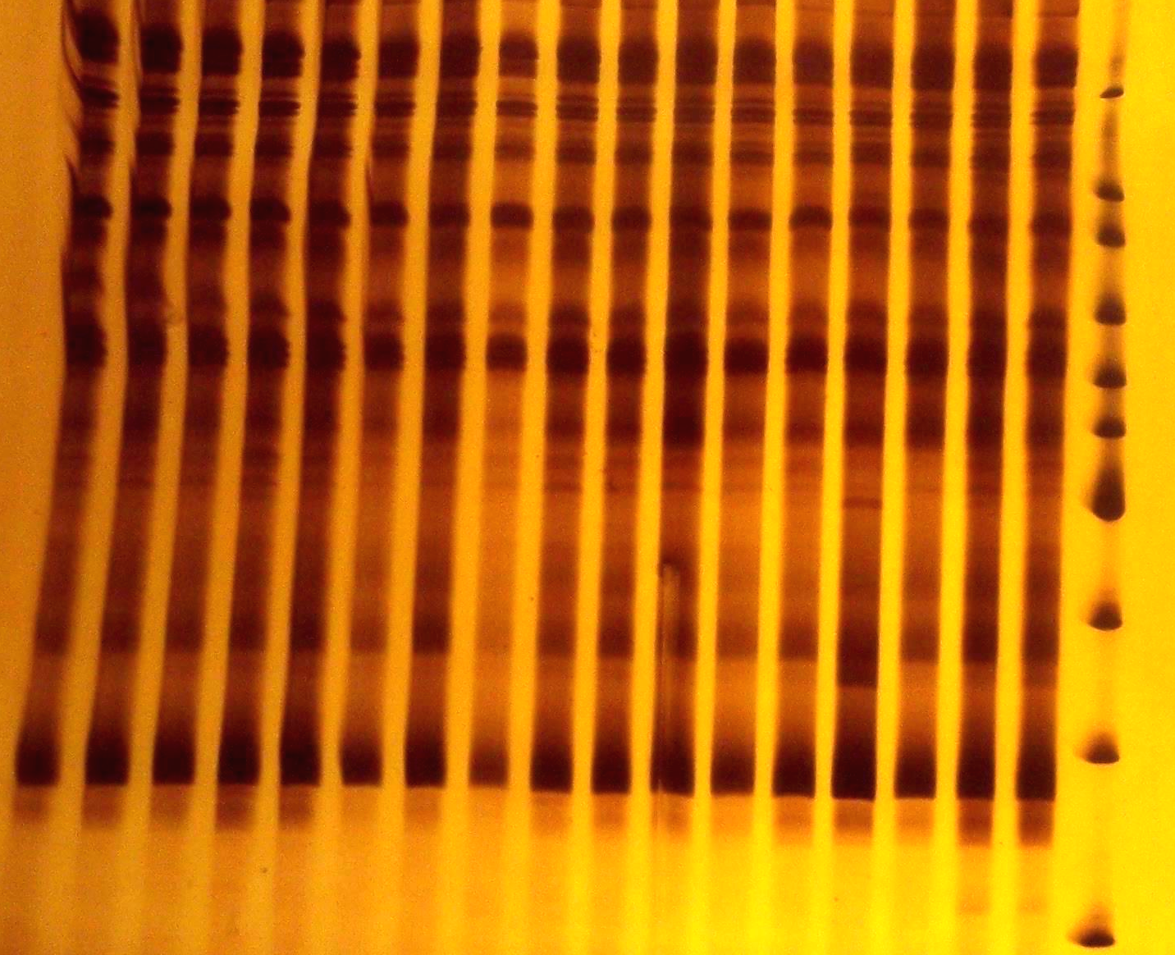

500bp
400bp
300bbp

200bp
W1 W2 W3 W4W5W6Va1Va2Va3Va4VaVa6Va7Va8Va92-12-2 M 10

Figure1. Banding pattern generated by IRAP with primers to retrotransposon Tto1. Lanes from the 1-6 are the controls, including 18 individuals; Lanes from 7-15 are the samples is exposure to the vacuum, including 27 individuals; Lanes from 16-17 are the samples implanted by the ion beam with dosage: 2×10¹⁷ N⁺/cm² , including 6 individuals; lane 18 are the 100 bp ladder DNA marker. Marker sizes in bp are indicated on the right axis. W: the control; Va:vacuum; 2: 2×10¹⁷ N⁺/cm²

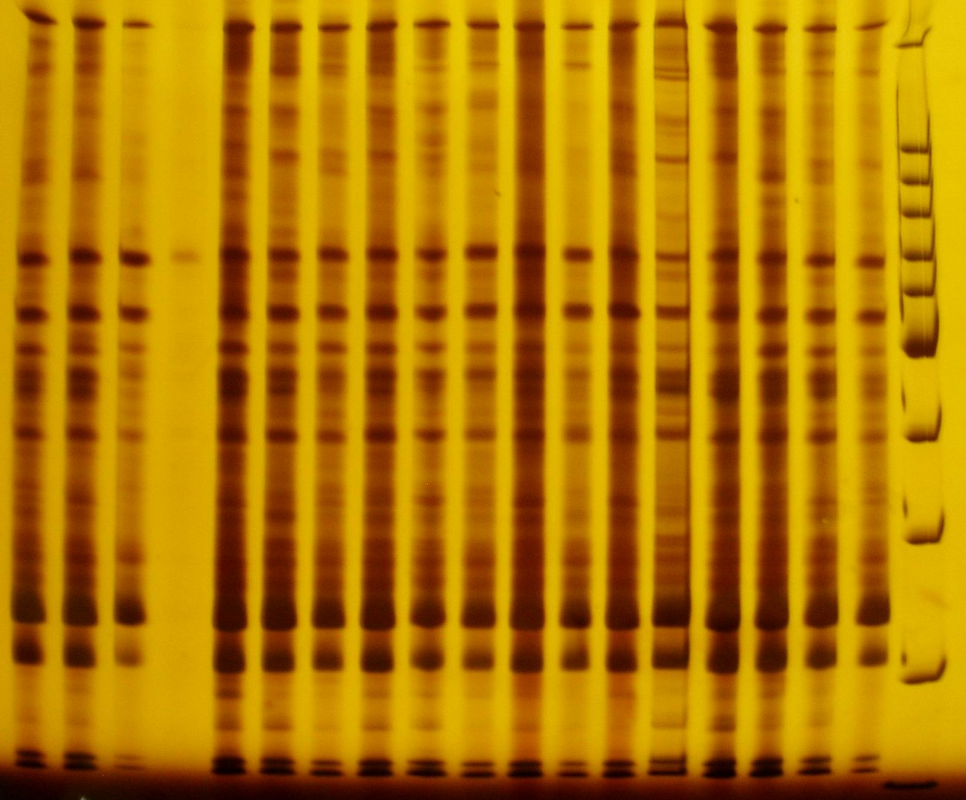

1kb

500bp

300bp

200bp

100bp
W1W2W3 W4 I-1 I-2 I-3 I-4 I-5 I-6 I-7 I-8 I-9 I-10I-11I-12I-13M

Figure 2. Banding pattern generated by IRAP with primers to retrotransposon Tto1. Lanes from the 1-5 are the controls, including 12 individuals; Lanes from6-18 are the samples treated by the ion beam with dosage: 1×10¹⁷ N⁺/cm² , including 39 individuals; lane 19 are the 100 bp ladder DNA marker. Marker sizes in bp are indicated on the right axis. W: WT or the control; I(ion): 1×10¹⁷ N⁺/cm²

Table2 Cycle threshold (CT) and relative copy number of Tto1 in five samples
Samples | Average CT of 18s rDNA | Average CT of Tto1 | △△CT | 2^{-△△CT} (Relative copy number)
Control | 14.48± 0.23 | 14.24±0.34 | ---- | ----
Vac3 | 14.58± 0.13 | 14.12± 0.03 | -0.22 | 1.16
Vac8 | 18.47± 0.42 | 14.90± 0.13 | -3.33 | 10.06
Ion1 | 15.64±0.61 | 14.28± 0.01 | -0.12 | 1.09
Ion9 | 17.53± 0.03 | 14.35± 0.04 | -3.31 | 9.92

Cycle threshold (CT) and relative copy number of Tto1 of five individuals were listed in this table, including the two samples which relative copy number were increased about 10 folds and two samples which relative copy number were isometric to the controls. The rows of the CT were expressed as Mean±STD
Relative copy number of Tto1 in the petal cell
To test the idea that whether the relative copy number of Tto1 were increased in the petal of the individuals isolated from the samples Vac8 and Ion9, which the copy number of the Tto1 was increased 10 folds in the second euphylla. Genomic DNAs of 27 individuals, isolated from the above DNA pools:Vac8 and Ion9 , other six DNA pools selected randomly and one DNA pool of the controls, were to be amplified with IRAP protocol. The results (details not shown) showed that the mean of the relative copy number of Tto1 in petal is 1.28±0.48 folds, and the score of it is 2.32~ 0.70 folds. However, the relative copy number of Tto1 in petal cell of the Vac8-3, Ion9-1, Ion9-3 are increased distinctly beyond 2.0 folds (Talbe3 listed only the relative copy number of Tto1 in the six tobacco individuals isolated from Vac8 and Ion9), that in other samples are increased slightly (1.57~0.70 folds)
Table3 CT and relative copy number of Tto1 of the six individual petal cells which increased 10 fold in euphylla
Samples | Average CT of 18s rDNA | Average CT of Tto1 | △△CT | 2^{-△△CT} (Relative copy number)
Control | 14.74± 0.52 | 17.06±0.14 | ---- | ----
Vac8-1 | 15.13± 0.05 | 17.46± 0.01 | 0.02 | 0.99
Vac8-2 | 14.72± 0.41 | 17.54± 0.37 | 0.50 | 0.70
Vac8-3* | 15.96±0.87 | 17.15± 0.23 | -1.13 | 2.19
Ion9-1* | 16.94±0.11 | 18.07±0.09 | -1.20 | 2.29
Ion9-2 | 14.52±0.23 | 16.69±0.36 | -0.15 | 1.11
Ion9-3* | 15.68±0.07 | 16.78±0.26 | -1.21 | 2.32

CT and relative copy number of Tto1 of six individuals were listed in this table, including the two DNA pools which relative copy number of Tto1 were increased about 10 fold. The rows of the CT were expressed as Mean±STD, Vac8-1, Vac8-2, Vac8-3 were isolated from the DNA pool: Vac8, Ion9-1, Ion9-2, Ion9-3 were isolated from the DNA pool: Ion9
UPGMA clustering analysis based on profile of IRAP with primers to Tto1 in petals
The DNAs from petal of twelve individuals were amplified with IRAP protocol. UPGMA （Unweighted Pair Group Method with Arithmetic Mean）clustering analysis (Fig.3) was performed by the software NTSYSpc 2.1 according to the banding pattern (data not shown) generated by IRAP with primers to retrotransposon Tto1 in petals. Coefficient =0.77 is considered as the demarcation of the independent groups in general. The results (Fig.3) showed that the population is classified into two groups. Ion9-3 (Relative copy number of Tto1 increased 2.3 folds in petals) comprised an independent group for its average dissimilarity coefficient against the controls is 1.0>0.77. The rest of the eleven individuals comprised a group that is isometric to the controls, but the average dissimilarity coefficients of the Vac8-3 (Relative copy number increased 2.19 folds in petal) and Ion9-1(Relative copy number increased 2.29 folds in petal) against that of controls are 0.7 and 0.6 respectively, being closed to 0.77
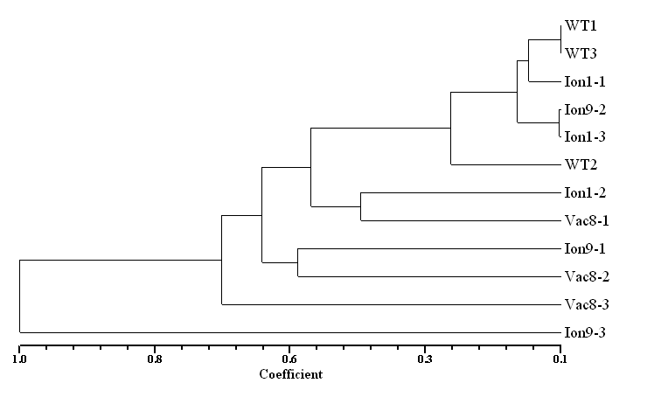
Figure 3.The clustering of the twelve individuals based on the IRAP marker analysis using the UPGMA clustering method. Coefficient is represented the average dissimilarity between individuals. WT: the controls, Ion1-1, Ion1-2, Ion-3 are the samples which Tto1 relative copy number in genome is isometric to the controls. Vac8-1, Vac 8-2, Vac 8-3 are isolated from the DNA pool Vac8 that Tto1 relative copy number in genome is creased to 10 folds in the second euphylla and 2.19 folds in petals. Ion9-1, Ion9-2, Ion9-3 are isolated from the DNA pool Ion9 that Tto1 relative copy number in genome is creased to 10 folds in the second euphylla and 2.32 fold in petals.

Discussion
The implantation of ion activated the transposition of the Tto1 in a lower frequency
Transposable elements constitute a very large proportion of eukaryotic genomes. The activation strategy of retrotransposons oﬀers the potential for explosive increases in copy number and leads to a concomitant genome size increase (Casacuberta JM et al. 2003).The tobacco retrotransposon Tto1, one of a few active retrotransposons of plants, has been shown to be activated by wounding stress, exogenous supply of methyl jasmonate (Shin T et al. 1998). The copy number of Ttol increased 10 folds in established tissue culture cell lines; it also increased in plants regenerated from tissue cultures and in transgenic plants (Hirohiko H et al. 1993). The relative copy number of the Tto1 in tobacco treated by vacuum and implantation of ion beam increased about 10 folds (Table2) in the second euphylla from plantlet and increased 2 folds (Table3) in petal cell from the apical meristem. On the other hand, low-energy ion beam and vacuum caused the genetic polymorphism of the Tto1 in tobacco detected by IRAP (Fig1 and Fig2) that can be used to detect any insertion event. Furthermore, the analysis of the UPGMA clustering method based on the IRAP of the Tto1 from the petal showed that three tobacco individuals under the vacuum and implantation of ion had serious dissimilarity to the controls. These results indicate that Ttol is activated by the implantation of ion and vacuum.
Although the transposition of the Tto1 was detected in euphyllas and petals (Incidence is 3/72=0.04), this does not necessarily mean that the transposition of Tto1 happened in all individuals treated with the implantation of the ion beam. The fact is that the insertion events of the Tto1 occurred in a low occurrence ratio under the vacuum and low-energy ion implantation. Many retrotransposons within the genome are integrated in either a transcriptionally or transpositionally incompetent state (Vicient CM et al. 2002). Developmental or physiological factors may be required for the strong response to Tto1 transcription to wounding stimuli. Experiments with transgenic tobacco plants carrying the Tto1-LTR:-glucuronidase fusion gene (LTR:GUS) revealed that Tto1 actually contains cis-regulatory regions in response to wounding and methyl jasmonate (Shin T et al. 1998). These ﬁndings suggest that the transpositional activation of the Tto1 is induced by suitable signals that we knew little. We think that there were few tobacco seeds having the suitable physiological state for the re-activation of the Tto1 induced by vacuum and radiation of the ion. The transposition occurred only in the sensitive cell to the radiation, so it is not strange that transposition of the Tto1 take place in the few tobacco individual under the vacuum and implantation of ion.
Transposition of the retrotransposons Tto1 is possibly related to the repair of the DNA damage damaged by the low-energy ion
The transposons altered gene expression in ways that allowed the cells to respond to stress (Hirotaka EHL et al. 2007). LINE-1 elements are retrotransposons that comprise 17% of the human genome. The relationship between stress and transposition was recently exemplified by the response of LINE-1 retrotransposons to telomere damage in CHO (Chinese hamster ovary) cells (Morrish TA et al. 2007). When telomere function is disrupted by a deﬁciency in DNA-dependent protein kinase, 30% of LINE-1 transposition events integrate into telomere sequences. These results indicate that LINE-1 transposition is capable of repairing telomere speciﬁc DNA damage (Morrish TA et al. 2003). Retroelements can repair the genomic double-strand breaks by homologous recombination in the plant genome (Ralph S and holger P. 2002). These reports indicate that the transposition of the retrotransposons is related to the repair of the damage to the DNA molecules. Low-energy ions can reach the nuclei and cause damage to the DNA molecules, and then induce mutations when the DNA repair fails (Ya HY et al. 2007). Up to this investigation, we consider that the transposition of the retrotransposons Tto1 is related to the repair of the DNA damage caused by the vacuum and the implantation of the ion.
At last, the conclusion is that Tto1 is re-activated by the implantation of the ion. It implied that Tto1 play important roles in response to the radiation of the ion. These results are helpful to fully understand mechanism of the deleted and inserted DNA of the chromosomes in cell after implantation of the ion.
Acknowledgements We are grateful to Jiao Z and Wu YP for excellent technical assistance. This research was supported by grants from the Henan Key Lab of Ionbeam Bioengineering, Zhengzhou University

References
- Andrew J F. Long terminal repeat retrotransposons jump between species. PNAS, 1999, 96(22):12211–12212
- Briard M, Clera VLE, Gnzebelus D, Senalik D and Simon PW. Modified protocols for rapid carrot genomic DNA extraction and AFLPTM analysis using silver stain on radioisotopes. Plant Mol Biol Rep, 2000, 18: 235–241
- Carlos MV, Annu S, Kesara AJ, Jaakko T, Alex B, Eviatar N and Alan HS. Retrotransposon BARE-1 and its role in genome evolution in the genus hordeum. The Plant Cell, 1999, 11: 1769-1784
- Casacuberta JM and Santiago N. Plant LTR-retrotransposons and MITEs: control of transpositon and impact on the evolution of plant genes and genomes. Gene, 2003, 11: 1-11
- Castelo J S B, Eduardo A. V, Gaspar M, Mauricio M K, Emilia M,Albina B, Claudete C M, Fernando I F C, Costa A O. IRAP and REMAP assessments of genetic similarity in rice. J Appl Genet,2007, 48(2): 107–113
- Feng HY, Yu ZL and Chu PK. Ion implantation of organisms. Materials Science and Engineering, 2006, 54:49-120
- Feschotte C, Jiang N and Wessler SR. Plant transposable elements: where genetics meets genomics. Genetics, 2002, 3: 329-341
- Grandbastien MA. Activation of plant retrotransposons under stress conditions. Trends Plant Sci, 1998, 3: 181-189
- Hirohiko H. Activation of tobacco retrotransposons during tissue culture. The EMBO Journal, 1993, 12(6): 2521 -2528
- Hirotaka EHL and Levin. Stress Management: How Cells Take Control of Their Transposons Molecular Cell, 2007, 27: 180-181
- Kalendar R, Grob T, Regina M, Suoniemi A, Schulman AH. IRAP and REMAP: two new retrotransposon-based DNA fingerprinting techniques. Theor Appl Genet, 1999, 98: 704-711
- Kazuhiko S, Shin T, and Hirohiko H. MYB-related transcription factor NtMYB2 induced by wounding and elicitors is a regulator of the tobacco retrotransposon Tto1 and defense-related genes. The Plant Cell, 2000, 12:2511–2527
- Kubis SE, Heslop-Harrison JS, Desel C and Schmidt T. The genomic organization of non-LTR retrotransposons from three Beta species and five other angiosperms. Plant Mol Biol, 1998, 36: 821-831
- Kumar A and Bennetzen JL. Plant retrotransposons. Annu RevGenet, 1999, 33: 479-532
- Malone G, Zimmer PD, Mattos LAT, Kopp MM, Carvalho FIF and Oliveira AC. Assessment of the genetic variability among rice cultivars revealed by AFLP. Revista Brasileira de Agrociencia, 2006, 12:21–25
- Meyers BC, Tingey SV and Morgante M (2001). Abundance, distribution and transcriptional activity of repetitive elements in the maize genome. Genome Res, 11: 1660-1676
- Morrish TA, Gilbert N, Myers JS, Vincent BJ, Stamato TD, Taccioli GE, Batzer MA and Moran JV. DNA repair mediated by endonuclease-independent LINE-1 retrotransposition. Nat Genet, 2002, 31(2): 159-165
- Morrish TA., Garcia-Perez JL, Stamato TD, Taccioli GE, Sekiguchi J, and MoranJV. Endonuclease-independent LINE-1 retrotransposition at mammalian telomeres. Nature, 2007, 446:208–212.
- Ralph S and holger P. Efficient repair of genomic double-strand breaks by homologous recombination between directly repeated sequences in the plant genome. The plant cell, 2002, 14:1121-1131
- Shin T, Kazuhiko S, Hiroshi O and Hirohiko H. Transcriptional activation of the tobacco retrotransposon Tto1 by wounding and methyl jasmonate. Plant Molecular Biology,1998, 36: 365–376
- Sonia C and Gopalakrishna T. Comparative assessment of REMAP and ISSR marker assays for genetic polymorphism studies in Magnaporthegrisea. CURRENT SCIENCE, 2007,93(5):688-692
- Vicient CM, Marko JJ, Kalendar R, Schulman AH. Active retrotransposons are a common feature of grass genomes. Plant Physiol, 2001, 125: 1283-1292
- Vicient CM, Schulman AH. Copia-like retrotransposons in the rice genome: few and assorted. Genome Lett, 2002, 1(1): 35-47
- Ya HY, Gu YH, Jiao Z, Wang WD, Qin GY, Huo YP. Low-Energy Ion Beam Promotes the Transcription and Transposition of the Copia-retrotransposons in Wheat (Triticum aestivum L.) Journal of Plant Physiology and Molecular Biology, 2007, 33 (6): 507-516
- Ya HY, Jiao Z, Gu YH, Wang WD, Qin GY, Huo YP (2007).Impact of low-energy ion beam implantation on the expression of Ty1-copia-like retrotransposons in wheat(Triticum aestivum L.). Plasma Sci Technol, 2007, 9(5): 626-633.

5/9/2010

