Estimating Of Some Trace Elements In Mineral Water In The Kingdom Of Saudi Arabia

Sana Arab¹ , Asia Alshikh²

¹Kingdom Of Saudi Arabia, Ministry of Higher Education, King Abdulaziz University, Deanship of Scientific Research, Girl’s College of Educational, Jeddah.²Kingdom Of Saudi Arabia, Ministry of Higher Education, Jizan University, Deanship of Scientific Research, Girl’s College of Educational, Jizan.
Ziadahmed1020@hotmail.com

Abstract: A novel sensor was developed for simultaneous detection of Pb, Cd, Cu and Zn concentration based on the differential pulse anodic stripping voltammetry techniques. Response (DPSV) performed on a hanging mercury drop electrode (HMDE). The estimation of Pb, Cd, Cu, Zn concentration in the mineral water of Al – Qasim, Hana Al Qasim, Najran, Nova, Safa Makah, and Mozn Jazan drinking water in the Kingdom of Saudi Arabia was accomplished. [Life Science Journal 2010;7(3):133-137]. (ISSN: 1097-8135).

Keywords: mineral water; voltammetry; Saudi; trace elements.

1. Introduction
The importance of the hygienic, safety, and validity of drinking water, was conceded by James. B. Grant the chief executive of The United Nations (UNICEF) who said: "It was well known that it is for a long time the majority of diseases in the third world were attached by one way or another by the shortage of purified water and by the hygienic reasons , so we have to attached to our believes in the importance of providing the purified water and in the importance of hygienic reasons".
The chemical analysis of drinking water is important because we should know about what it contains from mineral elements, pollution's degree, contaminated materials, and the most important mineral impurities.
The studies show that Cadmium (Cd) causes a lot of serious health problems and if it accumulates in the kidneys with a high critical amount it will affect them and weaken their functions to the point that they will probably fail to do their duty. On the other hand Cadmium is responsible about the blood pressure and affects heart making it inflate, also poisons of Cadmium affects from its the metabolism (Demetriades et al., 2004, He et al., 2007, Portugal et al., 2007)
While Lead (Pb) which is considered as an important and famous polluted substance in the aquatic environment, is very harmful for body health. When it transmits to human body it will ruin brain cells and causes slow death .The danger of lead due to the inability of body to get rid of its accumulates in the body causing a lot of physical, and healthy risks.
The important symptoms that appear is poising by lead, abdominal cramps and bouts of diarrhea, constipation and general weakness , paralysis of hands or feet, feeble eyes, sleeplessness, bouts of nervousness, depression, convulsions, fainting, nervous irritation, and embryo deformation (Sonthalia et al., 2004).
Copper (Cu) is an essential trace element. Copper is a vital part of several enzymes (e.g., ferroxidases, cytochrome coxidase, superoxide dismutase, tyrosinase, lysyl oxidase, and dopamine beta hydroxylase). The absorption depends on the amount ingested, its chemical form, and the composition of other dietary components such as zinc. Drinking water may contribute significantly to the daily copper intake because of the widespread use of copper pipes. Absorption is regulated by homeostatic mechanisms in the liver, and biliary excretion increases when copper is in excess. No quantitative data on pulmonary absorption are available (Ellingsen et al., 2007). The increasing of Copper concentration beyond the limits could cause acute intestinal effectiveness especially, nausea, diarrhea, and abdominal pains with unacceptable taste which may lead to aggressive erosion on metal bowls and Pipes (Herzog and Arrigan, 2005).
Zinc (Zn) leads to poison and irritate the digestive system (upset stomach), causing a lack of absorption of copper, and body temperature will be raised which will affect body immunity (Khun and Liu, 2009).
Stripping analysis has been proved a powerful and versatile technique for the determination of trace heavy metals in various samples (Wu et al., 2008).

2. Materials and methods.
Gathering samples:
Bottles water samples were chosen from Al Qasim, Hana Al Qasim, Najran, Nova, Safa Holy Makkah, and Mozn Jazan drinking water for one-year validity (Al-Saleh, 1996).

Preparing of samples:
The studied samples were acidified by adding one millimeter of intensified Nitric acid, HNO₃ (70%).

The apparatus used in the study:
The concentration of trace elements were measured by Polargraph instrumental 746 VA trace analyzer with 747 VA stand or from Metrohm company. The information storage is done by a computer, from Toshiba company 757 VA computracy joined with the device.

3. Results and discussion
Table 1 shows that the concentration of elements which is under study in the mineral water for the chosen six factories. They have been analyzed using SPSS program, at significant (p<0.01).

Table 1. The concentration of studied elements in the mineral water in the six factories.
Elements concentration |  |  |  | Factory
Mean ± S.D. |  |  |  | Factory
Zn | Cu | Cd | Pb | Factory
120.1086±  0.6303 | 66.5397±0.606 | 0.056±  0.0036 | 6.2049±0.311 | Hana  - Al Qassim
136.7745±  1.9165 | 40.1828±2.159 | 0.0376±  0.0146 | 2.3794±1.18 | Al-Qassim
193.2588±  17.9635 | 64.8513±2.0241 | 0.0811±  0.0031 | 13.4554±0.21 | Nova
199.3590±  0.2135 | 66.3968±3.199 | 1.8993±  0.2493 | 4.5461±0.94 | Safa Makkah
128.161±  4.9022 | 33.703±  6.1549 | 0.0615±  0.0003 | 18.0077±2.48 | Najran
143.1204±  9.879 | 58.4476±2.914 | 0.0564±  0.0038 | 4.643±  0.9435 | Mozn Jazan
Figure 1.Concenteration of Lead(Pb) in
mineral water of six factories

The highest concentration was found with Pb noticed is (18.0077 ppm) in Najran drinking water, while Al-Qasim has the lower concentration it reached (2.3794ppm)(van staden and Taljaard, 2004); the order is: Najran > Nova >Hana Al- Qasim> Mozn Jazan> Safa Holy Makkah >Al-Qasim.
Also the study showed that the highest concentration Cd was in Holy Makkah drinking water (1.8993ppm) then Nova drinking water where (0.0811ppm), then Najran drinking water (0.0615ppm) then Mozn Jazan drinking water (0.0564ppm), then Hana Al Qasim drinking water (0.056ppm),then Al Qasim drinking water (0.0376ppm)(Bakker and Pretsch,2005).
The study approved that the highest concentration of Cu was (66.5397ppm) in Hana Al Qasim drinking water then Safa Holy Makkah drinking water (66.3968ppm), then Nova drinking water reached to (4.8513ppm) after that Mozn Jazan drinking water reached to (58.4476 ppm) , then A l Qasim drinking water reached to (40.1828 ppm). Finally Najran drinking water where concentration reached to (33.703ppm) (Güler and Alpaslan, 2009).
Figure 2.Concenteration of (Cd) in mineral water of six factories.

Figure 3.Concenteration of Copper (Cu) in mineral water of six factories.

Figure 4.Concenteration of Zinc (Zn) in mineral water of six factories.

Also the study approved that the highest concentration of Zn was found in Safa Holy Makkah drinking water which reached (199.3590 ppm) then Nova drinking water reached to (193.3588 ppm) then Mozn Jazan drinking water reached to (143.1204 ppm), after that Al Qasim drinking water reached to (136.7745 ppm), after that Najran drinking water reached to (128.161 ppm), finally Hana Al Qasim drinking water reached to (120.1086ppm) (Emmanuel et al., 2009).
Also the study clarified the differences between elements concentration, so that it can be seen in :

1. Hana Al - Qasim water ,the highest concentration Zn element is found ,that it reached to (120.1086ppm) where the less concentration was Cd element , that it reached to (0.0560ppm . Cu reached to (66.5397ppm) , following that ,Pb element where it reached (6.2049ppm).
2. Al Qasim drinking water concerning Cd, it was the lowest concentration within (0.0376ppm) following that Cu within (40.1828ppm) after that Zn within (136.7745ppm).
3. Nova drinking water, in that the highest concentration Zn was within (193.2588ppm) ,and it was lower in concentration Cd element within (0.0811ppm).
4. Safa Holy Makkah drinking water ; it was the lowest concentration Pb element within (4.5461ppm), and the highest concentration Zn within (199.3590ppm).
5. Mozn Jazan drinking water concerning Cu within (58.4476ppm) and Cd concentration reached to (0.0564ppm) while the lowest concentration was in Pb element where it reached to (4.6430ppm) and the highest concentration was Zn element within (143.1204ppm).
6. Najran drinking water; was the lowest concentration of Cd element within (0.0615ppm), and the highest concentration of Zn within (128.161ppm).

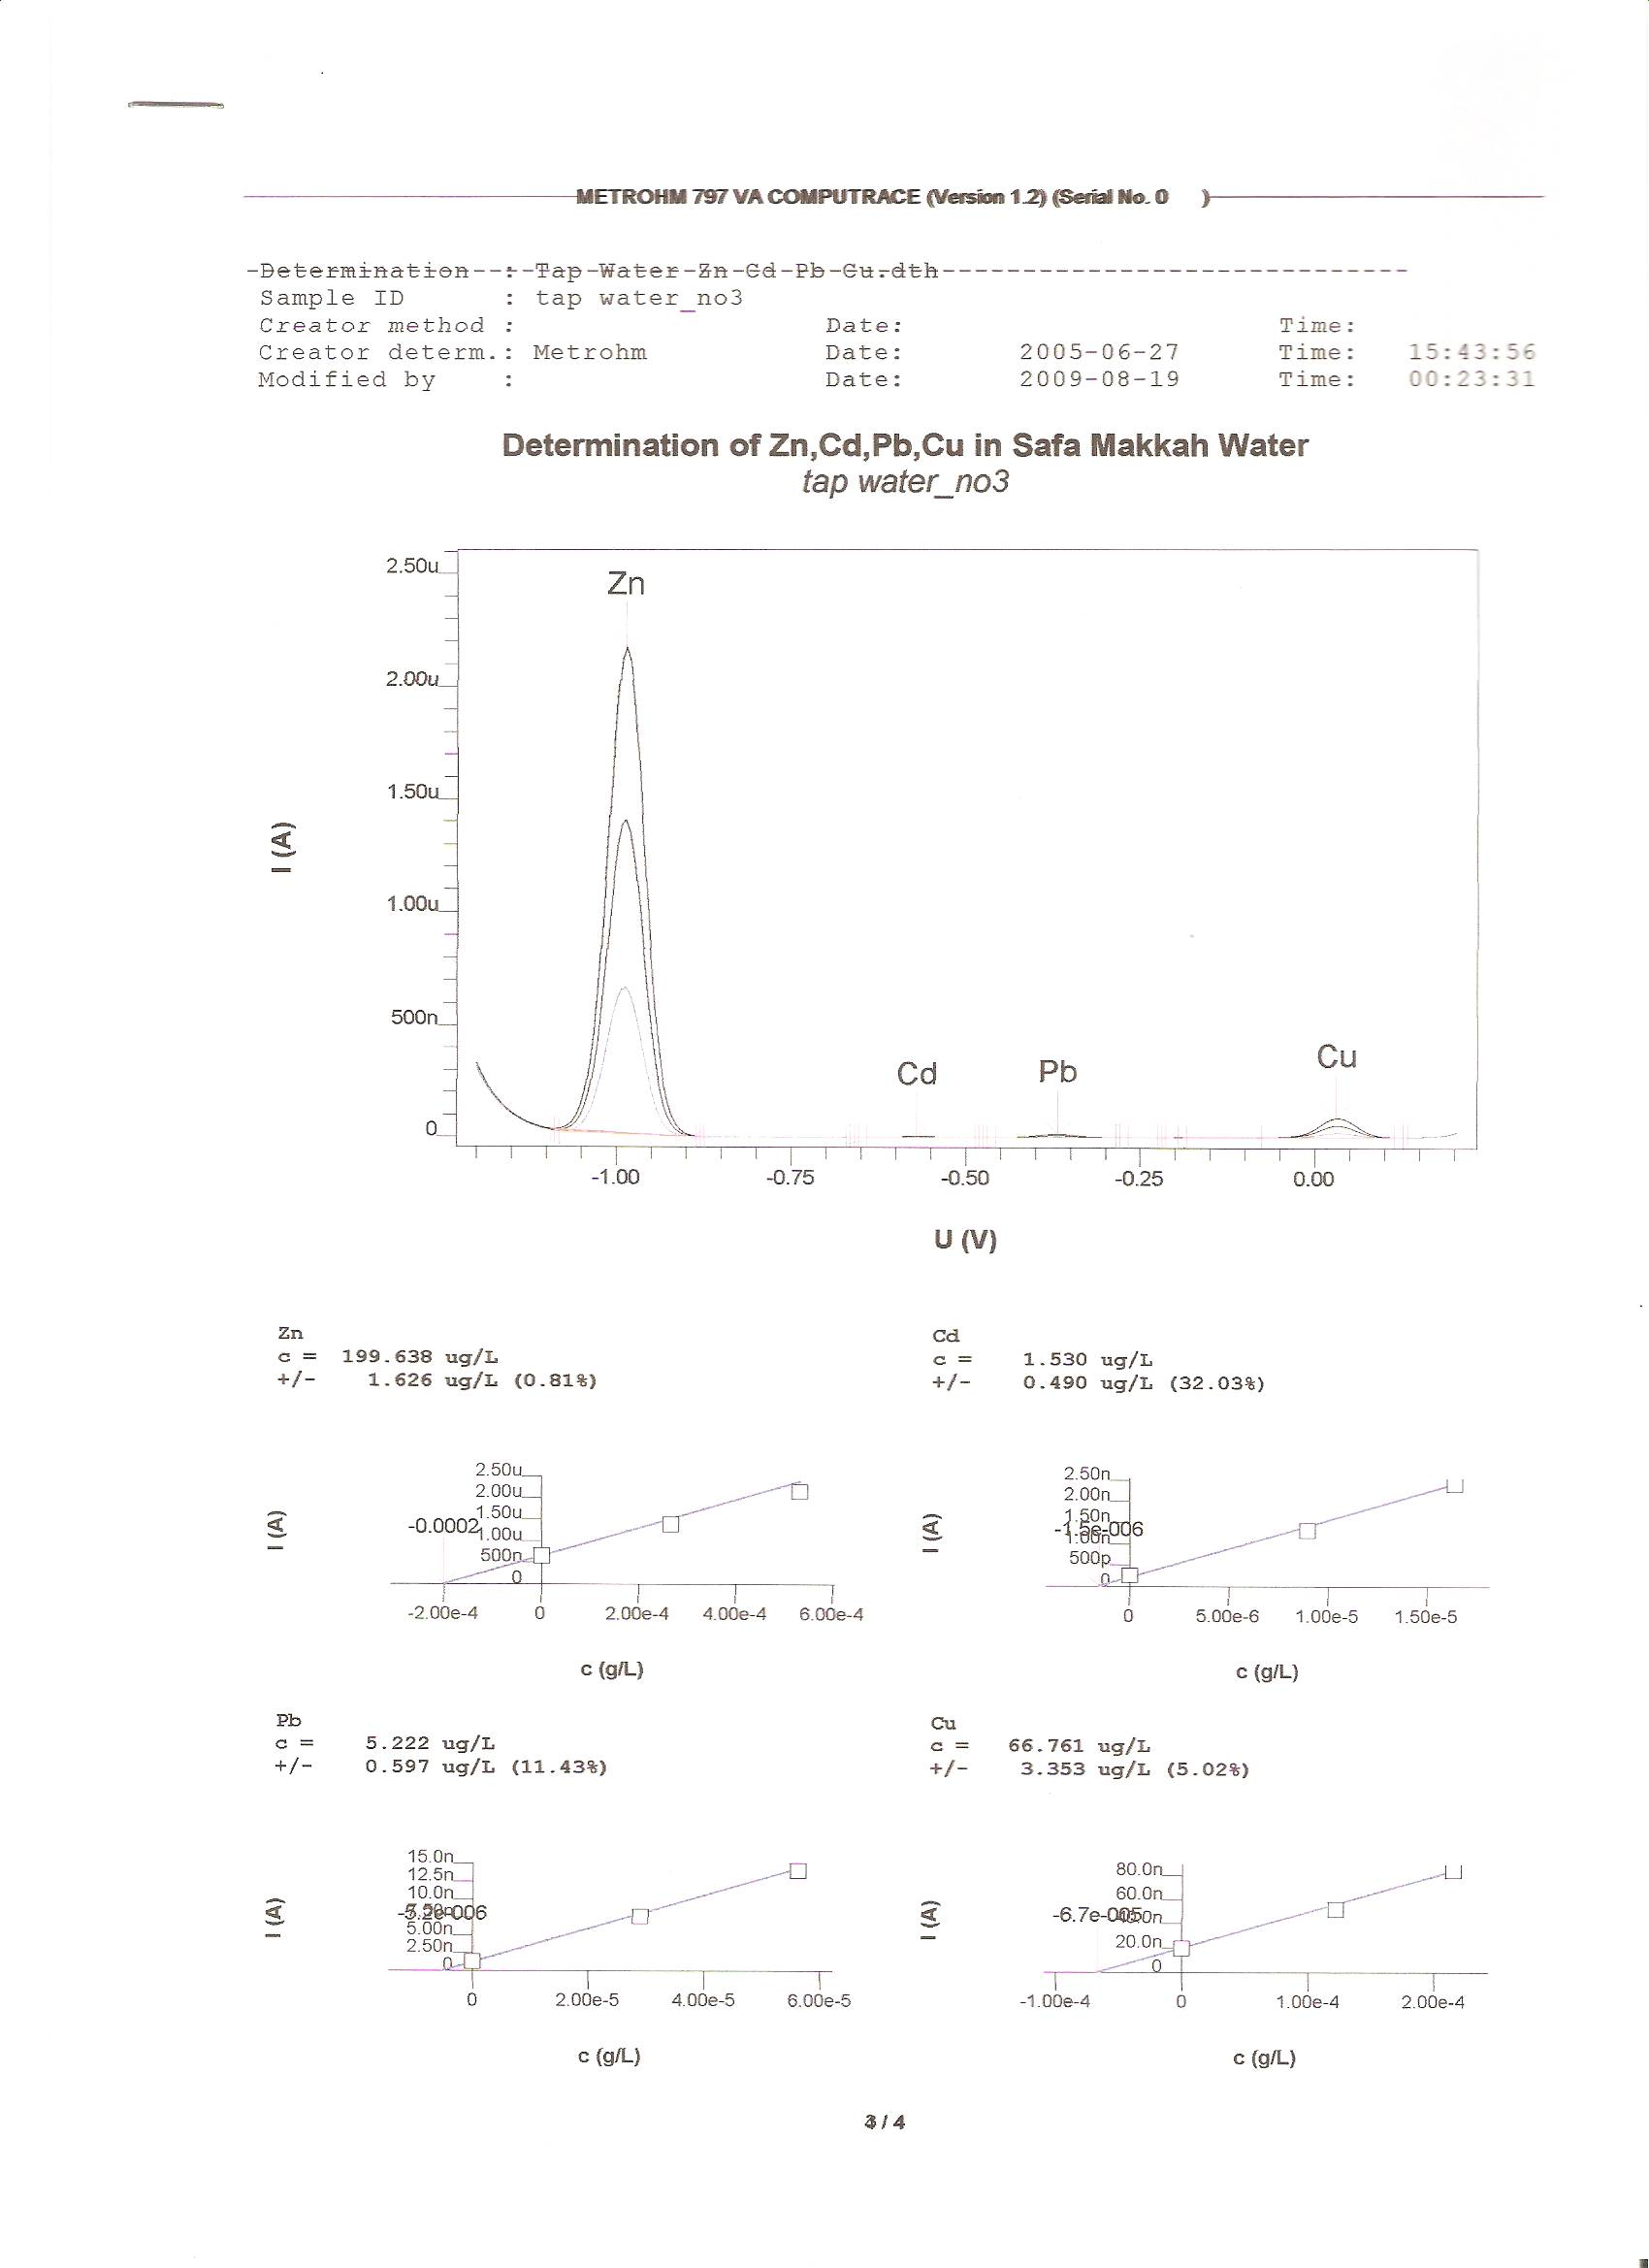
Figure 5. Voltammogram of the trace elements
(Cu,Pb,Cd,Zn) in drinking water.

Also it is clarified from the Figure 5. Voltammogram of the trace elements (Cu, Pb, Cd, Zn) in drinking water, that the highest concentration is of Zn element in all mineral water that is under the study , then Cu element concentration then Pb element concentration and finally Cd. The study of the correlation coefficient between elements shows the following:
(1) in Hana Al Qasim drinking water there is a strong positive correlation between Pb and Cd (r = 0.727), also correlation coefficient is strong positive between Zn and Cu (r = 0.886).
(2) in Al Qasim drinking water a strong positive correlation between Zn and Cu (r = 0.838) is found ; also the correlation coefficient is strong positive between Pb and Cd (r = 0.956).
(3) in Nova drinking water , it was found that there is a strong positive correlation between Pb and Cd (r = 0.66), and also the correlation is strong positive between Zn and Cu (r = 0.90).
(4) Also the correlation coefficient is strong positive between Cu and Cd (r = 0.925) and between Zn and Pb (r = 0.679) in the study of Safa Holy Makkah drinking water .
(5) the correlation coefficient is strong positive (r=0.987) between Pb and Cd ;and strong positive between Zn and Cu (r = 0.885) in the study of Mozn Jazan drinking water .
(6) in Najran drinking water the correlation coefficient is weak (r = 0.014) between Cd and Cu under the study , while it was strong between Zn and Pb (r = 0.958).
On the other hand , for the studied elements, it can be stated that :
The study of the concentration of Pb element in different bottled drinking water samples, showed that the correlation coefficient is strong positive between the concentration of Pb element in Al Qasim drinking water and the concentration of Pb element of Najran drinking water (r = 0.965).
Also the correlation coefficient is strong and positive (r = 0.937) between Pb element concentration in Al Qasim drinking water and the Pb element concentration in Safa Holy Makkah drinking water , while correlation is medium positive (r = 0.619) between Pb element condensation in Al Qasim and Hana Al Qasim.
The study also, showed that the correlation is weak (r = 0.059) between Pb element condensation in Al Qasim drinking water and Nova drinking water, while correlation is medium and positive (r = 0.681) between Pb element in Najran drinking water and Hana Al Qasim drinking water.
Also the correlation is weak (r = 0.20) between Pb element in Najran drinking water and Nova drinking water , while correlation coefficient is strong and positive (r = 0.943) between Pb concentration in Najran drinking water and Pb concentration in Safa Holy Makkah drinking water.
The study explained that the correlation coefficient is weak (r = 0.045) between Pb concentration in Nova drinking water and in Safa Holy Makkah drinking water.
The study of the correlation coefficient for Cd element among the samples of the studied factories clarified that the correlation coefficient is strong and positive between Cd element concentration in Al Qasim drinking water and Cd element concentration in Hana Al Qasim drinking water (r = 0.967), in Safa Holy Makkah drinking water (r = 0.978) , and in Nova drinking water (r = 0.990).
While the correlation coefficient is weak between Cd element concentration in Najran drinking water and in Mozn Jazan (r = 0.224). The study also showed that the correlation coefficient is strong and positive between Cd element concentration in Hana Al Qasim drinking water , and Nova drinking water (r = 0.974).
The study approved that the correlation coefficient is positive and strong between Cd concentration in Safa Holy Makkah drinking water, Cd element concentration in Hana Al Qasim drinking water (r = 0.955), and Nova drinking water (r = 0.969).
The study approved that the correlation coefficient is positive and strong among Cu element concentration in Mozn Jazan and Cu element in Hana Al Qasim (r = 0.964), in Safa Holy Makkah (r = 0.967) in Nova drinking water (r = 0.992).
The study clarified that the correlation coefficient between Cu concentration in Najran and Cu concentration in Al Qasim drinking water (r = 0.914) is strong and positive. Also the study clarified that the correlation coefficient is positive and strong between Cu in Nova drinking water and Hana Al Qasim drinking water (r = 0.967) .
Also the correlation coefficient between Cu element condensation in Safa Holy Makkah and Hana Al Qasim was positive and strong (r = 0.983).
The study confirmed that the correlation coefficient is strong between Zn element concentration in all of Nova drinking water , Najran drinking water (r = 0.971) , Mozn Jazan drinking water (r = 0.944) , Zn in Hana Al Qasim (r = 0.994) , and in Safa Holy Makkah drinking water (r = 0.652).
The study also clarified that the correlation is strong and positive between Zn concentration in all of : Najran drinking water , Mozn Jazan drinking water (r = 0.971) , Hana A l Qasim (r = 0.971) , and Safa Holy Makkah drinking water (r = 0.704). Also the study clarified that the correlation coefficient is positive and strong between Zn element concentration in Safa Holy Makkah , Mozn Jazan drinking water (r = 0.759) , and Hana Al Qasim (r = 0.613).

Figures (6 - 9) show the study of the timing effect on concentration of trace elements which is under study in the mineral water for the chosen six factories. The obtained data from the figures show that the Pb element concentration in Al-Qasim drinking water is reduced from (3.771ppm) to (0.7711ppm) and also it is reduced from (21.421ppm) to (13.3720ppm) in Najran drinking water (Dragoe et al.,2006). Pb concentration is reduced in Mozn Jazan from (5.762ppm) to (2.899ppm), and Pb concentration is reduced in Hana Al Qasim from (6.535ppm) to (5.662ppm). The study clarified that Pb element is reduced in Safa Holy Makkah from (5.937ppm) to (2.847ppm), Pb element concentration is reduced in Nova from (13.698ppm) to (13.159ppm) and also the situation as it concerning to Cd,Cu,and Zn (Asubiojo et al., 1997).

4. Conclusion
The estimation of Pb ,Cd ,Cu ,Zn concentration in the mineral water of Al – Qasim , Hana Al Qasim , Najran , Nova , Safa Makah , and Mozn Jazan drinking water was accomplished using voltametry techniques .The highest concentration of Pb is in Najran drinking water. Also the study showed that the highest concentration Cadmium is in Safa Holy Makkah drinking water. It approved that the highest concentration of Cu is in Hana Al Qasim drinking water. The study approved also that the highest concentration of Zn is in Safa Holy Makkah drinking water. The obtained results were lower than the average range of these elements in the maximum concentration as they were allowed to be by The World Health Organization (WHO) (Öztürk and Yilmaz, 2000).

Corresponding Authors:
Dr.Sana Taher Arab
¹Kingdom Of Saudi Arabia, Ministry of Higher Education, King Abdulaziz University, Deanship of Scienctif Research, Girl’s College of Educational, Jeddah.
Dr.Asia Ali Alshaik
²Kingdom Of Saudi Arabia, Ministry of Higher Education, Jizan University, Deanship of Scienctif Research, Girl’s College of Educational, Jizan.
E-mail: Ziadahmed1020@hotmail.com

References
- Demetriades D, Economou A, Voulgaropoulos A. A study of pencil-lead bismuth-film electrodes for the determination of trace metals by anodic stipping voltammetry. Analytica chimica acta 2004; 519(2):167-172.
- He Y, Zheng Y, Locke DC. Cathodic stripping voltammetric analysis of arsenic species in environmental water samples. Microchemical Journal 2007;85(2):265-269.
- Portugal L.A., Ferreira H.S.,dos Santos W.N.L., Ferreira S.L.C. Simultaneous preconcentration procedure for the determination of cadmium and lead in drinking water employing sequential multi-element flame atomic absorption spectrometry. Microchemical Journal.2007;87(1): 77-80
- Sonthalia P.,McGaw E.,Show Y.,Swain G.M.Metal ion analysis in contaminated water samples using anodic stripping voltammetry and a nanocrystalline diamond thin-film electrode.Analytica Chimica Acta. 2004;522 (1):35-44.
- Ellingsen DG, Horn N, Aaseth J. Copper 11- Handbook on the Toxicology of Metals (Third Edition)2007; 529-546.
- Herzog G.and Arrigan D.W.M.Determination of trace metales by underpotential deposition- stripping voltammetry at solid electrodes. TrAC Trends in Analytical Chemistry.2005;24(3):208 -217
- Khun N.W.and Liu E.Linear sweep anodic stripping voltammetry of heavy metals from nitrogen doped tetrahedral amorphous carbon thin films. Electrochimica Acta, 2009; 54(10):2890- 2898.
- Wu Y., Li N.B., Luo H.Q. Simultaneous measurement of Pb, Cd and Zn using differential pulse anodic stripping voltammetry at a bismuth / poly(p-aminobenzene sulfonic acid) film electrode. Sensors and Actuators B: Chemical 2008;133(2):677-681.
- Al-Saleh I.A..Trace elements in drinking water coolers collected from primary schools, Riyadh, Saudi Arabia. Science of The Total Environment, 1996;181 (3) :215-221.
- Van Staden J.F. and Taljaard R.E.Determination Of Lead (II), Copper (II), Zinc (II) ,Cobalt (II), Cadmium(II), Iron(III), Mercury(II) using sequential injection extractions. Talanta, 2004;64 (5):1203-1212.
- Bakker E. and Pretsch E.potentiometric sensors for trace-level analysis. TrAC Trends in Analytical Chemistry 2005;24(3)199-207.
- Güler C., Alpaslan M.Mineral content of 70 bottled water brands sold on the Turkish market: Assessment of their compliance with current regulations. Journal of Food Composition and Analysis, 2009.
- Emmanuel E., Pierre M.G., Perrodin Y.Groundwater contamination by microbiological and chemical substances released from hospital wastewater: Health risk assessment for drinking water consumers. Environment International 2009;35(4):718-726.
- Dragoe D., Spătaru N., Kawasaki R. Manivannan A., Spătaru T., Tryk D.A.and Fujishima A.Detection of trace levels of Pb²⁺in tap water at boron-doped diamond electrodes with anodic stripping voltammetry. Electrochimica Acta 2006; 51(12): 2437-2441.
- Asubiojo O.I.,Nkono N.A.,Ogunsua A.O., Oluwole A.F.,Ward N.I.,Akanle O.A.,Spyrou, N.M.Trace elements in drinking and groundwater samples in Southern Nigeria.Science of The Total Environment,1997;208(1-2):1-8.
- Öztürk N.and Yilmaz Y.Z.Trace elements and radioactivity levels in drinking water near Tuncbilek coalfired power plant in Kütahya, Turkey.Water Research 2000;34(2):704-708.

7/20/2010

